**Proficiency Academy Presenters BIO**

**Implementation Strand, Rebecca Blouwolff**

* 2020 ACTFL National Language Teacher of the Year
* Frequent presenter at ACTFL, NECTFL, MAFLA Proficiency Academy, PEARLL Summer Institute, and other MAFLA conferences
* French teacher at Wellesley Middle School since 1998
* Master’s degree from Harvard Graduate School of Education in Teacher Leadership
* Certified French teacher
* National Board Certified French teacherFormer World Language supervisor in Howard County, MD
* 27 years experience as a French and Spanish educator at the middle and high school levels
* Co-author of the ACTFL publication, The Keys to Strategies for Language Instruction
* Has served on the boards of ACTFL, NECTFL, NADSFL, and MFLA
* Frequent presenter at local, state, regional, and national conferences

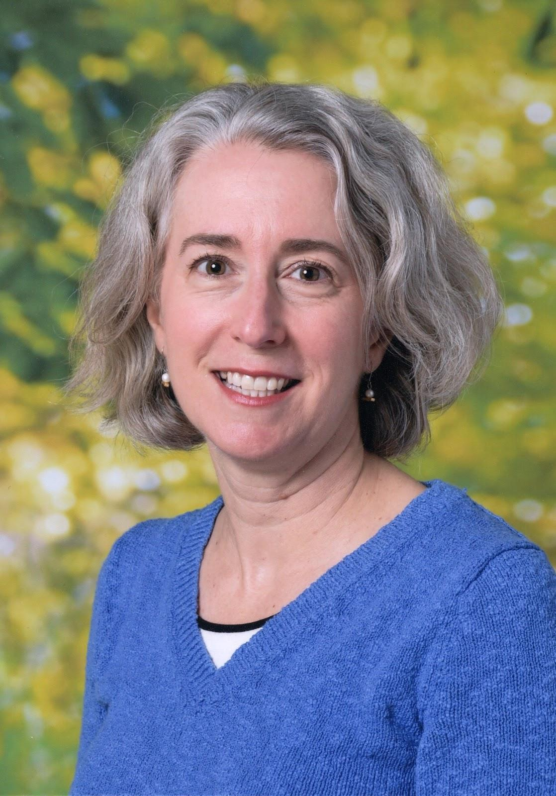

Rebecca Blouwolff was born and raised in the Pioneer Valley, where she studied French with an exuberant, immersion-style teacher in junior high. She has taught French at Wellesley Middle School in MA since 1998, but fell in love with middle schoolers while serving as a Fulbright teaching scholar at a collège in Saint-Omer, France. Rebecca is a seven-time attendee of Proficiency Academy, two-time facilitator, and is leading the Foundations Strand for a second year. She earned a BA magna cum laude at Brown University, and an MEd in Teacher Leadership at the Harvard Graduate School of Education. She is a National Board Certified Teacher, 2019 MaFLA and NECTFL Teacher of the Year.

**Curriculum Strand, Leslie Grahn**

* Former World Language supervisor in Howard County, MD
* 27 years experience as a French and Spanish educator at the middle and high school levels
* Co-author of the ACTFL publication, The Keys to Strategies for Language Instruction
* Has served on the boards of ACTFL, NECTFL and NADSFL.
* Frequent presenter at local, state, regional, and national conferences

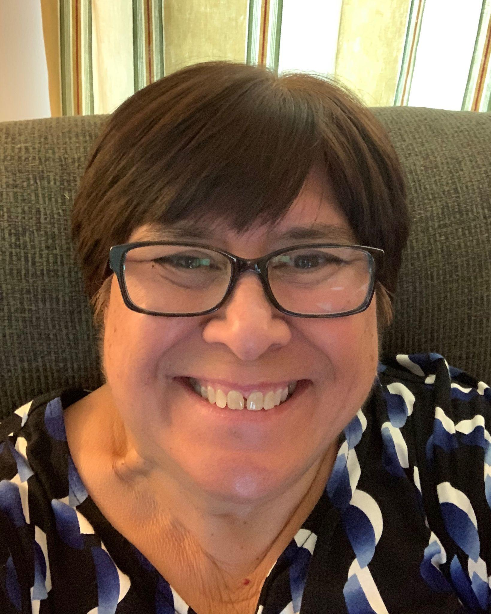

Leslie Grahn has twenty-seven years of language teaching experience at the middle and high school levels and twelve years of experience at the central office level, most recently as Coordinator of World Languages for the Howard County Public School System in Maryland. Leslie has been a course instructor on foreign language teaching methods and differentiated instruction, has led both curriculum and assessment development teams, and is a frequent presenter at state, regional, and national conferences, specializing in best practices. She curates and creates resources to support language teaching and learning and shares them through her website (www.grahnforlang.com) and on Pinterest (grahnforlang). She has experience in teacher and leadership development and leads training on instructional coaching, mentoring, leadership, and communication skills. Leslie is the co-author of The Keys to Strategies for Language Instruction and has served on the boards of NECTFL, NADSFL and ACTFL.