# **Special Education Policy Memo SY2024-2025 — 3**

**2024-2025 IDEA Equitable Services Child Count Application**

|  |  |
| --- | --- |
| To: | Local Education Agency Special Education Leadership |
| From: | Acting State Director of Special Education, Jamie Camacho |
| Date: | November 14, 2024 |
|  |  |

1. **Introduction**

The Department of Elementary and Secondary Education (DESE) has an imperative to locate and support all students with disabilities who qualify for equitable services and live and attend schools in our districts as we continue to work to eliminate the existing equity gaps and increase access.

The purpose of this memorandum is to inform special education administrators, school business managers, and other interested parties that the IDEA Equitable Services Annual Child Count Application for the 2024-2025 school year count and 2023-2024 equitable services record keeping are now open in the [MA Education Security Portal](https://gateway.edu.state.ma.us/stardust/login)

Child Count is a federally required activity of the IDEA[1] regarding equitable services for eligible privately enrolled students, including home-school[2] students, who are privately enrolled or home-schooled and educated within the geographic boundaries of the district. Preschool-aged children are considered parentally-placed private school students *if they are enrolled in a private school that meets the definition of an elementary school.2* The Child Counts must be conducted on October 1 each year, and are used to determine the amount the proportionate share of the district’s FC 240 and FC 262 IDEA Part B annual allocations to provide equitable services to eligible parentally-placed private school children with disabilities *in the subsequent fiscal year*.

1. **Equitable Services Requirements**

Districts are required, after completion of timely and meaningful consultation, child find activities, and eligibility determinations, to conduct the child count to be used in calculating proportionate share for eligible students ages 3–21 for the FC 240 grant and eligible preschool students ages 3–5[3] for the FC 262 grant.

Additional guidance, information, and sample templates regarding districts’ obligations can be found within the [Department's Equitable Services Resources](https://www.doe.mass.edu/sped/proshare/)

Included below are step-by-step instructions on how to access the Application and complete the child count and record keeping data entry.

1. **Equitable Services Child Count Application Step-by-Step Instructions**

There are four steps you need to take to report the Child Count and Record Keeping data through [MA Education Security Portal](https://gateway.edu.state.ma.us/stardust/login) the Security Portal:

**Step 1:** Access the [MA Education Security Portal](https://gateway.edu.state.ma.us/stardust/login) using your local credentials. Contact your District Administrator if you do not have or know the required credentials.[4] Once logged in, choose “IDEA Equitable Services Annual Child Count” and select your district from the drop-down menu.

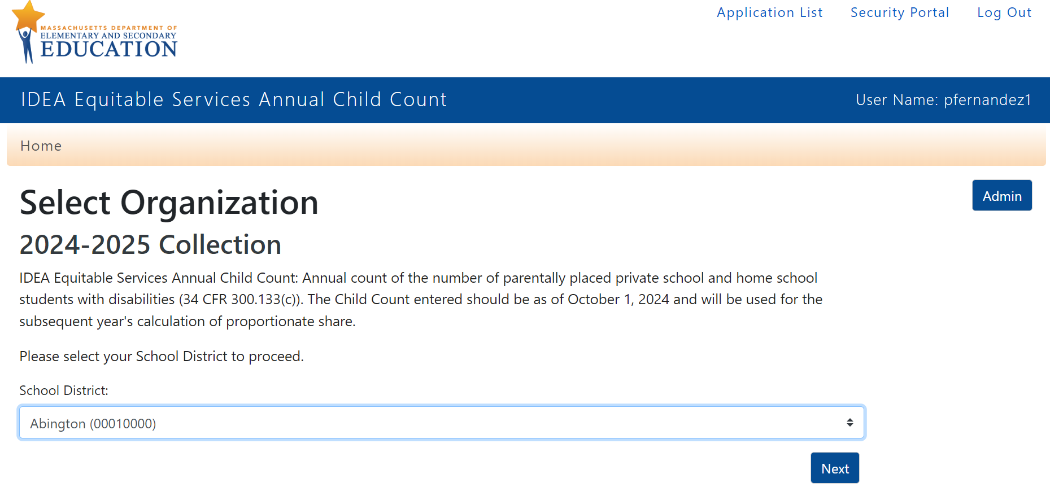

**Step 2: Child Count** - Complete the fields as indicated in the screenshot below.

* Fund Code 240 Child Count ages 3-21
* Fund Code 262 Child Count ages 3-5

Reminders:

* Count all students in each category who are determined eligible for special education and or services, regardless of whether a student receives services.
* Students are counted even if a parent declines services.
* Students whose parent(s) do not consent to an initial or reevaluation are not "eligible" and not counted.
* Students who were evaluated but determined not eligible for special education and or related services are not counted.
* All students remain eligible for three (3) years following an eligibility determination even if parent(s) declined an IEP or services.
* Students who reside in your district and evaluated, determined eligible for special education and or related services, and parentally-placed in a private school outside of your district, are not counted, even if your district provides direct services to such a student pursuant to an IEP.
* Preschool-aged (3-5) children are considered to be parentally-placed private school students *if they are enrolled in a private school that meets the definition of an elementary school* and should be counted in both the FC 240 & FC 262 child counts.
* For a private school to be considered an elementary school, it must provide instruction to grades one through five, six, seven, or eight.
* Students parentally-placed in stand-alone private preschools or childcare centers are not counted

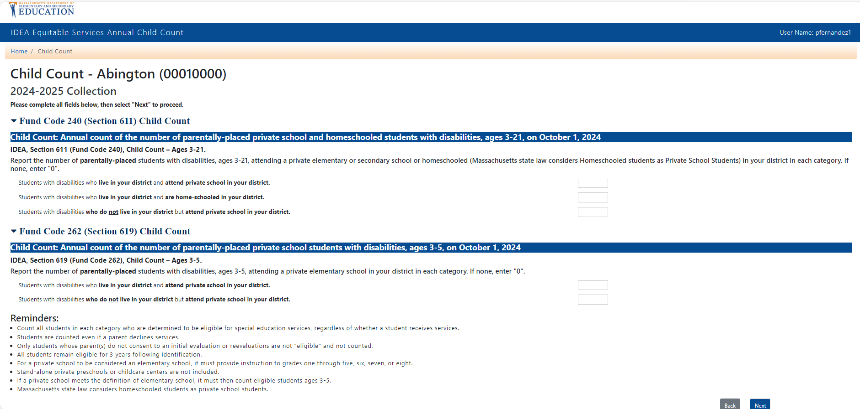

**Step 3:** **Record-Keeping Data** - Complete the fields as indicated in the screenshot below

* Fund Code 240 ages 3-21
* Fund Code 262 ages 3-5

Unlike for child count, which counts children at one point in time, the number of students for record keeping is aggregated at the end and includes the entire school year.

Fund Code 240

**Column A** includes the number of parentally-placed private school students living in your district and attending a private school in your district who were **evaluated**, found **eligible** for special education and, or related services, and **received equitable services**6 at all during the **2023-2024** school year.

**Column B** includes the number of resident students home schooled under a district approved plan who were **evaluated**, found **eligible** for special education and, or related services, and **received equitable services**at all during the **2023-2024** school year.

**Column C** includes the number of parentally-placed private school students *living in* the district and attending a private school outside your district who were **evaluated** and found **eligible** for special education and, or related services during the **2023-2024** school year. *Your district should enter “0” for the number of said students who received* ***equitable services*** *during the 2023-2024 school year where equitable services are provided by the district in which said students attend private school.*

**Column D (Gold)** includes the number of parentally-placed private school students living outside your district and attending a private school in your district who were **evaluated**, found **eligible** for special education and, or related services, and **received equitable services** at all during the **2023-2024** school year.

Fund Code 262

These numbers are the same as FC 240 with the exception that preschool students are not homeschooled under a district approved plan, and only preschool students who are parentally placed in a private *elementary* school as defined above are counted. Likewise, your number should be “0” for the evaluated and eligible parentally placed private elementary school students who attend school *outside your district* who received equitable services where equitable services, as defined by federal regulation, are provided by the district in which the private school is located.

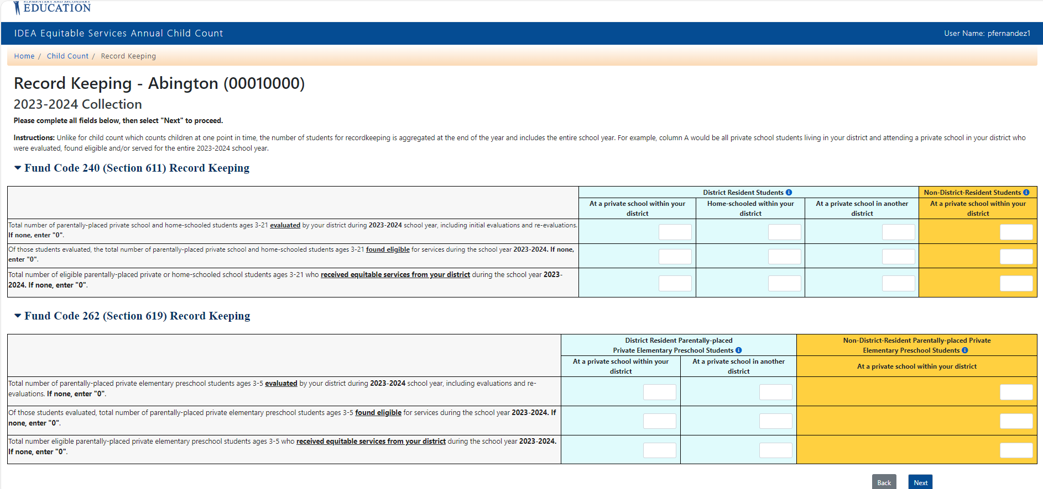

**Step 4**: **Certify the Submitted Data**

In this step you review and certify the data submitted. By clicking the “Certify” button, you certify that the district authorizes you to provide and certify the information. Furthermore, you certify the child count and record-keeping numbers provided are complete and accurate and were obtained in compliance with IDEA regulations. By certifying, you further agree to provide documentation supporting the child count(s) and record-keeping data provided if requested by the Department.

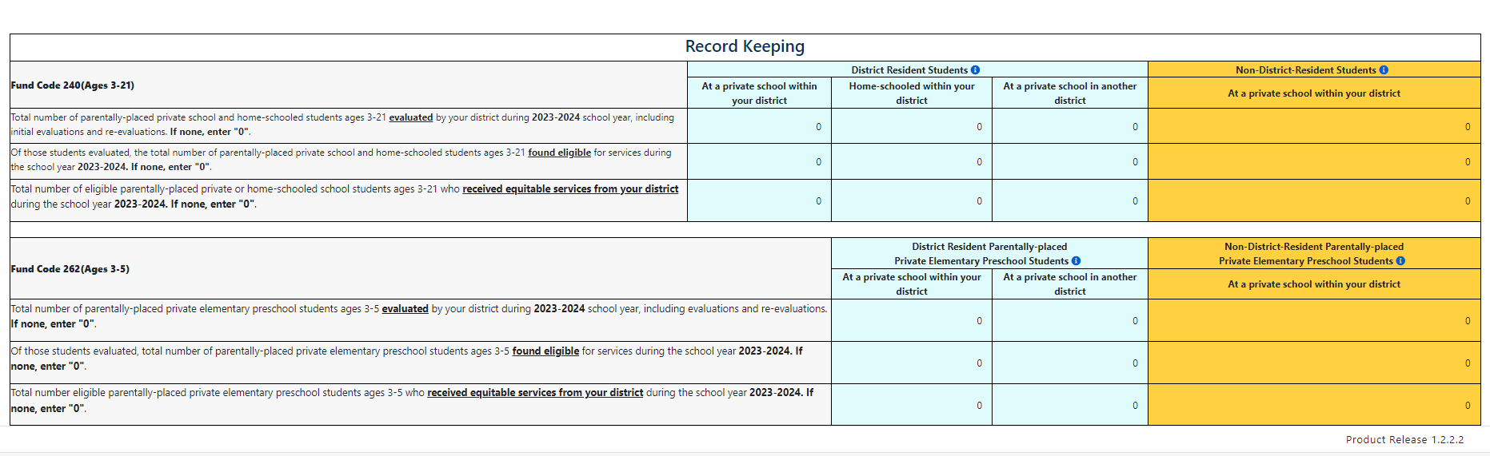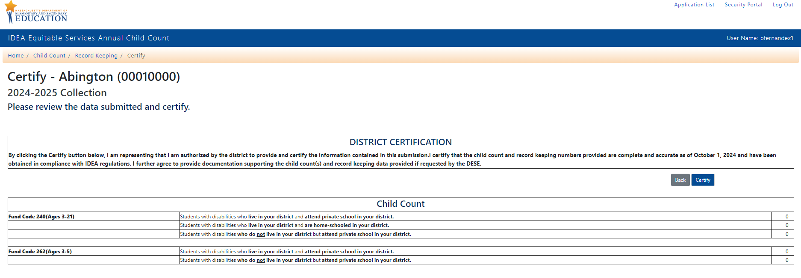

1. **Conclusion**

All child counts for this year must be as of **October 1, 2024**. Record keeping data is as of **June 30, 2024**, at the conclusion of the **2023-2024** school year. **Complete and accurate child count and record keeping data must be entered and certified no later than January 31, 2025.**

Any districts who submit or decertify child count and record keeping data after January 31, 2025, may be subject to targeted monitoring of district policies and procedures, and targeted monitoring and auditing of proportionate share IDEA Part B funds for equitable services by the Department.

1.
2. In Massachusetts, students homeschooled under a district-approved plan are considered parentally-placed private school students as it relates to equitable services.
3. These preschool students ages 3-5, not entered kindergarten, are included in both the FC 240 and FC 262 child counts.
4. Your District Administrator can be found in the [Department's School and District Profiles](https://profiles.doe.mass.edu/search/search.aspx?leftNavId=11239)