Instructions for Accessing a District’s SOA Plan in GEM$

This document provides step-by-step instructions for locating individual district SOA plans for FY25-FY27, which are available in DESE’s [Grants for Education Management System](https://mass.egrantsmanagement.com/default.aspx?ccipSessionKey=638568157391888847) (GEM$).

* A log-in and password are not required to access SOA plans in GEM$.
* You have the option of creating a PDF version of the plan that can be downloaded and printed or reading a plan online within GEM$

Overview and Background to SOA Plans

* Before reading individual district plans, we strongly encourage you to read the brief overview of the Student Opportunity Act and the purpose of SOA Plans on pages 4-5 of the [FY24 Student Opportunity Act Plans – Summary Report](https://www.doe.mass.edu/soa/plans/summary-report.docx). This report also provides a useful descriptive summary of what districts across the Commonwealth are prioritizing in their new SOA plans.
* Want more background information? Additional information is available on DESE’s [SOA District Resources](https://www.doe.mass.edu/soa/resources.html) page.

Quick Links

Getting Started in GEM$ 3

List of all available SOA district plans 4

To see a specific district’s plan 5

If You Are Unable to Locate a District’s SOA Plan in GEM$ 5

Printing and Downloading SOA Plans 6

Reading SOA Plans in GEM$ 8

SOA Plan Addenda 10

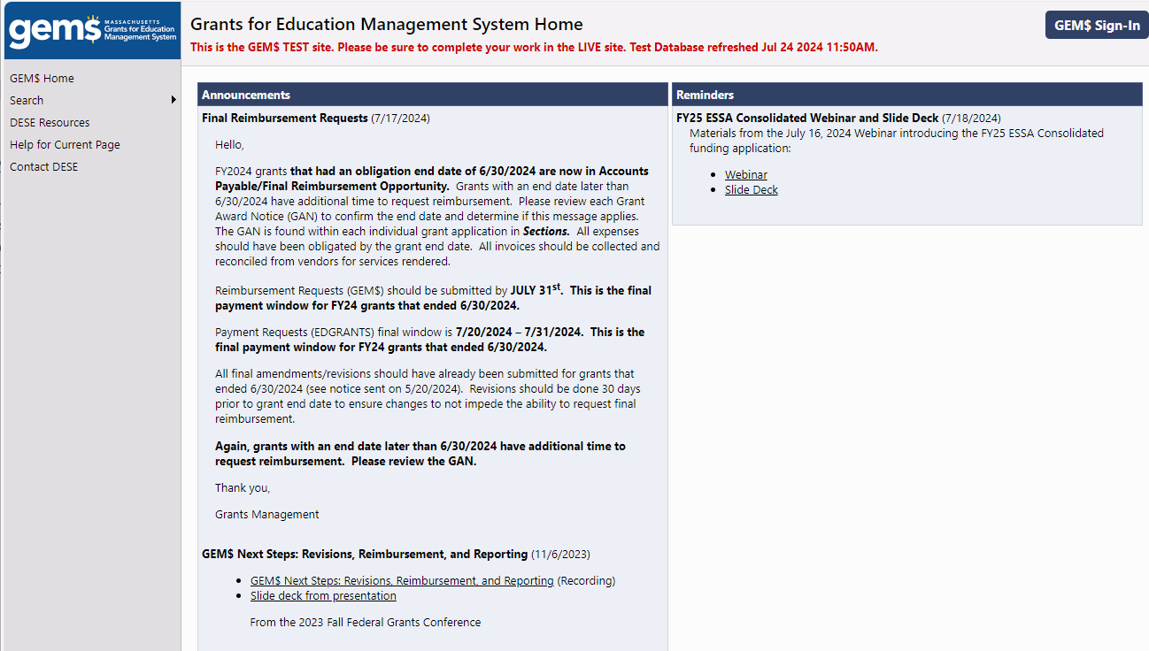 10

# Getting Started in GEM$

* Go to the [Grants for Education Management System Home (egrantsmanagement.com)](https://mass.egrantsmanagement.com/Default.aspx?ccipSessionKey=638543148571412451) landing page. Hover over the word **Search** in the column on the left-hand side of the page, navigate your cursor to **Application Supplement** (circled in Green in the screen shot below) and click.

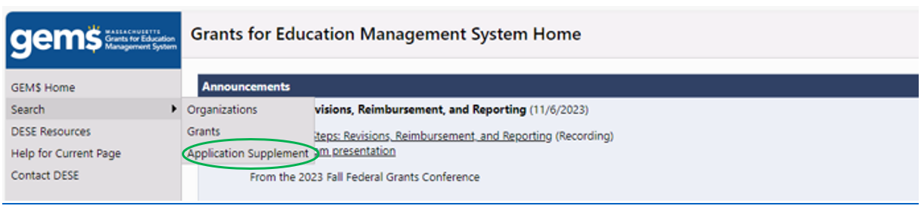

* The **Search Application Supplements Page** that appears below will open. You have the option of 1) listing all available plans and scrolling through the list until you find the plan you are interested in or, 2) specifying the district of interest to you.

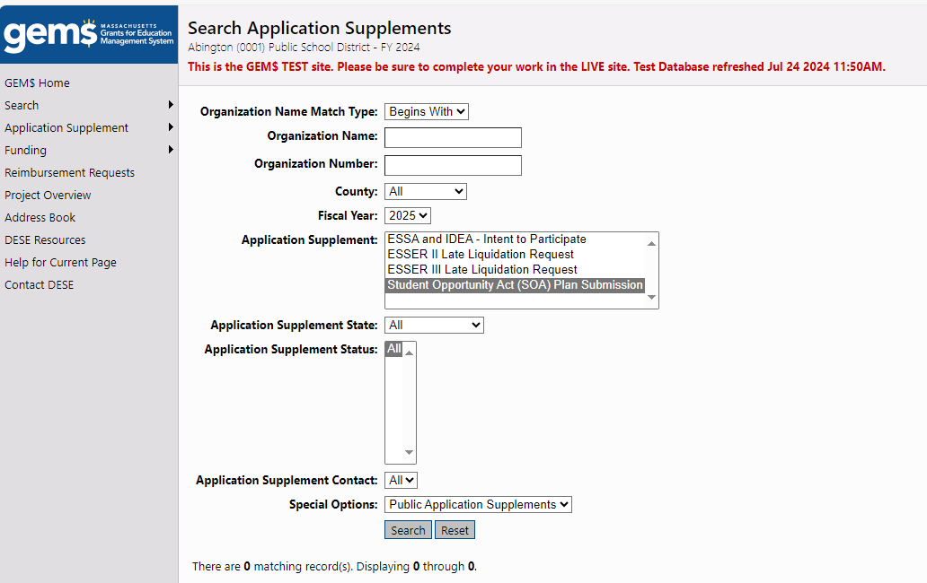

# List of all available SOA district plans

* Use the dropdown menu next to **Fiscal Year** to select 2024 *(Note: this field defaults to 2025; if you do not change it, the SOA Application Supplement will not appear in the list of Application Supplements*)
* Select **SOA Application Supplement** in the ***Application Supplement*** field.
* Make certain the ***Application Supplement State***field is set to **All**
* Click the Search button

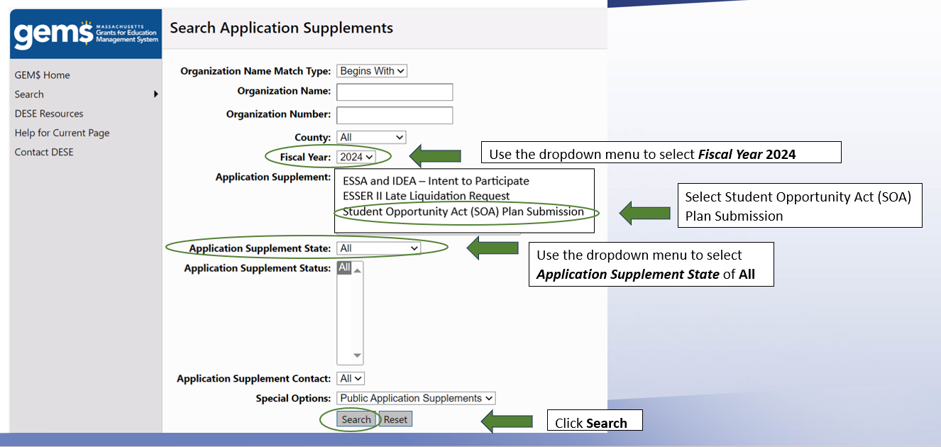

* GEMS will produce a list of all available SOA Plans, which will appear below the completed Search form.
* Click on the name of the district to open its SOA Plan
* Users can navigate through the list of districts using the *First, Previous, Next* and *Last* keys above the table

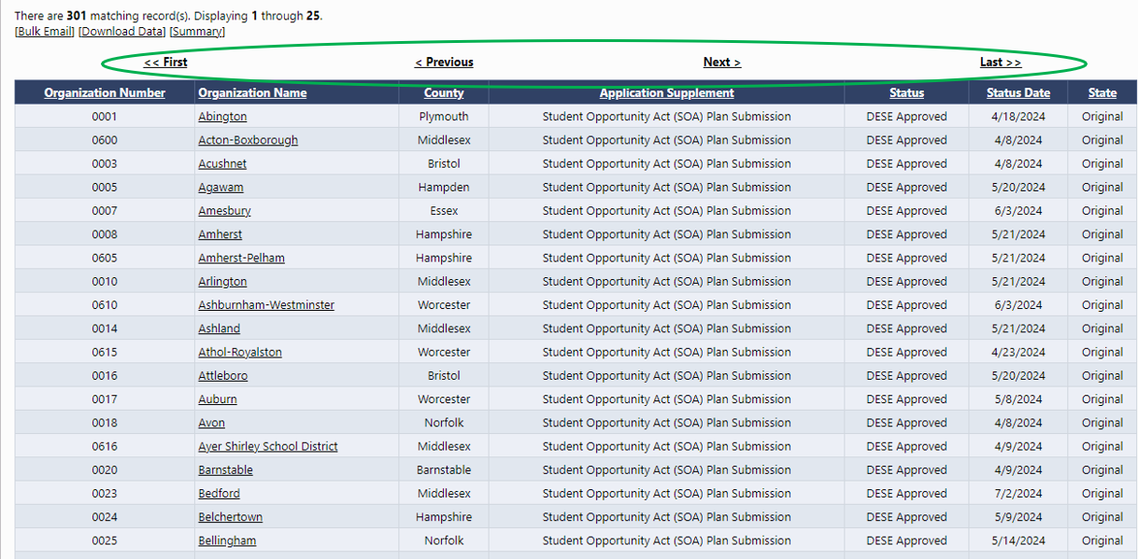

# To see a specific district’s plan

* + Enter the name of the district in the **Organization Name** text box OR the district’s organization number in the **Organization Number** text box
  + Complete the remainder of the Search form the same way you would to see a list of all districts, as described above.
  + Click the **Search** button
  + The district will be listed below the search form
  + Click the district’s name to open its SOA Plan

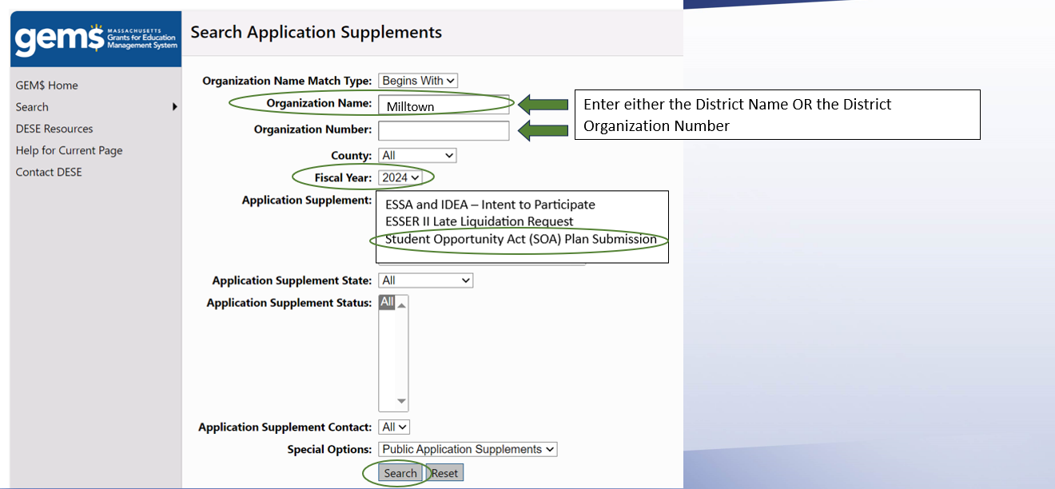



# If You Are Unable to Locate a District’s SOA Plan in GEM$

Well over 90 percent of districts’ SOA Plans are publicly available in GEM$. There are two key reasons why a district’s plan is not available in GEM$.

1. **The district has not yet submitted its SOA Plan, as required by legislation.** Keep in mind that SOA Plans from charter schools are due August 1, 2024 and will not be available in GEM$ until later in the calendar year.
2. **The district’s SOA Plan is still a work in progress.** This means that a district’s plan does not yet meet the required criteria for SOA Plans. Once a district’s plan meets the criteria, its plan will become publicly available via GEM$. The FY24 SOA Plan Rubric is available in Appendix B of the [FY24 Student Opportunity Act Plans – Summary Report](https://www.doe.mass.edu/soa/plans/summary-report.docx).

# Printing and Downloading SOA Plans

* When you click on the link to the district’s SOA Plan, the **Student Opportunity Act (SOA) Plan Submission Sections** will open (see screenshot below).
* SOA Plans are organized into the 5 sections listed in the graphic below.
  + A copy of the 2-page Plan Submission Guide (the SOA Plan Template) can be found on pages 6-7 of the [FY24 SOA Plan Guidance Materials](https://www.doe.mass.edu/soa/fy2024-guidance.docx).
* You can either print the entire SOA Plan or a single section of the plan by clicking the appropriate print button in the right hand column. **Note:** *Clicking the print button next to either of the* ***All*** *and the* ***District Student Opportunity Act (SOA) Submission*** *will print the district’s complete SOA Plan.*

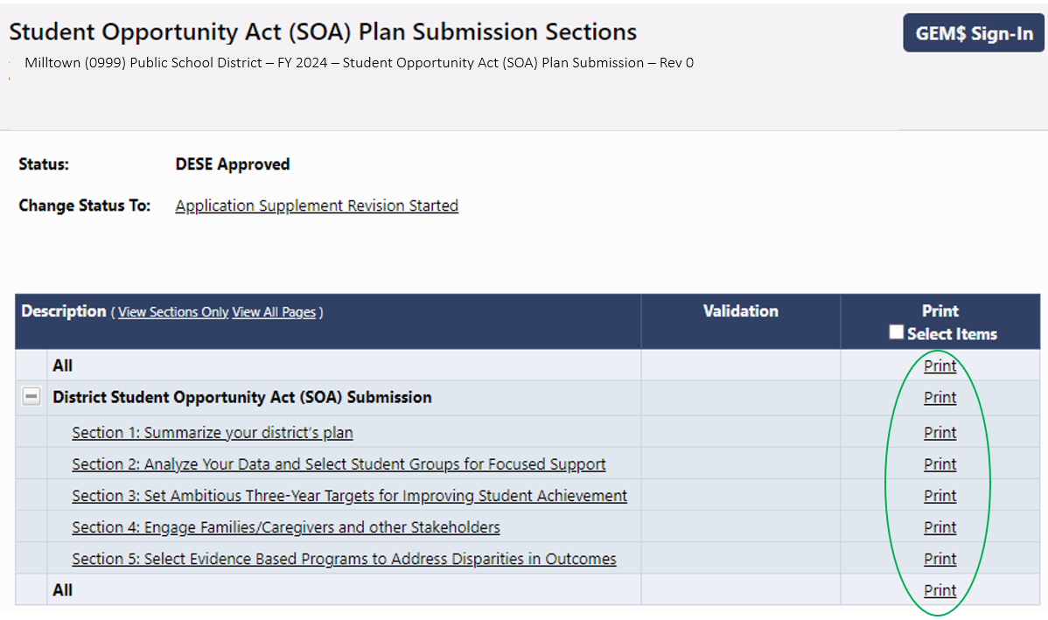

* You also have the option of checking the box in the *Print Selected* *Items* column on the far right. A set of boxes will appear next to each section. Place a checkmark next to the section(s) you would like to print, then click on the word *Print* in the column header or the *Print Selected Items* button at the bottom of the page

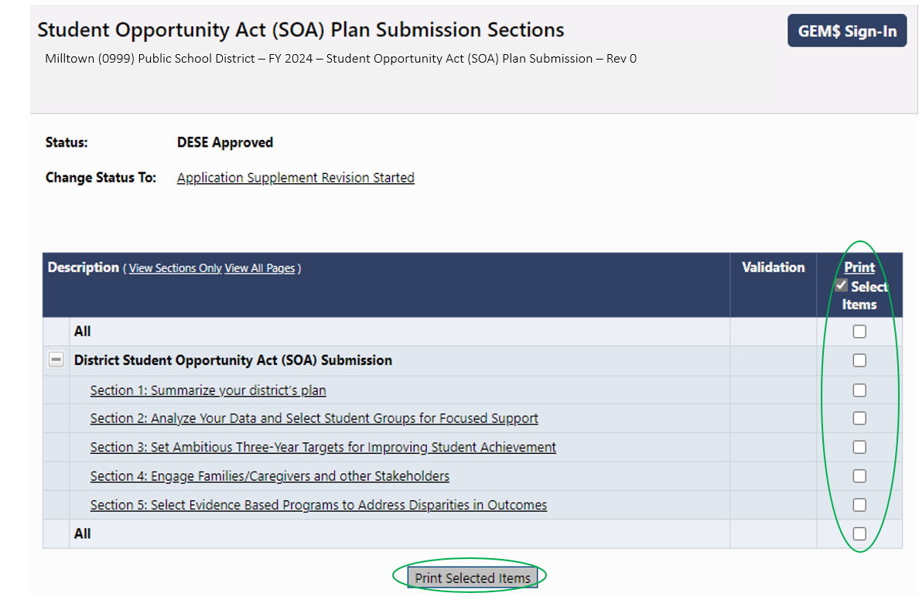

* Once you select the items to print, a **Print Request** page will appear
  + Make certain that the browser you are using is set to permit pop-ups
  + Enter your email and click **Print**
  + 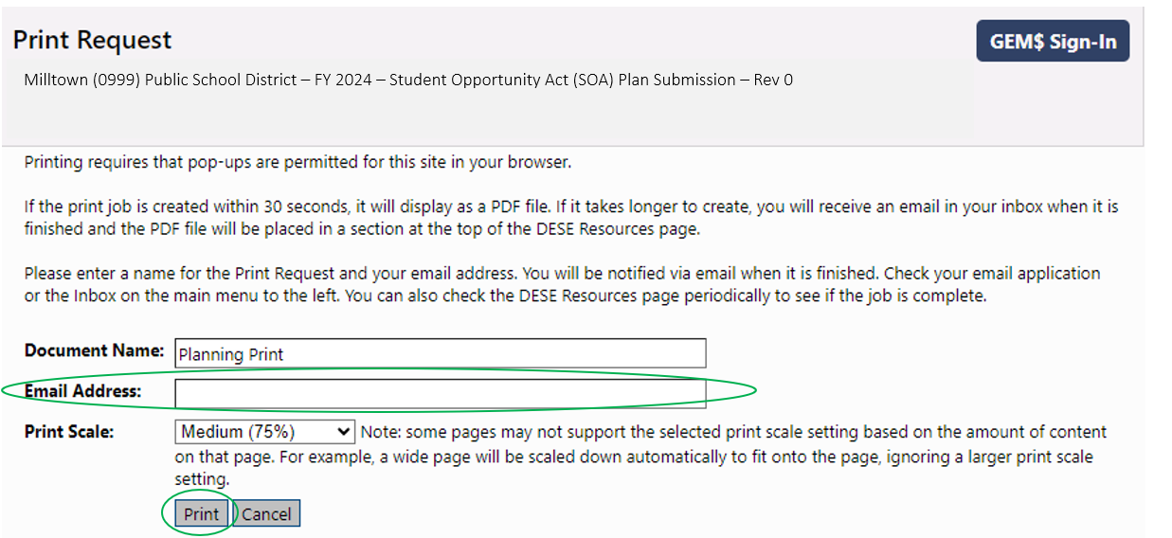A PDF file will open, which can be either printed or downloaded.

# Reading SOA Plans in GEM$

* Plans can be read section-by-section in GEM$ from the **Student Opportunity Act (SOA) Plan Submission Sections** page. Simply select the section of interest from the list on the left-hand side of the page.
* The template will open for the section of the plan you select
* The district’s responses to all items for that section will appear within the template *(See screen shot of Section 1: Summarize your district’s plan on page 8).*

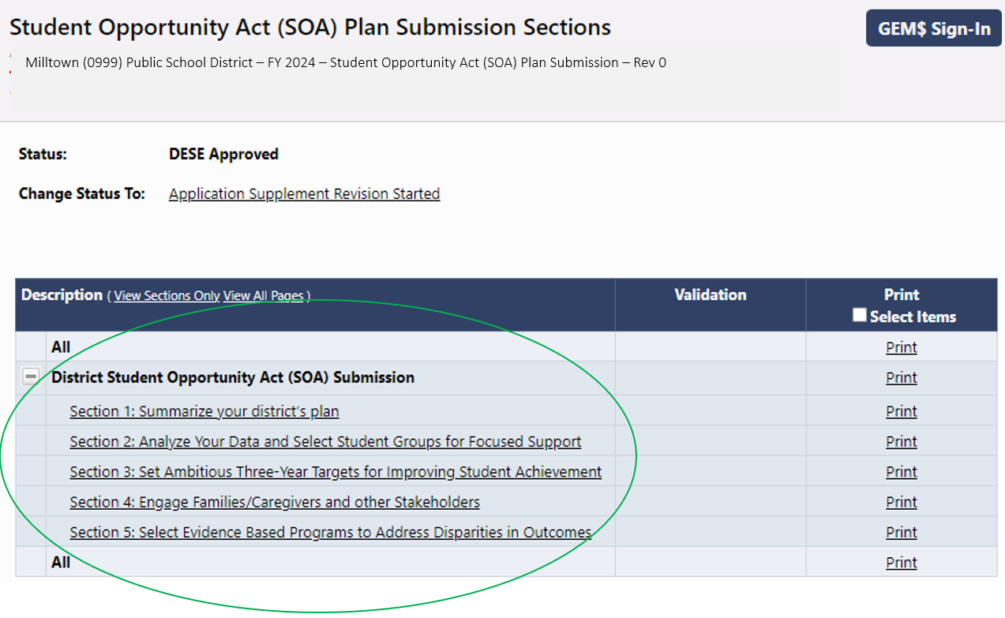

* When you are ready to read another section of the plan, move your cursor to the **Go To** arrow and a set of options for moving through the SOA Plan will appear. The **Sections** option returns you to the **Student Opportunity Act (SOA) Plan Submission Sections** page.

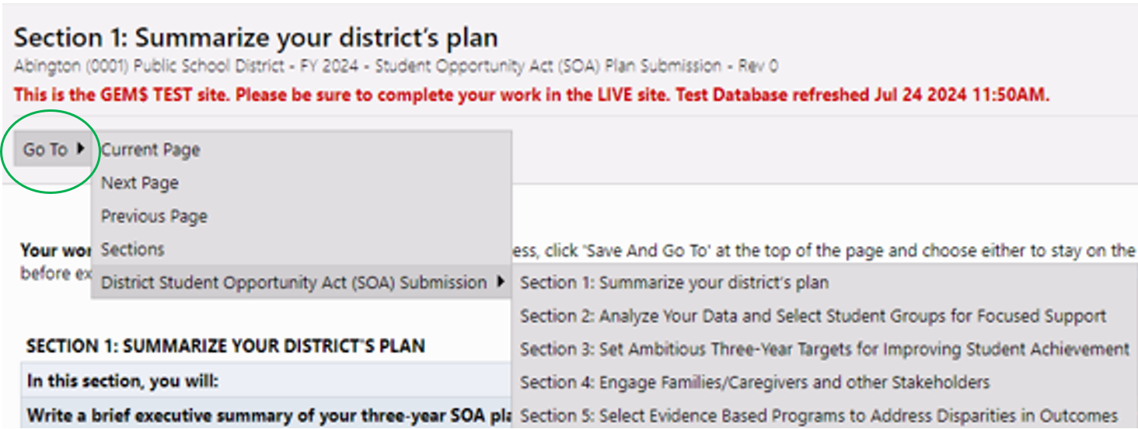

**On-Line View of SOA Plan: Section 1**

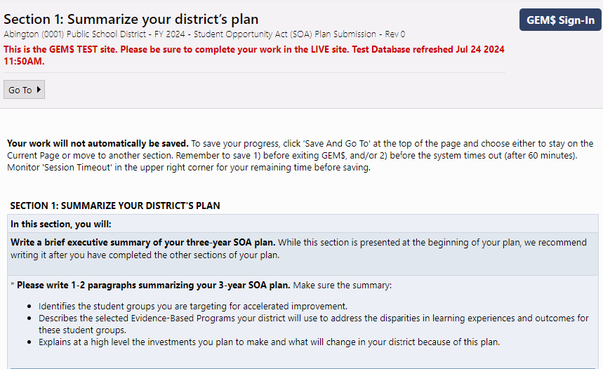

Milltown Public Schools is committed to developing and enhancing the following evidence-based programs to address disparities in performance between student groups in our district, and accelerate the improvement of our Black/African American students, Hispanic/Latino students, English learners, and students with disabilities.

1. Expand **full-day pre-kindergarten programming for 4-year-olds alongside a robust early literacy program for grades pre-K to 3** at four of our elementary schools.
2. Start an **Early College program** at Milltown High School focused primarily on students under-represented in higher education and aligned to the Massachusetts Early College designation criteria.
3. Launch an **Acceleration Academies program** to provide targeted support for select middle school students district-wide.

These investments are as follows: $4,265,000 for expanded pre-kindergarten and $2,350,000 for early literacy programming; $484,500 for Early College; and $477,300 for Acceleration Academies. The total investment in evidence-based strategies over the next three years will total **$7,576,800.**

2. Start an Early College program at Milltown High School focused primarily on students under-represented in

higher education and aligned to the Massachusetts Early College designation criteria.

3. Launch an Acceleration Academies program to provide targeted support for select middle school students

district-wide.

These investments are as follows: $4,265,000 for expanded pre-kindergarten and $2,350,000 for early literacy

programming; $484,500 for Early College; and $477,300 for Acceleration Academies. The total investment in

evidence-based strategies over the next three years will total $7,576,800.

Milltown (0999) Public School District – FY 2024 – Student Opportunity Act (SOA) Plan Submission – Rev 0

# SOA Plan Addenda

A small number of “Priority Districts” receiving greater than $75 million in Chapter 70 State Aid in fiscal year 2024 were selected to complete a SOA Plan Addendum. The addenda for these 17 districts provide more in-depth budget detail for FY25-FY27 across all funding sources*,* excluding federal Elementary and Secondary School Emergency Relief (ESSER) funds, which expire September 30, 2024*.* A list of these districts can be found in Appendix A of the [FY24 Student Opportunity Act Plans – Summary Report](https://www.doe.mass.edu/soa/plans/summary-report.docx).

Here are the steps for locating the SOA Plan Addenda in GEM$.

* Go to the [Grants for Education Management System Home (egrantsmanagement.com)](https://mass.egrantsmanagement.com/Default.aspx?ccipSessionKey=638543148571412451) landing page.
* Click on **DESE Resources** in the menu column on the left-hand side of the page. This opens the **DESE Resources** page that appears on the page 11.

# Screenshot of Grants for education Management system home page with DESE Resources circled

* Locate the Student Opportunity Act (SOA) Plans folder. Click on the plus sign () to its left to open the folder.

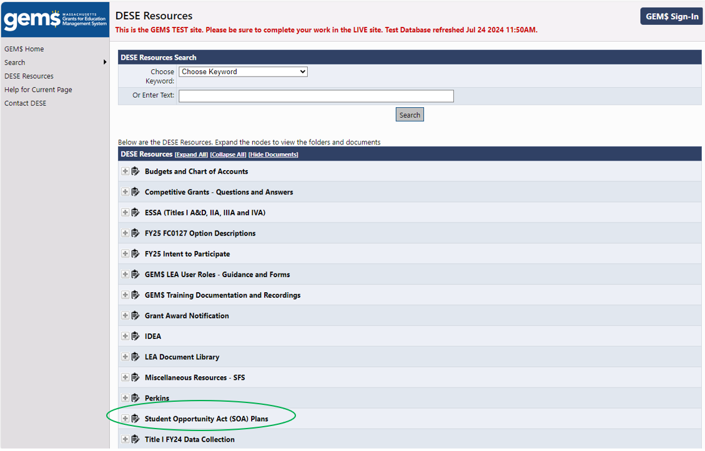

* Follow the same procedure to open the SOA Plan Addenda (FY25-FY27) subfolder.
* Clicking on the SOA Plan Addendum for the district of interest will automatically download the Excel file to your computer.

