Entriksyon pou gen Aksè ak yon Plan SOA Katye sou GEM$

Dokiman sa a bay enstriksyon etap pa etap pou jwenn plan SOA katye endividyèl yo pou Ane Fiskal 2025-Ane Fiskal 2027, ki disponib nan [Grants for Education Management System](https://mass.egrantsmanagement.com/default.aspx?ccipSessionKey=638568157391888847) (GEM$) DESE a.

* Ou pa oblije konekte ak yon modpas pou jwenn aksè nan plan SOA sou GEM$..
* Ou gen opsyon pou kreye yon vèsyon PDF nan plan an ki ka telechaje ak enprime oswa li yon plan sou entènèt la sou GEM$

Apèsi ak Enfòmasyon nan plan SOA

* Anvan ou li plan katye endividyèl yo, nou ankouraje w pou w li yon ti apèsi sou Lwa sou Opòtinite pou Elèv la ak objektif Plan SOA ki nan paj 4-5 [Plan Lwa sou Opòtinite pou Elèv Ane Fiskal 2024 – Rapò Rezime](https://www.doe.mass.edu/soa/plans/summary-report.docx). Rapò sa a bay tou yon rezime deskriptif itil sou sa katye atravè Commonwealth la ap bay priyorite nan nouvo plan SOA yo.
* Ou vle plis enfòmasyon? Gen plis enfòmasyon ki disponib sou [paj Resous Distri SOA DESE a.](https://www.doe.mass.edu/soa/resources.html)

Lyen Rapid

Komanse sou GEM$ 3

Lis tout Plan Katye SOA ki disponib yo 4

Pou Wè Yon Plan Katye Espesifik 5

Si w Pa Ka Jwenn Yon Plan Katye SOA sou GEM$ 5

Enprime ak Telechaje Plan SOA 6

Li Plan SOA yo sou GEM$ 8

Adendòm Plan SOA 10

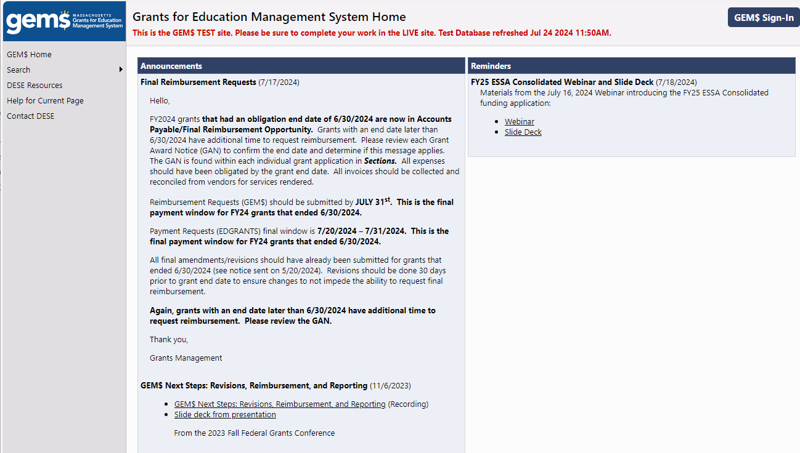 10

# Komanse sou GEM$

* Ale nan paj akèy [Grants for Education Management System Home (egrantsmanagement.com)](https://mass.egrantsmanagement.com/Default.aspx?ccipSessionKey=638543148571412451) la. Pase sou mo Search la nan kolòn ki sou bò gòch paj la, navige souri ou a nan **Application Supplement** (Sipleman Aplikasyon) (ansèkle an Vèt nan ekran ki anba a) epi klike sou li.

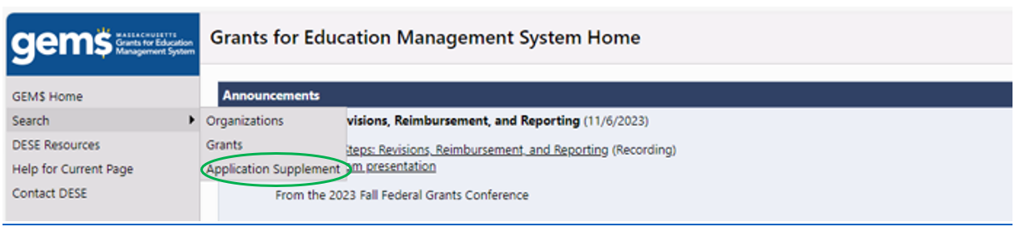

* Paj **Search Application Supplements** ki parèt anba a ap louvri. Ou gen opsyon pou 1) fè lis tout plan ki disponib yo epi defile nan lis la jiskaske ou jwenn plan ou enterese a oswa, 2) presize katye ki enterese w la..

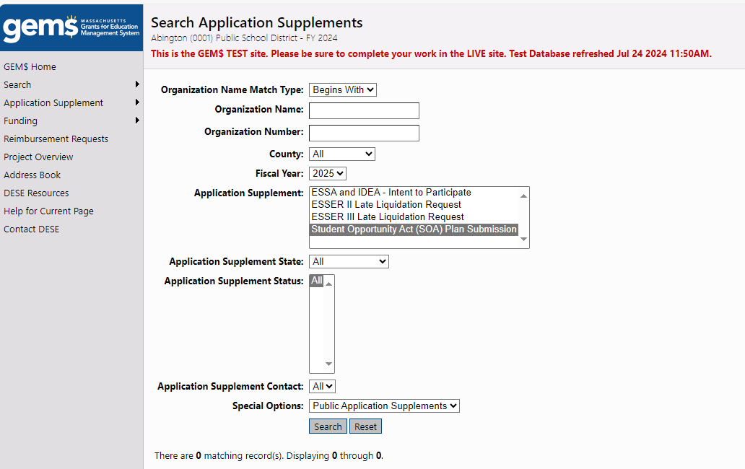

# Lis tout plan Katye SOA ki disponib yo

* Sèvi ak meni ki akote **Ane Fiskal** la pou w chwazi 2024 *(Remak: seksyon sa a pa chanje an 2025; si w pa chanje l, Sipleman Aplikasyon SOA a p ap parèt nan lis Sipleman Aplikasyon yo)*
* Chwazi **Sipleman Aplikasyon SOA** nan seksyon **Sipleman Aplikasyon** an.
* Asire w seksyon **Sipleman Aplikasyon** an sou **All (Tout)**
* Klike sou bouton Search

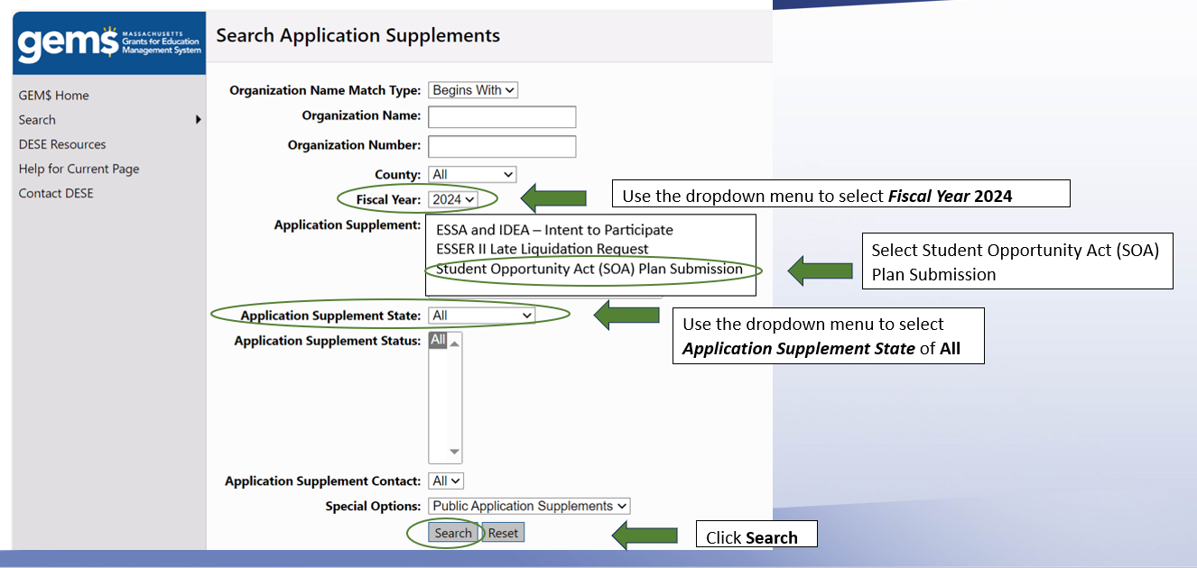

* GEMS pral pwodui yon lis tout plan SOA ki disponib, ki pral parèt anba fòm rechèch ki ranpli a.
* Klike sou non katye a pou ouvri Plan SOA li a
* Itilizatè yo ka navige nan lis katye yo lè yo sèvi ak First, Previous, Next ak Dènye kle ki anlè tablo a.

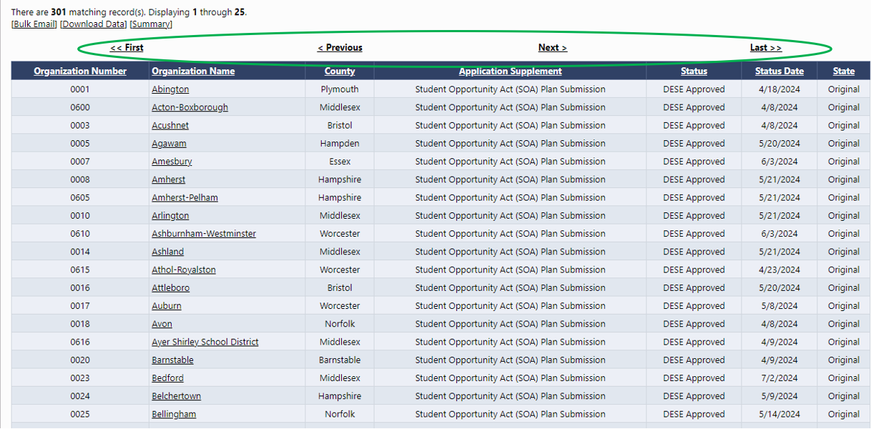

# Pou Wè Yon Plan Katye Espesifik

* + Antre non Katye a nan bwat tèks **Non òganizasyon** an OSWA **nimewo òganizasyon** Katye a nan bwat tèks Nimewo òganizasyon an.
  + Ranpli rès fòm rechèch la menm jan pou wè yon lis tout Katye yo, jan sa dekri pi wo a..
  + Klike sou bouton **Search**
  + Katye a pral nan lis fòm Search anba a
  + Klike sou non katye a pou louvri Plan SOA li a

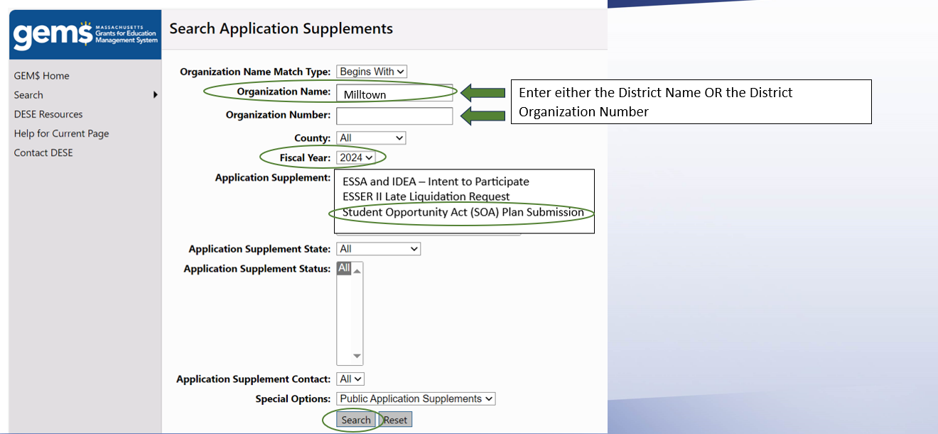



# Si w Pa Ka Jwenn Yon Plan Katye SOA sou GEM$

Plis pase 90 pousan Plan SOA katye yo disponib piblikman nan GEM$. Gen de rezon prensipal ki fè yon plan distri a pa disponib nan GEM$.

1. **Katye a poko soumèt Plan SOA li a, jan lalwa egzije sa.** Kenbe nan tèt ou Plan SOA ki soti nan lekòl endepandan yo gen delè premye Dawout 2024 epi yo ap disponib sou GEM$ pita nan ane kalandriye a.
2. **The district’s SOA Plan is still a work in progress.** This means that a district’s plan does not yet meet the required criteria for SOA Plans. Once a district’s plan meets the criteria, its plan will become publicly available via GEM$. The FY24 SOA Plan Rubric is available in Appendix B of the **Plan SOA katye a pako fini.** Sa vle di yon plan katye a poko satisfè kritè obligatwa pou Plan SOA yo. Yon fwa plan yon katye satisfè kritè yo, plan li a ap vin disponib piblikman atravè GEM$. Ribrik Plan SOA Ane fiskal 2024 la disponib nan Anèks B [Plan Lwa sou Opòtinite Elèv FY24 – Rapò Rezime.](https://www.doe.mass.edu/soa/plans/summary-report.docx)

# Enprime ak Telechaje Plan SOA yo

* Lè w klike sou lyen ki mennen nan Plan SOA distri a, **Seksyon Soumèt Plan pou Lwa sou Opòtinite pou Elèv la (SOA)** ap louvri (gade ekran ki anba a)..
* Plan SOA yo òganize an 5 seksyon ki endike nan grafik ki anba a.
* Ou ka jwenn yon kopi Gid pou soumèt plan 2 paj la (Modèl Plan SOA) nan paj 6-7 [FY24 SOA Plan Guidance Materials](https://www.doe.mass.edu/soa/fy2024-guidance.docx) (Materyèl Gid Plan SOA FY24.)
* Ou ka swa enprime tout Plan SOA a oswa yon sèl seksyon nan plan an lè w klike sou bouton enprime ki apwopriye a nan kolòn adwat la***. Remak:*** *Lè w klike sou bouton an enprime ki akote youn nan soumèt* ***Tout******ak Lwa sou Opòtinite pou Elèv katye a (SOA)*** *pral enprime Plan SOA konplè katye a.*

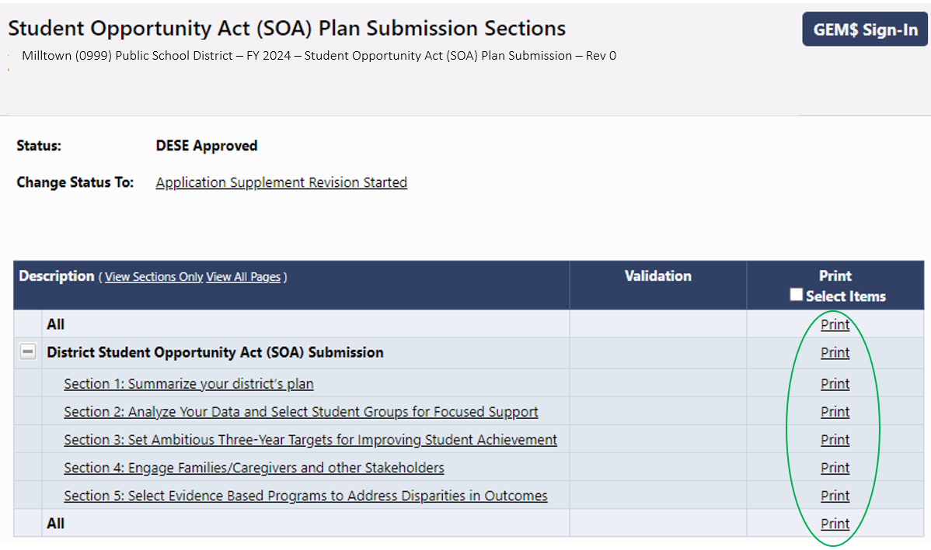

* Ou gen opsyon tou pou w tcheke kaz ki nan kolòn *Enprime Atik Chwazi* yo ki sou bò dwat la. Yon seri bwat ap parèt akote chak seksyon. Mete yon mak akote seksyon ou ta renmen enprime yo, apresa klike sou mo *Enprime* nan tèt kolòn oswa bouton *Enprime atik chwazi* ki anba paj la.

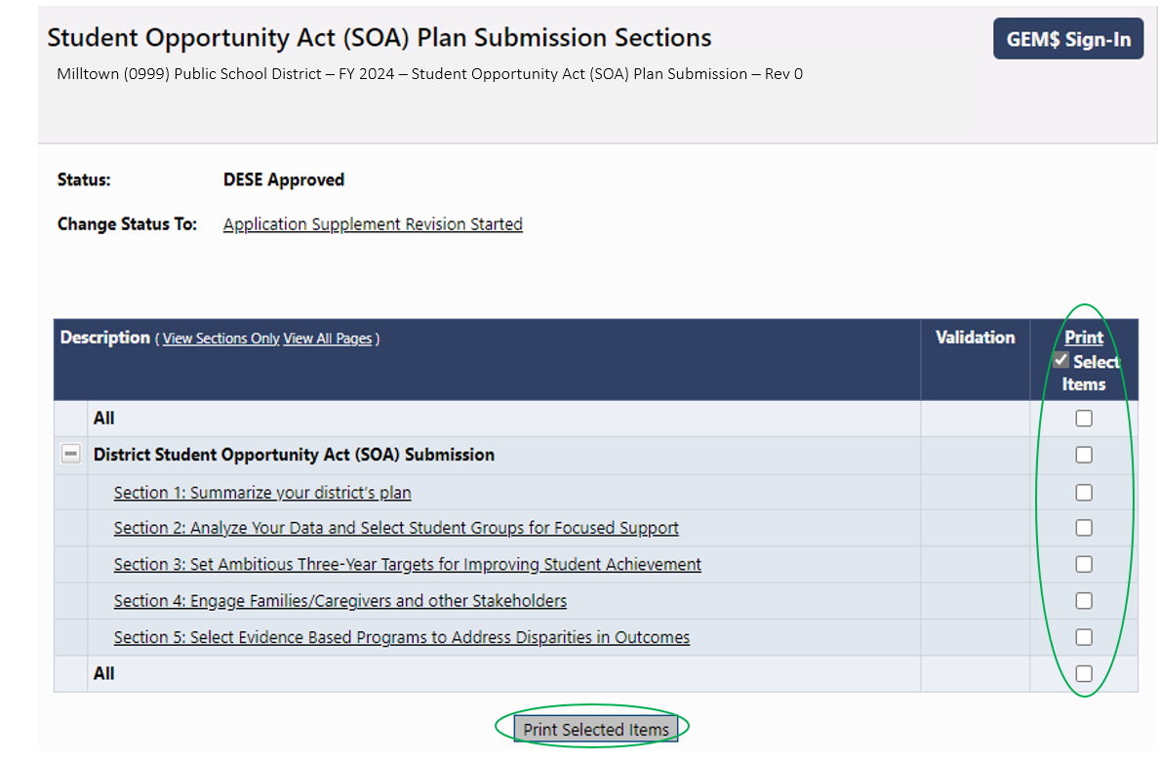

* Yon fwa ou chwazi atik yo pou enprime, yon paj **demann pou enprime** ap parèt
  + Asire w navigatè w ap itilize a fikse pou pèmèt paj monte
  + Mete imel ou epi klike sou **Print (enprime)**
  + 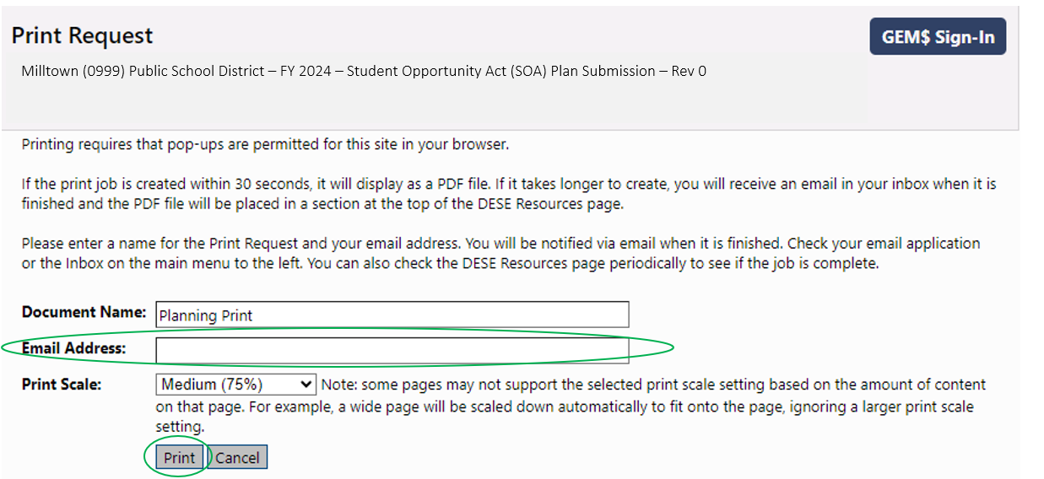 Yon dosye PDF ap louvri, ki ka swa enprime oswa telechaje.

# Li Plan SOA yo sou GEM$

* Ou ka li plan yo seksyon pa seksyon sou GEM$ nan paj **Student Opportunity Act (SOA) Plan Submission Sections**. Senpleman chwazi seksyon ki enterese w nan lis ki sou bò gòch paj la.
* Modèl la ap louvri pou seksyon plan ou chwazi a
* Repons distri a bay tout atik pou seksyon sa a ap parèt nan modèl la *(Gade ekran Seksyon 1: Rezime plan katye w la nan paj 8).*

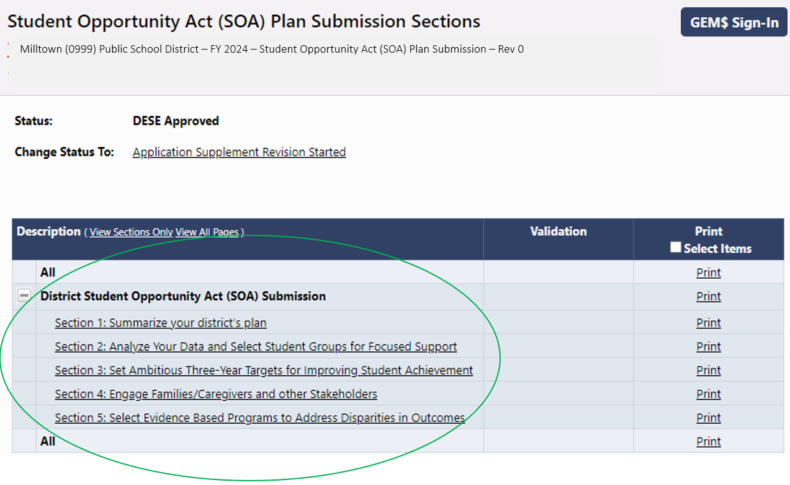

* Lè w pare pou w li yon lòt seksyon nan plan an, deplase souri w la sou flèch **Go To** a epi yon seri opsyon pou deplase atravè Plan SOA a ap parèt. Opsyon **Seksyon** yo ap retounen ou nan paj **Student Opportunity Act (SOA) Plan Soumission Sections**.

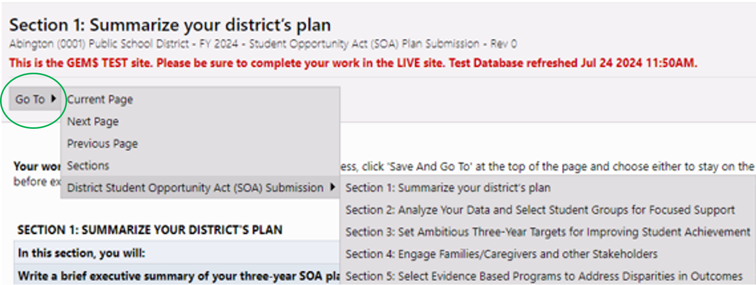

**Imaj anliy Plan SOA: Seksyon 1**

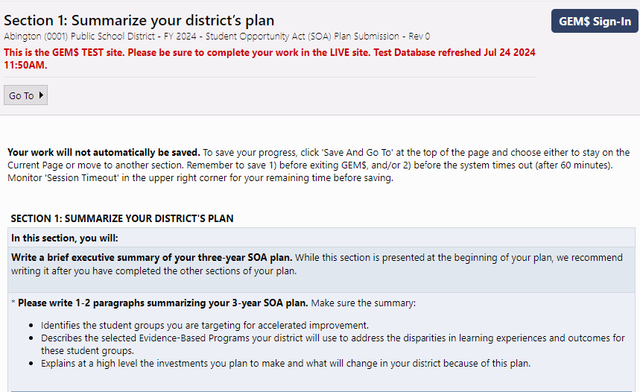

Milltown Public Schools is committed to developing and enhancing the following evidence-based programs to address disparities in performance between student groups in our district, and accelerate the improvement of our Black/African American students, Hispanic/Latino students, English learners, and students with disabilities.

1. Expand **full-day pre-kindergarten programming for 4-year-olds alongside a robust early literacy program for grades pre-K to 3** at four of our elementary schools.
2. Start an **Early College program** at Milltown High School focused primarily on students under-represented in higher education and aligned to the Massachusetts Early College designation criteria.
3. Launch an **Acceleration Academies program** to provide targeted support for select middle school students district-wide.

These investments are as follows: $4,265,000 for expanded pre-kindergarten and $2,350,000 for early literacy programming; $484,500 for Early College; and $477,300 for Acceleration Academies. The total investment in evidence-based strategies over the next three years will total **$7,576,800.**

2. Start an Early College program at Milltown High School focused primarily on students under-represented in

higher education and aligned to the Massachusetts Early College designation criteria.

3. Launch an Acceleration Academies program to provide targeted support for select middle school students

district-wide.

These investments are as follows: $4,265,000 for expanded pre-kindergarten and $2,350,000 for early literacy

programming; $484,500 for Early College; and $477,300 for Acceleration Academies. The total investment in

evidence-based strategies over the next three years will total $7,576,800.

Milltown (0999) Public School District – FY 2024 – Student Opportunity Act (SOA) Plan Submission – Rev 0

# Adenda Plan SOA

Yo te chwazi yon ti kantite “Katye Priyorite” pou resevwa plis pase $75 milyon dola nan Chapit 70 Èd Leta a nan ane fiskal 2024 pou ranpli yon Addendum Plan SOA. Addenda pou 17 katye sa yo bay plis detay sou bidjè pou Ane Fiskal 2025- Ane Fiskal 2027 atravè tout sous finansman, eksepte fon federal pou Sekou Ijans Lekòl Elemantè ak Segondè (ESSER), ki ekspire 30 septanm 2024. Ou ka jwenn yon lis katye sa yo nan Anèks A [Plan Lwa sou Opòtinite Elèv FY24 – Rapò Rezime.](https://www.doe.mass.edu/soa/plans/summary-report.docx)

Men etap pou jwenn Addenda Plan SOA sou GEM$.

* Ale nan paj akèy [Grants for Education Management System Home (egrantsmanagement.com)](https://mass.egrantsmanagement.com/Default.aspx?ccipSessionKey=638543148571412451).
* Klike sou **Resous DESE** nan kolòn meni ki sou bò goch paj la. Sa a ouvè paj **Resous DESE** ki parèt nan paj 11 la.

# Screenshot of Grants for education Management system home page with DESE Resources circled

* Chèche dosye Student Opportunity Act (SOA) Plans. Klike sou siy plis (+ ) ki sou bò gòch li pou louvri katab la

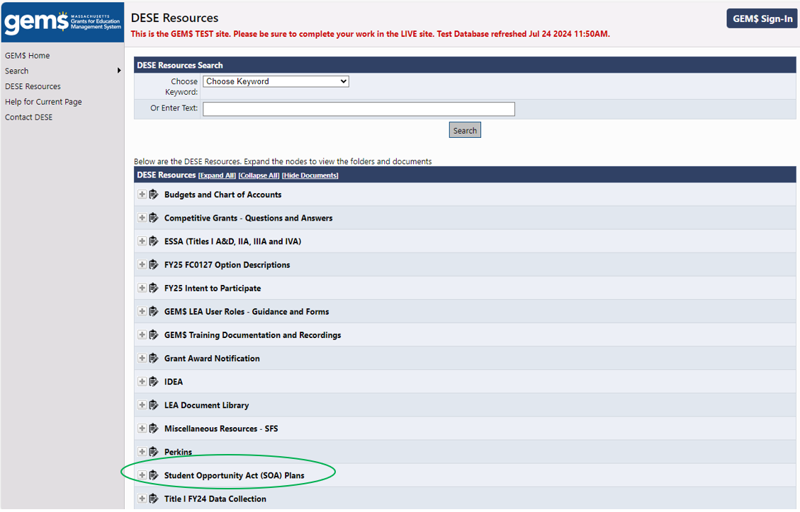

* Swiv menm pwosedi a pou w louvri sousdosye SOA Plan Addenda (Ane Fiskal 2025- Ane Fiskal 27).
* Klike sou Addendum Plan SOA pou katye ki enterese w pral telechaje dosye Excel la otomatikman sou òdinatè w la.

