**Instructions for Completing FY25 SOA Plan Progress Reports in GEM$**

**Contents**

**Quick Start Instructions** 2

**Assign SOA Roles in GEM$** 2

**How to locate your FY25 SOA Plan Progress Report in GEM$** 2

**How to begin entering data in your FY25 SOA Plan Progress Report** 4

**Save your work at regular intervals!** 5

**The FY25 SOA Plan Progress Report submission form in GEM$** 5

**Key Evidence-based Programs in District’s SOA Plan** 6

**Section 1: Summary of Progress to Date (Academic Year 2024-2025)** 7

**Section 2: Key Changes to Your Plan and Next Steps in Implementation** 8

**Section 3: Engaging Families/Caregivers and Other Stakeholders** 9

**How to submit your SOA Plan** 10

**How to print your FY25 SOA Plan Progress Report** 13

## **Quick Start Instructions**

1. Log into [GEM$](https://mass.egrantsmanagement.com/default.aspx?ccipSessionKey=638760851455063528) using your email and password
2. Select *Application Supplement* from the menu
3. Set Fiscal Year to 2025
4. Select *SOA Plan Progress Report* from list of application supplements
5. Change **Status** from *Not Started* to *Application Supplement Started*
6. Select section of FY25 SOA Plan Progress Report to begin entering information into template
7. Remember to save your work at regular intervals!

## **Assign SOA Roles in GEM$**

Make certain your User Access Administrator assigns at least one person the *LEA SOA Plan Writer* role in the Grants for Education Management System (GEM$). There are two only GEM$ roles involved in completing and approving FY25 SOA Plan Progress Reports:

* 1. LEA SOA Plan Writer
  2. LEA Superintendent/Chief Executive (likely already assigned)

1. **LEA SOA Plan Writer**: The *LEA SOA Plan Writer* enters data into the FY25 SOA Plan Progress Report (which is an *Application Supplement*) in GEM$.
   * More than one person may be assigned this role.
   * The LEA SOA Plan Writer is the only role with permissions to enter data into the application supplement.
   * Superintendents must be assigned *the LEA SOA Plan Writer* role, in addition to the *LEA Superintendent/Chief Executive* role, in order to directly edit/enter information in the template.
2. **LEA Superintendent/Chief Executive**: The superintendent or her/his designee either 1) returns the report to the *LEA SOA Plan Writer(s)* if edits are required or 2) approves the FY25 SOA Plan Progress Report. When the LEA Superintendent/Chief Executive approves the progress report in GEM$, DESE will receive an email indicating that it has been submitted for review.

## **How to locate your FY25 SOA Plan Progress Report in GEM$**

* Sign into GEM$ using your email address and password: <https://mass.egrantsmanagement.com/>
* Click **Application Supplement** in the left-hand navigation panel (circled in green).

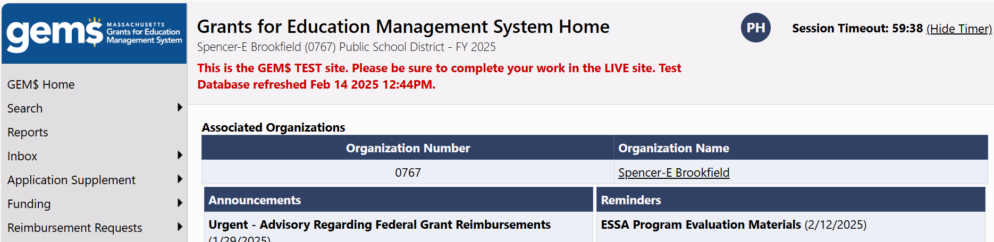

* Once the **Application Supplements** page opens, click on **FY25 SOA Plan Progress Report**  (circled in green). Make certain the Fiscal Year is set to 2025 (circled in green).

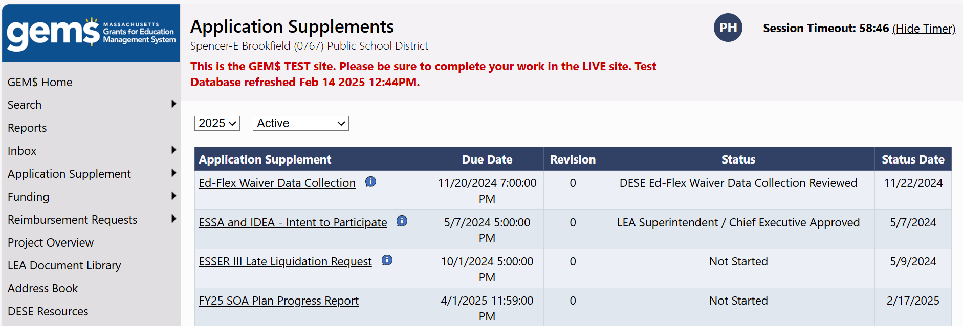

* The **FY25 SOA Plan Progress Report Submission Sections** page that appears below will open. The four sections of the FY25 SOA Plan Progress Report are listed here. From this page you can navigate to any section of the progress report by clicking on the section name. You may complete the sections in any order.

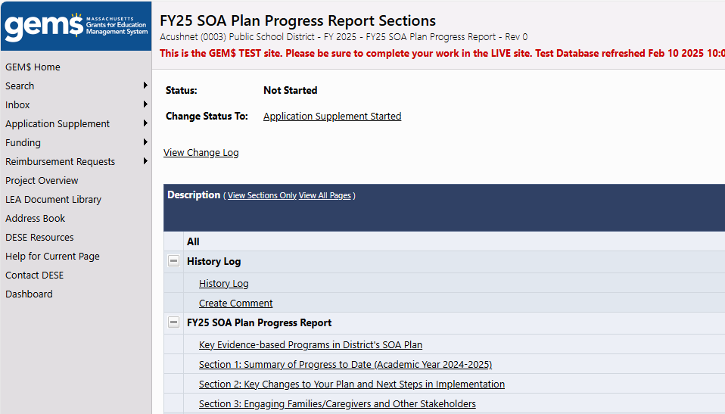

## **How to begin entering data in your FY25 SOA Plan Progress Report**

* When you first open the application supplement, your **Status**, circled in red in the screen shot below, indicates *Not Started*.
* To begin typing in your progress report, you need to start the application supplement by moving your cursor to the **Change Status To** line, circled in green, and clicking on *Application Supplement Started.*

**Note:** If you forget to complete this step, you will be able to see the instructions and items in the template, but the data entry screens will not open.

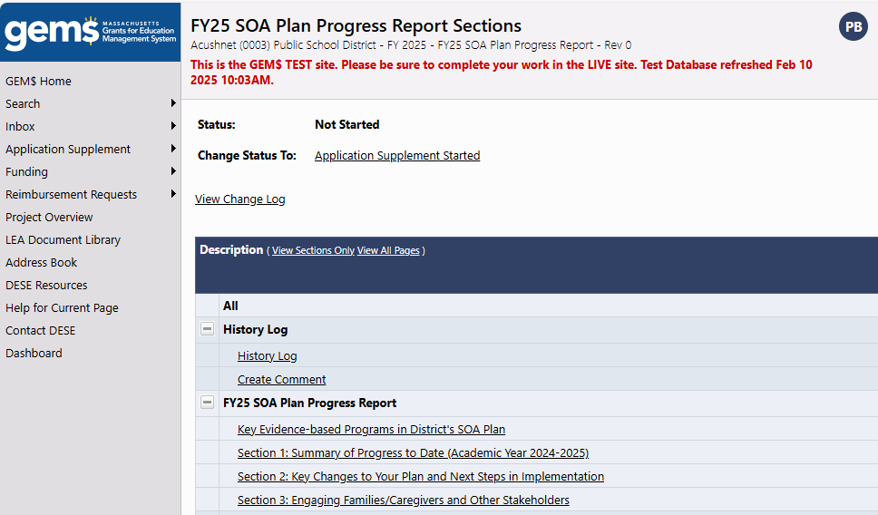

* A **Status Change Confirmation** page will appear. Click *Confirm* to change your status to *Application Supplement Started*. Once you have done that, your status will be updated on the FY25 SOA Plan Progress Report Sections page. You may begin entering data into your plan by clicking on the Section you wish to begin working on.

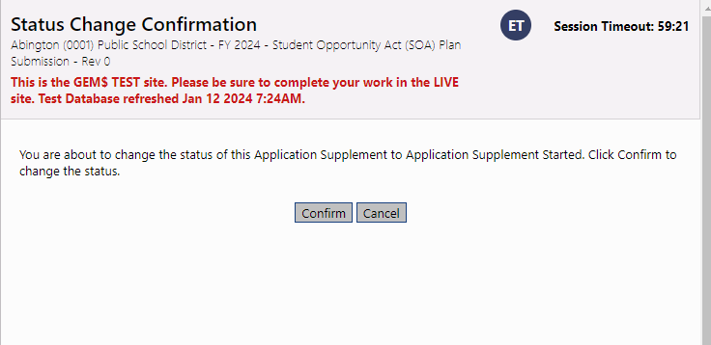

## **Save your work at regular intervals!**

* **Your work is not automatically saved by GEM$.** You will need to save your progress whenever you move from section to section and before you log out of GEM$. Do that by clicking the *Save And Go To* at the top of the section you are working on and indicate whether you want to continue working on Current Page or move to another section. If you want to save changes on the page you are working on, choose “Save and Go To > Current Page.” Clicking on *Sections* will take you back to the *FY25 SOA Plan Progress Report Sections page*.
* **Be sure to monitor the *Session Timeout* indicator in the upper right corner**. GEM$ automatically sets sessions for 60 minutes. Any work that has not been saved will be lost if your GEM$ session times out.

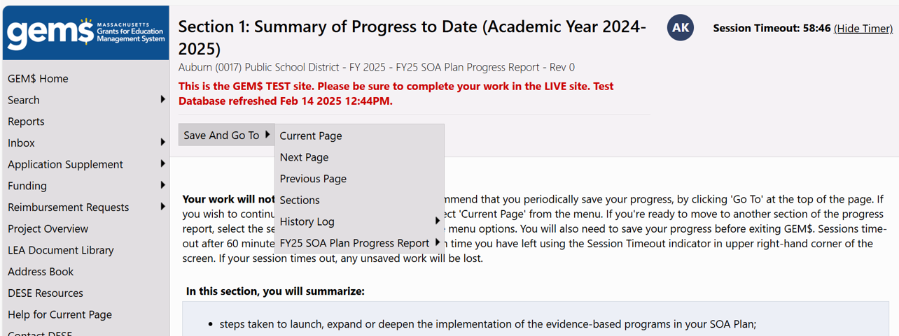

## **The FY25 SOA Plan Progress Report submission form in GEM$**

* **Screenshots of each section appear below.**
  + Most sections are relatively intuitive and straightforward to complete in GEM$.
* **General tips for completing each section.** 
  + Narrative response questions allow for a variety of formatting options, as you can see in the text box below.
  + It is possible to copy and paste text from other word processing applications into GEM$.
  + You can also copy and paste screen shots into GEM$ if you have visuals you would like to include.
  + Required questions are marked with an asterisk (*).

### **Key Evidence-based Programs in District’s SOA Plan**

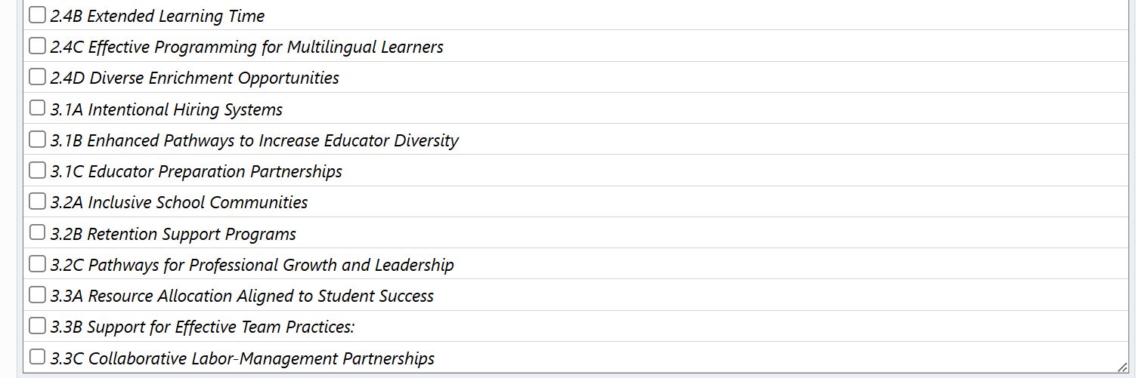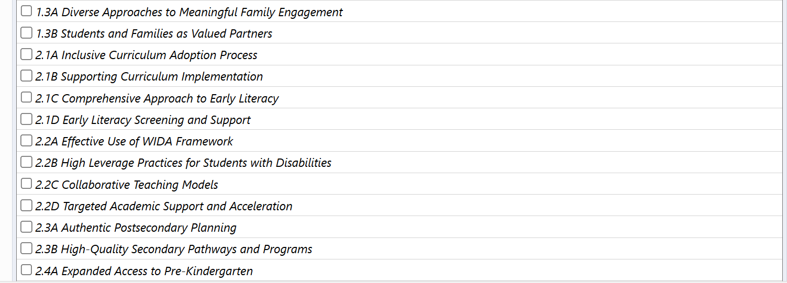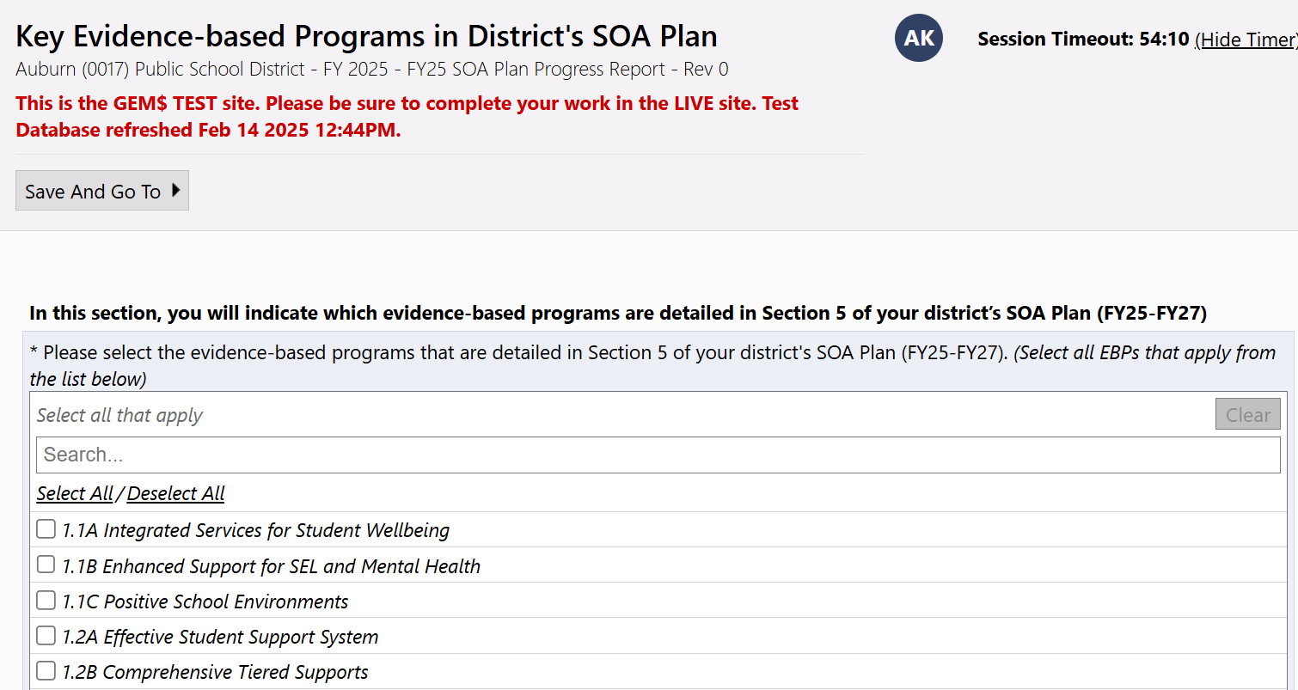

### **Section 1: Summary of Progress to Date (Academic Year 2024-2025)**

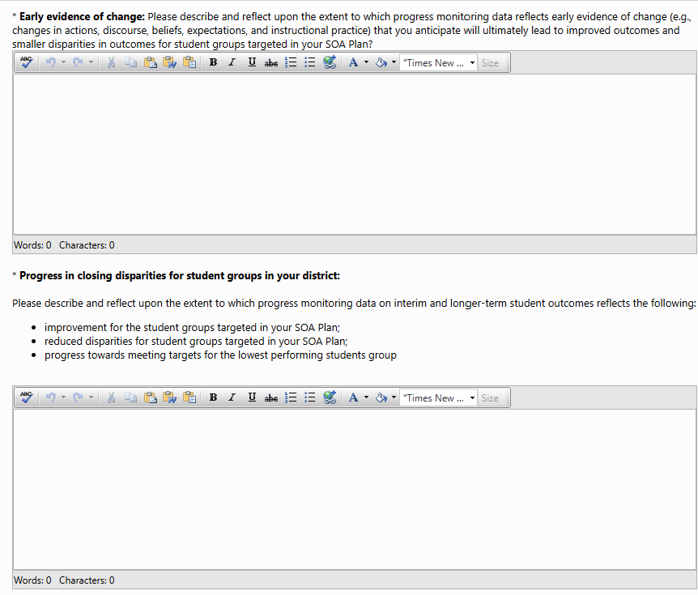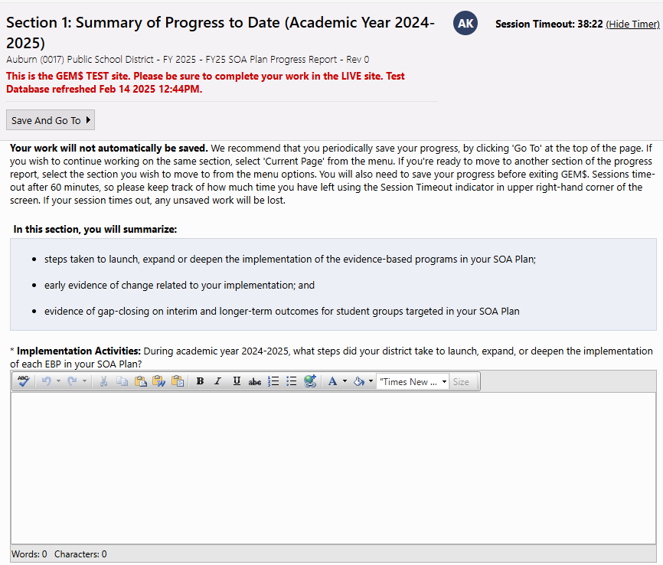

### **Section 2: Key Changes to Your Plan and Next Steps in Implementation**

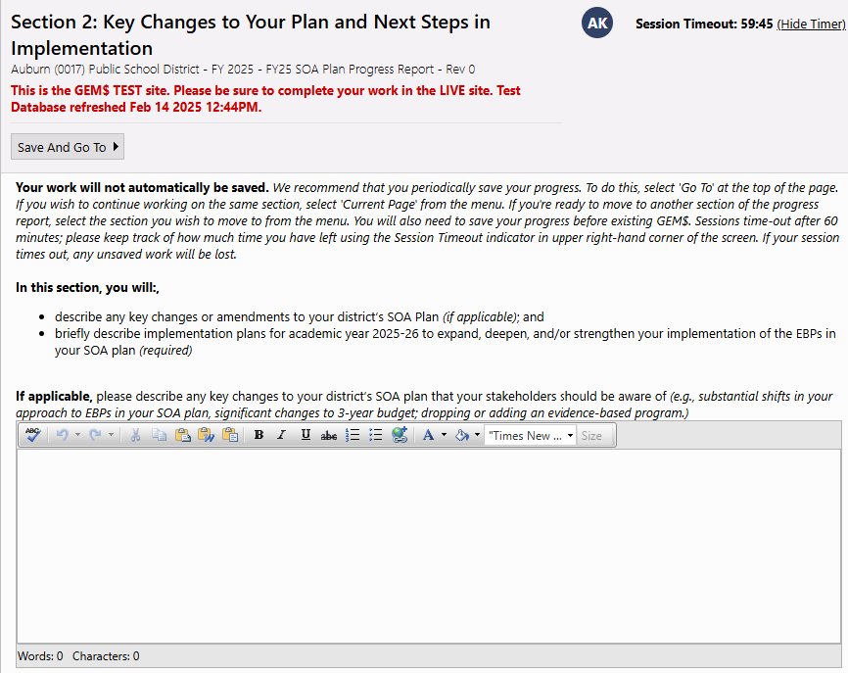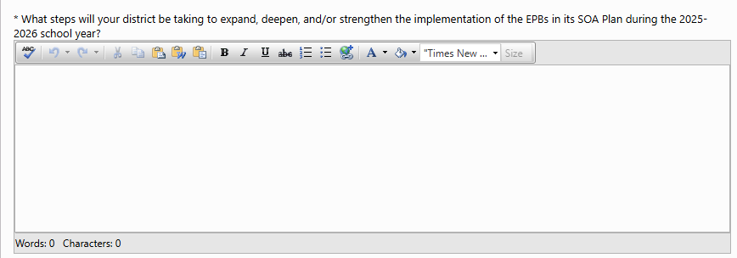

### **Section 3: Engaging Families/Caregivers and Other Stakeholders**

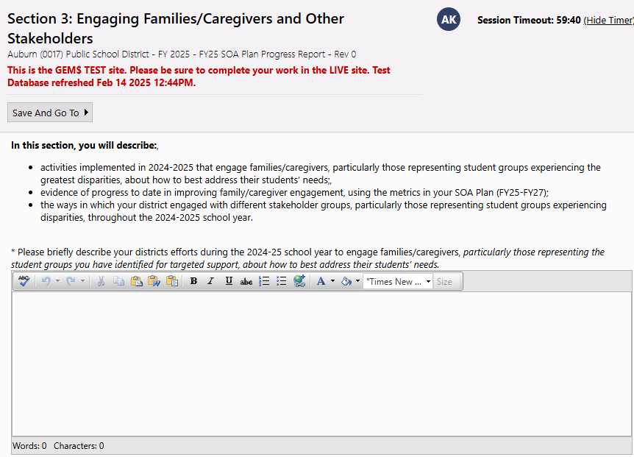 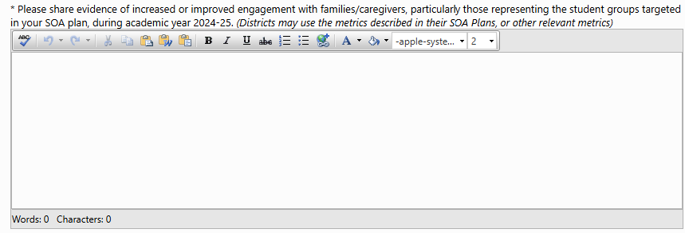 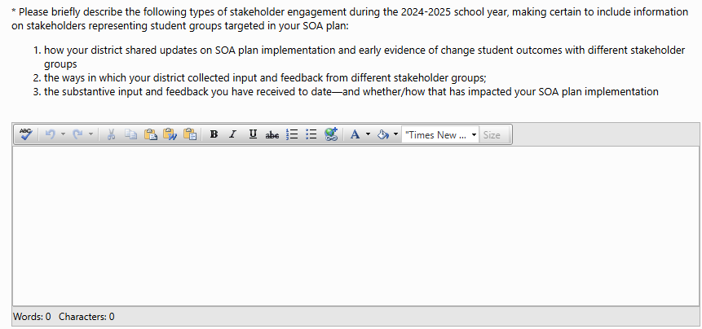

## **How to submit your SOA Plan**

#### **Instructions for LEA SOA Plan Writer(s)**

Once the progress report is fully entered into GEM$, the next step in the GEM$ ‘workflow’ is to send the report to the *LEA Superintendent/Chief Officer* for review by changing the ***Status*** of the report from *Application Supplement Started* to *Application Supplement Completed*. (**NOTE:** Superintendents who double as LEA SOA Plan Writers will need to follow these steps—essentially sending the report to themselves for approval.)

* **Check for validation errors on the *FY24 SOA Plan Progress Report Sections***.
  + If the *Validation Column* (outlined in green) is blank, you can change the status to *Application Supplement Completed*.
  + If the word Messages appears in the column, the section(s) has a validation error. All validation errors must be resolved before GEM$ will permit the status to be updated to be moved to *Application Supplement Completed*.

|  |  |
| --- | --- |
| **No Validation Errors** | **Validation Errors** |
| This screenshot shows no validation errors. | This screenshot shows validation errors. |

* **Click on Messages for a description of any error(s)**. If multiple sections have errors, clicking on Messages in either of the **All** rows will open a *Validation Messages* table that describes errors for each section. Clicking on *Review* (circled in green in screenshot on p11) will take you to the section of the report that requires attention.

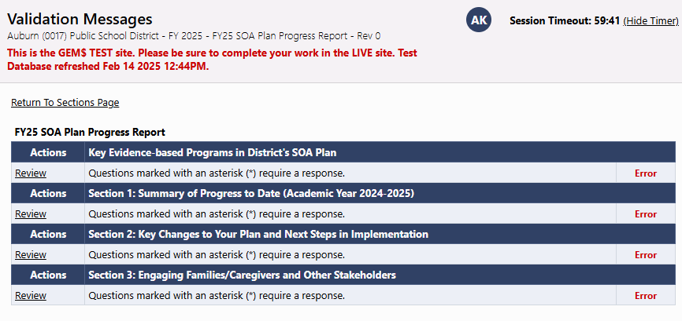

* + When all validation errors (Messages) have been eliminated (green box) and the SOA Plan is ready for the LEA Superintendent/Chief Executive’s review and approval, return to the **Student Opportunity Act (SOA) Plan Submission Sections**
* **Update the *Status* from *Application Supplement Started* to *Application Supplement Completed*** by clicking *Application Supplement Completed* on the ***Change Status To:*** line (green circle) and confirm that you want to update the status. Once the status is updated, GEM$ automatically generates an email that goes to the *LEA Superintendent/Chief Executive* letting them know that the application supplement is complete.

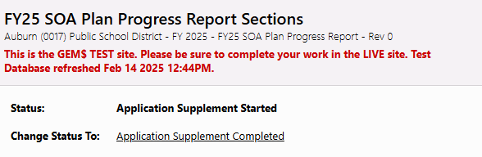

* **No further edits can be made once the Status has been updated to *Application Supplement Completed***. If additional edits are required, the *LEA Superintendent/Chief Executive* will need to change the Status to *LEA Superintendent/Chief Executive Returned – Edits Needed.* This will generate an email for the LEA SOA Plan Writer(s) and restores access to the data entry template.

#### **Instructions for LEA Superintendent/Chief Executive**

The LEA Superintendent/Chief Executive, will receive a *No Reply* email from GEM$ indicating that the LEA SOA Plan Writer has completed the FY25 SOA Plan Progress Report Application Supplement. This is the superintendents’ cue to review the plan and either approve it, or return it to the LEA SOA Plan Writer for edits. (**REMINDER:** the *LEA Superintendent/Chief Executive* role does not have permissions to make direct edits to the progress report.

* To do that, navigate to the **FY25 SOA Plan Progress Report Sections** page and update the ***Status*** from *Application Supplement Completed* to either *LEA Superintendent/Chief Executive Approved* **or** *LEA Superintendent/Chief Executive Returned – Edits Needed* by clicking on the appropriate link on the ***Change Status To:*** line.

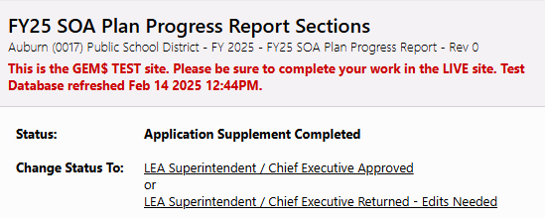

* + Changing the **Status** to *LEA Superintendent/Chief Executive Returned – Edits Needed* generates an email to the LEA SOA Plan Writer(s) that signals the progress report needs and permits them to make edits to the data entry screens.
  + Changing the **Status** to *LEA Superintendent/Chief Executive Approved* generates a GEM$ email to DESE letting us know the progress report is submitted and ready for review.

## **How to print your FY25 SOA Plan Progress Report**

* *FY25 SOA Plan Progress Reports* can be printed at any time from the **FY25 SOA Plan Progress Report Sections** page by clicking on *Print*. You can print either the entire report, or individual sections.

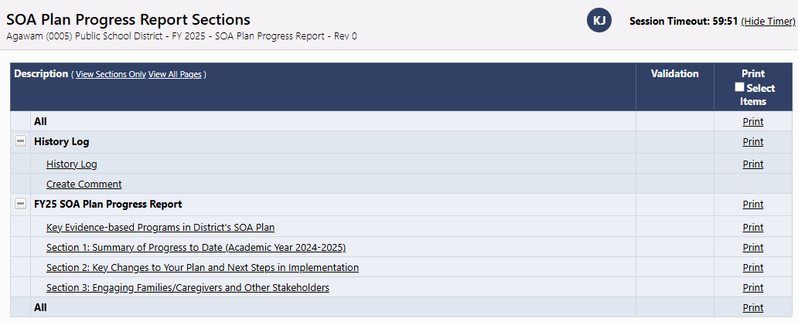

* You also have the option of printing your choice of sections in a single document. Check the box in the *Print Selected* *Items* column on the far right. A set of boxes will appear next to each section. Place a checkmark next to the section(s) you would like to print. (In the example below, Sections 1 and 2 would be printed as a single document. ) You can either click on the word *Print* in the column header or click the Print Selected Items box at the bottom of the table to print the selected sections.

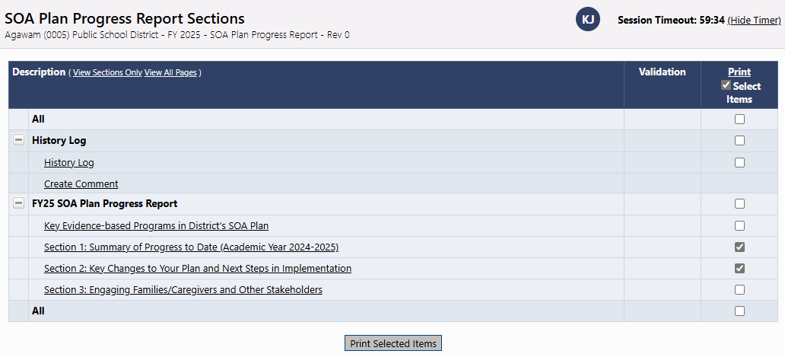

* Once you select print, a **Print Request** page will open. *Your browser must be set to accept pop-ups.*
  + Give your document a name and type it in the **Document Name** field
  + Enter your **Email Address**
  + Click the **Print** button

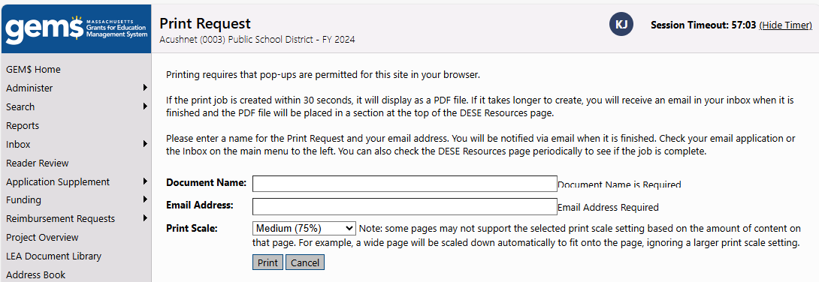

* + A message will appear letting you know that GEM$ is preparing your progress report for printing.

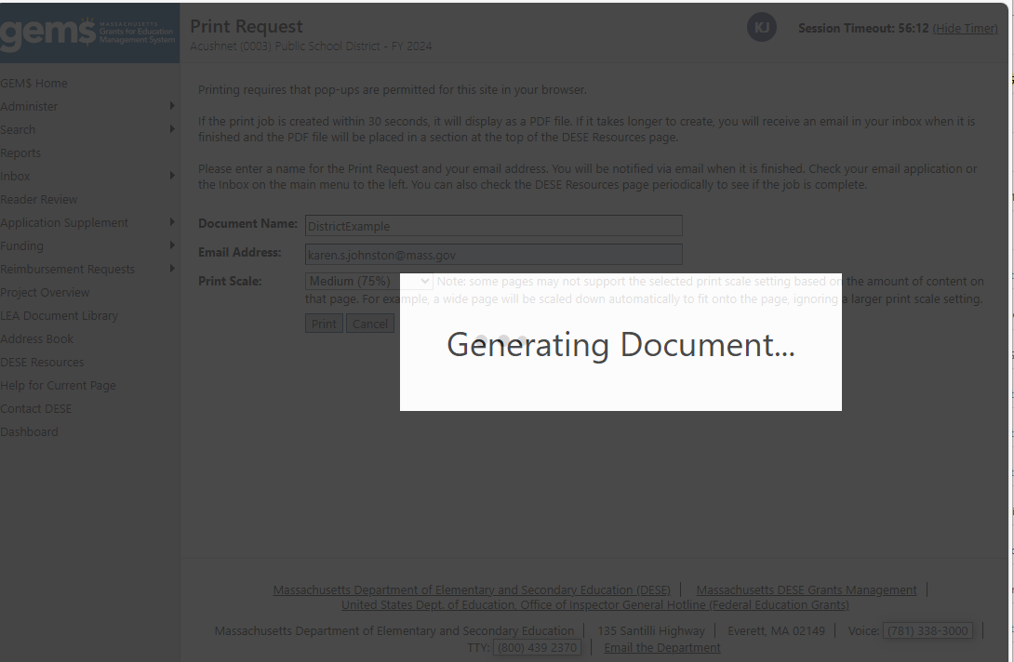

Your report will either:

1. Open on your screen in a pdf format (e.g., in Acrobat Reader). You can either print from the screen or download and save the file to print later.

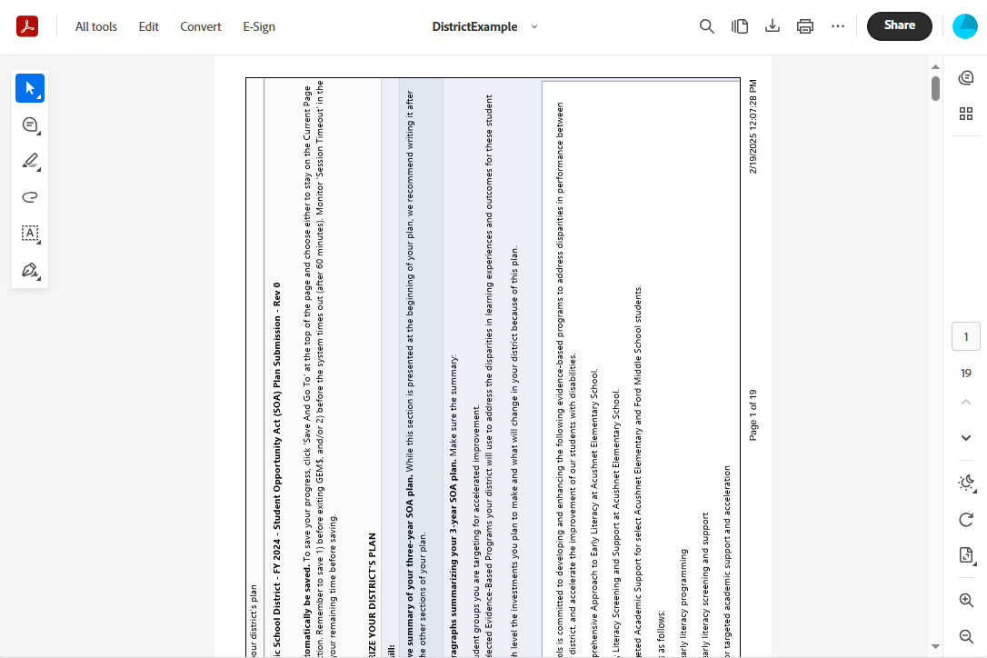

1. If it takes GEM$ longer than 30 seconds to prepare the report, the system ([GEM$NoReply@eGrantsManagement.com](mailto:GEM$NoReply@eGrantsManagement.com)) will instead send an email to the address you provided with the subject line *GEM$ - PDF Generated*

