Student Opportunity Act Plan: SY 2021-2023
Martin Luther King, Jr. Charter School of Excellence

→ Commitment 1: Focusing on Student Subgroups

Which student groups will require focused support to ensure all students achieve at high levels in school and are successfully prepared for life?

At Martin Luther King, Jr. Charter School of Excellence, we are committed to ensuring that every student in kindergarten through grade 5 is equipped to think critically, communicate clearly, and are empowered with a strong ethical foundation to be set on the path for success in college, career, and life. Based on our most recent MCAS data and other internal quantitative and qualitative metrics, our student subgroups that will require focused support to ensure that they are achieving at high levels are our High Needs students, particularly our emerging bilingual students. The majority of our emerging bilingual students are Level 3 (Developing). They know and use social English and some specific academic language with visual and graphic support. However, language acquisition is complex and student challenges with oral language, reading fluency, and comprehension all contribute to the disparity that exists. In addition, the language demands in math, ELA, and science increase year-to-year. With respect to student enrollment, our population of emerging bilingual students is growing nearly exponentially. Our goal is to thoughtfully and strategically support our high needs students to meet or exceed growth targets.
A Sample of Supporting Data for our Most Struggling Learners
Math
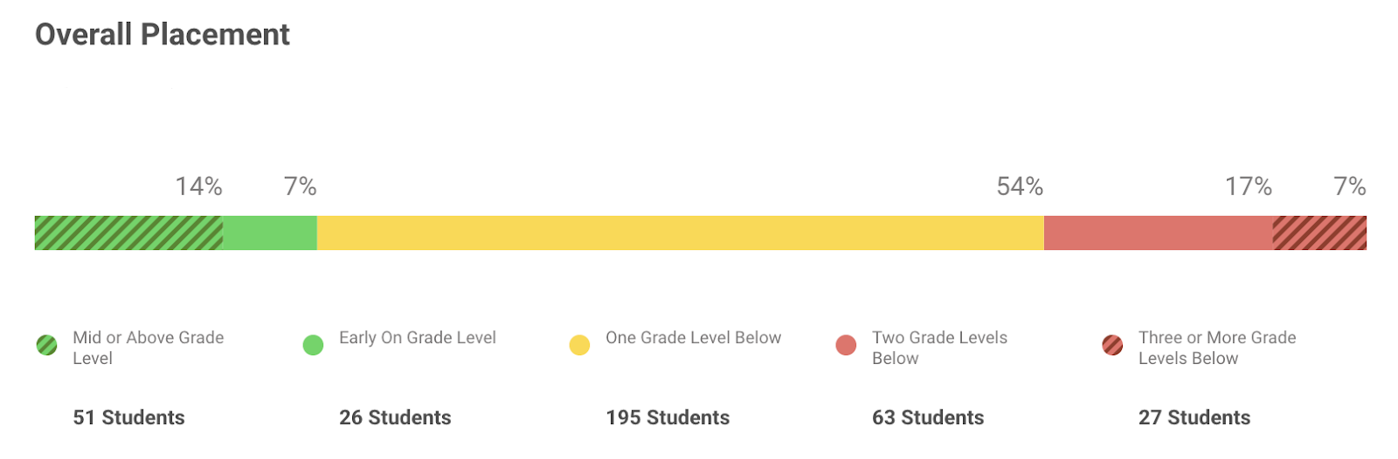

Reading
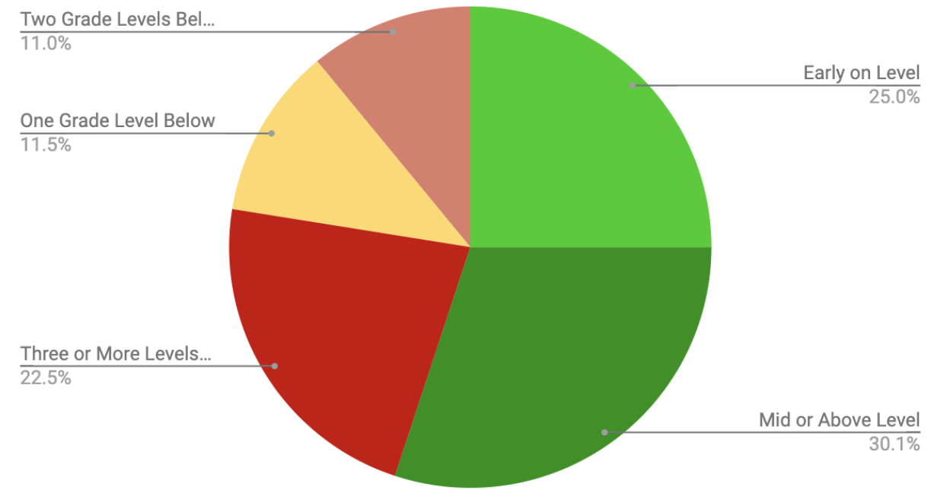

→ Commitment 2: Using Evidence-Based Programs to Close Gaps

What evidence-based programs will your charter school adopt, deepen, or continue to best support the closure of achievement and opportunity gaps? What resources will be allocated to these programs?
We are deeply committed to implementing research-based early literacy and intensive balanced literacy instruction for our students. We plan to dedicate increased time to literacy instruction and expand upon the programming shifts we have been making over the last two academic years. With the two initiatives below, we will continue to strengthen our instruction and improve outcomes for our high need students.

Evidence-based program #1: Increased personnel and services to support holistic student needs

We have analyzed our MCAS, ACCESS, and internal progress monitoring assessments. Additionally, we have conducted informal self-assessments for our EL and Special Education programs. Through these efforts, we have seen a disparity in the performance levels and growth between our high need students and their counterparts. We believe that the significant programmatic changes we have implemented in the last two years have primed us for improved results.

To build upon this, we believe that expanding our co-teaching staffing model and providing targeted accommodations and adaptations will support our students towards continued growth and progress. The ELE department will continue developing Next Generation ESL Curriculum Units aligned to the WIDA Standards and the Massachusetts Curriculum Frameworks. Additionally, units will be created to align to content-area topics that students will encounter in their core content classes. Over the next few years, we will continue to provide high quality SEI professional development to all core content teachers in addition to implementing structures and systems for ensuring that teachers are implementing strategies with consistency and fidelity.

We plan to have a co-teaching model in every general education classroom. We utilize an inclusion model and currently provide at least the minimum amount of time for pull out services for both English learners and students with special needs in accordance with their service hour demands. Inclusion/co-teaching for students with disabilities and English learners will support their academic growth by allowing us to implement more small group instruction opportunities.

FY21 budget item | Amount | Foundation Category
SEI professional development |  | Professional Development
Teachers inclusion/co-teaching model) |  | Classroom and Specialist teachers, Employee Benefits/Fixed Charges
Wilson |  | Professional Development
Evidence-based program identified by the Department: |  | Diversifying the educator and administrator workforce
SOA program categories: |  | Hiring school personnel that best support improved student performance

Evidence-based program #2: Additional language development support for students

Our informal self-assessment of our EL and Special Education programs revealed that research-based and adaptive interventions are critical to the continued progress on our high need students. The provision of professional development and coaching will be necessary to successful implementation. Professional learning is a key aspect of implementing evidence-based early literacy practices. Our teachers will benefit from training on early reading content pedagogy in order to understand and respond to individual student literacy needs. This training is particularly impactful when a high-quality, evidence-based curriculum is in place. We have identified strong evidence-based intervention programs such as Enhanced Proactive Reading, Read Well, and SRA Corrective Reading. Additionally, our teachers need increased structured high-quality common planning time. This dedicated time to thoughtful plan and the resources needed for intervention will support student growth and achievement.

FY21 budget item | Amount | Foundation Category
Intervention technology |  | Instructional materials, equipment, and technology
Lindamood Bell |  | Instructional materials, equipment, and technology
Small group intervention training |  | Professional development; Instructional materials
Evidence-based program identified by the Department: |  | Research-based early literacy programs in early elementary grades
SOA program categories: |  | Increased or improved professional development

→ Commitment 3: Monitoring Success with Outcome Metrics and Targets
What metrics will your charter school use to monitor success in reducing disparities in achievement among student subgroups? Select from the list of Department metrics or provide your own.

Metric Type | Metric | Aligned to
Department provided | The mean ELA student growth percentile (SGP) for emerging bilingual students and students with special needs will exceed the 50th percentile. | Additional language development support for students and training for teachers
Department provided | The mean Math student growth percentile (SGP) for emerging bilingual students and students with special needs will exceed the 50th percentile. | Additional language development support for students and training for teachers
Department provided | 80% of emerging bilingual students will meet their individualized progress targets towards attaining English language proficiency on ACCESS | Additional language development support for students and training for teachers

→ Commitment 4: Engaging All Families

How will your charter school ensure that all families, particularly those representing the student subgroups most in need of support, have the opportunity to meaningfully engage with the charter school regarding their students’ needs?

We will continue to facilitate and expand membership of both our English Learner Advisory Council (ELPAC) and our Special Education Parent Advisory Council (SEPAC). We will measure increases in family engagement based on these efforts by taking attendance and maintaining notes for each event and meeting. We plan to engage families in determining how we can strengthen our school-to-home connection as well as procuring resources to be responsive to their needs and topics that our families would like to learn more about. We also plan to hold workshops for our families on ways that they can support their child(ren) at home.

In addition to our ELPAC and SEPAC we have other general structures in place to promote and maintain two-way communication with our families. We utilize ClassDojo to communicate daily with families in informal ways. More formal structures for engaging our families include communication about student progress, progress notes, report cards, parent/teacher conferences each semester, Back to School Night, Academic Nights, and Middle School Night for our fifth graders’ families. We also analyze disaggregated data from our family satisfaction survey to ensure that all families are satisfied and engaged with their child’s learning experience and the school community.

Certifications:

☒ By checking here, I certify that our charter school has engaged stakeholders in our community in accordance with the Student Opportunity Act
Please summarize your stakeholder engagement process, including specific groups that were engaged:
The Leadership Team, which is comprised of academic, culture, and operational team members analyzed data and drafted proposed subgroups to target. We then solicited feedback from our Board of Trustees and incorporated parent feedback. Once we determined the student groups to target, we assessed what systems, supports, and resources we had in place and what resources would further support the initiatives. *Our stakeholder engagement process was limited by the COVID-19 pandemic.

☒ By checking here, I certify that the Martin Luther King, Jr. Charter School of Excellence’s Board of Trustees voted on our Student Opportunity Act Plan.
Date of vote: July 30, 2020 Outcome of vote: Approved unanimously

The foundation categories are: Administration; Instructional Leadership; Classroom & Specialist Teachers; Other Teaching Services; Professional Development; Instructional Materials, Equipment, and Technology; Guidance and Psychological; Pupil Services; Operations and Maintenance; Employee Benefits/Fixed Charges; and Special Education Tuition.

