Report on the Status of the Public Education Financing System in Massachusetts
Chapter 12 of the Acts of 2010, Section 16

July 2013

Massachusetts Department of Elementary and Secondary Education
75 Pleasant Street, Malden, MA 02148-4906
Phone 781-338-3000 TTY: N.E.T. Relay 800-439-2370
www.doe.mass.edu

This document was prepared by the
Massachusetts Department of Elementary and Secondary Education
Mitchell D. Chester, Ed.D.
Commissioner

Board of Elementary and Secondary Education Members
Ms. Maura Banta, Chair, Melrose
Mr. Daniel Brogan, Chair, Student Advisory Council, Dennis
Dr. Vanessa Calderón-Rosado, Milton
Ms. Harneen Chernow, Jamaica Plain
Ms. Karen Daniels, Milton
Ms. Ruth Kaplan, Brookline
Dr. Matthew Malone, Secretary of Education, Roslindale
Dr. Pendred E. Noyce, Weston
Mr. David Roach, Sutton

Mitchell D. Chester, Ed.D., Commissioner and Secretary to the Board

The Massachusetts Department of Elementary and Secondary Education, an affirmative action employer, is committed to ensuring that all of its programs and facilities are accessible to all members of the public.
We do not discriminate on the basis of age, color, disability, national origin, race, religion, sex, gender identity, or sexual orientation.
Inquiries regarding the Department’s compliance with Title IX and other civil rights laws may be directed to the
Human Resources Director, 75 Pleasant St., Malden, MA 02148-4906. Phone: 781-338-6105.

© 2013 Massachusetts Department of Elementary and Secondary Education
Permission is hereby granted to copy any or all parts of this document for non-commercial educational purposes. Please credit the “Massachusetts Department of Elementary and Secondary Education.”

This document printed on recycled paper

Massachusetts Department of Elementary and Secondary Education
75 Pleasant Street, Malden, MA 02148-4906
Phone 781-338-3000 TTY: N.E.T. Relay 800-439-2370
www.doe.mass.edu

Massachusetts Department of
Elementary & Secondary Education

75 Pleasant Street, Malden, Massachusetts 02148-4906 Telephone: (781) 338-3000

TTY: N.E.T. Relay 1-800-439-2370

Mitchell D. Chester, Ed.D.
Commissioner

July 30, 2013

Dear Members of the General Court:

I am pleased to submit this Report to the Legislature: Report on the Status of the Public Education Financing System in Massachusetts pursuant to Chapter 12 of the Acts of 2010, Section 16:

“The department of elementary and secondary education shall prepare a report on the current status of the public education financing system in the commonwealth as it currently exists. The report shall include, but shall not be limited to, the following: (1) the source of and potential remedies for any existing discrepancies between the fiscal demands placed upon and the fiscal assistance provided to municipalities and school districts with similar fiscal capacity and educational responsibilities, including those placed and provided pursuant to chapter 70; (2) a consideration and evaluation of all the financial resources made available to schools and districts, from all sources, and how they relate to student learning and educational opportunity; and (3) a review of successful educational programs in schools and school districts that achieve their success at relatively lower per pupil costs when compared with schools and districts serving student populations with similar academic and socio-economic characteristics and an assessment of the possibility of replicating such programs in other schools and school districts.”

The Report

This report provides an overview of the Chapter 70 program, the Commonwealth's primary state aid program for elementary and secondary education. The report describes the history of the program's key provisions, analyzes the budget assumptions in the formula in light of actual district expenditures, and examines aid distribution and the efforts that have been made to address equity and fairness issues. The report identifies a number of changes that could be made to the existing formula to address issues that have arisen.

In short, since McDuffy, the Commonwealth has made substantial progress toward improving the adequacy of school funding – through the adoption of the foundation budget and fairer distribution of resources by targeting more aid to the state’s neediest districts. Economic downturns have at times slowed this progress, particularly in recent years, but even during those periods the state has maintained its commitment to ensuring that all districts are funded at foundation.

The report explores the relationship between resources and student performance by focusing on a group of exemplary schools. As the present study illustrates, districts from a wide range of expenditure levels are achieving exemplary outcomes. At the same time, districts with similar levels of expenditures are achieving widely disparate student outcomes. More spending by itself does not guarantee a better education for the Commonwealth’s students.

While funding is clearly an important factor in how schools perform, it is less easy to discern from available data exactly how districts are utilizing their resources to positively impact student performance. The review of exemplary schools indicates that factors other than funding – such as instructional leadership, savvy deployment of educator talent, school based autonomies, student and staff scheduling and use of time, using data to inform instruction, and targeted student interventions – have the greatest potential to influence student educational attainment. Understanding how these schools use their resources towards these ends is an important enterprise and warrants further investigation.

Moving Forward

When all sources of revenue (local, state, federal, and other) are taken into account, Massachusetts’s K-12 public education system represents an annual investment of roughly $15 billion – an average of about $15,000 per student. As the attached report illustrates, expenditure level alone is a weak predictor of student outcomes.

In considering the future of Chapter 70 – in order to maximize educational opportunity and attainment for all students and to ensure that taxpayer money is most efficiently and effectively deployed – I recommend that the Commonwealth:

- adopt incentives to promote effective use of resources, including incentives to repurpose existing revenue away from ineffective investments and toward adoption of effective education reform strategies;
- incorporate provisions that encourage the implementation of promising education strategies, including, but not limited to, school-based autonomies, staff compensation reform, a longer year for staff, and more learning time for students; and
- require state approval for the utilization of foundation premiums to support the education of high risk students in the lowest performing schools and districts.

These recommendations will help to effectively leverage the considerable investment by the Commonwealth to promote promising education strategies.

The strong educational outcomes that Massachusetts has enjoyed relative to other states are the product of improvements in curriculum and instruction, accountability for results, and increases in school funding that are progressively distributed. The Department of Elementary and

Secondary Education’s capacity to promote a program of study that prepares students for the 21st Century and to intervene when results are lagging is essential to securing continuous improvement in the years ahead. Any discussion of the future of the Chapter 70 program would wisely consider how to leverage this evolving state role in the next stage of education reform.

If you would like to discuss this report in greater detail or have questions, please feel free to contact me or Deputy Commissioner Jeff Wulfson at jwulfson@doe.mass.edu or 781-338-6500.

Sincerely,

Mitchell D. Chester, Ed.D.
Commissioner of Elementary and Secondary Education

Table of Contents
Introduction 2
Section 1: Overview of the Chapter 70 State Aid Program 3
Key provisions of state aid to education 3
Chapter 70: Historical trends 8
Section 2: Comparisons of Actual Spending to the Foundation Budget 11
Methods for comparing foundation budgets and actual expenditures 11
Section 3: Comparisons of Aid and Local Fiscal Capacity 16
A new aid formula to reduce discrepancies 16
Target shares for required local contributions 18
Target shares for state aid to districts 21
Section 4: Resources and Student Performance 24
All fiscal resources 24
Fiscal resources and student learning outcomes 26
Section 5: Exemplary Schools’ Use of Fiscal Resources 29
Section 6: Recommendations 33
Appendix 1: FY12 foundation budget rates ($ per pupil) 36
Appendix 2: Conditions for school effectiveness 37

Introduction

The Department of Elementary and Secondary Education (ESE) respectfully submits this Report to the Legislature as directed pursuant to the Act Relative to the Achievement Gap (St. 2010, c. 12, §. 16). The Legislature directed ESE to address the following:

- The source of and potential remedies for any existing discrepancies between the fiscal demands placed upon and the fiscal assistance provided to municipalities and school districts with similar fiscal capacity and educational responsibilities, including those placed and provided pursuant to Chapter 70.

- A consideration and evaluation of all the financial resources made available to schools and districts, from all sources, and how they relate to student learning and educational opportunity.

- A review of successful educational programs in schools and school districts that achieve their success at relatively lower per pupil costs when compared with schools and districts serving student populations with similar academic and socio-economic characteristics and an assessment of the possibility of replicating such programs in other schools and school districts.

This report provides an overview of the Chapter 70 program, the Commonwealth's primary state aid program for elementary and secondary education. It describes the program's key provisions when it was first implemented in FY94; changes to the aid formula subsequent to that time; and the impact of the fiscal crisis that began in FY09. It then looks at existing discrepancies in the foundation budget and state aid formulas as well as budgetary pressures that have been of particular concern to districts in recent years. The report also explores the relationship between resources and student performance at both district and school levels.

Section 1: Overview of the Chapter 70 State Aid Program

Key provisions of state aid to education

“It is the intention of the general courts, subject to appropriation to assure fair and adequate minimum per student funding for public schools in the commonwealth by defining a foundation budget and a standard of local funding effort applicable to every city and town in the commonwealth.” [M.G.L. c. 70, §. 1]

The Chapter 70 program for state aid to education was enacted as part of the Education Reform Act of 1993 (St. 1993, c.71, hereinafter “the Act”). Prior to that time, decisions on education spending were matters of local control. The state had not defined what constituted an adequate education, and state and local officials were not required to ensure that districts met annual spending goals. As a result, wealthier school districts were spending substantially more on their students than the districts that served our most disadvantaged students. Further compounding this situation was the economic recession that the Commonwealth experienced in the early 1990s, which severely limited the amount of aid available from the state to supplement local resources.

The Board and Department of Education played important roles in documenting these conditions in two influential reports that were published in the fall of 1991: “Report on the Condition of the Public Schools in Holyoke, Lawrence, Brockton, and Chelsea” and “A Policy Position on Distressed School Systems and School Reform.”

This situation led the Supreme Judicial Court to rule in McDuffy v. Secretary of the Executive Office of Education, 415 Mass. 545, 615 N.E.2d 516 (1993) that the Commonwealth was not meeting its constitutional obligation to provide an adequate level of education to its students. The Act, which included substantial changes to how the Commonwealth funds public education, was signed into law a few days after the McDuffy decision.

The Act defined a foundation budget for each operating school district, representing the amount of money deemed necessary to provide an adequate education to all students in that district. Each district's foundation budget reflected its enrollment and the demographics of its student body. Forty percent of school districts were already spending at or above the foundation budget level, but many urban and rural districts were spending at levels far below it. The Act also established annual spending requirements for cities and towns to make on behalf of their schools, with higher requirements for wealthier municipalities and lower requirements for poor cities and towns. Finally, the Act committed the state to a significant increase in education aid, to ensure that every district could reach its foundation budget target.

The Chapter 70 formula has two goals: adequacy and fairness. The adequacy standard requires that every school district be provided with sufficient financial resources to give all of its students, regardless of their background, the opportunity to succeed. It was expected that these financial resources would come from a combination of state and local funding. The fairness standard requires that the calculation of state and local shares be done equitably and consistently in light of local fiscal capacity to fund schools. Several key provisions of the formula help to achieve these goals.

- Foundation budgets are established annually for each school district, representing the minimum funding level needed to provide an adequate education.
- The foundation budget calculation recognizes that different categories of students require different levels of resources. The foundation budget for each district is based not only on the district's total enrollment, but on the grade levels, programs, and demographics of its students.
- Foundation budget rates are adjusted annually for inflation.
- Foundation budget rates are also adjusted to reflect differences in labor costs in different parts of the state.
- Targets for how much communities can afford to contribute to the foundation budget are calculated annually based upon the most recent property value and personal income data. Wealthier communities have higher local effort targets than those with less ability to pay.
- Annual minimum contribution requirements are designed to get communities closer to their local effort targets.
- Chapter 70 aid from the state makes up the difference between districts’ foundation budgets and the minimum required local contributions.
- The sum of each district’s minimum required local contribution(s) and its Chapter 70 aid equals its “net school spending requirement.”
- School committees have broad discretion in deciding on how to use their available funds, but the total amount of spending is expected to meet or exceed the net school spending requirement.

Foundation budget

As the basis for the distribution of education aid to local districts, a foundation budget is calculated annually for each school district. The original foundation budget rates were formulated in 1993, and were based on the professional judgment of a group of superintendents about the resources needed to support an adequate level of educational services. This approach was groundbreaking at the time and has since been adopted by many other states.

At its core the foundation budget calculation is designed to establish a budgetary basis for the delivery of a fundamentally sound education for any public school student in the Commonwealth, regardless of where they reside and seek such services. In so doing, the formula establishes the foundation concept as the definition of budgetary need that other fiscal portions of the formula seek to meet by apportioning fiscal responsibility for meeting those established needs.

The foundation budget is organized into eleven expenditure categories and fourteen student groups, with a per pupil rate assigned to each expenditure category for each student group (see the table of foundation budget rates in Appendix 1: FY12 foundation budget rates ($ per pupil)). These rates are based on assumptions about the number of staff, salaries, and other costs needed to provide an adequate level of services in each expenditure category. Changes were made to the foundation budget categories in FY07 to align them with the major functional categories that districts use to budget and report actual expenditures. The changes allow direct comparisons between foundation budget categories and what districts actually spend.

The foundation budget groups students by grade level (pre-school, kindergarten, elementary, secondary), program (general or vocational), and/or special populations (limited English proficiency (LEP) and low-income). Special education enrollment is based on an assumed percentage for in-district and out-of-district students, not on actual headcounts. Students are counted once in their grade level or program group and assigned an additional increment based on their special population status, LEP or low-income, if any. Rates vary based on assumptions about specific cost categories, especially in teacher costs and related benefits. An element that distinguishes Massachusetts’ funding formula from those in many other states is the significant amount of additional weight given to students from low-income families (defined as eligible for free or reduced price lunch).

ESE uses October 1 enrollment data from the prior fiscal year to determine each district’s foundation budget for the subsequent fiscal year. For example, FY12 foundation enrollment is based on students reported on October 1, 2010. Foundation enrollment includes all of the students for whom the district is financially responsible, whether they attend school in the district, attend school in another district through school choice or a tuition agreement, attend a charter school, or attend an out-of-district special education program. The headcount of resident public school students is adjusted in three ways that make foundation enrollment different (sometimes substantially so) from headcounts in local schools:

- Pre-school and half-time kindergarten students count as a 0.5 student. Foundation enrollment at the pre-school level is adjusted further by capping regular education pre-school enrollment at twice the number of special education pre-school students. Pre-school and half-time kindergarten students with limited English proficiency are counted in the same way, but have higher foundation budget rates.
- Special education student enrollment is estimated rather than based on actual enrollment, to avoid creating a perverse incentive to classify students as having special needs. For academic districts, the number of in-district special education students is estimated at 3.75 percent of total enrollment, and for vocational districts, 4.75 percent.
- Out-of-district special education students are estimated at 1 percent of enrollment .
- Low-income students are counted for an increment to their foundation rate. For example, a low-income elementary student generates the elementary rate of $6,796 plus the low-income elementary increment of $3,224, an increase of nearly 50 percent in resources for educating that student.
Foundation rates are adjusted annually for inflation using the implicit price deflator for state and local government services calculated by the federal Bureau of Economic Analysis. For some districts, the foundation budget is adjusted further by a wage adjustment factor using annual employment and wage data submitted to the Massachusetts Executive Office of Labor and Workforce Development for all employment sectors. This adjustment applies only to higher-cost areas of the state, and affects only salary items in the foundation budget. At one time the wage adjustment factor was used to deflate the salary assumptions for districts in regions where wage rates were below state averages, but this practice was ended in FY04 in order to increase the level of resources available to these districts.

Required local contributions, state aid, and net school spending requirements

Once each district’s foundation budget is established, the purpose of other elements of the formula is to determine how the spending goal will be reached through a combination of local and state resources. The initial formula was particularly focused on meeting the foundational needs of all districts as defined in the formula and less focused on promoting cross-district equity in contribution requirements and aid levels. The categories of required and actual net school spending were created to facilitate the establishment of requirements in service to those goals and in order to monitor compliance with those requirements.

Before the McDuffy ruling, each city and town determined its own funding levels for public education without any guidelines from the state. McDuffy fundamentally changed this by establishing a minimum local contribution requirement for each school district. When setting contribution levels at the outset of education reform, the Commonwealth used the amounts that communities chose to spend from property taxes (“local contributions”) in FY93 as the starting point for FY94. Each subsequent year’s contribution was then determined by increasing the prior year’s contribution by the municipal revenue growth factor (MRGF), as determined by the Massachusetts Department of Revenue. The MRGF is an estimate of the anticipated increase in local revenues (including unrestricted state aid) from one year to the next. This percentage was applied to the prior year’s local contribution requirement to reflect the belief that schools should share equally in these new revenues. The decision to tie the contributions to the FY93 spending levels resulted in some criticism in the ensuing years, as it appeared to “penalize” the higher spending districts, even those that were not particularly wealthy. Over time, this contributed to some inequities in the state aid distribution. The Act, as originally adopted, included mechanisms to relieve relatively “high effort” municipalities of some of their burden and increase the contribution of relatively “low effort” municipalities, but these proved difficult to implement and were ultimately abandoned.

The required local contribution portion of the formula was substantially rewritten in FY07, moving the formula away from reliance on the MRGF as the primary factor. The goal of the FY07 changes, which will be described in further detail below, was to bring local contribution requirements more in line with the current fiscal capacity of each local municipality. Annually updated target contribution and aid levels were established for each municipality and district in the Commonwealth. Since these changes are still being phased in, current local contribution requirements still retain some statistical ties to those established in FY94.

The state aid component of the Chapter 70 formula has included a number of different aid categories over the years. The most important is foundation aid, which is the mechanism for ensuring that all districts have sufficient resources to meet their foundation budget. Foundation aid is determined by taking the difference between a district’s foundation budget and the sum of their local contribution requirements and their base aid (which is typically their aid from the prior fiscal year). If additional resources are needed to reach the foundation budget target, foundation aid fills the gap. Minimum aid is the second principal mechanism that has been used to distribute state aid dollars. Minimum aid is most often distributed in per pupil increments to guarantee that all districts receive at least some aid increase in a given fiscal year; $25 per pupil has been the most common increment, but minimum aid has risen as high as $125 per pupil in some years. Growth aid, also created during the FY07 reform, was funded for several years to provide additional resources to districts based on their enrollment growth, and target aid has been used to resolve inequities in the aid distribution based on property wealth and income factors. Only foundation aid is constitutionally mandated; the use of these other aid categories has been dependent in large part on the state's fiscal situation in any particular year.

Required net school spending is defined as the sum of a district’s minimum contribution(s) plus its Chapter 70 aid. ESE counts only those cost categories included in the foundation budget when measuring compliance with this spending requirement. Some functional areas such as school lunch, transportation, and school construction were excluded intentionally from the foundation budget. School lunch programs had a long history of being funded almost exclusively from federal aid and student lunch fees, and other state aid programs already shared in the cost of services for transportation and school construction. An additional state aid program to assist districts with extraordinary special education costs, the special education circuit-breaker, was put in place in FY04 to address concerns about particularly high individual special education costs that were not well anticipated by the foundation budget.

Actual net school spending does not include any outlays from outside the general fund, such as federal grants, state grants, special education circuit breaker, school choice, tuition revolving funds, local receipts, or school lunch aid. Net school spending does include general fund spending on education services outside the school committee appropriation that is part of a city or town’s budget. These municipal “indirect” costs typically include health insurance for school staff, retirement costs, maintenance, and/or administration. Actual net school spending in FY10 accounted for $10.6 billion, or 77 percent, of the $13.8 billion spent overall for K-12 education.

ESE monitors annual net school spending requirements for each district in the Commonwealth. Districts are free to exceed their spending requirements and many do. In FY10, districts exceeded their mandated spending levels by 14 percent on average. If a district's net school spending falls short of its requirement but is at least 95 percent, the shortfall is added to the subsequent year’s requirement, so ultimately a district cannot avoid its obligations. If a district falls below 95 percent, its Chapter 70 aid is reduced by the amount of the shortfall below 95 percent. While a number of districts fall between 95 percent and 100 percent, only 12 districts have been penalized through FY11 for falling below the 95 percent threshold.

Chapter 70: Historical trends

Getting all districts to foundation

When the Education Reform Act was enacted in 1993, the Commonwealth committed to bringing all districts up to their foundation budget spending level within seven years. The economic growth that occurred in the middle and late 1990s allowed the state to meet this commitment on schedule, an achievement that few had thought possible seven years earlier. Chapter 70 funding increased by $1.5 billion during this period, with annual rates of growth consistently over 10 percent. There were few substantive changes to the program during this period, reflecting a steady focus on getting all districts up to their foundation budgets by FY00.

The influx of state aid increased spending overall and directed more resources to less advantaged school districts since their spending was typically further away from foundation levels. In FY93, districts in the lowest quartile of per capita income spent about $1,400 less per pupil than high-income districts. By FY00, this gap had narrowed to $370 per pupil.

Impact of economic cycles and formula adjustments

State revenues continued growing during 2001 and 2002. However, with all districts having reached foundation spending levels, the amount of foundation aid needed was much less than in previous years. A growing percentage of annual aid increases was distributed to districts through minimum aid, which guaranteed districts an annual per pupil aid increase. At the outset of education reform, minimum aid was funded at $25 per pupil, but over time this was increased to as much as $125 per pupil as the state’s revenue picture improved. While this was an expedient and simple way to distribute funds, it resulted in districts with very different abilities to pay and educational needs receiving the same per pupil aid increases, which eroded some of the basic equity principles of the aid formula.

For several years there was increasing pressure to base more of the formula for state aid on a community’s ability to pay rather than per pupil allotment. This came amid increasing concern that towns with similar means were receiving different levels of Chapter 70 aid. In addition to the increasing share of aid based on per pupil allotments, this variation was also due to districts’ differing spending levels in FY93. An effort was made in FY02 to use income and property wealth to direct funds to resolve these inequities, but the changes were not made permanent and a subsequent decline in state revenues shifted the focus back to foundation aid. In FY03, districts not needing foundation aid were level funded, and in FY04 the Chapter 70 appropriation sustained its first cut since the Act was enacted, totaling 4.5 percent or $150 million. Many districts saw their state aid reduced by as much as 20 percent, although foundation aid still ensured that all districts were funded at least at their foundation budget level. In FY05, state revenues had recovered sufficiently so that districts not receiving foundation aid were level funded, and by FY06 the state was once again able to provide a small minimum aid increase to all districts.

During this period, Hancock v. Commissioner of Education, 443 Mass. 428, 822 N.E. 2d 1134 (2005), the successor case to McDuffy, was once again challenging the fairness of the state’s school funding formula in the courts. Hancock focused on the adequacy of the foundation budget. The plaintiffs received a favorable ruling at the superior court level, but the judgment was overturned on appeal to the Supreme Judicial Court (SJC). The SJC cited not only the significant increase in state funding under the Act but also the Act's extensive provisions dealing with improvements to curriculum, instruction, and accountability. The Court concluded that the legislative and executive branches were taking reasonable steps to improve the state's education system and it declined to order any further judicial intervention.

Legislative changes to the Chapter 70 formula had been on hold during the pendency of the Hancock case. After the case ended, there was renewed interest in addressing the inequities in the state aid distribution. ESE proposed a new “aggregate wealth” model that used property wealth and personal income to determine local contribution and aid targets for each community. The proposed new formula set a statewide target of 59 percent local funding and 41 percent state funding. For individual communities, the target percentages would vary depending on the community's wealth. These targets are recalculated annually, reflecting changes in property value, income, and enrollment. The goal of this approach is to ensure that similar communities receive similar aid through a more transparent calculation. The target local contributions are capped at 82.5 percent of foundation budget. When fully phased in, this cap will guarantee that every district receives state aid for at least 17.5 percent of its foundation budget, regardless of its wealth. This formula change will be explained in further detail in a later section.

The "aggregate wealth” model was adopted by the Legislature, with a phase-in of the new targets beginning in FY07. Chapter 70 aid increased by 6.6 percent that year and brought total aid to $3.5 billion. It increased again in FY08 by another 6.3 percent. These increases made it easier to adjust district aid levels without reducing total aid to any district. Districts benefiting most from the new approach were those that had been making higher contributions than their ability to pay would indicate. The required contributions for these districts—the local funding to be added to Chapter 70 state aid—are being brought down over time to the target level defined by the formula. In most cases, this results in an increase in their foundation aid.

The recession and stimulus funding

Chapter 70 was expected to increase by 6.0 percent in FY09, which would have continued the progress in bringing districts closer to their targets. However, the economic downturn that began in the fall of 2008 changed this picture dramatically. State revenues plummeted and within the fiscal year, state budget reductions were implemented. Fortunately, over $400 million in federal stimulus funds, under the State Fiscal Stabilization Fund (SFSF) program, became available to help the Commonwealth meet its obligations. Another $200 million in SFSF funds were distributed in FY10 and FY11, largely to fund foundation aid. In FY11, the SFSF funds were supplemented by $203 million in federal Education Jobs funds, which allowed the state to not only fully fund foundation aid but to also restore a small amount of minimum aid ($25 per pupil).

In FY12, Chapter 70 aid rose from $3.851 million to $3.991 million, an increase of $139.6 million or 3.6 percent. The formula replaced all of the $20.7 million in FY11 SFSF grants with Chapter 70 aid and funded an additional $119.0 million in foundation aid. The FY13 budget saw a further increase of $180 million or 4.5 percent, allowing an increase in the minimum aid allotment to $40 per pupil. While Massachusetts continues to recover from the economic downturn, state revenues have still not rebounded to the point where the Commonwealth can complete the implementation of the FY07 reforms or consider other enhancements to the formula.

Progressive impact of Chapter 70 program on aid and expenditures

Today all districts are spending at or above foundation and the correlation between property wealth and per-pupil spending is far weaker than in earlier years. Since the implementation of the Education Reform Act, overall spending has increased and it has increased the fastest in districts that serve the highest numbers of low-income students.

The foundation budget portion of the state aid formula does produce a progressive distribution of state aid. Table 1: FY10 Per pupil financial data by low-income percentage district quartile compares aid and spending averages in quartiles based on percentage of low-income student enrollment. It shows that in FY10, on average, districts that educate the highest percentages of low-income students have higher foundation budget rates and receive the most state aid per pupil, with aid almost three times that of districts with the lowest percentages. The highest quartile also has, on average, higher levels of per pupil spending and higher average teacher salaries.

Table 1: FY10 Per pupil financial data by low-income percentage district quartile
Quartile of percentage of low income students | Foundation budget | Chapter 70 aid | Spending  (all funds) | Average teacher salary
Lowest quartile  (lowest percentage of low-income students) | $8,578 | $2,292 | $12,458 | $69,425
Second quartile | $8,729 | $2,732 | $11,691 | $67,318
Third quartile | $9,177 | $3,251 | $12,695 | $66,513
Highest quartile  (highest percentage of low-income students) | $10,844 | $6,481 | $14,249 | $70,442
Difference between lowest and highest quartile | $2,266 | $4,189 | $1,791 | $1,017

Section 2: Comparisons of Actual Spending to the Foundation Budget
In the last few years, questions have been raised about whether the Chapter 70 formula's foundation budget rates continue to reflect the educational needs of school districts. As a result of the adjustments to the foundation budget categories, it is now possible to compare the foundation budget with actual district spending.

Two issues must be addressed before conducting the analysis: whether to compare foundation budgets to actual expenditures from all sources of funding, and how to account for the shift of funds from in-district foundation budgets to out-of-district options such as charter and choice schools. Both of these issues arise, at least partially, from changes in the uses to which collected data are being applied. The net school spending concept was originally enacted as a means to monitor and enforce the Act's spending requirements. In recent years, educators and policy makers have been increasingly looking for financial data to support policy decisions, a very different purpose for which net school spending statistics are necessarily well suited.

Methods for comparing foundation budgets and actual expenditures

Use general fund or total spending

Since FY93, ESE has tracked district expenditures against foundation budgets by calculating net school spending as a percent of foundation budget. Most districts spend more than their foundation budget; over the past decade statewide district spending has exceeded foundation by as much as 20 percent. In addition, districts spend considerable resources from local revolving funds and federal and state grants that are not included in net school spending. Although these do not need voter or council approval, and may or may not be included in spending plan presentations, these other expenditures do directly affect pupils. On average, they represent 13 percent of total school operating expenditures.

One can make the case that if the foundation budget is intended to represent an adequate funding level for a district based on the grade levels and characteristics of its students, then an analysis that compares the foundation budget to what districts actually spend should include all expenditures because from the perspective of a pupil, the revenue source is irrelevant. However, there are reasons not to use this more expansive approach. In any event, it is clear that the Act itself excluded major categories such as transportation and capital infrastructure costs from inclusion in both foundation and net school spending calculations. In doing so, the Act clearly did not expect the concept of foundation to be an exhaustive listing of all possible, or even all necessary, spending associated with the educational enterprise.

The Chapter 70 statute and ESE regulations (603 CMR 10.06) define net school spending in terms of local appropriations. Local property tax effort is quantified by subtracting a district’s aid from its actual net school spending. Grants and revolving funds have historically been considered unpredictable and irregular revenue streams. To incorporate them into the calculation of local effort would be an annual exercise in guesswork. In addition, grants — which accounted for $1.005 billion or 57 percent of the $1.766 billion in non-appropriated spending in FY10 — have traditionally been offered to “supplement not supplant” local budget plans. There is a strong argument that anything spent in excess of appropriations should be targeted to particular needs of a district’s student population, program offerings, or reform efforts in ways that a formula-driven calculation such as the foundation budget cannot begin to measure. So while it is useful to know a district’s entire spending picture, the current analysis retains the traditional approach of comparing foundation budgets to general fund expenditures.

Analyze in-district and out-of-district expenditures separately

The second methodological issue concerns the need to present both foundation budget categories and general fund expenditures in per pupil terms. The foundation budget was conceptualized in the early 1990s based on the premise that most of a district’s pupils were enrolled in local schools, with only certain special education pupils being tuitioned to settings outside the district. At the time, that design was sensible, but since then tuition for other student groups has become far more prevalent, especially with the growth of school choice and charter schools. Pupils enrolled in other districts or charter schools are counted in a district’s foundation enrollment because they are the fiscal responsibility of the district where the student lives. There are also a number of towns that enter into tuition agreements with neighboring districts to educate some or all of their students. A district’s cost for pupils being educated outside the district is recorded as tuition, but those pupils’ foundation allotments are calculated as if they were enrolled in the district of residence. For example, Nahant pays tuition to send its grade 7 to 12 students to Swampscott. Nahant’s FY10 foundation budget includes 101 high school students enrolled at Swampscott, as well as four tuitioned-out special education students. These 105 pupils generate $966,570 of Nahant’s $3,140,213 foundation budget. The $966,570 is generated by the underlying foundation rate assumptions in ten in-district foundation categories, such as $382,733 for teaching.

Nahant’s foundation budget for teaching (which includes its high school students) cannot be fairly compared to what the district actually spends on teaching, which includes only elementary school teachers. Its spending for the 105 high school pupils is reported as tuition. It is, however, fair to control for the number of pupils in the in-district categories and do comparisons on that basis. Nahant’s FY10 foundation budget for teaching was $1,258,871 for 377 pupils in grades PK to 12, or $3,339 per pupil. Its actual general fund spending for teaching in FY10 was $818,918 for 227.1 full-time equivalent pupils, or $3,606 per pupil. Using state-wide per pupil averages, we can make a sound comparison of foundation budgets and actual expenditures.

In-district foundation budgets and actual expenditures

In FY10, districts spent an average of $10,526 per pupil on in-district expenditures, 11 percent more than the $9,447 average foundation budget per pupil. Figure 1 reveals, however, that actual spending in many categories is remarkably close to the foundation budget. In fact, combining all categories except insurance, retirement, and other fixed charges yields a foundation budget of $8,548 per pupil, while districts actually spent slightly less at $8,430. This would seem to indicate that, for the most part, the inflation factors applied over the years have been fairly successful at keeping pace with spending trends. The glaring exception to this finding is in the area of employee benefits, which comprises health insurance, retirement for non-teachers, and other types of insurance. Spending on employee benefits exceeded foundation budget assumptions by a staggering 133 percent: $2,096 per pupil in actual spending versus $899 foundation per pupil.

Figure 1: FY10 general fund spending compared to foundation budget ($ per pupil)
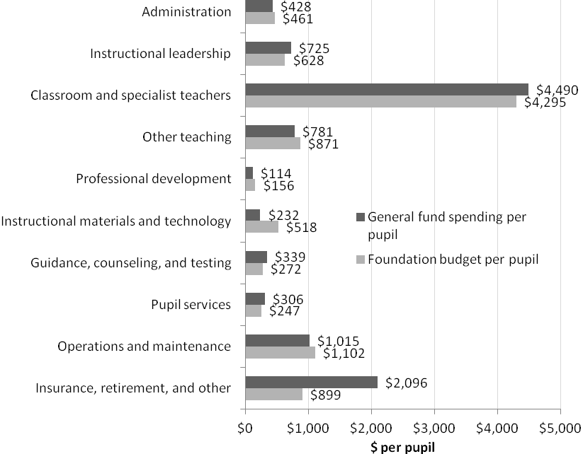

It is no secret that the cost of health insurance for active and retired district employees has increased more rapidly than other costs for many years. A recent study by Ed Moscovitch, an economist actively involved in developing the foundation budget concept in Massachusetts, found that during the 1990s the rate of increase in district health care costs was relatively small, but that during the 2000s it accounted for one-third of the entire increase in school spending. In FY00, insurance for active and retired employees stood at $563 million, or 7.1 percent of total general fund operating expenditures. In FY10 it climbed to $1.550 billion, or 13.9 percent. In seven districts, these benefits are more than one-fifth of the operating budget.

In an attempt to address the discrepancy in costs, in 2011 Governor Patrick proposed and the Legislature passed the Municipal Health Reform Act (St. 2011, c. 69), which allows municipalities to make health care plan design changes locally. This legislation is increasing the participation of school district employees in the state's Group Insurance Commission health plans and is expected to generate significant savings for school districts and other municipal employers.

On a related note, new accounting rules will now require municipalities to calculate and report their unfunded liability for “other post-employment benefits” such as retiree health insurance. The Massachusetts Taxpayers Foundation estimates the unfunded liability for the 50 largest communities in the state at nearly $20 billion. If reporting this liability leads to increased pressure to assign current dollars to meet future costs, the budgetary impact of retiree health insurance on school district and municipal services is likely to be an ongoing challenge for many years into the future.

One last consideration in our analysis of insurance and retirement cost changes is a provision of the Chapter 70 statute that has become outdated. When districts’ 1993 baselines were established for FY94 spending requirements, a number of municipalities had not included retiree health insurance in their FY93 expenditures data. In accordance with statute, annual state budget language, and regulation, ESE does not include retiree health insurance when calculating a district’s actual net school spending unless it was originally included. Given that the implementation of the aggregate wealth model is reducing and will eventually eliminate the ties to districts' FY93 spending, the disparate treatment of this particular expense item will become an increasing problem.

While benefits are the in-district expense most out of line with foundation budgeting, teacher salaries is the largest single component of the foundation budget. In FY10 they generated $4.042 billion, or 45 percent of the $9.008 billion budgeted. In per pupil terms, this translates to $4,295. Actual spending per pupil in this category was $4,490—just 4.5 percent higher than foundation. This does not mean that foundation budget accurately reflects teacher salary increases over time because salary rates were actually increased by more than inflation for a formulaic reason. The wage factor applied annually to increase foundation budget rates affects only those districts whose labor market area’s average exceeds the state. During the 1990s, some districts, especially in the western part of the state, had wage factors as low as 83 percent, and at that time those districts saw their foundation teacher rates reduced to reflect actual employment costs in their vicinity. Beginning in FY01, legislative language mandated that wage factors below 100 percent rise over a four-year period to 100 percent, and since FY04, no district has had a wage factor below 100 percent. This has provided a bonus to the 67 districts whose FY10 average teacher salaries were below the $61,966 rate used in the foundation budget, and whose unadjusted wage factors were below 100 percent. Given that there was no change in contribution requirements made in connection with this change in foundation calculations, the cost of meeting any increased spending needed to meet the higher foundation levels was borne by increased state aid requirements. This change also slightly inflated the state-wide average rate for teachers.

One last comparison of foundation budget to actual spending is in the instructional supplies and materials, equipment, and technology category. This category is notable among several areas where districts actually spend less than the foundation budget. Districts spent an average of $232 per pupil, only 44 percent of the foundation budget of $518. While this does not represent a very large share of the overall foundation budget, the disparity between what was put forward as a reasonable amount to spend, and what districts actually spent, is cause for concern and raises a number of questions. Are the assumptions in the foundation budget outdated or do districts cut back in this area when they are faced with prioritizing in an austere budget climate? To what extent is technology replacing textbooks, and are there legitimate cost-savings associated with this change? Are local education foundations and other organizations providing support in this area, shifting the expenditure out of net school spending, which tracks only general fund expenditures?

Out-of-district foundation budgets and actual expenditures

The analyses provided above intentionally did not address out-of-district tuition costs, although special education placements are known to be an area where expenditures have been rising much faster than most costs, and the increases are not completely offset by the state’s circuit-breaker aid program. The following analysis separates special education tuitions from other out-of-district costs to analyze the real extent of increases compared to budget. Actual expenditures for charter schools, school choice, regular education tuition to other Massachusetts school districts, and non-resident vocational tuition cannot be compared directly to foundation budgets. For purposes of calculating foundation budgets, they are counted in their sending district as allotments for in-district education categories such as teachers, while for actual expenditures, they are included in the receiving district’s per pupil costs in both the numerator and denominator of the calculation. They were accounted for in the analysis of average in-district costs above. General fund out-of-district tuitions totaled $897 million in FY10, with special education tuitions accounting for more than half, as shown in Table 2. The total special education tuition of $493.7 million in FY10 was 249 percent of the $197.7 million foundation budget for this category.

Table 2: FY10 tuitions paid from general funds
Regular and vocational tuitions |  | Special education tuitions
Charter schools | $292,203,678 | MA public schools | $49,409,609
School choice | $67,678,400 | Out of state non-public schools | $16,936,401
Regular education tuition agreements | $18,253,600 | In-state non-public schools | $302,471,709
Vocational non-resident tuition | $25,253,786 | Collaboratives | $124,926,397
Total | $403,389,464 | Total | $493,744,116

Because foundation budgets are based on an assumed 1 percent of total enrollment for special education out-of-district, the dramatic divergence of budgeted and actual could be due to understated enrollment as well as to a difference between the budgeted and actual per pupil rates. ESE’s Student Information Management System (SIMS) data shows that on October 1st of FY10 there were 11,400 students in special education out-of-district placements: 10,579 pupils at in-state special education private schools or collaboratives, 304 out-of-state, and 517 attending other Massachusetts school districts through tuition agreements. The corresponding 1 percent of foundation enrollment for FY11 Chapter 70 was 8,846, so actual enrollments were 11,400, or 29 percent more than foundation assumptions.

The average rate for special education placements was also much higher at $43,311, or 43 percent higher than the foundation budget rate of $24,671. Therefore both factors—the assumed number of pupils and the budget rate for them—were significantly lower in the foundation budget than in actual enrollments and expenditures in FY10. However, re-evaluation of the foundation budget assumptions must also take into consideration the state’s circuit-breaker aid program, which reimburses districts for a percentage of each individual student’s costs above the state’s foundation rate. The circuit-breaker program funded a total of $135.7 million in tuition costs in FY10, which was supplemented by the American Recovery and Reinvestment Act (ARRA) Individuals with Disabilities Education Act (IDEA) funds that year.

Section 3: Comparisons of Aid and Local Fiscal Capacity

A new aid formula to reduce discrepancies

From a student's perspective, the source of the funds used to provide his or her education is not important. But from a local taxpayer's perspective, the ratio of state and local funding is extremely important. School finance programs typically strive for two collateral types of fairness. Vertical equity means that districts with different characteristics should be treated differently. Horizontal equity means that similar districts should be treated the same. On both measures the Chapter 70 formula passes muster both in design and results.

When the target share calculations were developed in FY07 to make the process more transparent and uniform, a number of municipalities were above or below their target local contribution, and a number of districts were above or below their target state aid amount. Prior to FY07, there was no definition of what the “right” amount of aid should be for a district based upon its fiscal capacity and needs of its students, except for the recognition that some combination of property taxes and aid had to add up to foundation budget. The focus on bringing all districts to foundation level spending reflected the primary objective of the Act as adopted in 1993. By 2006, with all districts having reached foundation by 2000 and the FY02-05 fiscal crises receding, attention became more focused on the so-called equity side of the formula.

The aggregate wealth model adopted in FY07 establishes a funding target for each district, and adjusts that target annually based on changes in economic factors. The model first takes the aggregate property value from all taxable properties in a city or town and applies a fixed percentage to yield the amount of funding from that source of wealth. It then takes the aggregate income reported on state returns by residents of the community and applies a separate fixed percentage to yield the contribution from income. For FY12, the property factor was 0.3148 percent and the income factor was 1.4641 percent. These are the only two factors that, in this particular year, yield exactly half of the statewide target local contribution from property and half from income. The same factors are applied to all 351 cities and towns.

A community’s combined effort from the two income sources is then compared to its total foundation budget, including its share of costs at all local and regional districts to which it belongs. The resulting percentage is its target local share, and the target aid share is the difference between the target local share and 100 percent.

For communities with target local shares less than the 82.5 percent cap, the formula imposes both horizontal and vertical equity. If two communities had exactly the same profile of property value, income, and students they would both have the same exact target local and aid shares. State aid targets range from the minimum of 17.5 percent in the wealthiest districts, to a maximum of 86 percent in the neediest. Ninety-seven of the state’s 326 operating districts are assigned the 17.5 percent minimum. Within that group, there is a range of wealth which guarantees that vertical equity would not be fully achieved when the targets are reached. This reflects a consensus among state policymakers that the Commonwealth should share in some of the cost of educating pupils in every district, regardless of wealth.

In evaluating the aggregate wealth model, it should be remembered that it is still being phased in, as not all districts are at their targets yet. We need to look not just at where we stand currently, but at how the formula would look when all districts reach their targets.

Target shares for required local contributions

In FY07, 232 municipalities had required local contributions above their calculated targets and 119 were below. Five communities were capped at 150 percent of foundation, or 67.5 percent above the 82.5 percent maximum. Seven communities were more than 20 percent below their targets, one by 39 percent. That year, the excess effort above target was reduced by 20 percent. As needed, state aid was increased to prevent required net school spending from going below the foundation budget. Most districts already spent well above required net school spending, and it appears that few districts and municipalities took advantage of the reduction in required net school spending to cut education budgets.

Adjusting required contributions up for those below target local contribution levels would have generated an immediate need to increase local appropriations, and the FY07 formula made no change in the formula for this group. It continued to raised municipalities’ required contribution from the previous year by MRGF, a percentage measure calculated annually by the Massachusetts Department of Revenue, which takes into account local revenue capacity under Proposition 2 ½. MRGF typically ranges from 2 percent to 6 percent, but can be much higher or lower if influenced by new growth, increases or decreases in state aid, and other factors. The following year an additional change was adopted for those significantly below target levels. For municipalities more than 10 percentage points below target (15 municipalities in FY12), an additional 2 percentage points are added to the MRGF; for those with a shortfall between 5 percent and 10 percentage points, 1 additional percentage point is added (26 municipalities in FY12).

The impact of setting the target share goals and applying the adjustment formulas can be documented in terms of total required amounts above and below target state-wide, and of individual municipalities above and below. Figure 2: FY07 to FY12 required contributions above and below target shows that state-wide totals above and below target were substantially adjusted, particularly for municipalities in excess of their target share. From FY07 to FY10, the excess required effort was reduced from about $497 million to $193 million. Even with a small increase in FY11 and FY12, the net reduction is 53 percent. The total amount of requirements below target actually increased slightly from FY07 to FY09; inflation in foundation budgets exceeded increases in contributions dictated by MRGFs and the additional adjustments. In FY10 there was a one time increase in required contributions for some communities whose actual contributions had significantly exceeded requirements in recent years but not been reflected in aid calculations. In FY11 and FY12, there was dramatic improvement, driven mostly by the fact that inflation was negative 2.2 percent in FY11, but also due to MRGFs being lower than normal due to cuts to general government assistance. By FY12, the dollar amount below target had fallen to $201 million from a high of $338 million in FY09, a 41 percent reduction.

Figure 2: FY07 to FY12 required contributions above and below target
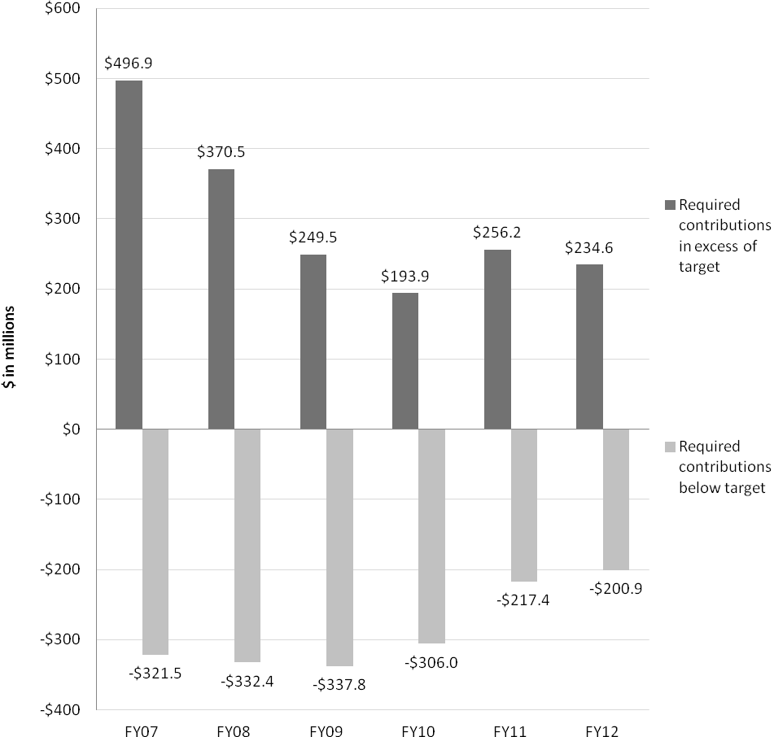

From the perspective of individual municipalities, the number of districts above their target shares actually increased slightly, from 232 of 351 total in FY07 to 257 in FY12, even though the total amount by which they were above target share declined.

Figure 3: FY07 and FY12 contributions as percent of foundation, target and required provides a quick visual summary of change between FY07 and FY12 for municipalities, and clearly demonstrates a movement toward target local shares. Each chart shows each municipality’s actual and target contributions as a percent of its foundation budget. When the goal of all required contributions being at target share is reached, every municipality will be on the diagonal line running from lower left to upper right. By FY12, municipalities cluster much more closely to the target line than in FY07.

Figure 3: FY07 and FY12 contributions as percent of foundation, target and required
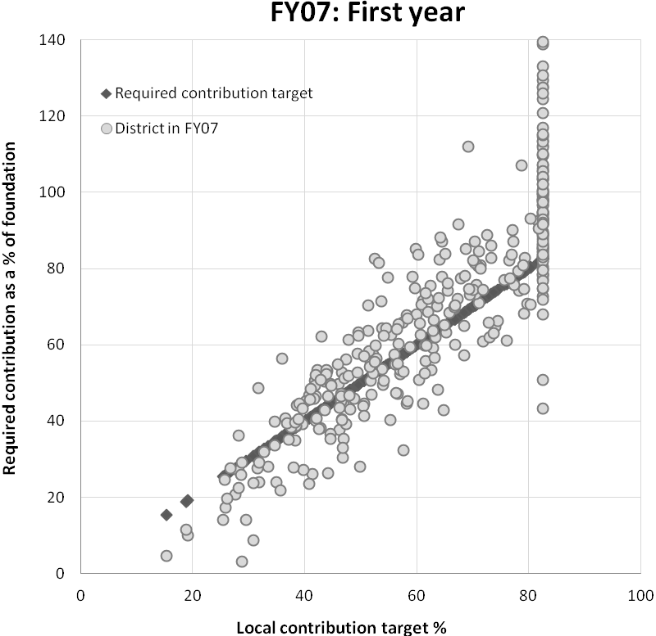

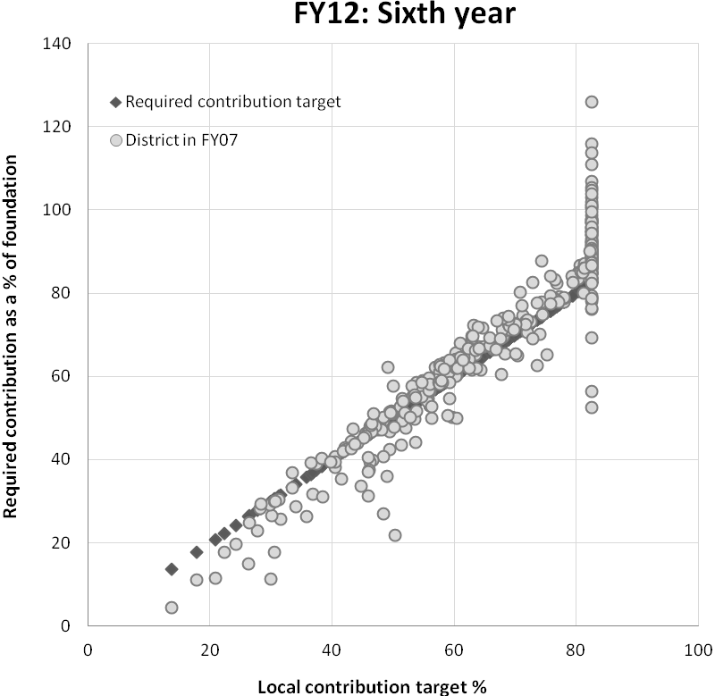

Target shares for state aid to districts

State aid allocations are paid directly to districts rather than municipalities. Regional district target aid shares are composites of the weighted shares of all of its members. In FY07, 165 districts were below their target aid share and 163 were above. The extremes were from 25 percent below to 38 percent above. In FY12, there are 148 below and 178 above.

The impact of adjusting state aid to target shares of foundation budgets can be documented in terms of total amounts above and below aid targets statewide, and individual districts above and below. Figure 4: FY07 to FY12 Chapter 70 aid above and below target shows that the statewide totals above and below target shifted more gradually than required contributions, partly because there were so many districts above target. This amount actually increased for several years, and over the whole period was reduced from $393M to $360M, or by 8 percent. In FY11, negative inflation again had a deleterious effect and the amount above rose to $489 million. With federal Education Jobs Fund (Ed Jobs) money pushing aid amounts up while inflation was falling by more than 2 percent, far more districts exceeded their targets at 214. But in FY12, the amount above target fell back to $361 million for 178 districts, as Ed Jobs funds were excluded from the calculation and the formula returned to being entirely state-funded.

More overall progress was made on decreasing the amount that aid fell below target shares, from $176 million to $110 million, a 38 percent decrease. Note that Figure 4: FY07 to FY12 Chapter 70 aid above and below target includes federal SFSF and Ed Jobs grants, which partially offset reductions in state payments and appropriations of aid between FY09 and FY11. Although it is not appropriate to count these grants toward net school spending, they were run through the formula and essentially replaced what would otherwise have been state-appropriated Chapter 70 monies.

Figure 4: FY07 to FY12 Chapter 70 aid above and below target
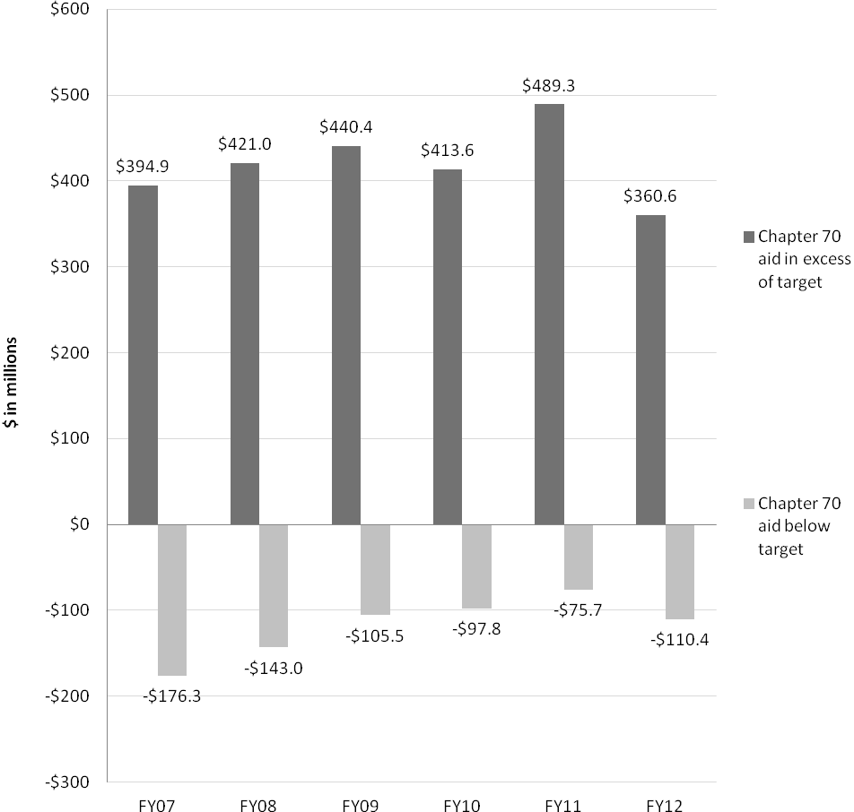

Figure 5: FY07 and FY12 Chapter 70 aid as a percent of foundation, target and actual provides a quick visual summary of change between FY07 and FY12 for districts. Figure 5 shows each district’s actual and target aid shares as a percent of foundation. If the goal of all aid allotments being at target share is met, all districts will be on the diagonal line from lower left to upper right. It is easy to see that despite the difficult economic period, districts below the target line in FY07 are generally much closer to it in FY12. However, reducing the number of districts above the target and their amounts of disparity showed less progress over this period.

Figure 5: FY07 and FY12 Chapter 70 aid as a percent of foundation, target and actual

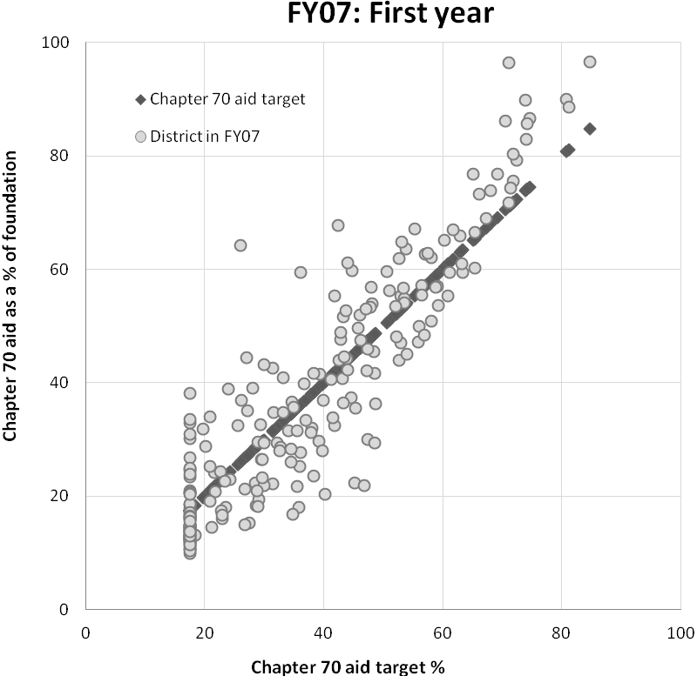

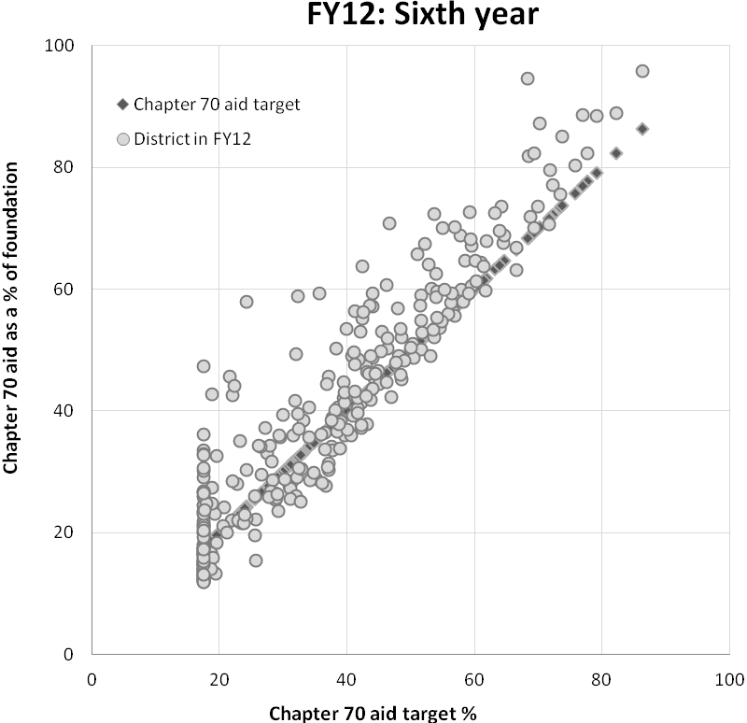

Section 4: Resources and Student Performance

All fiscal resources

Since the passage of education reform, the level of investment in public education in Massachusetts has increased substantially. Without adjusting for inflation, district operating expenditures have more than doubled since FY93, not including federal grants or capital expenditures. It is not likely that we will see a similar level of increase in the next 20 years, yet the demands being placed on our public school districts will, by some measures, likely continue to grow. Given this reality, more attention needs to be directed at using our existing resources more efficiently.

In FY10, combined total spending on K-12 education in Massachusetts, including local, state, and federal funds, was $13.8 billion. Looking at current resource allocations, school districts spend most of their money on providing instructional services for students (see Table 3). Instructional spending amounts to $7.2 billion statewide and comprises 52 percent of total operating expenditures. Teacher salaries comprise $4.6 billion or 33 percent of total spending. Other instructional services include salaries for principals, curriculum directors, paraprofessionals, librarians, medical and therapeutic staff, and guidance counselors and psychologists. Districts also need to purchase instructional materials and technology and provide professional development programs for their staff. Collectively these and other associated items amount to $2.6 billion, or 19 percent, of total district spending.

While not considered part of instructional spending, districts spend a significant amount of money on tuition to send students to schools or programs outside of their home districts. These include students who attend charter schools or other public school districts through the school choice program. It also includes special education students who attend collaboratives or private day or residential schools. Close to $928 million, or 7 percent, of district spending goes to cover these tuition costs.

The infrastructure that supports teachers and students in the classroom is also extensive. School districts provide transportation and food services for their students. They also cover a significant percentage of the health insurance costs for teachers and other district staff. Furthermore, districts oversee the general maintenance and upkeep of their buildings. These indirect services amount to $5.3 billion, or 38 percent, of total district operating costs. Health insurance costs in particular have increased as a share of total spending. Administrative costs occupy a relatively small part of the overall spending picture at $414 million, or 3 percent.

There are three broad categories of funding sources from which these expenditures were made: local appropriations, both school committee and municipal as applicable, which include direct state aid such as Chapter 70 funds; local revolving funds; and federal and state grants. Local appropriations constitute by far the largest share at 87.5 percent; local revolving funds, which include circuit-breaker aid for special education costs, account for 5.4 percent; and federal and state grants account for the remaining 7.1 percent.

Table 3: FY10 expenditures by category
Category | Amount | Percent
Administration | $414,359,996 | 3 %
Instructional Leadership | $762,464,740 | 6 %
Teachers | $4,600,908,165 | 33 %
Other Teaching Services | $889,399,538 | 6 %
Professional Development | $209,399,091 | 2 %
Instructional Materials, Equipment and Technology | $365,475,055 | 3 %
Guidance, Counseling and Testing | $337,169,504 | 2 %
Pupil Services | $1,189,721,994 | 9 %
Operations and Maintenance | $971,913,122 | 7 %
Insurance, Retirement Programs and Other | $2,042,922,683 | 15 %
Payments to Out-of-District Schools | $927,896,127 | 7 %
Debt and BANs | $786,916,984 | 6 %
Fixed Assets (Buildings, Equipment) | $279,273,110 | 2 %
Community Activities | $56,426,615 | 0 %
Total | $13,834,246,723 | 100 %

While school committees, municipalities, and charter school boards budget the expenditure of 87.5 percent of public education funds, this overstates the amount they actually pay. The Commonwealth funded $4.7 billion of FY10 local appropriations through several direct state aid programs, of which the largest is Chapter 70 aid. State aid is deposited directly into municipal or regional district general funds and spent through local budgets. Most aid programs are reimbursement for documented expenses, e.g., charter school reimbursements or special education expenses, while Chapter 70 aid is based on foundation budgets and ability to pay. In total, state aid provided 39 percent of local general fund appropriations.

Table 4: FY10 state aid to education
State Revenues | Amount | Percent
Chapter 70 school aid | $3,869,847,585 | 69%
Charter school reimbursements | $65,090,972 | 1%
Pupil transportation | $40,519,630 | 1%
School Building Authority | $611,487,298.00 | 11%
Circuit Breaker | $128,357,830.00 | 2%
MTRS appropriation (teacher pensions) | $933,254,000 | 17%
Total | $5,648,557,315 | 100%

Fiscal resources and student learning outcomes

The relationship between district spending and outcomes has long eluded education finance researchers. Most studies report a weak relationship between spending and learning outcomes. This section examines the relationship between financial resources and student learning outcomes, focusing on the 208 K-12 districts across the state. In-district expenditures are most relevant to student learning outcomes because they are budgeted and managed by school committees and district administrators, whether they are from local appropriations, local revolving funds, or federal and state grants. The K-12 districts include almost all of the medium and large districts and, though they vary greatly in size, as a group they have more similar cost structures than vocational-technical high schools, charter schools, or elementary or secondary districts.

Figure 6 shows the correlation between learning outcomes, measured here as combined percent proficient or higher on the state’s English language arts (ELA) and mathematics assessments, with expenditures per pupil and with the percentage of low-income students. The percentage of low-income students shows a strong correlation with performance, while the range of spending at every level of achievement is wide. If anything, Figure 6 shows some correlation of higher achievement and lower spending.

Figure 6: (A) Performance and expenditures (B) Performance and percent low income
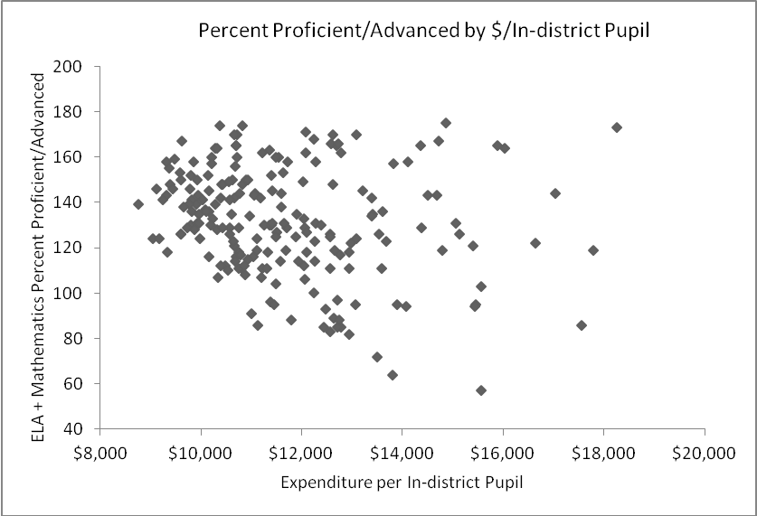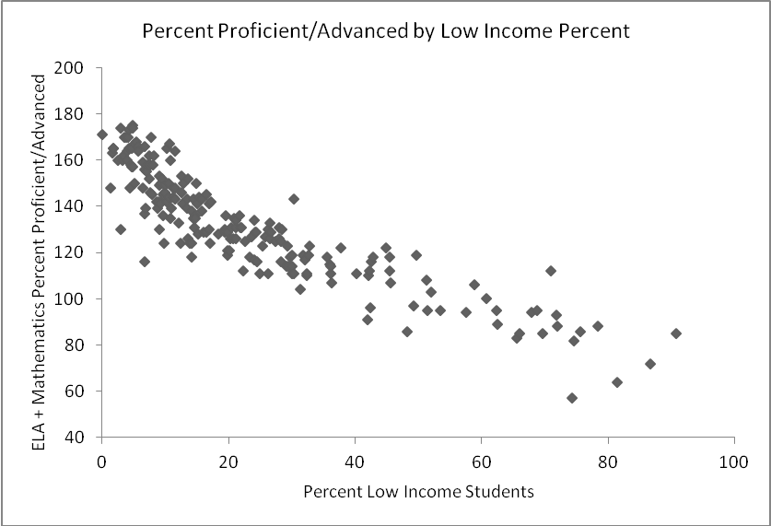

In 2008, ESE instituted an additional measure of performance, the student growth percentile. The student growth percentile identifies students, schools, and districts that demonstrate a high rate of learning improvement regardless of a student’s achievement level. The following figures replicate those above using student growth percentile as the performance measure. Not surprisingly, the correlation between student growth and low income status is not as strong, indicating that while it has been challenging to improve absolute achievement levels, and some districts are already improving outcomes for low-income students at higher than average rates. However, as with percent advanced/proficient, the correlation between student growth and per pupil expenditures shows no systematic relationship, with wide ranges of spending at every level of student growth.

Figure 7: (A) Growth and expenditures (B) Growth and percent low income
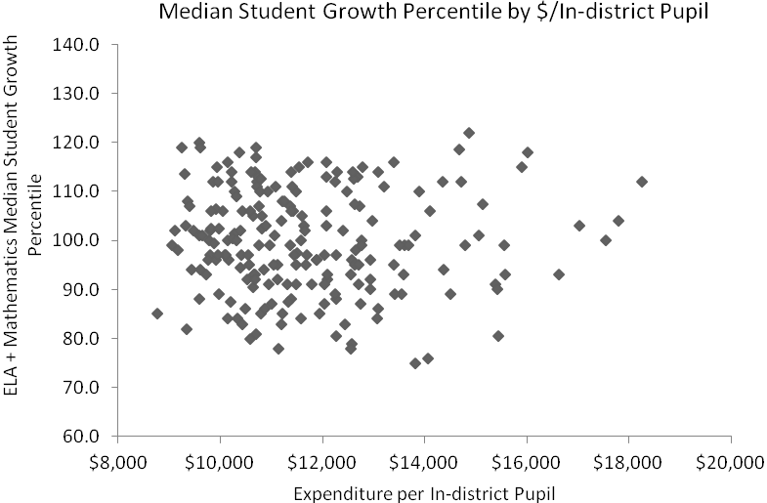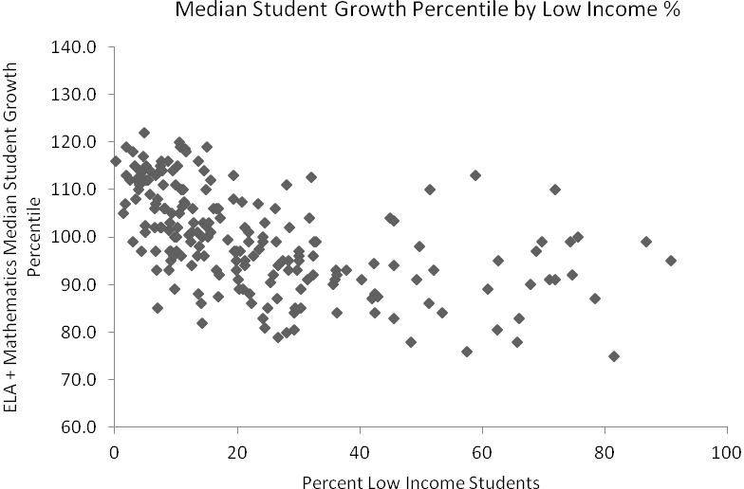

The Chapter 70 formula directs additional resources to districts with more low-income students. Some federal and state grant programs, especially Title I, also target students at risk and increase resources available to districts with more low-income students. Table 5 divides the 208 K-12 districts in the state into three equal groups based on their percentage of low income students. Looking at per pupil spending among these three groups, the median per pupil expenditure was 16 percent higher for districts with the highest percentages of low income students.

Table 5: Median expenditure per in-district pupil
Percentage of low-income students | Median per pupil
Districts with 0-11 percent low income students | $10,718
Districts with 11-26 percent low income students | $10,749
Districts with 26-91 percent low income students | $12,433

Within each group, however, there was a wide range of both spending and achievement levels, as shown in the following figure, which reproduces Figure 6 above, with districts grouped by their low-income percentage groups in Table 5.

Figure 8: Performance and spending by concentration of low-income students
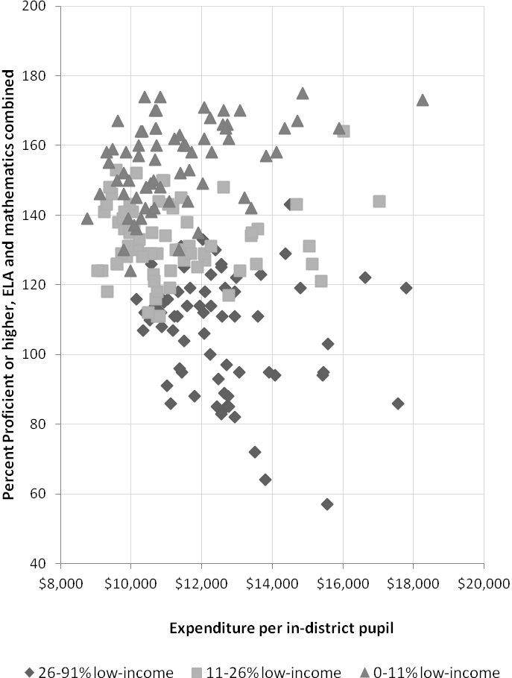

This analysis shows that funding appears to be a necessary, but not sufficient, condition for effective teaching and learning. Just as important, if not more important, are the decisions that districts make about how to allocate their resources. In the current context of significant education funding cutbacks, national research and policy debates are addressing the question of how best to spend limited dollars (funding, staff, time) to improve instruction. ESE provides guidance about essential conditions for school improvement; in some cases, these require direct financial resources, while most require a reallocation of resources or redirection of effort. (See Appendix 2: Conditions for school effectiveness.)

An example where reallocation of resources and redirection of effort might improve student performance is in the area of professional development, where the approach is shifting from “stand and deliver” workshops to “embedded professional development” with supervision and support based in the classroom and teacher planning sessions, and closely aligned to teachers evaluation and school improvement goals.

Another example where educational resources might be invested differently is in the area of class sizes. National research shows that reducing class size is an expensive strategy with mixed results as far as improving student achievement. By contrast, the differential impact of a highly effective teacher compared to a weak teacher can mean as much as a year or more of learning gains for students in the course of a single year of instruction. The implication is that resources tied to maintaining smaller class sizes could be reallocated to instructional coaches and expanding common planning time to drive improvements in teaching and learning.

The following section takes a closer look at the school level, seeking to answer the question of whether exemplary schools that spend less than average could serve as models of efficient and effective resource allocation.

Section 5: Exemplary Schools’ Use of Fiscal Resources
In 2010, ESE commended 186 schools, about 10 percent of all schools, for high growth in student performance, closing achievement gaps, and/or exiting No Child Left Behind (NCLB) status for Improvement, Corrective Action, or Restructuring. Given their success, this group of schools provides a useful source of data to analyze possible resource allocation models. The 186 commended schools are a representative group in various ways. There are 135 elementary schools, 49 secondary (middle and high), two K-12 schools, and 14 charters, representing close to 25 percent of all charter schools. Most of the schools, 135, are at Level 1 in the Massachusetts performance accountability system, while 37 are in Levels 2 or 3, yet achieved high growth or closed achievement gaps. The following table summarizes some characteristics of the commended schools.

Table 6: Characteristics of commended schools
Characteristic | Results
Grade span | Elementary – 135  Secondary – 49  K-12 - 2
Charters / non-charters | 14 / 172
School performance level  (MA accountability system, charters NIC) | Level 1 – 135  Level 2 – 14  Level 3 – 23
Percent low-income | 0-97 percent
Percent SPED | 7-38 percent
Percent LEP | 0-59 percent

For a comparable analysis of school level expenditures, ESE created hypothetical foundation budgets for the exemplary schools using school- based foundation enrollments. At the school level, ESE tracks only instructional expenditures, so foundation budgets were calculated accordingly. Because instructional expenditures make up 60 percent of district budgets on average, this analysis, while not complete, covers a significant share of expenditures. Table 7 shows the expenditure categories that are included in the school analysis and those that are excluded.

Table 7: Available district and school financial data
District data | School data
District administration  Instructional leadership  Teachers  Other teaching services  Professional development  Instructional materials/equipment/technology  Guidance, counseling, testing  Pupil services  Operations and maintenance  Insurance, retirement programs, other fixed charges  Out-of-district tuitions and transport  Fixed assets and debt payments | Instructional leadership  Teachers  Other teaching services  Professional development  Instructional materials/ equipment/technology  Guidance, counseling, testing

Per pupil foundation budget rates were higher for schools with more low-income, English language learners, and vocational students due to the weighted allocations for these populations. School foundation budgets varied by 100 percent, $5,218 to $10,388, but actual expenditures varied much more, from $2,372 to $18,831. The difference between a school’s actual expenditures and its foundation budget ranged from minus $4,237 to plus $11,819. Figure 9 plots each school’s actual expenditures against its hypothetical foundation budget. Six schools that stand out as a group on the upper right are vocational-technical schools that have both high foundation budgets and high actual expenditures.

The range of actual expenditures may reflect factors ranging from reporting issues to staffing differences to the number of special education high-needs classrooms in each school. At the extreme low end, reporting may be incorrect or inconsistent with other districts. For instance, some districts, especially smaller ones, may report certain kinds of expenditures at the district level instead of distributing them across schools, such as staff serving special populations or multiple schools, e.g., special education or arts teachers. Teacher salaries comprise 64 percent of statewide instructional costs, but the relative age and experience level of the teachers in an individual school can have a large impact on relative costs. Two schools with the same student to teacher ratio might have significantly different costs because one has senior teachers at the highest step of the salary schedule while the other has mostly newer teachers at the lower steps.

Figure 9: FY10 foundation budget and expenditures per pupil for commended schools

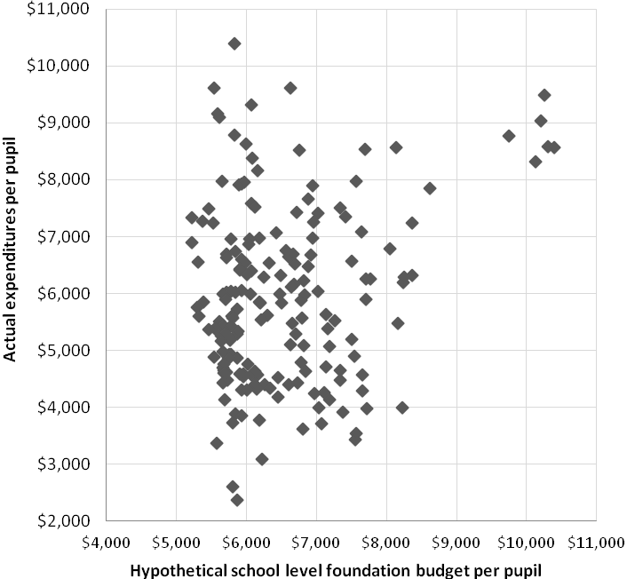

The dotted lines in Figure 9 isolate a subset of the commended schools that fall between two boundaries. The lower bound is $4,000 per pupil (horizontal dotted line), which eliminates the lowest reported expenditures that are most likely to have reporting inconsistencies. The upper bound is the line where foundation budget per pupil equals actual expenditures per pupil (diagonal dotted line). The schools within these boundaries have actual costs that are below foundation and serve a range of at-risk students. The fact that they are successful might point to some model resource allocation strategies.

Figure 10 looks at the range of minimum, maximum, and median per pupil expenditures for each category of instructional expenditures for both hypothetical school foundation budgets and actual expenditures. It demonstrates that the range of expenditures in each category for foundation budgets was very tight, except for teaching. This is not surprising since the weighting factors in the foundation budget are applied largely to teacher staffing. Actual expenditures for teachers have about the same variation as budgeted expenditures, but at a slightly lower range. For all other expenditures, the range of actual expenditures is much wider than the foundation budget range, while the range of total actual expenditures is slightly lower than the range of budgeted ones.

Figure 10: Comparison of foundation budget ranges to actual spending ranges

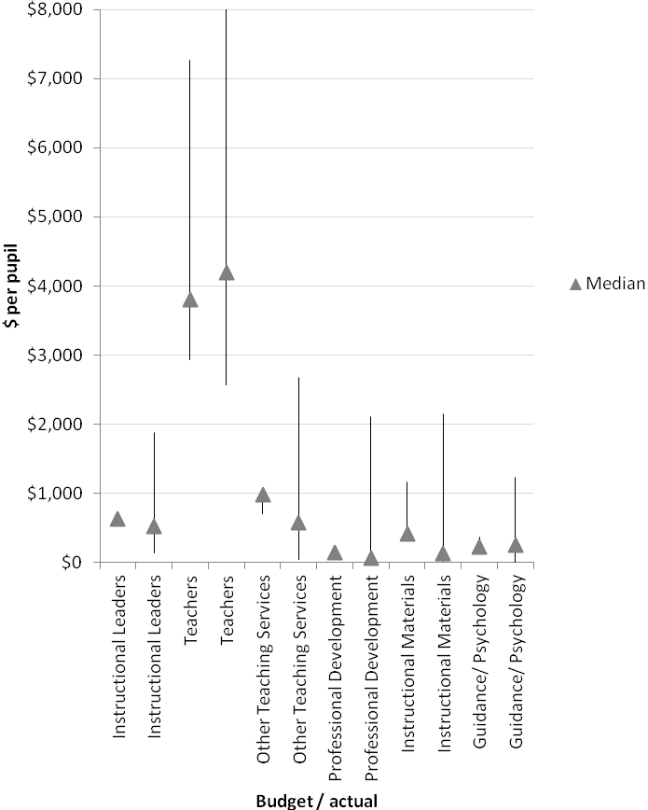

Given the variation in spending between these schools, it is unclear whether or how they can serve as models of efficient and effective resource allocation. While funding is clearly an important factor, how these schools are utilizing their resources to positively impact student performance is not easy to discern from the available data. The review of exemplary schools indicates, consistent with the district analysis in the prior section, that factors other than funding have a greater impact on performance. Research supports that the factors emphasized in the Essential Conditions (see Appendix 2) such as instructional leadership, common planning time, using data to inform instruction, and targeted student interventions have the greatest potential to influence student educational attainment. Understanding how these schools are using their resources towards these ends would require more investigation than we can accomplish through this study.

Section 6: Recommendations
Since McDuffy, the Commonwealth has made substantial progress toward improving the adequacy of school funding, through the adoption of the foundation budget, and improving equity in the distribution of resources by targeting more aid to the state’s neediest districts. Economic downturns have at times slowed this progress, particularly in recent years, but even during those periods the Governor and the Legislature have maintained the commitment to ensuring that all districts are funded at foundation.

There have been calls for the state to engage in an extensive adequacy study to review all of the underlying assumptions in the formula. Completing such a study would involve a major effort, both in terms of time and resources. Whether or not such a study is undertaken, there are a number of changes that have already been extensively studied that could be implemented to address some of the commonly expressed concerns.

Foundation budget
- Increase the employee benefits rate. There is broad consensus that the foundation budget rates for employee benefits needs an upward adjustment. Rather than adjusting rates to reflect current actual spending levels, we should consider tying the rates to the state's Group Insurance Commission costs, representative of best practices for cost containment.
- Allow all districts to include retiree health insurance in net school spending. This would provide additional equity by treating all districts in a similar fashion. Particular attention would need to be given to transition issues, to avoid a sudden drop in instructional spending in some districts.
- Increase the foundation rate for out-of district special education students. This, along with employee health benefits, are the two most frequently cited areas where the foundation budget has not kept pace with actual costs. Any adjustment to this rate, however, should take into account the availability of circuit breaker funding.
- Eliminate the cap on pre-school enrollment. Currently the foundation budget formula caps the number of pre-school students that a district can count toward its foundation enrollment at twice the number of special education pre-schoolers enrolled in the district. Lifting this cap would encourage the expansion of early education programs, which is a key element of current education reform strategies.
Chapter 70 aid formula
- Continue to fund reductions in excess effort. When the aggregate wealth model was adopted in FY07, it was anticipated that “above target contribution” communities would be brought down to their target contribution levels over a five year period. Although significant progress has been made, the extended economic downturn has delayed full implementation of these provisions.

- Cap local contributions at 100 percent of foundation. There are still a handful of communities whose required local contribution exceeds their foundation budget, generally the result of declining enrollments. Recognizing that full implementation of excess effort reduction in the formula is likely still several years away, we suggest providing immediate relief to these communities by capping local contributions at their foundation budget level.

- Continue efforts to bring “below target contribution” communities up to their target. Full equity will not be achieved until all cities and towns are at or near their target contribution levels. Raising the required contributions of below target communities has proven difficult, given the constraints of Proposition 2-1/2, and so progress has been slow. Consideration should be given to raising the adjustment factors (currently 1-2 percent). Another option would be to lower the statewide local contribution target (currently 59 percent) by a small amount.

- Codify the equity provisions formula in statute. Each year the state budget contains language that overrides the statutory Chapter 70 formula, which still contains antiquated factors such as “equity aid” and “overburden aid.” If there were sufficient agreement that the current approach is indeed making school funding more equitable, then codifying it in the General Laws would make sense.

- Use Chapter 70 funds to create incentives to encourage better resource allocation decisions. Chapter 70 represents the largest share of the state's annual investment in K-12 education, but the funds are distributed with few requirements and no incentives to encourage better resource allocation decisions or to implement proven reform strategies. Areas where incentives could potentially be useful include:

- Regionalization—Recent progress has been made in this area, but we need to encourage more districts to either regionalize fully or to make greater use of collaboratives and other shared resources.

- Health insurance—New reforms that give municipalities more freedom to purchase their health insurance though the state’s Group Insurance Commission (GIC) are showing promise for reducing costs. The Commonwealth could use the formula to support this trend by increasing the employee benefits rate in the foundation budget for districts that adopt best practices in the procurement of health insurance plans.

- Technology—Technology is rapidly replacing traditional methods of delivering curriculum and assessing students. The state could encourage this transition and the potential costs savings and educational benefits that it can bring by directing more resources to districts that are investing in hardware and software for digital learning.

- New teacher and administrator compensation systems—The state could leverage Chapter 70 dollars to encourage districts to implement new compensation models that better reflect the new teacher evaluation systems currently being implemented and that reward teachers for reaching higher levels of competency.

Even the most optimistic fiscal forecasts for the next five to ten years suggest that annual increases in Chapter 70 state aid will continue to be modest. It is extremely unlikely that the state will have the resources to afford the double-digit increases seen in the late 1990's. Even the modest recommendations for adjustments described above will take some time to fully implement. Therefore, we expect that most school districts will continue to face the difficult challenge of improving their performance with only limited increases in funding. We hope this report will encourage continued discussion on how the state – using Chapter 70 and other currently available resources – can best help districts to meet that challenge.

Appendix 1: FY12 foundation budget rates ($ per pupil)

 | Student Group | Adminis- tration | Instructional Leadership | Classroom & Specialist Teachers | Other Teaching Services | Professional Develop-ment | Instructional Materials, Equipment & Technology | Guidance & Psycholo-gical | Pupil Services | Operations & Maint-enance | Employee Benefits & Fixed Charges | Special Ed Tuition | Total
1 | Pre-School | 169 | 306 | 1,402 | 360 | 55 | 203 | 102 | 41 | 389 | 351 | 0 | 3,378
2 | Kindergarten-Half-time | 169 | 306 | 1,402 | 360 | 55 | 203 | 102 | 41 | 389 | 351 | 0 | 3,378
3 | Kindergarten-Full Time | 339 | 611 | 2,804 | 719 | 111 | 406 | 204 | 81 | 779 | 702 | 0 | 6,755
4 | Elementary | 339 | 611 | 2,804 | 719 | 111 | 406 | 204 | 122 | 779 | 702 | 0 | 6,796
5 | Junior/Middle | 339 | 611 | 2,467 | 518 | 120 | 406 | 272 | 199 | 844 | 667 | 0 | 6,443
6 | High School | 339 | 611 | 3,628 | 431 | 117 | 649 | 340 | 459 | 818 | 641 | 0 | 8,034
7 | Special Ed In-district | 2,337 | 0 | 7,710 | 7,199 | 372 | 325 | 0 | 0 | 2,610 | 2,957 | 0 | 23,509
8 | Special Ed Tuitioned-out | 2,337 | 0 | 0 | 36 | 0 | 0 | 0 | 0 | 0 | 0 | 22,185 | 24,557
9 | Limited English PK | 169 | 306 | 2,111 | 288 | 75 | 203 | 136 | 61 | 527 | 441 | 0 | 4,317
10 | Limited English K Half-time | 169 | 306 | 2,111 | 288 | 75 | 203 | 136 | 61 | 527 | 441 | 0 | 4,317
11 | Limited English Full Time | 339 | 611 | 4,223 | 575 | 150 | 406 | 272 | 122 | 1,054 | 883 | 0 | 8,634
12 | Vocational | 339 | 611 | 6,168 | 431 | 193 | 1,136 | 340 | 459 | 1,532 | 1,041 | 0 | 12,250
 | Incremental rates
13 | Low Income Elementary | 0 | 0 | 2,522 | 0 | 56 | 0 | 0 | 0 | 390 | 256 | 0 | 3,224
14 | Low Income Secondary | 0 | 0 | 1,906 | 0 | 56 | 0 | 0 | 0 | 390 | 256 | 0 | 2,607

Appendix 2: Conditions for school effectiveness
- Effective district systems for school support and intervention: The district has systems and processes for anticipating and addressing school staffing, instructional, and operational needs in timely, efficient, and effective ways, especially for its lowest performing schools.
- Effective school leadership: The district and school take action to attract, develop, and retain an effective school leadership team that obtains staff commitment to improving student learning and implements a clearly defined mission and set of goals.
- Aligned curriculum: The school’s taught curricula are aligned to state curriculum frameworks and the MCAS performance level descriptions, and are also aligned vertically between grades and horizontally across classrooms at the same grade level and across sections of the same course.
- Effective instruction: Instructional practices are based on evidence from a body of high quality research and on high expectations for all students and include use of appropriate research-based reading and mathematics programs; the school staff has a common understanding of high-quality evidence-based instruction and a system for monitoring instructional practice.
- Student assessment: The school uses a balanced system of formative and benchmark assessments.
- Principal’s staffing authority: The principal has the authority to make staffing decisions based on the School Improvement Plan and student needs, subject to district personnel policies, budgetary restrictions, and the approval of the superintendent.
- Professional development and structures for collaboration: Professional development for school staff includes both individually pursued activities and school-based, job-embedded approaches, such as instructional coaching. It also includes content-oriented learning. The school has structures for regular, frequent collaboration to improve implementation of the curriculum and instructional practice. Professional development and structures for collaboration are evaluated for their effect on raising student achievement.
- Tiered instruction and adequate learning time: The school schedule is designed to provide adequate learning time for all students in core subjects. For students not yet on track to proficiency in English language arts or mathematics, the school provides additional time and support for individualized instruction through tiered instruction, a data-driven approach to prevention, early detection, and support for students who experience learning or behavioral challenges, including but not limited to students with disabilities and English language learners.
- Students’ social, emotional, and health needs: The school creates a safe school environment and makes effective use of a system for addressing the social, emotional, and health needs of its students that reflects the behavioral health and public schools framework.
- Family-school engagement: The school develops strong working relationships with families and appropriate community partners and providers in order to support students’ academic progress and social and emotional well-being.
- Strategic use of resources and adequate budget authority: The principal makes effective and strategic use of district and school resources and has sufficient budget authority to do so.

The program was originally codified in Chapter 70 of the General Laws. However, many of the subsequent changes to the formula were implemented through language in the annual state appropriations act and not codified, so the language in Chapter 70 itself no longer accurately reflects all aspects of the formula. Nonetheless, the program is still commonly referred to as the “Chapter 70” program.
Originally, there were 19 expenditure categories, but a number of categories were combined in FY07 to provide for a better alignment between the foundation budget and the state’s chart of accounts. This change had no impact on the overall foundation, although there were differential impacts among districts, especially those with junior high/middle school students. The impact of removing six old categories and adding four new ones changed the per pupil rates for junior high/middle school and senior high pupils. The junior high/middle school rates ended up being lower than they were previously, but this was a direct result of the underlying class size assumption of 25 pupils per teacher at the junior high/middle school level as opposed to 22 for elementary and 17 for high school.
The General Appropriations Act of 2002 (St.2002, c.184, §76) increased these estimates from their original level under the Act of 3.5 percent and 4.5 percent, respectively.
Regional school districts will receive a required local contribution from each of its member municipalities.
This figure includes school building assistance funds, but not pension expenditures.
For example, if a community’s target local share was 60 percent of its foundation budget, its target aid share would be 40 percent.
Ed Moscovitch, “School Funding Reality: A Bargain Not Kept”, prepared for the Boston Foundation and The Massachusetts Business Alliance for Education, 2010, p. 1.
Massachusetts Taxpayers Foundation, “The Brick That Broke Municipalities’ Backs,” February 2011, p. 2.
Non-resident vocational tuition does not include assessments paid by members of regional vocational districts.
The original Act included a complicated calculation to establish local contributions which included a measure of fiscal capacity to establish initial year contribution levels. There was no provision for annual updates of that measurement of fiscal capacity, however, and no clear establishment of target levels of aid or contributions.
The statewide total contribution from all cities and towns is set at 59 percent of foundation budget, or $5.4 billion.
For regional district, the member communities’ target local shares are weighted by enrollment to calculate a district wide local target share, with the aid share again being derived by subtracting from 100 percent.
There are two fewer operating districts in FY12 due to regionalization.
Whitehurst, G. J. and Chingos, M. M. (2011). Class Size: What Research Says and What it Means for State Policy. The Brookings Institution.
Hanushek, E. A. (2002). Teacher quality. In L. T. Izumi and W. M. Evers (Eds.), Teacher quality (pp. 1–12). Stanford, CA: Hoover Press.

