2024 Strand Cover Sheet
Student: 
Grade: 08
Content: Science and Technology/Engineering
Strand: Earth and Space Sciences
Core Idea: Earth's Place in the Universe
2024 STE Summary Sheet
Student: 
Grade: 08
Date: 11/17/2022
Content: Science and Technology/Engineering
Strand: Earth and Space Sciences
Core Idea: Earth's Place in the Universe
Science Practice: 3. Analyzing and interpreting data

Entry Point: Group information/data about seasonal changes to the environment to identify patterns.

Brief Description of activity describes process of matching pictures to seasons on a divided piece of paper. 
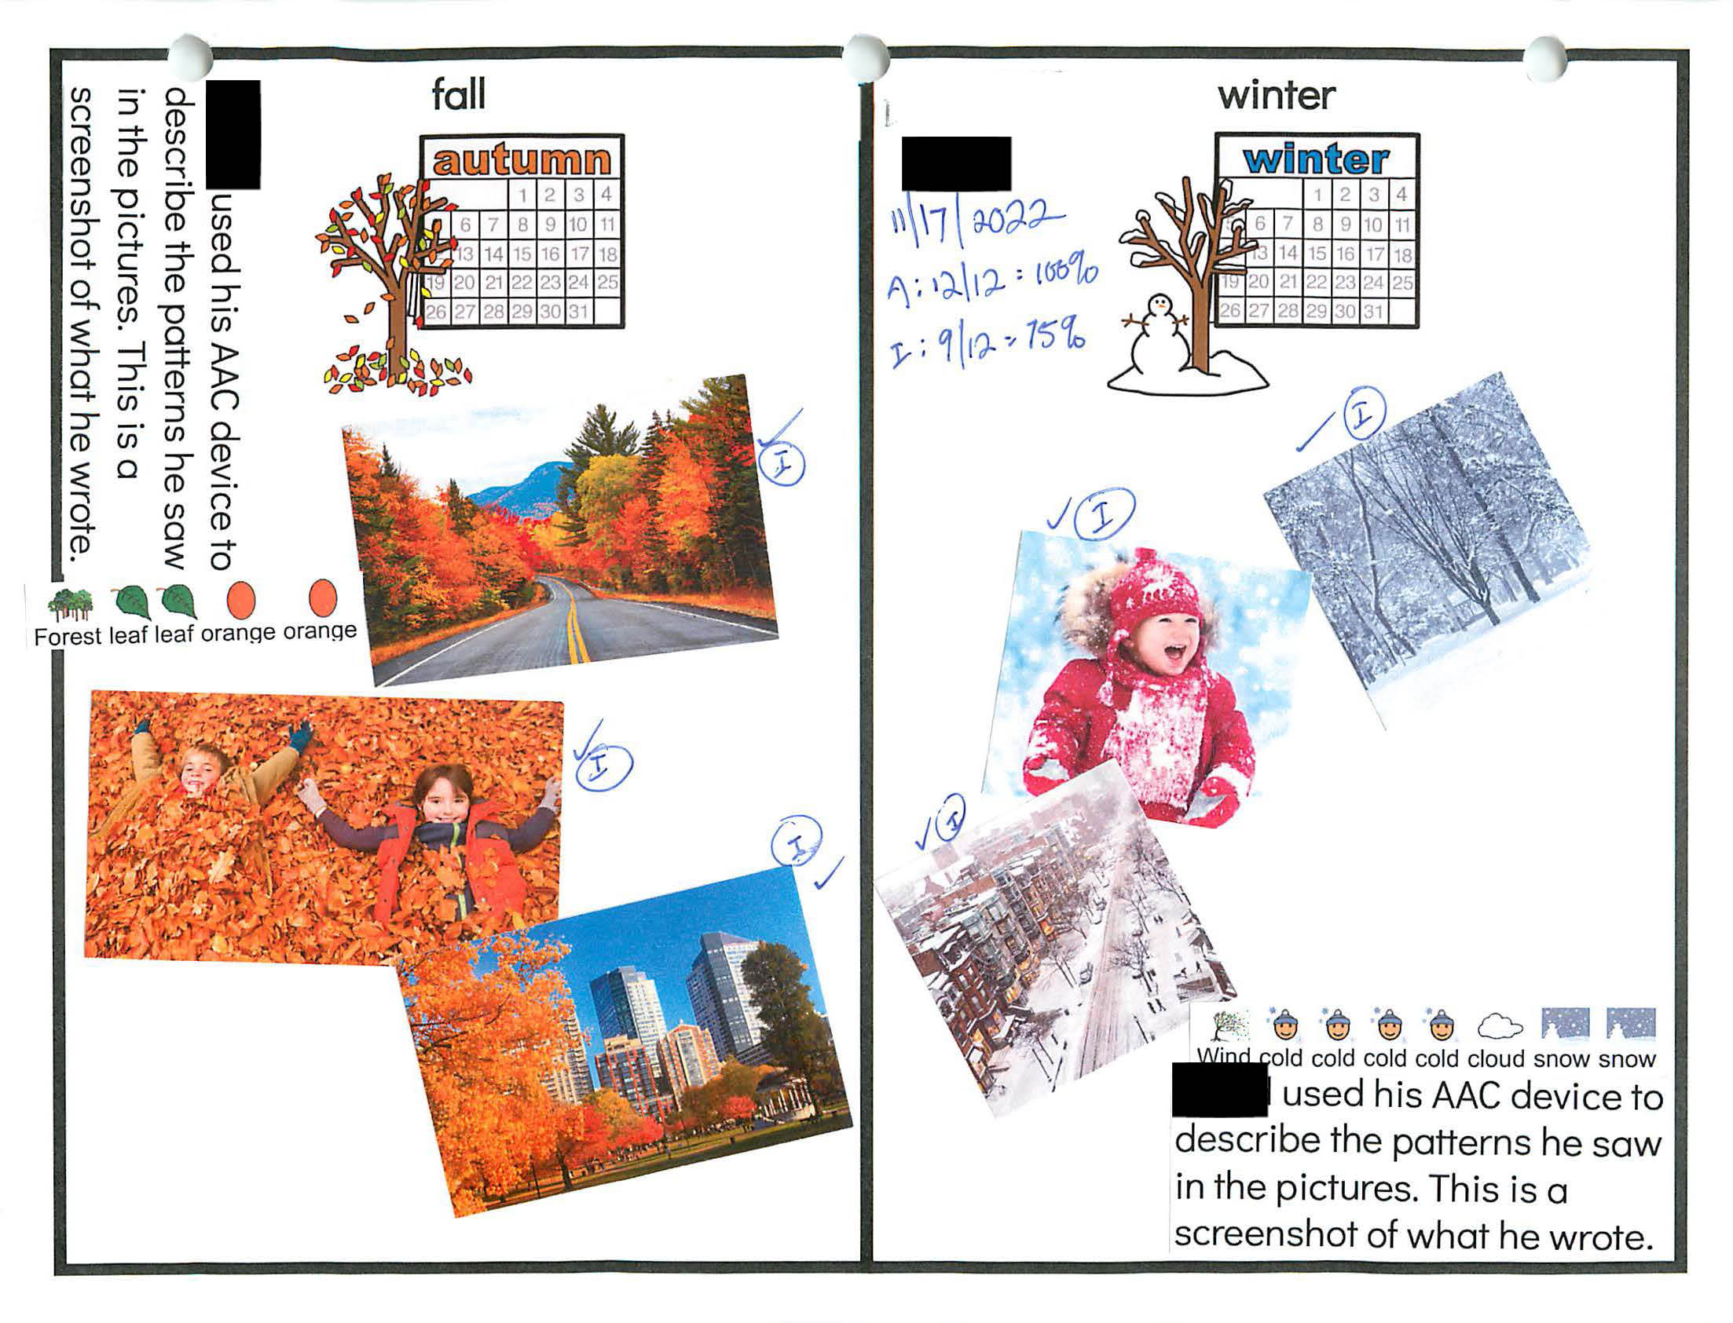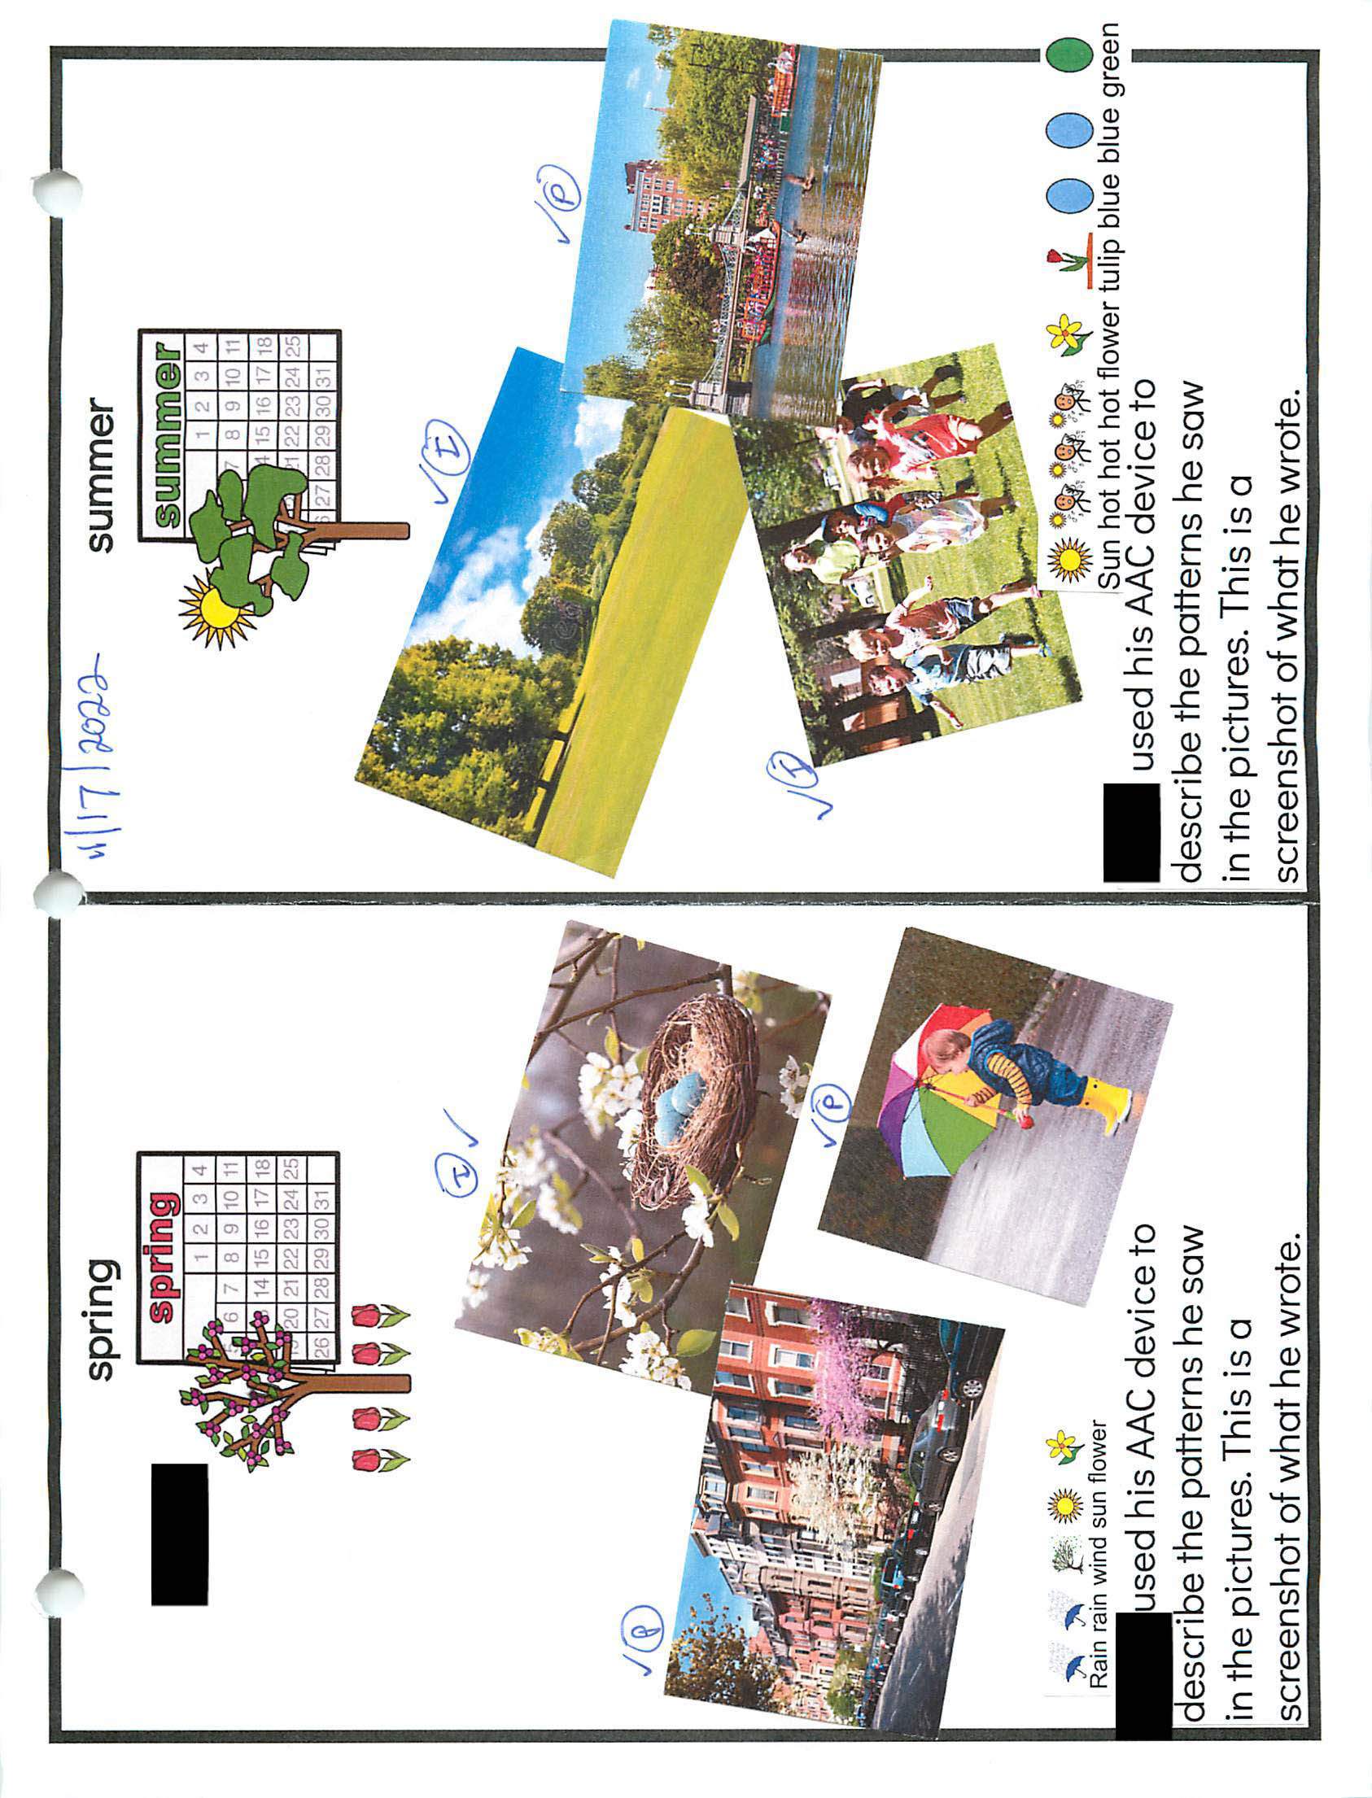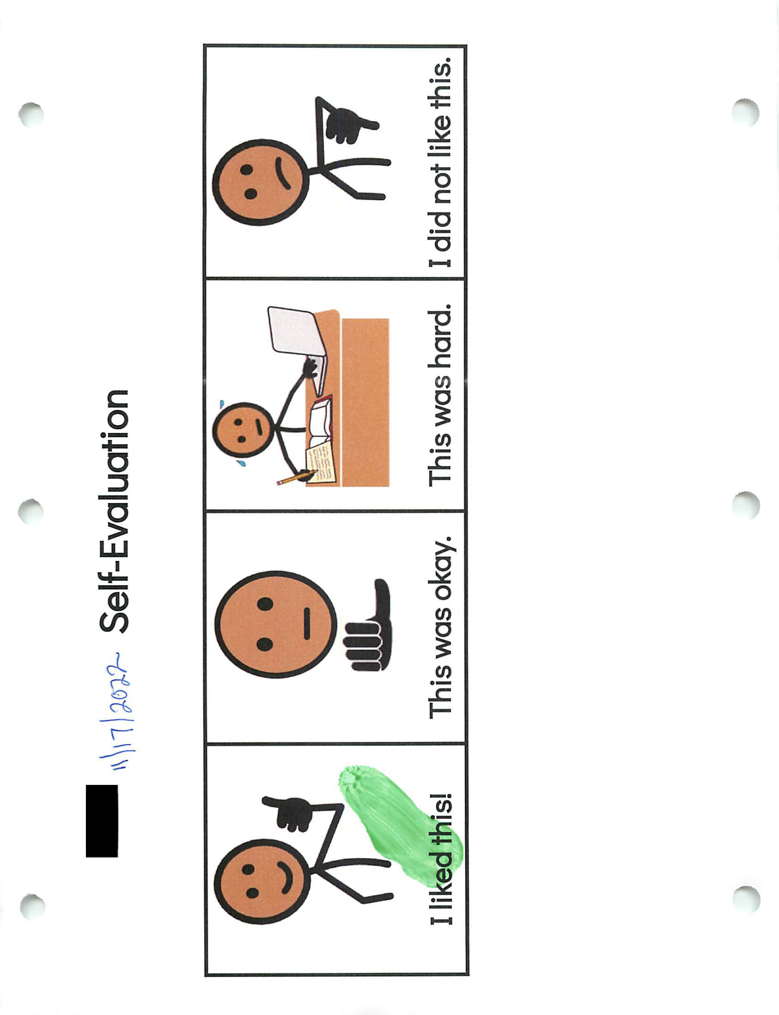2024 STE Summary Sheet
Student: 
Grade: 08
Date: 12/2/2022
Content: Science and Technology/Engineering
Strand: Earth and Space Sciences
Core Idea: Earth's Place in the Universe
Science Practice: 5. Developing and using models

Entry Point: Illustrate, construct, and/or label a model to show/explain seasonal changes to the environment (e.g., leaves fall in the autumn, flowers bloom in the spring)

Brief description of activity describes the process labeling a model of the seasons to show environmental changes brought on by each season.
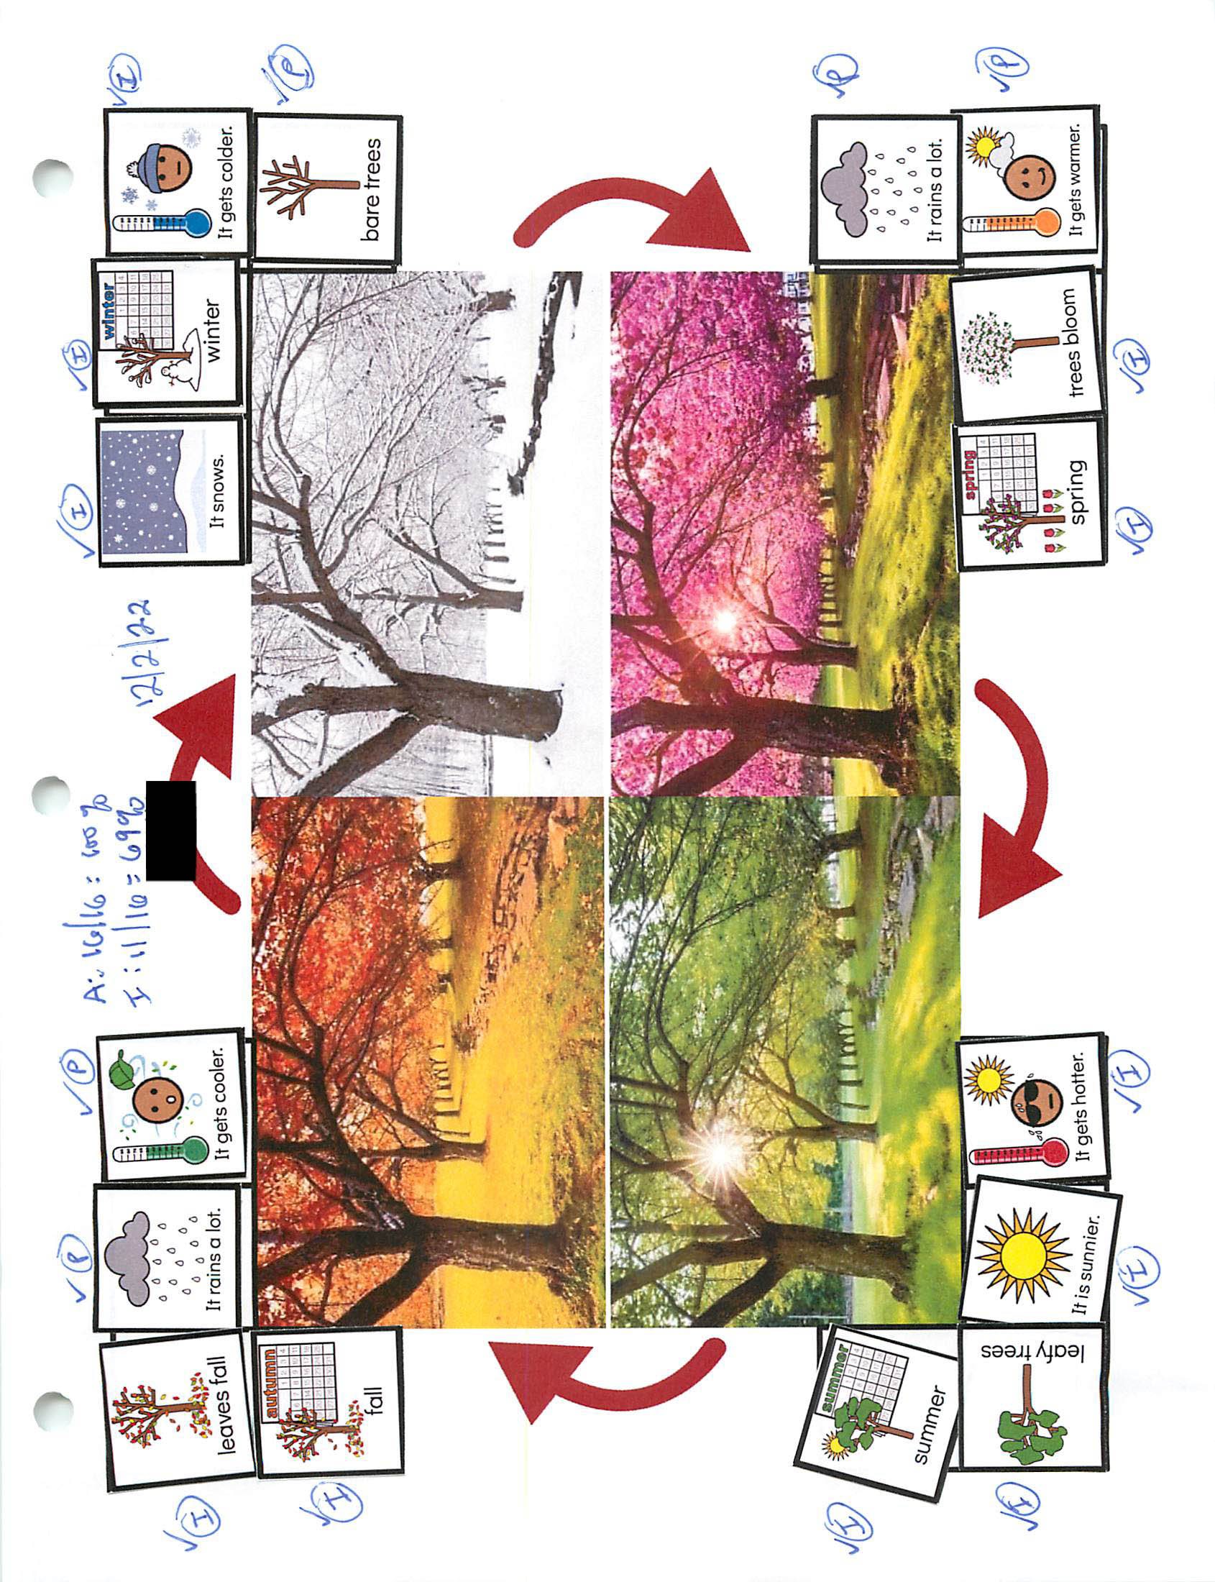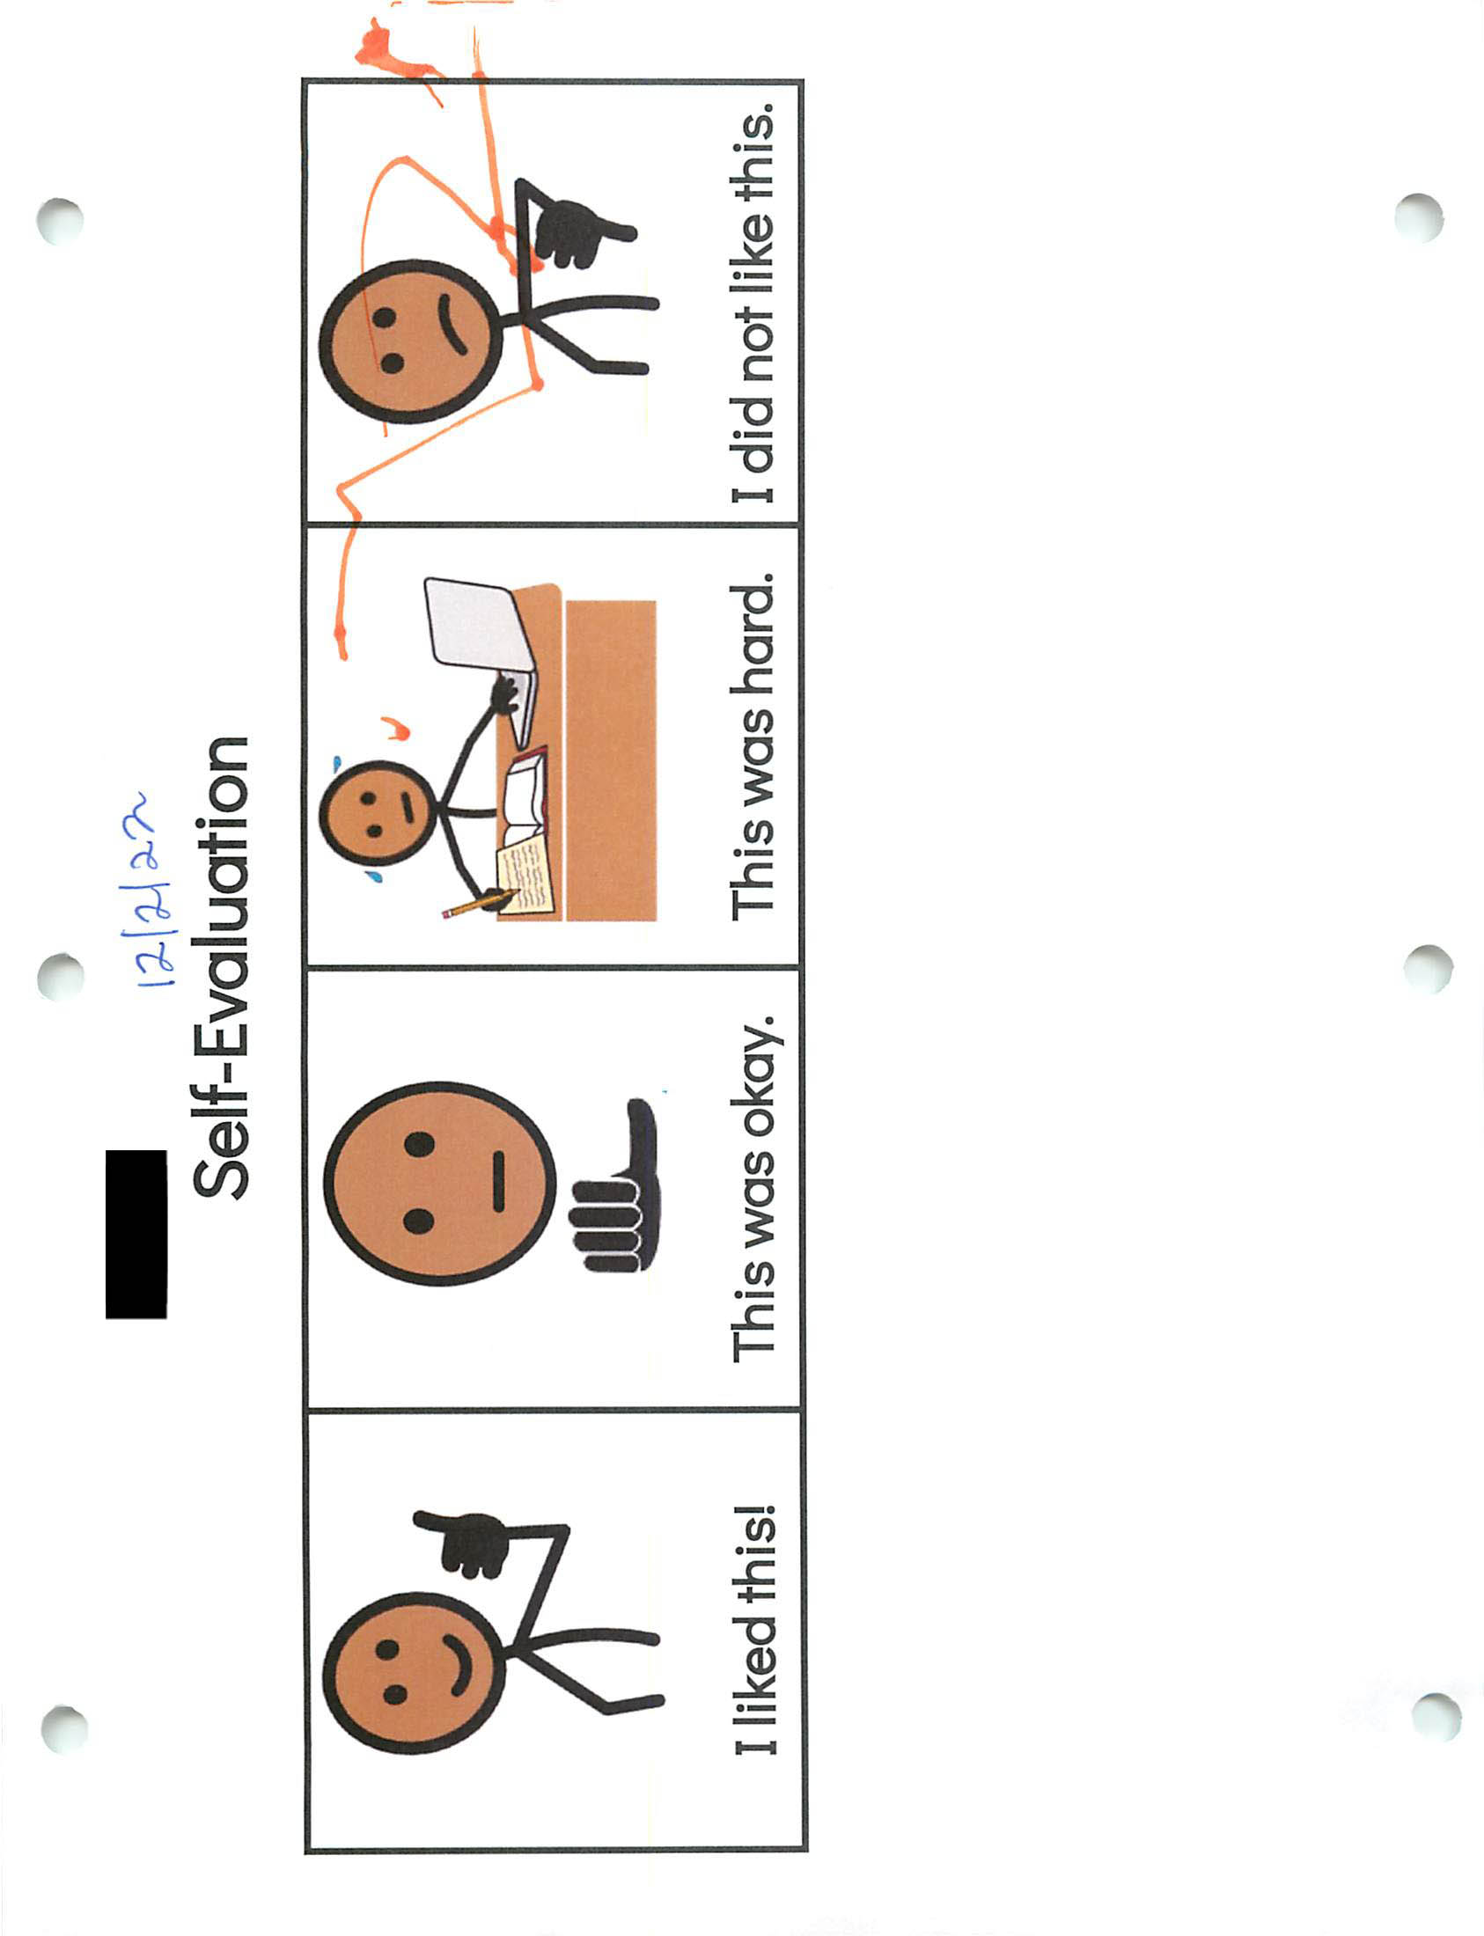2024 STE Summary Sheet
Student: 
Grade: 08
Date: 12/15/2022
Content: Science and Technology/Engineering
Strand: Earth and Space Sciences
Core Idea: Earth's Place in the Universe
Science Practice: 1. Asking questions/defining problems

Entry Point: Record relevant questions about the seasonal changes to the environment based on observations or other media sources (e.g., leaves fall from trees, buds blooming)

Brief description of activity describes the process recording relevant questions from the student based on the question was appropriate for one of the four seasons. 
