Guidelines for Using Assistive Technology as an MCAS Test Accommodation
(Excerpted from the Accessibility and Accommodations Manual for the 2023–24 MCAS)

Appendix D: Guidelines for Using Assistive Technology as an MCAS Test Accommodation
These guidelines will assist schools in determining how specific assistive technology (AT) programs may be used by students with disabilities for computer-based MCAS testing.
Assistive Technology is categorized into the following three groups for the purpose of MCAS testing:
- Embedded web extensions: Assistive Technology programs that are embedded as web extensions in the TestNav computer-based testing platform to access speech-to-text and word prediction applications.
- Compatible assistive technology: Assistive Technology, such as Screen Readers and Dragon Naturally Speaking, that are external (a school-owned program) but are compatible with TestNav.
- AT on a separate device: Assistive Technology programs that are known to be incompatible with TestNav (i.e., cannot be used with TestNav) and therefore must be used on a separate device at an adjacent computer station during testing.
Either the Assistive Technology Form or the Assistive Technology Screen Reader Edition Form of the test must be pre-selected, as appropriate, in the SR/PNP, so the correct accommodated test edition can be made available to the student.
See Appendix A of the Guide to the SR/PNP Process for important information about assigning these accommodations.

Group 1: Web Extensions for Speech-to-Text and Word Prediction
This group includes AT programs that are embedded within TestNav as web extensions, and is available for ELA, grades 5 and 8 STE, and high school Biology, as described in the table below.
Group 1. Web Extensions for Speech-to-Text and Word Prediction
Web Extension | Expected User Experience
Co:Writer Universal: Word Prediction or Speech-to-Text tools  Read&Write: Word Prediction or Speech-to-Text tools | After logging into the TestNav app, students should select the appropriate web extension.  The web extensions are supported on Windows, Mac, iOS (iPad), and Chromebook operating systems. They are not currently supported on Androids. Android users should refer to Groups 2, 3, and 4 in this document for alternative AT options.  The web extensions are available for all ELA tests and for grades 5 and 8 STE. They are not available for the Mathematics and high school Introductory Physics tests, due to conflicting requirements for using the Equation Editor box (students may instead need a scribe or an external speech-to-text or word prediction device).  Word prediction and speech-to-text are standard accommodations for STE tests but are considered “special access” accommodations for ELA tests. Refer to the additional eligibility requirements for the use of “special access” accommodations noted in section IV of this manual.  Web extensions must be designated in a student’s SR/PNP for the Co:Writer or Read&Write options to appear on their computer-based test.  The student should attempt the practice test prior to actual testing using this accommodation.

Group 2: Assistive Technology Confirmed as Compatible with TestNav
This group includes AT used by the student that is known to be compatible with TestNav, and both can run on the same student testing device at the same time.
If any of the assistive technologies listed below are listed in the student’s IEP or 504 plan, and the student plans to use it during MCAS testing, then the appropriate assistive technology program(s) must be installed on the student’s device by the school.
Group 2: Assistive Technology Confirmed as Compatible with TestNav
Assistive Technology | Expected user experience
Jaws 2021, 2022 (screen reader) | Students should be able to use this AT during MCAS testing without any issues.
NVDA 2020.1, 2022.2.2 (screen reader) | Students can change user settings before testing but not once their test is loaded.
Dragon Professional 14 and 15 (Speech-to-text) | Students should be able to use this AT during MCAS testing without any issues.
ZoomText 2021, 2022 (screen magnification) | Student can use pre-set features during testing. Students cannot make adjustments during testing with the exception of magnification levels that can be increased using keyboard commands.
Fusion (Combination JAWS & ZoomText) 2020, 2022 | Students should be able to use the screen reader (JAWS) during MCAS testing without any issues.  ZoomText 2020 pre-set features can be used during testing. Students cannot make adjustments during testing with the exception of magnification levels that can be increased using keyboard commands.
Hardware-based technology (special equipment used with the computer, such as an alternate keyboard or mouse) | Always have students use hardware-based device during an Infrastructure Trial prior to testing.

Group 3: Assistive Technology Not Compatible and Requires a Separate Computer
This group includes ATs that cannot be used on the same computer as the one used by the student to take the test (i.e., cannot interact directly with TestNav) and therefore must be accessed by the student using a separate external (i.e., stand-alone) computer. In this case, a test administrator must assist the student to transition between the external device used for the student’s AT and the computer used by the student for their test (either computer-based or paper-based). All responses generated using an external assistive technology device must be transcribed verbatim by a test administrator (or the student) onto the student’s computer-based test or into their paper-based booklet as described in Section IV.
Stand-alone AT programs are prohibited for MCAS testing if they provide coaching or assistance to the student or allow a student to access the internet.
Contact the Department at mcas@doe.mass.edu for approval to use stand-alone AT devices or programs and for specific test administration instructions.
Programs that have been tested and confirmed as unable to interact directly with TestNav and require a stand-alone external computer are listed on the following table. Do not select the Assistive Technology Form in the SR/PNP if the student will use stand-alone external AT, since a special form of the test is not required.
Group 3: Expected User Experience for Assistive Technologies
Assistive Technology | Expected user experience
Chrome and other web extensions | No web extensions other than the Co:Writer Universal and Read&Write described in Group 1 above will work with TestNav.
Other proprietary software not previously mentioned | It is not likely that any other proprietary software programs, applications, or extensions will work with TestNav.

Checking the Compatibility and Proper Operation of AT Prior to MCAS Testing
Schools should conduct an Infrastructure Trial using student devices to determine whether an AT application and/or hardware will operate concurrently with TestNav. Follow the steps below using the grade level and subject test available on the PearsonAccess Next training site. See additional information about Infrastructure Trials in the Infrastructure Trial Readiness Guide.
Note: In the Infrastructure Trial practice tests, the Screen Reader edition is only available for grade 3 Mathematics, and the Compatible Assistive Technology edition is only available for grade 3 ELA. Therefore, high schools preparing for the November retests will need to use the Spring 2023 MCAS Grades 3–8 administration in the PAN training site to check compatibility prior to testing, which will be available beginning in late September. Both accommodations will be available for all tests as described in this appendix during operational testing.
- Step 1: Download the TestNav app to the student’s computer from https://download.testnav.com.
- Step 2: Log in to the MCAS PearsonAccess Next Training Site at http://trng-mcas.pearsonaccessnext.com.
  - Select Spring 2023 MCAS Gr. 3–8 from the drop-down in the top right-hand corner.
- Step 3: Create a student and assign a test.
  - Click the Setup drop-down and select Students.
  - Select Generate Sample Students, Register Students, and Manage Student Tests from the Select Tasks drop-down, and click Start.
  - Select the Generate Sample Students tab. Create a sample student in grade 3, and click Generate.
  - Select the Register Students tab at the top of the screen. Click the Registered checkbox; under Student Grade, choose Grade 3 and click Save.
  - Select the Manage Student Test tab and complete the information for all required fields. Under the test drop-down, select the following:
    - Grade 3 ELA to test the Compatible Assistive Technology edition
    - Grade 3 Math to test the Screen Reader edition
  - Ensure that the test format is online; and add the appropriate accommodations. When finished, click Create. When you see the green “Success” notification, click Exit Tasks in the top right.
- Step 4: Create a PAN Session and add students.
  - Click the Testing drop-down and select Sessions.
  - Select Create / Edit Sessions from the Select Tasks drop-down and click Start.
  - Complete all the required fields.
  - In the Students box at the bottom, click in the box to select the student. Click Create. Once you see the green “Success” message, click Exit Tasks at the top right.
- Step 5: Start the test session and access student testing tickets.
  - Select Show Students in Sessions & Control Sessions from the Select Tasks drop-down and select your session name on the left-hand side of the screen.
  - Click Prepare Session, and then click Start when it appears.
  - Select Student Testing Tickets from the Resources drop-down.
- Step 6: Log into the practice test from student’s device. Use the Student Testing Ticket to log into the practice test.
Practice using the AT to determine if it works as expected within the TestNav app.

Accessing Co:Writer Universal and Read&Write Web Extensions in the TestNav Desktop App
- Step 1: The student’s SR/PNP must designate that the student will have access to web extensions for the specific test (e.g., Grade 5 ELA) in PearsonAccess Next.
- Step 2: After student logs in, the test administrator (or student) must select the appropriate web extension to be used during the assessment. (If the screen below does not appear, then web extensions were not properly designated in the student’s SR/PNP.)
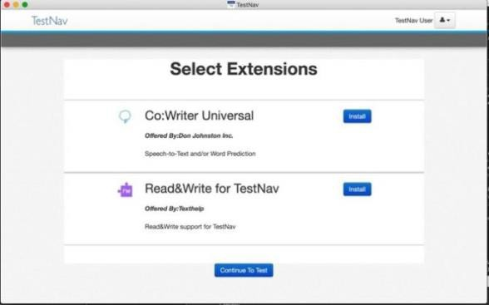

  - Select one web extension; do not enable both. The web extensions have similar features, and the student should select the web extension they are most familiar with. Do not assign a web extension to a student on the day of the test if the student is unfamiliar with its use.
  - Click Install next to the correct extension.
- Step 3: If selecting Read&Write for TestNav, no further action is necessary.
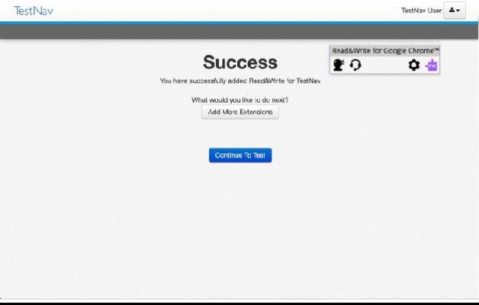
- Step 4: If selecting Co:Writer Universal, complete the following steps:
  - The test administrator (or student) must toggle off Word Prediction or Speech-to-Text if the student is not approved for both features.
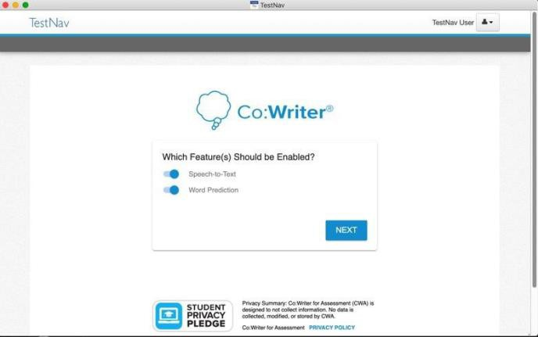
  - Select Next.

The student does not need a license to use Co:Writer Universal during MCAS testing. If the student has an existing license for Co:Writer, they can log into their account and load their previously selected user settings for MCAS testing. If the student does not have a license or chooses not to load their settings, the test administrator (or student) can skip this step.
