# Resubmitting a Waiver Request

When a waiver request has been reviewed, but isn't approved, it gets moved into a "Pending" status. In response, the district/school uploads a new file and/or new information. The next step is to "Resubmit" the waiver request which puts the request back into the queue for review.

# "Resubmit” Process

## Step 1: Go into the educator's ELAR account and click 'Applications.' Find the "Pending" waiver request and click 'District Waiver.'

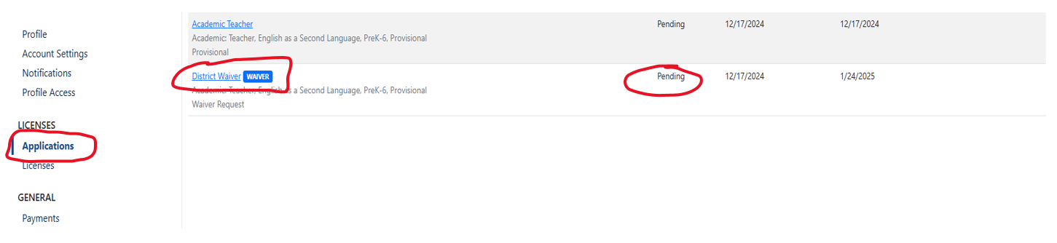

## Step 2: Click 'Overview' then click 'Resubmit Pending Application.'

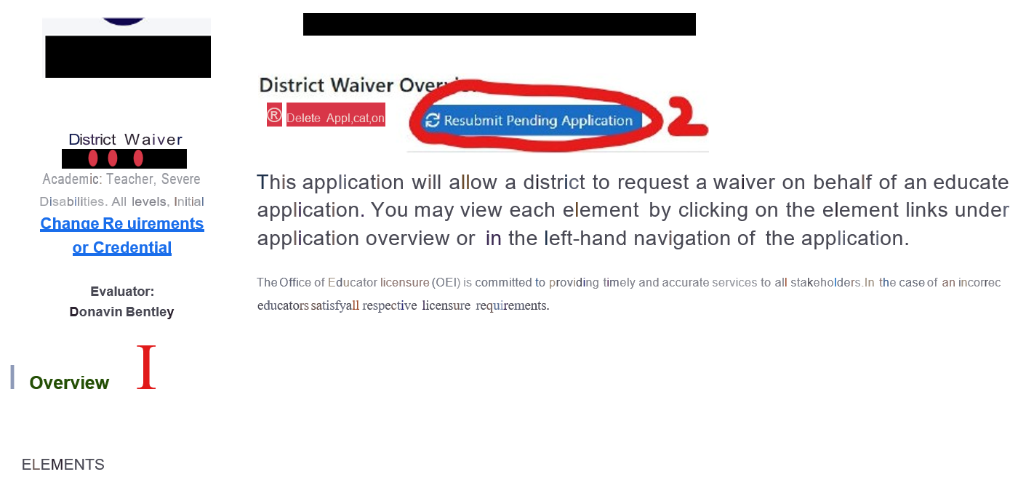

**Step 3: A “Resubmit Application” window pops up. Click ‘Conﬁrm.’**

**Step 4: The resubmission has ‘Started,’ but the request is still considered ‘Not Submitted’ at this point. Click on “Resubmittal # ”**

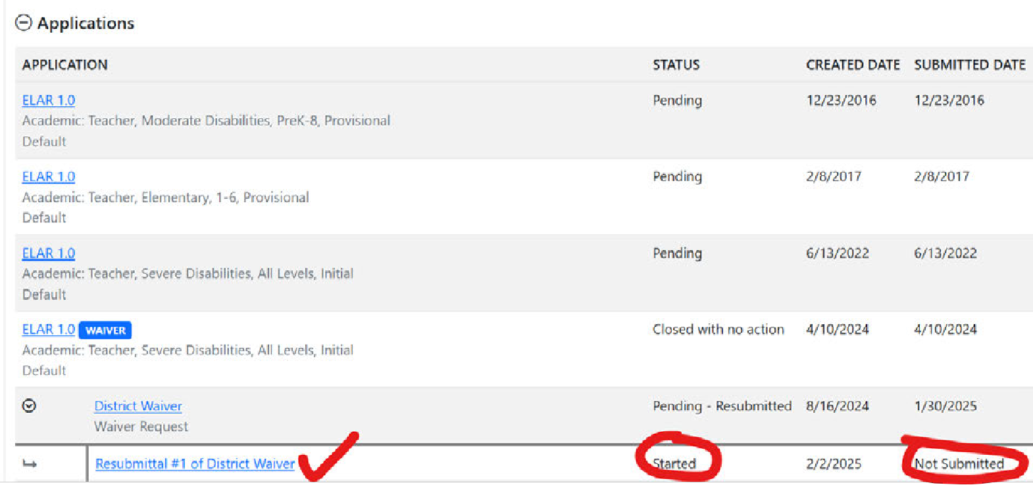

**Step 5: Click ‘Mark as Ready for Submittal’**

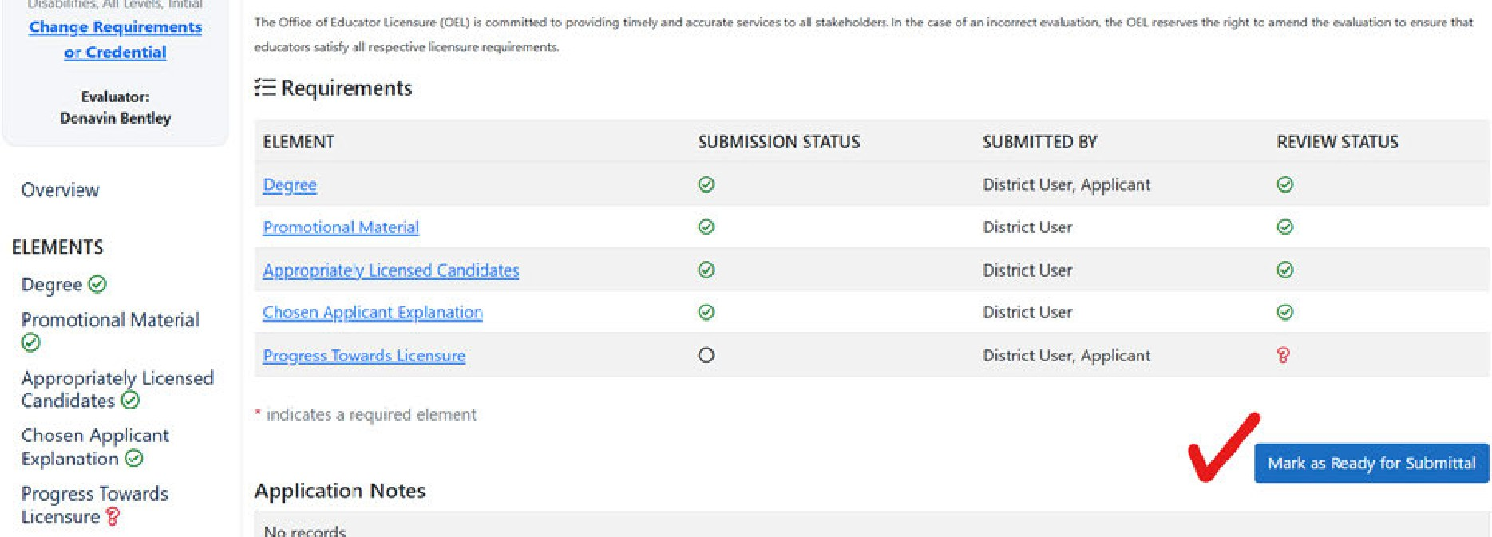

### Step 6: A small new window pops up. Click 'Submit Eligible Applications.' Then place a checkmark in the box.

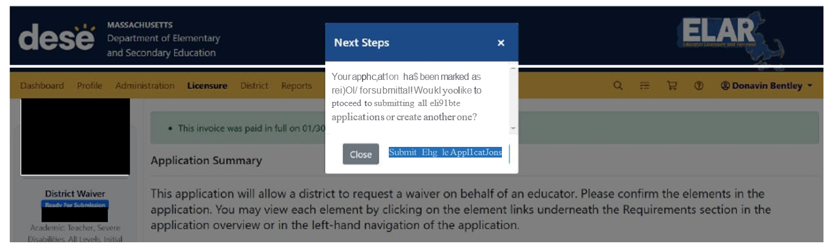

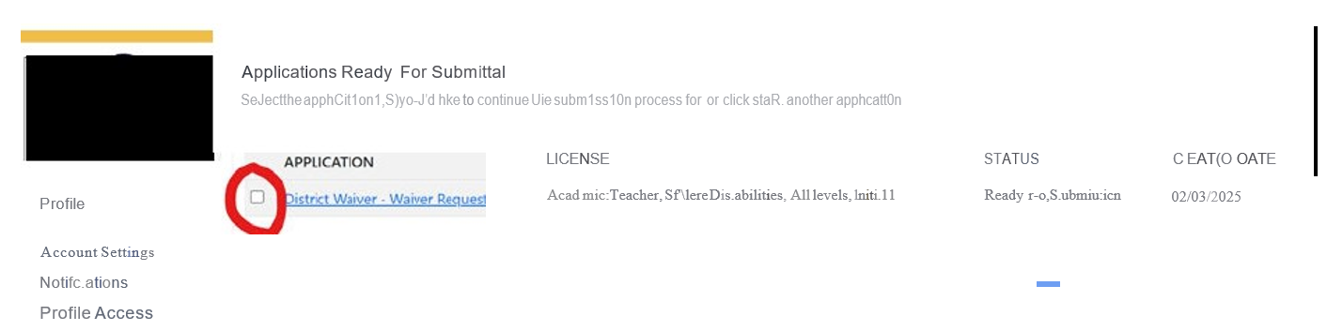

### Step 7: Click 'Proceed to Submit'

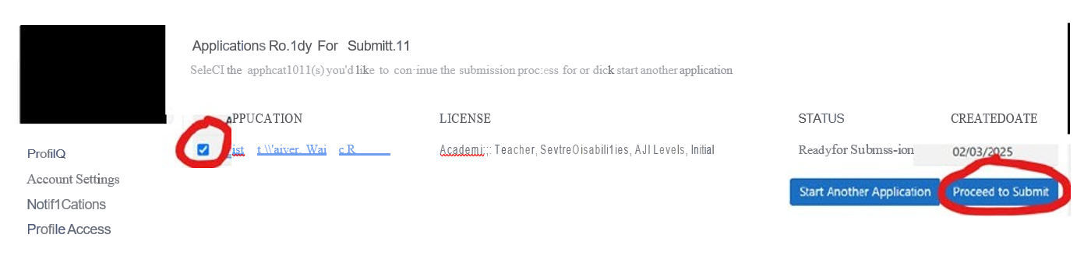

You have completed the resubmission process, and the waiver request is now in "Pending Review" status.