 

**EXPEDITING an APPLICATION**

**To assist school districts and their staff, the Licensure Office offers an ability to expedite an application. When an application is expedited it is placed on a list of applications that are prioritized with a goal of having the application reviewed within 72 hours. This guide aims to help an authorized district user with how to expedite an application.**

Step 1: There are several district search options to look up educators in ELAR. First, you may search for educators by clicking the District tab on the top navigation and then clicking on Person Search under the Search section. You may search by the educator’s MEPID, last four of their SSN, their Date of Birth, or by their License Number

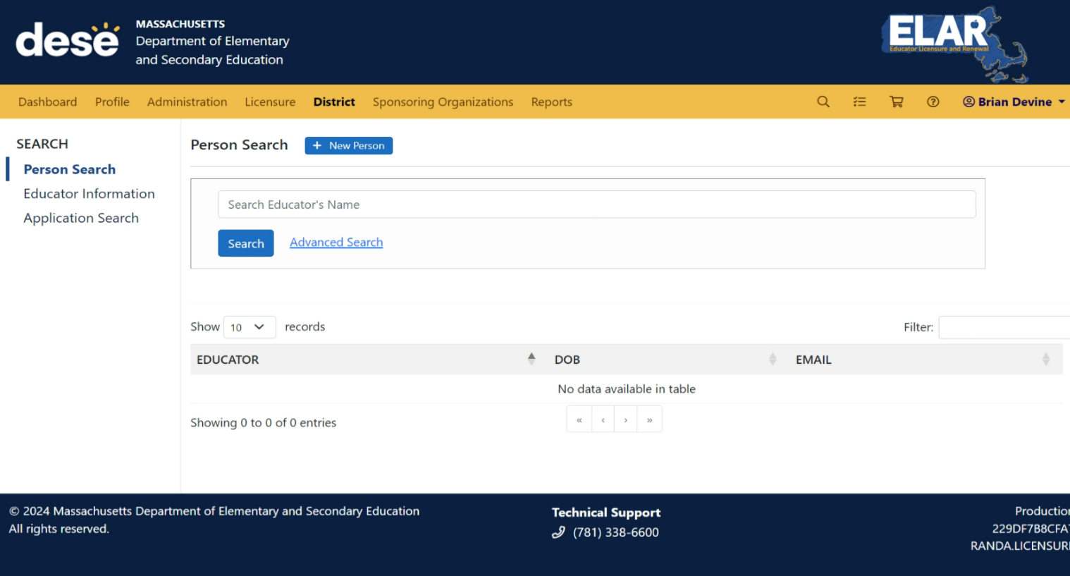

Step 2: Following a successful search, select the educators name which will bring you to their profile. From the left hand navigation area, select applications (found under profile).

Step 3: Select the application that you wish to expedite. Please note that the application must be in a Submitted or Pending Review status in order to be expedited. Now, select the Overview option in the left navigation area.

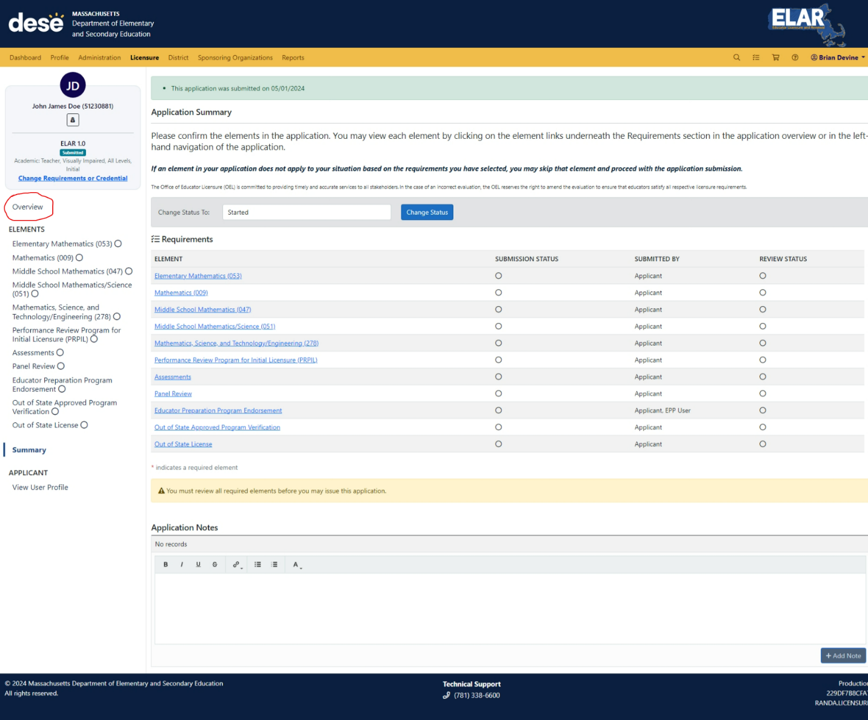

Step 4: In the “Overview” section, you should now notice the “Expedite Application” button over to the right of the applicant/educators name and MEPID number. Click the button to expedite the application.

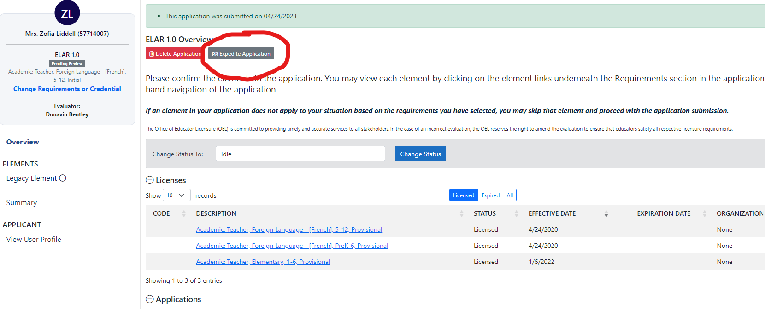

Step: After clicking on the expedite button, you will need to confirm that you would like to have this application expedited.

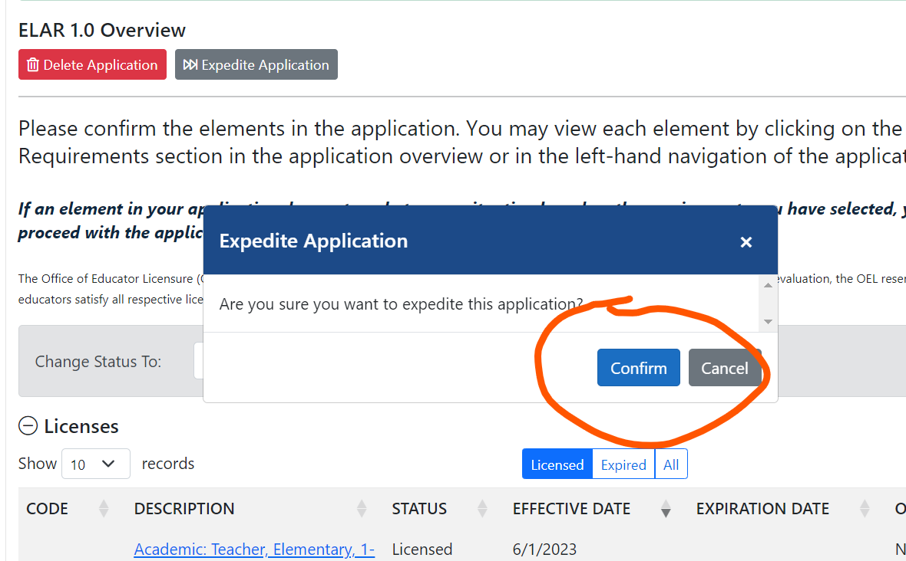

Note: After an application has been expedited successfully, the fast forward symbol shows up next to the application. The application is included in an expedite report that the Licensure Office prioritizes.

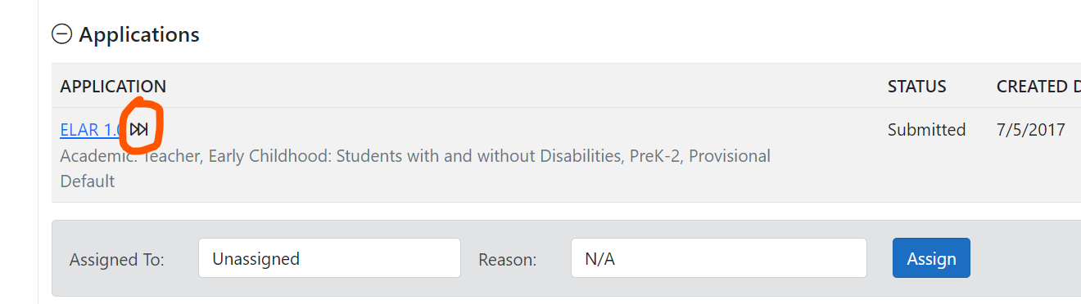

Note: If an expedite is no longer needed, the application can be “unexpedited” by selecting the grey “Unexpedite Applicaiton” button.

