**UPLOADING DOCUMENTS** 

In ELAR, applicants/educators as well as authorized users in a school district and approved educator preparation program (see page 4) can upload documents to ELAR. This guide directs users how they can upload a document to ELAR.

Please note that applicants/educators may upload/add documents via the documents section found in their Profile. In addition, individual users can upload documents in additional areas, such as in the application element confirmation.

**Applicant/Educator :**

1. Login to your ELAR account and navigate to Profile tab
2. From the left column links click on Documents.

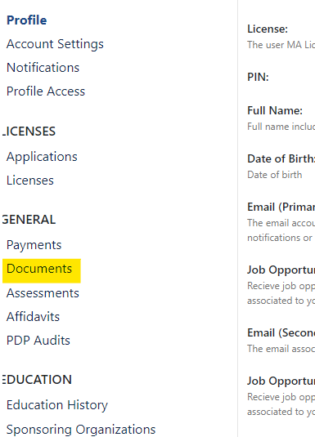

1. Once in the documents section of your account, now choose the file to be uploaded and insert it.

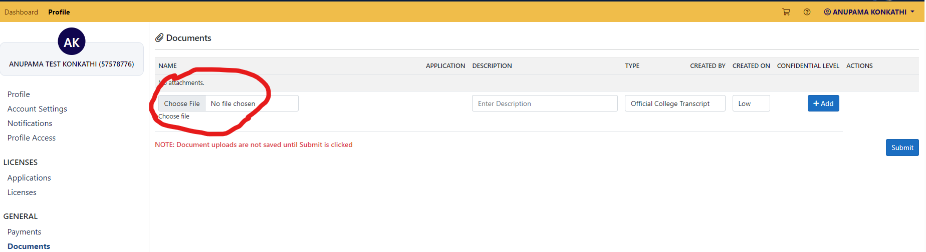

1. Click on the text box under “Type” to choose the type of document being uploaded, for example you are uploading an official college transcript or an experience letter.

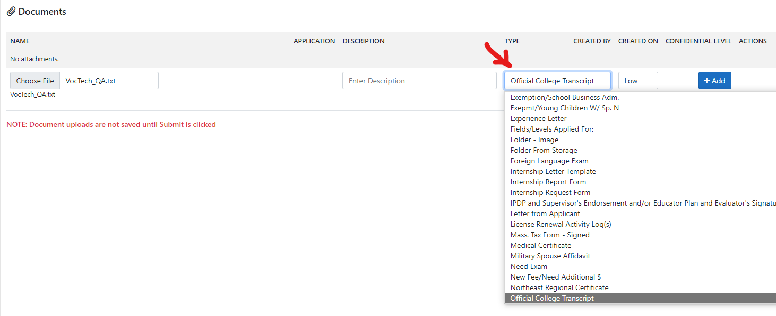

1. Click the “Add” button. If you want to upload another document, repeat the steps referenced above and select the add button. The add button needs to be selected after each and ever document you want to submit. When all documents you would like to upload have been added, click the submit button to successfully complete uploading the documents . Please note that clicking the add button without selecting the submit button will not result in the document being uploaded, both buttons need to be selected.

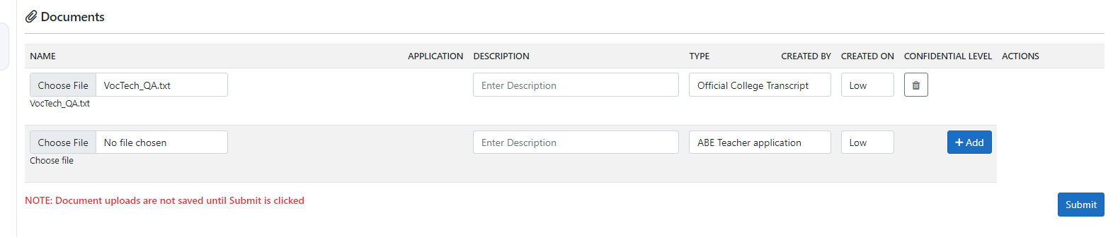

**Authorized District or Approved Program user :**

1. Authorized school district and educator preparation program users can also upload documents for an educator.
2. Look up the applicant/educator from your appropriate access (either district or sponsoring organization) tab at the top and then navigate to their profile.
3. From the limited view in their profile area, click on the documents option to upload the documents and submit.
4. Follow steps 3-6 referenced above in the applicant/educator section.

