Educator Licensure and Renewal Portal Resubmitting an Application

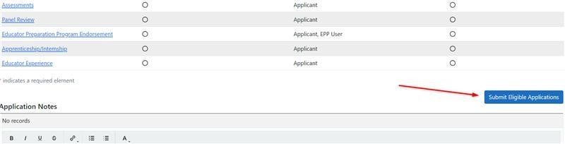
In order to resubmit an application that is marked as “Pending,” you will need to click on the blue “Resubmit” button next to the application, either from the Dashboard or in the Applications section of your Profile tab. This will open the application back up for you to add any additional documentation and information. This begins the resubmittal process, but more steps are needed.

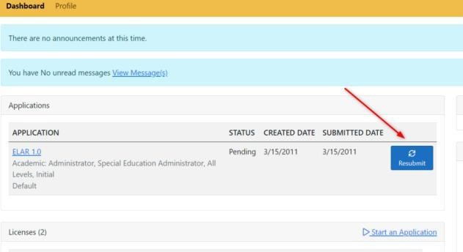

After starting the resubmittal, you must then complete the process. You will not need to pay again or fill out another affidavit for an application that was originally submitted on the original ELAR website or if the application has already been paid in the current website, but you will need to complete the submittal process once the resubmit is started. After updating or confirming any elements in resubmittal, go to the Summary page of the resubmittal. Once on the Summary page, and depending on your situation, you will see either a button titled "Submit Eligible Applications" or "Mark as Ready for Submittal.” Click that button, which will then take you to your cart.

On your cart page, you need to check the box next to your application, and then click on "Proceed to Submit." That will then put the application back into Pending Review (if it's already assigned to an evaluator) and will complete the resubmission of the application.
