

**NOTIFICATIONS**

1. Educators can view all the notifications current and old (legacy). Navigate to Profile and choose notifications from the left column

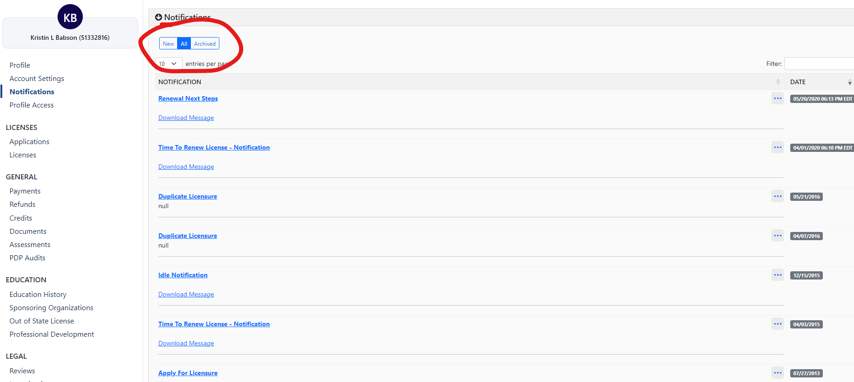

1. Click on All and download message

Image shows a red circle around the selection to be made such as New, All, and Archived on the Notifications page. 
A red line is drawn under: "Downloaded Message" to direct you to your notification 

1. Message downloads into your computer download folder. Can also open the file by clicking on the download symbol on the top right of the browser

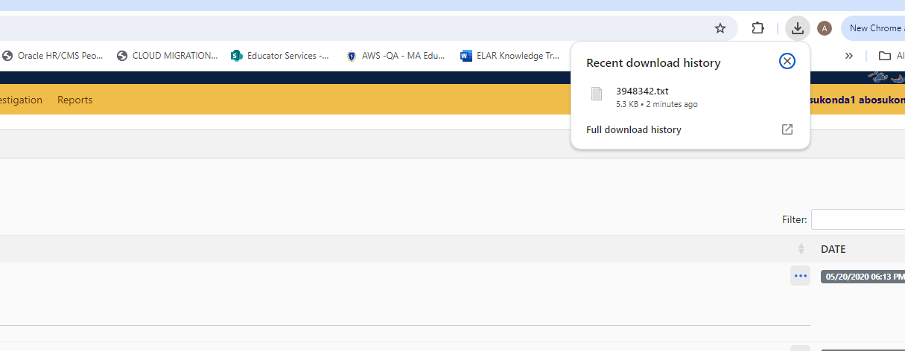

1. The notification downloads as a .txt file, click on the file name to open the notification.