Educator Preparation Promising Practices Resource Kit

October 2024

*Created for DESE in partnership with WestEd*

Contents

Introduction to the Educator Preparation Promising Practices Resource Kit 1

Promising Practices Guide for Educator Preparation Programs 2

Promising Practices for the Continuous Improvement Domain 3

Promising Practices for the Candidate Domain 7

Promising Practices for the Partnerships Domain 12

Case Studies of Promising Practices 16

Stonehill College: Continuous Improvement 16

Springfield College: Candidate Supports 19

Mount Holyoke College: Partnerships 22

Action Planning Tools 24

Continuous Improvement Action Planning Tool 25

The Candidate Action Planning Tool 32

Partnerships Action Planning Tool 40

Tools and Resources 47

## Introduction to the Educator Preparation Promising Practices Resource Kit

The Massachusetts Department of Elementary and Secondary Education (DESE) is committed to supporting educator preparation programs to ensure that all educators are prepared to be effective, meaning they use evidence-based practices, including anti-racist and culturally and linguistically sustaining practices to provide all students with an equitable and effective education. This Resource Kit focuses on promising practices that align with the Continuous Improvement domain, the Candidate domain, and Partnerships domain from DESE’s [*2023 Guidelines for Educator Preparation Program Approval*](https://www.doe.mass.edu/edprep/resources/guidelines-advisories/program-approval/).

**Purpose:** The purpose of this Resource Kit is to build the knowledge capacity of educator preparation personnel and provide concrete support and direction for improving practices in alignment with DESE’s 2023 Program Approval Criteria by presenting research/evidence-based promising practices.

This Resource Kit is comprised of three sections:

* The Promising Practices Guide, which contains promising practices for the three featured domains and real-life examples of the practices in action.
* Case Studies, each of which profiles a sponsoring organization who demonstrates multiple promising practices within the featured domain.
* Action Planning Tools that sponsoring organizations can use to evaluate their own practices and identify areas of strength and opportunities to improve.

## **Promising Practices** Guide for Educator Preparation Programs

|  |  |
| --- | --- |
| **Continuous Improvement** | **What are promising practices?**  Promising practices are research-backed strategies and actions that are aligned with MA DESE’s *2023 Guidelines for Educator Preparation Program Approval* (Program Approval Guidelines)*.* To ensure that educator preparation programs are aligned with the highest standards of equity and effectiveness, the Program Approval Guidelines were updated in 2023 to be: |
| **Candidates** | 1. **Evidence-based**: grounded in a review of research focused on equity-based approaches in educator preparation; drawing on evidence-based practices with documented effectiveness at yielding positive results and improving outcomes across diverse populations. 2. **Anti-racist:** actively seeking to reimagine the structures, policies, institutions, and systems that erect barriers and perpetuate race-based inequities among candidates from marginalized groups; fostering recognition and respect for the full humanity and dignity of all candidates, while also preparing them to extend the same level of respect and understanding to their future students. |
| **Partnerships** | 1. **Culturally and Linguistically Sustaining:** enabling sponsoring organizations to not only respect and affirm the diverse backgrounds of candidates but also treat their cultural knowledge and language practices as assets for their training as future educators.   The promising practices illustrated in this resource kit draw on initiatives that sponsoring organizations have already developed and adopted within their programs. |

The Continuous Improvement Domain

Sponsoring organizations should create a comprehensive system for collecting and analyzing multiple data sources to frequently reflect upon strengths and areas for growth in their programs and take action towards more equitable and effective preparation experiences.



### How does a continuous improvement system ensure equitable experiences and outcomes for all candidates, PK-12 students, schools, and districts?

An effective continuous improvement system promotes equitable experiences and outcomes for all participants by:

* **Establishing a leadership vision for continuous improvement:** Institutional leaders must be committed to anti-racist and culturally sustaining guiding principles and foster a culture based on these guiding principles with all staff (Temponi, 2005). This includes reflecting on whether end goals of the continuous improvement system, like improving candidate outcomes, are culturally sustaining and anti-racist (Cochran-Smith et al., 2016).
* **Creating actionable data systems and supporting equity-oriented data analysis:** Educator preparation programs should shift from analysis void of racial, cultural, and linguistic considerations to disaggregated data analysis by identity markers. They should examine data in context to account for the existence of institutional racism and its effects on people’s experiences, and work to disrupt its impact (Kohli et al., 2022).
* **Assess program complexities using diverse data:** Two-part investigations of “how things are” and “how things work” can support effective continuous improvement systems. Sponsoring organizations can analyze both “how things are” by describing and analyzing the current conditions, potential successes, and constraints, and “how things work” by investigating the programming processes that lead to inequity (Cochran-Smith, 2016).

**Why does an evidence-based continuous improvement system matter?**

Systematically analyzing educator preparation programs to inform continuous improvement shifts the responsibility from an individual to the collective for ensuring equitable educator candidate experiences and outcomes (Kohli et al., 2022). Furthermore, consistency in using evidence to inform continuous improvement efforts mitigates bias in the analysis of what works and what doesn’t.

### Promising Practices for the Continuous Improvement Domain

Establish Systems to Support Equitable Data Practices

|  |  |
| --- | --- |
| Practice | Example |
| Create a leadership team dedicated to regularly collecting and analyzing a variety of data about educator candidate progress towards outcomes or other parallel initiatives. Encourage discussions about the data amongst all faculty to understand the strengths of the program and actionable areas for growth (White et al., 2020). | Mount Holyoke College’s graduate program directors collect quantitative and qualitative data from multiple sources. The directors use these data to facilitate an annual data dive with faculty to assess areas of growth and determine programmatic shifts. |
| Foster a shared vision based on equitable guiding principles, invested member buy-in, and structures for shared decision-making when collectively analyzing data for continuous improvement (Reusser et al., 2007). | Stonehill College uses their Equity in Teacher Education Framework to center equity and ensure a shared understanding of their program goals and outcomes during cycles of continuous improvement. |
| Create a culture of data-sharing that uses agreed upon assessments to cultivate collective accountability for educator candidate growth and values each member’s perspective (Temponi, 2005). | The Elementary and Early Childhood Education Department at Bridgewater State University utilizes shared assessments and templates to periodically distribute information amongst course instructors about candidate growth. Information is then used to reflect on the supports and instruction provided in each course as well as to preemptively provide candidates supports as needed. |

Create Accessible and Actionable Data Systems

| Practice | Example |
| --- | --- |
| Collect *meaningful* and *actionable*data that relates to key organizational initiatives and educator candidate progress. Disseminate results along a timeline that encourages stakeholders to take informed action to improve practices and processes within your organization (White et al., 2020). | Endicott College utilized the Data Wise protocol to analyze the first-time pass rates of teacher candidates on the MTEL exam. The team focused on a learner-centered problem of supporting candidates to instruct students on alternative methods to solve a math problem, created a math lab support program for candidates, and continued to assess progress via formative assessments and Math MTEL pass rates. |
| Ensure that meaningful data is accessible and usable for all pertinent members. This can create a cultural shift that increases personnel’s awareness of the data being collected and analyzed, so they feel invested in the need for change (Reusser et al., 2007; White et al., 2020). | MA DESE publishes data about educator preparation programs so that educator preparation personnel have direct access to a variety of data about their candidates and completers, including their employment, impact on student growth, and results on several key assessments. This data also includes perception data from candidates, completers, supervising practitioners, and hiring principals. |

Equitably Assess Diverse Data Sources

| Practice | Example |
| --- | --- |
| Gather diverse qualitative and quantitative data sources that gauge educator candidate growth towards determined outcomes, including sources that highlight the voices of a variety of invested stakeholders (Reusser et al., 2007). | The University of Massachusetts Amherst uses annual ‘all licensure candidate’ exit surveys, as well as supervising practitioner and program supervisor feedback surveys. Feedback surveys are used to set goals for all programs for the following year. The resulting data is also shared with program coordinators, who meet with faculty teaching in their programs to reflect back on the progress toward the previous year’s goals. |
| Disaggregate qualitative and quantitative data sources by race, language, LGBTQ+ membership, first-generation status, and additional identities when possible to identify disparate experiences for educator candidates with different identities or backgrounds. Use this data to take action to support and prepare candidates more equitably (Kohli et al., 2022). | Kholi et al. (2022) encourage faculty and administration of educator preparation programs to prioritize the voices of community members of Color when analyzing whether organizations are promoting a healthy racial climate within historical, psychological, behavioral, compositional, and organizational and structural dimensions. |
| Assess completer impact on PK-12 student outcomes to gauge the longitudinal impact of your preparation programs on student learning (Reusser et al., 2007). | Reusser et al. (2007) described how one midwestern university created a teacher work sample performance test for physical education teacher candidates. Faculty collected data about the degree to which high-scoring candidates supported positive K-12 student outcomes and adjusted the performance test based on this data. |

### Tools and Resources

* [Candidate Journey Map example from California State University System](https://search.issuelab.org/resources/37749/37749.pdf) (White, et al., 2020, p.14)
* [Data Wise Improvement Processes Example Protocol](https://digitalcommons.usf.edu/cgi/viewcontent.cgi?article=1092&context=jpr) (Endicott College; Quay & Lockwood, 2019, p.11)
* [Guiding Questions for a Healthy Racial Climate for Teacher Candidates](https://journals.sagepub.com/doi/pdf/10.1177/00224871211051980) (Kohli et al., 2022)
* Equity in Teacher Education Framework and Program Outcomes (Stonehill College)

## 

The Candidate Domain

Sponsoring organizations determine candidates’ readiness for endorsement and, in turn, readiness to impact PK-12 students from all races, ethnicities, identities, and backgrounds in the licensure role. The Candidate domain articulates the expectation that a sponsoring organization provides strong supports that candidates need to complete their program of study and be prepared for employment in their licensure role.



### How can strong supports prepare candidates to be effective educators?

Comprehensive and evidence-based supports ensure that candidates are prepared for employment and emphasize anti-racist and culturally and linguistically sustaining approaches. Providing strong candidate supports involves:

* **Providing a multi-tiered system of supports:** Candidates, like the students they will eventually serve, have varying learning styles, backgrounds, and abilities. Providing differentiated supports in preparation programs allows for individualized learning experiences and ensures that all candidates can fully grasp and apply educational concepts and are prepared for their roles as in-service educators (Sallese, Fogarty, & Whiteside, 2023).
* **Creating an equity-centered program culture:** A program-wide commitment to equity requires continuous awareness and action against systemic obstacles that may impede the inclusion and success of candidates from marginalized backgrounds (Holyoke et al., 2023; Rucinski, 2023). This includes identifying and addressing aspects of curriculum and policies that perpetuate a dominant culture of whiteness that further marginalizes and silences the experiences of candidates of color (Amos, 2010; Gist, 2017; Pizarro & Kohli, 2020). By doing so, programs not only enhance the retention and preparedness of these candidates but also ensure that future educators are ready to thrive in the complex realities of PK-12 school systems.
* **Making informed decisions by collaboratively monitoring and democratizing responsibility for candidates' readiness:** By promoting a team-based approach to supervision, sponsoring organizations can encourage candidates’ ownership of their own progress and shift the roles of faculty mentors and supervising practitioners from evaluators to collaborators. Choosing or designing assessments that reflect both the standardized criteria and candidates’ individual growth goals can also alleviate the tensions of assessment with equity-based approaches (Holyoke et al., 2023) while also ensuring that only candidates who are prepared to be effective educators are endorsed for the licensure role.

**Why do strong candidate supports matter?**

In Massachusetts, the educator workforce still does not fully reflect the diverse identities of its students (Rucinski, 2023). Research indicates that for candidates of color there are barriers to entry, experiences of discrimination within field placements, and an undervaluing of their cultural identities within their programs (Amos, 2010; Gist, 2017; Pizarro & Kohli, 2020). By providing strong supports, sponsoring organizations can build equitable access and outcomes for all candidates, especially those from systemically marginalized backgrounds. Comprehensive guidance and support will also sustain candidates throughout their training to graduation and employment, ultimately contributing to a more diverse and effective educational workforce.

### Promising Practices for the Candidate Domain

Adopt a multi-tiered system of supports (MTSS)

| Practice | Example |
| --- | --- |
| Establish a routine check-in process to identify early on which candidates may need additional support, whether it be in their coursework, fieldwork, or with social and emotional well-being; maintain consistent communication among the support team to track candidates’ progress and address areas where they need support. (Foran & Mee, 2019). | Harvard Graduate School of Education has implemented a comprehensive Tier 1 support system in which mentors meet with their mentees weekly and use a Google form to flag any concerns with fieldwork. This process maintains a focus on growth and relationships, with follow-up actions tracked for continuity. Typically, the field administrator, core faculty member, or advisor closest to the candidate initiates contact, aiming to provide support through a "circle of support" meeting.  Springfield College also provides Tier 1 support and prioritizes candidates’ social and emotional wellbeing by providing all candidates with a trauma-informed practice training module and a wellness training during their practicum that is specific to dealing with educator stress and in which they develop and implement self-care plans. |
| Offer different levels of help and unique supports based on candidates' identities and needs so that they have opportunities to succeed from the application to the program through completion. Simultaneously, encourage students to actively manage and be responsible for their own growth throughout their training (Cochran-Smith et al., 2015; Holyoke et al., 2023). | Mount Holyoke College helps potential students to apply to the program through advising sessions outside of working hours. Additionally, directors offer one-to-one sessions to support candidates with the application process.  In addition, as a Tier 2 support, Stonehill College has developed a mini-course library that all candidates can access throughout their program to supplement their knowledge in areas where they need additional support. |
| Incorporate individualized and intensive interventions to assist pre-service teachers facing challenges beyond academic issues, such as food insecurity, mental health concerns, student loans, and family responsibilities. Provide holistic support by actively coordinating wraparound services from both campus and community resources. Ensure mental health and well-being are destigmatized, empowering pre-service teachers to access care and build resilience. | Northeastern University has engaged in participatory action research on 'praxis shock'—the sense of surprise or disorientation that can occur when a candidate’s preconceived notions of the profession do not match the actual experience. To enhance Tier 3 interventions, they have piloted a community support structure using cross-college collaborators and offer candidates an extended network of wraparound support services. In seminar, candidates are educated on praxis shock and its impact on candidate mental health and well-being, and a faculty member from the psychology department facilitates small group conversations to destigmatize "talk therapy" to manage stress. The program has also adopted self-reflection practices and activities specifically targeted to support social-emotional resilience in pre-service teachers, and candidates are encouraged to develop individualized strategies for self-care and well-being prior to exiting the program (Ballantyne and Retell, 2020; Madonna, 2024; Sharp, 2015). |

Ensure candidate supports are equity-oriented

| Practice | | Example |
| --- | --- | --- |
| Because education and its practices are historically entrenched in a culture of white supremacy, encouraging and integrating anti-racist and culturally sustaining pedagogy throughout coursework functions as a form of candidate support for those traditionally not reflected within their educational experience (Crenshaw & Yusuf, 2024). Doing so will ensure coursework reflects and validates the backgrounds and identities of all candidates while also preparing them to apply concepts effectively in diverse classroom settings. | Springfield College works to support diverse learners’ learning needs while also “setting white students on the path to addressing their biases and recognizing structural inequality” and embedding social justice education and multicultural education across all of their coursework. | |
| Center anti-racism and culturally sustaining principles and practices in supervising practitioner selection; communicate with candidates and district partners a programmatic expectation that supervising practitioners practice anti-racism and cultural responsiveness (Rodriguez-Mojica et al., 2020). | Stonehill College puts the guiding principles of anti-racism and cultural responsiveness at the forefront when partnering with districts which then inform the ways in which district partners can select supervising practitioners who practice these principles. This ensures that supervising practitioners are prepared to support candidates if they come across issues of racism or inequity in their placements. | |
| Be responsive to candidates and provide a network of support as they balance the competing challenges of navigating their early field-based experiences and enacting equity-based practice anti-racist and culturally sustaining practices that they are learning about in their programs (Strom & Martin, 2016). | If candidates at Stonehill College face difficulties because the school's commitment to anti-racist and culturally sustaining practices doesn't align with the practices at their teaching placement, the college steps in to offer more guidance. They work to involve both the placement school and the supervising practitioner in embracing the college's mission to create a more supportive learning environment. | |

Make Informed Decisions

| Practice | | Example |
| --- | --- | --- |
| Regularly examine recruitment, admissions, and retention data to make intentional, equity-informed choices about how to provide strong supports for candidates to become well-prepared educators. | MA DESE uses a Racial Equity Decision Making Tool to make informed, equity-based decisions. The tool includes steps for analyzing data and historical context to inform how best to move forward. | |
| Identify students who may need more targeted support early by using placement or in-class assessments at the beginning of programs and courses (Goe & Roth, 2019). Ensure everyone has the chance to succeed on required programmatic benchmarks. | Springfield College proactively identifies students requiring extra support by their foundational knowledge (using course grades as screeners), skills (using observation rubrics), and dispositions (notes from supervising practitioners and mentor faculty). This comprehensive approach ensures timely targeted assistance, aiming for every student's success in meeting program requirements. See more about Springfield College’s comprehensive supports for candidates in the case study below. | |
| Actively listen to and observe candidates to understand their distinctive identities and strengths, particularly those from marginalized communities to tailor supports that are responsive to those identities and strengths and effectively foster their access, progress, and graduation from the program. | Springfield College, recognizing the increase in Spanish-dominant speakers enrolling in recent years in their counseling program, has taken proactive steps to support these students by hiring a Spanish-bilingual faculty member. This faculty member not only instructs courses in Spanish but also serves as a program supervisor, offering bilingual coaching thus honoring candidates’ distinctive identities and building upon their linguistic strengths. | |

### Tools and Resources

* [MA DESE Resources](https://www.doe.mass.edu/sfss/mtss/) for Multi-Tiered Systems of Support (MTSS)
* Social-Emotional Supports for Teacher Candidates (Springfield College)

The Partnerships Domain

Sponsoring organizations should maintain effective partnerships with PK-12 schools/districts. Effective partnerships go beyond transactional relationships; they are mutually beneficial, sustainable relationships built upon open lines of communication, data sharing, and collaborative decision-making, such that they remain responsive to both preparation program and PK-12 school/district needs.



### How can strong partnerships support candidates’ field-based experiences?

Strong partnerships between sponsoring organizations and PK-12 schools/districts foster opportunities to develop shared expectations of effective practice and support educators at different points in their career to meet those expectations. This strengthens educator candidates’ preparation by providing authentic experiences to observe, practice, and receive feedback on what they learn through coursework. Culturally responsive and anti-racist partnerships honor educator candidates’ identities, support candidates to value PK-12 students’ identities, and prepare educators that will support all students to thrive. Features of strong partnerships can include:

* **Attending to “Strong Equity” in partnerships:** Strong equity consists of four interrelated and mutually reinforcing concepts that support equitable access – redistribution of resources and opportunities, recognition of the values of minoritized groups, representation in establishment of norms and practices, and reframing assumptions. In partnerships, strong equity can be reflected in the representation of all voices, particularly minoritized voices, in decision-making or to inform the redistribution of resources and supports (Cochran-Smith & Keefe, 2022).
* **Explicitly acknowledging oppressive systems and working to disrupt them within the collaboration:** This includes questioning existing processes, who they serve, and development of new structural approaches (Hill-Jackson, 2023).
* **Venturing out of your comfort zone:** Moving away from what is familiar and comfortable to a place where tensions, contradictions, uncertainty, and discomfort are welcome can bring about meaningful change for the partnership, educator candidates, and PK-12 students. This involves taking time to consider approaches to sustaining partnerships that challenge the status quo and advance equity (Kumashiro, 2013).

**Why do strong partnerships matter?**

Strong partnerships are essential to educator preparation and fundamental to ensuring that candidates are well-. Strong partnerships integrate culturally responsive and anti-racist framing, structures, and practices, and value candidates’ humanity. This focus can more adequately reflect the identities and values of the larger school community, thus facilitating more effective learning experiences for education candidates (Marchitello & Trinidad, 2019).

### Promising Practices for the Partnerships Domain

Establish a Foundation Focused on Strong Equity

|  |  |  |
| --- | --- | --- |
| Practice | | Example |
| Build a shared mission and vision with partner schools/districts based on culturally sustaining and anti-racist guiding principles. Begin new sponsoring organization-district partnerships by sharing your organization’s principles for partnering and discussing whether these principles align with the school district’s principles. If they are aligned, collaborate to establish a shared mission and vision for the partnership and identify action steps to achieve that vision (Torre Gibney et al., 2020). | Stonehill College begins district partnerships by sharing their anti-racist, anti-oppressive, and social justice guiding principles to determine if they align with the district’s beliefs and guiding principles. They have a collaborative dialogue about whether the organizations’ respective principles are conducive to a strong partnership rather than asking districts to conform to the sponsoring organization’s model. | |

Collaborate to Disrupt and Reimagine Inequitable Systems

| Practice | | Example |
| --- | --- | --- |
| Collaborate with districts to provide ongoing support to educator candidates during field-based experiences and beyond. Provide training, tools, and resources to supervising practitioners to strengthen their skills in mentoring, and align expectations for supporting candidates (Wexler, 2020). Communicate regularly with districts, supervising practitioners, and candidates so that adjustments can be made as needed. | Clark University provides opportunities for supervising practitioners to engage in content-specific curriculum teams in after-school meetings so that participants can share information and build skills that support them in their classroom teaching and mentorship of candidates. In addition to a survey to learn about supervising practitioners’ strengths and needs, Clark solicits feedback in person, through luncheons that they host twice a year. | |
| Reflect upon ways both the sponsoring organization and partner school/district can adapt their systems and structures to honor educator candidate strengths and attend to their needs. This collaboration can include developing clear criteria for anti-racist and culturally and linguistically sustaining practices, providing training to support educators’ growth in practices, and using a matching process to pair educator candidates with effective supervising practitioners (Foran & Mee, 2019). | Fitchburg State University collaborates with districts to identify supervising practitioners that utilize anti-racist practices and meet DESE regulations. Supervising practitioners and educator candidates’ complete applications to support matching based on needs, identities, and dispositions. Supervising practitioners then participate in a remote training that includes videos, calibration exercises and exemplar language to support their mentoring of candidates. | |
| Consider establishing a cohort model with a partner school/district. The use of this model can foster deeper relationships, facilitate two-way communication between the SO and district, and strengthen academic and social and emotional supports for the educator candidates at each site. | Westfield State University has recently started using an informal cohort model in a few schools, with plans to amend existing district MOUs to include more structured cohorts in the future. In this early work, program supervisors are more present in the schools. Program supervisors’ additional time at the school enhances dialogue between the SOs and school staff, including between program supervisors, supervising practitioners and administrators. Program supervisors have shared that this closer collaboration gives them deeper insight into the unique atmosphere of each school and how they can provide the most effective support. | |
| Work in tandem with the partner school/district to understand and respond to their changing needs. Take responsibility for making aligned programmatic changes to improve partnerships or candidates’ preparation. | Bridgewater State University utilizes a professional development school model with gateway cities in Southeastern Massachusetts. University administrators and faculty meet monthly with teachers and school administrators to collaborate and discuss teaching and learning best practices. These PDS teams work together to provide support, share resources and provide professional development around current issues in education. | |

Gather Feedback to Make Changes Outside Your Comfort Zone

| Practice | | Example |
| --- | --- | --- |
| Solicit frequent and actionable input from a variety of stakeholders at partner schools/districts to inform improvements or revisions to preparation programs’ curricula, processes, or supports. | Stonehill College asks school principals, program supervisors, supervising practitioners, and educator candidates to complete a survey on their experiences to determine how well the partnership and field-based experiences align with the SO programmatic outcomes and mission. | |

### Tools and Resources

* Example of Matrix of Learning in Practicum (Stonehill College)
* 360° Clinical Evaluation Tool Categories (Stonehill College)

## Case Studies of Promising Practices

Stonehill College: Continuous Improvement

This case study spotlights Stonehill College’s Graduate Teacher Education programs and the ways faculty center equity in their continuous improvement process, engage with diverse data sources, and make programmatic shifts based on data. Explore tools and consider how their best practices can be adapted to your own context.

**Context:** Stonehill College is a private Catholic college located in Easton, Massachusetts. As a part of their graduate educator programs, Stonehill offers an accelerated, eleven-month graduate pathway for teacher preparation. This pathway began in January 2020 on the premise of inclusive education and currently serves a high percentage of teacher candidates of color. Candidates either join the program directly after attaining their undergraduate degree, deciding upon a career change, or after hearing about the program from district partners. The graduate teacher education faculty and administration of Stonehill focus on recruiting diverse teacher candidates and have created a scholarship for candidates who work in urban settings through donated funding.

**Promising practice #1: Establishing an equity-oriented framework for continuous improvement.** Key leaders of the graduate program, Drs. Elizabeth Stringer Keefe and Rebekah Louis, utilize the Cochran Smith & Keefe’s (2022) Equity in Teacher Education Framework to focus their program and continuous improvement efforts on anti-racist, anti-oppressive, social justice, and democratic guiding principles. The framework concentrates the sponsoring organization’s continuous improvement efforts on four dimensions of strong equity in teacher preparation: the economic dimension, the cultural dimension, the political dimension, and the discursive dimension. Use of this framework supported the graduate faculty and administrators of the teacher education program to focus on internal accountability for ensuring equity rather than relying on external factors or supports.

**Promising Practice #2: Using** **multiple sources of data.** Stonehill uses multiple data sources to gauge the degree to which their programs, its processes, and its partnerships are meeting the four dimensions of their teacher equity framework and advancing equitable student outcomes. The team has also developed tools based on the framework itself to ensure that the dimensions are reflected in the planning and measurement process. One of these tools is the 360° evaluation which gathers feedback from teacher candidates, supervising practitioners, program supervisors, and administrators about the practicum experience and growth towards shared outcomes. The 360° evaluation compliments student-centered data in which candidates collect and reflect upon evidence of their growth through the program, using tools such as the Matrix of Practicum Experiences (MOPEX) Matrix, Student Support Access & Success Framework (SSAS) which includes a student Career and Educator Readiness (CAER) Dispositions self-assessment, and student-created MTEL Plan of Action (MPA) which comprehensively offer a holistic picture of if and how education candidates are meeting program outcomes (see the Promising Practices Guide for more information on these tools). Drs. Stringer-Keefe and Louis have also conducted a self-study, or self-initiated and focused research approach for studying professional practice settings (Kuber LaBoskey, 2004), to understand the degree to which their own practice aligns with the Equity in Teacher Education Teacher Equity Framework (*forthcoming*). They also utilize this data for self-reflection and as a part of the continuous improvement process.

**Promising Practice #3: Recurring opportunities to access, analyze, discuss, and make equitable programmatic changes based on data.** Drs. Stringer-Keefe and Louis facilitate assessment retreats for the faculty who teach and support the Stonehill graduate program. During these retreats, faculty review their program’s portfolio to highlight successes, name potential areas of need, and ensure continuity of certain efficacious program and instructional practices across all coursework that are making a positive impact based on the data. During these retreats, faculty also analyze and discuss student work, such as gateway tasks and key assignments in relation to key program outcomes.

Additionally, during assessment retreats, faculty utilize a portfolio of data, including the 360 evaluation feedback, MOPEX evidence, and student data from gateway tasks to assess and make changes to the program structure and course instruction. For example, the data from the 360 evaluation supports faculty to ensure that each component of SO-district partnerships and members in these partnerships are reflecting the equitable values and outcomes based on the framework. There are multiple ways in which faculty can pivot if the data from the 360 evaluation suggests misalignment with the framework, including providing professional development for district partners or no longer continuing to partner with certain sites.

School and district leaders also intermittently review the data from the MOPEX, into which candidates and supervising practitioners provide evidence for how education candidates are meeting specific required practicum experiences. All participating faculty utilize this data to discuss supports that candidates might need and ways to adjust coursework or mentorship.

**Promising Practice #4: Incorporating programmatic opportunities for education candidates to contribute to and mirror continuous improvement practices.** Stonehill College utilizes data and tools that afford education candidates the opportunity to collect evidence themselves about how they are meeting program outcomes and dispositions. This frequent engagement of education candidates with data tools, along with regular meetings with faculty and advisors to speak about their evidence towards program outcomes, is intended to foster a heightened understanding of candidates’ own goals and progress towards their goals. Education candidates utilize the MOPEX during practicum to discuss progress with faculty, program supervisors, and supervising practitioners. Education candidates also collect data through reflections in strategic assessments after each class session. Faculty review candidate reflections in order to build candidate capacity toward continuous reflection.

**Next steps and continuous growth:** Stonehill College is still thinking through ways to grow their graduate program and decrease barriers to entrance and success for education candidates, particularly teacher candidates of color. Faculty and administration will continue to gather data through surveys, student-led artifacts, and self-study in their process for determining next steps and equitably improving their teacher preparation program.

Springfield College: Candidate Supports

Read about how Springfield College provides strong supports for its candidates by centering equity, engaging diverse voices in decision-making, and offering prolonged, targeted assistance from recruitment through to licensure, ensuring every completer is well-prepared for their professional journey. Explore tools and consider how their best practices can be adapted to your own context and program.

**Context:** Springfield College is a small, private institution in the heart of Springfield, Massachusetts, home to one of the largest school districts in the state. Springfield College has a comprehensive education department that serves diverse undergraduate and graduate candidates across a variety of subject areas and student age groups.

**Promising Practice #1: Centering equity program-wide.** Springfield College has taken deliberate steps to weave cultural competence and responsiveness into the fabric of its program. For instance, Springfield College's faculty actively incorporate culturally responsive pedagogy (CRP) into the curriculum. Department Chair and Associate Professor, Dr. Stephanie Logan, who specializes in elementary, multicultural, and social justice education has played a key role in leading the department to thread these critical topics throughout program coursework. This integration ensures that CRP is a consistent element of the program rather than a topic isolated to a single course.

At Springfield, cultural responsiveness extends to all candidates, including those who are white. The college is committed to helping students confront and understand their own biases and the broader issues of structural inequality. Identity work is infused throughout the program courses. Extending the cultural responsiveness and anti-racist content embedded throughout the program curriculum, Director of Educator Preparation, Valerie Annear, uses the book, *The Identity Conscious Educator* by Liza A. Talusan, with practicum students to prompt discussion and reflection on how various aspects of identity influence teaching practices. By engaging with the framework presented in Talusan's book, Springfield's candidates consider the impact of race, social class, gender, sexual orientation, and disability on their professional identity and responsibilities.

Springfield College also incorporates the [MA DESE’s culturally relevant pedagogy rubric](https://www.doe.mass.edu/edeval/resources/calibration/crt-rubric.docx) into their practicum expectations and explicitly engages candidates with using the rubric throughout practicum, prompting teacher candidates and program supervisors to understand the connections of CRP to the Essential Elements practicum students must demonstrate in their teaching practice. It also supports candidates to critically examine their practices, aligning them with teacher indicators and exploring their application in the classroom. Together, providing culturally responsive instruction and support draws on research and considers candidates' identities to ensure their success in the program and for working with diverse PK-12 students in the future.

**Promising Practice #2: Making informed decisions using diverse voices.** Springfield College prioritizes candidate supports by ensuring that decisions are made with input from a variety of voices, reflecting a commitment to diversity and inclusivity. Springfield College actively maintains connections with alumni, who provide valuable feedback that shapes the support offered to current students in the program. Mentor teachers from partner schools provide real-time insights into the practical needs of educator candidates. In addition, strategic meetings with district leaders keep the college's curriculum and support systems aligned with the goals of local schools. To capture the full spectrum of feedback, faculty conduct surveys among students and practicum coordinators, with graduate student support to manage survey data. This information is then used to tailor support for candidates, whether their needs are academic help, test preparation, or emotional well-being. Springfield College has also sought the perspectives of its candidates through several student advisory boards. One of the advisory boards consists of undergraduate students, graduate students, and recent program completers and is facilitated by the Director of Educator Preparation. The purpose of the advisory board is to ensure that candidate and completer voices directly influence candidate support.

**Promising Practice #3: Offering prolonged, targeted assistance to candidates.** Springfield offers strong candidate supports starting in candidates’ first year, throughout practicum experiences, and all the way through to graduation. Springfield College offers a robust support system throughout the four years of the program. The Educator Preparation Office at Springfield College plays a central role by providing multiple candidate supports including MTEL mentoring and study groups, financial support via MTEL vouchers for testing, and personalized one-on-one guidance from the Director of Educator Preparation. The Educator Preparation Office also facilitates intensive practicum meetings, offering a forum for problem-solving and success sharing, and provides technical assistance with the Candidate Assessment of Performance (CAP). The Director of Educator Preparation meets with candidates three times for full days during their practicum semester with the goals of providing additional support for candidates in areas of need and promoting self-care practices and routines around educator well-being and successful teaching practice. Topics explored during these meetings include a mini-module that introduces students to the structures of trauma-informed teaching practices and asks them to self-assess their implementation of key practices during practicum. Candidates are also provided with an introduction to the science of self-care, examples of self-care practices, and guidance to develop a self-care implementation plan. The Director of Educator Preparation provides feedback on plans and checks in with the candidates throughout their practicum.

Complementing the individualized support, Springfield College also emphasizes the importance of community engagement and professional networking through the organization of social gatherings and clubs. These initiatives are specifically tailored to enrich the student experience for future educators, fostering a sense of community and belonging that extends beyond the classroom and into their professional lives.

**Next steps and continuous growth:** The student advisory board at Springfield College has seen significant engagement from undergraduate candidates, so faculty are now considering ways to see similar rates of participation among graduate candidates to better represent the collective voice and concerns of the entire student body. Springfield faculty and administration also acknowledge that their diverse candidates bring a wealth of knowledge and critical perspectives from their lived experiences. Thus, Springfield is imagining professional development for partnering school districts to support retention of diverse teachers that extend equitable approaches beyond the college itself.

Mount Holyoke College: PK-12 School and District Partnerships

Read about how Mount Holyoke College’s graduate teacher license programs respond to the needs of their districts to create mutually beneficial partnerships using differentiated approaches that support district interests and needs. Explore tools and consider how their best practices can be adapted to your own context or program.

**Context:** Mount Holyoke College, located in South Hadley, Massachusetts, is a leading gender-diverse liberal arts college for women. Their teacher education graduate programs, which were inaugurated a decade ago, are specifically tailored to meet the needs of individuals seeking to transition into the teaching profession.

Students can opt to enroll in graduate programs on a full-time or part-time basis depending on their needs. Candidates of color currently make up more than 25% of their students and approximately 90% of candidates are actively working in schools.

**Promising Practice #1: Adapting systems and structures to attend to district needs.** The partnership between Mount Holyoke and Holyoke Public Schools initially began with informal conversations about how sponsoring organizations might better meet the needs of teachers. Mount Holyoke College’s graduate teacher license programs recognized the need to adapt their approach to better serve districts and teachers, which laid the groundwork for a collaborative partnership. The partnership was solidified in 2016 when Mount Holyoke College’s graduate teacher license programs responded to a pressing need for special education teachers within the Holyoke Public Schools. In an effort to address this need, Mount Holyoke first took steps to establish a special education licensure program. As the work progressed, it became clear to Mount Holyoke that it was necessary to modify some of their course schedules and structures to better support their new teacher candidates who were already working in schools. These changes, such as adapting the course schedules and format to candidate needs, served as a springboard for further partnerships with diverse public schools across the Commonwealth. Their responsive program continues to focus on diversifying the teacher workforce and providing educators from the community during a teacher shortage.

**Promising Practice #2: Customizing collaborations to reflect the interests and strengths of district partners.** Mount Holyoke College’s graduate teacher licensure programs believe that every PK-12 partnership is unique. Each partner should be clear and specific about their needs, interests, and potential contributions to the collaboration. Some of Mount Holyoke College’s district partners oversee and support the application process for teacher candidates in their districts, while others have the capacity to provide stipends. Some administrators support the planning of, and attend, end-of-the-year celebrations. For each partnership, there is a memorandum of understanding (MOU) which lays out detailed requirements for how to ensure rigor and to collectively adhere to DESE requirements. The MOUs are customized to the partnership and focus on the unique contributions each partner brings to the collaboration.

**Promising Practice #3: Providing supports and collaboration based on district needs.** In 2022 and 2023, Mount Holyoke piloted a training program to work with two school districts who employ their completers. This support was aimed at identifying gaps in new teachers’ knowledge that could be provided by joint partnership between the sponsoring organization and the school district. Mount Holyoke College’s graduate teacher licensure program surveyed new teachers to understand their needs and then worked in partnership with the districts to provide monthly professional development sessions tailored to the new teachers’ needs. The program had high engagement and was positively received by both participants and the districts during the pilot.

**Promising Practice #4: Collecting data to understand the degree to which SO-district partnerships are successful in supporting candidate outcomes.** Mount Holyoke College uses diverse data sources to analyze the health of SO-district partnerships, including state data compiled by DESE, exit interviews with each of the teacher candidates, and interviews with supervising practitioners. Mount Holyoke College’s graduate teacher licensure program’s faculty continually revise the survey questions based on new initiatives established by them and their partner districts. For example, a change that came from the survey included how the Candidate Assessment of Performance requirements were addressed within practicum. Formatively, the faculty also intermittently review survey data and utilize data to inform the regular check-ins with supervising practitioners and program supervisors. The data also influences the content of the formal training they provide at the beginning of practicum and the strategies they share for how to mentor and gather data when supporting teacher candidates.

**Next steps and continuous growth:** Mount Holyoke College’s graduate teacher license program is continuing to consider the ways they can support diverse in-service teacher candidates to successfully complete and excel in their program. For example, the program continues to offer MTEL preparation courses to its partner districts and current students. The program continues to evaluate candidates' needs around MTEL support and design programming accordingly.

## Action Planning Tools

These tools are designed to help you reflect on your current practices and identify areas for growth towards the expectations in three domains of the 2023 Guidelines for Educator Preparation Program Approval: Continuous Improvement, The Candidate, and Partnerships.

Suggested process for using these Action Planning Tools:

* Select the domain and criteria that best align with your sponsoring organization’s goals and initiatives. The language of each criterion describes DESE’s expectation for your organization. Use the reflective prompts to evaluate how your current practices align with the expectation.

1. First, describe your current systems, structures, and practices. Include how you know whether and for whom these are working well. Celebrate areas of strength, where the work is aligned with your sponsoring organization’s vision and DESE’s expectations.
2. Then consider areas for growth that could support your sponsoring organization to meet the stated criterion, the promising practices, and your vision for your program.
3. After completing all reflective prompts, describe specific actions steps you will take to address your areas for growth:
   * Identify key personnel responsible for each step
   * Set a realistic timeline
   * Define your intended short- and long-term outcomes from this action, including how they will be measured. These should align with the expectations described in the criteria.

**Tips for Defining and Measuring Outcomes**

* Consider a variety of ways to determine outcomes: documentation and records, feedback and testimonials, assessment/evaluation data or outcomes, program initiatives and events, and practices and processes that advance student outcomes
* Consider how your outcomes will support increasingly effective and equitable experiences and outcomes for candidates, PK-12 students, or other impacted stakeholders.
* For more information about DESE’s definition of high-quality evidence of impact, which may help you measure your progress, please see the [High-Quality Evidence of Impact Advisory](https://www.doe.mass.edu/edprep/review/toolkit/impact-advisory-evidence.docx).

**Navigate to:** Continuous Improvement Domain, Candidate Domain, Partnerships Domain

## 

## Continuous Improvement Domain Action Planning Tool

#### CI 1: The sponsoring organization’s continuous improvement efforts are intentionally designed to involve a variety of stakeholders (including those directly impacted by programming) in decision-making to ensure equitable program experiences and improve candidate outcomes.

Does your SO have a leadership team in charge of collecting, analyzing, and facilitating dialogue for continuous improvement? Is the leadership team well-supported to employ equity-oriented guiding principles, framework, or outcomes throughout continuous improvement processes?

|  |  |
| --- | --- |
| Question | Response |
| **Current Practices and Outcomes**  (What are you doing now? How do you know whether and for whom it is working?) |  |
| **Areas for Growth and Future Outcomes**  (Where do you hope to grow? How will your next steps impact your programmatic and candidate outcomes?) |  |

Who are the stakeholders that your SO involves in decision-making to ensure equitable program experiences and improve candidate outcomes?

|  |  |
| --- | --- |
| Question | Response |
| **Current Practices and Outcomes**  (What are you doing now? How do you know whether and for whom it is working?) |  |
| **Areas for Growth and Future Outcomes**  (Where do you hope to grow? How will your next steps impact your programmatic and candidate outcomes?) |  |

For each of those stakeholders, how are processes designed so they are involved in making evidence-informed decisions towards increasingly equitable and effective preparation programs?

|  |  |
| --- | --- |
| Question | Response |
| **Current Practices and Outcomes**  (What are you doing now? How do you know whether and for whom it is working?) |  |
| **Areas for Growth and Future Outcomes**  (Where do you hope to grow? How will your next steps impact your programmatic and candidate outcomes?) |  |

#### CI 2: At least annually, the sponsoring organization collects and analyzes evidence from a variety of sources (including stakeholder feedback, data collected by the organization, and, when available, state-collected data) in order to understand the experiences and outcomes of all candidates (with particular focus on those from systemically marginalized races, ethnicities, identity groups, and backgrounds) and identify program strengths and areas for improvement.

What data sources does your SO consider to understand the experiences and outcomes of all candidates, with particular focus on those from systemically marginalized groups and communities? Do these data sources provide multiple sources of qualitative and quantitative information?

|  |  |
| --- | --- |
| Question | Response |
| **Current Practices and Outcomes**  (What are you doing now? How do you know whether and for whom it is working?) |  |
| **Areas for Growth and Future Outcomes**  (Where do you hope to grow? How will your next steps impact your programmatic and candidate outcomes?) |  |

What processes are in place to collect that data?

|  |  |
| --- | --- |
| Question | Response |
| **Current Practices and Outcomes**  (What are you doing now? How do you know whether and for whom it is working?) |  |
| **Areas for Growth and Future Outcomes**  (Where do you hope to grow? How will your next steps impact your programmatic and candidate outcomes?) |  |

How is that data organized to be accessible to those involved in decision-making processes? How does the organization of the data promote your understanding of equitable experiences across candidates, with particular focus on those from systemically marginalized groups and communities?

|  |  |
| --- | --- |
| Question | Response |
| **Current Practices and Outcomes**  (What are you doing now? How do you know whether and for whom it is working?) |  |
| **Areas for Growth and Future Outcomes**  (Where do you hope to grow? How will your next steps impact your programmatic and candidate outcomes?) |  |

What processes does your SO use for analyzing and disaggregating data sources to ensure equitable systems and candidate outcomes, particularly for candidates whose identities have been systemically marginalized? Who is included in those processes?

| Question | Response |
| --- | --- |
| **Current Practices and Outcomes**  (What are you doing now? How do you know whether and for whom it is working?) |  |
| **Areas for Growth and Future Outcomes**  (Where do you hope to grow? How will your next steps impact your programmatic and candidate outcomes?) |  |

How is data shared with stakeholder groups who are not directly involved in but impacted by the continuous improvement processes?

|  |  |
| --- | --- |
| Question | Response |
| **Current Practices and Outcomes**  (What are you doing now? How do you know whether and for whom it is working?) |  |
| **Areas for Growth and Future Outcomes**  (Where do you hope to grow? How will your next steps impact your programmatic and candidate outcomes?) |  |

How does your SO integrate evidence and research about educator mindsets and skills that positively impact PK-12 students into coursework, assessments, and candidate outcomes?

|  |  |
| --- | --- |
|  |  |
| **Current Practices and Outcomes**  **(**What are you doing now? How do you know whether and for whom it is working?) |  |
| **Areas for Growth and Future Outcomes**  (Where do you hope to grow? How will your next steps impact your programmatic and candidate outcomes?) |  |

#### CI 3: The sponsoring organization regularly analyzes available local and state PK-12 student outcomes data related to completers’ effectiveness and PK-12 school/district partnerships’ impacts and uses the data to inform aligned actions.

What data sources does your SO regularly analyze to understand completers’ effectiveness in their licensure role?

|  |  |
| --- | --- |
| Question | Response |
| **Current Practices and Outcomes**  (What are you doing now? How do you know whether and for whom it is working?) |  |
| **Areas for Growth and Future Outcomes**  (Where do you hope to grow? How will your next steps impact your programmatic and candidate outcomes?) |  |

What data sources does your SO regularly analyze to understand the impact of its PK-12 school/district partnerships?

|  |  |
| --- | --- |
| Question | Response |
| **Current Practices and Outcomes**  (What are you doing now? How do you know whether and for whom it is working?) |  |
| **Areas for Growth and Future Outcomes**  (Where do you hope to grow? How will your next steps impact your programmatic and candidate outcomes?) |  |

What processes does your SO use for analyzing these data sources to inform actions that improve outcomes? Who is included in those processes?

|  |  |
| --- | --- |
| Question | Response |
| **Current Practices and Outcomes** (What are you doing now? How do you know whether and for whom it is working?) |  |
| **Areas for Growth and Future Outcomes**  (Where do you hope to grow? How will your next steps impact your programmatic and candidate outcomes?) |  |

#### CI 4: The sponsoring organization makes evidence-informed, equity-centered decisions that lead to improved experiences and outcomes for all candidates.

How does your SO develop critical consciousness and anti-racist approaches to analyzing data amongst its faculty, partners, and candidates?

|  |  |
| --- | --- |
| Question | Response |
| **Current Practices and Outcomes**  (What are you doing now? How do you know whether and for whom it is working?) |  |
| **Areas for Growth and Future Outcomes**  (Where do you hope to grow? How will your next steps impact your programmatic and candidate outcomes?) |  |

How does your SO determine how it will measure the impact of decisions made in the process of continuous improvement? How is equity centered in that monitoring?

|  |  |
| --- | --- |
| Question | Response |
| **Current Practices and Outcomes**  (What are you doing now? How do you know whether and for whom it is working?) |  |
| **Areas for Growth and Future Outcomes**  (Where do you hope to grow? How will your next steps impact your programmatic and candidate outcomes?) |  |

How does your SO communicate about the decisions made as a result of the continuous improvement process? Do these processes communicate the goal of increasingly effective and equitable experiences and outcomes?

|  |  |
| --- | --- |
| Question | Response |
| **Current Practices and Outcomes**  (What are you doing now? How do you know whether and for whom it is working?) |  |
| **Areas for Growth and Future Outcomes**  (Where do you hope to grow? How will your next steps impact your programmatic and candidate outcomes?) |  |

#### Continuous Improvement Domain Action Plan

|  |  |  |  |  |
| --- | --- | --- | --- | --- |
| Focus | Action Steps | Key Personnel | Timeline | Intended Outcomes (Short and Long Term) |
| **CI 1** |  |  |  |  |
| **CI 2** |  |  |  |  |
| **CI 3** |  |  |  |  |
| **CI 4** |  |  |  |  |

### 

## The Candidate Domain Action Planning Tool

### CAN 1: The Sponsoring Organization regularly examines recruitment, admissions, and retention data and revises policies and practices to address systemically inequitable barriers to entry and completion.

How does your SO learn about candidates as racially, culturally, linguistically, and experientially diverse individuals?

|  |  |
| --- | --- |
| Question | Response |
| **Current Practices and Outcomes**  (What are you doing now? How do you know whether and for whom it is working?) |  |
| **Areas for Growth and Future Outcomes**  (Where do you hope to grow? How will your next steps impact your programmatic and candidate outcomes?) |  |

How does your SO identify program policies or practices (such as advising practices or course grading policies) that may present barriers to program completion for candidates, particularly those with identities from systemically marginalized communities? How are revisions made to address these program policies or practices? Who is involved?

|  |  |
| --- | --- |
| Question | Response |
| **Current Practices and Outcomes**  (What are you doing now? How do you know whether and for whom it is working?) |  |
| **Areas for Growth and Future Outcomes**  (Where do you hope to grow? How will your next steps impact your programmatic and candidate outcomes?) |  |

How does your SO adjust their instruction, curriculum, and instructional policies to ensure the equitable success of candidates, particularly candidates with identities from systemically marginalized communities?

|  |  |
| --- | --- |
| Question | Response |
| **Current Practices and Outcomes** (What are you doing now? How do you know whether and for whom it is working?) |  |
| **Areas for Growth and Future Outcomes**  (Where do you hope to grow? How will your next steps impact your programmatic and candidate outcomes?) |  |

#### CAN 2: The sponsoring organization positions all candidates to be successful in their program, licensure, and career through equitable, effective, and comprehensive guidance and support systems.

How does your SO define common, equity-oriented benchmarks or outcomes candidates need to meet to progress through the program? How are these benchmarks/outcomes communicated to candidates?

|  |  |
| --- | --- |
| Question | Response |
| **Current Practices and Outcomes**  (What are you doing now? How do you know whether and for whom it is working?) |  |
| **Areas for Growth and Future Outcomes**  (Where do you hope to grow? How will your next steps impact your programmatic and candidate outcomes?) |  |

How does your SO integrate a foundation of anti-racist and culturally and linguistically sustaining practices that well-support all candidates throughout the program(s) of study?

|  |  |
| --- | --- |
| Question | Response |
| **Current Practices and Outcomes**  (What are you doing now? How do you know whether and for whom it is working?) |  |
| **Areas for Growth and Future Outcomes**  (Where do you hope to grow? How will your next steps impact your programmatic and candidate outcomes?) |  |

How does your SO provide comprehensive guidance and support to all candidates throughout their experience? How do you determine whether this is equitable and effective for all candidates, particularly those from systemically marginalized communities?

|  |  |
| --- | --- |
| Question | Response |
| **Current Practices and Outcomes**  (What are you doing now? How do you know whether and for whom it is working?) |  |
| **Areas for Growth and Future Outcomes**  (Where do you hope to grow? How will your next steps impact your programmatic and candidate outcomes?) |  |

How does your SO provide candidates with support to honor and value their identities and enact culturally and linguistically sustaining practices within various district and school settings?

| Question | Response |
| --- | --- |
| **Current Practices and Outcomes**  (What are you doing now? How do you know whether and for whom it is working?) |  |
| **Areas for Growth and Future Outcomes**  (Where do you hope to grow? How will your next steps impact your programmatic and candidate outcomes?) |  |

#### CAN 3: The sponsoring organization identifies and provides differentiated interventions for candidates who need additional support in coursework, fieldwork, or for their social and emotional well-being, and ensures that only candidates who are prepared to be effective educators are endorsed for the licensure role.

How does your SO create systems of communication and data sharing to identify candidates that may need additional support in coursework, fieldwork, or for their social and emotional well-being? How do you design these systems to identify and reduce bias that may contribute to inequitable identification of candidates?

|  |  |
| --- | --- |
| Question | Response |
| **Current Practices and Outcomes**  (What are you doing now? How do you know whether and for whom it is working?) |  |
| **Areas for Growth and Future Outcomes**  (Where do you hope to grow? How will your next steps impact your programmatic and candidate outcomes?) |  |

How does your SO model and provide opportunities for reflection, self-advocacy, and goal-setting for candidates that need additional supports, particularly candidates from systemically marginalized communities?

|  |  |
| --- | --- |
| Question | Response |
| **Current Practices and Outcomes**  (What are you doing now? How do you know whether and for whom it is working?) |  |
| **Areas for Growth and Future Outcomes**  (Where do you hope to grow? How will your next steps impact your programmatic and candidate outcomes?) |  |

How does your SO provide a multi-tiered system of supports for candidates in coursework?

| Question | Response |
| --- | --- |
| **Current Practices and Outcomes**  (What are you doing now? How do you know whether and for whom it is working?) |  |
| **Areas for Growth and Future Outcomes**  (Where do you hope to grow? How will your next steps impact your programmatic and candidate outcomes?) |  |

How does your SO provide a multi-tiered system of supports for candidates in pre-practicum and practicum?

|  |  |
| --- | --- |
| Question | Response |
| **Current Practices and Outcomes**  (What are you doing now? How do you know whether and for whom it is working?) |  |
| **Areas for Growth and Future Outcomes**  (Where do you hope to grow? How will your next steps impact your programmatic and candidate outcomes?) |  |

How does your SO measure improvement for candidates receiving differentiated supports? What culturally responsive and anti-racist structures and systems are used if, despite receiving differentiated supports, a candidate does not make the necessary improvements?

|  |  |
| --- | --- |
| Question | Response |
| **Current Practices and Outcomes**  (What are you doing now? How do you know whether and for whom it is working?) |  |
| **Areas for Growth and Future Outcomes**  (Where do you hope to grow? How will your next steps impact your programmatic and candidate outcomes?) |  |

What biases contribute to inequitable experiences or outcomes for candidates? How do you design structures to support and monitor candidates that reduce these biases?

|  |  |
| --- | --- |
| Question | Response |
| **Current Practices and Outcomes**  (What are you doing now? How do you know whether and for whom it is working?) |  |
| **Areas for Growth and Future Outcomes**  (Where do you hope to grow? How will your next steps impact your programmatic and candidate outcomes?) |  |

#### CAN 4: The sponsoring organization’s waiver policy is applied equitably across programs and candidates and ensures that academic and professional standards of the licensure role are met.

How does your SO communicate its waiver policy to current or prospective candidates?

|  |  |
| --- | --- |
| Question | Response |
| **Current Practices and Outcomes**  (What are you doing now? How do you know whether and for whom it is working?) |  |
| **Areas for Growth and Future Outcomes**  (Where do you hope to grow? How will your next steps impact your programmatic and candidate outcomes?) |  |

Who participates in determining whether a waiver will be granted?

|  |  |
| --- | --- |
| Question | Response |
| **Current Practices and Outcomes**  (What are you doing now? How do you know whether and for whom it is working?) |  |
| **Areas for Growth and Future Outcomes**  (Where do you hope to grow? How will your next steps impact your programmatic and candidate outcomes?) |  |

What biases contribute to inequitable access, experiences, or outcomes for candidates who may be eligible for a waiver? How do you design waiver policies, systems, and structures that reduce these biases?

|  |  |
| --- | --- |
| Question | Response |
| **Current Practices and Outcomes**  (What are you doing now? How do you know whether and for whom it is working?) |  |
| **Areas for Growth and Future Outcomes**  (Where do you hope to grow? How will your next steps impact your programmatic and candidate outcomes?) |  |

#### Candidate Domain Action Plan

|  |  |  |  |  |
| --- | --- | --- | --- | --- |
| Focus | Action Steps | Key Personnel | Timeline | Intended Outcomes and Measures (Short- and Long-Term) |
| **CAN 1** |  |  |  |  |
| **CAN 2** |  |  |  |  |
| **CAN 3** |  |  |  |  |
| **CAN 4** |  |  |  |  |

## Partnerships Domain Action Planning Tool

#### PAR 1: The sponsoring organization establishes, evaluates, and sustains partnerships with PK-12 schools/districts to ensure partnerships meet the needs of all candidates (with particular focus on those from systemically marginalized races, ethnicities, identity groups, and backgrounds) and improves or discontinues those that do not meet candidates’ needs.

Please note, some of the prompts below intersect with criteria in the Field-Based Experiences Domain. Depending on the scope and structure of your partnerships, these prompts may or may not apply to your specific circumstance.

How does your SO identify the qualities or offerings of a PK-12 partner that will meet the needs of all candidates, particularly those from systemically marginalized identities? Who participates in that decision-making?

|  |  |
| --- | --- |
| Question | Response |
| **Current Practices and Outcomes**  (What are you doing now? How do you know whether and for whom it is working?) |  |
| **Areas for Growth and Future Outcomes**  (Where do you hope to grow? How will your next steps impact your programmatic and candidate outcomes?) |  |

How does your SO establish partnerships and communicate partnership expectations to meet the needs of all candidates, particularly candidates with identities from systemically marginalized communities?

|  |  |
| --- | --- |
| Question | Response |
| **Current Practices and Outcomes**  (What are you doing now? How do you know whether and for whom it is working?) |  |
| **Areas for Growth and Future Outcomes**  (Where do you hope to grow? How will your next steps impact your programmatic and candidate outcomes?) |  |

How does your SO evaluate partnerships to determine whether they continue to meet the needs of all candidates? What steps does your SO take to sustain partnerships that do meet the needs of all candidates?

|  |  |
| --- | --- |
| Question | Response |
| **Current Practices and Outcomes**  (What are you doing now? How do you know whether and for whom it is working?) |  |
| **Areas for Growth and Future Outcomes**  (Where do you hope to grow? How will your next steps impact your programmatic and candidate outcomes?) |  |

How does your SO define a high-quality placement site to align with your guiding principles for equity, and identify placement sites that meet those expectations?

|  |  |
| --- | --- |
| Question | Response |
| **Current Practices and Outcomes**  (What are you doing now? How do you know whether and for whom it is working?) |  |
| **Areas for Growth and Future Outcomes**  (Where do you hope to grow? How will your next steps impact your programmatic and candidate outcomes?) |  |

How does your SO define an effective supervising practitioner and identify supervising practitioners that meet those expectations?

|  |  |
| --- | --- |
| Question | Response |
| **Current Practices and Outcomes**  (What are you doing now? How do you know whether and for whom it is working?) |  |
| **Areas for Growth and Future Outcomes**  (Where do you hope to grow? How will your next steps impact your programmatic and candidate outcomes?) |  |

How does your SO match candidates with their field-based experience placement sites and supervising practitioners? How does this process ensure that all candidates, particularly those from systemically marginalized groups and communities, have high-quality experiences that honor and value their identities?

|  |  |
| --- | --- |
| Question | Response |
| **Current Practices and Outcomes**  (What are you doing now? How do you know whether and for whom it is working?) |  |
| **Areas for Growth and Future Outcomes**  (Where do you hope to grow? How will your next steps impact your programmatic and candidate outcomes?) |  |

In what ways does your SO provide opportunities for candidates to exercise agency over their own growth and experience by reflecting on how your PK-12 partnerships have impacted their strengths, required supports, and progress toward expected outcomes? In what ways does your SO use candidate feedback and reflections to better understand their experiences in partner schools/districts?

|  |  |
| --- | --- |
| Question | Response |
| **Current Practices and Outcomes**  (What are you doing now? How do you know whether and for whom it is working?) |  |
| **Areas for Growth and Future Outcomes**  (Where do you hope to grow? How will your next steps impact your programmatic and candidate outcomes?) |  |

#### PAR 2: The sponsoring organization collaborates with PK-12 partners in order to respond to school/district needs (e.g., increasing the diversity of educators; supporting the use of evidence-based practices, including anti-racist and culturally and linguistically sustaining practices; developing new programs for high-needs subject areas; offering professional development; or providing services for students).

How does your SO build trust, establish responsive relationships, and maintain clear communication with PK-12 school/district partners?

|  |  |
| --- | --- |
| Question | Response |
| **Current Practices and Outcomes**  (What are you doing now? How do you know whether and for whom it is working?) |  |
| **Areas for Growth and Future Outcomes**  (Where do you hope to grow? How will your next steps impact your programmatic and candidate outcomes?) |  |

How does your SO seek to understand and responsively attend to PK-12 partner school/district needs? Whose voices are included in that process?

|  |  |
| --- | --- |
| Question | Response |
| **Current Practices and Outcomes**  (What are you doing now? How do you know whether and for whom it is working?) |  |
| **Areas for Growth and Future Outcomes**  (Where do you hope to grow? How will your next steps impact your programmatic and candidate outcomes?) |  |

How do the SO and PK-12 partners develop and implement opportunities for two-way feedback and to learn from one another?

|  |  |
| --- | --- |
| Question | Response |
| **Current Practices and Outcomes**  (What are you doing now? How do you know whether and for whom it is working?) |  |
| **Areas for Growth and Future Outcomes**  (Where do you hope to grow? How will your next steps impact your programmatic and candidate outcomes?) |  |

What processes are in place to solicit input from PK-12 partners on the strengths and areas for growth in the partnership? Whose voices are represented in that input?

|  |  |
| --- | --- |
| Question | Response |
| **Current Practices and Outcomes**  (What are you doing now? How do you know whether and for whom it is working?) |  |
| **Areas for Growth and Future Outcomes**  (Where do you hope to grow? How will your next steps impact your programmatic and candidate outcomes?) |  |

How does your SO analyze the input to decide what actions to take to build upon what is working well in its partnerships? To address areas for growth in its partnerships? Whose voices are represented in this decision-making?

|  |  |
| --- | --- |
| Question | Response |
| **Current Practices and Outcomes**  (What are you doing now? How do you know whether and for whom it is working?) |  |
| **Areas for Growth and Future Outcomes**  (Where do you hope to grow? How will your next steps impact your programmatic and candidate outcomes?) |  |

#### PAR 3: The sponsoring organization solicits input from PK-12 partners to identify its strengths and areas for growth and takes aligned actions (e.g., improving preparation curriculum, strengthening field-based experiences).

What processes are in place to solicit input from PK-12 partners on the strengths and areas for growth in preparation programs? Whose voices are represented in that input?

|  |  |
| --- | --- |
| Question | Response |
| **Current Practices and Outcomes**  (What are you doing now? How do you know whether and for whom it is working?) |  |
| **Areas for Growth and Future Outcomes**  (Where do you hope to grow? How will your next steps impact your programmatic and candidate outcomes?) |  |

How does your SO analyze the input to decide what actions to take to build upon what is working well in preparation programs? To address areas for growth in preparation programs? Whose voices are represented in this decision-making?

|  |  |
| --- | --- |
| Question | Response |
| **Current Practices and Outcomes**  (What are you doing now? How do you know whether and for whom it is working?) |  |
| **Areas for Growth and Future Outcomes**  (Where do you hope to grow? How will your next steps impact your programmatic and candidate outcomes?) |  |

### Partnership Domain Action Plan

|  |  |  |  |  |
| --- | --- | --- | --- | --- |
| Focus | Action Steps | Key Personnel | Timeline | Intended Outcomes (Short and Long Term) |
| **PAR 1** |  |  |  |  |
| **PAR 2** |  |  |  |  |
| **PAR 3** |  |  |  |  |

**Stonehill College Resources**

## Tools and Resources

### Stonehill College’s Equity in Teacher Education Framework

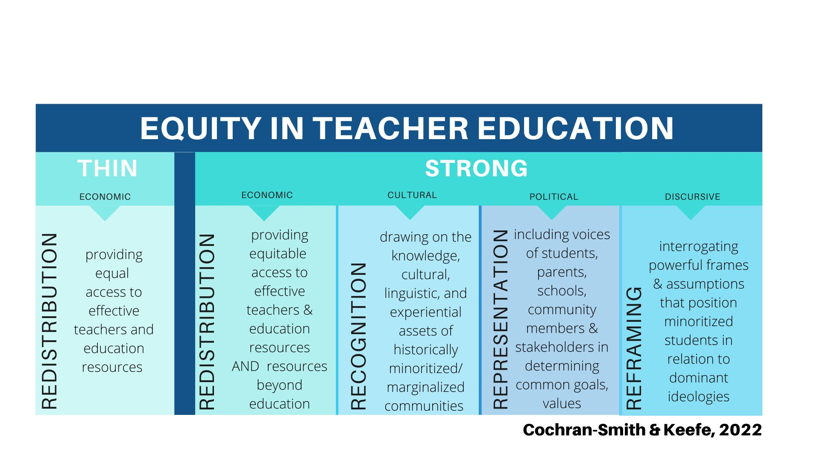

Equity in Teacher Education demonstrates the difference in attendance to thin equity vs. strong equity which is attributed to Cochran-Smith and Keefe (2022). Thin equity is depicted as operating in only the economic dimension and involves providing equal access to effective teachers and education resources. The interrelated dimensions of strong equity include economic, cultural, political, and discursive dimensions. In strong equity, the economic dimension, as in thin equity, involves redistribution by providing equitable access to effective teachers, education, and resources but also includes redistribution of resources beyond education. The cultural dimension engages in recognition by drawing on the knowledge, cultural, linguistic, and experiential assets of historically marginalized communities. The political dimension includes representation by including voices of students, parents, schools, community members, and stakeholders in determining common goals and values. Finally, the discursive dimension interrogates powerful frames and assumptions that position minoritized students in relation to dominant ideologies.

#### Stonehill College’s Teacher Education Graduate Program Outcomes

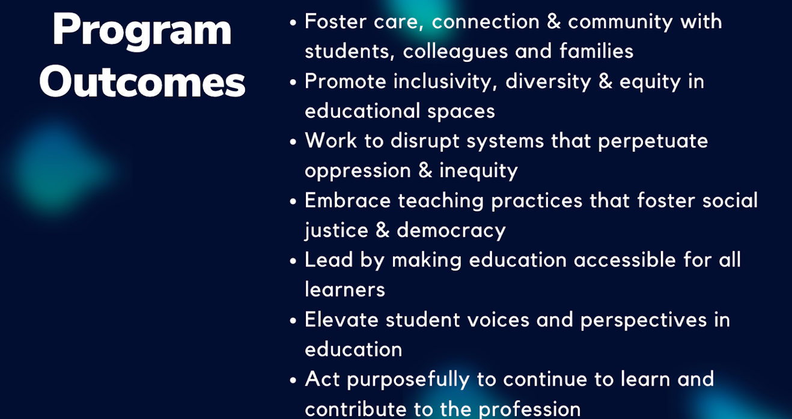

Stonehill College aims to create the above outcomes through its use of the Equity in Teacher Education Framework.

#### Stonehill College’s Example of Matrix of Learning in Practicum

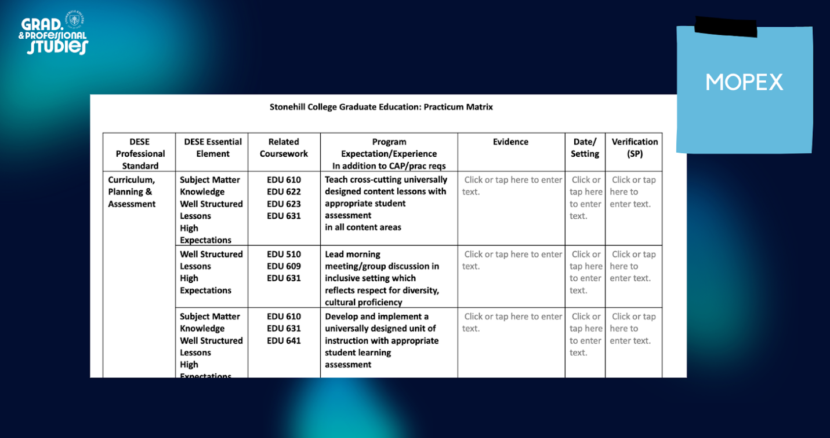

Stonehill College’s Matrix of Learning in Practicum aligns DESE Professional Standards, Candidate Assessment of Performance (CAP) Essential Elements, coursework, program expectations, experiences in addition to CAP, and practicum requirements.

**Stonehill College’s 360° Clinical Evaluation Tool Categories**

| Stonehill College’s | 360° Clinical Evaluation Tool Categories |
| --- | --- |
| School Culture | The school culture:   * values family and community. * is a cohesive community and collegial environment. * promotes diversity through representation of historically marginalized/minoritized groups. |
| Supervising Practitioner | The supervising practitioner:   * elevates student voices and perspectives in the classroom learning. * engages in continuous growth and professional learning in and outside of school. * supports and encourages the teacher candidate to develop skills and extend learning within the school and the field. |
| Program Supervisor | The program supervisor:   * prompts the teacher candidate to recognize and adjust existing systems that perpetuate educational oppression and inequity. * helps extend the teacher candidate’s teaching practices that foster social justice and democracy through feedback and coaching. * underscores the importance of elevating student voices and perspectives within the teacher candidate’s instruction. |
| Teacher Candidate | The teacher candidate:   * learns and contributes to the profession, as evidenced by engaging in professional activities above and beyond required expectations to extend their knowledge. * constructs healthy boundaries and prioritizes well-being in the classroom. * reflects the program’s mission and philosophical tenets in their teaching and in interactions with students, colleagues, and families. |

#### Stonehill College’s MTEL Plan of Action Example

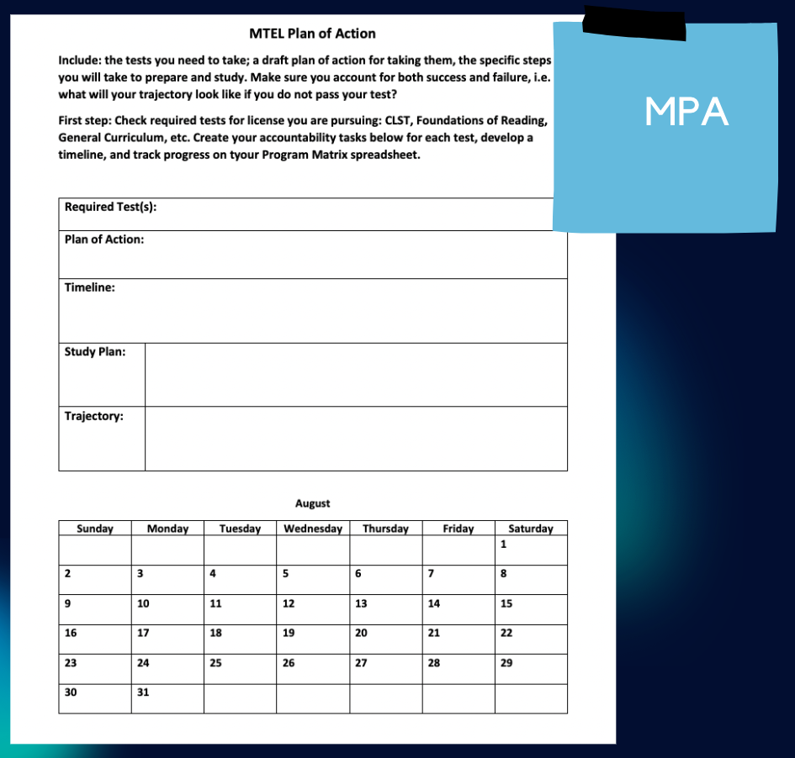

Stonehill College’s MTEL Plan of Action instructs candidates to determine the tests they need to take, create draft plan of action for taking them, and write out the specific steps they will take to prepare and study. Candidates are encouraged to account for both success and failure, i.e., what their trajectory will look like if they do not pass their test. Candidates are also asked to create accountability tasks for each test, develop a timeline, and track progress on their Program Matrix spreadsheet.

#### Springfield College Resources

#### Social-Emotional Supports for Teacher Candidates

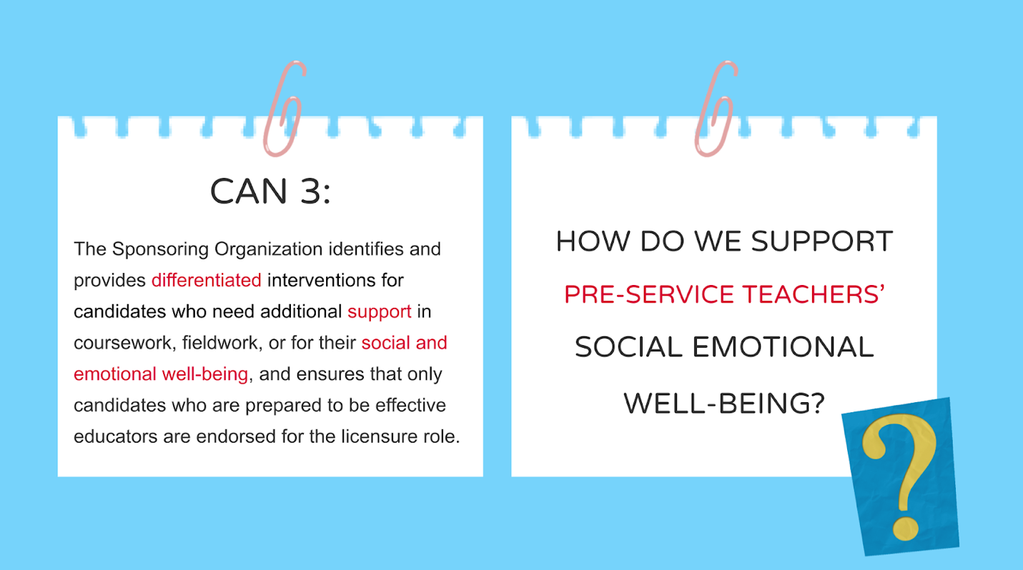

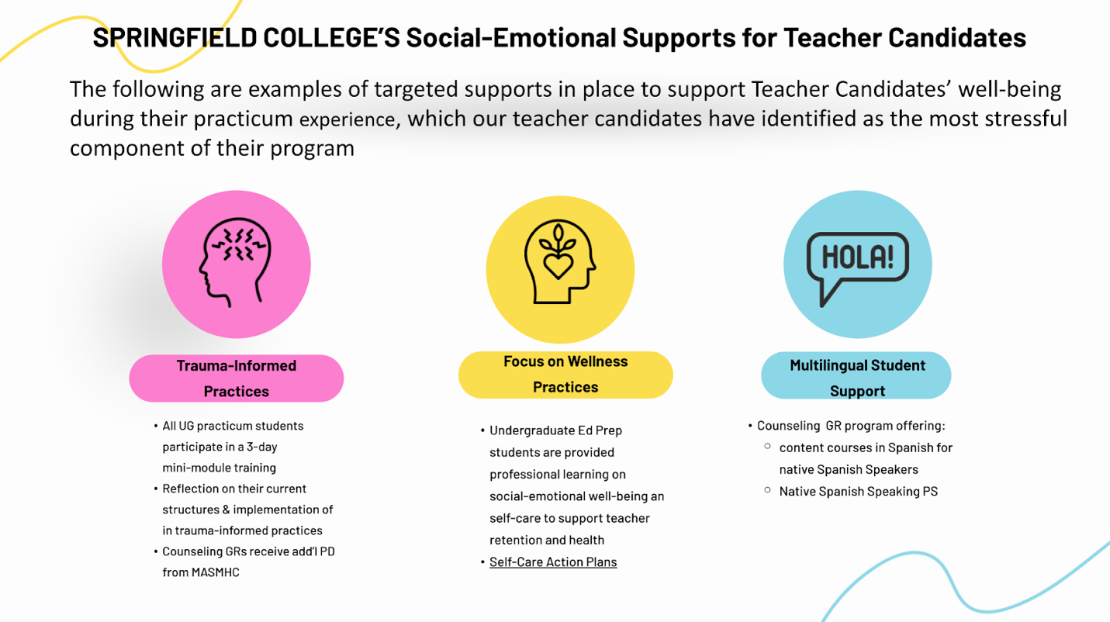

## References

References

Amos, Y. T. (2010). “They don’t want to get it!” Interaction between minority and White pre-service teachers in a multicultural education class. Multicultural Education, 17(4), 31-37.

Ballantyne, J., & Retell, J. (2020). Teaching careers: Exploring links between well-being, burnout, self-efficacy and praxis shock. Frontiers in Psychology, 10. <https://doi.org/10.3389/fpsyg.2019.02255>

Cochran-Smith, M., & Stringer Keefe, E. (2022). Strong equity: Repositioning teacher education for social change. Teachers College Record, 124(3), 9-41. <https://doi.org/10.1177/01614681221087304>.

Cochran-Smith M., Villegas A. M., Abrams L., Chavez-Moreno L., Mills T., Stern R. (2015). Critiquing teacher preparation research: An overview of the field, Part II. Journal of Teacher Education, 66(2), 109–121.

Crenshaw, A., & Yusuf, A. (2024). Do You See Me? An Examination of Black Pre-Service Teacher Experiences in a Teacher Preparation Program. Journal of Education, 00220574231190934.

Farley, A. N., Clayton, G., & Kaka, S. J. (2018). Linking teacher education to redesigned systems of accountability: A call for multiple measures in pre-service teacher effectiveness. Education policy analysis archives, 26(12).

Foran, J., & Mee, M. (2019). Improving Teacher Candidate Readiness through Enhanced Articulation and Targeted Assistance. School-University Partnerships, 12(2), 42-49.

Gist, C. D. (2017). Voices of aspiring teachers of color: Unraveling the double bind in teacher education. Urban Education, 52, 927-956.

Goe, L., & Roth, A. (2019). Strategies for supporting educator preparation programs’ efforts to attract, admit, support, and graduate teacher candidates from underrepresented groups. Research Memorandum No. RM-19-03). Princeton, NJ: Educational Testing Service.

Hill-Jackson, V. (2023). Three approaches to school-university partnerships among teacher residencies: can HBCUs lead the way to an equity-centric model?. School-University Partnerships (ahead-of-print). <https://doi.org/10.1108/SUP-08-2023-0030>

Holyoke, E., Wetzel, M. M., Dunham, H., Alexander, K., Collins, C., & Hills, L. E. (2023). Creating Equity-Focused Networks of Support for Teacher Candidates through Coaching: A Design-Development Study. Educational Research and Development Journal, 26(2), 41-61.

Kohli, R., Dover, A.G., Jayakumar, U.M., Lee, D., Henning, N., Comeaux, E., Nevárez, A., Hipolito, E., Carreno Cortez, A. & Vizcarra, M., (2022). Toward a healthy racial climate: Systemically centering the well-being of teacher candidates of color. Journal of Teacher Education, 73(1), 52-65.

Kumashiro, K. K. (2013). Against common sense: Teaching and learning toward social justice. Routledge.

Madonna, J (2024). Preparing Teachers for Praxis Shock Through Pre-Service Teacher Preparation Programs (Publication No. 31140346) [Doctoral dissertation, Northeastern University]. ProQuest LLC.

Marchitello, M., & Trinidad, J. (2019). Preparing teachers for diverse schools: Lessons from minority serving institutions. Bellwether Education Partners. Pizarro, M., & Kohli, R. (2020). “I stopped sleeping”: Teachers of color and the impact of racial battle fatigue. Urban Education, 55(7), 967-991.

Quay, S., & Lockwood, M. (2019). Sustaining a continuous improvement culture in educator preparation: A higher education network based on data wise. Journal of Practitioner Research, 4(1), 3.

Reusser, J., Butler, L., Symonds, M., Vetter, R., & Wall, T. J. (2007). An assessment system for teacher education program quality improvement. International Journal of Educational Management, 21(2), 105-113.

Rodriguez-Mojica, C., Rodela, K. C., & Ott, C. (2020). “I didn’t wanna believe it was a race issue”: Student teaching experiences of preservice teachers of color. The Urban Review, 52(3), 435-457.

Sallese, M. R., Fogarty, M., Whiteside, E., & Montague, M. (2023). Multi-tiered system of supports for teacher preparation: A framework to attract, retain, and prepare special educators. Journal of Special Education Preparation, 3(1), 34-45.

Sharp, W. (2015). Chapter 9: Consultation with Teachers. In Psychoanalytic Counseling: An Evidence Based Appraoch (pp.124-157). Cognella.

Strom, K., & Martin, A. D. (2016). Pursuing lines of flight: Enacting equity-based preservice teacher learning in first-year teaching. Policy futures in education, 14(2), 252-273.

Temponi, C. (2005). Continuous improvement framework: implications for academia. Quality assurance in education, 13(1), 17-36.

Torre Gibney, D., Rutherford-Quach, S., Milby, A., Lam, A., & White, M.E. (2020). Building strong partnerships to improve clinically oriented teacher preparation. WestEd.

Wexler, L.J. (2020). ‘I would be a completely different teacher if I had been with a different mentor’: Ways in which educative mentoring matters as novices learn to teach. Professional Development in Education, 46(2), 211-228. <https://doi.org/10.1080/19415257.2019.1573375>

White, M. E., Hirschboeck, K., Donahue, C., & Torre Gibney, D. (2020). Strengthening the data use and continuous improvement capacity of teacher preparation programs. WestEd.