Follow-Up Inquiry Stage Overview and Purpose
This planning guide provides an overview of the Follow-Up Inquiry stage of the Formal Review process. The Follow-Up Inquiry gives sponsoring organizations (SOs) an opportunity to provide written responses and/or additional documentation to address gaps or inconsistencies and elevate strengths that were identified based on a review of evidence collected during the Initial Inquiry stage.
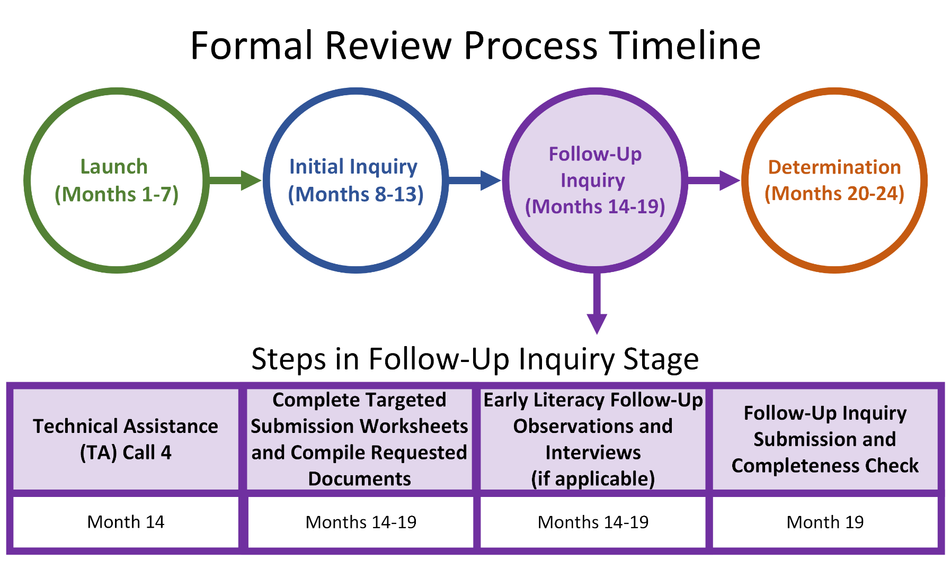

Tailoring of the Follow-Up Inquiry
To prepare the Follow-Up Inquiry, DESE and the review team review all evidence collected through the sources listed below and tailor the Follow-Up Inquiry to each SO (see decision-making chart below). DESE requests additional evidence for each criterion with gaps or inconsistencies in the evidence collected or with strong practices that may lead to a commendation. For any criterion where the data indicates that the expectation is being met consistently and effectively across programs and stakeholder groups, additional evidence is not required in the Follow-Up Inquiry. Even if not requested by DESE, the SO may choose to submit additional evidence in support of a commendation if they believe their practices would serve as a model for other SOs.
Evidence Sources:
- Program Overview Worksheet
- Early Literacy Matrix (if applicable)
- Required Documents
- Candidate Artifacts
- State-Collected Data:
  - EP701 or EP902 Educator Prep Program Cohort Pipeline
  - EP703 or EP902 MTEL Pass and Retake Rates
  - EP703 PAL Pass and Retake Rates
  - EP703 or CAP Data Dashboard
  - EP703 or EP902 Employment and Educator Evaluation
- Welcome Meeting
- Interviews:
  - Advising Staff Interview
  - Field-Based Experiences Staff Interview
  - Leadership Interview
  - Literacy Faculty (if applicable)
- Surveys and Focus Groups:
  - Candidate/Completer Survey and Focus Groups
  - Educator Preparation Personnel Survey and Focus Groups
  - PK-12 Partner Survey and Focus Group
  - Supervising Practitioner Survey and Focus Group

Follow-Up Inquiry Decision-Making Flowchart
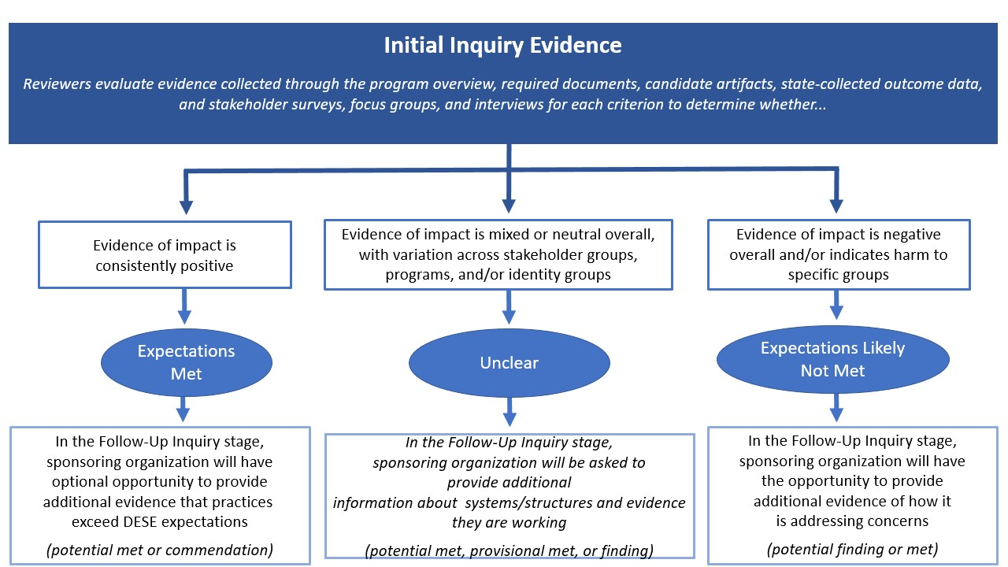

Step-by-Step Guide for the Follow-Up Inquiry Stage
Step 1: Technical Assistance (TA) Call 4
Step 2: Complete Targeted Submission and Compile Requested Documents
Targeted Submission Worksheet Overview
Step 3: Early Literacy Follow-Up Observations and/or Interviews (if applicable)
Step 4: Follow-Up Inquiry Submission and Completeness Check

Step 1: Technical Assistance Call 4

What happens during this step?
- DESE leads a call with the SO to provide an orientation to the Follow-Up Inquiry worksheets, requested artifacts, and any additional evidence collection requested in this stage. DESE also provides expectations and tips for completing the Follow-Up Inquiry worksheets and submitting all requested documents or artifacts.

When does this step happen?
- Month 14

Important Details
- During the call, DESE pulls up specific components of the Follow-Up Inquiry to orient the SO to the worksheets.
- For SOs with Elementary, Early Childhood, Moderate Disabilities PK-2, and Moderate Disabilities PK-8 programs,, DESE will provide an overview of any additional evidence collection, including observations of additional literacy coursework, field-based experiences, or additional interviews with faculty, personnel, district partners, or candidates.
  - The SO’s early literacy review designee should join this call.
- Following the TA call, DESE provides the SO with an individual worksheet for each domain as well as an overview document detailing all components included in their Follow-Up Inquiry. Your DESE Specialist will be available to answer any questions that arise from a more detailed review of your Follow-Up Inquiry.
  - For SOs with Elementary, Early Childhood, Moderate Disabilities PK-2, and Moderate Disabilities PK-8 programs, the INS, PAR, and FBE domain worksheets will include an Early Literacy section with questions specifically geared toward evidence collection for the Early Literacy Program Approval Criteria. A DESE content specialist will join the TA call to answer any questions about these sections.

Deliverables
- Send list of SO personnel who will be joining the TA call, including key individuals completing the Targeted Submission worksheets and/or assembling the requested documents and artifacts.

Step 2: Complete Targeted Submission Worksheets and Compile Requested Documents

What happens during this step?
- The SO completes each Targeted Submission worksheet and collects the requested documents or artifacts.
- The SO submits the completed materials electronically.

When does this step occur?
- Months 14-19

Important Details
- DESE provides a tailored worksheet for each domain. The set of worksheets is referred to as the Targeted Submission.
- At the top of each worksheet is a summary of the included criteria and requested documents.
  - For SOs with Elementary, Early Childhood, Moderate Disabilities PK-2, and Moderate Disabilities PK-8 programs, this summary may include the Early Literacy Program Approval Criteria.
- For each criterion included in the Follow-Up Inquiry, DESE provides a summary of key evidence collected in the Initial Inquiry. The summary is intended to reflect specific evidence or gaps in the evidence that led to the criterion’s inclusion in the Follow-Up Inquiry. The summary may not reflect the totality of evidence collected through the Initial Inquiry.
- Responses should speak to recent decisions or current organizational practices/structures/systems that address the criterion. The SO may also speak to plans to design such systems if it is clearly indicated that the response refers to future plans rather than existing structures. The SO should not manufacture artifacts for the sole purpose of this review. If it does not have additional evidence or artifacts for a specific criterion, simply state that in the response box.
- Judgments for each criterion and domain will be reflected in the Final Report. All judgments are made based on triangulation of the totality of evidence collected across each stage of the review, with evidence of impact weighted most heavily.

Helpful Tips
- To ensure your responses are clear, ask a colleague to read each worksheet and identify any areas where clarification may be helpful to support the review team.

Deliverables
- A specific list of deliverables will be provided to each SO during the TA Call 3. Deliverables will include:
  - A completed cover sheet attesting to the accuracy of the evidence provided through the Follow-Up Inquiry;
  - A completed worksheet for each domain and each program grouping in the Instruction domain;
  - Clearly labeled requested documents; and
  - Clearly labeled linked evidence sources (see below for expectations regarding any linked materials).

Targeted Submission Worksheet Overview
During TA Call 3, DESE provides the SO with a Targeted Submission worksheet for each domain (and each program grouping in the Instruction domain) as well as an overview document detailing all components included in the Follow-Up Inquiry. Each Targeted Submission worksheet follows a similar structure and will be tailored to reflect the evidence collected through the Initial Inquiry. Each worksheet includes:
- Follow-Up Inquiry Overview: A table listing each criterion included in the Follow-Up Inquiry, whether it is included to address gaps in the evidence or as an opportunity for a commendation, and any additional requested artifacts.
- Targeted Submission Questions for each Criterion: A section for each criterion included in the Follow-Up Inquiry including a summary of key Initial Inquiry evidence and a series of questions to collect additional evidence from the SO.
- Additional Documents Table: A table at the end where the SO can list any documents or resources linked in a written response.
Commendations
For any criterion where the review team finds that data is consistently positive and may indicate exceptional and/or innovative practices that exceed the expectations set in the Program Approval Criteria (including the Early Literacy Program Approval Criteria where applicable), DESE may request additional documentation to be reviewed in order to elevate the criterion to a commendation. The SO may also choose to submit evidence for additional criteria if it feels that its practices may warrant a commendation.

Follow-Up Inquiry Overview
The first page of each Targeted Submission worksheet provides a list of all criteria within the domain and a summary of the information requested in the Follow-Up Inquiry. In the middle column, DESE indicates whether, based on the review of Initial Inquiry evidence, each criterion is:
- Not included in the worksheet because there is sufficient evidence that the SO is meeting that expectation;
- Included in the worksheet to allow the SO to address any gaps or inconsistencies identified in the evidence collected; or
- Included in the worksheet based on strengths identified in the evidence collected to provide an opportunity for the SO to elevate practices or outcomes that may warrant a commendation.
In addition to written responses to prompts included in the worksheet, DESE may request additional documents and/or artifacts. These may include, but are not limited to, candidate artifacts; documentation of SO systems and structures such as budgets or meeting agendas; and detailed course information such as syllabi or SMK matrices. Any additional materials required will be listed under the criterion for which they will be reviewed.
A sample screenshot of the ORG domain Targeted Submission worksheet is below.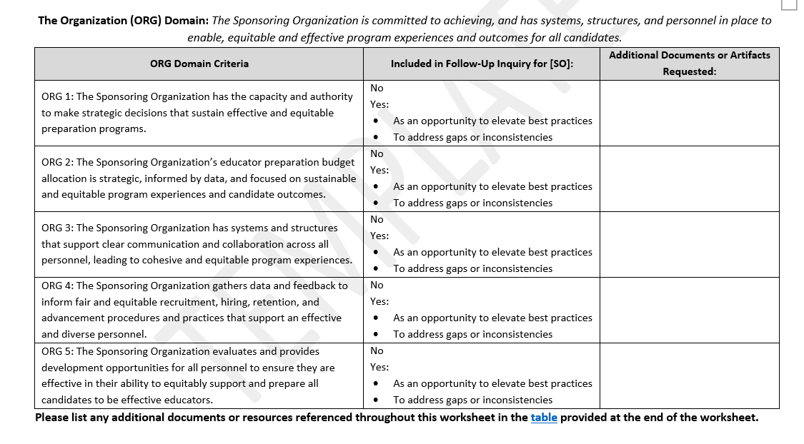

Targeted Submission Questions for Each Criterion
For each criterion included in the Follow-Up Inquiry, the Targeted Submission worksheet includes a section summarizing key evidence from the Initial Inquiry and requesting written responses with additional evidence from the SO.
Initial Inquiry Summary
For each criterion, DESE lists the sources of evidence where the criterion is likely to be addressed most explicitly in the Initial Inquiry. Additional sources of evidence (e.g., other focus groups) may be referenced if they align with the expectations described in a specific criterion.
Below this list, DESE summarizes key evidence collected in the Initial Inquiry. This summary elevates the gaps, inconsistencies, or promising practices that the SO should prioritize in the evidence it shares through the Follow-Up Inquiry. This summary does not reflect the totality of evidence collected through the Initial Inquiry.

A sample screenshot of the Initial Inquiry Summary is below.
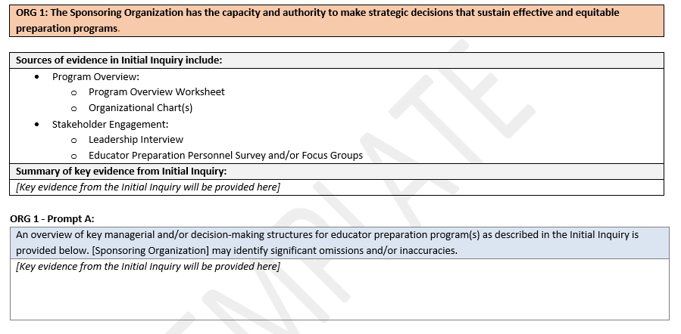
Prompt A: For most criteria, Prompt A provides a summary of the key systems or structures that were described throughout the Initial Inquiry as contributing to the SO meeting the expectation described. This is intended to provide the SO with space to identify omissions or errors in the evidence that may be critical to understanding responses to the following prompts. The suggested length for responses to Prompt A is 150 words.

Additional Prompts – Specific Examples
Following Prompt A are additional prompts soliciting evidence of how the SO is meeting the expectations and how it is measuring the impact of its systems, structures, or decisions related to the criterion. For each response, evidence that is specific and closely aligned to the criterion will be most informative.
Depending on the criterion, the prompts ask for example decisions or example systems/structures that illustrate how the SO is meeting the expectation, its intended impact, and how the SO is monitoring whether those systems, structures, or decisions are contributing to effective preparation and/or increasingly equitable experiences and outcomes for all candidates. Each prompt includes space for up to three examples.
Example decision  OR  Key system or structure, including frequency and participating group(s) | What evidence led your organization to make this decision?  OR  What evidence led your organization to establish this system/structure?  (Optional if the system/structure has existed for three or more years) | What was the intended impact of this [decision or system/structure]? | What evidence demonstrates that (or will be used to monitor whether) this [decision or system/structure] is supporting the [criterion-specific language about effective preparation]?  If applicable, describe the actions your organization is taking to address evidence that this decision is not having its intended impact. | What evidence demonstrates that (or will be used to monitor whether) this [decision or system/structure] is contributing to [criterion-specific language about increasingly equitable experiences or outcomes for candidates]?  If applicable, describe the actions your organization is taking to address evidence that this decision is not having its intended impact.

Key Details for Completing the Targeted Submission Worksheets:
- In addition to the sample prompts above, some criteria include additional or different prompts to better understand the SO’s approach to meeting the expectations.
- If the SO wishes to submit evidence for consideration of a commendation, the evidence must demonstrate how the SO is exceeding expectations. This may include evidence of innovative practices or evidence of exceptionally positive outcomes.
- SOs are not required to provide answers in each column or prompt, nor is it necessary to provide three examples for each set of prompts. If an SO does not have examples or evidence aligned with each prompt or column within a prompt, this does not necessarily mean that the criteria will be a finding. DESE and the review team considers the totality of evidence presented when making judgments. There may be instances in which an SO demonstrates sufficient evidence supporting the criterion using fewer than three examples.
- Responses should be succinct; one to two paragraphs or several bullet points typically provide the appropriate level of detail.
- In addition to providing a brief description of the evidence, the SO may choose to link to raw data and/or notes from the analysis of the evidence. For all linked materials, please provide the specific page number(s) or section to reference. Links should only be added if the additional evidence provides crucial information beyond what can be shared in the written response (see below). In most instances, including raw data sets is not necessary and does not improve the review team’s understanding of the SO’s practices.

Additional Documents Table
At the end of each worksheet, there is a table for the SO to list any additional documents or resources linked in a written response to the prompts on that worksheet. This table makes clear to the DESE Specialist and review team the set of materials to be reviewed, how each additional document aligns to a criterion, and specifically where within each document the relevant evidence can be found.
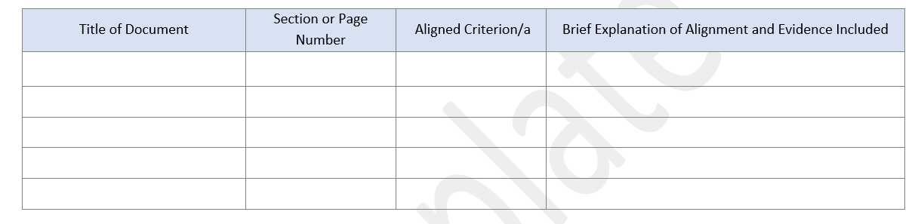
Expectations for Including Additional Documents or Resources
While there are circumstances that warrant additional documents or resources, they should be included sparingly. The DESE Specialist will review all additional materials as part of the Completeness Check (see below) and will communicate any instances where additional specificity in the purpose or section of the document must be included. If an additional document does not align with the expectations below, DESE and the review team may not consider it as evidence.
When linking to additional documents or artifacts:
- Be very specific in identifying the section or page number where relevant evidence can be found.
- Ensure the additional document or artifact adds to, rather than duplicates, the evidence described in the prompt.
- Ensure the additional document or artifact provides key information that will directly inform the review team’s judgments at the criterion level.

When including survey, evaluation, or other data sources:
- Ensure the additional information is not duplicative of the evidence in the written response.
- Rather than including raw results for each data point, include key data points.
- Include data that is specific to the criterion and can directly inform the review team’s judgments at the criterion level.
- Always include what your SO’s takeaways are from those data or how the data is being used by your SO.
Helpful Tips: While not required, using the recommendations below will help DESE and the review team triangulate the additional data with the data collected by DESE during the Initial Inquiry:
- Use language directly from DESE’s Program Approval Criteria to design survey items or other mechanisms for collecting data.
- Use DESE’s survey scales (agree, somewhat agree, neither agree nor disagree, somewhat disagree, disagree) and include the full distribution of responses.
- Include n-sizes for all relevant data sources.
- Disaggregate data collected from different stakeholder groups or program groupings used within the formal review.

Note: For New Programs, generally DESE will request the following:
- Instruction Worksheets
- Programs of Study
- Course Descriptions
- Course Syllabi
- PST/PSI Matrices (if applicable)
- Cross-Cutting SMK Matrices (if applicable)
- SMK Matrices (if applicable)
- Early Literacy Matrices (if applicable)

Step 3 (if applicable): Early Literacy Follow-Up Observations and Interviews

What happens during this step?
- DESE may conduct additional observations of early literacy coursework and field-based experiences to collect additional evidence that may address gaps or inconsistencies in the evidence collected during the Initial Inquiry.
- DESE may conduct additional interviews with faculty, personnel, district partners, and/or candidates to collect additional evidence that may address gaps or inconsistencies in the evidence collected during the Initial Inquiry.

When does this step occur?
- Months 14 - 19

Important Details
- DESE Literacy Content specialists will coordinate scheduling additional observations, interviews, and/or focus groups.
- All observations will be conducted by DESE Literacy Content specialist(s).

Deliverables
- If applicable, complete the Observation Schedule Template.
- If applicable, notify PK-12 schools of the observation schedule so they know to expect the DESE Literacy Content Specialist(s).
- If applicable, complete a Focus Group/Interview Schedule Template.
- Notify impacted early literacy faculty, field supervisors, candidates, and completers.

Step 4: Follow-Up Inquiry Submission and Completeness Check

What happens during this step?
- The DESE Specialist reviews the Targeted Submission to ensure all of the items are completed, clearly labeled, and aligned with the expectations for the submission. If any changes need to be made before the Follow-Up Inquiry materials can be reviewed, DESE will notify the SO.
- The SO will have approximately one month to complete any necessary revisions.

When does this step occur?
- Month 19

Important Details
- The DESE Specialist does not review any component of the submission for the quality or alignment of evidence provided. All feedback will be narrowly focused on the completeness of the submission.
- If significant revisions are required to complete the Follow-Up Inquiry submission, DESE will schedule a call with the SO to review the submission expectations and required revisions.

Deliverables
- If required, review DESE feedback and make necessary revisions to ensure the completeness of the Follow-Up Inquiry submission.
- If required, participate in a call with DESE to ensure expectations and required revisions are clear.
- Upload the revised submission.

