CONTRACT

between the

AGAWAM SCHOOL COMMITTEE

and the

AGAWAM EDUCATION ASSOCIATION

affiliated with the

MTA and the NEA

September 1, 2019

to

August 31, 2022
ALPHABETICAL INDEX

 | Page(s)
Adoption Leave | 29
Agreement | 6
Application to Fill a Vacancy | 27
Assignments | 24
Attendance at Summer School | 24
Bereavement Leave | 23-24
Changes in Salary Scale Level | 11
Class Size | 20
Classroom Money | 14
Coaches | 43-46
Committee Meetings (Minutes) | 7
Compensation | 40-51
Conferences (Association) | 7
Curriculum Development/Curriculum Structure | 30-31
Deductions | 16
Drug-Free Workplace Act | 37
Early Release Time | 29-30
Early Retirement Incentive | 28
Evaluations and Personnel Files | 8-9
Evening Meetings | 18
Extracurricular Compensation | 47-49
Grievance Procedure | 34-36
Guidance Counselors | 20-21
Insurance | 27
Involuntary Transfers | 25
Jury Duty | 24
Just Cause | 9-10
Leaves and Absences | 22-24
Longevity | 15
Memorandum of Agreement – Team Teaching | Appendix
Memorandum of Agreement –Teacher Evaluation | Appendix
Memorandum of Agreement – Health Insurance | Appendix
Maternity Leave | 28-29

Alphabetical Index (cont’d) | Page(s)
New Positions | 25
Non-Discrimination | 38
Paternity Leave | 28-29
Personal Business Leave | 23
Placement of Newly Hired Teachers on Salary Schedule | 52
Posting | 26
Preamble | 6
Preparation Periods, Elementary | 34
Printing of Agreement | 7
Professional Days | 30
Professional Development | 12-13
Promotions | 26
Protection of Teachers | 16
Recall from Lay-Off | 33
Recognition | 6
Reduction in Force | 31-34
Request for Transfer | 25
Required Courses | 11-12
RETELL | 38
Sabbatical Leave | 16-17
Salaries and Increments | 14-15
Salary Schedules | 40-51
Savings Clause | 39
School Committee Authority | 39
School Hours | 17-18
Seniority | 32
Sick Leave | 22-23
Sick Leave Buy Back | 27
Statutory Leave | 15
Teaching Hours and Teaching Loads | 17-21
Teacher Transfers and Assignments | 24-25
Term of Agreement | 7
Travel Expense | 20
Use of the Buildings | 8
Use of Preparation Time | 26
Work Stoppage | 8
Work Year | 17
Worker’s Compensation | 10

INDEX BY ARTICLE
Agreement | 6
Article 1 Recognition - | 6
Article 2 Preamble – | 6
Article 3 Term of Agreement – | 7
Article 4 Printing – | 7
Article 5 Conferences – | 7
Article 6 Committee Meetings – | 7
Article 7 Use of Building – | 8
Article 8 Work Stoppage – | 8
Article 9 Evaluations and Personnel Files – | 8-9
Article 10 Just Cause – | 9-10
Article 11 Worker’s Compensation – | 10
Article 12 Master’s Degree Level – | 10
Article 13 Placement Beyond Master’s Level – | 11
Article 14 Changes in Salary Scale Level – | 11
Article 15 Required Courses – | 11-12
Article 15A Professional Development - | 12-13
Article 16 Classroom Money – | 14
Article 17 Salaries and Increments – | 14-15
Article 18 Statutory Leave - | 15
Article 19 Longevity – | 15
Article 20 Deductions – | 16
Article 21 Protection of Teachers – | 16
Article 22 Sabbatical Leave – | 16-17
Article 23 Teaching Hours and Teaching Load – | 17-21
Article 24 Leaves and Absences – | 22-24
Article 25 Teacher Transfers and Assignments – | 24-25
Article 26 New Positions – | 25
Article 27 Use of Preparation Time – | 26
Article 28 Promotions – | 26
Article 29 Posting – | 26
Article 30 Application – | 27
Article 31 Insurance – | 27
Article 32 Payment for Accumulated Sick Leave Upon Retirement – | 27
Article 32A Early Retirement Incentive – | 28
Article 33 Maternity, Paternity, or Adoption Leave – | 28-29
Article 34 Teacher Assistants – | 29
Article 35 Early Release Time – | 29-30
Article 36 Professional Days – | 20
Article 37 Curriculum Development/Curriculum Structure | 20-31
Article 38 Reduction in Force – | 31-34

Index by Article (cont’d)

Article 39 Preparation Periods of Elementary Classroom Teachers – | 34
Article 40 Grievance Procedure – | 34-36
Article 41 Drug-Free Workplace Act – | 37
Article 42 RETELL | 38
Article 43 Non-Discrimination – | 38
Article 44 Reopening of Negotiations During the Life of the Contract | 38
Article 45 School Committee Authority – | 39
Article 46 Savings Clause – | 39
Article 47 Compensation Schedules – | 40-51
Appendix A Placement of Newly Hired Teachers on Salary Schedule | 52
Addendum A Memorandum of Agreement – Team Teaching | 53
Addendum B Memorandum of Agreement – Teacher Evaluation | 54
Addendum C Memorandum of Agreement – Health Insurance | 55-56

AGREEMENT

Pursuant to the provisions of General Laws Chapter 150E, this Agreement is made and entered into by and between the School Committee of the Town of Agawam, hereinafter referred to and designated as the Committee and the Agawam Education Association, Unit A, a voluntary association formed by certain individuals employed by the Town of Agawam School System, hereinafter referred to and designated as the Association.

Article 1
RECOGNITION

- The Committee recognizes the Association for the purpose of professional negotiation as the exclusive representative of certain members of the present entire professional staff below the rank of Superintendent, Assistant Superintendent, Principal, Assistant Principal Director, and School Business Administrator.

- For the purpose of this Agreement, teachers include Speech Pathologist, Occupational Therapist, Behavior Specialist, Interventionist, Instructional Coach, Math Coach, Educational Team Facilitator, ELA Coach, Lead Teacher, Librarian, School Counselors, and School Psychologists. Teachers in the regular Agawam Evening Adult Education classes, Agawam Extended Year Program for Special Education, and the Agawam Summer School Program are not part of the bargaining unit.

- The Association agrees to represent equally, all members of the professional staff without regard to membership status, race, color, sex, pregnancy or pregnancy related condition, religion, national origin, age, handicap, gender identity, or sexual orientation.

- The Committee or Association may, at their discretion, appoint a single representative or a group of representatives for the purpose of such negotiation.

Article 2
PREAMBLE

Recognizing that our prime purpose is to provide the highest quality education for the children of Agawam and that good morale within the professional staff of the Agawam Public Schools is essential to the achievement of that purpose, the Committee and the Association, parties to this Agreement declare that:

- The Committee, elected by the citizens of the Town of Agawam, has final responsibility for establishing the educational policies of the Public Schools, and nothing herein contained is intended to limit the right or discretion inherent in the Committee by law.

- The Superintendent of Schools of the Town of Agawam, hereinafter referred to and designated as the Superintendent, has the responsibility for carrying out the policies established by the Committee.

- The teaching staff of the Public Schools of Agawam has the responsibility for providing education of the highest possible quality in the schools.

- Fulfillment of these responsibilities can be facilitated and supported by consultations and free exchanges of views and information between the Committee, the Superintendent and the professional staff in the formulation and application of policies related to salaries, hours, and other conditions of employment.

Article 3

TERM OF AGREEMENT

This Agreement shall remain in effect for the period of three (3) years commencing September 1, 2019 and ending on August 31, 2022. Following a timely request for negotiations, the School Committee will meet promptly with the Association.

Article 4

PRINTING

One-half (1/2) of the cost of printing this Agreement will be paid for by the Committee. The Association will arrange for printing copies for new bargaining unit members, and a minimum number of copies deemed necessary by mutual agreement of the parties.

Article 5

CONFERENCES

The Association may be represented at conferences up to a total of ten (10) teacher days at the discretion of the Superintendent.

Article 6

COMMITTEE MEETINGS

The Committee will supply to the Executive Director and the President of the Association, a copy of the Final Minutes of the Committee Meetings.

Article 7

USE OF THE BUILDING

The Committee agrees that the Association may use school buildings for meetings during the term of this Agreement with the permission of the principal of the building and the Superintendent. The Association has the right to use the bulletin boards located in the teachers’ rooms and to place Association literature in the teachers’ mailboxes with the approval of the building principal.

The Association is to be allowed one (1) hour between the hours of 9 a.m. and 2 p.m. for Association business on orientation day.

Article 8

WORK STOPPAGE

The Association and the Committee recognize that strikes, slow-downs, withholding of services and other forms of work stoppages by the persons covered by this Agreement are contrary to law. The Association and Committee agree that differences shall be resolved by peaceful and appropriate means without interruptions to the school program. The Association, therefore, agrees that there shall be no strikes, work stoppages, slow-downs, withholding of services or other concerted refusal to perform work by any of the employees covered by this Agreement.

The Association agrees that if the current “no strike law” contained in General Laws Chapter 150E, Section 9A is amended so that strikes, work stoppages, slow-downs and withholding of services are permissible by the employees covered by this Agreement, then the Association agrees not to avail itself of the provisions of any amended law for the duration of this Agreement.

Article 9

EVALUATIONS AND PERSONNEL FILES

- Each teacher shall be shown his/her evaluation report and shall have the opportunity to discuss this report with his/her supervisor or principal. After such discussion, the teacher shall sign the report, but the teacher’s signature does not necessarily indicate agreement with the report’s content. The teacher may request a delay of one (1) day prior to the signing and filing of such report. The teacher may file a separate companion report or response to be attached to the evaluation form before it is placed in his/her personnel file. (The evaluation report shall indicate whether or not a companion report was filed.)

- At the request of the teacher, he/she is to be provided with a copy of any formal evaluation reports.

- The granting of any salary increment as set forth in the salary schedule shall not be deemed to be automatic; and if withheld, the employee shall be given a written notice with reasons no later than April 1. The Superintendent shall have the power to recommend to the School Committee the withholding of any salary increment for inefficiency or for other good cause. The withholding of any salary increment shall be subject to the grievance procedure.

- Upon written request, each teacher has the right to review the contents of his/her personnel file, excluding confidential references received prior to his/her employment. At the teacher’s request, a representative of the Association may accompany the teacher in such review. The review shall be made in the presence of the person responsible for the safekeeping of such file. Facilities shall be made available for the teacher to make photocopies of such contents and records, except in circumstances beyond the control of administration.

- If any material of an evaluative nature concerning a teacher’s performance is inserted into his/her personnel file, the teacher will be notified and given a copy of said material. If the teacher so elects, he/she will have the right to respond, in writing, to any such material and such response will be included in the personnel file.

- Any reprimand or discipline of a teacher by a supervisor or administrator shall be done in a manner that will not embarrass the teacher before other employees, pupils, parents or the public.

- The Evaluator shall provide the teacher with written feedback within ten (10) work days of an observation.

- The Association and the Committee agree to form a subcommittee made up of equal numbers from each side for the express purpose of analyzing the current elementary assessment system. The subcommittee shall hold their first meeting within thirty (30) days of September 12, 2019. The meetings shall be open to the public. The subcommittee shall present a plan to the respective bargaining teams no later than May 29, 2020. If agreement is reached regarding the plan, the plan will be implemented by September of 2020.

Article 10

JUST CAUSE

- If a complaint is received by an administrator which will likely result in the reprimand or other discipline of a teacher, the teacher will be promptly notified of the complaint within seventy-two (72) hours, if possible. .

- No teacher will be reprimanded, either orally or in writing, suspended, demoted dismissed or disciplined without just cause.

- No teacher shall be suspended except under the provisions of Massachusetts General Laws, Chapter 71, Section 42D as amended from time to time.

- No teacher shall be dismissed or demoted except under the provisions of Massachusetts General Laws, Chapter 71, Section 42 as amended from time to time.

- In the event of an appeal of a teacher suspension, dismissal and/or demotion, the teacher and/or the Union may elect to appeal according to the provisions of Massachusetts General Laws, Chapter 71, Sections 42 and 42D or under the provisions of Article 41 of this Agreement, but not both.

Article 11

WORKER’S COMPENSATION

When a teacher is entitled to Worker’s Compensation because of injury arising out of or in the course of employment, the teacher may use sick leave to the extent that the teacher has accumulated sick leave pursuant to the provisions of Article 24 of this Agreement, so that when the dollar amount of the Worker’s Compensation and the accumulated sick leave are added together, the sum will equal the dollar amount of the teacher’s regular compensation.

Article 12

MASTER’S DEGREE LEVEL

New teachers may arrive at Master’s Degree level only by means of earned degree acquired from an accredited university or college. Teachers employed prior to September 1968 may work toward the Master’s Degree or equivalency and must submit to the Superintendent’s office a transcript of courses taken and plans for completion of Master’s Degree level or thirty-two (32) approved graduate credit hours beyond the Bachelor’s degree.

A second Bachelor’s degree can serve as an equivalent to the Master’s degree provided that:

- There can be no transfer of credits from prior degree work.

- The second Bachelor’s degree must be totally unrelated to the original Bachelor’s degree.

- The proposed second Bachelor’s degree courses must be submitted to the Superintendent of Schools for approval.

Article 13

PLACEMENT BEYOND MASTER’S LEVEL

In order to promote further education of teachers, those teachers who have or are eligible for an equivalency may go to Master plus 15, Master plus 30 and Master +45/CAGS by taking courses approved by the Superintendent. For the school year 2001-2002 the salary schedule will consist of five (5) levels: Bachelor’s, Bachelor’s plus 15, Master’s, Master’s plus 15, and six year level. Effective 2002-2003 the salary schedule will consist of seven (7) levels: Bachelor’s, Bachelor’s +15, Master’s, Master’s +15, Master’s +30, 45/CAGS, Doctorate. The plus 15 are graduate credits beyond the degrees in a program approved by the Superintendent.

Members of the bargaining unit who have achieved a Second (2nd) Masters Degree shall be compensated at the rate established under the agreement for Masters plus 45/CAGS. Accordingly, Articles 13 and 47 of the agreement are, by agreement, to be interpreted as including 2nd Masters as part of the MA+45/CAGS.

Article 14

CHANGES IN SALARY SCALE LEVEL

Teachers who earn sufficient credits or degrees to be placed on a different salary schedule column during any school year will be placed on new salary schedule column in September or February, as applicable. Official grades and transcripts must accompany the letter to the Superintendent requesting a salary schedule column change. Said documentation and accompanying letter must be received by the Superintendent’s Office no later than seven (7) calendar days prior to the 1st payroll of the school year in order to be placed on the new salary schedule column effective the first payroll of September, or no later than February 1 in order to be placed on the new salary schedule column effective the 14th pay period of the year. An electronic version of the official grades and transcript will be accepted for purposes of column movement so long as the Superintendent subsequently receives the official version.

Article 15

REQUIRED COURSES

Recognizing that regular improvement and self-development are necessary attributes for a teacher, the Committee and the professional staff agree that professional development should be encouraged for all members of the professional staff in whatever manner desired, available and necessary in order to properly fulfill job requirements.

Every teacher who has not achieved the M+30 level must take an approved two-credit course or its equivalent once in three years. Within twenty (20) working days of receipt of a proposed course or equivalent, the Superintendent shall grant or deny approval, in writing, to the teacher. Credit shall be given for courses previously approved by the Superintendent or his designee, which approval shall be given if the Superintendent agrees the course is:

- in the teacher’s field,

- in methods, techniques, or philosophy of classroom teaching or the individual’s special field,

- for an advanced degree in the teaching major or,

- related to the teacher’s subject area,

- other – as approved by the Superintendent.

The Committee and the Association agree that for the increment requirement, in lieu of the two-credit course, an in-service course will be made available. The Superintendent, with any designees he appoints, will institute such courses at his discretion after consulting with appropriate representatives of the teaching staff for the level and type of course to be offered. It is agreed that no more than two (2) courses shall be offered. The Superintendent may require a member of the professional staff to pursue a specific course of study. This requirement shall not be unreasonable and, if desired, written reasons for the request will be given to the individual. If a course is required, the School Committee will pay the cost of the tuition.

Another alternative way of completing the increment requirement is to accumulate vouchers totaling twenty (20) clock hours in one (1) school year by attending workshops and conferences, etc. scheduled beyond the school day. In order to qualify, the workshop or conference, etc., must be endorsed by the Committee on Professional Development and approved by the Superintendent or his/her designee.

Article 15A

PROFESSIONAL DEVELOPMENT

- The Committee and the Association on behalf of the teachers recognize their respective statutory obligations regarding professional development as set forth in Massachusetts General Laws Chapter 71, Sections 38G and 38Q, as amended from time to time. In furtherance of the current statutory obligations, the Committee will offer locally developed options related to teacher professional development plans for certification offered at no cost to the teachers.

- A Professional Development Committee consisting of four (4) members designated by the Agawam Public Schools, three (3) Curriculum Facilitators chosen by the AEA, and one (1) member designated by the AEA shall be formed. The Professional Development Committee shall be responsible for making recommendations regarding the professional development to the Superintendent.

- The locally developed options may include in-service courses, workshops and other professional development activities. The Superintendent shall institute such in-service courses, workshops and other professional development activities at his/her sole discretion after reviewing recommendations from the Professional Development Committee and assessing the needs of the school district. The Superintendent shall select the instructors and determine their necessary qualifications and compensation for in-service courses, workshops and other professional development activities at his/her sole discretion.

- Opportunities to serve as instructors for in-service courses or workshops shall be posted in every school building at least ten (10) days in advance of the date for selection of the instructor, and a copy of such posting shall be given to the President of the Association. During the summer months, such postings shall be made at the Central Office with a copy mailed to the President of the Association. If a teacher is selected as an instructor for an in-service course, workshop or other professional development activity, they shall be compensated at the rate of seventy-five dollars ($75.00) per hour for presentation time outside of the school day. For in-service courses, workshops or other professional development activities taught by two (2) or more teachers, total compensation for all teachers shall not exceed one hundred twenty-five dollars ($125.00) per hour for presentation time outside of the school day. For instruction during the regular work day, the rate of compensation shall be forty dollars ($40.00) per hour for preparation time, not to exceed the length of presentation time. For in-service courses, workshops or other professional development activities taught by two (2) or more teachers, total compensation for all teachers shall not exceed eighty dollars ($80.00) per hour for preparation time during the regular work day, not to exceed the length of presentation time.

- Individual teacher participation in the locally developed professional development activities, whether as an instructor or a course participant is voluntary.

The Agawam School Committee will reimburse up to $600 per year for a completed and paid for course per year (July-June) toward the cost of individual courses for credit, workshops and other activities supporting the recertification of each teacher that are approved in advance by the Superintendent of Schools. The teacher requesting said reimbursement shall request approval at least fourteen (14) days prior to the expected date of the course or workshop and will provide sufficient information to the Superintendent for his/her review. Approved activities should directly relate to the re-certification of the teacher and the needs of the Agawam Public Schools. Upon completion of a course and prior to receiving reimbursement, the teacher shall provide evidence to the Superintendent that she/he received a grade of “B” or better in the course; along with a receipt for proof of payment on the course taken. Upon completion of a workshop or other activity, the teacher shall provide evidence of attendance to the Superintendent. Reimbursement for a course will be credited to the fiscal year in which the course was completed. If the course overlaps two fiscal years, the employee must notify Central Office of the overlap no later than June 30th in order to be reimbursed.

- NATIONAL BOARD CERTIFICATION – Teachers who are in the process of fulfilling the requirements for National Board Certification will be allowed three (3) release days per year. The School Committee further agrees that it will compensate each teacher for the required application fee.

- If curriculum writing and/or development occurs on professional development days, teachers will receive professional development points (PDP’s) for time spent on said activity. If curriculum writing and/or development occurs during normal work time, said activity will be voluntary and teachers will receive PDP’s. If curriculum writing and/or development occurs outside of normal contractual work time, teachers can choose to receive PDP’s or compensation at the rate specified in Article 23, Section 11. In the event that only one bargaining unit member is working on single course curriculum writing, at the discretion of administration, said teacher may be allowed to perform said work off-site with agreed upon work product and amount of time in advance.

Article 16

CLASSROOM MONEY

Teachers will collect monies only for individual classroom activities. Teachers will collect money only in a sealed envelope or check from, checks to be made payable only to the school, P.T.O. or other organization, and not to the individual teacher.

Article 17

SALARIES AND INCREMENTS

- Individual salaries shall be divided into twenty-six (26) pay periods. Checks will be mailed to the homes of the teachers during periods when school is not in session.

Teachers shall be given the option of the following two (2) pay methods:

- Regular two-week period during the school year with a lump sum for summer pay to be paid on the last payroll of the fiscal year, if notified by June 1.

- 26 pays at two-week intervals.

- At the time of hire, new teachers will be informed of the anticipated date of their first paycheck.

- During certain contract years, it is possible to divide individual salaries into twenty-seven (27) pay periods. The Superintendent will notify the Association in writing on or before May 1st of the year prior to such a year that the twenty-six (26) or twenty-seven (27) pay period option exists. The Association will notify the Superintendent in writing on or before June 15th of the year prior to such a year regarding whether bargaining unit members will receive their compensation in twenty-six (26) or twenty-seven (27) pay periods. This decision will apply to all bargaining unit members except for bargaining unit members who choose option A above. If the Superintendent does not receive notification by the Association on or before June 15th, the individual salaries will be divided by twenty-six (26) pay periods.

- Increments as set forth in the salary schedule are effective September 1 annually.

- Teachers who are in service one hundred (100) or more teaching days in any school year, including sick leave, if granted by the School Committee for the teacher, shall be granted the earned increment and any special increase in accordance with the established requirements relating thereto.

- A teacher will proceed from minimum to maximum by earned increments.

Article 18

STATUTORY LEAVE

The Committee agrees to provide unpaid leave in accordance with the Small Necessities Leave Act, the Family and Medical Leave Act, and the Domestic Violence Leave Act. Employees may also be entitled to paid leave in accordance with other provisions of this Agreement, in which case, the statutory and contractual leave shall run concurrently in accordance with the current practice.

Article 19
LONGEVITY

Longevity schedule is as follows:

 | 2019-2020 | 2020-2021 | 2021-2022
Effective September 1, 2019 (and not retroactive prior to said date), End of 13th year | $1,025 | $1,075 | $1,125
End of 20th year | $1,575 | $1,625 | $1,675
End of 25th year | $1,825 | $1,875 | $1,925
End of 30th year | $2,075 | $2,125 | $2,175
Teachers who have completed the number of consecutive years (calculated from date of hire) listed in the chart above while employed in the Agawam Public Schools shall be entitled to the applicable longevity amount. In order for a year to count toward said calculation, the teacher must have actually been paid at least one hundred (100) work days during the school year.

Article 20

DEDUCTIONS

The Committee agrees that whenever duly authorized by any teacher on a form or forms approved by the Committee, and provided that accounting equipment is available, payroll deductions on behalf of such teacher shall be made every pay day and paid over in accordance with such form or forms for any or all of the following purposes:

- Association dues.

- Premiums under Agawam Employee’s Group Insurance.

- Payments to the Agawam Federal Credit Union and MTA Credit Union for premiums under any annuity contract purchased for the teacher by the Committee.

- Contributions to the Agawam Instructional Trust Fund.

- Contributions to MTA-VOTE.

F. Premiums for long-term and short-term disability insurance providers as selected by the Agawam Association Executive Board.

Article 21

PROTECTION OF TEACHERS

The Committee shall reimburse teachers for:

- The cost of any clothing and other personal property damaged or destroyed as a result of an assault suffered in the course of his/her employment.

- The cost of any medical, surgical, or hospital services over and above the amount of any insurance reimbursement and Worker’s Compensation received by said teacher, incurred as the result of any assault suffered in the course of his/her employment.

Provided that this protection shall apply only to situations in which the teacher is blameless.

Article 22

SABBATICAL LEAVE

Sabbatical leaves may be granted by the Committee for the purpose of substantially contributing to the improvement of the quality of the professional staff, subject to the following:

- Upon the recommendation of the Superintendent and the approval of the Committee, sabbatical leave may be granted to two (2) or more teachers in one year, at the discretion of the Committee.

- A request for sabbatical leave must be received by the Superintendent, in writing, on or before December 31 prior to the school year for which it is requested. The Committee shall act upon a request for sabbatical leave not later than March 1.

- The teacher must have completed at least seven (7) consecutive full school years of service in the Agawam Public Schools before said leave begins.

- Teachers on sabbatical leave will be paid 50% of their regular salary rate, provided that such pay, when added to any program grant will not exceed the regular salary rate. Salaries will be computed from September 1 of the sabbatical year.

- The teacher will agree to return to employment in the Agawam School System for one (1) full year for each college semester of sabbatical leave.

- The teacher must sign a contract agreeing to return the proportionate part of the money advanced if he or she does not return to the Agawam School System or leaves before his/her contract is fulfilled. This will be binding except for death, illness, or other circumstances beyond his or her control.

- The teacher will return to the pay schedule as though he or she has never taken leave.

Article 23

TEACHING HOURS AND TEACHING LOAD

The School Committee and the Association recognize and agree that the teacher’s responsibility to his/her students and his/her profession generally entail the performance of duties and the expenditure of time beyond the regular work day, but that time and work schedules can and should be established.

- The work year of teachers, other than new personnel who may be required to attend additional orientation sessions, will begin no earlier than September 1st and will terminate no later than June 30th, but will in no event be less than one hundred eighty three (183) work days. The one hundred and eighty three (183) day work year shall include one hundred and eighty (180) days with students. The school calendar shall also include the scheduling of five (5) emergency/inclement weather days. (For payroll purposes, fractional amounts paid or deducted shall be at the rate of 1/183 per day.)

Orientation days for other than new personnel shall be considered as scheduled work days. Any days above this limit shall be reimbursed at the 1/183 of the teacher’s contracted salary.

On the last day of the school year, teachers shall be released with the students.

- A convocation shall be scheduled for the first teacher work day. Said day shall also be used for presentations (including one hour for use by the AEA as outlined in Article VII), professional development, or other matters at the discretion of Administration. Teachers shall be allowed to work in their classrooms and have a lunch period after the conclusion of the convocation and the AEA meeting until 1:00 p.m. From 1:00 p.m. until 3:00 p.m., staff will attend professional development and/or staff meetings.

- The schedule for school hours for abnormal conditions of enrollment and housing is subject to modification by the School Committee providing that such modification will not increase the length of the teacher’s workday. Hours for normal conditions will be 7:20 a.m. to 3:30 p.m., and under any conditions will not be more than a continuous six and one-half hour’s workday except for one hour per week for scheduled consultations with parents or administrative meeting times. Teachers are required to attend administrative meetings. If a teacher cannot attend an administrative meeting, they must notify the administrator in writing in advance of the meeting. Any teacher who misses an administrative meeting will be responsible for meeting with the building administrator to review what they missed within five (5) school days of the meeting. If abuse is suspected by administration, then disciplinary action may result. Effective September 1, 2008, the teacher work day will be increased by ten (10) minutes, five (5) minutes in the morning and five (5) minutes in the afternoon (hours for normal conditions to be 7:15 a.m. to 3:35 p.m.), for a continuous workday of six hours and forty minutes, except for one hour per week for scheduled consultations with parents or administrative meeting times. A teacher at the Agawam High School shall be required to arrive in the school building five (5) minutes before the start of the student day and shall not leave the school building until five (5) minutes after student dismissal. A teacher at the Agawam Junior High School shall be required to arrive in the school building eight (8) minutes before the student day and shall not leave the school building until five (5) minutes after school dismissal. Teachers at the Agawam Middle School, the elementary schools and the Early Childhood center shall be required to arrive in the school building ten (10) minutes before the start of the student day and shall not leave the school building until ten (10) minutes after student dismissal. It is recognized that procedure for detention, emergencies, and after school help will be continued.

- Attendance at evening meetings and social affairs, except for district back to school night and district parent conferences, shall be at the option of the teacher, but the School Committee and the Association encourage participation in such meetings as part of the teacher’s responsibility. District back to school night and district parent conferences shall take place only on regularly scheduled school days and shall not exceed three (3) per year for secondary schools and three (3) per year for elementary schools. Effective September 1, 2020, an additional half-day shall be scheduled in the Spring for elementary teachers, grades K-4 only, in order to hold afternoon parent-teacher conferences in addition to the evening conferences.

- Teachers at Agawam High School shall work a seven-period day with a six-day cycle. Teachers shall teach no more than thirty (30) periods within the six-day cycle and within the six-day cycle shall have the equivalent of one (1) preparation period per day and one (1) duty period per day. Science laboratories will be counted as one of the five teaching periods or equivalent permissible per day. In addition, all teachers will mentor an Advisory Group for 30 minutes twice a month.

It shall not be the policy of the School Committee to require teachers to teach a sixth period. In situations when scheduling requirements demand the teaching of a sixth period, the vacancy will be posted. If there are no applicants and/or qualified candidates after interviews, then administration may appoint a qualified teacher to teach a sixth period. The annual stipend is $7,000.00 per school year to be prorated if less than a full school year. Teaching a sixth period must not result in a teacher teaching outside of their license area more than the percentage allowed by law, and must fit within a non-teaching period of their schedule

The teacher’s lunch period shall be a minimum of twenty (20) minutes per day free from all duties.

- Teachers at Agawam Junior High School shall work a seven (7) period day with a six (6) day cycle. Teachers shall teach no more than thirty (30) periods within the six (6) day cycle and within the six (6) day cycle shall have the equivalent of one (1) preparation period per day and one (1) supervisory class per day except that teachers of art, music, family and consumer science, health, technical education, physical education, business, resource room, and reading shall teach no more than the equivalent of six (6) periods per day and shall have the equivalent of one (1) preparation period per day with no supervisory class. The teacher’s lunch period shall be a minimum of twenty (20) minutes per day free from all duties. The parties have agreed to a Side Letter Agreement, which is attached to the contract as Addendum A.

- Teachers at the Roberta G. Doering School shall work a seven-period day with a five-day cycle. Teachers shall teach no more than twenty-five (25) periods within the five-day cycle, and within the five-day cycle shall have the equivalent of one (1) preparation period per day and one (1) supervisory period per day, except for the following: Teachers of computer, music, art, physical education, extra math, and intensive math shall teach no more than the equivalent of six (6) period per day, one (1) of which could be a supervisory period, and shall have the equivalent of one (1) preparation period per day. Teachers of Intensive Reading, Academic Support, Intensive Learning, Connections and Language-based Special Education teachers shall teach no more than six (6) periods, including teaching and flexible testing periods, and the equivalent of one (1) preparation period per day. In the event that a teacher has an unassigned period(s), said teacher may be assigned additional supervisory duty period(s). The teacher’s lunch period shall be a minimum of twenty (20) minutes per day, free from all interruptions and duties.

- Effective September 1, 2019, elementary teachers, grades K through 4, will be guaranteed a minimum of thirty (30) minutes of preparation time per day, plus an additional fifteen (15) minutes after the lunch period.

Early Childhood teachers shall be guaranteed at least five hundred (500) minutes of preparation time in a three (3) week cycle.

In addition, all elementary teachers shall have a minimum of twelve (12) personal hygiene periods of a minimum of fifteen (15) minutes each during a three (3) week cycle.

There will be a one-half (1/2) hour of uninterrupted noon lunch period, free from all duties allotted to each elementary school teacher.

Elementary teaches shall not be required to perform lunch duty or noon recess duty, and one-half of such time shall be devoted to student instruction, and the other one-half of such time shall be preparation time.

- Teachers may leave school during lunch or preparation periods. Principals may withhold this privilege with reason. The administration may establish reporting procedures for the absence of teachers from the building.

- The School Committee and the Association realize that a small class size is of advantage in the teaching process.

- Teachers who perform additional work not covered by this Agreement shall be paid at the rate of thirty-three dollars ($33.00) per hour effective September 1, 2019. Additional work is at the discretion of the teacher.

- Every teacher who is required to travel using their own motor vehicle in the performance of his/her duties will be compensated at the current IRS rate per mile. Such travel may take place to and from facilities or residences other than schools, and such travel may be to communities outside the City of Agawam. Requests for reimbursement of expenses shall be made within ten (10) days from the date a total claim for reimbursement of $25.00 or more has accrued on forms prepared for this purpose. Payment of approved travel expenses shall be made within thirty (30) days of submission of the travel voucher.

- Teachers who must stay past their normal end of the work day for joint professional development or who must arrive early before their normal work day begins for joint professional development shall be released for an equal amount of time from their weekly school building administrative meeting. Teachers affected by this schedule change shall be notified at least five (5) school days in advance.

- A. Guidance Counselors shall work 189 days per year, they shall work six (6) days which shall normally be before the opening of school or after the close of school.

- Effective September 1, 2019, Guidance Counselors will be paid for additional days in the work year on a per diem basis based upon the Guidance Counselor’s annual salary using the salary schedule in effect at that time. The per diem rate will be calculated at 1/183 of the Guidance Counselor’s salary.

- Guidance counselors will be released one day per month 2 hours earlier than the normally scheduled end of their workday. Guidance counselors will schedule evening office hours three (3) times per year, at the close of each marking period for the purpose of conferencing with parents. Evening office hours will be held in November, February, and April, and will be scheduled between 5:00 p.m. and 7:00 p.m. Middle School, Junior High School and High School guidance counselors will schedule conference evenings and during alternate nights.

- The Committee will work with the Town in order to provide teachers access to the school buildings prior to the commencement of the work year. However, it is understood that said access may not be possible each year.

- Effective September 1, 2016, teachers shall no longer be required to issue progress reports, unless said reports are required by law or regulation and/or a request is made by a parent due to lack of access to the online grading system.

- Effective September 1, 2016, Pre-K-6 teachers who administer benchmark testing shall be provided at least one (1) day of coverage at the beginning of the school year and at least one (1) day of coverage at the end of the school year for the purpose of conducting benchmark testing and/or grading tests.

- Administration and teachers have the ability to switch preparation and duty times with mutual prior agreement and without additional compensation.

- Teachers who receive a stipend for a position they hold will not get coverage pay for their prep time if they are not covering a class. For example, if they are meeting with administration regarding their stipend position, and/or conducting duties for their stipend position. Additionally, to the extent possible, work conducted for a stipend position, must be done outside of the school day.

- Duties and/or supervisories at all school levels will be rotated annually, whenever possible, as determined by building administration.

- The Committee shall continue its current practice regarding coverage pay at each building. In the case of the High School, this shall mean that bargaining unit members will receive $33 per period if they agree to perform work and/or attend a meeting requested by administration during their preparation period, provided the period of time is greater than fifteen (15) minutes.

Article 24

LEAVES AND ABSENCES

Sick Leave

- All members of the bargaining unit shall be entitled to twelve (12) days sick leave for each completed academic year. These days are to be credited to the employee at the end of each month at the rate of 1.2 days for each month of work completed. However, in order to facilitate record keeping, the payroll department will credit all employees with all twelve (12) days at the start of the academic year.

Any unused personal days, from the previously earned academic year will be credited as sick time. Due to the nature of the calculations, your sick leave will not reflect this change until the second paycheck of the current academic year.

Any unused sick leave may be accumulated with no maximum limit.

For teachers beginning employment after the start of the school year, the sick leave amount shall be prorated at the rate of 1.2 days per month.

For teachers who leave employment and who have used sick leave in excess of that which they would have earned at a rate of 1.2 days per month through the date of separation, they will have the amount of unearned used sick leave deducted from their final check.

- Sick leave shall be interpreted as:

- Illness of the teacher himself/herself.

- A maximum of twelve (12) days per school year for critical illness in the immediate family or significant other when emergency illness or injury in the family requires a teacher to make arrangements for necessary medical or nursing care.

- Extended illness of a teacher beyond his/her accumulated sick leave may be considered at the discretion of the School Committee.

- Medical examinations.

- Any other reason approved by the Superintendent.

3. After an absence of five (5) consecutive school days for sick leave or when sick leave abuse is suspected, the Superintendent or designee may require a certificate from a doctor concerning the nature and duration of the teacher’s illness.

After ten (10) days of absence during a school year and each subsequent absence, the Superintendent (or designee) may require a note from the teacher’s physician explaining the causes for the absence.

During periods of rehabilitation, the teacher shall inform administration where he/she can be reached. A teacher shall not travel or reside in an area 200 miles distant from Agawam for rehabilitation except when his/her doctor advises such travel and then only with the approval of the Superintendent.

4. Any teacher covered by this contract known to be suffering from tuberculosis in a communicable form, shall be subject to the provisions of General Laws, Chapter 71, Section 55B.

5. In the event of illness in the immediate family with whom the teacher is living, sick leave up to three (3) days may be taken from available sick days.

6. The Office of the Superintendent shall supply each teacher with a record of his/her accumulated sick leave up to June 30 of the previous school year. This information shall be supplied no later than September 30 of the current year.

Absences with Pay

- Teacher may take up to three (3) days off for personal business during the school year without loss of pay. Said days may be taken to attend to personal business which is beyond the control of the teacher and cannot readily be scheduled after school hours. Unless circumstances otherwise dictate, personal leave may not be taken on the day before or after a holiday or vacation period. If a teacher provides less than a forty-eight (48) hour notice and/or if the teacher is requesting to take a personal leave on the day before or after a holiday or vacation period, then the teacher must provide the reason for the request for leave to Principal. Failure to provide the reason in accordance with the preceding sentence will result in denial of the paid personal day. Any unused personal days will rollover to the next contract year, and will be converted to accumulated sick leave.

- Bereavement leave shall be in addition to sick or personal leave as defined above. An employee shall be granted bereavement leave of up to five (5) work days to be taken within seven (7) consecutive calendar days upon the death of their spouse, child or step-child, mother and father, step-parent, legal guardian, individual living in the employee’s immediate household; and up to three consecutive work days to be taken within five consecutive calendar days upon the death of their son-in-law, daughter-in-law, grandparent, grandchild, mother-in-law, father-in-law, brother, sister, step-brother, step-sister, and significant other. Three (3) of the bereavement days listed above may be taken within six (6) months of the death to attend a memorial service. An employee shall be granted one (1) calendar day of bereavement leave upon the death of their aunt, uncle, niece, nephew, brother-in-law, or sister-in-law for the purpose of attending the funeral. An employee may extend their bereavement leave by utilizing personal leave as described above with the advance approval of the Superintendent. The decision of the Superintendent regarding the extension of bereavement leave shall not be subject to the grievance procedure outlined in Article 41.

- If the school year is extended because of unforeseen circumstances such as days of snow and teacher attendance at summer school is required before the close of the school year, the teacher may apply to the School Committee for early release without loss of pay, and such early release shall be at the discretion of the School Committee. If the teacher receives remuneration for attendance during any day in question, his/her compensation from the Agawam Public Schools shall be reduced by that amount.

- A teacher actually serving on jury duty on a workday, or who actually reports to the Court for jury service as required by said Court for any portion of a workday, shall receive his/her regular rate of pay for each day served, reduced by the amount of jury pay, if any, received from the Court. Jury pay, however, shall not include any meal or travel expenses paid by the Court. Jury pay received for service on non-working days shall not be deducted from a teacher’s pay. Teachers are required to check with the court the night prior to scheduled jury duty to determine if they are required to appear. If not, teachers are required to report to work.

A teacher serving on jury duty shall furnish the Superintendent or designee with written documentation with respect to days actually served on jury duty, days or any portion of a day the teacher reported to the Court for service as required by the Court, and the amount of jury pay, if any, (not including meals or travel expenses paid by the Court) received from the Court within ten (10) school days of service.

A teacher on call for jury duty shall notify the Superintendent or his designee as soon as possible if he/she is scheduled to serve on jury duty the next day.

Article 25

TEACHER TRANSFERS AND ASSIGNMENTS

- Assignments

As soon as practicable and under normal circumstances not later than June 30, each teacher shall be notified of any change in the subject area of his/her program for the ensuing year, including the school to which he/she will be assigned, the grades and subjects that he/she will be assigned, the grades and subjects that he/she will teach and any special or unusual classes or assignments that he/she will have, provided that in the event of a change in circumstances or conditions during the months of May through September (e.g. death, resignation, leave of absence, unanticipated change in enrollment) the assignee must be sent immediate notice when the change is made. Teachers shall be provided with a list of students assigned to their classes at least five (5) calendar days before the commencement of the first day of work each year. However, it is understood that the list of students may be adjusted based upon changed circumstances (e.g., late enrollments, etc.).

- Transfer or Reassignments

- Teachers desiring a transfer will submit a written request to the Superintendent stating the assignment preferred including grade or subject. Such request should be submitted between September 1 and April 1. The Superintendent will post anticipated openings in-house for the following school year as soon as practicable. The Superintendent will make a decision regarding transfer requests prior to the outside posting of vacancies. The Superintendent will provide written notification of the Superintendent’s decision to the teachers requesting a transfer. A request for transfer will expire on June 30. Nothing in this section will prevent a teacher from applying and being considered for the position posted at other times, under the terms of this Article and Articles 28, 29 and 30 of this agreement.

- The Association, Unit A, acknowledges the right of the School Committee to transfer. In cases of involuntary transfer, the teacher involved will at the teacher’s request be entitled to meet with the Superintendent to discuss the implications of the transfer and the teacher’s preference in that regard. Such transfers shall be made only for the good of the school system and shall not be made for arbitrary, capricious, or punitive reasons.

Teachers being involuntarily transferred shall be placed before requests for voluntary transfers are granted.

- In the determination of reassignment and transfers, the convenience and wishes of the senior transfer teacher will be honored to the extent that these considerations do not conflict with the instructional requirements and best interests of the school system and the pupils.

- Notice of transfer shall be given to teachers as soon as practicable (and under normal circumstances not later than June 30).

Article 26

NEW POSITIONS

Following the establishment of staffing of new positions other than those specified in this Agreement, such new positions shall be incorporated into and subject to the provisions of this Agreement insofar as they are applicable. The posting and application provisions contained below shall apply to new positions except for compensation.

Article 27

USE OF PREPARATION TIME

It shall not be the policy of the Committee to require teachers to use their preparation period for substituting for other teachers. The Committee will make every effort to provide substitutes. In situations where substitutes are necessary but not available, the principal may assign a teacher to use his/her preparation period for substituting. A substituting teacher will be paid thirty-three dollars ($33.00) effective September 1, 2019.Teachers shall use their preparation periods to prepare for their professional responsibilities. Administration may not require teachers to perform other duties during their preparation periods.

Article 28

PROMOTIONS
Definition

A promotional position is any professional position providing greater compensation.

Article 29

POSTING

Vacancies within the bargaining unit caused by resignation, death, retirement, promotion, transfer and newly created positions within the bargaining unit shall be posted in every school building and on line at least five (5) school days in advance of the date for the filling of such vacancy. The School Committee agrees to notify the President of the Agawam Education Association, or his/her designee of all vacancies within the bargaining unit at least five (5) school days in advance of the date for filling of such vacancy. Such notice shall clearly set forth the specifications, qualifications and compensation of the position. Postings for the following school year will be simultaneously posted internally and externally after one (1) round of posting. The School Committee agrees that during the summer vacation period notices of vacancies within the bargaining unit will be posted at the Central Office at least ten (10) calendar days in advance of the date for filing of such vacancy until on or after August 1st when the five (5) calendar days posting requirement will be in effect. The parties may by mutual written agreement amend the posting period contained herein. E-mail notification to teachers covered by this agreement will be deemed to satisfy internal posting requirements established pursuant to this agreement. All postings will be simultaneously posted internally and externally, except: 1. When the Superintendent or the Superintendent’s designee determines to only post internally; and/or 2. The first round of anticipated vacancies for the following year.

Article 30

APPLICATION

- Every teacher who desires to fill any such vacancy shall file an application in writing before the closing date of application. The application shall be acknowledged as quickly as possible.

- Nothing in this Article shall prevent the School Committee from transferring persons covered by this contract and this Article shall be subject to the provisions of the Article entitled “Teacher Transfers and Assignments.” The proposed notice concerning vacancies shall contain the following language. “The filling of this vacancy is subject to the School Committee’s right to transfer.” The applicants may be eligible for any vacancy that occurs because of transfer.

- The Committee has the right to make temporary appointments and to call for new applications if the original applicants are not considered as qualified.

Article 31

INSURANCE

Medical insurance and life insurance shall be provided to each professional staff member, the cost shared equally by the Committee and the individual, and shall be comparable to that in effect at the date of the signing of this Agreement.

Article 32

PAYMENT FOR ACCUMULATED SICK LEAVE UPON RETIREMENT

- Upon retirement from Agawam, or death (while employed by Agawam), teachers or their estate shall be entitled to one (1) day’s pay for every four (4) days of accumulated sick days above thirty (30). The Superintendent must be notified of a teacher’s intent to retire by January 1st of the year preceding retirement in order to budget. A teacher may rescind his/her retirement notice no later than sixty (60) days prior to the effective date of retirement, unless a material change in personal circumstances warrants otherwise. A teacher may submit a letter of intent to retire after January 1st of the year preceding retirement; however, if the teacher does so, the Committee has the option to defer payment to the fiscal year next following the date of notification.

- The provisions of Paragraph A above shall apply to teachers hired after December 1, 1982 to the extent that the accumulated sick leave shall be limited to 150 days, with the net affect then being that a teacher may receive compensation for a total of 30 days maximum.
Article 32A

EARLY RETIREMENT INCENTIVE

Teachers who elect to retire in accordance with the following table shall receive the amount shown. To be eligible for early retirement, teachers must have served a minimum term of ten (10) years continuous employment, including time spent on authorized leaves of absences, in the Agawam School System. This retirement must take place at the end of a school year. The School Committee must be notified of the intention to retire no later than January 1 of the school year in which the retirement will take place for this provision to apply.

RETIREMENT INCENTIVE

 | AGE | 2019-2022
 |  | 0%
 | 55 | 20,447
 | 56 | 19,295
 | 57 | 18,193
 | 58 | 17,026
 | 59 | 15,892
 | 60 | 14,774
 | 61 | 13,620

This article will not apply to teachers who begin employment on or after the first work day of the 2003-2004 school year. The parties agree that the Superintendent will notify such new employees of this exclusion prior to their acceptance of employment with the Agawam Public Schools.

Article 33

MATERNITY, PATERNITY, OR ADOPTION LEAVE

A teacher who wishes maternity leave, paternity leave, or adoption leave shall be granted leave without pay in accordance with the requirements of the Massachusetts Parental Leave Act and/or the Family and Medical Leave Act. Leave under the Massachusetts Parental Leave Act or the Family and Medical Leave Act may be extended as unpaid leave for the period up to September 1 immediately following one (1) year from the date of termination of pregnancy or one (1) year from the date of legal custody. If a teacher is to return on September 1, written notice must be given to the Superintendent no later than the preceding March 1.

If the teacher so desires, he/she will be granted a second year of leave in accordance with the preceding procedure, except that he/she shall not earn seniority credit during the second leave year. Reinstatement to the teacher’s former position in the same building cannot be guaranteed but if reinstated the teacher will be returned to the same level.

Maternity leave shall be granted to pregnant teachers upon the receipt by the Superintendent of a physician’s statement verifying the pregnancy and stating the expected delivery date and recommended termination of teaching date. If the teacher’s physical condition requires that she leave her position before the recommended termination date, the Superintendent shall be notified immediately.

In the event a maternity leave has been granted and the pregnancy does not result in the birth of a living child, the teacher may apply for termination of her maternity leave. Upon two weeks’ written notice to the Superintendent, and with a doctor’s certificate indicating physical ability to return to work, the teacher shall be reinstated.

Medical certified disabilities caused or contributed to by pregnancy and recover there from shall be treated as temporary disabilities for all job-related purposes. Accumulated sick leave shall be available for use during period of such temporary disability upon written certification of the attending physician that the disability was caused or contributed to by pregnancy.

The parties agree that only one (1) member of the family may claim leave under this Article at any one time.

The Committee agrees to allow employees to utilize unused personal days (up to three (3) days) and unused family illness days (up to ten (10) days) for the purpose of paternity leave or adoption leave. In addition, the Committee agrees to provide employees with two (2) additional paid days to be deducted from sick leave for the purpose of paternity leave or adoption leave.

The Committee agrees to allow female employees to utilize all available unused sick leave time for purposes of maternity leave which commences on or before August 31, 2016. In regard to any maternity leave which commences on September 1, 2016 or later, said requests will be granted in accordance with the provisions of Article 33 (i.e., accumulated sick leave will not be allowed for periods beyond the time period which the attending physician has certified that the employee is temporarily disabled).

Article 34

TEACHER ASSISTANTS

Teacher assistants will be assigned by the Superintendent, and such assignment shall not be subject to the grievance procedure.

Article 35
EARLY RELEASE TIME

At least three (3) early release days for students will be scheduled by the Superintendent of Schools during each school year. Each early release day will create a professional development release day for teachers. Each professional development release day will be three (3) hours in length of which one (1) hour will be considered administrative meeting time as set forth in Paragraph 1 of Article 23. The calendar and programs for professional development release days will be established by the Superintendent of Schools after consultation with the Assistant Superintendent and Principals, and input from the Agawam Education Association. The calendar shall clearly delineate which offerings are required due to Federal and/or State mandates/requirements, and which time slots are available for other professional development. Administration shall create the calendar in August, and shall provide the calendar to the Association in September. Bargaining unit members shall submit their input and/or proposals regarding professional development to the Superintendent of Schools in writing no later than thirty (30) calendar days prior to the available time slot. All professional development activities and/or proposals are subject to the approval of the Superintendent; must be aligned with Federal and State mandates/requirements, and District and School Improvement Plans; and may be on a full system or partial system basis as determined by the Superintendent.

Article 36
PROFESSIONAL DAYS

The Committee and the Association agree that educational conferences, observations, visitations, workshops, and similar professional development activities can be of benefit to the educational process. At the discretion of the Superintendent, an absence with pay may be provided for such professional development activities.

Article 37
CURRICULUM DEVELOPMENT

Curricula consistent with the applicable state curriculum frameworks will be provided for the various subject areas. These curricula shall present an outline of instruction and a basis for further development of the particular course. The curricula shall be designed to assist in strengthening and clarifying philosophies regarding the teaching of a subject and will offer suggestions on a variety of possibilities for instruction, patterns of individualization, variations of approaches, and materials.

Development of Curriculum:

- Curricula are best developed by the staff and teachers who are to use them. The Superintendent, with any designee he/she appoints, will institute such curriculum development.

- When entire staff participation is not feasible, a system of representatives of staff and/or departments concerned shall form system-wide committees for study, creation, and revision of any particular curriculum.

- If at the discretion of the Superintendent, teachers are to be used in curriculum development work, they will each be compensated at the educational rate provided in Section 11 of Article 23. All such positions shall be posted in accordance with the terms of this Agreement.

- A dynamic instructional program requires ongoing alteration in the curriculum and courses of study. It is the policy of the School Committee that no basic course of study shall be eliminated or new courses added without the approval of the Committee, nor shall any sharp alteration or reduction of a course of study be made without such approval.

- When work is completed on the curriculum, the committee responsible for its development shall present it, through the Office of the Superintendent, to the School Committee.

The Agawam Schools will develop their own courses of study as reflected by the needs of the local situation.

Article 38

REDUCTION IN FORCE

It is the School Committee’s responsibility and policy to maintain good public schools and to obtain the most qualified applicants from all available sources. However, if it becomes necessary to eliminate certified staff positions, a fair and orderly process will be followed. The provisions of this Article do not apply to teachers without Professional Teacher Status (PTS).

- In the event it becomes necessary to reduce the number of teachers or the number of hours worked by teacher(s) in the bargaining unit, Administration will take into consideration the teacher’s area of certification, major and minor field of study, overall evaluation ratings, and the best interests of students. For purposes of this Section, no distinction shall be made between the overall performance ratings established by the board of elementary and secondary education finding that the teacher has met or exceeded acceptable performance standards developed under said section 38 and that are defined by the board as proficient and exemplary. The number of summative evaluations compared will include all those evaluations written for teachers during the time equal to the most recently hired professional status teacher in the targeted license area. Length of service in the Agawam School System shall be the determining factor only if the other factors listed above are equal.

- A teacher whose position is eliminated or reduced in hours shall:

  - Be transferred to an open position for which the teacher is licensed and qualified.

  - Replace a teacher with the lowest seniority within the Agawam School System whose position the senior teacher is licensed and qualified to fill.

- Definitions:

“QUALIFIED” means that the teacher has on file with the Office of the Superintendent evidence that he/she possesses the necessary qualifications as outlined in the School Committee job description for a position or can obtain said qualifications by the effective date of the layoff.

“CERTIFIED” means that the teacher has on file with the Office of the Superintendent evidence that he/she possesses the necessary certification or can obtain said certification by the effective date of the layoff.

“SENIORITY” means a teacher’s length of service in years, months and days of current employment, permanent or temporary, in the Agawam School System. Approved leaves of absences shall be included for the purpose of crediting seniority. Breaks in service when the teacher has resigned shall not be included; neither shall time spent as a substitute be included. Part-time service shall be computed based on the number of days worked regardless of the number of hours (e.g. teacher under contract for 2 ½ days per week will be credited for 3 days per week, a teacher working one-half day for the entire school year will be credited with one year). In computing part-time service, 183 days shall be considered the equivalent of one year. In cases involving teachers who have identical seniority, preference for retention shall be given to the teacher who has achieved the highest level of any degree as of September 1 in each school year as described in the compensation schedule. Changes in degree level will be made once a year prior to the issuance of the new list each September. If ties still exist, the person with the greatest number of years of teaching outside Agawam in other public school systems shall be senior. Service outside of Agawam does not include substitute service and shall be expressed in years only unless there is a tie in all other service criteria.

The above notwithstanding, effective September 1, 1998, seniority for part-time teachers will be calculated on a pro-rated basis, based upon the percentage of part-time service to full time service (e.g. a teacher working fifty (50%) percent will be granted one-half (1/2) year seniority, regardless of the number of days worked by that teacher.) All future seniority will be calculated on this formula, however, previous seniority earned under the prior formula will remain unchanged.

- Procedure:

- The Agawam Education Association will be notified, in writing, on or before June 15 if a reduction-in-force is necessary.

- Teachers who are to be affected by a reduction-in-force must be notified, in writing, no later than June 15 of the school year preceding the school year in which the reduction will take effect. Said notice shall include the specific reasons for the layoff.

- Laid-off teachers may continue group health and life insurance coverage as provided to members of the bargaining unit by reimbursing the Town for premium cost. Failure to forward premium payments to the Town or refusal to return to employment upon recall will terminate this option.

- While members of the bargaining unit continue on layoff, the Committee agrees not to hire any new teachers unless:

- No teacher on layoff is qualified to fill a position, nor could become qualified with retraining; and

- All qualified teachers on layoff decline to fill the vacancy.

- Recall:

- Teachers who have been laid off shall be entitled to recall rights of twenty-seven (27) months. During the recall period, teachers shall be notified by certified mail to their last address of record at least thirty (30) school days prior to the anticipated date of reemployment, and given preference for positions as they develop in the inverse order of their respective layoff. The laid-off teacher shall, within fifteen (15) school days after mailing of notice of recall by certified mail and return receipt requested, file acceptance of their intention to return or not return. If such acceptance is not received by the Superintendent’s office at the end of the fifteen (15) school days, it shall be considered a declination and a resignation from the school system by the teacher, unless there are extenuating circumstances approved by the Superintendent and the Committee. A maternity or illness situation shall constitute extenuating circumstances so that a teacher will maintain his/her position in the pool.

- All benefits to which a teacher was entitled at the time of layoff shall be restored in full upon reemployment.

- During the recall period, teachers who have been laid-off shall be given preference on the substitute and teacher assistant lists if they so desire.

- If a teacher laid-off is not rehired at the end of the twenty-seven (27) months period and is otherwise eligible for retirement, then those teachers will be entitled to payment for an accumulated sick leave or retirement in accordance with whatever provisions are contained in the collective bargaining agreement with respect to that subject.

- Seniority List:

A list specifying the seniority of each member of the bargaining unit shall be prepared by the Committee and forwarded to the President of the Association within thirty (30) days following the execution of this Agreement. An updated “Seniority List” shall be supplied by the Committee on or before November 1 annually thereafter.

- Disputes:

Any allegation that there has been a violation of this section will not be subject to or processed through the grievance and arbitration procedure provided by this Agreement, but will instead be discussed between the teacher and his/her principal, then between the teacher and the Superintendent. Should resolution of the problem not be effected, the allegation will be submitted for deliberation and advice directly to an ad hoc committee which will be composed of three (3) persons, one (1) person to be selected by the Superintendent, one (1) person to be selected by the Association and these two (2) selectees shall choose the third person. Upon completion of its deliberations, the Committee will report its findings and recommendations to the School Committee. The recommendation must state which teachers should be retained. These findings and recommendations shall be final and binding on the parties. The School Committee shall take prompt and final action in accordance with the findings and recommendation of the ad hoc committee. It is the intention of the parties that, whenever they deem it appropriate, a reasonable effort will be made to select as their respective members of the committee persons who are or have been members of the educational profession. Any expenses incurred by either party in preparing for or in making presentations to the ad hoc committee will be borne by the party incurring such expense.

Article 39

PREPARATION PERIODS OF ELEMENTARY CLASSROOM TEACHERS

Periods when the specialist in art, music, STEM, and physical education have taken over the responsibilities in an elementary classroom will be considered preparation periods for the regular classroom teacher.

Article 40

GRIEVANCE PROCEDURE

The purpose of the procedure set forth hereinafter is to produce prompt and equitable solutions to those problems which from time to time may arise concerning the violation of, the application of, or the interpretation of this contract.

- Definition - Any claim by the Association or a teacher that there has been a violation, misinterpretation, or misapplication of the terms of this Agreement.

- Time Limits – All time limits shall consist of school days.

- Association Representation – Upon selection by the Association and notification to the Committee, the Committee shall recognize a grievance representative in each building and an Association Grievance Committee of five (5) members. At least one (1) representative of the Association’s Grievance Committee shall be present for any meetings, hearings, appeals, or other proceedings relating to a grievance which has been formally presented. Nothing herein contained will be construed as limiting the right of any teacher having a grievance to discuss the matter informally with his/her supervisor, and having the grievance adjustment without intervention with the terms of this Agreement, and further, that no teacher shall be required to discuss any grievance except in the meetings provided below and where his/her representative is present.

- Procedure – The parties acknowledge that it is usually most desirable for an employee and his/her supervisor to resolve any problem through free and informal communication. When requested by either party, the building representative may intervene to assist in this resolution. However, should such informal processes fail to satisfy the supervisor and/or the teacher, then a grievance may be filed. A written statement of grievance must be filed within fifteen (15) days after the employee knew of the act or condition upon which the grievance is based. The written statement or grievance must clearly enumerate the facts and issues upon which the grievance is based as well as the contractual provisions alleged to be violated, misapplied or misinterpreted. In addition, the remedy sought should be clearly stated. This requirement shall not affect the arbitrability of the grievance. If it is alleged that an employee or a group of employees has been or is being unfairly treated, then the reasons for such allegations must be clearly stated showing how the employee or group of employees has been singled out in a discriminatory manner. The filing of the written statement of grievance shall cause the following steps to occur:

Step 1. Within three (3) days, the Association’s representative, the supervisor and the aggrieved teacher shall meet to discuss the grievance. The supervisor must provide the grievance chair and the Association with a written answer to the grievance within five (5) days.

Step 2. If the grievance is not resolved in Step 1, then the Association shall refer the grievance to the Superintendent within six (6) days. The Superintendent shall have ten (10) days to respond, in writing, to the grievance chair and the Association.

Step 3. If not resolved at Step 2, the Association shall, within ten (10) days of the date of the Superintendent’s response at level two, or within ten (10) days of the date said response is due, whichever is earlier, appeal the grievance to the School Committee. The School Committee will hear the grievance at the next regularly scheduled meeting. Upon conclusion of the hearing, the Committee will have fourteen (14) days in which to provide a written response to the Association.

- Arbitration – If either party is not satisfied with the disposition of the grievance at Step 3, or the Step 3 limits expire without the issuance of the Board’s written decision, then final and binding arbitration shall take place. If the parties can agree on an arbitrator, he/she shall arbitrate the matter in accordance with the rules and regulations of the American Arbitration Association; if the parties cannot agree on an arbitrator within seven (7) days of the Step 3 time limit, then the matter shall be arbitrated by the American Arbitration Association under its rules. If a demand for arbitration is not filed within thirty (30) days of the date for the Committee’s Step 3 reply, then the grievance will be deemed withdrawn. Neither the Board nor the Association will be permitted to assert any grounds or evidence before the arbitrator which was not previously disclosed to the other party. The arbitrator shall not have the authority to add to, subtract from, modify, change or alter any of the provisions of this Agreement.

- General Provisions

- The Association shall have the right to use in its presentation of any level of this Grievance Procedure any representative of its own choosing.

- The costs of the services of the arbitrator, including per-diem expenses, if any, and actual and necessary travel subsistence expenses, will be borne equally by the School Committee and the Association.

- Provided the parties agree, Step 1 and Step 2 of the Grievance Procedure may be bypassed and the grievance at any level brought directly to Step 3.

- The School committee acknowledges the right of the Association to participate in the processing of a grievance brought directly to Step 3.

- No reprisals of any kind will be taken by the School Committee, the Superintendent, or Assistant Superintendents against any teacher because of his/her participation in a Grievance Procedure.

- The School Committee, Superintendent, and Assistant Superintendents will cooperate with the Association in its investigation of any grievance and further will furnish the Association with such public information as is requested for the processing of any grievance.

- All documents, communications, and records dealing with the processing of a grievance will be filed separately from the personnel files of the participants.

- If in the judgment of the Association, a grievance affects a group or class of teachers, the Association may submit such a grievance in writing at Step 1 of the Grievance Procedure. The Association may process such a grievance through all levels of the Grievance Procedure even though the aggrieved person does not wish to do so. Provided that the Association and the Superintendent agree, a grievance that affects teachers in more than one building may be filed at Step 2 of the Grievance procedure.

- All decisions rendered at Steps 1, 2 and 3 of the Grievance Procedure will be in writing, setting forth the decision and the reasons therefore and will be transmitted promptly to the grievant and/or the Association.

- If a decision at one step is not appealed to the next step of the procedure within the time limit specified, the grievance will be deemed to be discontinued and further appeal under this Agreement shall be barred.

- When it is necessary, pursuant to the Grievance Procedure for a member of the Association to attend a grievance meeting, hearing, or arbitration hearing during a school day, he/she will be released without loss of pay as necessary in order to permit participation in the foregoing activity.

Article 41

DRUG-FREE WORKPLACE ACT

Pursuant to the Drug-free Workplace Act (20 U.S.C. 701, et. seq.) and the regulations promulgated there under, the Agawam School committee hereby adopts and implements a program to prevent the use of illicit drugs by employees in the workplace.

- The Committee hereby notifies all employees that the unlawful manufacture, distribution, dispensation, possession, or use of a controlled substance is prohibited in the workplace, on school property, or as a part of school activities.

- As a condition of employment, all employees of the Agawam Public Schools shall:

- Notify the Committee in writing of any conviction for a violation of a criminal drug statute occurring in the workplace no later than five (5) calendar days after said conviction; and

- Within thirty (30) calendar days of giving notice under paragraph (2), above any employee so convicted for a violation of a criminal drug statute occurring in the workplace shall satisfactorily participate in a drug abuse assistance or rehabilitation program approved for such purposes by a federal, state, or local health, law enforcement, or other appropriate agency.

- During the course of participation in a program under Paragraph 2 (b), above, the employee shall be considered on voluntary leave of absence without pay.

- Any employee who is so convicted and who satisfactorily participates and completes an approved drug abuse assistance or rehabilitation program shall forthwith be restored to his/her former employment position.

- An employee who is so convicted and who does not satisfactorily participate and complete an approved drug abuse assistance or rehabilitation program shall be terminated from his or her employment by the Committee for failure to satisfactorily participate and complete said program.

- Based upon reasonable suspicion, the Committee shall notify local, state, or federal law enforcement authorities, of any unlawful manufacture, distribution, dispensations, possession, or use of a controlled substance by any employee in the workplace.

- The Committee shall provide the Director of Finance and Human Resources and President of the Association with information regarding drug abuse assistance or rehabilitation programs approved by federal, state, or local health, law enforcement, or other appropriate agency.

Article 42

RETELL

Any AEA member who is employed in the Agawam Public Schools during the 2016-2017 school year and who earns the Sheltered English Immersion (SEI) Endorsement by July 1, 2019 while employed by the Agawam Public Schools shall receive three (3) Agawam Increment Credits that may be utilized toward advancement on any and all lanes of the AEA’s Salary Schedule (Appendix A). The parties expressly agree that the three (3) Agawam Increment Credits earned for the SEI Endorsement constitute graduate credits within the meaning of the Agreement. No other compensation will be sought or given for obtaining this Endorsement. Said training will be scheduled at times outside the contractual work day. In filling slots, preference will be given to members who are required under DESE regulations to earn the SEI Endorsement by July 1, 2019. In the event that all training slots are not taken, and as long as the following is allowed by DESE, the Superintendent or his/her designee shall notify all AEA members in writing that additional slots are available. If the number of applicants for these additional slots exceeds the number of available slots, then the slots will be awarded based upon student need and teacher licensure need. The AEA may submit suggested applicants for the additional slots, but the final determination will be made by administration.

Article 43

NON-DISCRIMINATION

It is the policy of the Agawam School Committee to abide by the letter and spirit of the laws of the Commonwealth and of the United States that guarantee the equal and unbiased treatment of all students, parents, and employees of the Agawam Public Schools. The General Laws cited in the policies generally require that no person be discriminated against in employment practices including, but not limited to, hiring, promotion, transfer, discharge, pay, fringe benefits or access to educational programs and services on the basis of race, color, sex, pregnancy or pregnancy related condition, religion, national origin, age, handicap, gender identity, or sexual orientation.

Further, it is the policy of the Agawam Public Schools to not permit unlawful discrimination on the basis of sex, including, but not limited to, sexual harassment as defined pursuant to Title VII of the Civil rights Act of 1964, Title IX of the Educational Amendments of 1972 and M.G.L. Chapter 151B, §1 (18). Sexual harassment is also prohibited in the workplace by M.G.L. Chapter 151A, §25. All persons have the right to be free from sexual harassment (M.G.L. Chapter 214, §1); therefore, sexual harassment in any form is strictly forbidden in school, on school grounds, or at school-related activities.
Article 44

REOPENING OF NEGOTIATIONS DURING THE LIFE OF THE CONTRACT

By mutual agreement the parties to this Agreement may, during the period of its existence, negotiate changes. However, neither party is under obligation to do so, and the refusal of either party to enter into such negotiations shall not be subject to charges of unfair labor practices or failure to bargain in good faith.
Article 45

SCHOOL COMMITTEE AUTHORITY

The School Committee is a public body established under and with powers provided by the statutes of the Commonwealth of Massachusetts, and nothing in this Agreement shall be deemed to derogate from or impair any power, right, or duty conferred upon the Committee by statute or any rule or regulation of any agency of the Commonwealth. All of the rights, powers, and authority held by the Committee are retained by the Committee, except as provided for in this Agreement or any supplement thereto, and the exercise of said rights, powers, or authority shall not be subject to the grievance procedure or arbitration.

Article 46

SAVINGS CLAUSE

If any provision of this Agreement is or shall at any time be contrary to law, then such provisions shall not be applicable or performed or enforced, except to the extent permitted by law; and if such provision involves a mandatory subject of bargaining, substitute action shall be subject to appropriate consultation and negotiation with the Association.

In the event that any provisions of this Agreement is or shall be contrary to law, all other provisions of this Agreement shall continue in effect.

Article 47

COMPENSATION SCHEDULES

The following compensation schedules will govern during the term of this Agreement.

TEACHERS SALARY SCHEDULE
2019-2020
(2.0% increase)

STEP | BA | BA+15 | Masters | MA+15 | MA+30 | MA+45 | Doctorate
 |  |  |  |  |  | CAGS
1 | $46,126 | $47,333 | $48,541 | $49,868 | $51,215 | $52,968 | $55,892
2 | $47,013 | $48,253 | $49,495 | $50,822 | $52,161 | $53,917 | $56,840
3 | $47,899 | $49,172 | $50,448 | $51,774 | $53,110 | $54,864 | $57,786
4 | $49,927 | $51,141 | $52,345 | $53,738 | $55,161 | $56,914 | $59,839
5 | $51,981 | $53,184 | $54,392 | $55,785 | $57,176 | $58,931 | $61,855
6 | $53,996 | $55,201 | $56,413 | $57,875 | $59,336 | $61,089 | $64,014
7 | $56,036 | $57,247 | $58,456 | $60,050 | $61,641 | $63,394 | $66,318
8 | $58,089 | $59,338 | $60,617 | $62,273 | $63,923 | $65,679 | $68,601
9 | $60,219 | $61,549 | $62,895 | $64,544 | $66,190 | $67,943 | $70,867
10 | $62,381 | $63,849 | $65,309 | $66,896 | $68,476 | $70,228 | $73,153
11 | $64,522 | $66,100 | $67,700 | $69,351 | $70,998 | $72,750 | $75,676
12 | $72,297 | $73,426 | $74,564 | $76,322 | $78,076 | $79,829 | $82,755
13 |  |  | $78,798 | $80,767 | $82,741 | $84,497 | $87,423

Part-time teachers will be paid and receive benefits on a pro-rated basis.

Placement of newly hired teachers on the salary schedule shall be determined according to Appendix A.

A second (2nd ) Masters Degree shall be compensated at the rate established under the agreement for Masters plus 45/CAGS

TEACHERS SALARY SCHEDULE
2020-2021
(2.0% across the wage scale increase)

 | BA | BA+15 | Masters | MA+15 | MA+30 | MA+45 | Doctorate
STEPS |  |  |  |  |  | CAGS
1 | $47,048 | $48,279 | $49,511 | $50,865 | $52,240 | $54,027 | $57,010
2 | $47,954 | $49,218 | $50,485 | $51,839 | $53,205 | $54,995 | $57,976
3 | $48,857 | $50,155 | $51,457 | $52,809 | $54,172 | $55,961 | $58,941
4 | $50,926 | $52,163 | $53,392 | $54,813 | $56,264 | $58,053 | $61,036
5 | $53,020 | $54,248 | $55,480 | $56,901 | $58,320 | $60,109 | $63,092
6 | $55,076 | $56,305 | $57,541 | $59,033 | $60,522 | $62,311 | $65,294
7 | $57,157 | $58,392 | $59,625 | $61,251 | $62,874 | $64,662 | $67,645
8 | $59,250 | $60,525 | $61,830 | $63,519 | $65,201 | $66,992 | $69,973
9 | $61,423 | $62,780 | $64,153 | $65,835 | $67,513 | $69,302 | $72,284
10 | $63,628 | $65,126 | $66,615 | $68,234 | $69,845 | $71,633 | $74,616
11 | $65,812 | $67,422 | $69,054 | $70,738 | $72,418 | $74,205 | $77,190
12 | $73,743 | $74,894 | $76,056 | $77,849 | $79,637 | $81,426 | $84,410
13 |  |  | $80,374 | $82,382 | $84,396 | $86,187 | $89,171

Part-time teachers will be paid and receive benefits on a pro-rated basis.

Placement of newly hired teachers on the salary schedule shall be determined according to Appendix A.

A second (2nd ) Masters Degree shall be compensated at the rate established under the agreement for Masters plus 45/CAGS

TEACHERS SALARY SCHEDULE
2021-2022
(2.0% across the wage scale increase)

 | BA | BA+15 | Masters | MA+15 | MA+30 | MA+45 | Doctorate
STEPS |  |  |  |  |  | CAGS
1 | $47,989 | $49,245 | $50,502 | $51,882 | $53,284 | $55,108 | $58,151
2 | $48,913 | $50,202 | $51,495 | $52,876 | $54,269 | $56,095 | $59,136
3 | $49,834 | $51,158 | $52,486 | $53,865 | $55,255 | $57,081 | $60,120
4 | $51,944 | $53,207 | $54,460 | $55,909 | $57,389 | $59,214 | $62,257
5 | $54,081 | $55,333 | $56,590 | $58,039 | $59,486 | $61,312 | $64,353
6 | $56,177 | $57,431 | $58,692 | $60,214 | $61,733 | $63,557 | $66,600
7 | $58,300 | $59,559 | $60,817 | $62,476 | $64,132 | $65,955 | $68,998
8 | $60,436 | $61,735 | $63,066 | $64,789 | $66,506 | $68,332 | $71,373
9 | $62,652 | $64,036 | $65,436 | $67,152 | $68,864 | $70,688 | $73,730
10 | $64,901 | $66,429 | $67,947 | $69,599 | $71,242 | $73,065 | $76,108
11 | $67,128 | $68,770 | $70,435 | $72,153 | $73,866 | $75,689 | $78,733
12 | $75,218 | $76,392 | $77,577 | $79,406 | $81,230 | $83,054 | $86,098
13 |  |  | $81,981 | $84,030 | $86,084 | $87,910 | $90,955

Part-time teachers will be paid and receive benefits on a pro-rated basis.

Placement of newly hired teachers on the salary schedule shall be determined according to Appendix A.

A second (2nd ) Masters Degree shall be compensated at the rate established under the agreement for Masters plus 45/CAGS

COMPENSATION SCHEDULE FOR COACHES
VARSITY HEAD COACHES
2019-2020 (2.0%)
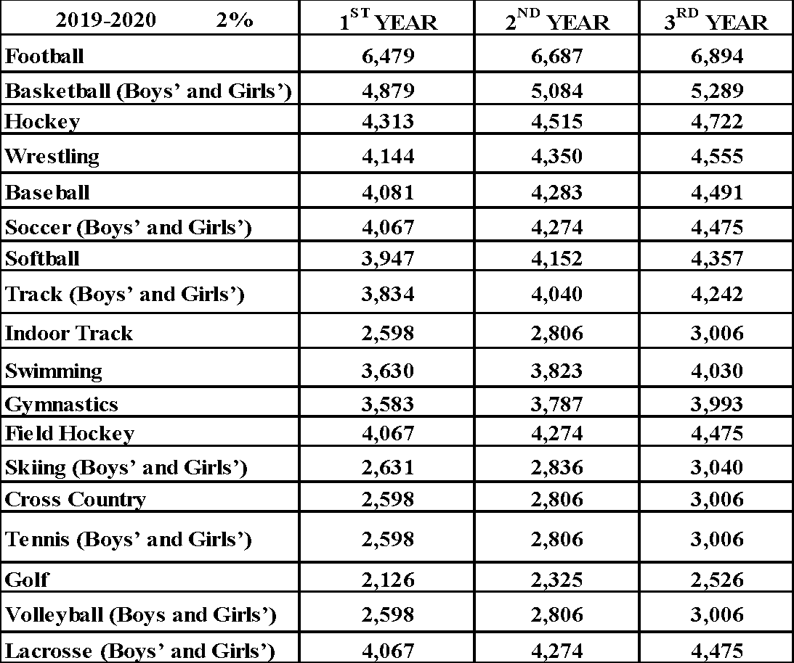
- Assistant and J.V. Coaches, shall be 60% of varsity head coach scale
  - JV Coach – Field Hockey, Boys’ Basketball, Girls’ Basketball, Ice Hockey, Girls’ Soccer, Girls’ Volleyball Golf, Baseball, Softball, Boys’ Lacrosse, Girls’ Lacrosse, Boys’ Volleyball
  - Assistant Coach – Football, Ice Hockey, Indoor Track, Swimming, Wrestling, Boys’ Track, Girls’ Track, Cross Country
- Freshmen head coach’s scale shall be 50% of varsity head coach scale
- Field Hockey, Football, Boys' Basketball, Girls’ Basketball, Boys’ Soccer, Girls’ Soccer, Baseball, Softball
3. Freshman Assistant Coach – shall be 60% of Freshman head coach scale
- Football Assistant
4. Unified Basketball Coach – shall be 50% of the varsity head coach scale.
5. Eighty dollars and ninety-five cents (80.95) shall be paid for every 4 years of coaching in the same sport.
6. Club Sports $1,352
7. Intramurals – Sr. High, Jr. High, Middle $862
8. Equipment Manager $3,242
9. Cheerleader Coach $2,698
10. Cheerleader Coach – Assistant $1,619
11. Faculty Manager Athletics $2,146
12.Post Season play: Head Coaches $314 /week
Assistant & J.V, coaches $190 /week

COMPENSATION SCHEDULE FOR COACHES
VARSITY HEAD COACHES
2020-2021 (2.0%)
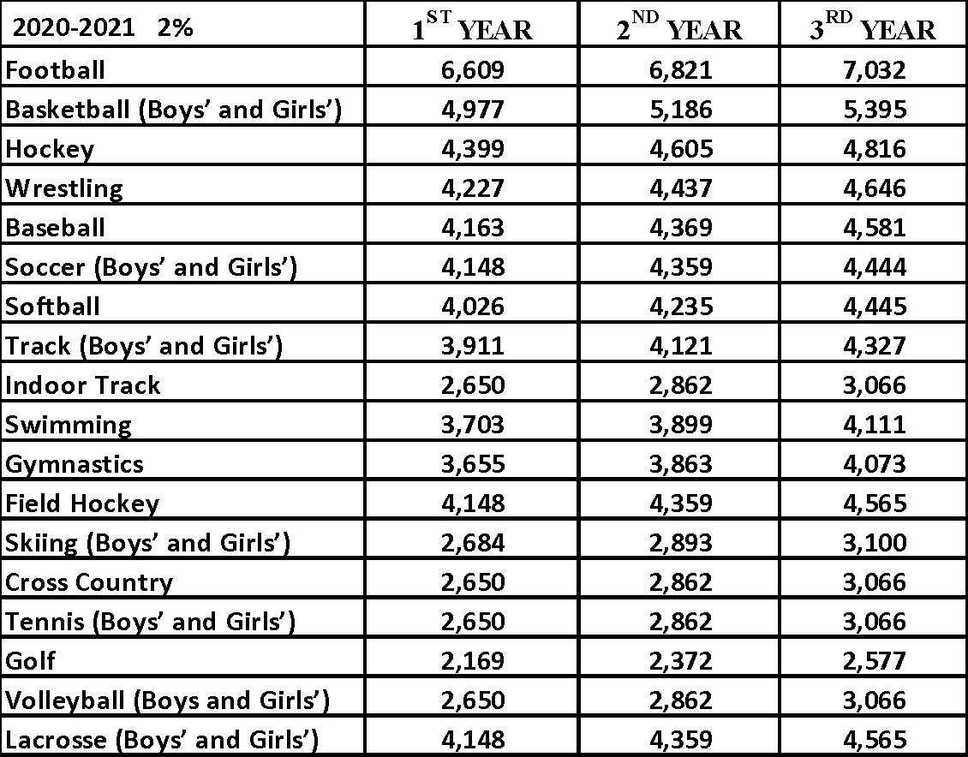
1. Assistant and J.V. Coaches, shall be 60% of varsity head coach scale
  - JV Coach – Field Hockey, Boys’ Basketball, Girls’ Basketball, Ice Hockey, Girls’ Soccer, Girls’ Volleyball Golf, Baseball, Softball, Boys’ Lacrosse, Girls’ Lacrosse, Boys’ Volleyball
  - Assistant Coach – Football, Ice Hockey, Indoor Track, Swimming, Wrestling, Boys’ Track, Girls’ Track, Cross Country
- Freshmen head coach’s scale shall be 50% of varsity head coach scale
- Field Hockey, Football, Boys' Basketball, Girls’ Basketball, Boys’ Soccer, Girls’ Soccer, Baseball, Softball
- Freshman Assistant Coach – shall be 60% of Freshman head coach scale
- Football Assistant
- Unified Basketball Coach – shall be 50% of the varsity head coach scale.
- Eighty-two dollars and fifty-seven cents ($82.57) shall be paid for every 4 years of coaching in the same sport.
- Club Sports $1,379
- Intramurals – Sr. High, Jr. High, Middle $879
- Equipment Manager $3,307
- Cheerleader Coach $2,752
- Cheerleader Coach – Assistant $1,651
- Faculty Manager Athletics $2,189
- Post Season play: Head Coaches $320 /week
Assistant & J.V, coaches $194 /week

COMPENSATION SCHEDULE FOR COACHES
VARSITY HEAD COACHES
2021-2022 (2.0)
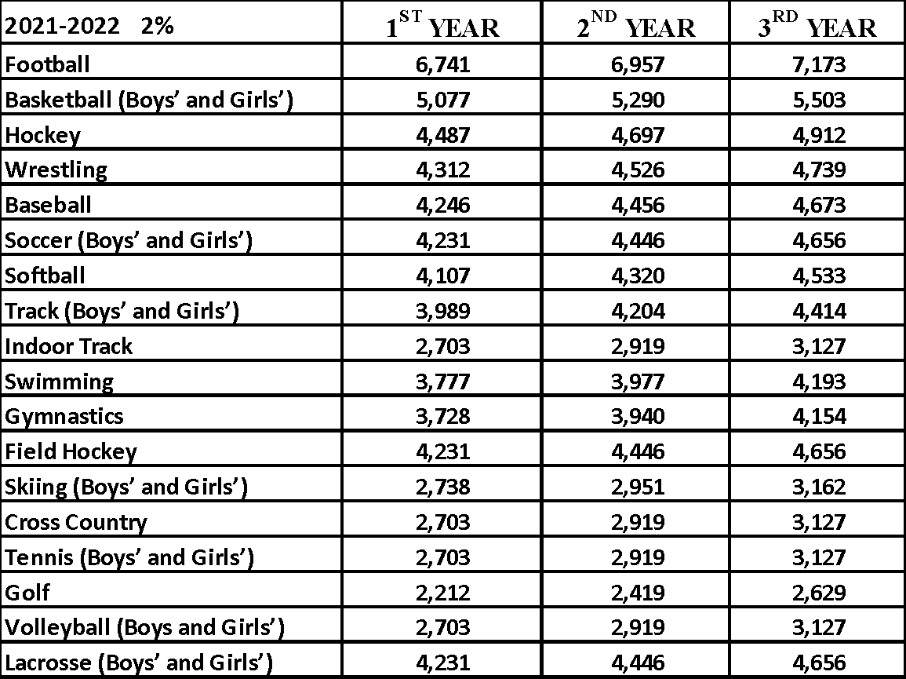
1. Assistant and J.V. Coaches, shall be 60% of varsity head coach scale
  - JV Coach – Field Hockey, Boys’ Basketball, Girls’ Basketball, Ice Hockey, Girls’ Soccer, Girls’ Volleyball Golf, Baseball, Softball, Boys’ Lacrosse, Girls’ Lacrosse, Boys’ Volleyball
  - Assistant Coach – Football, Ice Hockey, Indoor Track, Swimming, Wrestling, Boys’ Track, Girls’ Track, Cross Country
- Freshmen head coach’s scale shall be 50% of varsity head coach scale
- Field Hockey, Football, Boys' Basketball, Girls’ Basketball, Boys’ Soccer, Girls’ Soccer, Baseball, Softball
3. Freshman Assistant Coach – shall be 60% of Freshman head coach scale
- Football Assistant
- Unified Basketball Coach – shall be 50% of the varsity head coach scale.
- Unified Basketball Coach – shall be 50% of the varsity head coach scale.
- Eighty-four dollars and twenty-two cents ($84.22) shall be paid for every 4 years of coaching in the same sport.
- Club Sports $1,407
- Intramurals – Sr. High, Jr. High, Middle $897
- Equipment Manager $3,373
- Cheerleader Coach $2,807
- Cheerleader Coach – Assistant $1,684
- Faculty Manager Athletics $2,333
- Post Season play: Head Coaches $326 /week
Assistant & J.V, coaches $198 /week

EXTRACURRICULAR COMPENSATION SCHEDULE
(2019-2022)
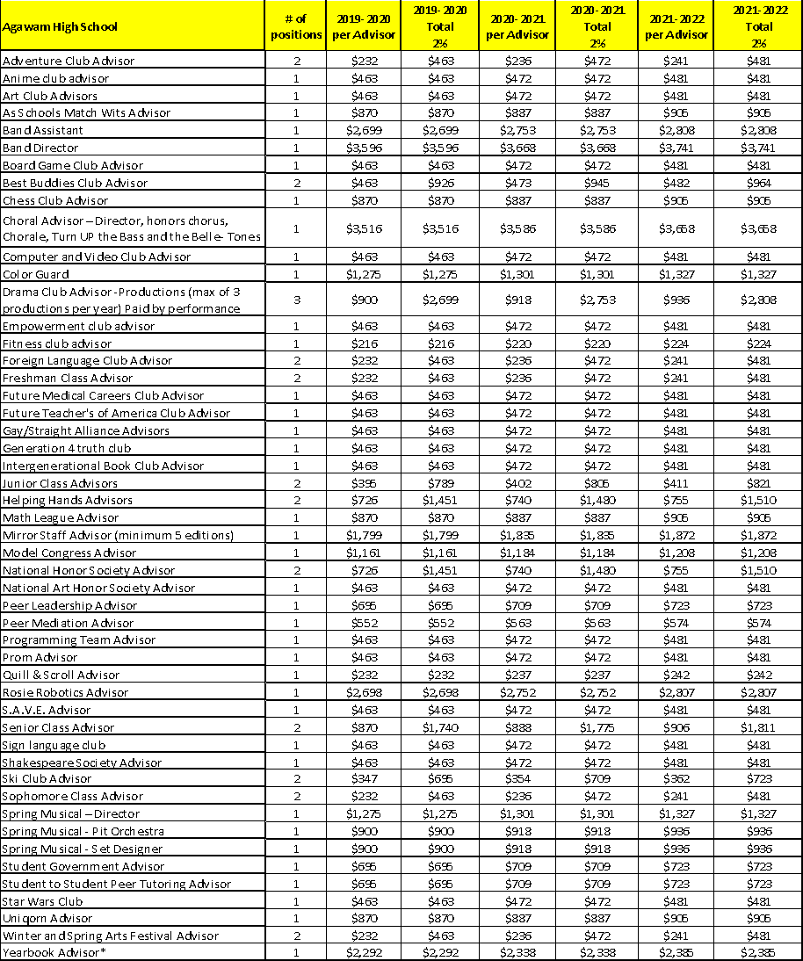

EXTRACURRICULAR COMPENSATION SCHEDULE
(2019-2022)
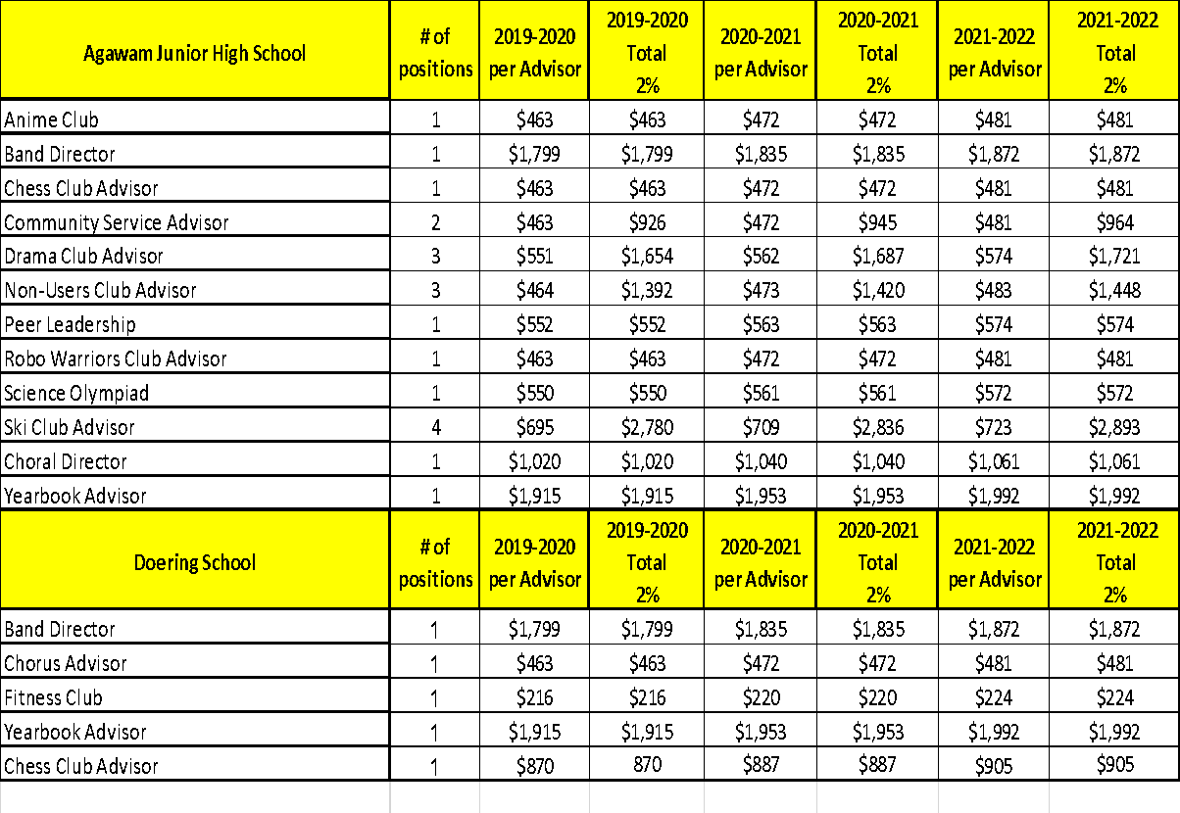
For a given extracurricular activity if there are more adviser’s appointed than the number of positions stated, the advisers will split the total stipend for that year evenly. If only one adviser is selected for a given extracurricular activity with more than one position stated, the adviser will only get the Per Adviser stipend listed.

PROCEDURES FOR EXTRACURRICULAR ACTIVITIES

All new extracurricular activities must meet for one year prior to seeking school committee approval per school committee policy. The steps for seeking approval include:

- Any club/activity that has run for one (1) school year, in which the adviser(s) has not been compensated, may apply for approval. Attendance records must have been kept for each meeting during that year.
- The adviser(s) submits a letter to the building principal stating the club/activity has run for one (1) school year along with the meeting dates. The adviser(s) must describe the activities of the group, include attendance sheets, and categorize the club according to Appendix E.
- The building principal forwards this information to the superintendent of schools in a memo stating he approves of the new club/activity with adviser(s).
- The superintendent of schools approves the club/activity proposal to be placed on the school committee agenda. This takes two (2) school committee meetings. It will first appear as new business, then during a second meeting, the school committee will vote on approving the club/activity. Adviser(s) should be present at the second school committee meeting in order to answer questions.

Once approved, it will then be placed on the compensation schedule according to the established criteria (see Appendix E). Stipends should be comparable to existing extracurricular positions in order to maintain organization and equity.

The principal may use his/her discretion in assigning more than the recommended number of advisers, in which case the stipend will be divided equally. Extracurricular activities must have the stated number of advisers in order to safely proceed or will be postponed until appropriately staffed. If any activity deleted from the compensation schedule was to become active again, that the adviser(s) would need to seek school committee approval in order to receive a stipend.

EXTRACURRICULAR ACTIVITIES CATEGORIES FOR STIPENDS

The criteria listed below are used to classify each club or activity as a category A, B, or C based on several factors. Although not every position listed in the compensation schedule may meet every criterion in a category, most will meet several components. This chart of working criteria is to be used when considering stipends for advisers of future activities.
CATEGORY A: SMALL CLUB/ACTIVITY $200 - $500 STIPEND
- 8+ documented hours
- 10+ students involved
- 1+ products

CATEGORY B: MEDIUM CLUB/ACTIVITY $500 - $1000 STIPEND
- 40 + documented hours
- 20+ students involved
- 2+ products
- 1+ competitions/regional events
- specialized safety needs
- larger budgetary needs (money collection/fundraising)

CATEGORY C: LARGE CLUB/ACTIVITY $1000 + STIPEND
- 70+ documented hours
- 20+ students involved
- 4+ products
- 2+ competitions/regional events
- specialized safety needs
- larger budgetary needs (money collection/fundraising)

Special Stipend Positions
(2019-2022)

 | 2019-2020 | 2020-2021 | 2021-2022
 | 2% | 2% | 2%
Mentor Coordinator | $6,616 | $6,748 | $6,883
Adult Education | $6,616 | $6,748 | $6,883
School Based Data Success Team Member | $585 | $597 | $609
Summer School | $6,616 | $6,748 | $6,883
Virtual High School Coordinator | $1,137 | $1,160 | $1,183
Common Core (CC) Facilitators | $2,844 | $2,901 | $2,959
CC School Counselor Facilitator | $2,844 | $2,901 | $2,959
Enrichment Program Coordinator | $2,048 | $2,089 | $2,131
Pre-K Teacher Leaders-TBD
K-4 Math Teacher Leaders | $583 | $595 | $607
K-4 Literacy Teacher Leaders | $583 | $595 | $607
Teacher Mentor Program | $341 | $348 | $355
Lindamood Bell Coordinators | $797 | $813 | $829
Audio-Visual Aide Junior High | $1,799 | $1,835 | $1,872
Audio-Visual Aide Senior High | $2,698 | $2,752 | $2,807
Treasurer High School Accounts | $1,275 | $1,301 | $1,327
COMPUTER TECHNOLOGY FACILITATORS
High School | $3,938 | $4,017 | $4,097
Middle School | $2,363 | $2,410 | $2,458
Junior High | $3,150 | $3,213 | $3,277

APPENDIX A

PLACEMENT OF NEWLY HIRED TEACHERS ON SALARY SCHEDULE

As per the acceptance of proposal made by the Agawam Public Schools and the Agawam Education Association on June 13, 1997, the following language will be included in the Collective Bargaining Agreement.

“With respect to the placement of prospective new teachers on the salary schedule, the Superintendent of Schools shall:

- Review the academic credential of the prospective new employee, determine their validity, and place the prospective new employee on the applicable degree scale of the salary schedule;
- Review the prior teaching experience of the prospective new employee to determine its validity, and place the prospective new employee at the step on the applicable degree scale of the salary schedule which the Superintendent of Schools deems appropriate, based on such prior teaching experience”.

NOTE: This language will be adopted by a resolution of the School Committee for inclusion in the Collective Bargaining Agreement.

COROLLARY:

By way of clarification in reference to paragraph #2 (prior teaching experience) the following will apply.

- Only full-time teaching experience will be considered (Substitute teaching experience will not qualify.)
- The teaching experience may have taken place in a public school or a non-public school, private school, or charter school as long as the person was certified in the particular subject in which he/she claims the experience for those number of years; i.e. English, social studies, science, math, etc.
- Collegiate (full time) teaching experience will be recognized.

The Superintendent may, upon review and in his/her discretion, authorize placement at M+30 or M+45 in situations where a particular certification requires a master’s degree consisting of a minimum of 60 graduate credits.

This is the final disposition of the resolution to the Agawam, Arbitration Settlement. This document superseded any other document relative to this subject, specifically the letter of December 5, 1996, “Placement on Salary Schedule.” The School Committee will act on the resolution for the language change on August 26, 1997.

ADDENDUM A
TEAM MODELING

Updated Junior High School Teaming Model for Contract 2016-2019

As part of the terms of settlement of the 2007-2010 collective bargaining agreement, the Association and the School Committee record the following agreements and understandings for the Junior High School teaming model that has been implemented for the 2009-2010 school year.

- The parties hereby agree to implement a model of teaming (defined as common planning time for each group of teachers who are assigned to a defined group of students) for the Agawam Junior High School, said model to be implemented during the term of this Agreement.
- The Superintendent, Principal of the Junior High School, and Teaming Committee jointly retain the right to continue work/modify such teaming model as in their discretion they determine to be the most appropriate. Within the teaming model and concept, a common planning time has been implemented to allow for effective continuity.
- Teachers at Agawam Junior High School shall work an eight (8) period day with a six (6) day cycle. Teachers (“On-Team” including Special education & Critical Literacy Teachers) shall teach no more than thirty-six (36) periods within the six (6) day cycle including one (1) academic support and enrichment period and within the six (6) day cycle shall have the equivalent of one (1) unassigned period per day, and one (1) common planning time per day except that teachers of art, music, family and consumer science, health, technical education, physical education, computer skills/literacy, and intensive math and reading teachers (“Unified Arts Team”), shall teach 36 periods in a six (6) day cycle and have the equivalent of one (1) unassigned period per day and will be assigned a common planning time and one (1) supervisory period, three (3) periods within a six (6) day cycle and one (1) period will be assigned as directed by the Principal. The teacher’s lunch period shall be a minimum of twenty (20) minutes per day free from all duties.

ADDENDUM B
TEACHER EVALUATION
Teachers will follow the lesson plan requirements contained in the Teacher Handbook. Any subsequent changes regarding lesson plans in the Teacher Handbook shall be subject to negotiation with the Association.

ADDENDUM C
HEALTH INSURANCE MEMORANDUM

By and Between the

The Agawam School Committee

The Town of Agawam

and

The Agawam Education Association

WHEREAS, the Agawam School Committee and the Agawam Education Association are parties to a collective bargaining agreement dated September 1, 2007, to August 31, 2010; and

WHEREAS, revised HMO Blue New England health insurance plan designs were put into effect for the fiscal year beginning July 1, 2009; and

WHEREAS, said revised health insurance plan designs increased co-payments for hospital admission, out-patient services, emergency room visits, medical specialist office visits, and pharmaceutical prescription purchases; and

WHEREAS, the Agawam Education Association has filed a grievance presently pending before the Agawam School Committee, and has filed charges of prohibited practice against the Town of Agawam (MUP-09-5608) and the Agawam School Committee (MUP-09-5609) presently scheduled for investigatory hearing by the Massachusetts Labor Relations Commission; and

WHEREAS, all parties desire to reach a full and complete settlement of all matters regarding the implementation of said revised health insurance plans and of the grievance and charges of prohibited practice currently pending; now

THEREFORE, the Agawam School Committee, the Town of Agawam, and the Agawam Education Association, hereby agree as follows:

The Town of Agawam agrees to establish and maintain a system of reimbursement for
the amount of co-payments for hospital admission, out-patient surgery, and emergency
room visits in excess of those charged for HMO Blue New England plan coverage for
the fiscal year beginning July 1, 2008.

School department employees represented by the Agawam Education Association will,
upon submission of a receipt provided by The Provider, HMO Blue New England, be
reimbursed for the above-mentioned increased co-payments, up to the cap established by
the co-insurance maximum in effect for the HMO Blue New England plan, said
reimbursement to be retroactive to July 1, 2009.

Reimbursement requests will not be accepted for services rendered more than one (1)
year prior to the date of submittal of a receipt for services.

Reimbursement will be made within two (2) pay periods from the date of submittal of a
receipt for services, sixty (60) days upon receipt of proper documentation.

The parties agree that the School Department budget will be held harmless for the costs
of said reimbursement.

Upon execution of the Agreement, the Agawam Education Association agrees to
withdraw its grievance pending before the School Committee and to withdraw
MUP-09-5608 and MUP-09-5609 presently pending before the Massachusetts Labor
Relations Commission.

This agreement will be effective upon execution by the parties.

Signed:

On behalf of the Agawam Education Association:

_________________________________________ Date: _______________________

On behalf of the Town of Agawam:

_____________________________________ (Mayor/School Committee Chair)

Date: _________________________

On behalf of the School Committee:

______________________________________ (Vice Chair)

______________________________________

______________________________________

______________________________________

______________________________________

_______________________________________ Date: ______

