Cohort 4 Fellows – May 2024

Laura Assade, Director of Diversity, Equity, Inclusion & Engagement
Salem Public Schools

For seven years, Laura served as the Constituent Services Director in the Mayor's office for the City of Salem. In this role, Laura managed complex inquiries and supported residents in access to critical support and services. Laura developed and implemented a civic engagement plan to boost Latino participation in city activities, municipal boards, and public services. For her efforts, Laura was a recipient of the 2021 Change Agent award from the North Shore CDC, 2021 Salem United Award, 2021 Change Maker Award from the Institute for Nonprofit Practice, and the 2022 Adult Advisor Award from the 84 Movement.
In 2021, Laura joined Salem Public Schools as the Family Engagement Manager with a focus on connecting families to services and resources, helping them to become more empowered, and building relationships which will foster a better sense of community between families and the schools.
Laura currently holds a position in the district as the Director of Diversity, Equity, Inclusion & Engagement (DEIE). She oversees a team of 11 Family Engagement Facilitators and one Coordinator of Translation and Interpretation who focuses on language access for students and their caregivers. Laura also oversees the work of the district’s Family Enrollment Office. She works closely with the Academics, Student Support, and Out of School Time teams and leads a group of educators in a newly formed Racial Equity Advisory Team.

Stacia Copeland, Director of Student Services
Boston Renaissance Charter School
With “Students First” as her guiding principle and believing that education is the key to freedom, Stacia is committed to the work of ensuring all students are on the receiving end of a rigorous and high-quality education that will serve them locally, nationally, and globally. Stacia is further committed to working with stakeholders, building community partnerships, and building relationships that will enhance diversity and equity for students, families, and the community.
Stacia’s career in public education spans over 15 years, and she previously served as a special education teacher at Boston Renaissance Charter Public School. In her current role as Director of Student Services, Stacia’s leadership experience includes responsibilities for supporting students’ overall access to general curriculum as well as leading and supporting special education teachers, support staff and related service providers. Prior instructional experience includes serving as a high school history teacher and elementary teacher.
Stacia earned a Bachelor of Arts Degree in Secondary Education from Northern Caribbean University (JWI). She earned her Master of Science Degree in Special Education from Cambridge College. She obtained her Special Education Administration License through Curry College Principal and Supervisor Licensure Program (PSL). Stacia is currently completing her doctorate in Special Education at Regent University.

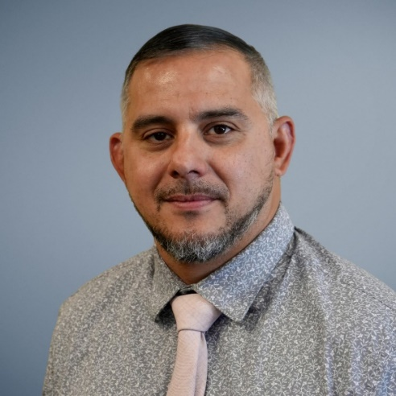
Jose Escribano, Chief of Family and Community Engagement
Springfield Public Schools

Jose Escribano is currently the Chief of Family and Community Engagement for Springfield Public Schools in Springfield Massachusetts. He previously served as Principal for Brightwood Elementary School. Jose has dedicated his career to working with youth in urban communities. Jose holds a master’s degree in education with a concentration in School Adjustment Counseling and Mental Health Counseling. Before entering education, he worked as a Social Worker for the Department of Children and Families where he started as an Ongoing Social Worker and then became an Adoption Social Worker. As an administrator, Jose was involved in turnaround work and was an integral part in improving three schools in the district.
In addition to his professional career in academia, Jose has volunteered his time, skills and talent to various organizations including Project Coach, school dances, city run parades and political events. Jose understands how important it is to keep the youth engaged and has been a volunteer coach for several sports teams. Jose is an active member of his community and enjoys being a positive leader in the City of Springfield.
In his new role, Jose hopes to engage the community to support all Springfield students. By bridging the gap between the community and its residents, Jose is skilled at making strong connections, providing resources to those in need and launching powerful initiatives that change the dynamics of the community and its members. Jose is continuously searching for people and resources that help make the city of Springfield a more positive environment for its students and their families.

Dr. Jamy Gaynor, Director of Health Services
Weston Public Schools

Dr. Gaynor is an action focused, yet reflective leader whose greatest strength is her ability to collaborate with students, families, and community members from varied backgrounds. A nationally certified school nurse, Jamy began her career as a neuroscientist investigating learning and memory at UMass Amherst prior to her transition to nursing where she has spent the last 15 years in both intensive care and school settings. She received her Ed.D. from Regis College in 2018 where she investigated social emotional supports for school nurses and educators. For the past eight years, Dr. Gaynor has worked as a school nurse and district leader where she continues to pursue best-practices for collaboration with families and community.
Currently, she serves as the Director of Health Services for the Weston Public Schools where she played an instrumental role in navigating the district and town through the COVID-19 pandemic. Before this, Dr. Gaynor worked with Marlborough Public Schools where she was runner-up for the Masonic Teacher of the Year in 2018, the first nurse to receive such an honor. She is an active member of both the National Association of School Nurses (NASN) and the Massachusetts School Nurse Organization (MSNO), where she served as an elected member of the Executive Board. Dr. Gaynor also served as an elected member of the Board of Trustees for Mount Wachusett Community College and is presently serving on an advisory board for Elms College’s Kirley School. In addition to her current leadership position and research pursuits, she is also a guest lecturer at the local and national level.

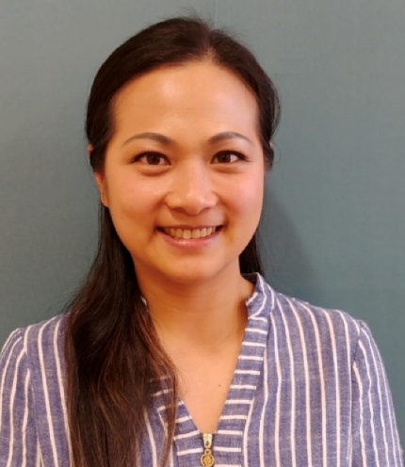
Dr. Scarlett Grandt, Principal, Callahan Elementary School
Norwood Public Schools

Scarlett Grandt has twelve years of administrative experience in the public school system. She is currently the principal of Callahan Elementary School in Norwood. Prior to that, Scarlett served as an interim principal in an elementary school in Salem. Scarlett also served as an assistant principal in multiple school districts including Salem, Everett, and Hartford Public Schools. Prior to her administrative career, Scarlett was the teacher-in-charge and a fourth-grade teacher for seven years.

Born and raised in Hong Kong, China and immigrating to the United States when she was 13 knowing limited English, Scarlett can relate to the students she serves. Scarlett believes in building meaningful relationships with students and families and being a role model for all. She is an advocate for social justice and educational equity. She strives to work with all stakeholders to create a positive, safe, and inclusive school culture.
Scarlett received her bachelor’s and master’s degrees from the University of Connecticut and Quinnipiac University and a Doctor of Education degree from John’s Hopkins University. Her doctoral dissertation focused on culturally responsive teaching practices. Scarlett and her husband have a two-year-old son and a baby daughter. They reside in Dedham, Mass.

Renée Heywood, CEO of Real Talk Leadership, AMSEL PD Chair

Renée Heywood began her career in education almost 30 years ago as a Spanish language teacher in public, private, and graduate school settings. She served 11 years as a licensed administrator in juvenile justice education for the Department of Youth Services. In 2018, she was appointed by the Commonwealth of MA as the Director of Educational Services, overseeing educational programming for all incarcerated youth for the state. As an internationally published writer and speaker, Renée has traveled the world to support education and music in places like Guatemala, Nicaragua, and Australia and has presented her work on racism in education at multiple venues including the Social Justice Conference in Finland.
Renée co-authored a book on marriage with her husband entitled, I Said, I do to All That? Unpacking Life's Baggage, and a weekly blog on marriage and family issues. She and her teenaged daughter co-authored a chapter of poetry about her experiences as a young Black girl in education in a compilation of Black women educators entitled The Majestic Place: The Freedom Possible in Black Women’s Leadership which will be available in the spring of 2024.
Renée holds a bachelor's degree in Spanish Language & Literature from Brandeis University, her M.Ed. in Educational Leadership from Bridgewater State, and her Ph.D. at UMass Amherst after serving as the Graduate School of Education Fellow. Her concentration was Language, Literacy and Culture with a focus on racial and equity issues in education. She is the CEO of her own consulting company Real Talk Leadership, is the Professional Development Chair of AMSEL, an Advisory Board member of PLEDJJ (Preparing Leaders in Education, Disability, and Juvenile Justice) and is a member of the Racial Imbalance Advisory Council.

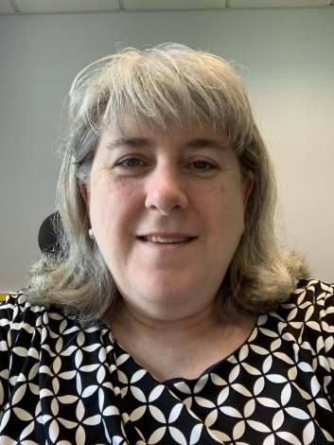
Joanne Menard, Assistant Superintendent for Curriculum and Instruction
Holliston Public Schools

Joanne Menard is honored to have served in Massachusetts public school districts for over 20 years. Joanne currently is Holliston’s Assistant Superintendent for Curriculum & Instruction. In this role, she is leading curriculum review work through a lens of equity and developing professional development opportunities with a Safe and Supportive Schools approach.
Being a principal at all levels has increased Joanne’s knowledge of how leaders can directly impact all learners. She served as an elementary school principal with a STEM focus for four years and a 6-12 Innovation Pathways school principal for two years. For 11 years, Joanne taught middle school science and math and developed/implemented an inquiry-based STEM class for all students. She served on the Massachusetts School Administrators’ Association’s Board of Directors for three years as the Ed Policy Chair and also led a regional principal’s group. Joanne taught adults as an adjunct professor for four years, concentrating on special education and inquiry-based instruction for science and math. While living in South Korea for three years, she taught elementary students at a language institute.
Joanne has completed her doctoral degree in Educational Leadership at the University of Hartford. She obtained her Certificate of Advanced Graduate Study in Educational Leadership from Fitchburg State University, her Master of Education in Elementary Education from Anna Maria College, and her Bachelor of Science in Marketing from the Ohio State University. Joanne has been married for over 32 years and has two grown children.

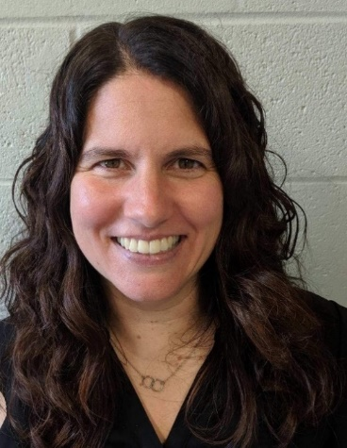
Dr. Marisa Mendonsa, Deputy Superintendent
Pittsfield Public Schools
Dr. Marisa Mendonsa is the Deputy Superintendent for the Pittsfield Public Schools. Over the past twenty-six years, Marisa has served as a secondary social studies teacher and principal. Her career has spanned rural, suburban, and urban communities. In July of 2024, Marisa will assume the Superintendency of the Waltham Public Schools.
As a Queer woman, Marisa believes in the power of representation and uses the knowledge gained from her doctorate in antiracist leadership from American University to ensure that schools are engaging in antiracist practices and procedures that move beyond statements and provide actionable responses to issues of diversity, equity, and inclusion. Currently, Marisa is engaged in the development and implementation of an Equity Plan rooted in the student and staff experience.
In addition to her doctorate, Marisa has a bachelor’s degree in Secondary Education/History from Springfield College, a Master’s degree in Multicultural/ESL/Bilingual Education and a Certificate of Advanced Graduate Studies in Educational Leadership from the University of Massachusetts, Amherst. Born and raised in Massachusetts, Marisa and her wife are the proud parents of two teenage daughters.

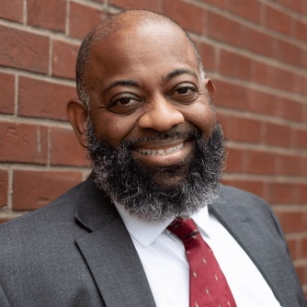

Steven Moguel, Executive Director of DEI and Family Engagement

Holyoke Public Schools

Steven Moguel served in a dual role as Morgan School principal while also supporting anti-racist, inclusion, and equity work at the district level in 2022-2023. Steven has worked in education for 15 years, serving in various roles from paraprofessional to principal. From 2018-2023, Mr. Moguel served as the building principal at Morgan School, where he supported a culture of equity with his staff and throughout the school. Through these efforts, Morgan has continued to transform into a space where staff address personal and systemic biases, openly learn about, understand, and work to transform embedded structures that have created opportunity gaps for marginalized Holyoke students.

Steven Moguel currently serves as the current Executive Director of DEI and Family Engagement and sits on the district level cabinet. In this current role he supports all district level DEI implementation, which includes asynchronous equity module learning for all instructional staff, facilitated debrief sessions at each school site, creating and delivering equity-based PD for district level directors (including cabinet), and school-based leaders (principals and assistant principals). In this role, he has also helped implement district-wide affinity groups for staff and an equity task force to support DEI implementation across all campuses. In addition to DEI initiatives, Steve also supports Family Engagement for the district. This includes leading the FACE department (family engagement and access coordinators) which supports creating family engagement events, connecting families with resources, and creating partnership with community organizations in service of student success.

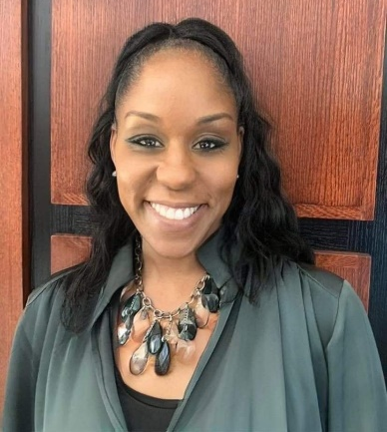

Terry Powe, Principal, Elias Brookings School
Springfield Public Schools

Terry D. Powe was born in Columbus, Ohio. She is the daughter of Pastor Charles E. Pratt Jr. and Evelyn J. Pratt. Her family moved from Ohio to Pittsfield, MA when she was in elementary school. She attended Pittsfield Public Schools from Elementary School until high school. She received a Bachelor of Science degree in Education from Springfield College in 1996 and received a master’s degree in education in 1998 from the University of Massachusetts at Amherst. She was an elementary school teacher at Freedman Elementary School, a District Literacy Coach for Springfield Public Schools and has worked at Elias Brookings School as the building administrator for the past 13 years.
Terry is very active within the school system and the wider community. She enjoys giving freely of her time and talent. She is a mentor principal who has provided leadership and mentoring to aspiring administrators. She serves on the Springfield Public Schools Principal Advisory Committee, is a Springfield Museum Committee Member and a 2012 Business West 40 Under 40 recipient.
Terry has received numerous awards and recognitions. She received a Partners in Progress Award from Develop Springfield in 2014, a Community Builder Award from The Urban League of Springfield in 2019, was a 100 Women of Color honoree in 2018 and received a Distinguished Mother award in 2019 from Jack and Jill of America. She is married to her high school sweetheart, Attorney Maurice Powe, and has three beautiful children, Tamira Powe and twins Maurice Powe Jr. and Maya Powe.

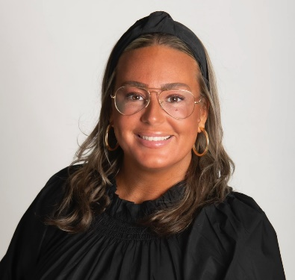

Caitlan Sheehan, Director of Diversity, Equity, and Inclusion
Duxbury Public Schools

Caitlan Sheehan is a devoted public-school administrator who promotes dialogue, power-sharing, and authentic collaboration in order to engage all stakeholders in data-driven responses to establish access for all students in inclusive, bias-free school environments.

Currently, Caitlan works to ensure Duxbury Public Schools provide skill-based, obstacle-free access for students to reach their full potential in a learning environment that affirms each student’s unique identity, fosters a respect for all viewpoints, and builds inclusivity for all groups. She believes adult learning and student learning are symmetrical, and educators must design at the margins to create deeper learning conditions for students. Before transitioning to her current role in school administration, Caitlan was a history teacher in Duxbury where she served as an integral member of the teaching staff and mentor program for ten years.

Caitlan is a Doctoral Candidate at the University of Massachusetts, Lowell. In addition to pursuing her Ed.D., she holds a Certificate of Advanced Graduate Study in Educational Leadership from the University of Massachusetts, Boston, a master’s degree in education from Lesley University, and a bachelor’s degree in history from the University of Massachusetts, Amherst.

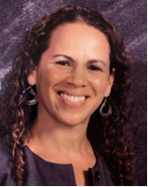
Nicole Shepardson, Principal, Morningside Community Elementary School
Pittsfield Public Schools
Nicole Shepardson is an elementary school principal in Western Massachusetts with over 20 years of experience working in public schools. Prior to her role as principal, Nicole was a school adjustment counselor in the same school district. She developed a leadership role in fostering social-emotional learning and creating trauma sensitive classrooms. Nicole began her career as a clinical social worker in an area mental health center. She specialized in working with children who experienced trauma and provided extensive teaching on the intersection of trauma and resiliency.
Nicole received a Master of Social Work from SUNY Albany. She is currently attending UMASS Lowell where she is pursuing a Doctorate in Educational Leadership. Nicole is deeply invested in equity-focused leadership and increasing educational equity for all students.

Dr. Charisse Taylor, Head of Workforce Development for BlocPower
Committed to “creating opportunities for young people to thrive,” Dr. Charisse Taylor has dedicated her life to supporting equity and excellence in education for young people from marginalized communities. Charisse most recently served as the Director of Strategic Initiatives for Norwood Public Schools. Prior to joining NPS, she led large-scale initiatives focused on racial and gender equity, increased access to computer science education and pipeline development of high-growth careers in the tech sector for the New York City Department of Education, serving 1.1 million students. In addition to her equity-centered innovation work, Charisse has been coaching persistently failing schools and districts on the path to improvement since 2015. Trained in several models of continuous improvement, including serving as a certified coach in the Data Wise Project at Harvard Graduate School of Education, Charisse has facilitated numerous workshops and coaching sessions for school leadership teams around the country.

Charisse earned a Bachelor of Science in Psychology from Smith College, a Master of Science in Social Work from Columbia School of Social Work, and a Doctorate in Education Leadership from the Harvard Graduate School of Education.

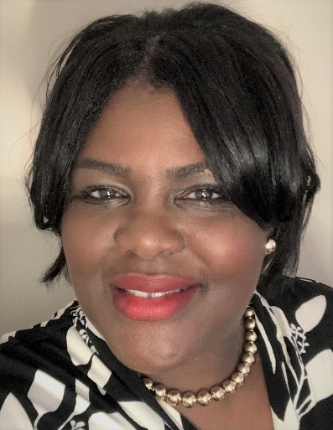
Dr. Kris Taylor, Director of Educational Leadership and Diversity, Equity, and Inclusion, William James College; Consultant with Blackstone-Millville Regional School District
Dr. Kris Taylor is an experienced educator who works to achieve educational equity for all students and strong learning environments for all adults. Kris is the Director of Educational Leadership and DEI for the Center for Behavioral Health, Equity and Leadership in Schools at William James College where she is also the Director of the Graduate Certificate in School Leadership focused on Racial Understanding, Educational Equity and Organizational Transformation. Kris is a former manager at DESE, where she collaborated with school leadership and district teams to improve outcomes for all students. Prior to her work at DESE, Kris was a district leader for Boston Public Schools. As the Director of Leadership Development, she collaborated with an array of stakeholders, school leaders and partners to design and implement inquiry-based professional learning experiences for Boston principals. In addition, she created and coordinated learning experiences for new leader induction to advance the skills and competencies of new principals and aspiring principals.

Kris taught middle and high school for nine years. She was an academic coach, supporting K-5 educators. She was a Boston Principal Fellow before becoming the principal of a large K-8 school in Boston.

Kris attended U.C. Berkeley and double majored in psychology and social welfare with a minor in African American studies. From there, she attended Harvard University where she earned a teaching credential and master’s degree. In May of 2018, Kris graduated from Boston College with a Doctorate in Educational Leadership and Administration.

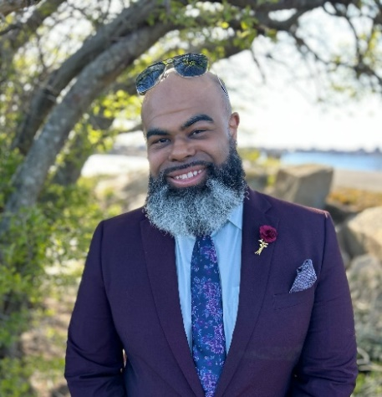
Dr. Bruce W. Tench, II, Assistant Principal, Keith Middle School
New Bedford Public Schools

Dr. Bruce Tench has worked with a wide range of students, from infants and toddlers to college students. He taught high school English within his hometown district of New Bedford Public Schools for eight years before leaving in 2016 to join the Dighton Rehoboth Regional School District where he served as an assistant principal at the high school for three years. Bruce then went to Attleboro Public Schools where he worked as the assistant principal at Thacher Elementary School and Early Learning Center for two years before returning home to New Bedford Public Schools. Currently, he is in his third year as the assistant principal of 6th grade at Keith Middle School. Bruce holds a bachelor’s degree and a master’s degree from the University of Massachusetts, Dartmouth, and a doctoral degree from Nova Southeastern University. Bruce is active in his community as well as with his international fraternity, Theta Delta Chi.

Jessica Torres, Assistant Principal, Stacy Middle School
Milford Public Schools

Jessica Torres, an experienced educator with 17 years of experience, is the assistant principal of sixth grade at Stacy Middle School in Milford, Massachusetts. In this role, she is dedicated to promoting academic success and well-being among students by overseeing school organization, operations, and resources to create a safe and effective learning environment. Before her current position, Jessica worked as a Spanish teacher in the Chicopee Public Schools for 13 years.
Jessica's educational background includes bachelor's and master's degrees from Our Lady of the Elms College in Chicopee, Massachusetts. She holds certifications in Principal/Assistant Principal for Pre-K-6, 5-8, and 9-12, as well as Foreign Language Spanish 5-12. Her commitment to teaching and motivating students, particularly those with limited opportunities, is evident in her work.
Jessica enjoys reading, basketball, traveling, and spending quality time with her family and friends outside of her professional life. She is happily married to her husband Johan Torres and has three daughters named Johanyliz, Juliany, and Jamilet. Jessica's passion for education and dedication to her students make her an asset to the school community.

Jariel Vergne, Director of Social-Emotional Learning and Equity
Holliston Public Schools

Jariel Vergne brings over 19 years of experience in diverse educational communities, passionately focused on the holistic development of students, families, and communities. Born in Puerto Rico and raised in Springfield, Massachusetts, he holds bachelor's and master's degrees from Emmanuel College and Boston University, respectively, in Clinical Social Work. Throughout his career, Jariel has held pivotal roles, including as a School Adjustment Counselor in Brockton Public Schools and an Assistant Principal in New Bedford, MA. Notably, from 2015 to 2021, he led New Bedford Public Schools' Wraparound Services Department, focusing on family engagement, safe and supportive school approaches, and attendance initiatives. Jariel was recognized as a 2020 NESSC Champion, “for his unwavering efforts to ensure high-quality, equitable learning for all students by: promoting and implementing changes in instructional practice, supporting key policies, and/or enhancing public engagement in education”. He has also presented at various national and regional conferences on such efforts.

Since 2021, Jariel has served as the Director of Social Emotional Learning and Equity for Holliston Public Schools. In this role, he leads initiatives utilizing the Safe and Supportive school framework, oversees crucial committees such as the Equity Audit Steering Committee and the HPS District Safety Committee, and facilitates the implementation of PBIS, SEL curriculum, trauma-sensitive schools, and culturally responsive teaching practices. Jariel's leadership extends to systematizing MTSS with a focus on Social Emotional & Behavioral approaches through a trauma sensitive lens and is focused on enhancing the district's data practices towards the actualization of Safe and Supportive experiences for students, staff, and families.

Shannon White-Cleveland, Principal, Athol Community Elementary School
Athol Royalston Regional School District

Shannon White-Cleveland is a 30-year veteran public school educator. Her range of teaching experience spans from preschool through high school and she has worked in both comprehensive and technical school settings. Shannon is currently the principal of Athol Community Elementary School (ACES). ACES has been identified as an underperforming school in need of assistance and serves a high needs student population. Working closely with local and state stakeholders, Shannon has led school efforts to plan, implement and monitor school improvement and turnaround efforts. Through this work at ACES, Shannon has become increasingly more aware of inequities in education and the systems that perpetuate these inequities. She is committed to removing access barriers and fostering inclusive learning environments focused on meeting student needs and providing rigorous programming for all students. Ms. White-Cleveland will assume the superintendency of Erving School Union 28 in July of 2024.
Shannon is a graduate of Worcester State University and the Wheelock School of Education at Boston University. She is a lifelong Massachusetts resident, and she and her husband are proud parents of four children and four grandchildren.

