Massachusetts Department of

Elementary and Secondary Education

135 Santilli Highway, Everett, Massachusetts 02149-1962 Telephone: (781) 338-3000 TTY: N.E.T. Relay 1-800-439-2370

Jeffrey C. Riley
Commissioner

MEMORANDUM

To: | Charter School Leaders, Business Managers, Charter School Admissions and Enrollment Coordinators, and District Data Coordinators
From: | Brenton Stewart, Coordinator of School Redesign and Impact, Office of Charter Schools and School Redesign
Date: | February 15, 2024
Subject: | 2024-2025 Pre-Enrollment, Sibling Pre-Enrollment, and Waitlist Data Submission Memorandum and Instructions  Submission Deadline Friday, March 15, 2024 at 5:00 p.m.

The Charter School Pre-Enrollment Report is used by the Department of Elementary and Secondary Education (Department) to collect projected enrollment data for the determination of each Commonwealth charter school's first five monthly tuition payments for the upcoming fiscal year. The projected enrollment submitted by Commonwealth charter schools sets the maximum number of students upon which each school's tuition calculation will be based for the upcoming fiscal year. It is also used to notify sending school districts by April 1, as required by law, of the number of students enrolled in charter schools during the next school year and to calculate the estimated charter school tuition for the next fiscal year. All charter schools are required to submit pre-enrollment data.
The Sibling Pre-Enrollment Report is used by the Department to collect projected sibling enrollment data from Commonwealth charter schools. Projected sibling enrollment data is used to determine estimated sibling tuition payments for sending districts projected to exceed the relevant net school spending (NSS) cap. As more districts reach NSS caps, Commonwealth charter schools face the possibility of proration of charter school tuition. The Commonwealth pays tuition for siblings when enrollment causes a district to exceed its NSS cap, subject to state appropriation. If tuition payments from a district to Commonwealth charter schools do not exceed its NSS cap in any year, the district will resume paying tuition for siblings. Only Commonwealth charter schools are required to submit sibling pre-enrollment data.
Please note: The enrollment numbers submitted must be based on actual enrollment data including, but not limited to, applications for admission, admission lottery results, accepted offers of admission, and students expected to return the following school year. The total number of pre-enrolled students in this upcoming March submission and the actual enrollment reported on the October 1 SIMS should be very similar.
As noted above, the first five charter tuition payments are based on the pre-enrollment number submitted by each Commonwealth charter school. If actual enrollment numbers, as collected by the October 1, 2024 SIMS submission, are lower than a school’s pre-enrollment projection, tuition payments will be adjusted over the course of the winter months to reflect the lower actual enrollment and to recoup the overpayment for the first five months.
Please note that the Department informs all Commonwealth charter schools of sending districts that are subject to “skip over” requirements or recommendations based on NSS caps by February 15 each year. The Department provides notice of all at-cap and near-cap sending districts for Commonwealth charter schools in its annual Pre-Enroll NSS Cap Guidance for Districts memorandum to inform the upcoming fiscal year’s enrollment. The NSS cap memorandum and this memorandum should be read and reviewed in tandem.
Please review the instructions below before beginning your submission. If the correct grade span is not available or the minimum and maximum enrollment do not align with your school’s approved growth plan, please contact Brenton Stewart at Brenton.Stewart@mass.gov to adjust it. Please feel free to contact Brenton with any questions.

Information and Instructions for FY2025 Charter School Pre-Enrollment data and Sibling Pre-Enrollment data submission
FY2025 pre-enrollment data must be submitted to the Department by 5:00 pm on Friday, March 15, 2024. All pre-enrollment data will be submitted via the Charter and Virtual School Pre-Enrollment application within the Security Portal. The school leader is required to certify and submit the data, even if someone else enters it into the application. Please plan for a careful check of the data because it will impact tuition payments for the upcoming fiscal year and cannot be changed once submitted.
The Department recommends that schools take the following steps prior to inputting pre-enrollment and sibling pre-enrollment data:
- Identify all students that will be enrolled in your charter school during the next school year, including current students who will return and students who are newly admitted.
  - Organize student information by town and grade level.
  - Identify the total number of students by town and grade level.
- Identify students, both newly admitted and currently attending students, who will be reported as a sibling in your student information system. The student may have been admitted through sibling preference after a lottery or if no lottery was required, they have a sibling who attended the school at the time the offer of admission was made. This may also include siblings who have been admitted from the waitlist. Please remember siblings are children who share a common biological or legal parent.
  - Organize sibling student information by town only.
  - Identify the total number of sibling students by town only.

Accessing the Pre-enrollment Application
The pre-enrollment module can be accessed from within the Security Portal. Once at the main security portal landing page, select ‘Charter and Virtual School Pre-Enrollment’ application. See screenshot for reference:
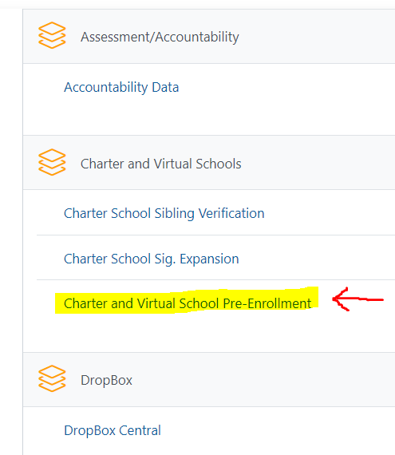

Inputting Pre-enrollment Data
- Select the upcoming fiscal year, the Pre-Enrollment module, and school name from each dropdown menu. Once all dropdowns are selected, click Next. You will be brought to the Pre-Enrollment landing page. The Pre-Enrollment landing page can also be accessed from the menu featured on the left-hand side of the screen.
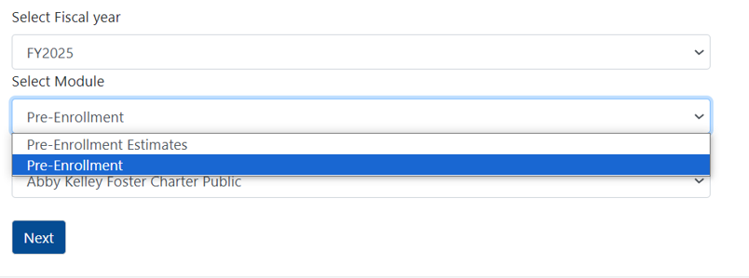
- Column 1: Select the first Town from the dropdown menu for which the school has pre-enrolled students. The town names will be listed in an order based on the school’s enrollment trends.
- Column 2: Select the applicable grade level from the Grade drop down menu for the town. Please note the additional ‘Grade SP’ for select students.
- Column 3: Enter the Total Pre-Enrollment Number for the applicable town and grade level.
- Click Add at the end of the row when finished.
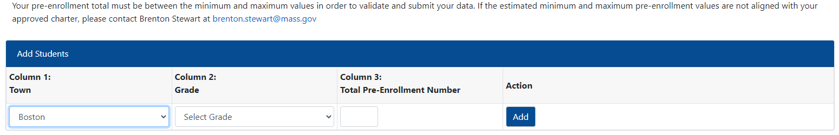
- Continue entering data for each town and grade, in the manner described above, until all pre-enrolled students have been entered.
- The final total enrollment must not exceed the estimated maximum, nor fall below the estimated minimum (Est. Min/Est. Max). If the final total enrollment falls outside of the min and max provided, your submission will receive an error at the validation stage.

Inputting Sibling Pre-Enrollment Data
- Select Sibling Pre-Enrollment from the menu featured on the left-hand side of the screen.
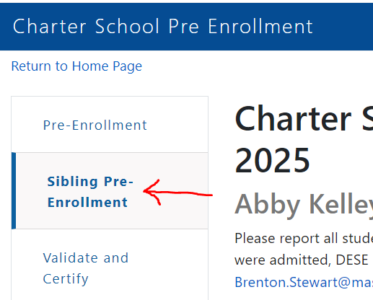
- No Siblings or Horace Mann:
Complete the No Sibling Pre-Enrollment Counts to Report if there are no students admitted through sibling preference or your school is a Horace Mann charter school. Check the available box and then click Save. You may proceed to Validate and Review from the menu featured on the left-hand side of the screen.
- Siblings to Report:
Column 1: Select the first Town from the dropdown menu for which the school has pre-enrolled students. The town names will be listed in an order based on the school’s enrollment trends.
- Column 2: Select the applicable grade level from the Grade drop down menu for the town. Please note the additional ‘Grade SP’ for select students.
- Column 3: Enter the Total Number of Students Admitted with Sibling Preference, including new and currently attending students. The student may have been admitted through sibling preference after a lottery or if no lottery was required, they have a sibling who attended the school at the time the offer of admission was made. This may also include siblings who have been admitted from the waitlist.
- Click Add at the end of the row when finished.
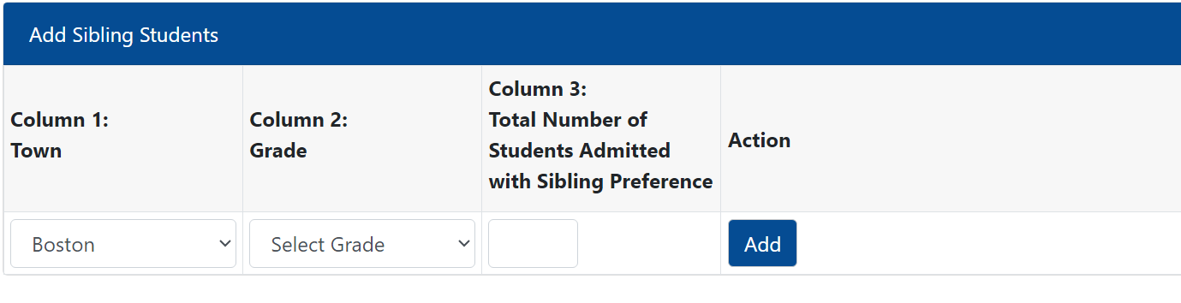
- Continue entering data for each applicable town where a sibling resides, in the manner described above, until all pre-enrolled siblings have been entered.
- The total number of siblings identified for each town cannot exceed the number of students reported for the same town in the overall Pre-Enrollment Report. If the number of siblings exceeds the number of pre-enrolled students reported, your submission will receive an error at the validation stage.

Validate and Certify Pre-Enrollment Data and Sibling Data
- Select Validate and Review from the menu featured on the left-hand side of the screen.
- Click the Validate and Review button to review your pre-enrollment and sibling submissions for errors.
- *No Errors: If there are no errors in your data, you will receive a message that identified no errors. Click Certify to complete your submission.

*Errors: If error(s) are present in your data, you will receive a message that identifies the number of validation errors found. Click on the click here link to view and download the error(s). See image below. A new tab will appear; your current tab will not close.
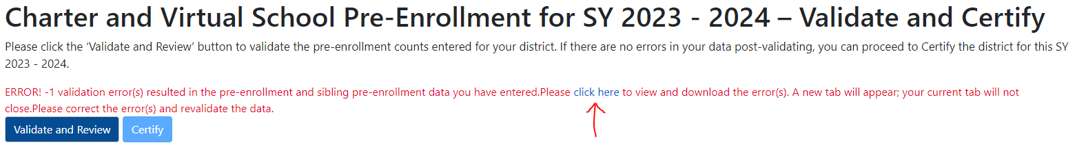
- Review the type of error(s) and the identified module where error(s) are present. Correct the error(s) by navigating back to that module’s subpage and editing the identified data error(s). After correcting the error(s), click Validate and Review again. If error(s) are rectified, you will receive a message that identified no errors. Click Certify to complete your submission.
- After certifying, you must take a screenshot of your submission to provide to your auditor.
After the pre-enrollment data has been collected and reviewed, the Department will determine if a charter school's enrollment qualifies as a significant expansion. Charter schools who qualify as significantly expanding will be required to submit additional enrollment data for select student populations. This additional data collection only applies to a few schools that are newly chartered, adding grades, or increasing enrollment by more than 10 percent when compared to the previous year. If applicable, the schools will be informed and given instructions to complete this report by the June submission deadline.
- Please contact Brenton Stewart at Brenton.Stewart@mass.gov with any questions regarding the pre-enrollment data submission, the sibling pre-enrollment data submission, or the significant expansion submission.

Information and Instructions for FY2025 Initial Waitlist submission
Each charter school is required to submit a waitlist to the Department by 5:00 pm on Friday, March 15, 2024. This submission will provide student level waitlist data established after the most recent lottery and should reflect an accurate student waitlist, as of March 15, 2024, for the upcoming school year. The FY2025 Initial Charter School Student-Level Waitlist Report should be completed using the Excel template named FY25_waitlist_March_[your school’s LEA Code] that was uploaded to your school's Charter School File Exchange dropbox within the Security Portal. See screenshots for reference.
First:
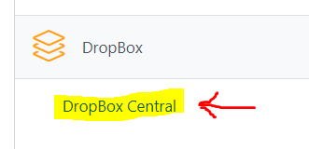
Then:
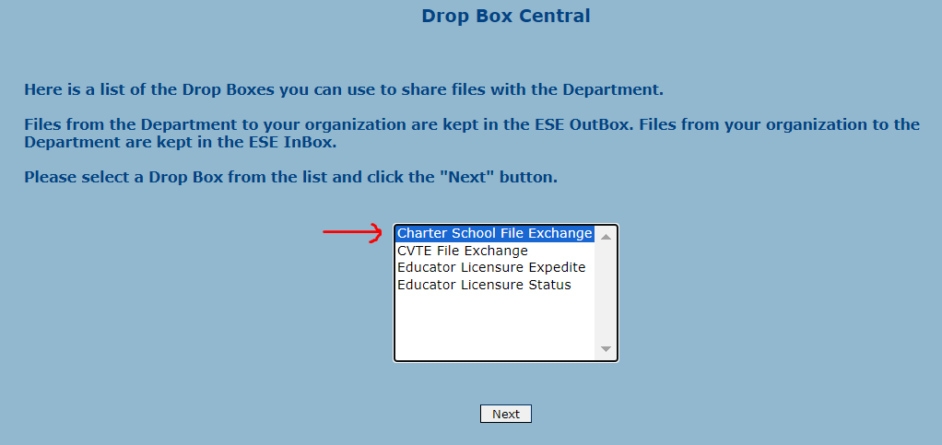
There are detailed instructions in the Instructions tab found within the uploaded FY2025 waitlist Excel template. Please review these instructions and fill out the contact information tab before completing your FY2025 initial waitlist report. Please note, the Department continues to collect additional information pertaining to the sibling status of waitlisted students. There is an additional column requesting schools to identify these students in its waitlist report. Sibling status is only applicable for waitlisted students that are siblings of currently enrolled students. Please identify each student’s sibling status with either a ‘Y’ or a ‘N’.
Embedded within the waitlist collection template (‘initial’ tab) are several data flags and error checks (i.e., duplicate records, unsupported characters within a student name, student age, etc.). The Department relies on complete and accurate waitlist submissions and these embedded tools are included to support accuracy. These data flags and error checks work properly with Microsoft Excel. The Department has added a field to the contact information page for schools to identify which spreadsheet program was used to complete the waitlist report (e.g., Google Sheets). Please be sure to provide this information.
The Department requests that each charter school provide the following data elements for each student included in their current waitlist:
FIRSTNAME | LASTNAME | MIDDLENAME | DOB (MM/DD/YYYY) | TOWNCODE | GRADE | SIBLING OF CURRENTLY ATTENDING STUDENT (Y/N)?
- Please contact Brenton Stewart (Brenton.Stewart@mass.gov) or Lee DeLorenzo (Lee.DeLorenzo@mass.gov) if you have any questions or have difficulty accessing your FY2025 waitlist Excel template.

