Massachusetts Department of

Elementary and Secondary Education

75 Pleasant Street, Malden, Massachusetts 02148-4906 Telephone: (781) 338-3000

TTY: N.E.T. Relay 1-800-439-2370

MEMORANDUM

To: | Charter School Leaders, Business Managers, and District Data Coordinators
From: | Joanna Laghetto, of Office of Charter Schools and School Redesign
Date: | February 12, 2021
Subject: | 2020-2021 Pre-Enrollment and Waitlist Data Submission Memo and Instructions  Due Date Monday March 16, 2020

Please read carefully. There are several additional steps to the Pre-Enrollment process regarding siblings that will result in additional preparation and reporting time.
The Charter School Pre-Enrollment Report is used by the Department of Elementary and Secondary Education (Department) to collect projected enrollment data in order to determine each charter school's first five monthly tuition payments for fiscal year 2021. The collected projected enrollment data represents the maximum number of students upon which each Commonwealth charter school's tuition calculation will be based for the upcoming fiscal year. It is also used to notify sending school districts by April 1, as required by law, of the number of students enrolled in charter schools for the upcoming school year and to calculate estimated FY21 charter school tuition that will be posted by the end of April.
Please note: The enrollment numbers submitted must be based on actual enrollment data including, but not limited to, applications for admission, admission lottery results, and students expected to return in FY21. The total number of pre-enrolled students in the March submission and the actual enrollment reported on the October 1, 2020 SIMS should be very similar.

As noted above, the first five charter tuition payments are based on the pre-enrollment number submitted by each school. If actual enrollment numbers, as collected by the October 1 SIMS submission, are lower than a school’s pre-enrollment projection, tuition payments will be adjusted to reflect the lower actual enrollment and to recoup the overpayment for the first five months.
In order to assist schools in budgeting conservatively, and using verifiable data in their pre-enrollment submission (such as applications, lottery results, and students expecting to return), the Charter School Annual Report Guidelines will now be collecting the following data (examples provided in parentheses):
FY21 Enrollment Table | Enter Number Below
Number of Students Pre-Enrolled via March 16, 2020 Submission | (440)
Number of students upon which FY21 budget tuition line is based | (430)
Number of expected students for FY21 first day of school | (435)
Please explain any variances: (Since March, 5 students informed us that they were not returning. We budget conservatively each year of 5-10 less than the expected students)
Information included in this memorandum includes:
- Information and Instructions for 2020-2021 Charter School Pre-Enrollment data submission
- Information and Instructions for FY 21 Initial Waitlist submission
- 2020-2021 Significant Expansion Information
Please note: Guidance regarding relevant Net School Spending (NSS) Caps to inform FY21 enrollment is found here: http://www.doe.mass.edu/charter/enrollment/fy2021/additional-guidance.html The NSS cap guidance and this memo should be read and reviewed in tandem.
- Information and Instructions for 2020-2021 Charter School Pre-Enrollment data submission
The web user interface for the Charter School Pre-Enrollment application is the same as last year and will be ready on February 14, 2020. Once again, the school leader is required to submit the data, even if someone else enters it into the application. I encourage you to allow enough time prior to submission for a careful check of the data as it cannot be changed once submitted.

As the instructions outline, detailed information is required regarding students admitted due to sibling preference. If there is not already a system to track this data in place, going forward, we are asking schools to develop a sibling preference database for the following information:

Name of student admitted with sibling preference | SASID of student admitted with sibling preference | Date of enrollment offer | First Date of Attendance | Name of original sibling who granted the admitted sibling preference | SASID of “original” sibling
Ie: Jayson Smith | 2222222222 | 3/10/19 | 9/1/19 | Jayden Smith | 1111111111

1a. Preparation for Submitting Pre-enrollment Data
- Organize pre-enrolled student information by town and grade level.
- Identify which students were admitted based on sibling preference.
- Login to the Security Portal on the Department of Elementary and Secondary Education website and under Application List. Select Charter School Pre-Enrollment and then choose Next. You will see the screen below containing the data entry table:

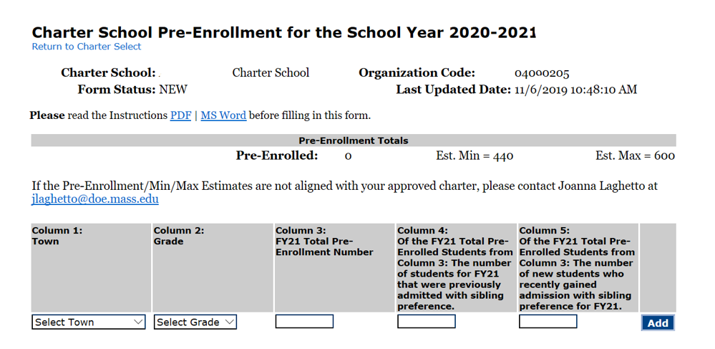

1b. Instructions for Entering Pre-Enrollment Data
- Column 1: Select the first Town for which the school has pre-enrolled students from the drop down menu.
- Column 2: Select the first grade level from that town from the Grade drop down menu.
- Column 3: Enter the total pre-enrollment number for the applicable town and grade.
- Column 4: Please enter the total number of students from Column 3 who were previously admitted due to sibling preference.
- Column 5: Please enter the total number of students from Column 3 who are newly admitted due to sibling preference.
- Click Add.
- Continue entering data for each town and grade, in the manner described above, until all pre-enrolled students and sibling data has been entered.

Examples:
The following charter school has twenty 3rd graders from Boston with five of these students who have been admitted under sibling preference: three admitted prior to FY21 and two who have been offered and accepted admission for FY21:
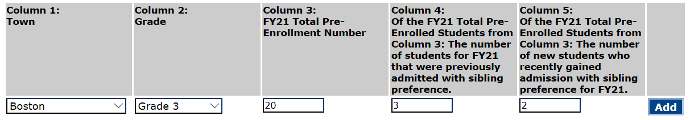

The following charter school has ten 6th graders from Randolph with two of these students who have been admitted under sibling preference: one admitted prior to FY21 and one who has been offered and accepted admission for FY21:
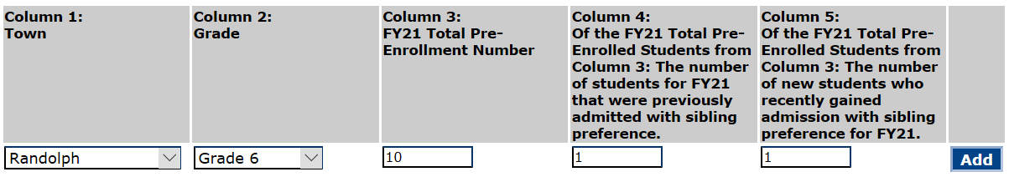

1c. Review the Data

Click on review the data to see summary information by enrollment status and review and verify your data.

1d. Final Submission of Data
The Charter School Leader must login to review the report data prior to submission. Only the Charter School Leader will be able to see and utilize the “Submit -- Final” button in order to submit the final report no later than March 16, 2020.
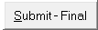
The data cannot be changed after the form is submitted.

1e. Please take a screenshot of your submission to provide to your auditor.
- Information and Instructions for FY 21 Initial Waitlist submission
Each school will once again be required to submit a waitlist to the Department by 5:00 pm on Monday, March 16, 2020. This list will contain your school's FY21 waitlist established after your most recent lottery and should reflect an accurate student waitlist as of March 16, 2020 for the upcoming school year. This FY21 Initial Charter School Student-Level Waitlist Report should be completed using the Excel template named FY21_waitlist_March_[your school’s LEA Code] that has been uploaded to your school's Charter School File Exchange dropbox within the ESE Security Portal.
There are detailed instructions in the Instructions tab found within the uploaded FY21 waitlist workbook. Please review these instructions and fill out the contact information tab before completing your FY21 initial waitlist report. Embedded within the waitlist collection template (‘initial’ tab) are several data flags and error checks (i.e., duplicate records, unsupported characters within a student name, student age, etc.). The Department relies on complete and accurate waitlist submissions and these embedded tools are included to support accuracy. The Department has discovered that these data flags and error checks work properly with Microsoft Excel. We have added a field to the contact information page for schools to identify which spreadsheet program was used to complete their waitlist report (e.g., Google Sheets). Please be sure to provide this information as well.
Once again, the Department requests that each charter school provide the following data elements for each student included in their current waitlist:
FIRSTNAME | LASTNAME | MIDDLENAME | DOB (MM/DD/YYYY) | TOWNCODE | GRADE
Please note that there are additional instructions that have been tailored for the three schools that continue to maintain roll-over waitlists established prior to March 31, 2014. Also note, that in addition to the embedded tools highlighted above, there’s another data flag that should identify students who are found on both the initial waitlist and on the rollover list--considered to be a duplicate record.
Each school’s waitlist collection template has already been placed in each school’s dropbox. Please let us know if you have any difficulty locating or accessing your waitlist collection template.
Questions Regarding the Waitlist submission:
Please feel free to contact Brenton Stewart (bstewart@doe.mass.edu or 781-338-3214) or Lee DeLorenzo (ldelorenzo@doe.mass.edu or 781-338-3227).
- 2020-2021 Significant Expansion Information
After the pre-enrollment data has been collected, it will be determined if a school's enrollment falls under the definition of Significant Expansion (FY20 Memo link for reference). If so, the school will be informed and given instructions for an additional report that will be submitted in June.
Please contact the Department with any questions.
Questions Regarding the Pre-enrollment submission:
Please feel free to contact Joanna Laghetto (jlaghetto@doe.mass.edu or 781-338-3221) or James DiMaio (jdimaio@doe.mass.edu or 781-338-3228).

MGL Chapter 71 §89(o): Each charter school shall annually, not later than April 1, notify each public school district in writing of the number and grade levels of students who will be attending the charter school from that district the following September as well as the number of new students who will be transferring from that district to the charter school in the following September. Tuition for charter school students shall only be paid for the number of students for whom notification has been reported by April 1. Tuition for charter school students shall be paid only for students actually enrolled in the school. 603 CMR 1.08(5): Enrollment Reports: Every charter school shall file a pre-enrollment report annually in accordance with deadlines established by the Department. Every charter school must keep accurate records related to enrollment including, but not limited to, applications for admission, the lottery process, and wait lists. The Department will report to districts the aggregate number of students who are selected for admission for the upcoming school year from their districts and the total enrollment for each charter school. No charter school shall receive tuition payments that exceed the total enrollment for that charter school as it was reported to the Department in the school's pre-enrollment report. In their pre-enrollment reports, charter schools must notify the Department of: (a) the school's total enrollment for the subsequent academic year; and (b) the projected number of students selected for admission, by grade and district of residence, for the subsequent academic year.
MGL Chapter 71 §89(i): The commonwealth shall incur charter school tuition payments for siblings attending commonwealth charter schools to the extent that their attendance would otherwise cause the school district's charter school tuition payments to exceed 9 per cent of the school district's net school spending or 18 per cent for those districts that qualify under said paragraph (3).

