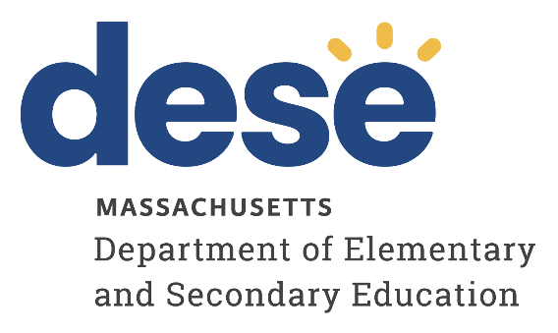

Office of Charter Schools and School Redesign

Recruiting and Retaining Culturally Responsive Educators of Color: A Case Study on Massachusetts Charter Schools

December 2022
Massachusetts Department of Elementary and Secondary Education
Office of Charter Schools and School Redesign
75 Pleasant Street
Malden, MA 02148
Phone: (781) 338-3227
Fax: (781) 338-3220

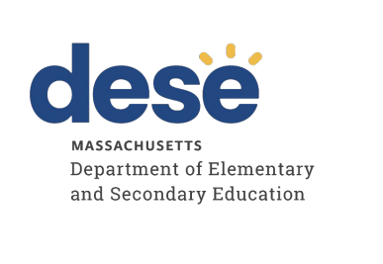

This document was prepared by the
Massachusetts Department of Elementary and Secondary Education
Jeffrey C. Riley
Commissioner

The Massachusetts Department of Elementary and Secondary Education, an affirmative action employer, is committed to ensuring that all of its programs and facilities are accessible to all members of the public.
We do not discriminate on the basis of age, color, disability, national origin, race, religion, sex, gender identity, or sexual orientation.
Inquiries regarding the Department’s compliance with Title IX and other civil rights laws may be directed to the
Human Resources Director, 75 Pleasant St., Malden, MA 02148-4906. Phone: 781-338-6105.

© 2022 Massachusetts Department of Elementary and Secondary Education
Permission is hereby granted to copy any or all parts of this document for non-commercial educational purposes. Please credit the “Massachusetts Department of Elementary and Secondary Education.”

This document printed on recycled paper

Massachusetts Department of Elementary and Secondary Education
75 Pleasant Street, Malden, MA 02148-4906
Phone 781-338-3000 TTY: N.E.T. Relay 800-439-2370
www.doe.mass.edu

Table of Contents
Overview 3
Theme #1: Creating a Culturally Responsive, Inclusive Work Climate 4
Theme #2: Developing Recruitment and Retention Systems and Goals 6
Theme #3: Providing Ongoing Professional Development on Culturally Responsive Instruction 11
Theme #4: Incorporating Criteria on Cultural Responsiveness in Teacher Evaluations 12
Promising Strategies in Charter Schools 12
Conclusion 16
Appendix A: Key Terms 19
Appendix B: School Profiles 21
Appendix C: Resources and Tools Shared by Charter Schools 24
Appendix D: Methodology 34

Overview
In April 2019 the Department launched a three-year Teacher Diversification Pilot Program Grant to support local school and district efforts to strengthen and diversify existing teacher recruitment and retention programs.

In October 2020, the Department released a guidebook reflecting the collective learnings that have emerged from the work of districts participating in the Pilot Program Grant, guided by research, and best practices: "Promising Recruitment, Selection, and Retention Strategies for a Diverse Massachusetts Teacher Workforce." This comprehensive, step-by-step guidebook is intended to support school and district efforts to increase and retain a diverse Massachusetts teacher workforce. The guidebook was developed collaboratively with The New Teacher Project (TNTP) and reflects current research, promising practices, and templates for school and district use. This case study is a continuation of the Department’s efforts to support recruitment and retention of culturally responsive educators of color.

This case study profiles three charter schools that have made steady progress in increasing the recruitment and retention of educators of color and in training all staff to be culturally responsive: Baystate Academy Charter Public School (BACPS), Community Charter School of Cambridge (CCSC), and KIPP Academy Boston Charter School (KABCS). The three schools were selected to represent differences in geography, school size, and grade level. The purpose of the case study is to provide schools with promising strategies to recruit and retain culturally responsive educators of color. In addition to the three profile schools, this report highlights promising strategies from multiple charter schools across the Commonwealth.

This case study specifically centers on culturally responsive educators of color in an effort to share how charter schools: 1) are supporting all educators to become culturally responsive and 2) are working towards recruiting and retaining a culturally responsive staff that reflects the racial and ethnic diversity of its student population.

The Department used elements of the Charter School Performance Criteria; specifically, Key Indicator 8.1: School Systems and Leadership and Key Indicator 8.2: Professional Climate and Standards for Performance to 1) select the three schools profiled in this case study and 2) identify four themes that would be use to guide the case study’s scope of inquiry. The themes are as follows.

Theme #1: Creating a Culturally Responsive, Inclusive Work Climate
School leadership takes active steps to create a more inclusive culture by implementing culturally responsive practices and policies and fostering a culture that welcomes and supports educators of color. The school’s professional environment promotes inclusive, respectful relationships between administrators and staff and amongst staff themselves, and a strong sense of belonging and connection for all staff.

Theme #2: Developing Recruitment and Retention Systems and Goals
The school has existing practices designed to recruit and hire culturally responsive staff. These practices are regularly evaluated and revised based on feedback from all school stakeholders including educators, families, and students. School leadership sets goals and establishes systems for the recruitment, development, and retention of culturally responsive educators reflective of the racial and ethnic composition of the students and families it serves.

Theme #3: Providing Ongoing Professional Development on Culturally Responsive Instruction
School leadership implements a comprehensive professional learning environment that supports the development of culturally responsive educators and provides the opportunity for staff to frequently collaborate and engage in conversations about both culturally responsive pedagogy and social-emotional learning. School leadership develops staff capacity to examine and dismantle implicit biases and systemic inequalities that affect both teachers and students. The school uses data from staff surveys to regularly evaluate the quality and effectiveness of the school’s professional development opportunities and systems of support for culturally responsive educators.

Theme #4: Incorporating Criteria on Cultural Responsiveness in Teacher Evaluations
The school’s formal process of evaluation for all employees includes evaluation criteria for the supervisor and supervisee to reflect on the supervisee’s implementation of culturally responsive strategies learned through professional development opportunities. All school staff are provided tools and resources, in an equitable manner, to perform their responsibilities and meet expectations for performance.

By conducting this case study, the Department provides useful examples for other schools. The Department understands not all strategies shared throughout the report may be applicable to every school and in every district.

Theme #1: Creating a Culturally Responsive, inclusive work climate
All participants shared that a culturally responsive, inclusive work environment is key to recruiting and retaining educators of color at each of their schools. Two overarching themes were observed across the three schools’ promising strategies for creating a culturally responsive, inclusive work environment: 1) developing self-reflection practices and creating safe spaces and 2) holistically supporting teachers inside and outside the classroom.

Developing self-reflection practices and creating safe spaces
All three school leaders shared that one of their top priorities for creating an inclusive and respectful environment for all staff is to engage in frequent self-reflection about areas of growth in their leadership, communication, and management style. School leaders interviewed believed that their school’s foundation for a culturally responsive, inclusive work climate starts with the school leader engaging in the following: 1) actively seeking feedback from staff on school leaders’ leadership areas of growth, 2) ensuring every adult is aligned to an equity mindset by sharing the school leader’s own vision for educational equity with all stakeholders, and 3) engaging in self-reflection based on staff feedback and the school leader’s focus on equity. School leaders shared that developing these skills takes time, humility (e.g., willingness to recognize areas of growth, to engage in difficult conversations with staff), and vulnerability (e.g., willingness to share self-reflections with staff, identify areas of leadership growth and ask school staff to hold school leaders accountable in these areas).

When asked, “How does school leadership build an inclusive, culturally responsive work environment for all staff?” a majority of teachers interviewed shared that their school leaders’ humility and willingness to identify his or her own areas of growth has created a safe space for teachers to provide feedback to school leaders and to engage in their own goal setting. Teachers reported that one of the reasons they stay at their respective schools is because they have seen school leaders listen to and utilize staff’s feedback, engage in self-reflection, and actively work on areas of growth such as improving communication and transparency on school-wide decisions and adapting management styles to individual teachers’ needs.

At BACPS, the principal has focused on conducting individual check-ins with all educators to solicit feedback on her leadership and management style, to ask educators how they are doing and how they feel about teaching at the school, and to constantly engage in building a relationship of trust between herself and individual educators. The principal believes that these check-ins have helped make the work culture more inclusive and less hierarchical because staff feel safe to voice their opinions and feedback on school matters and leadership decisions. Teachers shared that the principal’s efforts have created a more inclusive work environment and a culture that welcomes open communication.

At CCSC, the principal named two specific areas of growth that she is working on in response to educators’ feedback: 1) increasing her availability to teachers for any feedback or suggestions and 2) developing a management and leadership style based on her staff’s needs. Teachers shared that change in CCSC’s work environment has taken time, but it has been possible because of the principal’s systems for self-reflection and openness to feedback. The principal’s systems for self-reflection include scheduled periods throughout the year in which she reflects on her leadership and then shares out her reflection and self-identified leadership areas of growth with staff. The principal also maintains an open-door policy to gather feedback outside of the scheduled periods throughout the year. Teachers shared that the principal’s willingness to engage in vulnerable conversations about areas of growth in her management style has created a ripple effect for all CCSC educators. Teachers now feel more comfortable engaging in difficult conversations with colleagues about their own areas of growth in the classroom and in relation to each other.

CCSC has also developed a Critical Friends Group and an Equity Working Group to support safe spaces for staff to engage in courageous conversations centered on providing feedback to each other and on recognizing implicit biases. The Critical Friends Group was formed in response to an incident at the school that caused harm to educators of color. The group currently serves as affinity spaces and its purpose is to provide additional opportunities for learning about implicit biases and anti-racism work. Administrators shared that the Critical Friends Group is a work in progress, aiming to become a safe space for teachers with diverse backgrounds to connect and share their struggles in the classroom. Administrators also shared that administrators learned many lessons in the process of developing this Critical Friends Group. They emphasized the importance of setting group norms and beginning with a healing process for staff to discuss microaggressions within the school community before continuing anti-racism training. CCSC’s Equity Working Group was developed in the winter of 2019 with the goal to increase staff, family, and student voice on different school matters. Some of the topics covered in the Equity Working Group include staff retention and long-term planning to implement equity-based instructional practices.

Holistically supporting teachers inside and outside the classroom
All focus group participants emphasized that holistically supporting teachers inside and outside the classroom is essential to building a culturally responsive work environment. For example, the three schools are strategizing ways to ensure the compensation (compensation includes salaries, referral bonuses, stipends for leading PDs, etc.) offered is comparable to neighboring districts. See Theme 2: Developing Recruitment and Retention Systems and Goals for more information about how the schools are working to make compensation comparable. The schools are also working to ensure responsibilities are equitably distributed between white teachers and teachers of color (e.g., ensuring teachers of color are not solely responsible for the behavioral management of students of color, contracting with third-party vendors to provide anti-racism and implicit bias trainings instead of relying on teachers of color to lead the trainings).

At BACPS, teachers shared that, over the past six years, leadership has introduced a variety of initiatives to holistically support all educators. For example, Wellness Wednesdays are dedicated to weekly wellness activities like outdoor yoga and meditation. Other community-building activities are also organized throughout the school year including social events like bowling and attending food truck festivals together. Additionally, the leadership team sets aside time during staff meetings for staff to appreciate each other, to distribute feedback surveys, and to discuss how feedback will be incorporated in leadership decisions. Teachers expressed that having a leadership team that values individual wellness and actively seeks to appreciate staff is one of the reasons teachers have remained at BACPS since it first opened.

At KABCS, the principal implemented unlimited personal time off to prioritize teachers’ needs during the 2020-21 school year. School leadership understood the overwhelming stress teachers were under during the COVID-19 pandemic and frequently encouraged teachers to take time for themselves. All teachers shared that they were often encouraged to take personal time when needed and appreciated how school leadership gave teachers space to take care of themselves during a difficult year.

At CCSC, teachers reported feeling supported through the mentorship and support teachers provide each other. CCSC’s new teacher mentoring program focuses on relationship building between new and veteran teachers. The school leader shared that every week mentorship pairs are given $20 to grab coffee or a snack together and spend time on relationship building outside the school building.

Theme #2: Developing Recruitment and retention systems and goals
All participants shared multiple strategies for the recruitment and retention of culturally responsive educators of color. Below are examples of how each school is implementing promising strategies to increase recruitment and retention.

Promising Strategies for the recruitment of culturally responsive educators
All school leaders interviewed shared that their leadership teams focus on multiple factors (e.g., geographic location, school budgets, etc.) when creating yearly recruitment goals for teachers of color and all-staff recruitment systems. The case study team observed the school leaders shared three common questions that their leadership teams focus on when creating recruitment systems and goals.

HOW CAN WE OFFER A COMPETITIVE SALARY AND BENEFITS WHEN COMPARED TO NEIGHBORING DISTRICTS?

Participants from all three schools shared that one reason educators choose to leave their respective schools is the competitive salary offered by neighboring districts. One school leader shared that it is “difficult to compete with neighboring districts, especially in the city (Cambridge and Boston). Yet, we are honest and transparent with our staff in our efforts to provide a competitive salary while also developing other incentives and benefits for staff.” Referral bonuses are one example of incentives other than salary. CCSC and KABCS both provide staff with referral bonuses to 1) increase recruitment of educators of color and 2) provide monetary incentives for increased retention of all current educators. At CCSC, the referral bonuses of $250 started in the fall of 2019 and includes a CCSC t-shirt. At KABCS, the referral bonuses range between $500-$2,000 depending on the position to be filled.

In the 2020-21 school year, CCSC also started to provide a salary scale for non-teaching staff and began working to align its current salary scale to that of the Cambridge Public School District. In addition to monetary incentives, KABCS has also worked to provide teachers with benefits not provided in the neighboring public school district. For example, in the 2020-21 school year all staff had unlimited personal time off and in past years educators have been given greater flexibility to schedule non-instructional time around their personal schedule.

HOW CAN WE EXAMINE AND MINIMIZE IMPLICIT BIAS IN OUR HIRING PROCESSES?

All school leaders shared that in the past two to three years their schools have been working on examining implicit bias in recruitment systems and on redesigning what an equitable hiring process should look like for incoming educators.

For example, BACPS administrators shared that staff started to participate in implicit bias training three years ago. In the 2020-21 school year the school partnered with the Barr Foundation to strengthen its implicit bias trainings, and the school has used these professional development opportunities to revise its recruitment systems. Six years ago, only the BACPS executive director or the principal would interview incoming staff. Now, the interview process includes multiple steps and stakeholders including teachers and students. First, teachers screen resumes and conduct interviews with prospective applicants. Then, selected applicants conduct a model lesson for students. Finally, students provide feedback to administrators on their experience in the model lesson. One educator of color shared, “I liked interviewing [as a candidate] because it was different. I met first with a teacher and staff members and not just with the principal.”

Another culturally responsive promising strategy BACPS implements is the translation of all job postings and applications into multiple languages to increase accessibility. Administrators also shared that, “throughout the [hiring] process, [applicants are asked] questions related to cultural responsibility and competence, trauma informed instruction, and social emotional learning practices” to ensure culturally responsive educators are being hired.

CCSC has made many changes in the past two-three years to minimize implicit bias throughout the hiring process. The school leader shared the school has slowly transitioned from a hiring process centered on “White supremacy” to a process that focuses on “looking at the person behind the [application] documents.” After examining the school’s hiring process and the factors used to disqualify applicants (e.g., typos on resumes, performance tests “aligned to white supremacy attributes like scanning through emails while being timed”), the leadership team realized:
“We were being unintentionally biased by hiring a lot of Ivy League, middle and upper class, White educators who were coming from generational wealth and that was the majority of our staff for a long period of time and not what we wanted. We realized [our hiring process included] elements of White supremacy culture like perfectionism and worship of the written word. We realized that there’s a lot of privilege in having perfect hiring materials and that a lot of educators of color we hired [may not] have had someone to coach [them] on resumes and cover letters. We realized that people can be strong educators without perfect looking hiring documents, and we are really trying to get those unconscious biases out of the screening process.” – CCSC School Leader

The school leader and administrators shared that revising CCSC’s recruitment and hiring process took time and vulnerability on behalf of the leadership team to acknowledge the harm a hiring process centered on “White supremacy” was causing all CCSC educators. The leadership team also participated in multiple implicit biases trainings to learn how to identify the biases and “White supremacy elements” in CCSC’s hiring process. One administrator shared, “I had to unlearn everything I learned about recruitment in order truly say our goal was to recruit educators of color.”

The revised CCSC hiring process now requires applicants to read an educational equity case study and then share their reflections during the initial interview. This allows the interview team to assess cultural responsiveness and the applicant’s views on race and equity. In the 2020-21 school year, the leadership team started to include a family and student portion in the hiring process. The school leader shared that every year CCSC re-examines its recruitment systems and hiring processes to improve how it recruits culturally responsive educators of color and that “being clearer about our mission as an anti-racist organization has helped with our recruitment.”

At KABCS, the school leader shared the importance of communicating the school’s anti-racism mission and equity values at every stage of the hiring process. White educators at KABCS shared that it was clear during the interview process what values the school was looking for in educators. One teacher shared “they [hiring team] weren’t simply looking for any teacher, but instead someone who believes in the anti-racism mission and core values of the school.”

HOW CAN WE INCREASE OUTREACH TO MORE COMMUNITIES OF COLOR TO RECRUIT EDUCATORS?

Given BACPS’ urban location in Springfield, Massachusetts, school leaders shared that the school has struggled to recruit culturally responsive educators of color. To address this challenge, the school developed an innovative homegrown program. The school leader shared that many educators of color start off as teaching assistants (TAs) right after high school graduation and then enroll in a college or university and upon graduation with their bachelor’s degree return to teach full time; “I often tell them, go to school, learn what you need to learn and when you are ready we will be here.” BACPS also partners with local colleges and organizations to recruit undergraduate TAs, including Springfield College, Westfield State, Mount Holyoke, and Teach Western Mass.

School administrators shared that BACPS’ homegrown program includes the creation of internal pipelines. The internal pipelines were created after the school leadership team “recognized that all candidates were coming with a lack of culturally responsive mindsets and working with communities that don’t reflect them. [Now] we use the [internal] pipelines to really recruit teachers of color, first as TAs, and then translate them into actual teaching and [eventually] leadership positions.” The principal also shared that BACPS uses its internal contacts to recruit: “we use teaching staff to recruit individuals in their communities (e.g., sharing job postings at churches, with family members, etc.) so that our educators embrace the systems and philosophy at Baystate.” One educator of color shared they joined BACPS through word of mouth: “I had a friend who used to work here in an after-school tutoring program, and he recruited me as a TA.”

Promising recruitment strategies for CCSC include participating in the Teacher’s Lounge hiring fairs, local hiring fairs in communities of color, attending the yearly NIMET Minority Recruitment hiring fair, posting in alumni job boards and newsletters at Historically Black Colleges and Universities (HBCUs), and in organizations for students of color in colleges and universities across the Commonwealth. Administrators also shared that CCSC’s current educators of color have shared the importance of working in the communities they grew up in and getting to know students and families. For this reason, CCSC added a family and student panel to the interview process for all educators and started to participate in hiring fairs in the communities of color in which many CCSC students reside.

Some White teachers at KABCS said they learned about their current position through teacher fellowship programs across Boston. Like BACPS, many started off as fellows or TAs and then transitioned to full-time teaching. Some KABCS teachers of color shared learning about their current position through Generation Teach, an organization that also offers teaching fellowships. School administrators shared that recruiting through fellowships and TA positions has been a promising strategy to increase recruitment of culturally responsive educators of color.

Promising Strategies for the retention of culturally responsive educators
COACHING AND LEADERSHIP OPPORTUNITIES
Teachers in all three schools shared that two of the reasons they have remained at their respective schools are 1) classroom autonomy and 2) professional development and leadership opportunities. Many teachers interviewed shared that the level of classroom autonomy given to educators as they design lesson plans, student activities, etc. is very different from other schools. Teachers also described unique leadership opportunities offered at each school.

For example, BACPS teachers of color shared that all new teachers are “paired with mentor teachers for additional layers of support,” and that “one of [BACPS] best strategies is the excellent resources and necessary tools offered that help us [teachers of color] continue progressing professionally and become better educators.” BACPS teachers of color also referenced the school’s internal leadership pipelines and explained that “before hiring outside, they [admin] look to hire inside and reach out to the teachers in the building first before looking elsewhere. For example, I was supported to go from being an after-school tutor, to a TA, to a substitute, and now a teacher.” Another BACPS teacher of color shared how she started off as a teacher and is now the English as a second language (ESL) director.

In addition to also providing individualized coaching, mentorship, and other leadership opportunities, CCSC is working to find “opportunities to compensate educators of color for the [work] they are doing.” CCSC administrators explained that providing leadership opportunities like leading professional development, working with more students of color, etc. is not enough if the teachers of color doing this work are not being compensated monetarily.

INCLUSIVE WORK CULTURE AND ENVIRONMENT
Similar to the promising strategies shared in Theme 1: Creating a Culturally Responsive, Inclusive Work Climate, all participants shared a key reason educators stay at their schools is because of the school’s culture and environment of inclusivity, where staff feel accepted, valued, and safe to have vulnerable conversations about their professional and personal areas of growth.

BACPS’ retention strategy includes developing an inclusive work culture, “humanizing individuals, and creating a safe space for our educators of color to talk about equity and issues that impact our community.” BACPS teachers of color said the entire staff work as a family and that positive staff culture is the reason many remain at the school. One teacher of color shared:

“One of the best strategies the school uses for the retention of culturally responsive educators, regardless of our race or ethnicity, is the emotional, pedagogical, and family warmth we receive every day, in addition to the professional resources that are provided to us for our professional growth. The trust and credibility that we receive from our superiors are unique and fair.”

To develop this inclusive work culture, BACPS established a staff version of CREW (advisory for BACPS students). In CREW, staff focus on team building, unpacking implicit biases, and creating safe spaces to have conversations about personal (as it related to educational equity, anti-racism, implicit bias) and professional areas of growth. The BACPS guidance counselor and social worker also developed a Wellness Team that check-ins with teachers once a week to “make sure teachers are feeling okay and have someone to talk to if they have any concerns.”

At CCSC, the leadership team is also focused on making the job more sustainable. For example, when teachers are in-person they have at least one day a week they can come in a bit later than usual. Administrators also try to “not check people’s hours so closely and let people be adults. For example, if a teacher does not have any obligations they can leave early that day.” Non-teaching staff also have the option to work from home one day a week. School administrators shared that the leadership team is finding ways to make staff’s schedules even more flexible. Another promising strategy at CCSC is its series of “Stay Conversations.” Every December supervisors have a one-on-one conversation with their staff to check-in, ask what staff want to work on the coming year, if staff are thinking of staying or leaving at the end of the school year, etc. All CCSC focus group participants shared that the Stay Conversations have been very helpful. The school leader stated that this promising strategy was shared by the school leaders in the Phoenix Charter Network and that it has been really impactful for the retention of CCSC educators.

KABCS teachers of color shared that at every Friday staff meeting colleagues share shoutouts and moments of gratitude with each other and that this has been a great way to build culture amongst the staff. KABCS teachers of color also shared remaining at a culturally responsive school is important to them. One teacher of color shared that the school hosts different cultural events like Black History Month, Hispanic Heritage Month, family events, and organized activities in response to current events. For example, “In 2018 when [former President] Trump made many insensitive comments about Haiti, our school put up the Haitian flag.” KABCS teachers of color shared small, culturally responsive actions like these keep them at KABCS year after year.

Theme #3: providing Ongoing Professional Development on Culturally Responsive Instruction
All participants interviewed shared that professional development (PD) at their respective schools has transformed in the past four years. Many teachers, from all three schools, shared that professional development first started off as “data chats,” focusing predominately on student data and how to center instructional strategies around data. Then, PDs on implicit bias started to take shape and in the past year there has been an increase in anti-racism PDs. Teachers and school administrators shared that now that the foundation of implicit bias training has been established, schools have started to build on that with increased anti-racism trainings and PDs on cultural responsiveness in the classroom and amongst staff. The KABCS school leader shared that providing cultural responsiveness PDs is “where we talk about navigating our own story [and interactions with each other] and how [we can help] kids navigate their own story.” CCSC administrators and teachers of color shared that cultural responsiveness PDs also focus on intersectional identities that all staff embody. One CCSC administrator shared, “there is a piece being explored that speaks to intersectionality and we can’t just focus on race, but we have to also expose [staff and students] to the queer story, classicism, colonialism, etc.” CCSC teachers of color shared that when PDs claiming to focus on cultural responsiveness only touch on racism then “PDs become too polarizing, leaving out LGBTQIA+ folks, people with disabilities, etc.”

When asked “How effective have PDs been in helping your teaching practice and/or changing the work climate culture amongst staff?” teachers from all three schools shared PDs have been effective because every PD is followed by a feedback survey. Teachers shared that school leaders are responsive to feedback and have made changes based on feedback.
The school leader at BACPS shared that professional development is designed based on the needs of students and educators. For example, because BACPS heavily enrolls English learners, the school designates a large part of its PD budget to training staff in English Language Education (ELE) instructional practices, sending staff to ELE national conferences, reimbursing staff for multiple ELE external PDs, and paying for all staff to have Sheltered English Immersion (SEI) endorsements. The BACPS principal shared that the school also partners with multiple vendors to conduct in-house PD on culturally responsive teaching, implicit biases, self-reflection, and identifying personal areas of growth.

At CCSC, staff are incorporating student voice into culturally responsive PDs. In the past two years, students have been invited to PD sessions to review CCSC’s curriculum and share their feedback on how culturally responsive the curriculum and resources really are. CCSC also focuses on increasing PD opportunities for teachers outside of the school. For example, the school leader shared that CCSC partners with Boston University to provide teachers tuition reimbursement for their Master’s in Education and other degrees and certifications.

In addition to scheduled professional development, KABCS also organizes affinity spaces for all staff and provides one-on-one coaching, specific to delivering culturally responsive instruction and developing best practices, to all teachers. A unique element at KABCS is that every classroom has a lead and fellow teacher. This provides all teachers the opportunity to conduct peer observations and provide each other live coaching.

Theme #4: Incorporating Criteria on Cultural Responsiveness in Teacher Evaluations
School leaders and administrators in all three schools shared that their respective schools are in the beginning stages of developing teacher evaluation rubrics and systems to evaluate teachers’ culturally responsive instruction and classroom environments. Now that recruitment systems and professional development opportunities are ongoing, school leadership teams are starting to revise how they evaluate staff.

During the 2020-21 school year, the CCSC Equity Working Group, compromised of staff, families, and students, started to discuss potential revisions to its teacher evaluation systems. The Equity Working Group’s goal is to include more specific evaluation metrics for teachers’ usage of culturally responsive instructional practices and usage of promising strategies shared in professional development opportunities.

At KABCS, every teacher has a mid and end-of-year evaluation with specific components around teachers’ interactions with other staff, families, and students. This component allows supervisors to assess a teacher’s usage of culturally responsive strategies to communicate with various stakeholders from diverse backgrounds. During each evaluation, teachers are also asked to rate themselves on the school’s equity principals and then discuss their rating with the evaluating supervisor or coach. One teacher of color shared that the evaluations for the 2020-21 school year asked, “How have you incorporated culturally responsive teaching. Provide specific examples.”

At BACPS, the school principal was invited to speak at a panel hosted by the Department on how to incorporate culturally responsive practices into Massachusetts teaching standards. As a result of learning from panel peers, BACPS developed a new teacher evaluation rubric to evaluate teachers on culturally responsive teaching. The rubric incorporates the strategies shared in the panel and DESE’s ten Teacher Focus Indicators (indicators). See Appendix D: Resources and Tools Shared by Charter Schools for the rubric and indicators. The BACPS principal shared that the indicators are also integrated into the school’s strategic plan and used to develop the school’s professional development calendar to ensure topics in teacher evaluation rubrics are also covered by the supports given to teachers throughout the year.

Promising Strategies in charter schools
After focus groups were conducted with the three profiled schools, the Department distributed a second survey, the Department Case Study Snapshot Survey, to all charter school leaders in the Commonwealth. Below are brief charter school profiles and the promising strategies shared by the three school leaders who completed the survey.

Boston Collegiate Charter School (BCCS)
Type of Charter | Commonwealth | Location | Boston
Regional or Non-Regional | Non-Regional | Grade Span | 5-12
Year Opened | 1998 | Year(s) Renewed | 2003, 2008, 2013, 2018
Maximum Enrollment | 700 | Current Enrollment | 702
Mission Statement:
The mission of Boston Collegiate Charter School is to prepare each student for college.
Promising Strategy- Recruitment and Retention Systems and Goals:
“We established as part of our Accountability Plan in our 2018-2023 charter the goal that we would move our staff demographics to better reflect our student population. Those involved in this process were our board, staff, and families involved in our DEI work. With 2018 as the baseline, we engaged in a rigorous data tracking system for each hiring season that broke down current staff and new hires by demographics so we could see how we were tracking over the hiring season. We implemented an Associate Teacher program to hire diverse talent. We conducted an equity audit of our hiring processes and implemented a new approach, which involved a video interview, and which also includes questions such as, "what role has your race played in where you are today?" to better understand candidate awareness of bias, privilege, etc. We meet weekly in a Human Capital meeting to discuss the hiring and retaining of staff, and particularly staff of color. Our DEI Director is a standing member of that meeting. In addition, we implemented a Multilingualism Stipend, whereby staff who speak languages spoken by more than 1% of our student population can get $1,000 extra in their pay. We also do exit interviews for all departing staff members and screen for whether aspects of our culture impacted departure, particularly for BIPOC staff.” – BBCS Executive Director
See Appendix C: Resources and Tools Shared by Charter Schools for resources (Multilingualism Stipend Details and Sample Hiring Data Tracker) shared by BCCS.

Excel Academy Charter School (Excel)
Type of Charter | Commonwealth | Location | Boston, Chelsea
Regional or Non-Regional | Regional | Districts in Region | Boston, Chelsea
Year Opened | 2003 | Year(s) Renewed | 2008, 2013, 2018
Maximum Enrollment | 1,400 | Current Enrollment | 1,365
Chartered Grade Span | 5-12 | Grade Span | 5-12
Mission Statement:
Excel Academy’s mission is to prepare students to succeed in high school and college, apply their learning to solve relevant problems, and engage productively in their communities.
Promising Strategy- Professional Development Opportunities:
“Starting in August 2021, Excel is launching the Emerging Leaders Program. The Emerging Leaders Program aims to support Excel's commitment to creating an anti-racist, inclusive culture by cultivating a diverse pipeline of aspiring leaders. The ideal applicant is an individual who has worked at Excel for 2-4 years, has excelled in their current role, and is interested in pursuing additional leadership opportunities. Emerging Leaders will take on a meaningful, year-long leadership role at the school or network level while receiving support through mentorship, peer collaboration, and professional development. The Emerging Leaders Program will provide participants with increased recognition and compensation, new challenges, and opportunities for growth, and put them in a strong position for career and leadership opportunities as they become available.”- Excel Executive Director
See Appendix C: Resources and Tools Shared by Charter Schools for resources (Overview of Emerging Leader Program) shared by Excel.

Helen Y. Davis Leadership Academy Charter Public School (DLA)
Type of Charter | Commonwealth | Location | Boston
Regional or Non-Regional | Non-Regional | Grade Span | 6-8
Year Opened | 2003 | Year(s) Renewed | 2008, 2013, 2018
Maximum Enrollment | 216 | Current Enrollment | 138
Mission Statement:
Our school develops high-achieving students of good character who use problem solving, communication, and interpersonal skills to inspire others and to catalyze educational, economic, and political advancement within their communities and the broader nation.
Promising Strategy- Culturally Responsive and Inclusive Work Climate:
“Beginning in 2017, school leadership, including the Executive Director, Principal, and Assistant Principal designed and implemented the development of a culturally responsive and inclusive work climate that mirrors that of HBCU's (Historically Black Colleges and Universities). HBCU's have served as institutions of higher learning for people of color since the 1830's, and inherently create an environment of academic excellence, while simultaneously valuing the contributions and cultural values of the school community at large. Our HBCU culture is reflected in our emphasis on high academic achievement, the arts, and athletics, as well as our culturally responsive student and family events.” – DLA Executive Director

Conclusion
One trend the case study team observed across all three profiled schools is that change in recruitment, retention, and professional development takes time. All school leaders shared that changes in their processes have taken two to three years and that there “is still much work to be done.” Some school leaders emphasized that changing these processes and systems is a collective process that “does not happen overnight but that is necessary to ensure equity exits in schools.”

By conducting this case study and identifying promising strategies, the Department hopes to continue the statewide collaboration and conversation on how to increase recruitment and retention of culturally responsive educators of color. The Department understands all promising strategies including in this report may not be successful at or applicable to every school and in every district. By publishing this report, the Department’s goal is to disseminate promising strategies that have proven successful in a sample size of Commonwealth Charter Schools.

School leaders are encouraged to refer to the four themes and various promising strategies shared on a continuing basis to inform planning and conduct self-assessments of their school’s overall practices for 1) supporting all educators to become culturally responsive and 2) recruiting and retaining a culturally responsive staff that reflects the racial and ethnic diversity of its student population.

At the end of every interview and focus group we asked participants to share, “What is one final piece of advice you would share with school leaders looking to improve their recruitment and retention of culturally responsive educators of color?” Below is their advice (interview and focus group participants are listed in the order they were interviewed by Department staff).

BACPS School Leaders and Administrators
- “You have to know your community and staff. There will need to be multiple methods to engage communities of color [in your school’s recruitment strategies]. If you are not intentional about your [recruitment and retention] practices, then you will divide your staff. You don’t want teachers of color to come in and feel tokenized. It will take years of practice and conversation, connecting with communities and local colleges, and pushing the envelope for partnership with local colleges [to recruit a comparable percentage of educators of color]. Understand recruitment might not always start with people in education programs but second career people instead. Build a strategic plan with measurable goals. Make sure educators of color have the power to impact the work in the community.”
- “Communication – open communication about where we currently are and making sure it’s open and fluid regularly. Create that safe space for adults to make mistakes and feel safe with sharing their thoughts and past experiences. Continue maintaining safe space once you start creating it with openness, having difficult conversations, and making difficult conversations part of the culture- making it a normal process of having difficult conversations. We are all people, and we can’t perfect all the time but we can still talk about things. We need to have solutions-based conversations.”
- “Recruitment – you have to be creative. You got to look inside, if you already have folks in support roles [e.g., paraprofessionals, teacher assistants, etc.] and they are shining and connecting with staff, families, then recognize them and move them up the ranks. Not because they are people of color, but because they know the community.”

BACPS White Teachers
- “Listen to your teachers.”

BACPS Teachers of Color
- “Learn when to recognize the need to give shout outs and affirm the good work and when to step back and see that something is not working.”
- “Work as a unit.”
- “Keep your eyes, ears, and heart open to all needs”
- “[Provide] supportive leadership”
- “Make people feel at home and comfortable. If you have the support of the leader then you don’t need anything else.”
- “Encourage staff to be solution driven when there is an issue”

CCSC School Leaders and Administrators
- “If you have mostly white staff right now, you need to start do the work [anti-racism and implicit bias training] with them. You can hire your few educators of color but if your white staff are not ready to have these difficult conversations on systemic racism and implicit bias and do the work, then it falls on the educators of color and it creates an unsafe environment for educators of color. I think it’s immoral and unethical to do this work if you’re not pushing white staff to talk about that work.”
- “Review the decision-makers. It’s important that applicants don’t see a sea of white faces when they meet the hiring team.”
- “If you are asking staff to be part of an interview process, then that has to compensated [monetarily] and acknowledged.”
- “Be willing to go outside of the ‘Ivy league schools’ and be willing to reach out to state colleges, HBCUs, and understand if you want to hire educators of color then you have to have the right structures and systems in place. Don’t limit who you think should be in leadership seats like that and give everyone the opportunity to teach AP classes or other opportunities for leadership.”
- “Ask educators of color that remain at the school what school leadership can do better to retain them and ask educators of color who left the school what school leadership could have done better.”
- “Make sure the space you’re creating for educators of color is a safe space and that they are intentional of not perpetuating the inherited racist systems in institutions and schools.”

CCSC White Teachers
- “[Have] community meetings – out of specific moments you build community in tiny moments. Helps to make education of our students feel more balanced across all teachers and students.”

CCSC Teachers of Color
- “Pay them their money. Show the appreciation – be able to put them in higher places, career elevation, leadership opportunities.”
- “Create spaces for vulnerability – you cannot work with people if you don’t know who they are. Students need work with people who they know and feel comfortable with.”
- “Have mentor programs to match all teachers with someone experienced. This will increase retention.”
- “Teach students about diverse race and identities even if that representative identity is not at the school.”

KABCS School Leaders and Administrators
- “You make it clear that you’re trying to make a place where Black and Brown people thrive. You’re not hiring them to fix children or the world. You’re hiring them because of the strengths they play and their skills and knowledge, but also the unwritten things they’ve accomplished. You have to name that the children see people who look like them and leaders that look like them and it’s a strength. If you create a powerful place where Black and Brown people thrive, then they will tell other Black and Brown people to work here. The referrals have been the most powerful [to increase recruitment].”
- “Retention-people want to develop, and they want to know how to get to the next level. Make that clear- you have to explain how to go from a teacher to principal very clearly.”
- “Pay people. Money talks. Tell them they will get the salary they deserve for all the work they are doing and give them the PD and support to become leaders “
- “Recruit from the communities the school serves, it is what our students and families want”

KABCS White Teachers
- “Don’t separate culturally responsive into a separate box. It has to live in everything because it’s the thing that will drop off if you don’t have time.”
- “You cannot be a good teacher if you are not a culturally responsive teacher.”

KABCS Teachers of Color
- “There’s no finish line to cultural responsiveness, it’s the continuation. You need to keep learning. There’s not ‘winning’ at anti-racism. It requires continual reflection and doing that reflection. “

Appendix A: Key Terms
The foundational resources for the definitions below are District Standards and Indicators (2019 revision), Multi-Tiered System of Support, Culturally Responsive and Sustaining Schools and Classrooms, and the Educator Effectiveness Guidebook for Inclusive Practice, unless otherwise noted.
- All students: Given that some student groups have been historically underserved, and also that any student can be particularly “vulnerable” at any moment in time, it is important to consider practices and outcomes beyond the aggregate to ensure that all students are challenged and supported to learn and grow. The phrase “all” in this document refers to equity for and attention to students from all backgrounds and identities and experiences. These include but are not limited to all races and ethnicities, all genders and gender identities, all sexual orientations, all disabilities, all nationalities, all types of citizenship or immigration status, all religions, all family structures, all family housing situations, all medical/health needs, and all traumatic experiences.
- Culturally proficient and culturally responsive: Culturally proficient policies and practices enable staff members and students to interact effectively in a culturally diverse environment in which students’ backgrounds, identities, strengths, and challenges are respected. Cultural responsiveness is an approach to viewing culture and identity as assets, including students’ race, ethnicity, or linguistic assets, among other characteristics. Culturally responsive policies and practices acknowledge and actively draw upon diverse backgrounds, identities, strengths, and challenges of administrators, students, staff, and community as a way to deepen connections between the school and its community.
- Disaggregated student data and disaggregated educator data: Aggregate student and educator data that is broken down into smaller parts in order to learn about the performance, opportunities, and outcomes of specific student and educator groups populations; for example, schools, grade levels, and content areas. All data analysis described in this document should be conducted in accordance with all applicable laws pertaining to the confidentiality of student and educator data.
- Equity: Educational equity means ensuring and adjusting resources based on need such that all students have access to the educational resources, opportunities, and rigor they need at the right moment in their education across race, gender, ethnicity, language, disability, sexual orientation, family background and/or family income to meet high expectations for cognitive, behavioral, and social-emotional growth and development.
- Inclusive: In an inclusive school, all organizational levels of the school recognize, support, and celebrate all students, families, and staff members to create a climate where all students, families, and staff feel equally valued and part of the school community.
- Student group and educator group: Any group of students or educators who share similar characteristics, such as racial or ethnic identification, gender identification, socioeconomic status, physical or learning disabilities, or language skills. This includes, but is not limited to, the groups of students for which the Department issues annual performance determinations.
- Racial and Ethnic Diversity: While the Department values all types of diversity, in this context diversity refers to race and ethnicity. While Latinx and Hispanic can be considered cultural or linguistic categories rather than racial ones, for the purpose of this case study, Latinx is used as a racial category. Unless otherwise stated, the terms “people of color” or “students of color” refers to Latinx, African American, Asian, American Indian, Native Hawaiian, Pacific Islander, or multiracial individuals.
- Educator Workforce: Teachers, administrators, and professional support personnel.

Appendix B: School Profiles
Baystate Academy Charter Public School (BACPS)
Type of Charter | Commonwealth | Location | Springfield
Regional or Non-Regional | Non-Regional | Districts in Region | N/A
Year Opened | 2013 | Year(s) Renewed | 2018
Maximum Enrollment | 560 | Current Enrollment | 456
Chartered Grade Span | 6-12 | Current Grade Span | 6-12
Students on Waitlist | 0 | Current Age of School | 8
Mission Statement:
Baystate Academy Charter Public School is a college preparatory school that provides challenging academic standards in professional health career settings in order to prepare 6th – 12th grade students in Springfield to be inspired leaders in the 21st century workforce.

Source: Profiles and 2021-22 Race/Ethnicity and Gender Staffing Report

Community Charter School of Cambridge (CCSC)
Type of Charter | Commonwealth | Location | Cambridge
Regional or Non-Regional | Non-Regional | Districts in Region | N/A
Year Opened | 2005 | Year(s) Renewed | 2010, 2015, 2020
Maximum Enrollment | 420 | Current Enrollment | 288
Chartered Grade Span | 6-12 | Current Grade Span | 6-12
Students on Waitlist | 18 | Current Age of School | 16
Mission Statement:
Community Charter School of Cambridge (CCSC) combines challenging academics with creative use of technology and real-world experience to prepare a diverse student body, grades 6-12, for post-secondary success and productive citizenship. CCSC students are excellent problem solvers and communicators who contribute to their community through internships and other field experiences.

Source: Profiles and 2021-22 Race/Ethnicity and Gender Staffing Report

KIPP Academy Boston Charter School (KABCS)
Type of Charter | Commonwealth | Location | Boston
Regional or Non-Regional | Non-Regional | Districts in Region | N/A
Year Opened | 2012 | Year(s) Renewed | 2017
Maximum Enrollment | 588 | Current Enrollment | 600
Chartered Grade Span | K-8 | Current Grade Span | K-8
Students on Waitlist | 1, 232 | Current Age of School | 9 years
Mission Statement:
The mission of KIPP Academy Boston Charter School is to create a school environment where students develop the academic skills, intellectual habits and character traits necessary to maximize their potential in high school, college and the world beyond.

Source: Profiles and 2021-22 Race/Ethnicity and Gender Staffing Report

Appendix C: Resources and Tools Shared by charter schools
For a copy of the resources below please email Jacqueline Chavez, Jacqueline.g.chavez@mass.gov.

BACPS Resouces and tools shared
Department Focus Indicators used for teacher evaluations

Example of interview questions
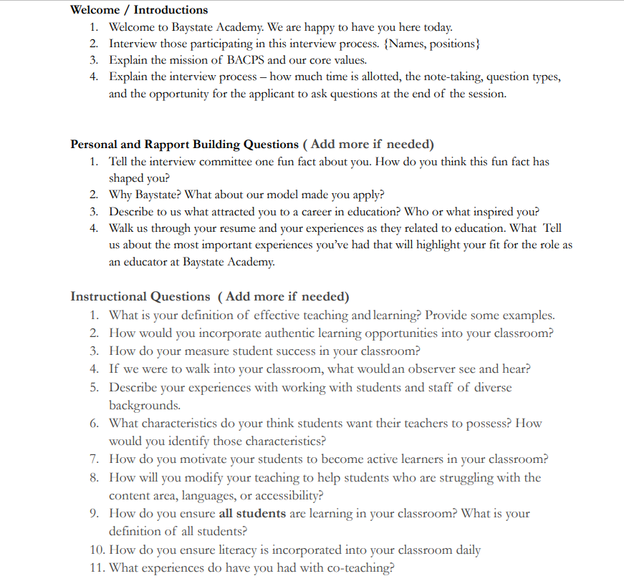

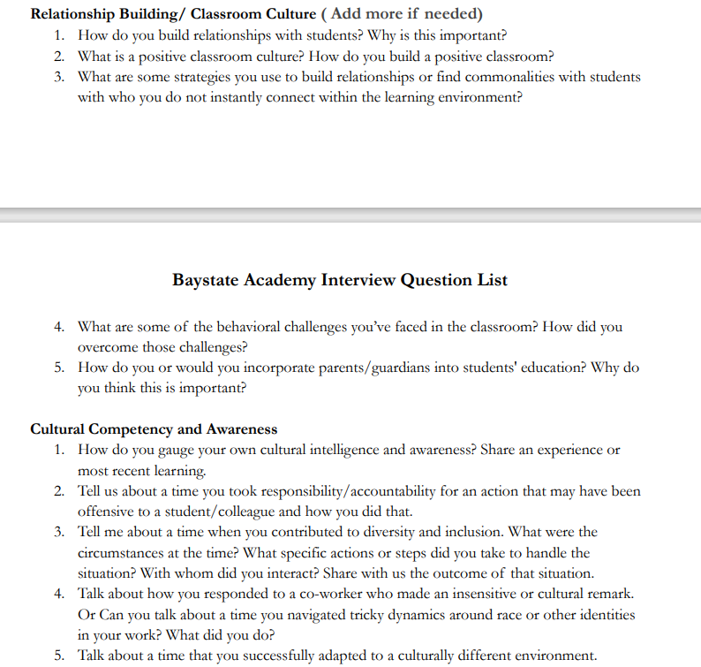

CCSC Resources and Tools shared
Example of PD focused on staff feedback
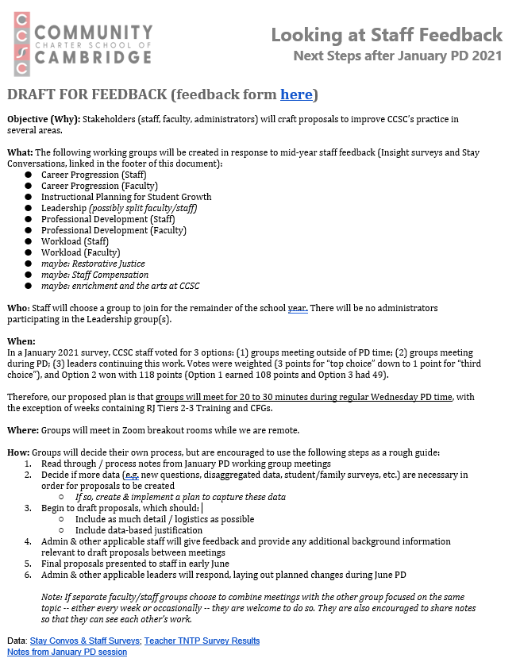

Example of teacher evaluation
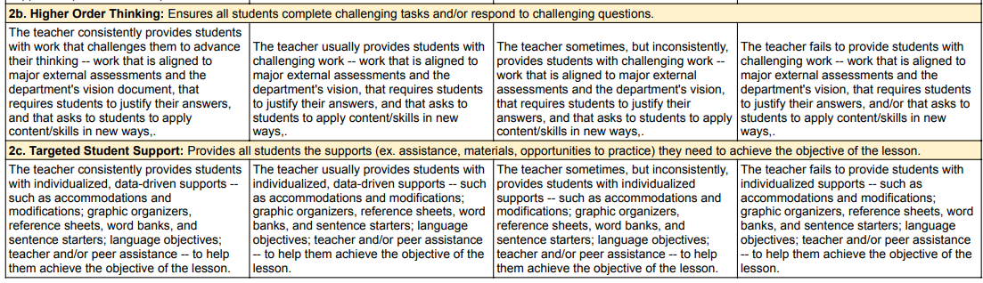
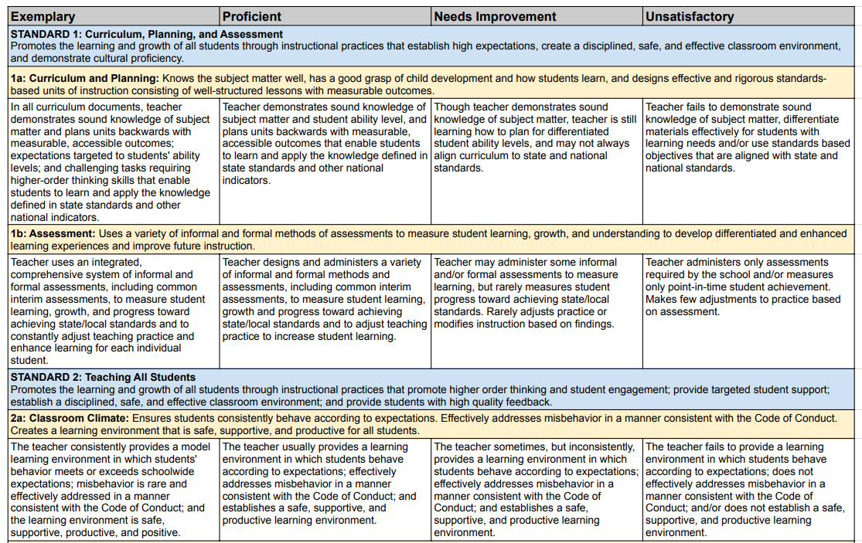

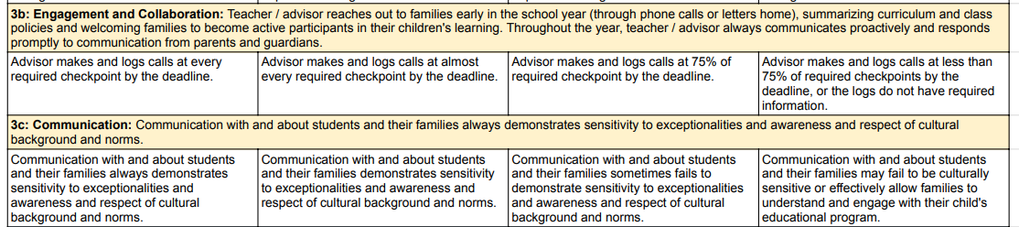
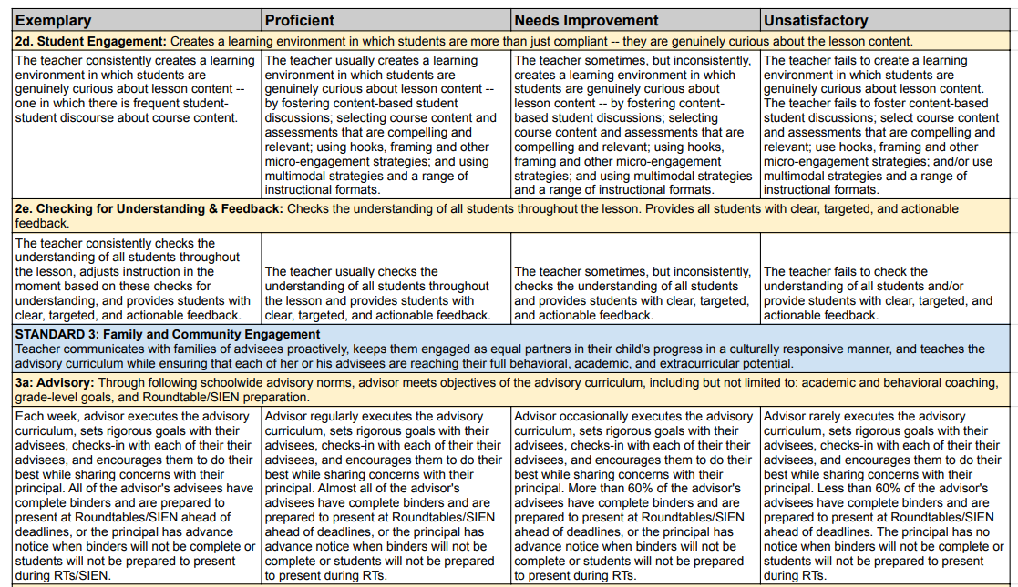

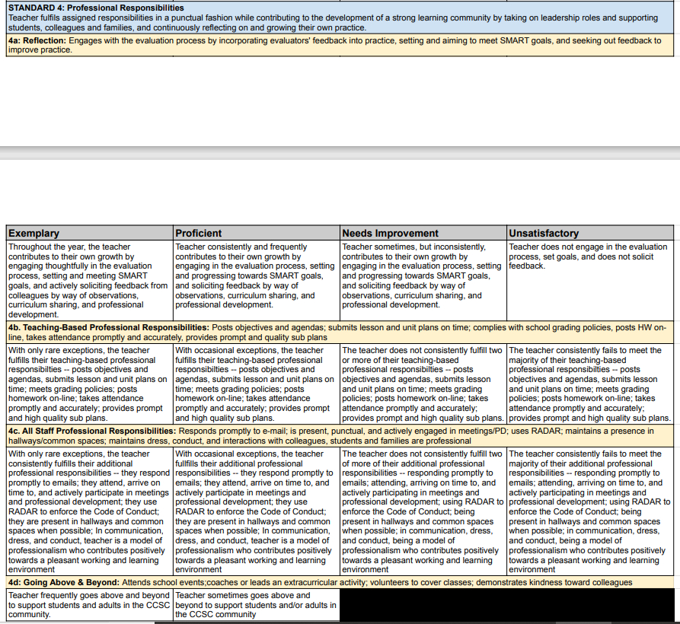

KABCS Resouces and Tools Shared
Example of work culture and environment planning
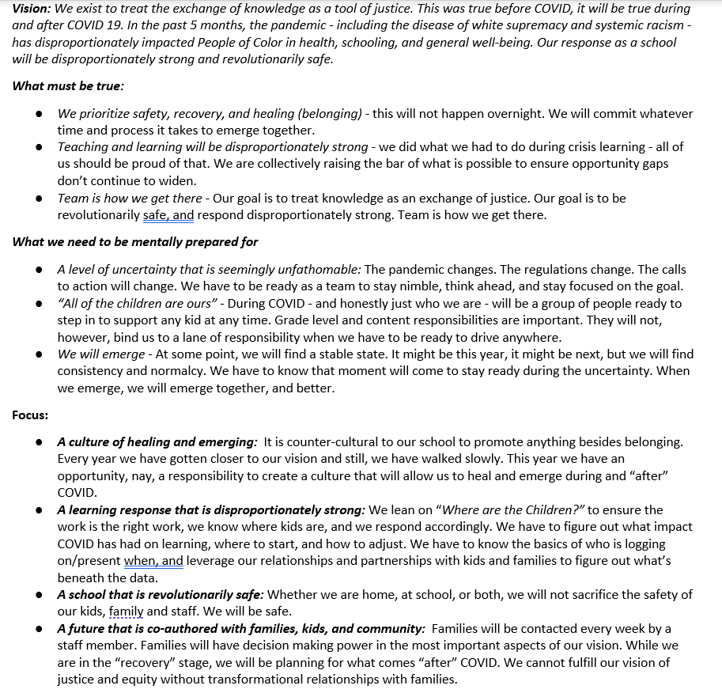

Example of leadership pipeline development and planning
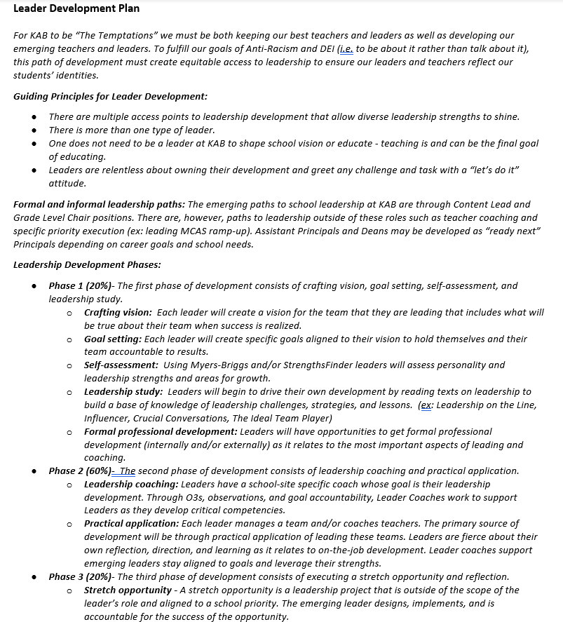

BCCS Resources and Tools Shared
Example of Multilingualism Stipends
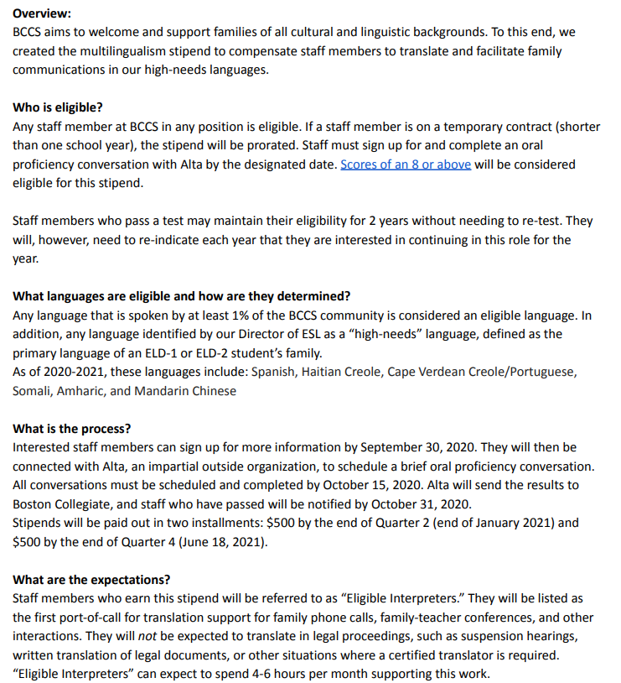

Excel resources and tools shared
Emerging Leader Program Overview
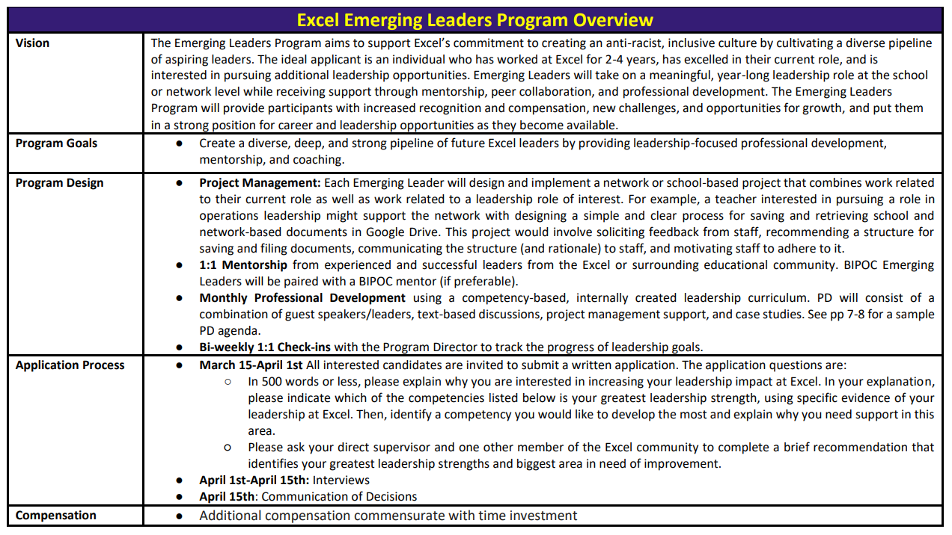

Appendix D: Methodology

Research questions
To identify promising strategies for recruiting and retaining culturally responsive educators of color, the case study examined three research questions:

- What promising strategies are schools implementing to recruit culturally responsive educators of color?
- What promising strategies are schools implementing to retain culturally responsive educators of color?
- How are schools supporting all educators to develop culturally responsive mindsets and instructional practices?

data collection
A combination of quantitative and qualitative data collection tools were used to address the research questions. Below we briefly describe the overall group of participants and the different data collection methods.

DOCUMENT REVIEW
The three profiled schools submitted a variety of documents that outlined each school’s efforts to recruit and retain culturally responsive educators of color including, but not limited to, staff recruitment and retention plans, strategic plans (long-term goals, created often with input from staff, board, and stakeholders, ranging on topics from instruction, organizational viability, to governance), staff evaluation tools, professional development calendars and materials, and staff climate surveys. All documents as well as publicly available school demographic data, were thoroughly reviewed before each visit.

WEB-BASED SURVEY
Two surveys were designed and administered.
- The Department Case Study Survey (see Appendix D) was distributed to all educators in the three profile schools to be completed between April 1-May 9, 2021.
- The Department Case Study Snapshot Survey (see Appendix D) was distributed to all charter school leaders in the Commonwealth to be completed between June 1-July 31, 2021.

INTERVIEWS AND FOCUS GROUPS
At each school, the following one-hour interviews and one-hour focus groups were conducted virtually, via Zoom. During each interview and focus group one Department team member asked the questions and a second team member took notes.

- School leader interview
- Administrators overseeing recruitment and retention focus group
- Teachers who self-identify as white focus group
- Teachers who self-identify as people of color focus group

DATA ANALYSIS
After the conclusion of interviews and focus groups, the notes from each school were organized by the corresponding four themes. Then, within each of these themes the notes were further separated into three categories: 1) promising strategies shared across all three schools; 2) unique strategies at each school; and 3) lessons learned and shared by participants. The evidence from the visits were corroborated with data from the Department Case Study Survey. The Survey was used to determine if the promising strategies shared in the focus groups and interviews aligned to the average rating survey participants gave their corresponding schools under each of the four themes. After having all the evidence and data organized, the promising strategies shared across all three schools were highlighted as the overarching trends in this report. The unique strategies shared are included as school specific examples in the report under each overarching trend; lessons learned are included where applicable.

CASE STUDY PARTICIPATING SCHOOL
The three charter schools profiled, Baystate Academy Charter Public School (BACPS), Community Charter School of Cambridge (CCSC), and KIPP Academy Boston Charter School (KABCS) were selected because they have made progress over the past three to four years toward 1) employing a proportion of educators of color that is comparable to the proportion of students of color enrolled and 2) training all staff to be culturally responsive and because as a group these three schools reflect variety in geography, school size, grade level, length of operation, and school model (part of a network, etc.).

This is the number as of October 15, 2022. Source: Profiles
This is the number as of October 15, 2022. Source: Profiles
This is the number as of October 15, 2022. Source: Profiles
Adapted from Leading for Equity: Opportunities for State Education Chiefs and the National Equity Project.
Adapted from The Glossary of Education Reform.
American Indian or Alaska Native; Asian; African American or Black; Hispanic or Latino; Multi-race, non-Hispanic or Latino; Native Hawaiian or Pacific Islander; White; economically disadvantaged students; students with disabilities; current and former English learners (ELs); and high needs students (an unduplicated count of students who are economically disadvantaged, students with disabilities, and/or ELs and former ELs).
This is the number as of October 15, 2022. Source: Profiles
This is the number as of March 15, 2022. Source: Massachusetts Charter School Waitlist Initial Report for 2022-23
This is the number as of October 15, 2022. Source: Profiles
This is the number as of March 15, 2022. Source: Massachusetts Charter School Waitlist Initial Report for 2022-23
This is the number as of October 15, 2022. Source: Profiles
This is the number as of March 15, 2022. Source: Massachusetts Charter School Waitlist Initial Report for 2022-23

