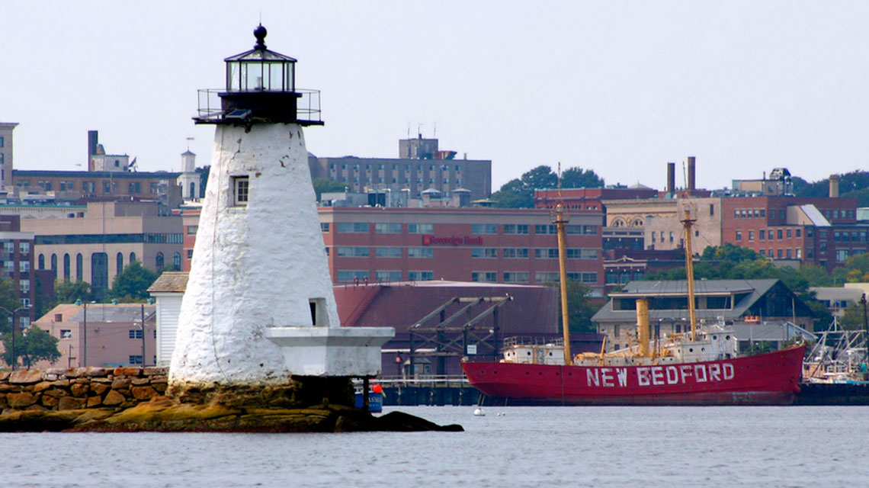

A look at the development, key decisions, and lessons learned from the New Bedford MassGrad Coalition and its strategies to improve graduation rates and provide a stronger city-wide system of support with a focus on college and career planning for youth at risk of dropping out.

New Bedford MassGrad Coalition Case Study

New Bedford MassGrad Coalition Case Study

Coalition Partners

City of New Bedford /Department of Community Services

New Bedford Public Schools

Immigrants Assistance Center

Child and Family Services of New Bedford

New Bedford Community Connection Coalition

NorthStar Learning Centers

Educational Talent Search, EOC and College Access Grant

Seven Hills Behavioral Health’s GEAR UP

Bristol Community College

UMass Dartmouth SouthCoast Education Compact

Through the MassGrad Initiative, funded through the federal High School Graduation Initiative, the Massachusetts Department of Elementary and Secondary Education (ESE) awarded four competitive awards in 2012 throughout the state to help ignite school-community coalitions. These four *MassGrad Coalition Challenge Awards* required recipients to focus on a specific topic area related to dropout reduction and improving graduation rates that warranted a school-community partnership response.

**New Bedford Public Schools received a MassGrad Coalition Challenge Award to establish a coalition to support a new College and Career Readiness Family Engagement Center (CCRFEC).**

This case study describes: the core coalition activities, the key steps and decisions, how the coalition works, the coalition’s impact, and lessons learned from the first three years of implementation (2012-13 school year through the 2014-15 school year). The case study ends with the future outlook of the coalition and some questions to consider based on the experiences of New Bedford.

## Overview of Core Activities

The Coalition’s primary goal has been to build the College and Career Readiness Family Engagement Center (CCRFEC) as the welcoming and culturally responsive hub for family engagement with a network of community partners working to ensure all students and families receive the support, guidance, and resources needed to graduate, and that all students graduate with a plan for pursuing post-secondary learning options or a job.

* With only isolated incidences of working together, the MassGrad Coalition created a much needed vehicle for school and community collaboration where partners could move beyond their “silos” and share critical information, resources, knowledge and expertise with each other and with New Bedford High School students and families around college and career planning.
* Coalition members provide and promote on-site and community-based activities, learning opportunities, one-to-one advisories, and special events for students, families, community members, and school staff with the common goal to ensure every student graduates with a plan for pursuing post-secondary learning opportunities or employment
* The CCRFEC prioritized a culturally responsive environment and provides bilingual staffing to provide a comfortable space for:
  + school staff to meet with families
  + workshops and one-on-one supports for essential immigration and deportation information
  + translation services
  + Adult Education and ESOL classes
  + workshops and events for students and family members on early college planning and application assistance, financial aid, career exploration
  + professional development opportunities and resources for school staff relating to college and career readiness

## Key Steps & Decisions

**Year One**

* The Coalition was formed in 2012 as an outgrowth of the New Bedford Public Schools “Future Ready College and Career Readiness Task Force”. A key recommendation of the Task Force was to convene a coalition of community partners to help support and grow the newly opened College and Career Readiness Family Engagement Center (CCRFEC) at New Bedford High School.by promoting the collaboration of school, family, community partnerships, engaging families in college and career planning, and ultimately improving graduation rates for all New Bedford High School students with an emphasis on the at-risk student population.
* In School Year 2011-2012 the dropout rate in New Bedford was 5.3%. With the development of the Coalition and the launch of the CCR FEC, in addition to other mutually supportive activities inside the high school, the dropout rate decreased to 4.2% in that first year.
* When the NBHS got the Coalition and Family Engagement Center up and running, the emphasis was on the community aspect much more so than a focus on the school. School staff were not fully aware of the resources, mission and value of the center at first. The Coalition then began a concerted effort to build staff awareness and professional development. Workshops were offered targeting cultural competency, dual-enrollment information, Your Plan for the Future Trainings and many more. By the close of year one, school staff had dramatically increased their use of the Center with an emphasis on language supports, student and family college and career resources, professional development opportunities, and referrals to community agency partners was doubled.
* The Coalition is comprised of targeted community partners with an organizational focus on serving culturally diverse populations as well as at-risk youth and their families. During development of the Coalition, specific attention was given to identifying two specific types of partners 1) those who served families of diverse students who have been identified as at-risk for school failure and; 2) those with a proven record for supporting graduation and post-secondary success.

**Year Two**

* Development and implementation of a Communication Plan to help:
  + Drive the Coalition message and its goals within the community to help engage new partners and needed resources;
  + Keep partners and potential partners abreast of the work and help share data and impact of services in the Family Engagement Center;
  + Ensure the work of the Coalition—goals, resources and activities—are marketed across the district, and
  + Help strengthen parent awareness and access to available resources and opportunities to help their children graduate with a plan for success in post-secondary and career options.
* As part of the Year 2 Communication Planning efforts, the Coalition determined 5 distinct aspects of work: 1) Center based language support for students and families; 2) College planning resources provided to students and families; 3) career exploration opportunities provided to students; 4) Professional development opportunities for school staff and Coalition members would be provided; and 5) the Coalition will help guide the decisions of the CCR Family Engagement Center.
* Expanded and shared partner resources and supports through co-location of various agency staff in the Family Engagement Center (FEC). An example of this was the significant increase in onsite college application and guidance provided through Bristol Community College “On the Spot” College Admissions events at the FEC.
* Early in year two - surveys were distributed to parents and family members of NBHS students to assess the types of projects and events they see as priorities for their student’s educational success.
* Partners identified a number of key goals to help drive the work of the coalition going forward. Metrics were under construction to help assess impact in the following:
  + Increase in the awareness, knowledge and access to available demand-driven careers for both students and parents/families
  + Increase in participation in the CCR FEC for students, parents and family members, faculty and staff, and community partners
  + Decrease in dropout rates

**Year Three**

* Use the CCRFEC as the model for expansion of family engagement centers into other schools.
* Continue to build the Coalition as a community bridge to additional resources and collaboration.
* Increase workforce program opportunities for parents and families.

Explore both short-term and long-range expansion of college and career readiness initiatives and other parent and family engagement activities that can be offered in the CCRFEC, along with developing a Parent Academy model with additional community-based parent and family-centered learning opportunities to help sustain the Coalition’s work beyond the MassGrad 3 year funding cycle.

## How the Coalition Works

* The Coalition meets every 6-8 weeks as a group to discuss activities, events, opportunities that have been planned or provided.
* As part of the school-wide advisory program, direct student services are provided by school staff as well as a cross-section of Coalition members in the Center. Every other week, four Coalition members meet with 35 students, in total, who were identified as at-risk, to discuss college aspirations and career plans. Two Coalition members lead additional groups of 15 students who are school athletes.
* During the advisory periods, student grades and attendance are monitored and individual students are connected to a variety of information and services to help support interests and plans.

## Lessons Learned

* Important to have a sustainability plan from the start and a “home” within the district leadership vision to ensure consistency and commitment during times of leadership turnover.
* Make sure that the “right people/partners” are at the table and that you take full advantage of their expertise, experience, resources and connections.
* Institute more regular, upfront team meetings to help establish partner ownership and shared leadership in the work and include more of the employer community in the Coalition mix.
* Keep all members engaged and continuously evaluate how effectively the partnership is addressing the goals of the work and also meeting the interests and needs of each partner to be sure a mutually beneficial relationship continues to exist.
* Designing communication strategies for family outreach—specifically for those students who demonstrate risk of falling behind or dropping out.

## Impact

* The communication between and across coalition members has not only increased the provision of direct services, it has substantially decreased the duplication of these types of services for students and families.
* Because Coalition partners have a variety of ways in which they interact with students—one-on-one consultation, group advisories, class work, college field trips, college application / financial aid process support, and independent center access, it has been a challenge to assess the specific level of impact. However, one key impact for year 3 was to increase the number of students—especially ELL students—accessing college and career readiness resources in the NBHS CCRFEC. Data was collected on students, parents, school staff and community members. In year 1, 213 students took advantage of the Center’s offerings. In Year 2, 1,544 students participated in Center opportunities. In all 3 years utilization by all constituencies quadrupled and more.
* Graduation rates have risen incrementally each year. By the end of year 2 the dropout rate has decreased to 3.5% from 4.2%.
* School and community partners and their programs report greater numbers of students referred and served.

## Future Outlook

* The primary goal of the next phase of coalition work is to continue to ensure all students and families have the resources and supports they need to achieve in school, graduate on time, see college and career readiness as a viable and essential goal to lifelong success.
* In year 4, the coalition is looking to expand efforts, in partnership with the school district, and develop a more formal vehicle to engage parents and families in lifelong learning opportunities The Coalition is in the initial stage of discussions with district administrators to develop an action plan and timeline around the launch of a “Parent Academy” model. It is envisioned that the development of a Parent Academy, as an initiative of the Coalition being led by the District and driven by the community, will help engage and mobilize additional community partners, deepen and strengthen school/community collaboration, and will result in the community being able to offer a broader array of parent and family learning opportunities. Empowering parents through additional types of supports and improving access to services that promote their family’s overall health and well-being will lead to greater academic success and life-long achievement of New Bedford Youth.
* With other community coalitions developing in the coming year focused on addressing an array of social, emotional and overall health and well-being of families, the New Bedford MassGrad Coalition will be looking to align vision, goals, membership, outreach and engagement, and service delivery strategies in order to maximize partner participation and ensure non-duplication of effort.

Case Study Questions

1. The birth of the MassGrad Coalition three years ago as a result of the New Bedford Public School’s Future Ready College and Career Readiness Task Force resulted in successfully launching the NBHS College and Career Readiness Family Engagement Center which in turn has provided a successful vehicle within the district to draw in community partners and families. The district is expanding the number of Family Engagement Centers in the district to four in total going forward. Why is the Coalition looking to now moving towards a Parent/Family Academy model? Why this approach? Growing the relationships and opportunities inside the district to strengthening relationships in the community will require dedicated leadership from both the district and community, as well as a strategic plan to align efforts. How will the Coalition approach this work?
2. The MassGrad Coalition has been staffed with a full time paid employee of the City of New Bedford’s Department of Community Services Office who helps convene and manage partnership efforts and monitor activities and offerings within the College and Career Family Engagement Center. How will the Coalition partners provide leadership and help, guide, and support college and career readiness opportunities, as well as the launch of the Parent/Family Academy going forward? How does this unique staffing structure strengthen the work of the coalition? Currently both GEAR UP and Educational Talent Search also help staff the Center and are committed to continuing beyond the grant. Are there other ways to engage partner staff so this work becomes part of their responsibilities?