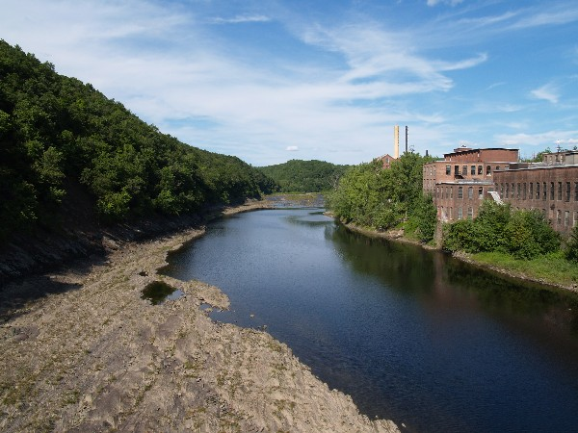

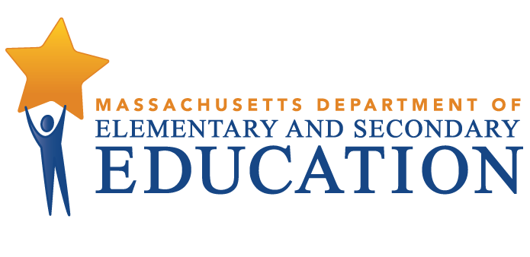

A brief look at the development, key decisions, and lessons learned by the Franklin County/North Quabbin MassGrad Coalition and its work to create a regional approach to providing a stronger network for support for youth at risk of dropping out and improving high school graduation rates.

Franklin County North Quabbin MassGrad Coalition Case Study

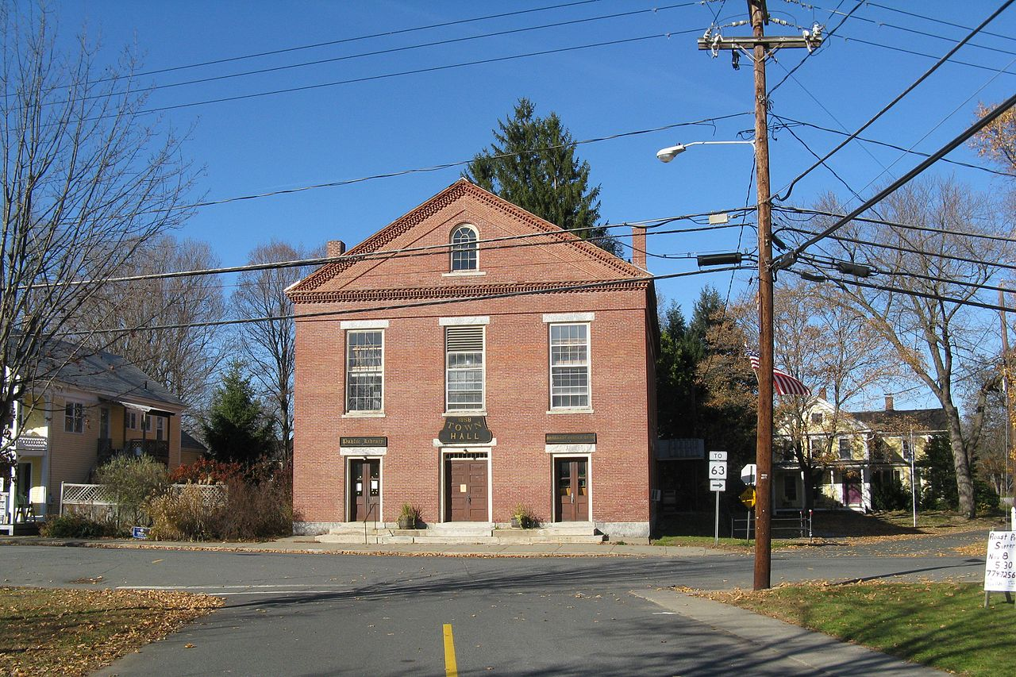

Franklin County North Quabbin MassGrad Coalition Case Study

Coalition Partners

Athol-Royalston Regional Schools

Big Brothers Big Sister

Boys to Men Mentoring Network

Center for Human Development

Clinical and Support Options

Community Action

Community Action Youth Programs

Court Service Center

DIAL/SELF Teen Services

Franklin Hampshire Regional Employment Board

Franklin/Hampshire Juvenile Court

Frontier Regional Schools

Gill Montague Regional Schools

Gil-Montague Community School Partnership

Greenfield 4S Coalition

Greenfield Community College

Greenfield Public Schools

Healthy Families

Institute for Health and Recovery

Job Corps

MA Department of Children & Families

MA Department of Mental Health

MA Department of Youth Services

Mahar Public Schools

Mass Rehab

Mohawk Trail Regional Schools

North Quabbin Community Coalition

Northwest District Attorney's Office

Partnership for Youth/Franklin Regional Council of Governments

Pathways North

The Brick House

The Garden – Center for Grieving Children & Teens

Turners Falls High School

Valuing Our Children/Family Resource Center

4-Rivers Charter Public School

Through the MassGrad Initiative, funded through the federal High School Graduation Initiative, the Massachusetts Department of Elementary and Secondary Education (ESE) awarded four competitive awards in 2012 throughout the state to help ignite school-community coalitions. These four *MassGrad Coalition Challenge Awards* required recipients to focus on a specific topic area related to dropout reduction and improving graduation rates that warranted a school-community partnership response.

**The Gill Montague Regional School District received a MassGrad Coalition Challenge Award to work with other school districts and community partners in the Franklin County / North Quabbin region. The purpose of the coalition was to create a system that enables school staff and community partners to work collaboratively to assess youth needs.** The coalition is centered around the collaboration between four rural school communities interested in creating a system that would enable school staff and community partners to work collaboratively to assess youth needs and track support for students at high risk of dropping out.

This case study describes: the core coalition activities, the key steps and decisions, how the coalition works, the coalition’s impact, and lessons learned from the first three years of implementation (2012-13 school year through the 2014-15 school year). The case study ends with the future outlook of the coalition and some questions to consider based on the experiences of Franklin County / North Quabbin Coalition.

## Overview of Core Activities

Coalition leaders were initially interested in developing a technology system that would allow for improved communication and collaboration; for example, a case management software system or shared database. After researching collaborative case management and data sharing models used or attempted elsewhere, Coalition members felt strongly that diving into technology so quickly would be premature. Instead they decided to redirect their effort into the development of “humanware” – or ways for partners to come together, build relationships and develop collaborative practices in face-to-face formats.

As a result, the Coalition focused on four strategies:

* Develop a better, shared understanding of why youth in the region drop out. This aspect of the Coalition’s work included a series of youth interviews and creation of short documentary film.
* Regularly convene regional *MassGrad Coalition* meetings – currently bimonthly - that bring together schools, community services, and state agencies to learn about each other, better understand services available and how to access them and dig into youth issues and best practices for addressing them.
* Convene quarterly *Resource Roundtables* in each district to connect school staff with resources in the community or from state agencies.
* Work actively to “connect the dots” and bring resources from one place to another, e.g., cross-fertilization of strong practices, improving communication between providers and systems. These connections often happened organically during Coalition and Roundtable meetings but were also facilitated by Partnership for Youth staff.

## Key Steps & Decisions

**Year 1**

* At the start of the coalition collaboration among the districts was limited (together they cover a large 35-mile swath of territory); however, Coalition leaders felt high student mobility across the area, the need to engage agency partners that operate at regional level, and other factors made an extremely strong case for increased regional collaboration
* The coalition was supported by the region’s Council of Governments and its Partnership for Youth (PFY), who had a strong history of working with area districts, identifying issues impacting area youth, and convening community providers. PFY also oversees the county’s annual Teen Health / Youth Risk Survey
* Initially, Partnership for Youth staff met with leaders in each of the four original districts to assess interest in working collaboratively on dropout prevention and recovery. School leaders were particularly interested in “data” and accessing data across districts, and less interested in talking to each other about strategies and resources
  + Staff also did “coffee meetings” to sounds out other community and agency staff on the idea of a regional coalition. Agency staff were particularly interested in a regional approach because “we can’t get to every school”
* Coalition members investigated different collaborative case management and data sharing models. They traveled to Providence, R.I. to visit the Rhode Island Shared Youth Vision project, a statewide collaborative case management effort involving nine agencies that had piloted use of a shared data platform. This visit proved critical in helping the Coalition revise its strategy to focus on “humanware rather than software” (see Core Activities)
* A decision was made during the first year to focus efforts on organizing the school districts rather than recruit community partners. The districts, having limited time for communication with one another, needed time to work together to reach consensus on priority issues for the coalition work. However, while this work was going on, members also worked on a solid plan for engaging more community partners in Year 2
* At the end of the first year the members wrestled with the emerging need for a two-tier coalition effort. The first tier would see the coalition continue to be organized and meet as a regional entity for collaborative problem-solving. The second tier would be the creation of student support teams in each district that would include community partners who could help strategize and contribute resources for at-risk student support. The meeting of these teams would be called “Resource Roundtables”

**Year 2**

* In Year 2 the Coalition doubled its efforts to bring community and agency partners into the regional group and district-based Roundtable groups – with great success. Much of this partnership engagement work was “slow, organic, and one partner at a time” and involved one-on-one meetings, legwork, and networking with other collaborative groups (e.g., Systems of Care). Staff supporting the Coalition also worked hard to perfect a strong high value, high engagement format and culture for their regional meetings
* Work began on a “[Why We Drop Out: Video Bridge](http://www.1degreeshiftproductions.com/#!scv5/c22wi)” project, was a first-of-its-kind production that allowed drop-outs to talk candidly about why they left school. This video was then shown to school personnel and their reaction and response to the students was also captured and shared back with the students. The complete video has been shown in community gatherings throughout the region
* A formal mission statement was created
* Partners confirmed the coalition was unique and valuable for school-community collaboration; possibly the only coalition with such access for community agencies
* The Coalition hired a part-time facilitator to help three of the four districts form their Resource Roundtables by identifying partners, and designing meeting agendas. Although the fourth district Roundtable met once it did not continue because of leadership turnover, time constraints, and a sense of only marginal benefit
* Midway through the year, the regional Coalition group moved from monthly to quarterly meetings. Coalition members were concerned that having both regional and local district-based meetings would be too time-consuming and partners would be forced to decide which forum to attend. They felt moving to quarterly meetings would help keep partners engaged at both the district and regional levels

**Year 3**

* Regional Coalition and district-based Resource Roundtable meetings continued and began to spin off projects; for example, expanding restorative practices, suicide prevention and substance abuse intervention approaches across school districts
* The Coalition wrapped the “Why We Drop Out” project and premiered the video at an event attended by more than 30 interested community members, youth, and school personnel. Several community agencies and schools held their own screenings of the video in order to shine a light on the factors that contribute to dropping out of school locally, and the video was soon picked up by a distributing company to be distributed nationally.
* he coalition began to expand to include new school districts and their focus on sustainability planning – how to keep going after state MassGrad funding ended - intensified
* Over three years, the Coalition has grown to include 7 districts, 19 community-based organizations, and 6 state agencies.

## How the Coalition Works

* Three staff from the Partnership for Youth/Franklin Regional Council of Governments in Greenfield support Coalition activities – two co-coordinators and evaluation specialist who provided approximately 15 hours a week of support to the Coalition
* The coalition has a two-tier format: 1) a regional coalition that met monthly for the first two and half years, and then moved to quarterly meetings, and 2) district-based Resource Roundtables that meet quarterly
* The two-hour regional meeting was planned and facilitated by Partnership for Youth staff, using input from members for topic ideas
  + The meetings followed a standard setup and format: each participant always had a table tent with their name, role and organization; meetings started with an icebreaker focused on relationship-building; partner announcements (news, opportunities, etc.) allowed partners to get to know about each other’s agencies and discover places of intersection of work
  + Following this opening, the meeting moved into a “learning” segment where a youth-related issue and effective practice/resource/strategy was presented, or an agency’s work in a particular area, (e.g., school connectedness, mental health and school success, students with anxiety, school discipline, substance abuse intervention, youth homelessness) was highlighted
  + The final portion of the meeting is usually reserved for organizational development related to how the group functions, improvements, needs, and lessons learned
* District-based Resource Roundtables meet quarterly and generally include 8-10 people to discuss problems, recurring themes, and/or scenarios (student problems that are barriers to success)
  + The discussions foster collaborative problem-solving and resource information sharing
  + Each Resource Roundtable group established its own meeting protocols and set its own agenda (each had specific partners and topics they wanted to cover), while the regional facilitator attended multiple Roundtables in an effort to identify common themes, needs, and issues that would be reported at the regional Coalition Meeting.

## Lessons Learned

* “The process is the product” – forming the Coalition and creating relationships has been extremely valuable in and of itself, likely more so than any single strategy or initiative the Coalition implemented
* Giving youth a voice through interviews and the Why We Drop Out video helped create a better understanding and empathy for at risk students
* Coalition members credit the careful selection of the learning segment topics at the regional meetings with the “explosion” in meeting participation
* After three years, Coalition members firmly believe the decision to stage partner engagement by solidifying collaborative ties among the four school districts first, then expanding community and agency partner participation, was the right call and Coalition members fully support the design of the “schools are driving the bus”
* Creating both a regional and district-based structure did involve trade-offs (e.g., fewer regional meetings), and this left some Coalition members wishing there could be more emphasis on the regional group and that the local Roundtables, which sometimes felt “a little forced,” should be voluntary spin-offs rather “part” of the Coalition – the Coalition could instead serve as a catalyst to help launch local teams and channel partners to them, if districts wanted them and were committed to maintaining them
* Regional partners in particular had to think through their participation strategy because they found they couldn’t “plug into everything” and instead determined participation based on specific interests (building district-based or regional connections, supporting a particular community or grant initiative, building agency presence, etc.)

• Coalition members find that there is a huge amount of convergence between education and public health, particularly when it comes to dropout prevention and efforts in rural areas, yet state and federal funding and supports are often quite separate

## Impact

* Enhanced understanding of the in-and out-of-school barriers and challenges that contribute to a student’s decision to drop out of school
* Improved relationships among coalition members – district to district, district to community partner/agency, and community/agency partner to partner – which resulted in new contacts, new referrals, and new programmatic partnerships
* Increased awareness of community resources and improved ability to access and use them
* Creation of an efficient way for districts and organizations to exchange information and share best practices such as Restorative Justice, implementation of LIFELINES a suicide prevention program, use of LifeSkills for substance abuse and violence prevention, and ways to expand credit recovery
* Direct impact on youth (apart from youth involved in the video project and anecdotal feedback from partner surveys) has been harder to gauge because the Coalition is not a direct service provider; rather, it enables partner organizations to deliver services more effectively.

## Future Outlook

* The regional Coalition will continue to meet without MassGrad Coalition Challenge Award funds; members remain committed because of the value in the networking and relationship building, as well as the value of the professional development that comes from the presentations and discussions at coalition meetings
* Areas of future focus include: improved referral systems, more collaborative projects, expansion to additional school districts, and continued spread of effective school connectedness and mental health practices
* The Coalition will face some larger organizational development questions such as should the group be integrated into an existing larger regional body, the “Communities that Care” coalition, which covers more territory and districts but has been focused on substance abuse prevention? Or should the Coalition remain its own separate entity and, if so, does it need a more official governance structure, with bylaws? For the coming year, however, the Coalition is more focused on maintaining momentum
* Of more immediate concern is the question “who will hold things together” for the group – staff from the Partnership for Youth will continue to convene the coalition without dedicated funding, since the relationships the Coalition has helped them build are valuable to all of their other work, and Coalition members have also offered to step up and help organize agendas

Case Study Questions

1. The MassGrad Challenge put out a call to districts and regions interested in finding a community-wide approach to dropout prevention and recovery, on the principle schools can’t and shouldn’t do this work alone. Franklin County/North Quabbin’s coalition decided to “organize the school districts first” and “put the schools in the driver’s seat” – and had a strong rationale for doing so. Other partnerships and coalitions bring representatives from all sectors to the table at the beginning and negotiate a set of shared interests which they then advance. What do you think? What are the pros, cons, and key considerations of each approach?
2. As they head into their fourth year, Coalition members are thinking about where their group fits on their region’s landscape of collaborative groups. Should they merge into another existing structure? Remain separate? On one hand, many communities and regions are full of cross-sector partnerships, committees, and coalitions – many formed by a specific grant, funding stream, initiative or agency – and Franklin County/North Quabbin coalition members feel these connections and intersections acutely. On the other hand, their coalition has achieved something others did not: they created a regional table where school districts, in particular, could work collaboratively with community partners and regional agencies, specifically on school dropout prevention and supporting school success. If you were in their shoes, how would you approach this structural question they face?