Early Warning
Indicator System
Assisting Massachusetts educators in the identification, support, and monitoring of at-risk students

Data-Driven Actions for Rapid Intervention
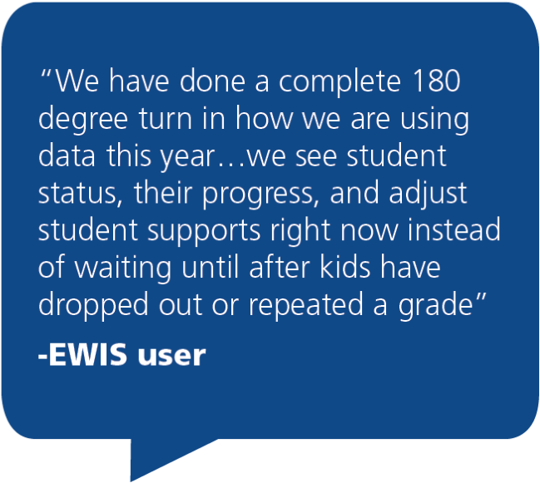
The Massachusetts EWIS identifies students at risk across the academic trajectory, from early elementary through postsecondary participation. With EWIS, educators can develop targeted interventions, allowing students to follow a path to success. Using EWIS in combination with local data and context, educators can explore underlying factors leading to academic risk and respond early, meeting the unique strengths and needs of their students. This approach may lead to interventions at the individual, small group, and whole school or district-wide levels.

The EWIS academic milestones are important to the success of Massachusetts students, and are actionable for educators working with students across grades. With EWIS, educators can target supports to prepare each student for the world after high school.
Grades | EWIS Risk Levels predict a student’s likelihood of missing Academic Milestones:
Grades 1-3 | Reading by the End of Third Grade  Meeting/Exceeding Expectations on grade 3 ELA assessment
Grades 4-6 | Middle School Ready  Meeting/Exceeding Expectations on gr. 6 ELA & math assessments
Grades 7-9 | High School Ready  Passing grades on all 9th grade courses
Grades 10-12 | High School Graduation  Meeting all local and state graduation requirements
College Enrollment
Enrolling in 2-year or 4-year postsecondary education
College Persistence
Enrolling in the second year of postsecondary education
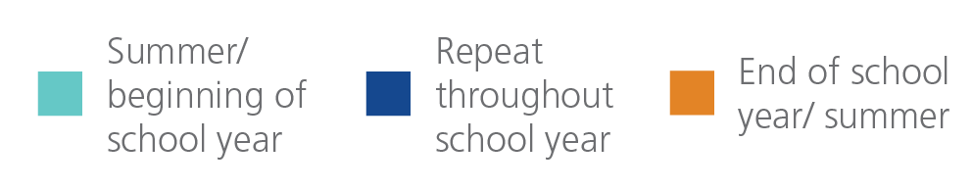
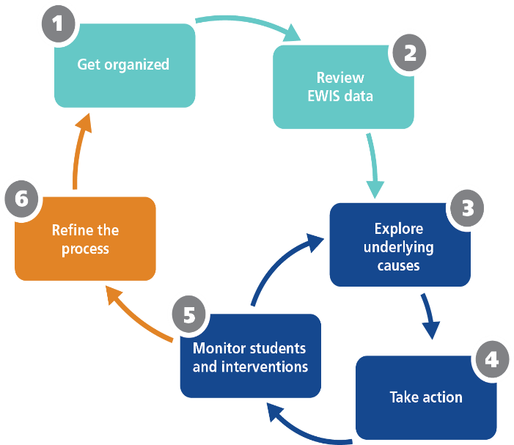
Accessing EWIS Reports
Each Massachusetts district has access to EWIS reports in the late summer, allowing educators to examine details and identify interventions as soon as the school year begins. All EWIS reports are available on Edwin Analytics: https://gateway.edu.state.ma.us/. Contact your district’s directory administrator for access.

Email the EWIS team with questions: EWIS@doe.mass.edu
The Early Warning Implementation Cycle is a method of using early warning data alongside other resources to systematically identify and support students who may need additional attention in order to reach an upcoming academic milestone.
Visit the EWIS website for a tutorial, a Guide and other resources.
Google Mass EWIS or go to http://www.doe.mass.edu/ccr/ewi/ .

