Use EWIS to Prepare Students for Success after High School

z
The challenge:  Massachusetts graduation rates have increased over the past decade, to 89.8% in 2021  yet  there are deep gaps in high school graduation rates between student groups across Massachusetts.  How can all students be set up for success?  DESE developed the EWIS to help districts understand who is at risk of missing key academic milestones, to intervene early and prepare all students for success. | EWIS: A data-informed approach  With the Early Warning Indicator System (EWIS) reports, educators can see exactly who is at risk of not graduating, beginning with students entering 10th grade.  Using early warning tools and local context, educators explore underlying factors leading to academic risk and respond based on the strengths and needs of their students.  This data-driven approach may lead to interventions at the individual, small group, and school- or district-wide levels.
How does it work?  - Early in the year, review EWIS reports to understand who is at risk.  - Then, explore causes to determine why they are at risk. For example: Are students who are missing more than 10% of school days having health issues, or unstable transportation, or are they disengaging from school?  - After considering why students are at risk, assign supports.  - Then, monitor risk through the year to ensure supports are having desired effects. By tracking ABCs (Attendance, Behavior and Course selection & performance) educators can update their view of which students are still at risk and adjust supports throughout the year.  See the reverse for more about a data inquiry cycle. | Here are some examples:  With the help of EWIS, school counselors in one school saw tardiness increasing among students who were at risk. Knowing tardiness is an early sign of disengaging from school, they intervened quickly and offered lunchtime dance parties to grade teams with the lowest tardy rates – a huge hit!  Another counselor learned that many of her English Language Learner students were flagged in EWIS. She repeatedly heard they felt isolated at school. She gathered them regularly, giving a space to relax and connect. Though their stories varied, they bonded over shared experiences – developing close friendships and strengthening their sense of belonging at school.  These strategies might not suit your students – and that’s OK! Build context from a school climate survey, student feedback, or simply what you know about your students, and craft something that works for them.
What are the ABCs and how do we monitor them?
EWIS reflects students’ risk at the beginning of each year. To see who is at risk throughout the year – and if interventions need to be changed – monitor Attendance, Behavior and Course selection & performance.
Here’s how:
- Decide which indicators to use – just attendance, or all three – and how to get it for your students.
- Set risk thresholds: 90% attendance, 1 behavior incident, 1 failing course – or adjust for your context.
- After the first marking period, gather all the pieces and combine them in one file.
- Check to see who’s still at risk and no longer at risk.
- With colleagues, reflect on students’ progress, diagnose any new needs and adjust supports.

Use EWIS in an ongoing cycle of inquiry.
Consult the e-learning tutorial for more about each step.
In the Summer or Beginning of the School Year
Step 1: Get Organized
Collect your teammates, line up access to Edwin and plan time to review EWIS together. All EWIS tools are online, and reports are in Edwin. Districts control access to Edwin. Contact your district’s directory administrator for access. If there is a team already reviewing data and making decisions about how to support students, they may be able to incorporate early warning data into their scope.
Step 2: Review EWIS
Students’ EWIS risk levels are available every year in the late summer to coincide with the start of the school year. Use the EWIS reports to examine students’ strengths and weaknesses. If you work directly with students, the Student Roster is a good place to start. If you work with adults who work with students, you may find the Indicator Analysis most valuable. Either way, draw concrete conclusions about students’ indicators and begin to form hypotheses about causes of students’ risk.
Repeat Each Marking Period or Throughout the School Year
Step 3: Explore Underlying Causes  Continue to identify causes of risk, pulling in local data and context for a comprehensive picture. Note whether students across a district, school or grade have common needs for universal supports.  Step 4: Take Action  Compare students’ needs to the services available, and assign interventions that will best meet their needs. Examine any gaps in support, and consider school-wide or universal efforts.  Step 5: Monitor  Monitor students’ ABCs to assess student progress, see who else may be at risk, and improve interventions. Then, refer back to Steps 3 & 4 as the cycle is repeated. |  | 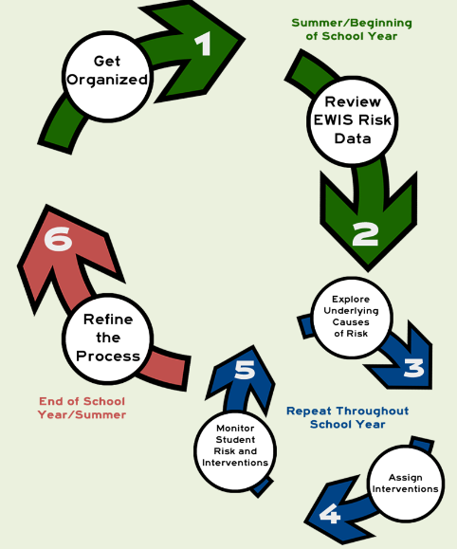
At the End of the School Year or In the Summer
Step 6: Refine the Process
How did it go? What was easy, what was hard? Take time at the end of year to reflect on the approach and outcomes, and make plans to incorporate changes next year.
Would you like to get better at ‘using data’?

Many strategies work; choose one that feels right for you and your team. Periodically, reflect on what is working and what is not working, and adapt your strategies as needed. Start small, stay flexible and tap others for support.

You – and your students – are worth it!

For questions: Email EWIS@doe.mass.edu or see resources at https://www.doe.mass.edu/ccte/ccr/ewis/default.html .

Massachusetts graduation rates have improved statewide: 88.9% complete high school in 4 years.
African American or Black students, Hispanic/Latino students, students who are English Language Learners, students with disabilities and economically disadvantaged students complete high school at lower rates than students who are white and students who are Asian. Explore gaps at Success After High School DART or www.mass.gov/SuccessABCs.

