**Designing a High School Schedule**

**Introduction/Overview**

Designing a school schedule is a critical, multi-variable process that directly and indirectly influences various levels of administration, operations, teaching, and learning. The school schedule reflects your school’s priorities, values, and student experience. To support schools and districts in designing their schedule, DESE’s Office of College, Career, and Technical Education (CCTE) is aggregating resources, tools, and models based off work in the field that has led to the development of new school schedules. In 2023-2024, DESE CCTE identified three priorities to support the development of school schedules:

**Priority 1:** Maximize scheduling to ensure English learners and Students with Disabilities have equitable access to meaningful and rigorous learning opportunities that build on their cultural and linguistic assets and the academic, linguistic, social, and emotional supports they need to excel.

**Priority 2:** Increase and enable all students to complete a MassCore aligned program of study to ensure all students have an authentic choice to pursue postsecondary education upon graduation   
   
**Priority 3:** Increase ability for students to participate and succeed in College & Career Ready coursework and Designated Pathway programs, aligned to student-directed post-graduation goals (MyCAP) including flexibility for partnerships with postsecondary institutions, employer partners in work-based learning, and other educational programming partners such as After Dark to ensure all students graduate with a tested plan based on their goals and interests

***Where are we going with this in the future***

Our vision is to offer resources and guidance that will support leaders through the complexities of designing a schedule. Our goal is to empower schools to create schedules that meet the needs of students and foster a thriving, inclusive, and academically rigorous environment.

Our office imagines a near future where we will be able to provide workshops, webinars, other types of replicable tools and resources that will enable school and district leaders the opportunity to reimagine their schedule in their community’s context, with support from their liaison.

**Coherence Map**

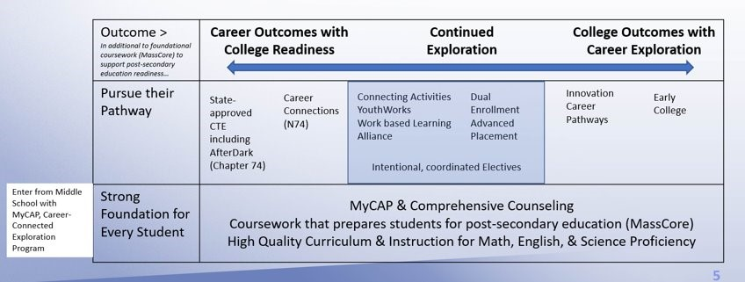

One of the first steps in redesigning a schedule is having a 50,000-foot view of the student experience from a programmatic level. DESE’s CCTE coherence map offers the opportunity to check how students move through middle school to high school. Beginning in middle school, students develop a strong foundation of career-connected exploring through their MyCAP. In High School, students continue to use their MyCAP with support from school counselors, and engage in high-quality curriculum, instruction, and coursework that is connected to their post-secondary success (MassCore). Educators use tools such as the Early Warning Indicator System (EWIS), and plan for their targeted intervention blocks (SEL/WEL, WIN, Advisory) to provide students with the supports they need to be successful.

Students may begin 9th grade in an Exploratory program prior to choosing a pathway, though will ultimately become concentrators in a pathway that aligns with their interests. Schools have various pathway options available to students for them to explore their interests through offerings such as Advanced Placement, Innovation Career Pathways, Connecting Activities, Career Connections, Chapter 74, and AfterDark.

Each of these pathways have outcomes that lead to advanced standing in a career (e.g. Industry Recognized Credentials), advanced standing in college (e.g. transcripted college credit), and/or continued exploration from the student.

**What?**

|  |  |  |
| --- | --- | --- |
| **What and why is scheduling important?** | **How does this connect to DESE’s Strategic Objectives?** | **What is the desired outcome of designing a new schedule?** |
| The Schedule is a reflection of your school’s and district’s priorities. Applying a strategic lens to scheduling means examining pathways, key data metrics (e.g. MassCore, Advanced Coursework, MCAS, ACCESS, Enrollment) and other systems that directly impact the student experience. Through this work, schools and districts will apply an equity lens to their schedule, a student’s academic experience (e.g. course progression), and build systems and structures to ensure that all students can learn and thrive. | This work aligns with DESE’s *Educational Vision* that all students are known and feel valued, receive relevant and real-world learning experiences, and obtain individualized supports that allow them to excel at and beyond grade level. Through this process schools will reflect on their core values, what is expected of students (and by time of graduation), and create a new schedule intentionally designed with students at the center and with teachers, staff, and stakeholders in mind. | The goals of designing a new schedule depend on your school’s community and context. For example, if your school has identified a priority area such as multilingual learners needing targeted intervention, your school may review the schedule with a lens that seeks to create intervention blocks for all students, but especially to help support multilingual learners.    The schedule is at the center of the school improvement cycle, supports preparing students for success in college and career, are data-driven and informed, and are intentionally designed with all stakeholders. |

Key Takeaways

School schedules should increase equity, allow for more individualized supports, and have enough flexibility to accommodate many learners. The primary goal is to use schedules as a mechanism for creating pathways for students to explore their passions and interests so they can graduate high school college and career ready.

**So What?**

|  |  |  |
| --- | --- | --- |
| **Where do I start on designing a new schedule?** | **Who at my school can help design a new schedule?** | **How long will it take to completely redesign a new schedule?** |
| The first step in designing a new schedule is to examine where the need for it came about. Begin to ask why a new schedule is important, who is being left behind in the current scheduling model, and what the goal of a new schedule is. Reflect on the current state and begin imagining what a great schedule could look like (there will be resources below to help guide this step). | The work of creating a new master schedule and staffing plan cannot be done in silos. The first step in this process is identifying the team of people who will assist in this work. The team should minimally consist of the principal/assistance principal, a school administrator, school counselor, and department heads. At the district level, the Superintendent/Assistant Superintendent should be aware and involved to the extent that they are able to make greater connections. | A new master schedule and staffing plan does not happen quickly, but do not let that hinder plans. In a perfect scenario where this design process is done intentionally and with fidelity, it will take around a year to get from the beginning to implementation. However, the process does not stop at implementation. Continuous improvement and feedback should be integrated through reflection, surveys, and possible adjustments. A calendar below can help visualize the length of this process. |

Key Takeaways

Designing a new school schedule takes time, effort, and a team of people to do adequately and efficiently. Engage your stakeholders like students, teachers, parents, and more to get the best schedule possible. Remember that this is a process and will not happen over night, but the payoff is well worth it.

**Now What?**

|  |  |  |
| --- | --- | --- |
| **What can I do to make sure my new schedule will be good for next school year?** | **How do I know that I’ve done it right?** | **What are the next steps?** |
| If the goal is to implement a new school schedule for the following school year, begin this process immediately. Take your time in building a great team and support system. Talk with key stakeholders and get their advice. Be sure to take surveys and have focus groups to make sure no one gets left out of the conversation. The best thing a scheduling team can do it start early ang allow for plenty of time to complete. The most important thing to remember is always to keep students and their college and career readiness at the center. | Success will look slightly different for every school, however, there will be some shared milestones and outcomes. | Consistently check in with key stakeholders on how the new schedule is working and don’t be afraid to make necessary adjustments. Perhaps create time for an annual schedule audit to ensure it is the best fit schedule for students, teachers, and staff. Talk with other school leaders about their schedules and be ready to share resources with others. Creating a new schedule and staffing plan is an ongoing process and conversation. |

Key Takeaways

**Timeline of Designing a New School Schedule**

Designing a new schedule takes many design stages as seen in the below graphic. Each stage is as important as the one before it and involves a team of people brainstorming, collecting and analyzing data, and weighing options. If at any point in the design process advice from DESE employee would be helpful, contact [ccte@mass.gov](mailto:ccte@mass.gov).

define the why, root cause analysis, prioritize strategies and design levers, explore options and architypes, choose a schedule, set a budget and staffing plan, articulate roles and responsibilities, implementation CI planning, change management and stakeholder engagement


**Examples of School Schedules**

DESE CCTE aims to provide examples of school schedules for districts who have partnered with vendors in redesigning their schedules by the end of 2024.