BESE 2024 Annual Report Board Members
(2023-24)

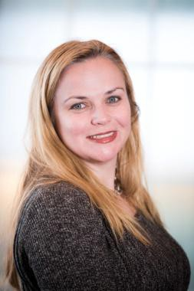  Katherine Craven  Chair  2019 - present  Member, 2014 – 2019 | Katherine Craven currently serves as the Chief Administrative Officer of Babson College, one of the nation's leading business colleges. Craven began her career as a budget director and policy advisor to the Massachusetts House of Representatives Committee on Ways and Means. Craven was named Executive Director and Chief Executive Officer of the newly created Massachusetts School Building Authority in 2004, where she won plaudits for her effective management and leadership. While leading the School Building Authority, Craven was named First Deputy Treasurer of the Commonwealth. Craven left the School Building Authority and the Treasurer's Office in 2011 when she was appointed Executive Director of the UMass Building Authority and Assistant Vice President for Capital Finance for the University of Massachusetts. Craven received a Bachelor of Arts in History from Harvard University. She is a resident of Brookline, where she lives with her husband and four children. Craven fills the business seat on the Board.
  Matt Hills  Vice Chair  2022 - present  Member, 2019 - present | Matt Hills served on the Newton School Committee from 2010-2018, during which time he was Chair of the School Committee and Chair of the collective bargaining team. He is a Managing Director at LLM Capital Partners, a private equity firm. Matt's career has been in private equity, investment banking, and strategy consulting. He has served on public and private corporate and non-profit Boards in the U.S., Canada, and Israel.  Matt has been active in Newton's community and public-school affairs for many years. Matt and his wife Lisa have four children, all of whom were Newton Public Schools K-12 students. He holds a B.A. from Brandeis University and an M.B.A. from Harvard Business School.  .

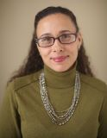  Ericka Fisher  2023 - present |  | Ericka Fisher is Chair and Associate Professor of Education at the College of the Holy Cross. Specializing in multicultural education, intersectionality, student socioemotional wellness, and human development her publications include: a book entitled Educating the Urban Race, as well as several articles related to students' lived experience in schools including, The N-Word: Reducing Verbal Pollution in Schools, and The Moral Consequences of Studying the Vulnerable: Court Mandated Reporting and Beyond. Ericka also serves on various community and civic committees related to educational matters in Worcester.  She holds a BA in Sociology from the College of the Holy Cross, a master's in school counseling, and an EdD in Social Justice Education from the University of Massachusetts at Amherst. She resides in Worcester with her family.
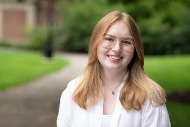  Ela Gardiner  2023 - 2024 |  | Ela Gardiner was elected as the Student Member of the Board of Elementary and Secondary Education in June 2023, one of the only student board members to have full voting rights in the country. Ela has been a trailblazer for young voices in Massachusetts advocacy, working with the Massachusetts Association of Student Representatives and the National Student Board Member Association. Beginning in October 2021, Ela has served as the top Communications official with the Young Democrats of Massachusetts and was the youngest person to hold the office when elected. Ela has worked both locally and statewide to advance educational policy, with particular focuses on financial literacy education; LGBTQ+ and women's resources; and mental, physical, and emotional health education. She lives in Wellesley and graduated from Wellesley High School in June 2024. She plans to go to college to further her studies in political science and advocacy.
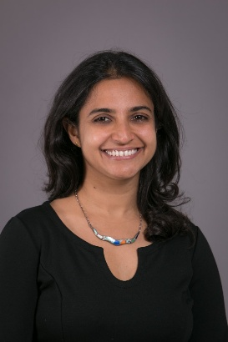  Farzana Mohamed  2022 - present |  | Farzana Mohamed is a native of Nairobi, Kenya, where she was raised by parents and a community deeply committed to educational advancement. Admitted to MIT as an undergraduate, she was the first in her family to attend university. While at MIT, she participated in tutoring programs for students of diverse backgrounds. She stayed on to graduate with two Masters degrees, one in Environmental Engineering and one in Urban Studies and Planning. A career in healthcare followed, first with an emphasis on strategic planning, governance, and clinical quality improvement at Beth Israel Deaconess Medical Center and BID Hospital~Needham, and later in helping to establish clinical research and educational programs in India and Spain. For the last decade, she has focused on teaching and advising on negotiation, especially for students and young professionals, both domestically and abroad. Farzana has served as a member of the Board of Trustees of the Eliot School of Fine and Applied Arts in Jamaica Plain, Board of Advisors of the Charles River Watershed Association, and the Metrowest Advisory Council of Mass Audubon Society. She has served in a variety of leadership roles, including youth education and sports programming, as well as clergy functions, in the Shia Ismaili Muslim community. She lives in Newton with her husband and son, who attends the local public elementary school.
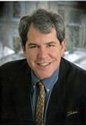  Michael Moriarty  2015 - present |  | Michael Moriarty is a lifelong resident of Holyoke, where he served for 13 years on the school committee. He was instrumental in the formation of the Holyoke Early Literacy Initiative, a community wide collaborative focused on increasing the number of students that are proficient in reading by the end of third grade. He has also been a vocal advocate for arts education.  In 2013, Attorney Moriarty was named the executive director of a community development corporation based in Holyoke. Olde Holyoke Development Corporation is a mission driven non-profit that believes every resident of Holyoke should live in a dignified home and a safe, attractive neighborhood. Prior to joining the company, he was a practicing attorney focused on real estate and civil matters. In the 1980's, he was a teacher at William R. Peck Junior High School. He has also taught at Holyoke Community College and retains an active educator's license.  He is a graduate of the Catholic University of America (BA '85) and Western New England University School of Law (JD '93). He is married to Attorney Susan Turcotte Moriarty. They are the parents of two children, who like Mike, are proud products of the Holyoke Public Schools.
 |   Dálida Rocha  2024 - present | Dálida Rocha is a Cape Verdean immigrant, mother of three, UMass Boston graduate, resident of Worcester and an active labor advocate.  Dálida is currently the Executive Director of Neighbor to Neighbor. As Political Director of SEIU 32BJ, she convened and served as the Co-chair of the Driving Families Forward Coalition to pass the Work and Family Mobility Act. Then, returned to serve as the Field Director for the Yes on 4 for Safer Roads Campaign.
 |   Paymon Rouhanifard  2019-2024 | Paymon Rouhanifard is the co-founder and CEO of Propel America, an organization that empowers students with the skills, experiences, credentials, and social networks necessary to transition from high school to an upwardly mobile first job within one-year of high school graduation.  Previously, he served as the superintendent of Camden, New Jersey from 2013 to 2018 where he helped lead improvements in student outcomes, reductions in out-of-school suspensions, stronger family engagement, and critical capital investments in school facilities.  Rouhanifard started his career in New York City as a 6th grade teacher in West Harlem and went on to work in the central office of the New York City Department of Education. Prior to that, Rouhanifard worked as an investment banking analyst at Goldman Sachs and a private equity associate.  He holds a B.A. in Economics and Political Science from the University of North Carolina at Chapel Hill.
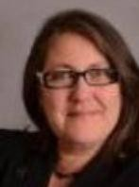  Mary Ann Stewart  2014 - present |  | Mary Ann Stewart was appointed Parent Representative to the Massachusetts Board of Elementary and Secondary Education by (then) Governor Patrick in August 2014. From  2010-2012, she served as President of the Massachusetts PTA and continues to serve on the state PTA Board as a Member-at-Large. She also serves as a member of the National Advisory Council for Media Literacy Now.  Mary Ann is a parent of three and resides in Lexington. She has been active in the schools and in town government, serving as an elected representative to Town Meeting since 2006 and on the School Committee from 2009-2014 where she led as Chair from 2011-2012.  Mary Ann has served in numerous leadership roles at the local, state, and national levels. She is a champion of children, youth, and families, and her experience in organizational development and passion for advocacy and creativity has leveraged engagement in professional and volunteer settings alike. Mary Ann received her Bachelor of Science from the University of Massachusetts for Music Education.
 | 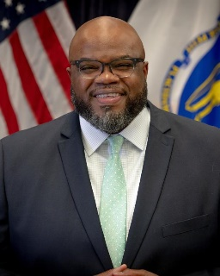  Dr. Patrick Tutwiler Secretary of Education  2023-present | Patrick Tutwiler, PhD is the Secretary of the Executive Office of Education, and the first Black person to ever hold that role in Massachusetts’ history. He most recently was the Senior Program Officer for Education at the Barr Foundation, where he specialized in developing new high school models that will have a positive impact across the entire school system. He has more than twenty years’ experience in public education as a high school history teacher, as a high school principal and as the superintendent of the Lynn Public Schools. As Lynn Superintendent, Secretary Tutwiler led a collaborative, equity-centered effort that resulted in increased graduation rates, decreased push out rates, a more racially diverse faculty and staff, and the establishment of Massachusetts’ second largest early college program. He earned a BA in history from The College of the Holy Cross, a master’s in education from Harvard University Graduate School of Education, and a PhD in curriculum and instruction from the Lynch School of Education at Boston College. He lives in Andover with his family.
 Martin West  2017 - present |  | Martin West is associate professor at the Harvard Graduate School of Education, a faculty research fellow at the National Bureau of Economic Research, and editor-in-chief of Education Next, a journal of opinion and research on education policy. He previously worked as senior advisor to the ranking member of the Senate Committee on Health, Education, Labor, and Pensions, taught at Brown University, and was a research fellow at the Brookings Institution. West received a B.A. in History from Williams College, an M.Phil. in Economic and Social History from Oxford University, and a Ph.D. in Government and Social Policy from Harvard University. He lives in Newton with his wife and two sons who attend public schools.
 | 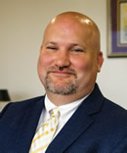 Jeffrey C. Riley  Commissioner | Jeffrey C. Riley was appointed Massachusetts’ 24th commissioner of elementary and secondary education in early 2018 and began serving as commissioner on April 5, 2018. A Massachusetts native, Mr. Riley’s experience spans urban and suburban districts and includes teaching in Baltimore, Md., being principal of Tyngsboro Middle School, and being principal of Boston's Edwards Middle School. In January 2012, Commissioner Riley was appointed superintendent/receiver of the Lawrence Public Schools. During his more than six years there, he led a team that brought major improvements by shifting more resources and autonomy to the school level, expanding the school day, increasing enrichment opportunities, and ensuring all schools had great leaders and teachers.  Commissioner Riley lives in Boston and holds a bachelor’s degree in philosophy from Pomona College in California, a master’s degree in counseling from Johns Hopkins University in Maryland and a master’s degree in school administration, planning and social policy from Harvard University.
 |  Russell D. Johnston  Acting Commissioner | Russell D. Johnston became acting commissioner of elementary and secondary education on March 16, 2024. He was previously a deputy commissioner, a role in which he oversaw special education, instructional support, and a variety of initiatives to identify interventions and monitor improvement. Before joining DESE in 2014, Acting Commissioner Johnston's prior positions include serving as superintendent of the West Springfield Public Schools, special education director for West Springfield, and head of the elementary special education department for the Wellesley Public Schools.  Acting Commissioner Johnston lives in Melrose with his family and holds a bachelor's degree in education from DePaul University in Chicago, a Master of Education degree from Boston College, and a Doctorate of Philosophy and Education, also from Boston College.

