**Enrollment Instructions for Students in MassSTEP Classes**

When you enroll students in your MassSTEP workforce training classes, you must select the IETP credential that corresponds to your award. If you have multiple workforce training classes, be sure to select the same IETP credential for all those enrollments. For example, if a student is expected to obtain a ServSafe credential at the end of the program, then all of that student’s MassSTEP classes should have “IETP/ServSafe” entered for the IETP field.  To enter the value for IETP, select the “Class” LACES menu.

LACES dashboard with CLASS highlighted


Select the class within the resulting list.



Go to the “Enrollment” tab and click on the “Enroll” button.



Select the student that you wish to enroll from the list.   At the bottom of the screen make the desired selection for IETP field.

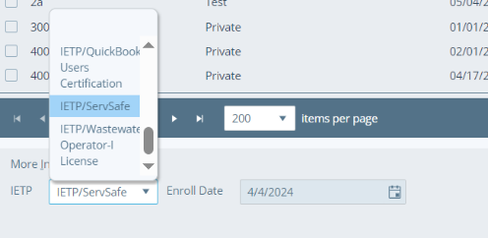

You will need to click the green “Enroll” button to complete this step.