

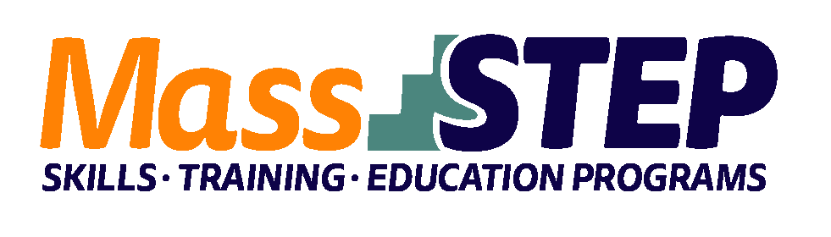

|  |  |
| --- | --- |
| Adult Education Provider: | Quinsigamond Community College (QCC) |
|  |  |
| Type of Organization: | Community College |
|  |  |
| Workforce Training Provider: | QCC Center for Workforce Development & Continuing Education |
|  |  |
| Employer Partners: | UMass Memorial |
|  |  |
| Level: | ESOL SPL 5 |
|  |  |
| Credentials: | Certified Clinical Medical Assistant (CCMA) |
|  |  |
| Occupational Cluster: | [Healthcare](https://www.bls.gov/ooh/healthcare/home.htm) |
|  |  |
| Occupation: | [Medical Assistants](https://www.bls.gov/ooh/healthcare/medical-assistants.htm) |
|  |  |
| Program Description: | In this 18-week course, students will learn medical terminology, medical law and ethics, HIPAA rules, scheduling systems, patient check-in and check-out procedures, contents of a medical record, anatomy, pathophysiology, pharmacology, nutrition, phlebotomy theory, injections, and routine treatment and laboratory duties. Students who successfully complete this program can sit for National Healthcare Association’s CCMA exam. |

**Weekly Schedule**



|  |  |  |  |  |
| --- | --- | --- | --- | --- |
|  | **Monday** | **Tuesday** | **Thursday** | **Saturday** |
| 8:00 AM – 4:00 PM |  |  |  | Medical Assistant Instruction |
| 5:00 PM – 10:00 PM | ESOL Instruction | ESOL Instruction | Medical Assistant Instruction |  |

**Contact:** Kate O’Connor, [kaoconnor@qcc.mass.edu](mailto:kaoconnor@qcc.mass.edu)

**Website:** [*https://www.qcc.edu/learn-qcc/advance-your-career*](https://www.qcc.edu/learn-qcc/advance-your-career)