What’s New in Modern DA

The Directory Administration App (DA) has been modernized to increase ease of use and to protect your information through improved security. We have included some of the new features and capabilities here so you can best take advantage of them.

Also, Modern DA will now adapt to the display, whether it is your Mobile Phone, your tablet, or the browsers that you use.

**No more “Welcome” landing page**

Now when you go into the Directory Administration application, you will land on the Organizations page to quickly view and search your organizations.

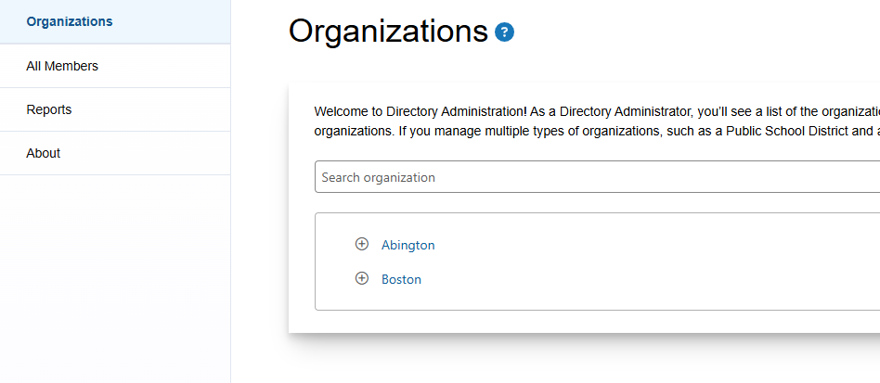

**Searching for Members, and more**

sorting and filter iconsJust as you can search in Legacy DA, you can search for Members with a ‘search as you type’ capability. Modern DA provides this functionality along with Sorting and increasing the flexibility to find what you are looking for. Additionally:

1. Searching (filtering icon) can be done on the Members page by User Name, First Name, Last Name, and even now Organization.
2. You can also use the Sorting icon to sort the full list or your filtered list, ordering the list alphabetically or numerically from low to high or high to low.

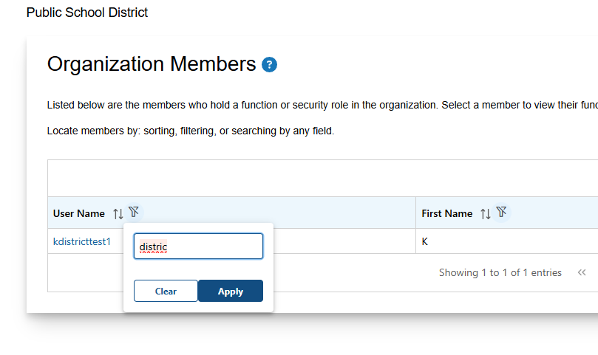

Sorting and Filtering is also applied to Functions and Roles – these same capabilities are now fully available when trying to find or select a Function or Role.

The ‘search as you type’ feature also allows you to key word search for things like application names within the security role descriptions.

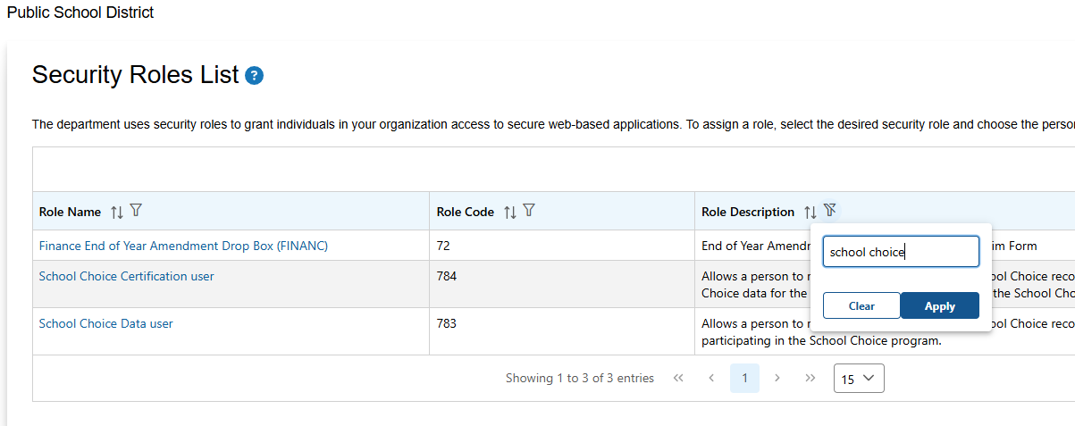

**Select ‘Edit’ to change**

Edit button example within directory administration applicationThe Modern DA Pages are now better protected from inadvertent changes; you now select the ‘Edit’ button to begin any changes. For example, see the screen below for the Member Information page. Once you select ‘Edit’, you can begin to make changes to the Organization Description field. Once you begin editing you can CANCEL your changes or SAVE them using the appropriate buttons at the bottom of the page.

You can expect to have this same Edit/Cancel-Save functionality across virtually all pages where information can be changed.

|  |  |
| --- | --- |
| Edit Button | Cancel and Save Buttons |
| Edit feature screen within directory administration application | Cancel and save screen example within directory administration |

For additional information and directory administration application help, please click on the Help icon example within directory administrationicon located at the top of each page within the directory administration application.

