1

**Massachusetts Department of Elementary and Secondary Education**

135 Santilli Highway,

Everett, MA 02149 02148-4906

Phone 781-338-3000 TTY:

N.E.T. Relay 800-439-2370

21st Century Community Learning Centers Program

Fiscal Year 2023 Year End Report

## June 2024





This document was prepared by the

Massachusetts Department of Elementary and Secondary Education, with support from the National Institute on Out-of-School Time at Wellesley College

Russell D. Johnston Acting Commissioner

The Massachusetts Department of Elementary and Secondary Education, an affirmative action employer, is committed to ensuring that all of its programs and facilities are accessible to all members of the public.

We do not discriminate on the basis of age, color, disability, national origin, race, religion, sex, gender identity, or sexual orientation.

Inquiries regarding the Department’s compliance with Title IX and other civil rights laws may be directed to the Human Resources Director 135 Santilli Highway, Everett, MA 02149. Phone: 781-338-6105.

© 2024 Massachusetts Department of Elementary and Secondary Education

*Permission is hereby granted to copy any or all parts of this document for non-commercial educational purposes. Please credit the “Massachusetts Department of Elementary and Secondary Education.”*

Massachusetts Department of Elementary and Secondary Education 135 Santilli Highway, Everett, MA 02149

Phone 781-338-3000 TTY: N.E.T. Relay 800-439-2370

[www.doe.mass.edu](http://www.doe.mass.edu/)



# Table of Contents

Executive Summary 5

Sample Description 5

Growth in SAYO-Teacher and SAYO-Staff Ratings 5

Special Populations 6

SEL Skills Promote Growth in ELA and Math 6

SAYO-Youth Survey 6

Introduction 7

Background Information 7

Regional Networks 8

1. Sample Description 9

21st Century Community Learning Centers 9

Activities Offered/ Academic Subjects 9

Student Population 10

1. Survey of Academic and Youth Outcomes (SAYO) 12

SAYO-S and SAYO-T: Introduction to the Tools 12

Academic Outcomes (SAYO-T) 12

Social and Emotional Learning (SEL) Outcomes (SAYO-S and SAYO-T) 13

Program Staff Version (SAYO-S) 13

Growth in Social and Emotional Learning SAYO Outcomes 14

Methods and Analysis 14

SAYO-Teacher Ratings 15

SAYO-Staff Ratings 16

Differences in SAYO Growth by Grade 19

Special Populations SAYO Social and Emotional Learning Outcomes 21

Income 21

Special Education 22

Gender 23

Race 24

Multi-language learners 27

SEL Skills Promote ELA and Math Academic Progress 29

Measures 29

Analysis 29

Results 29

Correlations in SEL Skill Growth 30

Improved SAYO Outcomes Correlate with Hours Attended 31

Differences in Outcomes as Measured by Teachers and Staff 31

1. Survey of Academic Youth Outcomes Youth Version (SAYO-Y) 33

SAYO-Y: Description of the Tool 33

SAYO-Y Likert Scales: Program Experience, Sense of Competence and Retrospective 33

SAYO-Y Matrix Questions: Academic Subjects and Settings 34

SAYO-Y Sample Description 34

Demographics 34

Youth Reported Outcomes (Likert Scales) 35

Youth Selection of Subjects and Settings (Matrix Questions) 36

Change in proportion of respondents by subject 37

Appendix A. DESE 21st Century Community Learning Program Site List 39

Appendix B. Hierarchical Linear Model Visualizations: Change in ELA and Math 40

Appendix C. Pre, post and change statistics by grade and special population 41

Grade 41

SAYO-S Pre, Post & Change 41

SAYO-T Pre, Post and Change 42

Income 43

SAYO-S Pre, Post and Change 43

SAYO-T Pre, Post and Change 44

Gender 45

SAYO-S Pre, Post and Change 45

SAYO-T Pre, Post and Change 46

MLL 47

SAYO-S Pre, Post and Change 47

SAYO-T Pre, Post and Change 48

Race 49

SAYO-S Pre, Post and Change 49

SAYO-T Pre, Post and Change 50

Special Education 51

SAYO-S Pre, Post and Change 51

SAYO-T Pre, Post and Change 52

## Massachusetts 21st Century Community Learning Centers

## Executive Summary

FY23 Report

Key Takeaway: Students in Massachusetts 21st Century Community Learning Centers Improved Social-Emotional Learning (SEL) Skills and Academic Performance

*Data in this report is from the*[***Survey of Academic and Youth Outcomes***](http://www.doe.mass.edu/21cclc/ta/sayo.html) *(SAYO) evaluation tool, developed by the Massachusetts Department of Elementary and Secondary Education and the National Institute on Out-of-School Time. SAYO is a research-based evaluation system that assesses changes in youth that are associated with participation in high-quality academic enrichment programs that are likely to occur over a one-year period.*

### Sample Description

Students in 21st CCLC come from diverse racial and ethnic backgrounds have had a range of educational experiences. They attend schools that demonstrate financial need. 21st CLCC students are:

* 69 percent low-income (LI)
* 22 percent English learners (EL)
* 19 percent students with Disabilities (SWD),
* 38 percent Hispanic or Latino (HL),
* 36 percent White (WH)
* 14 percent Black or African American (BAA),
* 7 percent Asian (AS),
* 5 percent two or more races (multirace-non-Hispanic).

### Growth in SAYO-Teacher and SAYO-Staff Ratings

* On average, students **improved** their social and emotional learning (SEL) skills across all outcome areas.
* Across all SEL areas, the **majority of students (> 50%) increased their SEL skills** as reported by program staff.
* Both staff and teachers reported **improved SEL skills** in students enrolled in 21st CCLC programs.
* Staff reported the most change in Relationships with Adults and teachers reported the most change in Critical Thinking

### Special Populations

* **Low-income (LI)** youth (69 percent of total participants) showed more growth in all areas rated by staff compared to other youth.
* **English learners (EL)** showed more growth in Math, ELA, Homework, Critical Thinking, Leadership, Perseverance, Relationships with Peers and Relationships with Adults as rated by teachers compared to other youth.
* **Students with Disabilities (SWD)** showed more growth in Perseverance and Relations with Peers as rated by staff compared to youth not receiving special educations services. They also showed equal or more growth in every outcome as rated by teachers.
* **Female** youth showed more growth in Leadership compared to male youth.
* Race Differences:
  + ELA: **BAA** and **HL** studentsshowed more growth in ELA scores compared white students. **BAA** students also showed more growth in ELA scores compared to students who are **HL**.
  + SAYO-Staff: **BAA** students showed more growth in Engagement in Learning, Perseverance, Relationships with Peers, Relationships with Adults and Self-Regulation compared to White students. **HL** students show more growth in all outcomes as rated by staff compared to White students, except for Communication in which the two groups showed equivalent change.
  + SAYO-Teacher: **BAA** students showed more growth in in all outcomes compared to White students, except for Self-regulation and Perseverance in which they showed the same growth. **BAA** students showed more growth in ELA, Homework, Relationships with Adults and Relationships with Peers compared to Hispanic students.

### SEL Skills Promote Growth in ELA and Math

* Students with **higher ratings on SAYO-Teacher** Communication, Critical Thinking, Engagement in Learning, Perseverance, Relationships with Peers and Relationships with Adults showed **more growth in ELA.**
* Students with **higher ratings on SAYO-Teacher Communication**, Critical Thinking, Engagement in Learning and Perseverance showed **more growth in Math**.

### SAYO-Youth Survey

* Youth rated most outcomes near or above 3 (range 2.91-3.49), which is a suggested benchmark for quality.
* Youth showed interest in **science**-related programming, selecting science more frequently than any other subject in response to the prompt “I want to learn more in.”
* Youth responses demonstrate that programs provide experiences that youth cannot access at home.
* Overall, youth self-reported outcomes showed insignificant or very small negative change across all outcomes. Some programs and sites saw improvement across several outcome areas.

# Introduction

This report provides information on the fiscal year 2022-2023 (FY23) 21st Century Community Learning Centers (21st CCLC) grant program. Specifically, it examines program information related to participation, activities, hours of service, and details the results of the Survey of Academic and Youth Outcomes (SAYO) tool for school year 2022-23 and summer 2023. SAYO was developed by the Massachusetts Department of Elementary and Secondary Education (DESE) and the National Institute on Out-of-School Time (NIOST) to track the impact of participation in 21st CCLC programs on student achievement, and provide feedback for ongoing program improvement.

The results described in this report point to significant contributions that 21st CCLC programs have made to the academic achievement and youth development of more than 16,000 students served across the state during FY23.

### Background Information

The Nita M. Lowey 21st CCLC program is authorized under Title IV, Part B of the Elementary and Secondary Education Act, as amended by the No Child Left Behind Act of 2001 and reauthorized by Every Student Succeeds Act (ESSA) of 2015. The program provides federal funding for the establishment of community learning centers that support the implementation of additional learning time through out- of-school time (OST) programming and/or through an expanded school day referred to as Expanded Learning Time (ELT). Programming is designed to help close proficiency and opportunity gaps, increase student engagement, support social and emotional learning, and promote college and career readiness and success. This program supports academic enrichment opportunities during non-school hours for children, particularly students who attend high-poverty and low-performing schools. The program helps students meet state and local academic standards in core academic subjects, such as reading and math; offers students a broad array of enrichment activities that can complement their regular academic programs; and offers literacy and other educational services to the families of participating children.

Additional learning time, for the purposes of Massachusetts 21st CCLC grants, is generally defined as follows:

* Out-of-School-Time (OST) — structured programming held outside of the regular school day, week and/or year for a selected group of students.
* Expanded Learning Time (ELT) — adding at minimum 180 hours to the required school day, week and/or year for all students enrolled and 120 hours of summer programming for a select group of students. The ability to support ELT programming through 21st CCLC funding was added as a result of the newly authorized ESSA.

Grants are awarded on a competitive basis for up to years. Grantees meeting all requirements may apply yearly for continuation funds until the three grant cycles are completed. Grantees in their final year of funding are also eligible to apply, through a competitive process, for an Exemplary Programs grant, generally at 85% of their current grant award. The goal of the Exemplary Programs grant is to expand and enhance a statewide network of high quality 21st CCLC programs that serve as resources and mentors. Applicants must demonstrate continuous program improvement and the ability to sustain programming at the same or increased levels.

Federally-funded 21st CCLC and state-funded After-School and Out-of-School Time (ASOST) Quality Enhancement Grants are designed to increase and enhance comprehensive and effective programming for students in grades K–12. Grants support children's and youth's academic, social, and emotional

development outside of the regular school day, for public and non-public school age students during the school year and over the summer months.

A priority for this grant is increasing access to quality OST programs for students who have been historically marginalized and underserved in educational settings, including but not limited to: students from families who are low-income or living in poverty; students who are Black, Indigenous, People of Color (BIPOC); emerging multilingual students (also known as Multi-language learners); students receiving special education services (Individual Education Plans, IEP); and students who are migrants, first generation, experiencing homelessness, in foster care and/or living in rural areas. Districts/schools in chronically underperforming status as well as schools designated as Title I School-Wide (SW) programs are also prioritized.

The goals of the 21st CCLC programs are to support student engagement by increasing motivation to learn through culturally responsive, interactive, relevant, and engaging programming that includes high quality Project Based Learning (PBL) that is aligned to the Department of Elementary and Secondary Education’s (Department) goals and strategies. This is accomplished through:

* Well-rounded, interactive, relevant, and engaging teaching and learning that meets the specific academic, social emotional learning, and developmental needs of students.
* Use of data to design programming that addresses student needs and interests.
* Use of data to demonstrate continuous program improvement efforts.
* Systems of support and programming that leverage the knowledge, strengths, and assets of students, families, educators, and the community.
* Summer programming that helps prevent and address the summer learning slide and helps students transition successfully into elementary, middle, and high school.
* Family engagement strategies that are culturally responsive, collaborative, and demonstrates an understanding of different languages, norms.
* Sustainable models for supporting additional quality learning time1.

### Regional Networks

The purpose of the Regional Networks is to develop and implement capacity-building activities that enhance the ability of 21st CCLC programs in particular, as well as OST programs in general, to collaborate and coordinate resources across districts and communities. These capacity-building activities foster continuous program improvement and support student achievement that furthers the Department’s efforts to support effective practices across the state during OST, as well as during the school day.

The Regional Networks (Northeast, Central, Southeast, and West) are managed by experienced Massachusetts 21st CCLC grantees that have demonstrated exemplary practices, and act as coordinators on behalf of their regional networks. Each regional network decides internally who will serve in this capacity. Networks develop capacity-building activities and professional development workshops based on the needs of the each of the programs in their region.

1 For more information see https://[www.doe.mass.edu/21cclc/](http://www.doe.mass.edu/21cclc/)

# Sample Description

### 21st Century Community Learning Centers

In FY23, 42 districts comprising 134 schools received 21st CCLC awards. Three (3) districts comprising three (3) schools offer expanded learning time for all students as part of the required school day (ELT). Both OST and ELT programs provide creative and engaging academic enrichment opportunities that help to close proficiency gaps, and support college and workforce readiness and success. Funded schools were required to offer a minimum of 180 additional hours of structured learning time beyond the [state](http://www.doe.mass.edu/lawsregs/603cmr27.html) [required](http://www.doe.mass.edu/lawsregs/603cmr27.html) hours for all students as part of their required school year, plus 120 hours for a targeted group of students during the summer. (FY23 21st CCLC grantees are listed in Appendix A and schools received ELT funding are indicated with an *)

A priority of 21st CLCC is increasing access to quality OST programs for students who have been historically marginalized and underserved including: students from families who are low-income or living in poverty; students who are Black, Indigenous, People of Color (BIPOC); emerging multilingual students, (a.k.a. English-language learners); students with special education status (Individual Education Plans, IEP). Eligible applicants are public school districts, public charter schools, cities and towns with at least 15 percent of students who are low-income as indicated at the Department’s School and District Profiles. Community-based organizations (CBOs), other public or private entities, or a consortium of two

(2) or more of such agencies, organizations, or entities that will partner with schools with at least 15 percent of students who are low-income. In districts/communities with at least 40 percent of students who are low-income, up to two (2) schools or sites can be funded. Priority is given to schools eligible for Title I school-wide programs or schools that serve a high percentage of students from low-income families.

### Activities Offered/ Academic Subjects

During FY23, all 21st CCLC program sites provided comprehensive programming by offering a wide variety of academic enrichment activities. FY23 21st CCLC grants supported the implementation of academically enriching OST programming during the school year and summer that increase student engagement, deepen student learning, and contribute to a well-rounded education. Programming that is culturally relevant is responsive to the needs and interests of diverse learners, and leverages the knowledge, strengths, and assets of students, families, educators, and the community so that all students can be successful in school and empowered to make informed choices in life. See Table 1 for a sampling of the academic subjects and activities that were offered at the 21st CCLC sites.

**Table 1. Subjects and Activities Offered at 21st CCLC Sites**

|  |  |
| --- | --- |
| Subjects | Activities |
| **English language arts (ELA)**   * ELA/Verbal Communication * ELA/Written Communication   **Mathematics**   * Problem Solving * Reasoning * Communication   **Science**  **Social Science** | Bullying Prevention/Healthy Relationships  Career and Technical Programs, Internships or, Apprenticeship Programs  Civic Engagement College Preparation  Creative Arts including: Performing Arts, Music, Dance, Graphic Design, Drawing/Painting, Arts Based Literacy  Culinary Arts Entrepreneurial Family Engagement  Financial and Environmental Literacy |

Health and Wellness, Nutrition Homework /Academic Support Literacy Skill-Building

Media Technology including Film Making, Writing, Print Media Mental Health/Substance Use and Violence Prevention Programs/Counseling Programs

Performing Arts

Physical Activity and Recreational Sports Picture Writing

Project-based Learning Reading

Social Emotional Learning

STEM – Science, Technology, Engineering and Math

Almost all districts offered a homework/academic support component during the school year (replaced by learning skills during the summer). Many focused on helping students develop specific mathematics and English language arts skills.

### Student Population

During FY23, 21st CCLC program served 16,215 students statewide. On average, students who attended MA 21st CCLC, received an additional 142 hours of academic support and enrichment programming during the school year and 82 hours in the summer. Almost one quarter (23.8%) of students attended more than 180 hours of academic support and enrichment. Table 2 shows the distribution of the total additional hours attended for all students during the school year and summer. Detailed descriptions of all demographic categories are outlined in Tables 2-6.

|  |  |  |
| --- | --- | --- |
| **Table 2. Sample Description: Hours Attended** | | |
| **Hours** | **N** | **Percentage** |
| Less than 15 hours | 736 | 4.5 Shape |
| 15-44 hours | 1,629 | 10 Shape |
| 45-89 hours | 3,992 | 24.5 Shape |
| 90-179 hours | 6,066 | 37.2 Shape |
| 180-269 hours | 2,452 | 15 Shape, rectangle |
| 270 hours or more | 1,434 | 8.8 Shape |

|  |  |  |
| --- | --- | --- |
| **Table 3. Sample Description: Gender** | | |
| **Gender** | **N** | **Percentage** |
| F | 8,203 | 50.4 Shape |
| M | 8,078 | 49.6 Shape |

21st CCLC program served students in grades pre-K through

|  |  |  |
| --- | --- | --- |
| **Table 4. Sample Description: Other Populations** | | |
| **Status** | **N** | **Percentage** |
| **Non Low Income** | 4,877 | 29.9 Shape |
| **Low Income** | 11,320 | 69.4 Shape |
| **Non-English Learners** | 12,650 | 77.6 Shape |
| **English Learners** | 3,530 | 21.7 Shape |
| **Students without Disabilities** | 13,088 | 80.2 Shape |
| **Students with Disabilities** | 3,110 | 19 Shape |

12. Approximately half of student participants were in grades 3 – 6th (49.2 percent). Less than ten percent of students were in high school (grades 9+ = 7.8 percent) or pre-K and kindergarten (5.3 percent). Table 5 shows the distribution of grade levels served.

Students in 21st CCLC programs come from diverse backgrounds and they live in communities that demonstrate financial need. The majority of participating students identified as low-income (69.4 percent). More than one third of students identify as Hispanic Latino (37.9 percent) and/or White (35.5 percent); 13.6 percent as Black African American and 7 percent as Asian. Approximately twenty percent of students are English learners (21.7 percent). Similar proportion are students with disabilities (19.1 percent) further demonstrating that the programs are serving the intended populations.

data graph

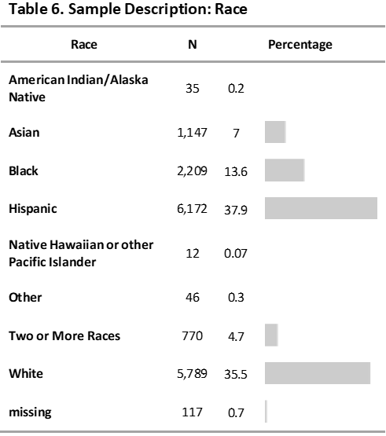

# Survey of Academic and Youth Outcomes (SAYO)

### SAYO-S and SAYO-T: Introduction to the Tools

The Department partnered with the National Institute on Out-of-School-Time (NIOST) to create the Survey of Academic Youth Outcomes (SAYO), an assessment tool for use by MA 21st CCLC grantees. The SAYO Assessment System measures youth’s academic and social emotional learning and outcomes from three perspectives: SAYO-Staff, SAYO-Teacher and SAYO-Youth. The SAYO Assessment System uses brief pre-participation (“pre” or “SAYO-pre”) and post-participation (“post” or “SAYO-post”) surveys to collect data from school-day teachers and 21st CCLC staff, and youth participants. Results from two rounds of field-testing with over 5,000 students indicated that the SAYO is a valid and reliable instrument for measuring change in youth. Results of testing show sufficient reliability and validity for use in 21st CCLC OST programs with evidence of change from pre to post-

|  |  |
| --- | --- |
| **Table 7. Number of Programs that Measure**  **Each Outcome** | |
| **SAYO T Outcomes** | **Number of Programs** |
| Communication | 63 |
| Critical Thinking | 20 |
| Engagement | 125 |
| Homework | 75 |
| Leadership | 31 |
| Perseverance | 29 |
| Relationships with Adults | 47 |
| Relationships with Peers | 75 |
| Self-regulation | 45 |
| **SAYO S Outcomes** |  |
| Communication | 75 |
| Critical Thinking | 30 |
| Engagement | 135 |
| Leadership | 40 |
| Perseverance | 37 |
| Relationships with Adults | 56 |
| Relationships with Peers | 81 |
| Self-regulation | 55 |

assessment.

The SAYO Assessment System is based on a “menu” approach, meaning that programs collect data on selected outcomes that are aligned with their program goals and practices. Each outcome area is measured by asking school-day teachers and program staff to respond to four or five questions related to observable youth behaviors. These items have been extensively tested and found to work as a single scale that effectively captures the outcome being measured.

The SAYO Assessment System enables 21st CCLC programs to capture information reflecting changes that are (a) associated with participation in a high-quality 21st CCLC programs and (b) likely to occur over a one-year period. Massachusetts requires all 21st CCLC grantees to use the SAYO as a part of their assessment and reporting efforts. All grantees use SAYO results to indicate the degree to which they have measured positive outcomes among the participants they serve. Grantees select from a list of academic and social emotional learning outcomes and measure what best reflects the focus and goals of their programs. Survey responses from school day teachers (SAYO-T) and program staff (SAYO-S) are completed for a sample of youth in each program. The number of programs that selected each of these outcomes is presented in Table 7.

#### Academic Outcomes (SAYO-T)

SAYO-Teacher (SAYO-T) surveys are completed by school-day teachers*.* Grantees are required to measure (1) “Engagement in Learning,” (2) choose one academic area as a focus of their programming, either ELA or Math, and (3) select at least two other SAYO-T outcomes related to the priorities of their school and district. The academic section of the tool contains two main

content areas – ELA and mathematics – into which evaluation of science and social studies are expected to be incorporated (science and social studies are explicitly addressed in the SAYO-Y tool—see Section

3). In addition, if assistance with homework is offered through the program, programs are expected to measure the “Homework” SAYO-T outcome area.

|  |  |
| --- | --- |
| **Table 8. SAYO Outcome Descriptions** | |
| **SAYO Outcome** | **Description** |
| **Communication** | Youth are able to effectively express themselves and share their thoughts and ideas with adults and peers. Youth are good listeners to other people’s ideas. Note that youth may use nonverbal indicators such as gestures or other devices to support communication. |
| **Critical Thinking** | Students are able to engage in disciplined thinking that is clear, rational, open-minded, and informed by evidence. Youth can analyze and evaluate information to form a perspective. They are able to make judgments and think logically. |
| **Engagement in Learning\*** | Youth show interest and are actively involved in school or OST program activities. |
| **Leadership** | Youth are able to motivate others toward a common goal. |
| **Perseverance** | Youth plan for and pursue reasonable goals to completion in the face of challenges. |
| **Relations with Adults** | A supportive relationship with an adult is marked by stability, mutual respect, trust, and honesty. |
| **Relations with Peers** | Youth interactions are collaborative, fun, and contribute to a positive social environment. These interactions include those who may differ by gender, age, race/ethnicity, ability, or peer group. |
| **Self-Regulation** | Youth are able to shape their thoughts, behaviors, and emotions to express their needs in a way that matches the needs of the context. |
| * Required for all grantees. | |

#### Social and Emotional Learning (SEL) Outcomes (SAYO-S and SAYO-T)

Grantees are required to measure Engagement in Learning and two other SEL outcomes from the following*:* Communication*,* Critical Thinking, Leadership, Perseverance, Relations with Adults, Relations with Peers, and Self-Regulation*.*

#### Program Staff Version (SAYO-S)

Grantees must collect responses from staff working with students served during the school year as well as during the summer for the same SEL outcomes selected as part of the SAYO-T described above. Using the SAYO-Staff (SAYO-S), grantees are required to collect and report on pre and post-participation ratings of students by program staff (which may include school-day teachers if they are working in the funded programs in the OST hours as well).

### Growth in Social and Emotional Learning SAYO Outcomes

This section includes descriptive statistics and T-test results that demonstrate growth across all SEL and academic outcome areas in the overall sample, and by grade. As mentioned above, each grantee selects from the menu of outcomes based on their program and district goals and priorities.

#### Methods and Analysis

The proportion of students who showed improvement in each outcome area are illustrated in Table 9.

Average (mean) SAYO-T scores were calculated for school year fall (pre) and school year spring (post). For SAYO-S scales, these were calculated for school year fall (pre) and school year spring (post) and summer (pre and post). Overall sample descriptive statistics (mean and standard deviation) are provided for all students who had a SAYO completed for them at school year and/or summer pre and post. Paired T-tests, using only students who had both a pre and post SAYO, were used to test whether students showed growth in SAYO outcomes over time.

|  |  |  |  |  |
| --- | --- | --- | --- | --- |
| **Table 9. Proportion of Students Who Improved, Maintained or Declined in SAYO Ratings by Outcome Area** | | | | |
| **Outcome** | **N** | **Improved** | **Maintained** | **Declined** |
| **Communication (SAYO-S)** | 7550 | 63% | 23% | 15% |
| **Communication (SAYO-T)** | 5468 | 54% | 23% | 23% |
| **Critical Thinking (SAYO-S)** | 2489 | 54% | 38% | 8% |
| **Critical Thinking (SAYO-T)** | 1752 | 50% | 35% | 15% |
| **ELA (SAYO-T)** | 8470 | 34% | 54% | 11% |
| **Engagement (SAYO-S)** | 12179 | 67% | 16% | 17% |
| **Engagement (SAYO-T)** | 8919 | 56% | 20% | 24% |
| **Homework (SAYO-T)** | 4728 | 42% | 40% | 18% |
| **Leadership (SAYO-S)** | 1890 | 56% | 36% | 8% |
| **Leadership (SAYO-T)** | 2019 | 47% | 36% | 17% |
| **Math (SAYO-T)** | 3041 | 28% | 59% | 13% |
| **Perseverance (SAYO-S)** | 2761 | 65% | 25% | 10% |
| **Perseverance (SAYO-T)** | 2207 | 46% | 31% | 23% |
| **Rel. w/ Adults (SAYO-S)** | 4410 | 57% | 35% | 8% |
| **Rel w/ Adults (SAYO-T)** | 3519 | 35% | 57% | 8% |
| **Rel. w/ Peers (SAYO-S)** | 7632 | 60% | 24% | 16% |
| **Rel. w/ Peers (SAYO-T)** | 5834 | 53% | 23% | 25% |
| **Self-regulation (SAYO-S)** | 3982 | 52% | 39% | 9% |
| **Self-regulation (SAYO-T)** | 3056 | 41% | 43% | 16% |

#### SAYO-Teacher Ratings

Table 10 shows the overall sample descriptive statistics for SAYO-T outcomes. SAYO-T outcome mean scores are reported on a 1-5 scale (low to high) along with mean change. SAYO-T ratings averaged between 3.44 (Critical Thinking) and 3.83 (Relations with Peers) in the fall of 2022. For the spring of 2023, SAYO-T ratings increased ranging from 3.83 (Engagement in Learning) to 4.08 (Relations with Peers). Teachers reported growth in all SAYO outcome areas measured. Students demonstrated positive improvement in all SAYO-T outcomes with Critical Thinking showing the largest amount of positive growth (0.5 mean change).

**Table 10. Overall SAYO-T Descriptive Statistics**

|  |  |  |  |  |  |
| --- | --- | --- | --- | --- | --- |
| **Communication** | 3.5 | 3.8 | 1 | 1 | 0.3 |
| **Critical thinking** | 3.4 | 4 | 1.2 | 1 | 0.5 |
| **Engagement** | 3.5 | 3.8 | 0.9 | 1 | 0.3 |
| **Homework** | 3.6 | 3.9 | 1.1 | 1 | 0.2 |
| **Leadership** | 3.6 | 4 | 1 | 1 | 0.3 |
| **Perseverance** | 3.7 | 4 | 1 | 1 | 0.2 |
| **Relationships with adults** | 3.5 | 4 | 1 | 0.9 | 0.5 |
| **Relationships with peers** | 3.8 | 4 | 0.8 | 0.8 | 0.3 |
| **Self-regulation** | 3.7 | 4 | 1.1 | 1 | 0.3 |

SAYO T Outcome Means Standard Deviations Outcome **Pre Mean Post Mean Pre SD Post SD Change**

All SAYO-T outcomes showed significant growth from fall to spring (see Table 11). Mean differences based on T-tests using fall and spring ratings ranged from 0.2 (Perseverance) to 0.5 (Critical Thinking).

|  |  |  |  |  |  |  |
| --- | --- | --- | --- | --- | --- | --- |
| **Table 11. SAYO-T T-test Results** | | | | | | |
| **SAYO – T**  **Outcome** | **t-value** | **Degrees of Freedom** | **p-value** | **Conf. Interval (lower bound)** | **Conf. Interval (upper bound)** | **Change** |
| **Homework** | 20.4 | 4,819 | <0.01 | 0.24 | 0.29 | 0.3 |
| **Communication** | 25.7 | 5,530 | <0.01 | 0.27 | 0.32 | 0.3 |
| **Engagement** | 38.3 | 9,588 | <0.01 | 0.31 | 0.34 | 0.3 |
| **Critical thinking** | 30.6 | 2,312 | <0.01 | 0.49 | 0.56 | 0.5 |
| **Self-regulation** | 20.3 | 3,109 | <0.01 | 0.26 | 0.31 | 0.3 |
| **Leadership** | 17.5 | 2,036 | <0.01 | 0.29 | 0.37 | 0.3 |
| **Perseverance** | 12.2 | 2,218 | <0.01 | 0.19 | 0.26 | 0.2 |
| **Relationships with peers** | 24.6 | 5,974 | <0.01 | 0.24 | 0.28 | 0.3 |
| **Relationships with adults** | 33.8 | 4,105 | <0.01 | 0.42 | 0.48 | 0.5 |

#### SAYO-Staff Ratings

SAYO-Staff (SAYO-S) data were collected during the school year (SY) of fall 2022–spring 2023 and the summer of 2023. Table 12 shows the overall sample descriptive statistics for SAYO-S outcomes for the school year. SAYO-S ratings averaged between 3.2 (Leadership) and 3.6 (Relations with Peers) in the fall of 2022. In the spring, SAYO-S ratings increased, ranging from 3.8 (Leadership) to 4.2 (Perseverance).

|  |  |  |  |  |  |
| --- | --- | --- | --- | --- | --- |
| **Table 12. Overall SAYO-S Descriptive Statistics** | | | | | |
|  | Means | | Standard Deviations | |  |
| **Outcome** | **Pre Mean** | **Post Mean** | **Pre SD** | **Post SD** | **Change** |
| **Communication** | 3.4 | 4 | 1 | 0.9 | 0.6 |
| **Critical thinking** | 3.4 | 4 | 1.2 | 0.9 | 0.7 |
| **Engagement** | 3.4 | 4 | 0.9 | 0.9 | 0.6 |
| **Leadership** | 3.2 | 3.7 | 1 | 01 | 0.6 |
| **Perseverance** | 3.6 | 4.2 | 1 | 0.9 | 0.6 |
| **Relationships with adults** | 3.4 | 4 | 1.1 | 0.9 | 0.7 |
| **Relationships with peers** | 3.6 | 4.2 | 0.9 | 0.8 | 0.5 |
| **Self-regulation** | 3.6 | 4 | 1.1 | 1 | 0.4 |

Students demonstrated positive improvement in all SAYO-S outcomes. Relationships with Adults showed the largest amount of positive growth (0.7 mean change).

All SAYO-S outcomes showed significant growth from fall to spring (see Table 13). Mean differences between fall and spring ranged from 0.4 (Self-Regulation) to 0.7 (Relationships with Adults).

|  |  |  |  |  |  |  |
| --- | --- | --- | --- | --- | --- | --- |
| **Table 13. SAYO-S T-test Results** | | | | | | |
| **Outcome** | **T-**  **value** | **Degrees of Freedom** | **P-**  **value** | **Conf. Interval (lower bound)** | **Conf. Interval (upper bound)** | **Mean Difference** |
| **Communication** | 47.9 | 5,562 | <.001 | 0.58 | 0.63 | 0.6 |
| **Engagement** | 60.7 | 9,530 | <.001 | 0.57 | 0.60 | 0.6 |
| **Critical thinking** | 36.3 | 2,322 | <.001 | 0.64 | 0.71 | 0.7 |
| **Self-regulation** | 31.2 | 3,160 | <.001 | 0.42 | 0.47 | 0.4 |
| **Leadership** | 21.1 | 1,201 | <.001 | 0.51 | 0.61 | 0.6 |
| **Perseverance** | 30.6 | 2,157 | <.001 | 0.59 | 0.68 | 0.6 |
| **Relationships with peers** | 46.1 | 5,919 | <.001 | 0.53 | 0.58 | 0.6 |
| **Relationships with adults** | 46.3 | 3,974 | <.001 | 0.67 | 0.73 | 0.7 |

Summer staff also complete SAYO-S for youth participating in summer programming. Table 14 shows the overall sample descriptive statistics for SAYO-S outcomes for the summer. SAYO-S ratings averaged between 3 (Critical Thinking) and 3.5 (Relations with Peers) in the pre- summer 2023 (July). For the post-summer 2023 (August), SAYO-S ratings increased ranging from

3.7 (Critical Thinking) to 4.1 (Relations with Peers). SAYO-S reported improvement in all outcomes with Perseverance showing the largest amount of positive growth (1.1 mean change).

All SAYO-S outcomes showed significant growth from pre-summer 2023 to post-summer 2023 (see Table 15). Mean differences between pre and post summer ranged from 0.5 (Self- Regulation) to 0.9 (Perseverance).

**Table 15. SAYO-S (Summer) T-test Results**

**Table 14. Overall SAYO-S (Summer) Descriptive Statistics**

Means Standard Deviations

**Outcome Pre Mean Post Mean Pre SD Post SD Change**

|  |  |  |  |  |  |
| --- | --- | --- | --- | --- | --- |
| **Communication** | 3.2 | 3.8 | 1 | 1 | 0.6 |
| **Critical thinking** | 3 | 3.7 | 0.9 | 1.3 | 0.7 |
| **Engagement** | 3.3 | 4 | 0.9 | 1.0 | 0.7 |
| **Leadership** | 3.1 | 3.9 | 0.9 | 0.9 | 0.8 |
| **Perseverance** | 2.8 | 3.9 | 0.8 | 0.8 | 1.1 |
| **Relationships with adults** | 3.2 | 3.8 | 0.9 | 0.8 | 0.6 |
| **Relationships with peers** | 3.5 | 4.1 | 1 | 0.8 | 0.6 |
| **Self-regulation** | 3.2 | 3.8 | 0.9 | 1.3 | 0.6 |

|  |  |  |  |  |  |  |
| --- | --- | --- | --- | --- | --- | --- |
| **Outcome** | **T-**  **value** | **Degrees of Freedom** | **P-**  **value** | **Conf. Interval (lower Conf. bound)** | **Interval (upper bound)** | **Mean Difference** |
| **Communication** | 33.1 | 3,482 | <0.01 | 0.55 | 0.62 | 0.6 |
| **Engagement** | 52.6 | 5,957 | <0.01 | 0.58 | 0.63 | 0.6 |
| **Critical thinking** | 28.9 | 1,339 | <0.01 | 0.61 | 0.70 | 0.7 |
| **Self-regulation** | 32.8 | 1,987 | <0.01 | 0.48 | 0.54 | 0.5 |
| **Leadership** | 31.3 | 1,270 | <0.01 | 0.72 | 0.81 | 0.8 |
| **Perseverance** | 38.7 | 1,304 | <0.01 | 0.89 | 0.98 | 0.9 |

**Relationships with peers**

|  |  |  |  |  |  |
| --- | --- | --- | --- | --- | --- |
| 33.2 | 3,467 | <0.01 | 0.51 | 0.57 | 0.5 |
| 31.2 | 1,864 | <0.01 | 0.57 | 0.65 | 0.6 |

**Relationships with adults**

#### Differences in SAYO Growth by Grade

Differences in growth by grade are shown below in Tables 16-17. Various kinds of kindergarten enrollment including part-time kindergarten (KP), full-time kindergarten (KF) and kindergarten tuitioned (KT) are grouped together and described as kindergarten (K) throughout this report. In the following tables, dark green shading indicates stronger growth.

|  |  |  |  |  |  |  |  |  |  |  |  |  |  |  |  |
| --- | --- | --- | --- | --- | --- | --- | --- | --- | --- | --- | --- | --- | --- | --- | --- |
| **Table 16. SAYO-T Change by Grade** | | | | | | | | | | | | | | | |
|  | **PK** | **K** | **1** | **2** | **3** | **4** | **5** | **6** | **7** | **8** | **9** | **10** | **11** | **12** | **SP** |
| **Math** | * | 0.2 | 0.0 | 0.3 | 0.2 | 0.1 | 0.1 | 0.0 | 0.1 | 0.2 | 0.2 | 0.2 | 0.3 | 0.2 | 0.0 |
| **ELA** | 0.4 | 0.4 | 0.3 | 0.3 | 0.3 | 0.3 | 0.3 | 0.3 | 0.2 | 0.3 | 0.2 | 0.3 | 0.2 | 0.3 | -0.5 |
| **Homework** | * | 0.4 | 0.0 | 0.1 | 0.2 | 0.2 | 0.3 | 0.2 | 0.3 | 0.5 | 0.3 | 0.2 | 0.2 | 0.3 | 0.0 |
| **Communication** | * | 0.4 | 0.3 | 0.3 | 0.4 | 0.3 | 0.3 | 0.2 | 0.3 | 0.4 | 0.5 | 0.3 | 0.2 | 0.1 | 0.0 |
| **Critical Thinking** | 1.0 | 0.7 | 0.3 | 0.3 | 0.5 | 0.3 | 0.5 | 0.2 | 0.3 | 0.6 | 0.5 | 0.2 | 0.1 | 0.3 | 0.0 |
| **Engagement** | 1.8 | 0.4 | 0.2 | 0.2 | 0.3 | 0.3 | 0.3 | 0.3 | 0.3 | 0.4 | 0.4 | 0.1 | 0.1 | 0.2 | 0.4 |
| **Leadership** | * | 0.5 | 0.2 | 0.2 | 0.2 | 0.2 | 0.4 | 0.3 | 0.3 | 0.4 | 0.5 | 0.4 | 0.5 | 0.4 | 1.0 |
| **Perseverance** | * | 0.4 | 0.2 | 0.2 | 0.1 | 0.1 | 0.2 | 0.2 | 0.3 | 0.4 | 0.6 | 0.3 | 0.1 | 0.2 | -0.1 |
| **Rel. w/ Adults** | 1.0 | 0.2 | 0.2 | 0.4 | 0.4 | 0.4 | 0.4 | 0.4 | 0.3 | 0.6 | 0.3 | 0.4 | 0.1 | 0.3 | 0.5 |
| **Self-Regulation** | * | 0.3 | 0.2 | 0.3 | 0.3 | 0.2 | 0.3 | 0.2 | 0.3 | 0.3 | 0.5 | 0.3 | 0.2 | 0.3 | 1.0 |
| *Empty cells are due to low sample size for the given population and outcome measured. | | | | | | | | | | | | | |  |  |

As shown in Table 16, kindergarten school day teachers reported positive growth in almost all student populations and SAYO-T outcome areas. Teachers reported pre-kindergarten children showed the most overall growth and especially in Engagement in Learning, Critical Thinking and Relationships with Adults. Teachers reported special populations (SP youth with an IEP) showed the most growth in Self-Regulation and Leadership skills; but were also reported to have declined in ELA (-0.5 change).

|  |  |  |  |  |  |  |  |  |  |  |  |  |  |  |  |
| --- | --- | --- | --- | --- | --- | --- | --- | --- | --- | --- | --- | --- | --- | --- | --- |
| **Table 17. SAYO-S Change by Grade** | | | | | | | | | | | | | | | |
| **Outcome** | **PK** | **K** | **1** | **2** | **3** | **4** | **5** | **6** | **7** | **8** | **9** | **10** | **11** | **12** | **SP** |
| **Communication** | 0.9 | -0.1 | -0.2 | -0.2 | 0.0 | -0.2 | 0.0 | 0.0 | 0.0 | 0.0 | 0.3 | 0.3 | -0.1 | 0.5 | 0.8 |
| **Critical Thinking** | 0.0 | 0.6 | 0.6 | 0.3 | 0.4 | 0.3 | 0.4 | 1.0 | 0.7 | 0.6 | 0.6 | 0.5 | 0.3 | 0.3 | 1.0 |
| **Engagement** | 1.0 | 0.6 | 0.5 | 0.5 | 0.6 | 0.4 | 0.6 | 0.6 | 0.8 | 0.8 | 0.6 | 0.4 | 0.4 | 0.4 | 1.1 |
| **Leadership** | * | 0.3 | 0.5 | 0.2 | 0.8 | 0.3 | 1.2 | 0.6 | 0.7 | 0.6 | 0.9 | 0.4 | 0.5 | 0.5 | 1.0 |
| **Perseverance** | * | 0.7 | 0.7 | 0.6 | 0.7 | 0.4 | 0.6 | 0.9 | 1.0 | 1.0 | 0.7 | 1.0 | 0.8 | 0.7 | 0.4 |
| **Rel. w/ Adults** | 1.1 | 0.7 | 0.8 | 0.5 | 0.6 | 0.6 | 0.6 | 0.8 | 0.7 | 0.7 | 0.6 | 0.5 | 0.5 | 0.3 | 1.0 |
| **Self-Regulation** | 0.8 | 0.7 | 0.5 | 0.4 | 0.5 | 0.5 | 0.4 | 0.3 | 0.5 | 0.4 | 0.5 | 0.4 | 0.3 | 0.1 | 1.0 |
| *Empty cells are due to low sample size for the given population and outcome measured. | | | | | | | | | | | | | |  |  |

According to program staff as reported by SAYO-S surveys, pre-K and special populations also showed the most growth over the school year. In addition, SAYO-S scores in the middle school grades show especially pronounced growth, particularly in the area of perseverance, when compared to other grades (see Table 17 and highlighted details in Figure 1).

4

3

2 Pre

Rating

Post

1

0

Change = 1 Change = 0.6

Middle Other Grades

**Figure 1. Change in SAYO-S Perseverance in Middle Grades Compared to Others**

### Special Populations SAYO Social and Emotional Learning Outcomes

Given the 21st CCLC’s focus on increasing access to quality OST programs for students who have been historically marginalized and underserved, this section focuses on SAYO-T and SAYO-S outcomes in subpopulations differentiated by: income, gender, English learner (EL) status, race, and whether or not students receive special education services. The proportion of subpopulations that experienced growth and the mean growth for each

outcome area is presented for each population below. For some populations, additional statistics of interest are presented to highlight relevant or unexpected findings. For full pre, post and change statistics for each subpopulation, see Appendix C.

|  |  |  |
| --- | --- | --- |
| **Table 18. Percent of Students**  **Demonstrating Improvement on SAYO-T and**  **SAYO-S by Income Status** | | |
| **Outcome\*** | **Not Low-**  **Income** | **Low- Income** |
| Communication (T) | 52 | 55 |
| Critical Thinking (T) | 46 | 53 |
| Self-Regulation (T) | 45 | 38 |
| Engagement (T) | 53 | 57 |
| Leadership (T) | 46 | 47 |
| Perseverance (T) | 46 | 46 |
| Rel. w/ Peers (T) | 52 | 53 |
| Rel. w/ Adults (T) | 28 | 40 |
| Homework (T) | 39 | 44 |
| Math | 27 | 28 |
| ELA | 32 | 35 |
| Communication (S) | 62 | 63 |
| Critical Thinking (S) | 56 | 53 |
| Self-Regulation | 49 | 54 |
| Engagement (S) | 65 | 68 |
| Leadership (S) | 55 | 56 |
| Perseverance (S) | 61 | 68 |
| Rel. w/ Peers (S) | 57 | 62 |
| Rel. w/ Adults (S) | 56 | 57 |
| *(S): SAYO-S. (T): SAYO-T. | |  |

#### Income

Of the 8659 students who were identified as low- income and rated on both SAYO pre and post, 88 percent improved in at least one outcome area.

A greater proportion of low-income students experienced growth across SAYO areas when compared to other students in all outcome areas with the exception of Critical Thinking (S) and Self- Regulation (T) (see Table 18). This difference was especially pronounced in the area of Relationships with Adults (T), in which 40 percent of low-income students improved, compared to 28 percent.

Low-income students saw equal or greater mean growth across all outcome areas. For mean growth compared across outcome areas see Tables 19-20.

**Table 19. Mean SAYO-T Change by Income Status**

**Outcome Not Low-**

**Income**

**Low-Income**

|  |  |  |
| --- | --- | --- |
| **Math** | 0.1 | 0.1 |
| **ELA** | 0.2 | 0.3 |
| **Homework** | 0.2 | 0.3 |
| **Communication** | 0.3 | 0.3 |
| **Critical Thinking** | 0.2 | 0.5 |
| **Engagement** | 0.3 | 0.3 |
| **Leadership** | 0.3 | 0.4 |
| **Perseverance** | 0.2 | 0.3 |
| **Rel. w/ Peers** | 0.3 | 0.3 |
| **Rel. w/ Adults** | 0.3 | 0.4 |
| **Self-Regulation** | 0.2 | 0.3 |

|  |  |  |
| --- | --- | --- |
| **Table 20. Mean SAYO-S Change by Income**  **Status** | | |
| **Outcome** | **Not Low-Income** | **Low-**  **Income** |
| **Communication** | 0.0 | 0.0 |
| **Critical Thinking** | 0.5 | 0.6 |
| **Engagement** | 0.5 | 0.6 |
| **Leadership** | 0.5 | 0.6 |
| **Perseverance** | 0.6 | 0.7 |
| **Rel. w/ Peers** | 0.5 | 0.6 |
| **Rel. w/ Adults** | 0.5 | 0.6 |
| **Self-Regulation** | 0.4 | 0.5 |

#### Special Education

Of the 2410 students who received special education services and were rated on both pre and post SAYO, 90 percent improved in at least one outcome area.

|  |  |  |
| --- | --- | --- |
| **Table 21. Percent of Students**  **Demonstrating Improvement on SAYO-T and SAYO-S by Special**  **Education Status** | | |
| **Outcome\*** | **Not receiving** | **Receiving** |
| Communication (T) | 53 | 57 |
| Critical Thinking (T) | 49 | 54 |
| Self-Regulation (T) | 40 | 44 |
| Engagement (T) | 55 | 59 |
| Leadership (T) | 46 | 49 |
| Perseverance (T) | 44 | 53 |
| Rel. w/ Peers (T) | 52 | 58 |
| Rel. w/ Adults (T) | 35 | 37 |
| Homework (T) | 41 | 47 |
| Math | 27 | 32 |
| ELA | 34 | 36 |
| Communication (S) | 62 | 65 |
| Critical Thinking (S) | 53 | 59 |
| Self-Regulation | 51 | 57 |
| Engagement (S) | 67 | 69 |
| Leadership (S) | 56 | 55 |
| Perseverance (S) | 64 | 71 |
| Rel. w/ Peers (S) | 60 | 62 |
| Rel. w/ Adults (S) | 56 | 58 |
| *(S): SAYO-S. (T): SAYO-T. | |  |

A greater proportion of students who receive special education services experienced growth across SAYO areas when compared to other students in all outcome areas with the exception of Leadership (SAYO-S) (see Table 21).

SAYO ratings for students receiving special education services improved to a similar extent compared to other students. These students met or exceeded other students’ mean growth in all SAYO-S and T outcome areas (Tables 22- 23).

**Table 22. Mean SAYO-S Change by Education Status**

**Outcome**

**Students without Disabilities**

**Students with Disabilities**

|  |  |  |
| --- | --- | --- |
| **Communication** | -0.1 | 0.1 |
| **Critical Thinking** | 0.5 | 0.6 |
| **Engagement** | 0.6 | 0.6 |
| **Leadership** | 0.7 | 0.7 |
| **Perseverance** | 0.7 | 0.8 |
| **Rel. w/ Peers** | 0.5 | 0.6 |
| **Rel. w/ Adults** | 0.6 | 0.6 |
| **Self-Regulation** | 0.5 | 0.5 |

**Table 23. Mean SAYO-T Change by Education Status**

**Outcome**

**Not receiving special education services**

**Receiving special education services**

|  |  |  |
| --- | --- | --- |
| **Math** | 0.1 | 0.2 |
| **ELA** | 0.3 | 0.3 |
| **Homework** | 0.2 | 0.4 |
| **Communication** | 0.3 | 0.4 |
| **Critical Thinking** | 0.4 | 0.5 |
| **Engagement** | 0.3 | 0.4 |
| **Leadership** | 0.3 | 0.4 |
| **Perseverance** | 0.2 | 0.4 |
| **Rel. w/ Peers** | 0.2 | 0.4 |
| **Rel. w/ Adults** | 0.3 | 0.3 |
| **Self-Regulation** | 0.2 | 0.4 |

#### Gender

SAYO ratings for female students improved to a similar extent compared to male students. There was an improvement in at least one SAYO outcome for 88 percent of the 6295 female identifying students and 88 percent of the 6251 male identifying students for whom both pre and post SAYO scores were reported.

|  |  |  |
| --- | --- | --- |
| **Table 24. Percent of Students**  **Demonstrating Improvement on SAYO-**  **T and SAYO-S by Gender** | | |
| **Outcome** | **F** | **M** |
| Communication (T) | 53 | 55 |
| Critical Thinking (T) | 49 | 50 |
| Self-Regulation (T) | 40 | 41 |
| Engagement (T) | 55 | 56 |
| Leadership (T) | 45 | 48 |
| Perseverance (T) | 45 | 47 |
| Rel. w/ Peers (T) | 51 | 54 |
| Rel. w/ Adults (T) | 36 | 35 |
| Homework (T) | 41 | 43 |
| Math | 28 | 27 |
| ELA | 34 | 34 |
| Communication (S) | 63 | 62 |
| Critical Thinking (S) | 53 | 55 |
| Self-Regulation | 50 | 55 |
| Engagement (S) | 68 | 67 |
| Leadership (S) | 56 | 56 |
| Perseverance (S) | 62 | 67 |
| Rel. w/ Peers (S) | 59 | 61 |
| Rel. w/ Adults (S) | 56 | 57 |

About equal proportions of male and female students improved across outcome areas (Table 24). Male and female students also experienced about the same mean growth (Tables 25-26).

|  |  |  |
| --- | --- | --- |
| **Table 25. Mean SAYO-S Change by Gender** | | |
| **Outcome** | **F** | **M** |
| **Communication** | 0.0 | -0.1 |
| **Critical Thinking** | 0.5 | 0.6 |
| **Engagement** | 0.5 | 0.6 |
| **Leadership** | 0.7 | 0.6 |
| **Perseverance** | 0.7 | 0.7 |
| **Rel. w/ Peers** | 0.6 | 0.6 |
| **Rel. w/ Adults** | 0.6 | 0.6 |
| **Self-Regulation** | 0.4 | 0.5 |

**Table 26. Mean SAYO-T Change by Gender**

|  |  |  |
| --- | --- | --- |
| **Outcome** | **F** | **M** |
| **Math** | 0.2 | 0.1 |
| **ELA** | 0.3 | 0.3 |
| **Homework** | 0.2 | 0.3 |
| **Communication** | 0.3 | 0.3 |
| **Critical Thinking** | 0.3 | 0.4 |
| **Engagement** | 0.3 | 0.3 |
| **Leadership** | 0.3 | 0.4 |
| **Perseverance** | 0.2 | 0.3 |
| **Rel. w/ Peers** | 0.2 | 0.3 |
| **Rel. w/ Adults** | 0.3 | 0.4 |
| **Self-Regulation** | 0.3 | 0.3 |

#### Race

A majority of every racial subpopulation experienced positive growth in at least one SAYO area. The following proportions experienced growth in at least one area: American Indian/Alaska Native (N=32): 91 percent; Asian(N=975): 86 percent; Black(N=1515): 91 percent; Hispanic (N=4828): 89 percent; Native Hawaiian or other Pacific Islander (N=11): 91 percent; Two or more races (N=596): 85 percent; White (N=4501): 87 percent.

In every SAYO outcome area with the exception of Self-Regulation (SAYO-T), a greater proportion of Hispanic students saw growth compared to White students. A prominently larger proportion of Black students experienced growth in Relationships with Adults (T) (49 percent vs. 31 percent) and ELA (46 percent vs. 29 percent) compared to White students.

|  |  |  |  |  |  |  |  |  |
| --- | --- | --- | --- | --- | --- | --- | --- | --- |
| **Table 27. Percent of Population Improved by Outcome and Race** | | | | | | | | |
| **American Indian/Alaska Native** | | **Asian** | **Black** | **Hispanic** | **Native Hawaiian or other Pacific Islander** | **Other** | **Two or More Races** | **White** |
| Communication (SAYO-T) | 53 | 57 | 57 | 54 | 33 | 48 | 53 | 53 |
| Critical Thinking (SAYO-T) | 29 | 43 | 51 | 59 | * | 50 | 43 | 46 |
| Self-Regulation SAYO- (T) | 11 | 45 | 37 | 38 | 33 | 43 | 61 | 43 |
| Engagement (SAYO-T) | 43 | 55 | 64 | 56 | 50 | 43 | 55 | 53 |
| Leadership (SAYO-T) | 29 | 49 | 40 | 49 | 0 | 48 | 44 | 47 |
| Perseverance (SAYO-T) | 41 | 46 | 39 | 47 | 0 | 45 | 32 | 47 |
| Rel. w/ Peers (SAYO-T) | 53 | 55 | 60 | 53 | 43 | 48 | 52 | 49 |
| Rel. w/ Adults (SAYO-T) | 24 | 16 | 49 | 36 | 50 | 0 | 41 | 31 |
| Homework (SAYO-T) | 48 | 38 | 51 | 42 | 60 | 30 | 42 | 40 |
| Math (SAYO-T) | 24 | 21 | 30 | 29 | 0 | 25 | 25 | 27 |
| ELA (SAYO-T) | 41 | 32 | 46 | 36 | 11 | 25 | 37 | 29 |
| Communication (SAYO-S) | 67 | 63 | 65 | 65 | 50 | 53 | 61 | 60 |
| Critical Thinking (SAYO-S) | 50 | 43 | 52 | 56 | * | 60 | 52 | 54 |
| Self-Regulation SAYO- | 53 | 42 | 55 | 56 | 0 | 38 | 58 | 48 |
| Engagement (SAYO-S) | 65 | 65 | 74 | 69 | 80 | 42 | 67 | 65 |
| Leadership (SAYO-S) | 44 | 46 | 45 | 58 | 100 | 100 | 58 | 58 |
| Perseverance (SAYO-S) | 47 | 54 | 74 | 66 | 100 | 56 | 66 | 63 |
| Rel. w/ Peers (SAYO-S) | 74 | 60 | 69 | 62 | 29 | 47 | 61 | 56 |
| Rel. w/ Adults (SAYO-S) | 50 | 53 | 65 | 57 | 25 | 49 | 55 | 54 |
| *Empty cells are due to low sample size for the given population and outcome measured. | | | | | |  |  |  |

Mean growth by subpopulations and outcome areas is reported in Tables 28-29. The high variance in growth across outcomes among Native Hawaiian or other Pacific Islander is likely due to the comparatively small sample size for this population.

|  |  |  |  |  |  |  |  |  |
| --- | --- | --- | --- | --- | --- | --- | --- | --- |
| Table 28. Mean SAYO-T Change by Race | | | | | | | | |
| **American Indian/Alaska Native** | | **Asian** | **Black** | **Hispanic** | **Native Hawaiian or other Pacific Islander** | **Other** | **Two or More Races** | **White** |
| **Math** | 0.0 | 0.0 | 0.2 | 0.2 | 0.0 | -0.1 | 0.2 | 0.1 |
| **ELA** | 0.4 | 0.2 | 0.5 | 0.3 | 0.0 | -0.1 | 0.3 | 0.2 |
| **Homework** | 0.2 | 0.3 | 0.4 | 0.2 | 0.9 | 0.2 | 0.2 | 0.2 |
| **Communication** | 0.2 | 0.3 | 0.3 | 0.3 | 0.4 | 0.2 | 0.2 | 0.2 |
| **Critical Thinking** | 0.3 | 0.2 | 0.6 | 0.6 | * | 0.2 | 0.4 | 0.3 |
| **Engagement** | 0.1 | 0.3 | 0.5 | 0.2 | 0.0 | 0.1 | 0.3 | 0.3 |
| **Leadership** | 0.2 | 0.2 | 0.4 | 0.4 | -0.5 | 0.2 | 0.5 | 0.3 |
| **Perseverance** | 0.3 | 0.2 | 0.2 | 0.2 | -1.0 | 0.2 | 0.3 | 0.2 |
| **Rel. w/ Peers** | 0.18 | 0.26 | 0.45 | 0.23 | -0.48 | 0.22 | 0.25 | 0.19 |
| **Rel. w/ Adults** | 0.1 | 0.1 | 0.6 | 0.4 | 0.0 | 0.0 | 0.3 | 0.3 |
| **Self-Regulation** | 0.0 | 0.1 | 0.3 | 0.3 | 0.3 | 0.1 | 0.6 | 0.3 |

Table 29. Mean SAYO-S Change by Race

**American Indian/Alaska Native**

**Asian Black Hispanic**

|  |  |  |  |  |  |  |  |  |  |
| --- | --- | --- | --- | --- | --- | --- | --- | --- | --- |
| **Communication** | 0.2 | 0.4 | -0.8 | 0.1 | -0.3 | 0.5 | -0.3 |  | -0.1 |
| **Critical Thinking** | 0.6 | 0.3 | 0.5 | 0.6 | * | 0.5 | 0.6 |  | 0.5 |
| **Engagement** | 0.4 | 0.6 | 0.8 | 0.6 | 0.3 | 0.4 | 0.6 |  | 0.5 |
| **Leadership** | 0.1 | 0.5 | 0.5 | 0.7 | 1.0 | 0.5 | 0.6 |  | 0.6 |
| **Perseverance** | 0.3 | 0.4 | 0.9 | 0.7 | 1.0 | 0.5 | 0.7 |  | 0.6 |
| **Rel. w/ Peers** | 0.4 | 0.60 | 0.79 | 0.54 | -0.01 | 0.32 | 0.51 |  | 0.44 |
| **Rel. w/ Adults** | 0.6 | 0.5 | 0.9 | 0.7 | 0.0 | 0.3 | 0.5 |  | 0.6 |
| **Self-Regulation** | 0.4 | 0.3 | 0.5 | 0.5 | -0.3 | 0.3 | 0.5 |  | 0.4 |

**Native Hawaiian or other Pacific Islander**

**Two or More Races**

**White**

**Other**

*Empty cells are due to low sample size for the given population and outcome measured.

The growth in SAYO-T outcomes shown in Figure 2, as measured by T-tests, is significantly larger for Black African American (BAA) students compared to all other students. This figure also demonstrates that, while Black students were rated lower, on average, than the rest of the population, for the SAYO pre, in the post SAYO, they met and exceeded the mean rating of the rest of the population.

Critical Thinking (p=0.07)

4

ELA (p<0.001)

Engagement (p<0.001)

Homework (p<0.001)

3

pre

Rating

2 post

1

0

Change=0.6 Change=0.2 Change=0.5 Change=0.2 Change=0.5 Change=0.3

Change=0.4

Change=0.2

BAA Other BAA Other BAA Other BAA Other

**Race**

**Figure 2. Mean SAYO-T Change: BAA Students and All Oth**

#### English Learners

Of the 2688 English learners who received ratings for SAYO pre and post, 86 percent experienced growth in at least one SAYO outcome area.

|  |  |  |
| --- | --- | --- |
| **Table 30. Percent of Students**  **Demonstrating Improvement on SAYO-**  **T and SAYO-S by EL Status** | | |
| **Outcome** | **Not MLL** | **MLL** |
| Communication (T) | 54 | 55 |
| Critical Thinking (T) | 47 | 59 |
| Self-Regulation (T) | 41 | 37 |
| Engagement (T) | 55 | 57 |
| Leadership (T) | 45 | 54 |
| Perseverance (T) | 44 | 52 |
| Rel. /w Peers (T) | 52 | 55 |
| Rel. w/ Adults (T) | 33 | 45 |
| Homework (T) | 41 | 49 |
| Math | 28 | 27 |
| ELA | 33 | 37 |
| Communication (S) | 63 | 60 |
| Critical Thinking (S) | 54 | 53 |
| Self-Regulation | 51 | 56 |
| Engagement (S) | 67 | 68 |
| Leadership (S) | 56 | 55 |
| Perseverance (S) | 65 | 66 |
| Rel. w/ Peers (S) | 59 | 63 |
| Rel. w/ Adults (S) | 55 | 62 |

A greater proportion of English learners (EL) experienced growth across SAYO areas when compared to other students in most (14/19) outcome areas with the exceptions of Critical Thinking (S), Math, Communication (S), Leadership (S) and Self-Regulation (T) (see Table 30). This difference was especially pronounced in the area of Relationships with Adults (T), in which 45 percent of MLL students improved, compared to 33 percent.

EL students saw equal or greater mean growth across all outcome areas. For mean growth compared across outcome areas see Tables 31-32.

Table 31. Mean SAYO-T Change by MLL status

|  |  |  |
| --- | --- | --- |
| **Outcome** | **Not MLL** | **MLL** |
| **Math** | 0.1 | 0.2 |
| **ELA** | 0.2 | 0.4 |
| **Homework** | 0.2 | 0.4 |
| **Communication** | 0.3 | 0.3 |
| **Critical Thinking** | 0.4 | 0.5 |
| **Engagement** | 0.3 | 0.3 |
| **Leadership** | 0.3 | 0.5 |
| **Perseverance** | 0.2 | 0.3 |
| **Rel. w/ Peers** | 0.2 | 0.4 |
| **Rel. w/ Adults** | 0.3 | 0.6 |
| **Self-Regulation** | 0.3 | 0.2 |

|  |  |  |
| --- | --- | --- |
| Table 32. Mean SAYO-S Change by MLL Status | | |
| **Outcome** | **Not MLL** | **MLL** |
| **Communication** | 0.0 | -0.1 |
| **Critical Thinking** | 0.5 | 0.5 |
| **Engagement** | 0.6 | 0.6 |
| **Leadership** | 0.6 | 0.6 |
| **Perseverance** | 0.7 | 0.8 |
| **Rel. w/ Peers** | 0.5 | 0.6 |
| **Rel. w/ Adults** | 0.6 | 0.8 |
| **Self-Regulation** | 0.5 | 0.5 |

Growth in SAYO-T ratings of Relationships with Adults, Leadership and Homework (see Figure 3) and SAYO-S ratings of Relationships with Adults (see Figure 4), as measured by T-tests, were significantly larger compared to the rest of the student population. As a result of this difference in growth, there is a much smaller difference between EL students and others in SAYO post ratings compared to SAYO pre.

Relationships with Adults (p<0.001)

4

Leadership (p=0.0012)

Homework (p<0.001)

4

Relationships with

3 3

Rating

2 2

Rating

pre post

1 1

0

Change=0.6 Change=0.3 Change=0.5 Change=0.3 Change=0.4 Change=0.2

0

Change=0.8 Change=0.6

EL Other EL Other EL Other

Adults (p<0.001)

**Status**

**Figure 3. Mean SAYO-T Change: EL Students and All Others**

EL Other

**Figure 4. Mean SAYO-S Change: EL Students and All Others**

SAYO post ratings of MLL students show significant growth in Leadership. However, as is shown in Figure 5, this growth is less pronounced among high school students. This may suggest that the high school environment poses additional challenges to

the development of leadership skills for older

youth. Implementing leadership building activities may also be more challenging for staff in high school level programs.

SAYO-S SAYO-T

3

2  Pre

Rating

Post

1

0

Change=0.3 Change=0.6 Change=0.4 Change=0.5

High School High School

Other Grades Other Grades

**Figure 5. Mean Leadership Change in High School EL Compared to Other Grades**

### SEL Skills Promote ELA and Math Academic Progress

This section focuses Academic Performance and SEL outcomes rated by teachers. Descriptive findings for students’ academic progress at fall and spring are presented. Hierarchical Linear Models (HLM) were used to understand the associations between change in teacher rated SEL skills and change in academic progress.

#### Measures

Eight SAYO-T SEL outcomes (Communication Skills, Critical Thinking, Engagement in Learning, Leadership Skills, Perseverance, Relations with Adults, Relations with Peers, and Self-Regulation) were included as potential predictors of Math and ELA performance in students. 21st CCLC programs choose whether they will rate students in ELA and/or Math performance, depending on the focus of their program. In the full sample of students, ELA performance was reported for 8470 students, and Math performance was reported for 3041 students. Academic performance is rated as follows: 1 = Poor, 2 = Needs Improvement, 3= Satisfactory, and 4 = Very Good.

#### Analysis

The analysis for this section demonstrates the relationship between social and emotional skills and academic growth. Because of a small but statistically significant effect of program site on math and ELA growth (7.1 percent and 6.3 percent of variance respectively), the below results take program site into account through a hierarchical linear model. This model accounts for variance that is attributable to differences in program site, and thus gives more accurate statistics on relationships at the individual participant level. This analysis focuses on growth in math and ELA as predicted by SAYO-T ratings in social-emotional learning areas.

Including Race, MLL, special education, and income as additional predictors was not statistically warranted in this case (for information on the role of these factors in SEL growth see Section 2.3).

#### Results

The below tables (33-34) demonstrate the growth in math and ELA skills that correlates to strength in social and emotional learning areas. Several social and emotional learning areas were associated with growth in academic subjects. These correlations are small to moderate (.16-.28) but statistically significant. The slopes of these correlations appear smaller than those comparing pre or post outcomes, because they represent change in math and ELA, which has a smaller range and standard deviation than the outcomes themselves. Critical thinking SAYO scores predict the greatest change in ELA scores, with each point of SAYO rating correlating with 0.3 points in ELA.

|  |  |  |  |  |
| --- | --- | --- | --- | --- |
| **Table 33. Change in Math as Predicted by SAYO T SEL Rating (Hierarchical Linear Model)** | | | | |
|  | **Communication** | **Critical Thinking** | **Engagement** | **Perseverance** |
| **ELA Change per point of SAYO** | 0.1 | 0.3 | 0.2 | 0.2 |
| **P-Value** | <0.001 | <0.001 | <0.001 | <0.001 |

|  |  |  |  |  |  |  |
| --- | --- | --- | --- | --- | --- | --- |
| **Table 34. Change in ELA as Predicted by SAYO T SEL Rating (Hierarchical Linear Model)** | | | | | | |
|  | **Communication** | **Critical Thinking** | **Engagement** | **Perseverance** | **Rel. w/ Peers** | **Rel. W/ Adults** |
| **ELA Change per point of SAYO** | 0.2 | 0.2 | 0.2 | 0.1 | 0.2 | 0.2 |
| **P-Value** | <0.001 | <0.001 | <0.001 | <0.001 | <0.001 | <0.001 |

### Correlations in SEL Skill Growth

#### SAYO-S Change Correlation Matrix

As a result of their conceptual relationships, ratings in any social and emotional outcome area often correlate with those in other areas. This section presents information about how positive growth in some areas is highly correlated with growth in others, demonstrating how these constructs not only correlate in overall rating, but how growth in social emotional learning occurs simultaneously across related areas.

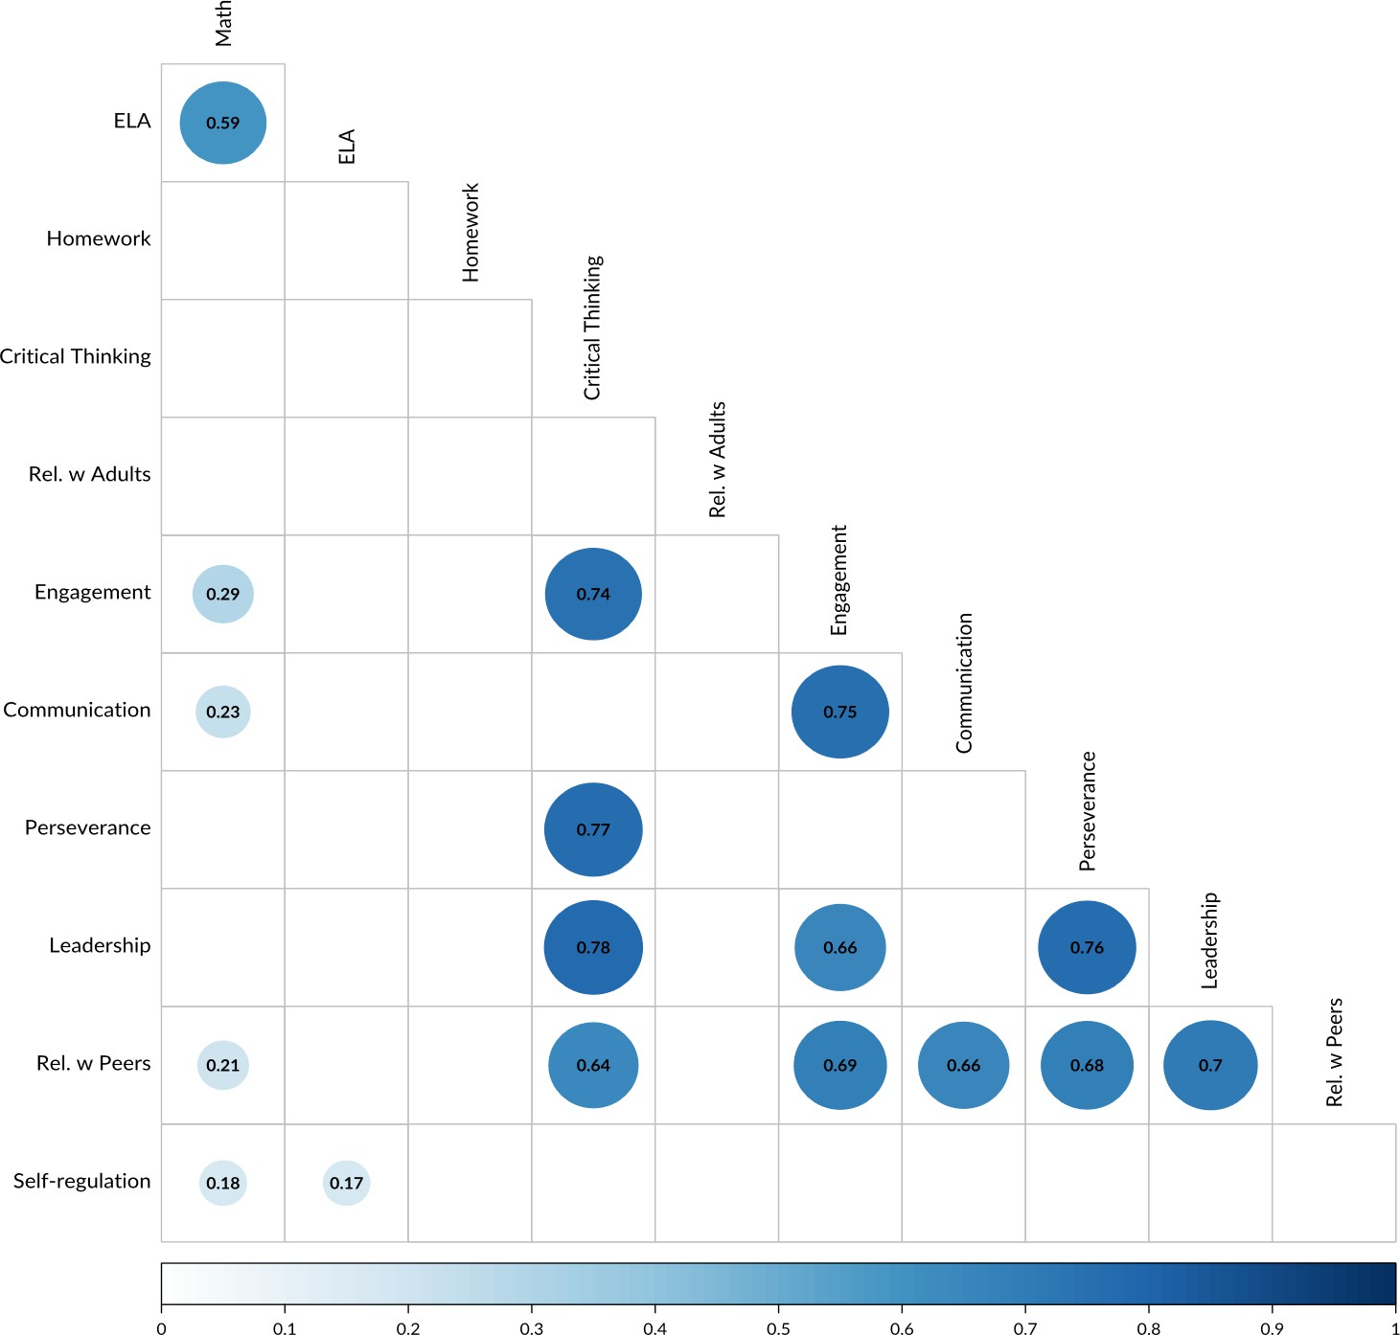Figure 6 demonstrates correlations in a matrix format. Each cell represents an intersection of two outcome areas.

Academic outcome areas are also included. The numbers inside cells represent the strength of correlation between the outcomes. This correlation statistic is also expressed in the size of the circle and the depth of its color.

Correlations in the range of 0-0.5 are weak, 0.5-0.75 are moderate, and 0.75-1 are strong. Empty squares represent intersections that lack a statistically significant correlation (p

<0.001). Of particular interest in the correlation matrix is the column that **shows correlations with Critical Thinking and the row that shows**

**correlations with Relationships with Peers**.

**Figure 6. Correlations Between SAYO-S Outcomes**

These two outcomes each have several strong, statistically significant correlations with other outcomes. Despite the differences between these outcome areas as they are measured on the SAYO-T, improvements in these two areas correlate with the largest improvements in other social and emotional skills. This demonstrates their centrality in a growth-oriented conceptualization of social and emotional skill-building**. Another explanation for these strong correlations in growth across outcomes is the role of single practices that simultaneously build skills in multiple areas.**

#### Improved SAYO Outcomes Correlate with Hours Attended

Two areas of particular relevance to academic performance were observed to correlate with hours attended at 21st CCLC programs. **SAYO-T post ratings for Homework and Critical Thinking outcome areas correlate with hours attended. Growth in these areas is not only a result of attending a program in general, but also increases with greater attendance hours.** This relationship is illustrated in Figure 7 (a-b). The blue line shows the line of best fit between a set of points, each of which represent one respondent, with its Y-axis value representing SAYO-T rating and X-axis representing hours attended.

The grey “shadow” surrounding the line represents the 95 percent confidence interval. There is 95 percent confidence that any particular number of hours attended would result in a SAYO-T rating within the dark grey area.

4.8

a. Homework (SAYO-T)

4.4

Rating

4.0

3.6

4.25

4.00

Rating

3.75

3.50

b. Critical Thinking (SAYO-S)

0 200 400 600 800

Hours Attended

3.25

100 200

Hours Attended

**Figure 7. Correlation Between Hours Attended and Homework and Critical Thinking SAYO-T Ratings (Shadow Represents 90% Confidence Interval)**

### Differences in Outcomes as Measured by Teachers and Staff

While significant positive changes were observed comparing pre and post SAYO-S and SAYO-T ratings, these changes were not always of the same magnitude. In Relationships with Peers and Relationships with Adults outcomes in particular, the SAYO-S ratings showed markedly more of a positive mean change compared to SAYO-T ratings. This finding is illustrated in Figure 8, which shows mean staff ratings in blue and mean teacher ratings in green. The lighter hues indicate pre ratings and the darker hues indicate post rating. The orange bar represents the change, or difference between the light and dark bars to its left.

While this could be attributable to differences in the respondent population, it is worth noting that pre ratings in these areas were on average higher in SAYO-T than SAYO-S, which rules out the possibly that the scale is generally inflated as it is rated by the staff or teacher population. SAYO-S ratings started lower but overtook SAYO-T ratings, on average, in both relationship-building outcome areas.

One possible interpretation of this finding is that growth in relationship building skills that occurs in 21st CCLC programs does not always translate from the OST program site to academic teaching environments.

Relationships with Adults Relationships with Peers

4.1

4

3.4

0.4

0.6

3.6

4.2

4.1

3.8

3.6

0.6

0.3

4

3

Teacher

Rating

2

Staff

Pre Post Change

1

0

SAYO-S SAYO-T SAYO-S SAYO-T

Respondent

**Figure 8. Relationships with Peers and Adults: Mean Change in Staff and Teacher Ratings Compared**

# Survey of Academic Youth Outcomes Youth Version (SAYO-Y)

### SAYO-Y: Description of the Tool

Students in fourth grade and above participate in the SAYO-Y survey. The SAYO-Y is a tool that asks students to report on their experiences at the program, their sense of competence in learning in various school subject areas, and how participating in the 21st CLCC program has helped them improve. All programs are required to survey youth with the SAYO-Y. Some sites survey all youth where as some sample their student population. Data for the SAYO-Y were collected in the school year of 2022-2023.

#### SAYO-Y Likert Scales: Program Experience, Sense of Competence and Retrospective

For most of the SAYO-Y questionnaire, students respond to questions using a 1–4 scale, sometimes called the “Likert Scale,” with options that include: 1 = No, 2 = Mostly No, 3 = Mostly Yes, and 4 = Yes. Student responses to these items comprise 13 scales or areas. These are grouped into broader categories of Program Experiences, Sense of Competence, and Retrospective. The name, description and an example-item for each scale is presented below in Table 35. Only the post SAYO-Y includes a set of Retrospective questions that ask youth to reflect on the impact of their participation in the program.

|  |  |  |
| --- | --- | --- |
| **Table 35. SAYO-Y Scales with Descriptions and Examples** | | |
| **Scale** | **Description** | **Example Item** |
| **Program Experience Scales** | | |
| **Engagement** | Youth enjoy and feel engaged in the program. | “I can find something that interests me to do here.” |
| **Challenge** | Youth feel challenged. | “I get to try new things.” |
| **Adults** | Youth believe they have a supportive adult. | “Adults here care about what I say, feel and think” |
| **Culture** | Youth’s perceptions of the program’s response to cultural, racial and gender differences. | “In this program we do activities and projects that recognize my culture, race, ethnicity and gender identity.” |
| **Behavior** | Youth’s behavior in the program. | “Student behavior expectations are clear here.” |
| **Family** | Youth family engagement. | “My family/caregivers are invited to visit and take part in this enrichment program.” |
| **Peers** | Peer supports in the program. | “I have good friends here.” |
| **Support** | Youth perceive a supportive environment. | “Students here help other students feel included.” |
| **Choice** | Youth choice and autonomy. | “I can make choices about the activities that I do.” |
| **Leadership** | Youth leadership and responsibility. | “I can help make decision and rules of the program.” |
| **Teamwork** | Youth teamwork. | “I share tasks and responsibility with other students to achieve our goal.” |

|  |  |  |
| --- | --- | --- |
| **Sense of Competence Scales** | | |
| **Social** | Youth sense of competence socially. | “It’s easy for me to get along with other students.” |
| **Learning** | Youth sense of competence as a learner. | “I’m good at solving problems.” |
| **Retrospective Scale** | | |
| **Retrospective** | Retrospective academic and social/personal skills. | “Coming here has helped or will help me do better in school.” |

#### SAYO-Y Matrix Questions: Academic Subjects and Settings

In the final section of the SAYO-Y, students are asked to select all subjects in which a given statement applies. These statements cover topics including the settings in which they enjoy subjects and their confidence in subject areas. Subjects include math, science, social studies, reading, writing, and specials (gym, art, dance, etc.). Students select the subjects to which the following statements apply: “I am good at”, “I enjoy”, “I like to try new things in”, “I enjoy at the program”, “I enjoy at school”, “I enjoy at home”, “I want to learn more about”, “The program helped me improve at.”

### SAYO-Y Sample Description

Students completed the SAYO-Y as they began the program year, in fall of 2022, and as they neared the end of the year in spring 2023. Because the SAYO-Y in an anonymous survey, pre and post participant responses are not matched. Also, as a result in differences in enrollments and administration of the survey, the sample size varies slightly between the pre and post surveys. In fall of 2022, 3719 students across 90 program sites completed the SAYO-Y pre survey. In spring of 2023, 3475 students across 109 program sites completed the post survey.

#### Demographics

The SAYO-Y is an anonymous report from youth. The survey asks youth their grade and gender of students. Students in grades 4–12 are eligible to complete the SAYO-Y. In the full sample of completed SAYO-Y, 39 percent (pre and post) of students were in elementary school (grades 4–5), 39 percent (pre) / 41 percent (post) were in middle school, and 12 percent (pre) / 10 percent (post) were in high school. See Table 36 for the number of students by grade.

|  |  |  |
| --- | --- | --- |
| **Table 36. SAYO-Y Sample by Grade** | | |
| Grade | N (Post) | N (Pre) |
| 4 | 1,007 | 931 |
| 5 | 819 | 764 |
| 6 | 656 | 604 |
| 7 | 476 | 440 |
| 8 | 330 | 362 |
| 9 | 115 | 107 |
| 10 | 120 | 98 |
| 11 | 101 | 90 |
| 12 | 95 | 59 |

Gender identity as indicated by youth on the SAYO-Y was nearly even between male and female gender identities and consistent across pre and post administration of the survey. Male and female gender identities were both indicated by 47 percent (pre and post). Non-binary/other and prefer not to answer were selected by 3 percent (pre and post). See Table 37 for the number of students by gender identity.

### Youth Reported Outcomes (Likert Scales)

|  |  |  |
| --- | --- | --- |
| **Table 37. SAYO-Y Sample by Gender** | | |
| **Gender** | **N (pre)** | **N (post)** |
| Male | 1,730 | 1,647 |
| Female | 1,761 | 1,620 |
| Non-Binary/Other | 109 | 90 |
| Prefer not to answer | 119 | 118 |

Mean scores across scales range from the lowest mean rated scale of Leadership at 2.7 (pre) / 2.6 (post), to the highest mean rated scale of Behavior at 3.5 (pre)/ 3.4 (post). Programs are advised to aim for a score of 3 as a benchmark for quality. Youth rated most outcomes near or above 3 (range 2.91-3.49). See Table 38.

To demonstrate differences in youth assessment of their Program Experience and Sense of Competence, the mean pre and post scores and standard deviations are presented in Table

38. Differences ranged from very small to negligible negative change.

|  |  |  |  |  |  |
| --- | --- | --- | --- | --- | --- |
| **Table 38. SAYO-Y Descriptive Statistics by Outcome** | | | | | |
|  | Means | | Standard Deviations | |  |
| Outcome | **Pre Mean** | **Post Mean** | **Pre SD** | **Post SD** | **Change** |
| **Adults** | 3.4 | 3.3 | 0.6 | 0.7 | -0.1 |
| **Behavior** | 3.5 | 3.4 | 0.6 | 0.7 | -0.1 |
| **Challenge** | 3 | 2.9 | 0.8 | 0.7 | -0.1 |
| **Choice** | 3.2 | 3 | 0.7 | 0.6 | -0.2 |
| **Culture** | 3.2 | 3.2 | 0.7 | 0.7 | 0 |
| **Engagement** | 3.4 | 3.3 | 0.6 | 0.7 | -0.1 |
| **Family** | 3.3 | 3.3 | 0.6 | 0.7 | -0.1 |
| **Leadership** | 2.7 | 2.6 | 0.9 | 0.8 | -0.1 |
| **Learning** | 3.1 | 3.1 | 0.7 | 0.7 | 0 |
| **Peers** | 3.1 | 2.9 | 0.8 | 0.6 | -0.2 |
| **Social** | 3 | 3 | 0.7 | 0.8 | -0.1 |
| **Support** | 3.1 | 3 | 0.7 | 0.7 | -0.2 |
| **Teamwork** | 3 | 3 | 0.7 | 0.6 | -0.1 |

The largest changes were in Choice

(-0.2) and Peers (-0.2). In most scales, less than a tenth of a point of difference was observed.

To compare likelihood of these changes occurring by chance, Table 39 reports the results of unpaired T- Tests for each scale. This test demonstrates that the very small negative changes in Culture and Learning are not statistically significant, as indicated by high P- values.

|  |  |  |  |  |  |
| --- | --- | --- | --- | --- | --- |
| **Table 39. SAYO-Y T-test Results** | | | | | |
| Outcome | **T-Value** | **Degrees of Freedom** | **P-Value** | **Conf. Interval (lower)** | **Conf. Interval (upper)** |
| **Adults** | 5.5 | 6,651.52 | <0.001 | 0.06 | 0.12 |
| **Behavior** | 5.8 | 6,551.55 | <0.001 | 0.06 | 0.12 |
| **Challenge** | 4.7 | 6,937.00 | <0.001 | 0.05 | 0.12 |
| **Choice** | 16.3 | 6,570.73 | <0.001 | 0.21 | 0.27 |
| **Culture** | 2.1 | 6,668.15 | **0.04** | 0.00 | 0.07 |
| **Engagement** | 7.8 | 6,677.06 | <0.001 | 0.09 | 0.15 |
| **Family** | 4.2 | 6,599.01 | <0.001 | 0.03 | 0.10 |
| **Leadership** | 6.5 | 6,576.41 | <0.001 | 0.09 | 0.18 |
| **Learning** | 0.4 | 6,455.93 | **0.69** | -0.03 | 0.04 |
| **Peers** | 12.8 | 6,606.67 | <0.001 | 0.18 | 0.25 |
| **Social** | 3.4 | 6,468.56 | <0.001 | 0.03 | 0.10 |
| **Support** | 9 | 6,653.53 | <0.001 | 0.12 | 0.19 |
| **Teamwork** | 8.4 | 6,476.46 | <0.001 | 0.10 | 0.17 |

### Youth Selection of Subjects and Settings (Matrix Questions)

As part of the SAYO-Y, students indicate to which activities and academic subjects various statements apply. These statements relate to their enjoyment of the activity, the settings in which they enjoy the activity, and their interest and confidence in learning more about the activity. The results of this section show the comparative enthusiasm among youth regarding different activities and academic subjects.

Figures 9 and 10 show the overall tallied responses to questions in this section on the pre and post SAYO-Y respectively. The colors on this figure represent different activities and academic subjects. Summaries of the question to which students respond are shown on the X-axis. The Y-axis indicates the number of times a given subject was selected as applicable to the question shown on the X-axis.

Specials, which includes activities like visual art, dance, sports, and gym class is the most popular choice across all prompts except “I want to learn more.” Students selected math with the second-most frequency for questions including “I am good at,” “I enjoy,” “The program helped me improve in,” and “I like to try new things in.” Students selected science most frequently in response to the prompt “I want to learn more in.” The “none” response option indicates that no activities or subjects apply to the prompt. This option was rarely selected in response to questions about program experiences and most often selected for “I enjoy at home,” demonstrating that youth perceive the school and program environments as providing experiences they do not access at home. These trends also describe the post questionnaire results, with the exception that, in the post questionnaire science was slightly less popular than specials as a response to “I want to learn more in,” making it the second-most popular response.

The stability of preferences demonstrated in the similarity between Figures 9 and 10 could be partly attributable to the carryover effect, a kind of retesting bias whereby some respondents are primed by their previous responses and biased toward consistency.

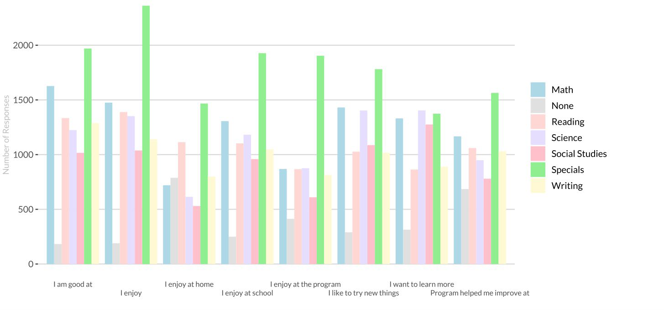**Figure 9. SAYO-Y Pre: Youth Selection of Subjects for Prompts on Settings and Interest in Learning More**

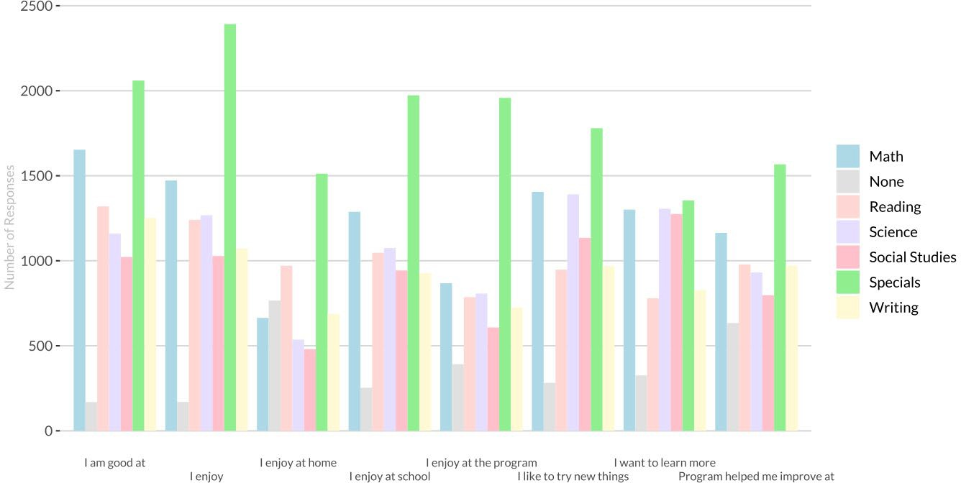

**Figure 10. SAYO-Y Post Youth Selection of Subjects for Prompts on Settings and Interest in Learning More**

#### Change in proportion of respondents by subject

To demonstrate the change in popularity of subjects as selections for prompts regarding enjoyment across settings and interest in learning more, Figure 11 shows the pre/post change in proportion of the entire sample that selected that outcome. The Y-axis of Figure 11 indicates the difference between the percentage of respondents that selected this outcome in the pre-questionnaire and the percentage that selected it in the post questionnaire. This is an imperfect measure of change in preferences, as pre and post responses are not matched by respondent and sample sizes differ. The changes shown in the figure do not sum to zero but rather indicate overall growth as students, on average, selected more subjects in the post questionnaire. This is the result of the nature of these questions, for which a student can select multiple subjects.

The figure demonstrates that specials, the most popular response to all but one prompt, gained an even greater proportion of the responses in the post questionnaire. Math was also already popular in the pre- questionnaire and, in post questionnaires, was selected by an even greater proportion of students. The popularity of social sciences increased in the two closely related “I like to try new things” and “I want to learn more.”

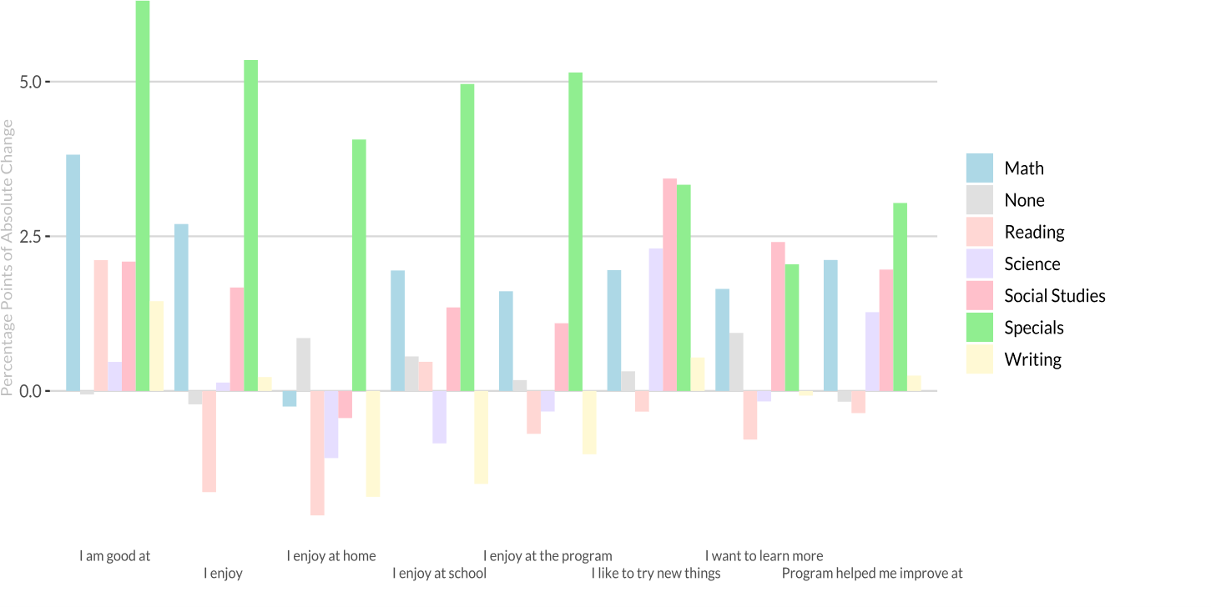**Figure 11. SAYO-Y Change in Proportion of Youth that Selected Subjects for Prompts on Settings and Interest in Learning More**

This report is provided to DESE 21st CCLC by NIOST in its role as a Technical Assistance Provider. NIOST partners with DESE 21st CCLC on the development and refinement of tools and supports the collection, organizing, and reporting of 21st CCLC data.

Appendices are provided in the following section.

#### Appendix A. DESE 21st Century Community Learning Program Site List

|  |  |  |  |
| --- | --- | --- | --- |
| **District** | **Site** | **District** | **Site** |
| Athol YMCA | Athol-Royalston MS | Haverhill | Bradford ES |
| Barnstable | Hyannis West ES | Haverhill | Consentino MS |
| Berkshire Hills Regional | Monument Mountain HS | Haverhill | Golden Hill K-4 |
| Berkshire Hills Regional | Muddy Brook ES | Haverhill | Haverhill HS |
| Berkshire Hills Regional | WEB DuBois MS | Haverhill | Nettle MS |
| Blackstone Millville Regional | Kennedy / Maloney Elementary | Haverhill | Tilton K-4 |
| Boston | Boston International HS | Haverhill | Whittier MS |
| Boston | Edison Elementary | Haverhill | Pentucket Lake ES |
| Boston | Elliot K-8 School [ELT]* | Haverhill | Tilton Upper MS |
| Boston | Lila Fredrick Pilot MS | Holyoke | McMann ES |
| Brockton | Ashfield MS | Holyoke | Morgan ES |
| Cambridge Housing Authority | Cambridge St. Upper School | Holyoke | Kelly School [ELT]* |
| Camp Fire North Shore | Connery ES Lynn | Lowell | Butler MS |
| Camp Fire North Shore | Washington ES, Lynn | Lowell | Lincoln ES |
| Camp Fire North Shore | Hood ES | Lowell | Lowell HS |
| Camp Fire North Shore | Lynn | Lowell | McAuliffe ES |
| Chelsea Public Schools | Chelsea HS | Lowell | Morey ES |
| Collaborative for Educational Services | Amherst MS | Lowell | Murkland ES |
| Collaborative for Educational Services | Dexter Park ES | Lowell | Robinson MS |
| Collaborative for Educational Services | Easthampton HS | Lowell | Stocklosa MS |
| Collaborative for Educational Services | Greenfield HS | Lowell | Shaughnessy ES |
| Collaborative for Educational Services | W. Springfield HS | Lowell | Rogers STEM |
| Collaborative for Educational Services | Orange | Lowell | MvAvinnue ES |
| Collaborative for Educational Services | Kozol ES Ware | Lowell | Wang MS |
| Collaborative for Educational Services | Maple ES | Lowell | Washington ES |
| Collaborative for Educational Services | Memorial ES | Lowell | Sullivan MS |
| Collaborative for Educational Services | Palmer MS program at Palmer HS | Malden YWCA | Ferryway ES |
| Collaborative for Educational Services | Pepin ES | Malden YWCA | Ferryway MS |
| Collaborative for Educational Services | Easthampton | Methuen | Methuen HS |
| Collaborative for Educational Services | W Springfield | Methuen | Timony Grammar |
| Collaborative for Educational Services | Easthampton | Nauset Regional | Nauset Middle School |
| Collaborative for Educational Services | Sheffield ES | New Bedford | Gomes ES [ELT]* |
| Collaborative for Educational Services | Ware MS | New Bedford | Gomes ES |
| Collaborative for Educational Services | Ware Jr/Sr HS | New Bedford | Jacobs ES |
| Collaborative for Educational Services | Gill-Montague | New Bedford | Parker ES |
| The Community Group- Lawrence | Bruce ES | North Adams | Brayton ES |
| The Community Group- Lawrence | Community Day Arlington | Old Sturbridge Village | Sturbridge Charter |
| The Community Group- Lawrence | Frost ES | Pittsfield | Conte Community |
| The Community Group- Lawrence | Tarbox ES | Pittsfield | Herberg MS |
| The Community Group- Lawrence | Wetherbee ES | Pittsfield | Morningside ES |
| The Community Group- Lawrence | S. Lawrence East ES | Pittsfield | Reid MS |
| Fall River | Doran ES | Quaboag Regional | Warren ES |
| Fall River | Durfee HS | Quaboag Regional | Warren HS |
| Fall River | Henry Lord Community School | Salem | Bates ES |
| Fall River | Talbot MS | Salem | Bentley Academy |
| Fall River | Greene ES | Salem | Collins MS |
| Fitchburg | Crocker ES | Southbridge | Charleton St. ES |
| Fitchburg | LongsJo MS | Southbridge | MS/HS |
| Fitchburg | McKay Arts Academy ES | Southbridge | West ES |
| Fitchburg | Memorial MS | Southbridge | Eastford Road |
| Fitchburg | Rheingold ES | South Shore Stars | Randolph HS |
| For Kids Only | Carroll ES Peabody | South Shore Stars | Randolph MS |
| For Kids Only | Center ES | Springfield Parks & Recreation | Bowles ES |
| For Kids Only | Sokowlowski ES Chelsea | Taunton Boys & Girls Club | Parker MS |
| For Kids Only | Welch ES | Tewksbury Public Schools | Dewing ES |
| Hale Education | Burke High School/Boston | Waltham Boys & Girls Club | Whitmore ES |
| Framingham | Cameron MS | Wareham | Decas ES |
| Framingham | Fuller MS | Wareham | Middle School |
| Framingham | Walsh MS | Wareham | High School |
| Gloucester | O’Maley Innovation MS | Wareham | Minot ES |
| *ELT | | Webster | Park Ave. |
| Whitman-Hansen Regional | High School |
| Winthrop | Cummings ES |
| Woburn Boys & Girls Club | Shamrock ES |
| Woburn Boys & Girls Club | Alta Vesta ES |
| Woburn Public | White ES |
| Worthington | Conwell ES |

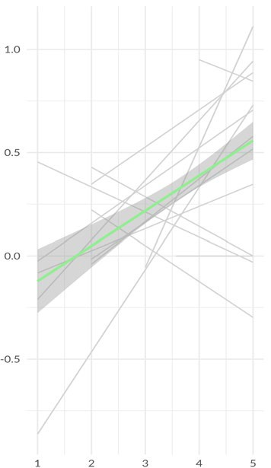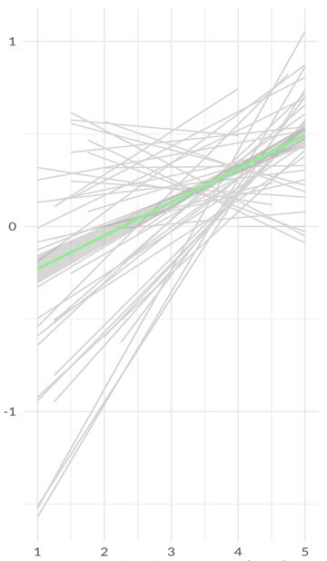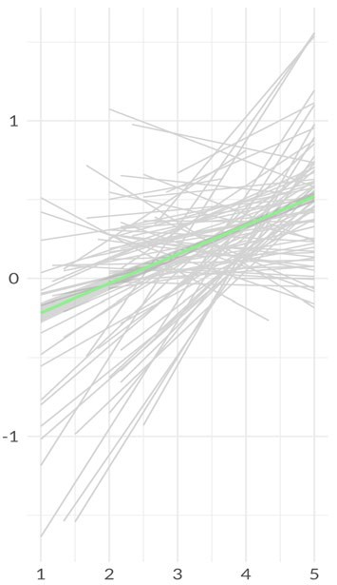**Appendix B. Hierarchical Linear Model Visualizations: Change in ELA and Math**

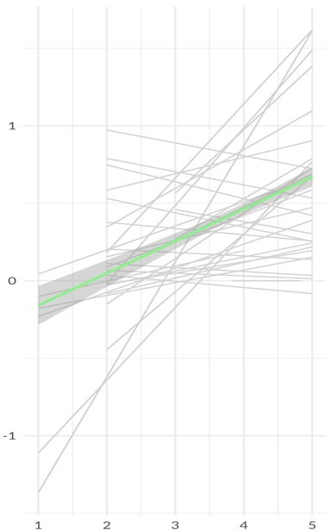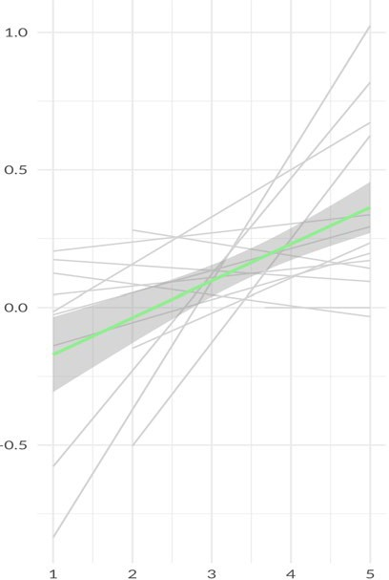Communication Critical Thinking Engagement

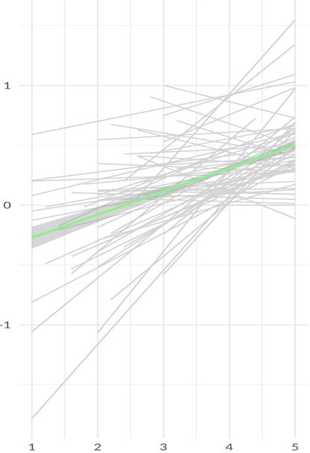

Rel. w/ Adults

**Change in ELA**

Perseverance Rel. w/ Peers

**SAYO-T (Post) Rating**

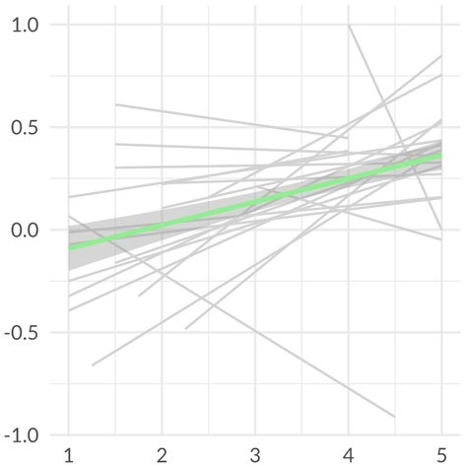 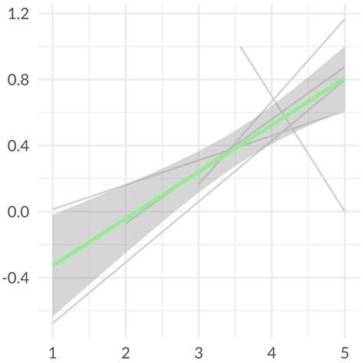 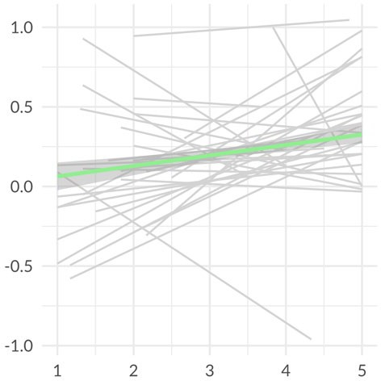 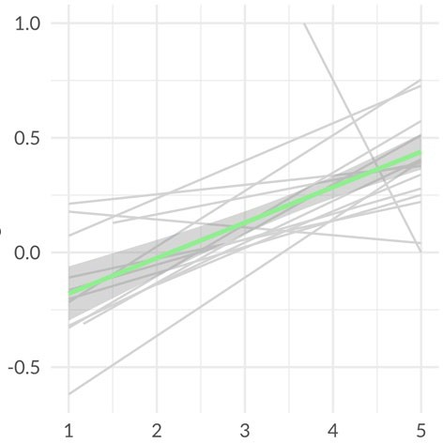

Communication Critical Thinking

**Change in Math**

Engagement

Perseverance

**SAYO-T (Post) Rating**

**Legend:**

**Green** regression lines indicate overall correlation.

**Grey** regression lines indicate correlation for individual program sites.

**Appendix C. Pre, post and change statistics by grade and special population**

Note: empty cells are due to low sample size for the given population and outcome measured.

### Grade

#### SAYO-S Pre, Post & Change

|  |  |  |  |  |  |  |  |  |  |  |  |  |  |  |  |  |
| --- | --- | --- | --- | --- | --- | --- | --- | --- | --- | --- | --- | --- | --- | --- | --- | --- |
|  | | **PK** | **K** | **1** | **2** | **3** | **4** | **5** | **6** | **7** | **8** | **9** | **10** | **11** | **12** | **SP** |
| **Communication** | pre | 2.6 | 3.3 | 3.5 | 3.4 | 3.3 | 3.4 | 3.4 | 3.3 | 3.3 | 3.4 | 3.1 | 2.8 | 3.3 | 3.3 | 2.3 |
|  | post | 3.5 | 3.2 | 3.3 | 3.2 | 3.3 | 3.2 | 3.4 | 3.3 | 3.3 | 3.4 | 3.4 | 3.1 | 3.2 | 3.8 | 3.1 |
|  | change | 0.9 | -0.1 | -0.2 | -0.2 | 0.0 | -0.2 | 0.0 | 0.0 | 0.0 | 0.0 | 0.3 | 0.3 | -0.1 | 0.5 | 0.8 |
| **Critical Thinking** | pre | 2.0 | 3.4 | 3.3 | 3.6 | 3.4 | 3.5 | 3.7 | 3.3 | 3.5 | 3.8 | 3.5 | 3.3 | 3.5 | 3.8 | 3.0 |
|  | post | 2.0 | 4.0 | 3.9 | 3.9 | 3.8 | 3.8 | 4.1 | 4.3 | 4.2 | 4.4 | 4.1 | 3.8 | 3.8 | 4.1 | 4.0 |
|  | change | 0.0 | 0.6 | 0.6 | 0.3 | 0.4 | 0.3 | 0.4 | 1.0 | 0.7 | 0.6 | 0.6 | 0.5 | 0.3 | 0.3 | 1.0 |
| **Engagement** | pre | 2.8 | 3.5 | 3.5 | 3.5 | 3.4 | 3.5 | 3.4 | 3.3 | 3.2 | 3.3 | 3.3 | 3.1 | 3.3 | 3.6 | 2.9 |
|  | post | 3.8 | 4.1 | 4.0 | 4.0 | 4.0 | 3.9 | 4.0 | 3.9 | 4.0 | 4.1 | 3.9 | 3.5 | 3.7 | 4.0 | 4.0 |
|  | change | 1.0 | 0.6 | 0.5 | 0.5 | 0.6 | 0.4 | 0.6 | 0.6 | 0.8 | 0.8 | 0.6 | 0.4 | 0.4 | 0.4 | 1.1 |
| **Leadership** | pre |  | 3.0 | 3.0 | 3.4 | 3.0 | 3.0 | 2.9 | 3.2 | 3.2 | 3.4 | 3.1 | 3.0 | 3.4 | 3.4 | 3.0 |
|  | post |  | 3.3 | 3.5 | 3.6 | 3.8 | 3.3 | 4.1 | 3.8 | 3.9 | 4.0 | 4.0 | 3.4 | 3.9 | 3.9 | 4.0 |
|  | change |  | 0.3 | 0.5 | 0.2 | 0.8 | 0.3 | 1.2 | 0.6 | 0.7 | 0.6 | 0.9 | 0.4 | 0.5 | 0.5 | 1.0 |
| **Perseverance** | pre |  | 3.6 | 3.4 | 3.4 | 3.4 | 3.6 | 3.6 | 3.2 | 3.2 | 3.3 | 3.5 | 2.9 | 3.3 | 3.4 | 2.8 |
|  | post |  | 4.3 | 4.1 | 4.0 | 4.1 | 4.0 | 4.2 | 4.1 | 4.2 | 4.3 | 4.2 | 3.9 | 4.1 | 4.1 | 3.2 |
|  | change |  | 0.7 | 0.7 | 0.6 | 0.7 | 0.4 | 0.6 | 0.9 | 1.0 | 1.0 | 0.7 | 1.0 | 0.8 | 0.7 | 0.4 |
| **Rel. w/ Adults** | pre | 2.3 | 3.5 | 3.5 | 3.7 | 3.5 | 3.4 | 3.5 | 3.2 | 3.2 | 3.4 | 3.4 | 3.2 | 3.2 | 3.7 | 3.0 |
|  | post | 3.4 | 4.2 | 4.3 | 4.2 | 4.1 | 4.0 | 4.1 | 4.0 | 3.9 | 4.1 | 4.0 | 3.7 | 3.7 | 4.0 | 4.0 |
|  | change | 1.1 | 0.7 | 0.8 | 0.5 | 0.6 | 0.6 | 0.6 | 0.8 | 0.7 | 0.7 | 0.6 | 0.5 | 0.5 | 0.3 | 1.0 |
| **Rel. w/ Peers** | pre | 2.9 | 3.7 | 3.8 | 3.8 | 3.6 | 3.7 | 3.6 | 3.4 | 3.4 | 3.4 | 3.5 | 3.3 | 3.5 | 4.0 | 3.0 |
|  | post | 3.9 | 4.2 | 4.2 | 4.2 | 4.1 | 4.1 | 4.2 | 4.1 | 4.2 | 4.2 | 4.1 | 3.7 | 3.8 | 4.1 | 4.0 |
|  | change | 1.0 | 0.5 | 0.4 | 0.4 | 0.5 | 0.4 | 0.6 | 0.7 | 0.8 | 0.8 | 0.6 | 0.4 | 0.3 | 0.1 | 1.0 |
| **Self-Regulation** | pre | 2.7 | 3.4 | 3.5 | 3.5 | 3.4 | 3.4 | 3.6 | 3.5 | 3.3 | 3.7 | 3.4 | 2.8 | 3.3 | 3.8 | 3.0 |
|  | post | 3.5 | 4.1 | 4.0 | 3.9 | 3.9 | 3.9 | 4.0 | 3.8 | 3.8 | 4.1 | 3.9 | 3.2 | 3.6 | 3.9 | 4.0 |
|  | change | 0.8 | 0.7 | 0.5 | 0.4 | 0.5 | 0.5 | 0.4 | 0.3 | 0.5 | 0.4 | 0.5 | 0.4 | 0.3 | 0.1 | 1.0 |

#### SAYO-T Pre, Post and Change

|  |  |  |  |  |  |  |  |  |  |  |  |  |  |  |  |  |
| --- | --- | --- | --- | --- | --- | --- | --- | --- | --- | --- | --- | --- | --- | --- | --- | --- |
|  | | **PK** | **K** | **1** | **2** | **3** | **4** | **5** | **6** | **7** | **8** | **9** | **10** | **11** | **12** | **SP** |
| **Math** | pre |  | 2.9 | 2.9 | 2.5 | 2.6 | 2.7 | 2.6 | 2.8 | 2.8 | 2.9 | 2.8 | 2.5 | 2.8 | 2.9 | 1.7 |
|  | post |  | 3.1 | 2.9 | 2.8 | 2.8 | 2.8 | 2.7 | 2.8 | 2.9 | 3.1 | 3.0 | 2.7 | 3.1 | 3.1 | 1.7 |
|  | change |  | 0.2 | 0.0 | 0.3 | 0.2 | 0.1 | 0.1 | 0.0 | 0.1 | 0.2 | 0.2 | 0.2 | 0.3 | 0.2 | 0.0 |
| **ELA** | pre | 2.8 | 2.6 | 2.5 | 2.4 | 2.4 | 2.4 | 2.5 | 2.7 | 2.8 | 2.7 | 2.8 | 2.6 | 2.9 | 3.0 | 3.0 |
|  | post | 3.2 | 3.0 | 2.8 | 2.7 | 2.7 | 2.7 | 2.8 | 3.0 | 3.0 | 3.0 | 3.0 | 2.9 | 3.1 | 3.3 | 2.5 |
|  | change | 0.4 | 0.4 | 0.3 | 0.3 | 0.3 | 0.3 | 0.3 | 0.3 | 0.2 | 0.3 | 0.2 | 0.3 | 0.2 | 0.3 | -0.5 |
| **Homework** | pre |  | 3.5 | 4.1 | 3.8 | 3.7 | 3.7 | 3.6 | 3.5 | 3.3 | 3.4 | 3.5 | 3.2 | 3.5 | 3.6 | 3.4 |
|  | post |  | 3.9 | 4.1 | 3.9 | 3.9 | 3.9 | 3.9 | 3.7 | 3.6 | 3.9 | 3.8 | 3.4 | 3.7 | 3.9 | 3.4 |
|  | change |  | 0.4 | 0.0 | 0.1 | 0.2 | 0.2 | 0.3 | 0.2 | 0.3 | 0.5 | 0.3 | 0.2 | 0.2 | 0.3 | 0.0 |
| **Communication** | pre |  | 3.7 | 3.7 | 3.6 | 3.4 | 3.6 | 3.5 | 3.5 | 3.4 | 3.6 | 3.5 | 3.1 | 3.5 | 3.6 | 2.8 |
|  | post |  | 4.1 | 4.0 | 3.9 | 3.8 | 3.9 | 3.8 | 3.7 | 3.7 | 4.0 | 4.0 | 3.4 | 3.7 | 3.7 | 2.8 |
|  | change |  | 0.4 | 0.3 | 0.3 | 0.4 | 0.3 | 0.3 | 0.2 | 0.3 | 0.4 | 0.5 | 0.3 | 0.2 | 0.1 | 0.0 |
| **Critical Thinking** | pre | 1.0 | 3.6 | 3.6 | 3.7 | 3.3 | 3.6 | 3.9 | 4.1 | 4.1 | 4.1 | 3.9 | 3.6 | 3.7 | 3.7 | 4.0 |
|  | post | 2.0 | 4.3 | 3.9 | 4.0 | 3.8 | 3.9 | 4.4 | 4.3 | 4.4 | 4.7 | 4.4 | 3.8 | 3.8 | 4.0 | 4.0 |
|  | change | 1.0 | 0.7 | 0.3 | 0.3 | 0.5 | 0.3 | 0.5 | 0.2 | 0.3 | 0.6 | 0.5 | 0.2 | 0.1 | 0.3 | 0.0 |
| **Engagement** | pre | 1.0 | 3.6 | 3.7 | 3.7 | 3.5 | 3.6 | 3.5 | 3.5 | 3.4 | 3.6 | 3.6 | 3.4 | 3.6 | 3.6 | 3.2 |
|  | post | 2.8 | 4.0 | 3.9 | 3.9 | 3.8 | 3.9 | 3.8 | 3.8 | 3.7 | 4.0 | 4.0 | 3.5 | 3.7 | 3.8 | 3.6 |
|  | change | 1.8 | 0.4 | 0.2 | 0.2 | 0.3 | 0.3 | 0.3 | 0.3 | 0.3 | 0.4 | 0.4 | 0.1 | 0.1 | 0.2 | 0.4 |
| **Leadership** | pre |  | 3.8 | 4.0 | 3.8 | 3.6 | 3.7 | 3.7 | 3.5 | 3.5 | 3.4 | 3.6 | 3.1 | 3.5 | 3.5 | 4.0 |
|  | post |  | 4.3 | 4.2 | 4.0 | 3.8 | 3.9 | 4.1 | 3.8 | 3.8 | 3.8 | 4.1 | 3.5 | 4.0 | 3.9 | 5.0 |
|  | change |  | 0.5 | 0.2 | 0.2 | 0.2 | 0.2 | 0.4 | 0.3 | 0.3 | 0.4 | 0.5 | 0.4 | 0.5 | 0.4 | 1.0 |
| **Perseverance** | pre |  | 4.0 | 3.9 | 3.7 | 3.7 | 3.7 | 3.8 | 3.6 | 3.6 | 3.8 | 3.8 | 3.3 | 3.8 | 3.7 | 2.8 |
|  | post |  | 4.4 | 4.1 | 3.9 | 3.8 | 3.8 | 4.0 | 3.8 | 3.9 | 4.2 | 4.4 | 3.6 | 3.9 | 3.9 | 2.7 |
|  | change |  | 0.4 | 0.2 | 0.2 | 0.1 | 0.1 | 0.2 | 0.2 | 0.3 | 0.4 | 0.6 | 0.3 | 0.1 | 0.2 | -0.1 |
| **Rel. w/ Adults** | pre | 2.0 | 3.8 | 3.9 | 3.8 | 3.6 | 3.6 | 3.6 | 3.5 | 3.4 | 3.4 | 3.8 | 3.3 | 3.5 | 3.7 | 3.7 |
|  | post | 3.0 | 4.0 | 4.1 | 4.2 | 4.0 | 4.0 | 4.0 | 3.9 | 3.7 | 4.0 | 4.1 | 3.7 | 3.6 | 4.0 | 4.2 |
|  | change | 1.0 | 0.2 | 0.2 | 0.4 | 0.4 | 0.4 | 0.4 | 0.4 | 0.3 | 0.6 | 0.3 | 0.4 | 0.1 | 0.3 | 0.5 |
| **Rel. w/ Peers** | pre |  | 3.8 | 4.0 | 4.0 | 3.9 | 3.8 | 3.8 | 3.7 | 3.7 | 3.8 | 3.9 | 3.7 | 3.8 | 4.0 | 4.0 |
|  | post |  | 4.2 | 4.1 | 4.1 | 4.1 | 4.1 | 4.1 | 4.0 | 4.0 | 4.2 | 4.2 | 3.6 | 3.7 | 4.2 | 4.0 |
|  | change |  | 0.4 | 0.1 | 0.1 | 0.2 | 0.3 | 0.3 | 0.3 | 0.3 | 0.4 | 0.3 | -0.1 | -0.1 | 0.2 | 0.0 |
| **Self-Regulation** | pre |  | 3.7 | 3.8 | 3.7 | 3.6 | 3.7 | 3.6 | 3.6 | 3.4 | 3.8 | 3.7 | 3.1 | 3.7 | 3.8 | 4.0 |
|  | post |  | 4.0 | 4.0 | 4.0 | 3.9 | 3.9 | 3.9 | 3.8 | 3.7 | 4.1 | 4.2 | 3.4 | 3.9 | 4.1 | 5.0 |
|  | change |  | 0.3 | 0.2 | 0.3 | 0.3 | 0.2 | 0.3 | 0.2 | 0.3 | 0.3 | 0.5 | 0.3 | 0.2 | 0.3 | 1.0 |

### Income

#### SAYO-S Pre, Post and Change

|  |  |  |  |
| --- | --- | --- | --- |
|  | | **Not Low-Income** | **Low-Income** |
| **Communication** | pre | 3.6 | 3.2 |
|  | post | 3.6 | 3.2 |
|  | change | 0.0 | 0.0 |
| **Critical Thinking** | pre | 3.9 | 3.2 |
|  | post | 4.4 | 3.8 |
|  | change | 0.5 | 0.6 |
| **Engagement** | pre | 3.6 | 3.3 |
|  | post | 4.1 | 3.9 |
|  | change | 0.5 | 0.6 |
| **Leadership** | pre | 3.4 | 3.1 |
|  | post | 3.9 | 3.7 |
|  | change | 0.5 | 0.6 |
| **Perseverance** | pre | 3.8 | 3.2 |
|  | post | 4.4 | 3.9 |
|  | change | 0.6 | 0.7 |
| **Rel. w/ Adults** | pre | 3.7 | 3.3 |
|  | post | 4.2 | 3.9 |
|  | change | 0.5 | 0.6 |
| **Rel. w/ Peers** | pre | 3.8 | 3.5 |
|  | post | 4.3 | 4.1 |
|  | change | 0.5 | 0.6 |
| **Self-Regulation** | pre | 3.8 | 3.3 |
|  | post | 4.2 | 3.8 |
|  | change | 0.4 | 0.5 |

#### SAYO-T Pre, Post and Change

|  |  |  |  |
| --- | --- | --- | --- |
|  | | **Not Low-Income** | **Low-Income** |
| **Math** | pre | 3.0 | 2.5 |
|  | post | 3.1 | 2.6 |
|  | change | 0.1 | 0.1 |
| **ELA** | pre | 2.9 | 2.4 |
|  | post | 3.1 | 2.7 |
|  | change | 0.2 | 0.3 |
| **Homework** | pre | 4.0 | 3.4 |
|  | post | 4.2 | 3.7 |
|  | change | 0.2 | 0.3 |
| **Communication** | pre | 3.8 | 3.4 |
|  | post | 4.1 | 3.7 |
|  | change | 0.3 | 0.3 |
| **Critical Thinking** | pre | 4.2 | 3.4 |
|  | post | 4.4 | 3.9 |
|  | change | 0.2 | 0.5 |
| **Engagement** | pre | 3.8 | 3.4 |
|  | post | 4.1 | 3.7 |
|  | change | 0.3 | 0.3 |
| **Leadership** | pre | 4.0 | 3.3 |
|  | post | 4.3 | 3.7 |
|  | change | 0.3 | 0.4 |
| **Perseverance** | pre | 4.1 | 3.4 |
|  | post | 4.3 | 3.7 |
|  | change | 0.2 | 0.3 |
| **Rel. w/ Adults** | pre | 3.9 | 3.4 |
|  | post | 4.2 | 3.8 |
|  | change | 0.3 | 0.4 |
| **Rel. w/ Peers** | pre | 4.0 | 3.7 |
|  | post | 4.3 | 4.0 |
|  | change | 0.3 | 0.3 |
| **Self-Regulation** | pre | 4.0 | 3.5 |
|  | post | 4.2 | 3.8 |
|  | change | 0.2 | 0.3 |

### Gender

#### SAYO-S Pre, Post and Change

|  |  |  |  |
| --- | --- | --- | --- |
|  | | **Female** | **Male** |
| **Communication** | pre | 3.4 | 3.3 |
|  | post | 3.4 | 3.2 |
|  | change | 0.0 | -0.1 |
| **Critical Thinking** | pre | 3.6 | 3.4 |
|  | post | 4.1 | 4.0 |
|  | change | 0.5 | 0.6 |
| **Engagement** | pre | 3.5 | 3.3 |
|  | post | 4.0 | 3.9 |
|  | change | 0.5 | 0.6 |
| **Leadership** | pre | 3.2 | 3.1 |
|  | post | 3.9 | 3.7 |
|  | change | 0.7 | 0.6 |
| **Perseverance** | pre | 3.5 | 3.3 |
|  | post | 4.2 | 4.0 |
|  | change | 0.7 | 0.7 |
| **Rel. w/ Adults** | pre | 3.5 | 3.4 |
|  | post | 4.1 | 4.0 |
|  | change | 0.6 | 0.6 |
| **Rel. w/ Peers** | pre | 3.7 | 3.6 |
|  | post | 4.2 | 4.1 |
|  | change | 0.5 | 0.5 |
| **Self-Regulation** | pre | 3.6 | 3.3 |
|  | post | 4.0 | 3.8 |
|  | change | 0.4 | 0.5 |

#### SAYO-T Pre, Post and Change

|  |  |  |  |
| --- | --- | --- | --- |
|  | | **Female** | **Male** |
| **Math** | pre | 2.7 | 2.7 |
|  | post | 2.9 | 2.8 |
|  | change | 0.2 | 0.1 |
| **ELA** | pre | 2.6 | 2.5 |
|  | post | 2.9 | 2.8 |
|  | change | 0.3 | 0.3 |
| **Homework** | pre | 3.7 | 3.5 |
|  | post | 3.9 | 3.8 |
|  | change | 0.2 | 0.3 |
| **Communication** | pre | 3.6 | 3.5 |
|  | post | 3.9 | 3.8 |
|  | change | 0.3 | 0.3 |
| **Critical Thinking** | pre | 3.8 | 3.7 |
|  | post | 4.1 | 4.1 |
|  | change | 0.3 | 0.4 |
| **Engagement** | pre | 3.6 | 3.5 |
|  | post | 3.9 | 3.8 |
|  | change | 0.3 | 0.3 |
| **Leadership** | pre | 3.7 | 3.5 |
|  | post | 4.0 | 3.9 |
|  | change | 0.3 | 0.4 |
| **Perseverance** | pre | 3.8 | 3.6 |
|  | post | 4.0 | 3.9 |
|  | change | 0.2 | 0.3 |
| **Rel. w/ Adults** | pre | 3.7 | 3.5 |
|  | post | 4.0 | 3.9 |
|  | change | 0.3 | 0.4 |
| **Rel. w/ Peers** | pre | 3.9 | 3.7 |
|  | post | 4.1 | 4.0 |
|  | change | 0.2 | 0.3 |
| **Self-Regulation** | pre | 3.8 | 3.5 |
|  | post | 4.1 | 3.8 |
|  | change | 0.3 | 0.3 |

### MLL

#### SAYO-S Pre, Post and Change

|  |  |  |  |
| --- | --- | --- | --- |
|  | | **Not MLL** | **MLL** |
| **Communication** | pre | 3.4 | 3.2 |
|  | post | 3.4 | 3.1 |
|  | change | 0.0 | -0.1 |
| **Critical Thinking** | pre | 3.6 | 3.1 |
|  | post | 4.1 | 3.6 |
|  | change | 0.5 | 0.5 |
| **Engagement** | pre | 3.4 | 3.3 |
|  | post | 4.0 | 3.9 |
|  | change | 0.6 | 0.6 |
| **Leadership** | pre | 3.2 | 3.1 |
|  | post | 3.8 | 3.7 |
|  | change | 0.6 | 0.6 |
| **Perseverance** | pre | 3.5 | 3.1 |
|  | post | 4.2 | 3.9 |
|  | change | 0.7 | 0.8 |
| **Rel. w/ Adults** | pre | 3.5 | 3.2 |
|  | post | 4.1 | 4.0 |
|  | change | 0.6 | 0.8 |
| **Rel. w/ Peers** | pre | 3.7 | 3.5 |
|  | post | 4.2 | 4.1 |
|  | change | 0.5 | 0.6 |
| **Self-Regulation** | pre | 3.5 | 3.2 |
|  | post | 4.0 | 3.7 |
|  | change | 0.5 | 0.5 |

#### SAYO-T Pre, Post and Change

|  |  |  |  |
| --- | --- | --- | --- |
|  | | **Not MLL** | **MLL** |
| **Math** | pre | 2.8 | 2.2 |
|  | post | 2.9 | 2.4 |
|  | change | 0.1 | 0.2 |
| **ELA** | pre | 2.7 | 2.2 |
|  | post | 2.9 | 2.6 |
|  | change | 0.2 | 0.4 |
| **Homework** | pre | 3.7 | 3.3 |
|  | post | 3.9 | 3.7 |
|  | change | 0.2 | 0.4 |
| **Communication** | pre | 3.6 | 3.3 |
|  | post | 3.9 | 3.6 |
|  | change | 0.3 | 0.3 |
| **Critical Thinking** | pre | 3.8 | 3.1 |
|  | post | 4.2 | 3.6 |
|  | change | 0.4 | 0.5 |
| **Engagement** | pre | 3.6 | 3.4 |
|  | post | 3.9 | 3.7 |
|  | change | 0.3 | 0.3 |
| **Leadership** | pre | 3.7 | 3.2 |
|  | post | 4.0 | 3.7 |
|  | change | 0.3 | 0.5 |
| **Perseverance** | pre | 3.8 | 3.2 |
|  | post | 4.0 | 3.5 |
|  | change | 0.2 | 0.3 |
| **Rel. w/ Adults** | pre | 3.7 | 3.3 |
|  | post | 4.0 | 3.9 |
|  | change | 0.3 | 0.6 |
| **Rel. w/ Peers** | pre | 3.9 | 3.7 |
|  | post | 4.1 | 4.0 |
|  | change | 0.2 | 0.3 |
| **Self-Regulation** | pre | 3.7 | 3.5 |
|  | post | 4.0 | 3.7 |
|  | change | 0.3 | 0.2 |

### Race

#### SAYO-S Pre, Post and Change

|  |  |  |  |  |  |  |  |  |  |
| --- | --- | --- | --- | --- | --- | --- | --- | --- | --- |
|  | | **American Indian/Alaska Native** | **Asian** | **Black** | **Hispanic** | **Native Hawaiian or other Pacific Islander** | **Other** | **Two or More Races** | **White** |
| **Communication** | pre | 2.7 | 3.6 | 3.4 | 3.2 | 3.1 | 4.5 | 3.2 | 3.4 |
|  | post | 2.9 | 4.0 | 2.6 | 3.3 | 2.8 | 5.0 | 2.9 | 3.3 |
|  | change | 0.2 | 0.4 | -0.8 | 0.1 | -0.3 | 0.5 | -0.3 | -0.1 |
| **Critical Thinking** | pre | 2.5 | 4.3 | 3.3 | 3.2 |  | 4.4 | 3.2 | 3.7 |
|  | post | 3.1 | 4.6 | 3.8 | 3.8 |  | 4.9 | 3.8 | 4.2 |
|  | change | 0.6 | 0.3 | 0.5 | 0.6 |  | 0.5 | 0.6 | 0.5 |
| **Engagement** | pre | 3.1 | 3.7 | 3.2 | 3.3 | 3.2 | 4.6 | 3.3 | 3.5 |
|  | post | 3.5 | 4.3 | 4.0 | 3.9 | 3.5 | 5.0 | 3.9 | 4.0 |
|  | change | 0.4 | 0.6 | 0.8 | 0.6 | 0.3 | 0.4 | 0.6 | 0.5 |
| **Leadership** | pre | 3.1 | 3.5 | 3.3 | 3.1 | 2.5 | 4.4 | 3.0 | 3.2 |
|  | post | 3.2 | 4.0 | 3.8 | 3.8 | 3.5 | 4.9 | 3.6 | 3.8 |
|  | change | 0.1 | 0.5 | 0.5 | 0.7 | 1.0 | 0.5 | 0.6 | 0.6 |
| **Perseverance** | pre | 3.0 | 4.2 | 3.1 | 3.2 | 3.0 | 4.4 | 3.0 | 3.7 |
|  | post | 3.3 | 4.6 | 4.0 | 3.9 | 4.0 | 4.9 | 3.7 | 4.3 |
|  | change | 0.3 | 0.4 | 0.9 | 0.7 | 1.0 | 0.5 | 0.7 | 0.6 |
| **Rel. w/ Adults** | pre | 2.9 | 3.9 | 3.2 | 3.3 | 3.5 | 4.6 | 3.3 | 3.5 |
|  | post | 3.5 | 4.4 | 4.1 | 4.0 | 3.5 | 4.9 | 3.8 | 4.1 |
|  | change | 0.6 | 0.5 | 0.9 | 0.7 | 0.0 | 0.3 | 0.5 | 0.6 |
| **Rel. w/ Peers** | pre | 3.1 | 3.8 | 3.4 | 3.5 | 3.5 | 4.6 | 3.5 | 3.7 |
|  | post | 3.5 | 4.4 | 4.2 | 4.1 | 3.5 | 5.0 | 4.1 | 4.1 |
|  | change | 0.4 | 0.6 | 0.8 | 0.6 | 0.0 | 0.4 | 0.6 | 0.4 |
| **Self-Regulation** | pre | 3.1 | 4.2 | 3.4 | 3.3 | 3.0 | 4.6 | 3.2 | 3.6 |
|  | post | 3.5 | 4.5 | 3.9 | 3.8 | 2.7 | 4.9 | 3.7 | 4.0 |
|  | change | 0.4 | 0.3 | 0.5 | 0.5 | -0.3 | 0.3 | 0.5 | 0.4 |

#### SAYO-T Pre, Post and Change

|  |  |  |  |  |  |  |  |  |  |
| --- | --- | --- | --- | --- | --- | --- | --- | --- | --- |
|  | | **American Indian/Alaska Native** | **Asian** | **Black** | **Hispanic** | **Native Hawaiian or other Pacific Islander** | **Other** | **Two or More Races** | **White** |
| **Math** | pre | 2.4 | 3.1 | 2.6 | 2.4 | 2.0 | 3.4 | 2.5 | 2.9 |
|  | post | 2.4 | 3.1 | 2.8 | 2.6 | 2.0 | 3.3 | 2.7 | 3.0 |
|  | change | 0.0 | 0.0 | 0.2 | 0.2 | 0.0 | -0.1 | 0.2 | 0.1 |
| **ELA** | pre | 1.7 | 2.8 | 2.4 | 2.4 | 2.6 | 3.5 | 2.6 | 2.7 |
|  | post | 2.1 | 3.0 | 2.9 | 2.7 | 2.6 | 3.4 | 2.9 | 2.9 |
|  | change | 0.4 | 0.2 | 0.5 | 0.3 | 0.0 | -0.1 | 0.3 | 0.2 |
| **Homework** | pre | 3.1 | 4.1 | 3.4 | 3.5 | 2.8 | 4.5 | 3.5 | 3.8 |
|  | post | 3.3 | 4.4 | 3.8 | 3.7 | 3.7 | 4.7 | 3.7 | 3.9 |
|  | change | 0.2 | 0.3 | 0.4 | 0.2 | 0.9 | 0.2 | 0.2 | 0.1 |
| **Communication** | pre | 2.6 | 3.8 | 3.5 | 3.4 | 3.7 | 4.5 | 3.4 | 3.7 |
|  | post | 2.8 | 4.1 | 3.8 | 3.7 | 4.1 | 4.7 | 3.6 | 3.9 |
|  | change | 0.2 | 0.3 | 0.3 | 0.3 | 0.4 | 0.2 | 0.2 | 0.2 |
| **Critical Thinking** | pre | 2.8 | 4.4 | 3.4 | 3.3 |  | 4.5 | 3.2 | 3.9 |
|  | post | 3.1 | 4.6 | 4.0 | 3.9 |  | 4.7 | 3.6 | 4.2 |
|  | change | 0.3 | 0.2 | 0.6 | 0.6 |  | 0.2 | 0.4 | 0.3 |
| **Engagement** | pre | 3.0 | 3.9 | 3.4 | 3.5 | 3.3 | 4.6 | 3.4 | 3.6 |
|  | post | 3.1 | 4.2 | 3.9 | 3.7 | 3.3 | 4.7 | 3.7 | 3.9 |
|  | change | 0.1 | 0.3 | 0.5 | 0.2 | 0.0 | 0.1 | 0.3 | 0.3 |
| **Leadership** | pre | 2.8 | 4.1 | 3.4 | 3.3 | 4.0 | 4.5 | 3.0 | 3.8 |
|  | post | 3.0 | 4.3 | 3.8 | 3.7 | 3.5 | 4.7 | 3.5 | 4.1 |
|  | change | 0.2 | 0.2 | 0.4 | 0.4 | -0.5 | 0.2 | 0.5 | 0.3 |
| **Perseverance** | pre | 3.0 | 4.3 | 3.6 | 3.4 | 4.0 | 4.5 | 3.0 | 4.0 |
|  | post | 3.3 | 4.5 | 3.8 | 3.6 | 3.0 | 4.7 | 3.3 | 4.2 |
|  | change | 0.3 | 0.2 | 0.2 | 0.2 | -1.0 | 0.2 | 0.3 | 0.2 |
| **Rel. w/ Adults** | pre | 3.2 | 4.2 | 3.4 | 3.4 | 3.5 | 4.6 | 3.4 | 3.7 |
|  | post | 3.3 | 4.3 | 4.0 | 3.8 | 3.5 | 4.6 | 3.7 | 4.0 |
|  | change | 0.1 | 0.1 | 0.6 | 0.4 | 0.0 | 0.0 | 0.3 | 0.3 |
| **Rel. w/ Peers** | pre | 3.2 | 4.1 | 3.7 | 3.8 | 3.6 | 4.5 | 3.6 | 3.9 |
|  | post | 3.4 | 4.4 | 4.1 | 4.0 | 3.1 | 4.7 | 3.9 | 4.1 |
|  | change | 0.2 | 0.3 | 0.4 | 0.2 | -0.5 | 0.2 | 0.3 | 0.2 |
| **Self-Regulation** | pre | 3.3 | 4.4 | 3.6 | 3.5 | 2.7 | 4.6 | 3.2 | 3.8 |
|  | post | 3.3 | 4.5 | 3.9 | 3.8 | 3.0 | 4.7 | 3.8 | 4.1 |
|  | change | 0.0 | 0.1 | 0.3 | 0.3 | 0.3 | 0.1 | 0.6 | 0.3 |

### Special Education

#### SAYO-S Pre, Post and Change

|  |  |  |  |
| --- | --- | --- | --- |
|  | | **Not receiving special education services** | **Receiving special education services** |
| **Communication** | pre | 3.4 | 3.1 |
|  | post | 3.3 | 3.2 |
|  | change | -0.1 | 0.1 |
| **Critical Thinking** | pre | 3.6 | 3.2 |
|  | post | 4.1 | 3.8 |
|  | change | 0.5 | 0.6 |
| **Engagement** | pre | 3.4 | 3.2 |
|  | post | 4.0 | 3.8 |
|  | change | 0.6 | 0.6 |
| **Leadership** | pre | 3.2 | 2.9 |
|  | post | 3.9 | 3.6 |
|  | change | 0.7 | 0.7 |
| **Perseverance** | pre | 3.5 | 3.1 |
|  | post | 4.2 | 3.9 |
|  | change | 0.7 | 0.8 |
| **Rel. w/ Adults** | pre | 3.5 | 3.3 |
|  | post | 4.1 | 3.9 |
|  | change | 0.6 | 0.6 |
| **Rel. w/ Peers** | pre | 3.7 | 3.4 |
|  | post | 4.2 | 4.0 |
|  | change | 0.5 | 0.6 |
| **Self-Regulation** | pre | 3.5 | 3.2 |
|  | post | 4.0 | 3.7 |
|  | change | 0.5 | 0.5 |

#### SAYO-T Pre, Post and Change

|  |  |  |  |
| --- | --- | --- | --- |
|  | | **Not receiving special education services** | **Receiving special education services** |
| **Math** | pre | 2.8 | 2.2 |
|  | post | 2.9 | 2.4 |
|  | change | 0.1 | 0.2 |
| **ELA** | pre | 2.7 | 2.2 |
|  | post | 2.9 | 2.6 |
|  | change | 0.2 | 0.4 |
| **Homework** | pre | 3.7 | 3.3 |
|  | post | 3.9 | 3.7 |
|  | change | 0.2 | 0.4 |
| **Communication** | pre | 3.6 | 3.3 |
|  | post | 3.9 | 3.6 |
|  | change | 0.3 | 0.3 |
| **Critical Thinking** | pre | 3.8 | 3.1 |
|  | post | 4.2 | 3.6 |
|  | change | 0.4 | 0.5 |
| **Engagement** | pre | 3.6 | 3.4 |
|  | post | 3.9 | 3.7 |
|  | change | 0.3 | 0.3 |
| **Leadership** | pre | 3.7 | 3.2 |
|  | post | 4.0 | 3.7 |
|  | change | 0.3 | 0.5 |
| **Perseverance** | pre | 3.8 | 3.2 |
|  | post | 4.0 | 3.5 |
|  | change | 0.2 | 0.3 |
| **Rel. w/ Adults** | pre | 3.7 | 3.3 |
|  | post | 4.0 | 3.9 |
|  | change | 0.3 | 0.6 |
| **Rel. w/ Peers** | pre | 3.9 | 3.7 |
|  | post | 4.1 | 4.0 |
|  | change | 0.2 | 0.3 |
| **Self-Regulation** | pre | 3.7 | 3.5 |
|  | post | 4.0 | 3.7 |
|  | change | 0.3 | 0.2 |