Targeted Assistance Grant (TAG)
FY24 Overview
September 13, 2023

Agenda

1.Eligibility and Requirements

2. Funding and Fund Use

3. Similarities and Differences

4. Submission

5. Grant Review Process

6. Next Steps

7. Questions and Resources

Which Districts are Eligible for TAG Funding?
- Any district with one or more schools:
- With a federal designation of CSI, TSI, ATSI
- In the lowest 10 percentiles on the 2022 state accountability system
- Identified as underperforming
- All schools eligible in 2022-2023 TAG are eligible this year, even if
2023 accountability data demonstrates they are not eligible
- More schools might become eligible based on 2023 accountability data
Not eligible: school served by the Strategic Transformation Office, charter schools, and virtual schools.

Requirements for Districts Accepting TAG Funding
Districts and schools receiving TAG funds commit to:
  - Engaging with assigned CSDP assistance staff (SSoS
  - Regional Team or another CSDP team)
  - Submitting updated district prioritization submissions to DESE
  - Taking part in a CSDP-sponsored progress monitoring processes

TAG Funding Sources
TAG is comprised of two funding sources totaling $4,500,000:
- Title I School Improvement funding (FC 325): $3,475,000
- State targeted assistance funds (FC 222): $1,025,000
- All funds must be expended by June 30, 2024*
* All districts will have the option to extend the grant to 8/31/24

What is the same as last year?
- Most of the 2023-2024 TAG application looks like last year
- Same focus on district systems to support schools
- Same alignment with TAG funding to a district priority
- Still using EdGrants
- While most district allocations will be similar to last year, allocations may be different
- Funding is based on a range of eligible schools
- More eligible schools means more funding
- Minimum allocation is now $30,000
- End date for ALL districts is 6/30/24 (option for everyone to extend to 8/31/24)

TAG Allocation Update
- When 2023 accountability figures are released later this month, we will add any eligible schools to your district total
- Schools no longer eligible will NOT be deducted from the district total for the 2023-2024 school year
- If the number of newly eligible schools increases significantly, the district may receive an increase in their TAG application

TAG Fund Use Example
Primary Purpose: to support the implementation of strategies in your district prioritization submission and monitor the progress of its implementation and outcomes
Let’s say your school is focusing on strengthening Tier 1
Mathematics instruction
- Stipends/substitutes
- External contractors and PD providers
- Instructional materials, technology, and supplies*

FY24 TAG Fund Use Alignment
- TAG funds should be aligned to each district’s District Prioritization Submission or a district identified priority for improvement
- Fund use recommendations have been aligned to core agency priorities: DESE's Educational Vision and CSDP Coherence Guidebook,
- Within those priorities, there are flexibilities in expending TAG funds

When is the TAG Application Due?

Application Deadline:
Tuesday, October 31, 2023
Districts are strongly encouraged to submit TAG applications in EdGrants prior to this deadline. District receive funds upon approval.

What Gets Submitted in EdGrants?
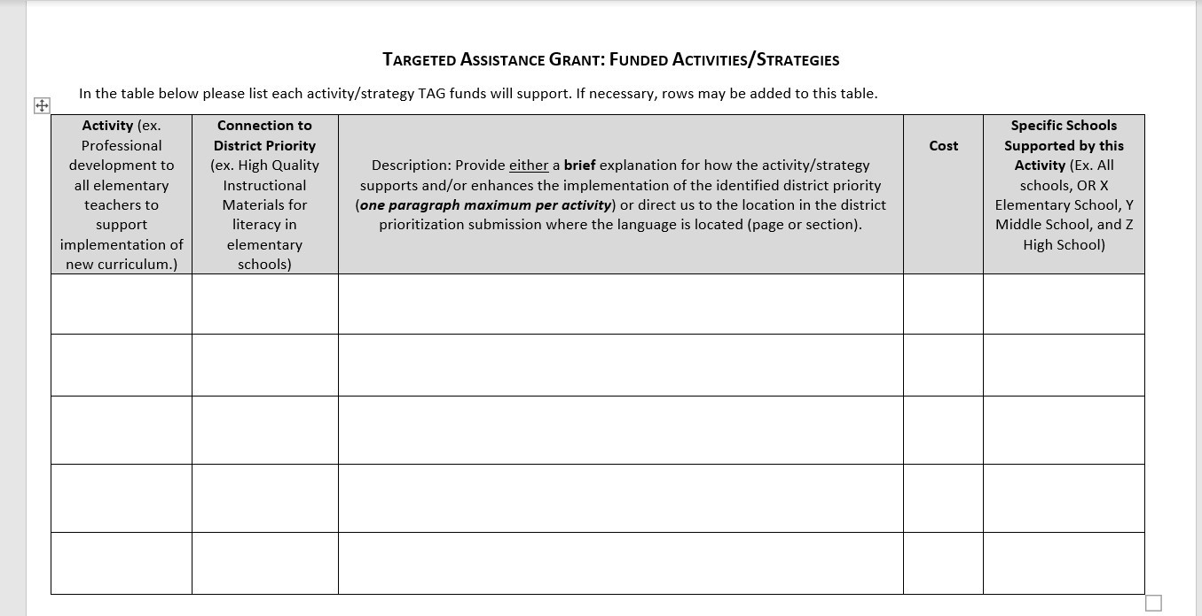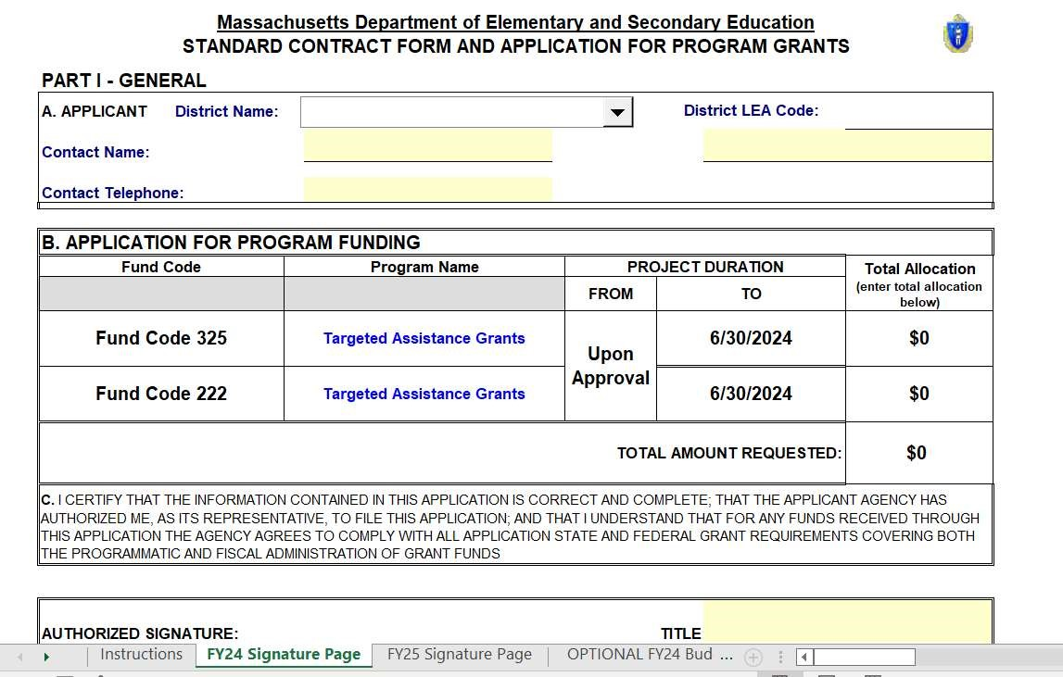
- Enter Budget directoly into EdGrants template
- Attach the TAG Narrative
- Attach scanned copy of signed Cover Page

What Gets Submitted: Narrative
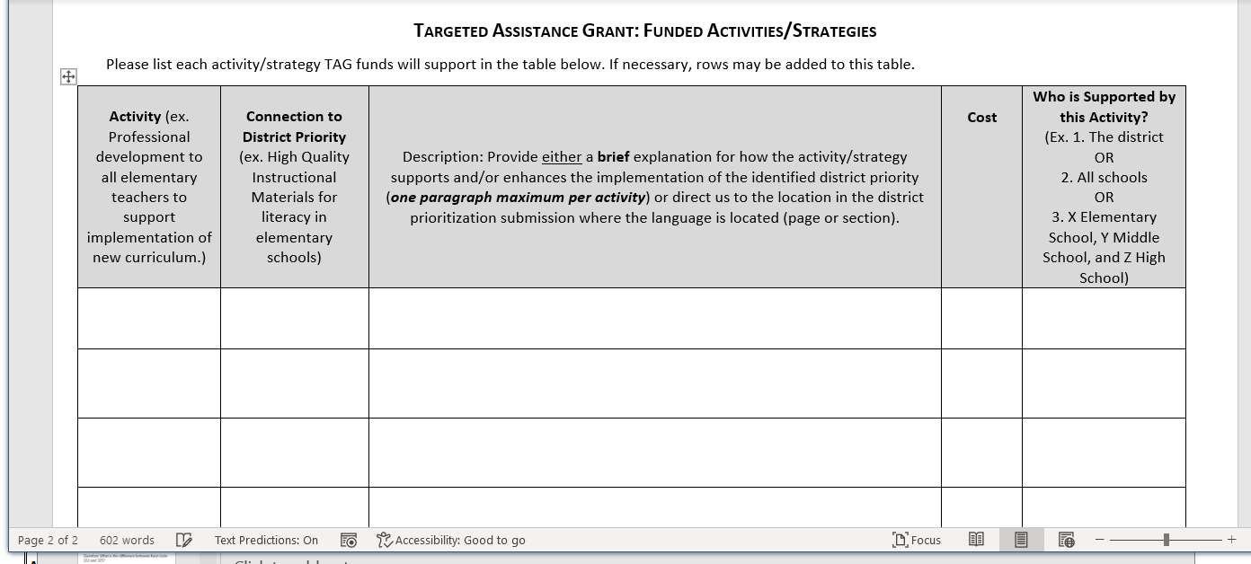

What Gets Submitted: Signed Cover Sheet

Grant Review Process
A DESE review team will review all submissions for:
- Alignment to district prioritization submission
- Technical requirements (e.g., budget details; signature pages);

Question: What is the difference between fund code 222 and 325?
Answer: essentially nothing. They are accounting figures DESE uses to know where the money is coming from. They are subject to the same spending rules, same end date, same everything.
Question: What if the 2023 data shows that we have fewer TAG eligible schools? Will our allocation be reduced?
Answer: No district allocation will be reduced in 20232024. Most district allocations will remain the same. A few may go up. Zero will go down.
Question: What if the 2023 data shows that we have more TAG eligible schools? Will our allocation be increased?
Answer: Maybe. If the new number of eligible schools increases significantly, then they could receive an increase.

Next Steps for Districts
- Consult with your regional SSoS team or other CSDP liaison
- As you develop your application, make certain it aligns to strategies in your district prioritization submission or other district identified priority
- Upload application to EdGrants

Questions about TAG?
Substantive questions related to your application
Reach out to your regional SSoS team or CSDP liaison
Technical questions about completing grant forms:
Contact Michael Seymour michael.j.seymour@mass.gov
Questions about progress monitoring
Contact Erica Champagne Erica.Champagne@mass.gov

Link to RFP
- Targeted Assistance Grant RFP (includes district allocations, fund use examples, Part III Application/Narrative, and budget workbook with Cover Page)

