|  |  |
| --- | --- |
| DESE logo |  |

Massachusetts Individualized Education Program

Requirements Document

User Stories and Acceptance Criteria

**Version Control**

|  |  |  |  |
| --- | --- | --- | --- |
| **Version** | **Date** | **Summary of Changes** | **Author** |
| v 0.1 | 02/24/2023 | Initial Draft | Walker Dauphin |
| v 0.2 | 03/15/2023 | Revised for 10 March 2023 IEP Mockup | Walker Dauphin |
| v 0.3 | 04/24/2023 | Revised to match the April 20, 2023, IEP mockup | Walker Dauphin |
| v 0.4 | 04/24/2023 | Revised to match the April 24, 2023, IEP mockup | Walker Dauphin |
| v 0.5 | 08/25/2023 | Revised to remove constraints and set the number of characters allowed by text fields to the maximum allowed by the database technology. Changes have been made to both in this narrative (section 7.2) and the companion Excel sheet, per Commissioner Russell’s request. | Walker Dauphin |
| v 0.6 | 01/09/2024 | Revised to change the functionality for the Response (section 10.21) and the companion Excel sheet, per Commissioner Russell’s request. | Walker Dauphin |
| v 0.6.1 | 01/17/2024 | Proofing for Accessibility Issues | Walker Dauphin |
| v 0.6.1 | 01/22/2024 | Adding DESE logo and Student Identification to first page. | Walker Dauphin |

**Approvals**

This document requires the following approvals:

|  |  |  |  |  |
| --- | --- | --- | --- | --- |
| **Version** | **Date** | **Title** | **Name** | **Signature** |
| V0.5 | 08/25/2023 | Director, SEPP | Jamie Camacho | 7Camacho |
| V0.5.2 | 08/25/2023 | Assistant Director, SEPP | April Rist | April Rist |
| V0.6 | 01/9/2024 | IDEA Equitable Services Supervisor | Zhaneta Liti | Zhaneta Liti |
| V0.6.2 | 01/23/2024 | IDEA Equitable Services Supervisor | Zhaneta Liti |  |

# Table of Contents

Table of Contents 3

1. Background 5

2. Project Goal 5

3. Purpose of this document 5

4. Project Scope 5

4.1. Deliverables 5

4.2. In Scope Features 5

4.3. Limitations of this document 6

4.4. Business requirements 6

4.5. Functional Requirements 7

4.6. Non-functional requirements 7

5. System Users and Secure Access Privileges 8

6. Key Stakeholders 8

7. Project Constraints 8

8. Project Assumptions 8

9. Key User Stories 9

10.1. User Story – Display DESE Logo and Student Identification 9

Massachusetts DESE Individualized Education Program (IEP) 9

10.2. User Story – Capture Student and Parents’ Concerns 11

10.3. User Story – Document the Student and Team’s Vision Statements for the Student 12

10.4. User Story – Capture the student’s profile 15

10.5. User Story – Document the student’s achievement and performance in Academic Areas 19

10.6. User Story – Document the Present Achievement and Performance in Behavioral, Social, and Emotional Areas 23

10.7. User Story – Document Present Levels of a Performance in Communication 28

10.8. User Story – Document the Present Achievement and Performance in Additional Areas 32

10.9. User Story – Track the Postsecondary Transition 37

10.10. User Story – Capture Community and Interagency Connections 42

10.11. User Story – Document the Transfer of Rights to Student 44

10.12. User Story – Capture Decision-Making Options for Student and Track Transition to Adult Service Agency 47

10.12.1. User Story – Capture Decision-Making Options for Student 48

10.12.2. User Story – Capture the Transition to Adult Service Agency or Agencies 52

10.13. User Story – Record Accommodations and Modifications 55

10.14. User Story – Document the Statewide or Districtwide Assessments 58

10.15. User Story – Document the Measurable Annual Goals and Schedule of Progress Reporting 61

10.16. User Story – Capture Participation in the General Education Setting 64

10.17. User Story – Document Service Delivery 66

10.18. User Story – Document Transportation Services 68

10.19. User Story – Document Schedule Modification 71

10.20. User Story – Document Service delivery for extended school year (ESY) 73

10.21. User Story – Capture Additional Information 78

10.22. User Story – Record Decision Maker’s Response 79

10.23. User Story – Print a Copy of the Student’s IEP 83

Business User Acceptance 84

# Background

In 2014, the Federal Office of Special Education Programs (OSEP) announced the implementation of a new accountability framework for special education. Known as Results Driven Accountability (RDA), the framework aims to better balance the focus on improving educational results and functional outcomes for students with disabilities with the compliance requirements of the Individuals with Disabilities Education Act (IDEA) special education law.[1]

Although the RDA framework brought OSEP in alignment with Massachusetts’ long history of emphasis on both compliance and results, the Department of Elementary and Secondary Education (DESE) recognizes the imperative to integrate best practices into the special education toolkit as it still experiences persistent outcome gaps between students with disabilities and non-disabled students.

Those gaps are partly due to the following factors:

* Capacity issues, such as high variability between MA school districts in their ability to offer effective inclusive options for children with disabilities.
* Societal/equity issues, including unequal access for students with certain disabilities to voc/tech schools and programs, unequal access for low-income students to out-of-district programs, and limited Cultural Proficiency & Reciprocity.
* Technical Issues related to a mostly manual IEP process in most districts.

To that effect, DESE has launched the IEP Improvement Project.

# Project Goal

The goal is to “improve outcomes for all students with disabilities by providing guidance, technical assistance, and tools on equitable processes to school and district professionals, families, and students so that all students with disabilities have meaningful access to the curriculum frameworks and life of the school.”[2]

# Purpose of this document

This Business Requirements Document (BRD) is based on the draft IEP document shared with the districts by DESE. It is part of a package that also includes a companion Excel document (IEP 2023 Preliminary data requirements analysis.xlsx), in which a preliminary database requirement analysis is provided. Neither of the documents is prescriptive.

# Project Scope

## Deliverables

The deliverable consists of a web-based IEP creation tool that streamlines IEP development, data entry and collection, based on the business process and new IEP form developed.

## In Scope Features

The future system shall enable users to:

* Capture the student and parent’s concerns.
* Document the student and team’s vision for the student.
* Capture the student’s profile.
* Document the student’s present levels of achievement and functional performance in academics, Behavioral/Social/Emotional competencies; Communication; and other areas.
* Plan the postsecondary transition process.
* Track the establishment of community and interagency connections; and the transitioning to adult service agency/agencies.
* Document the transfer of rights to student.
* Capture the decision-making option made by the student.
* Record the selection of accommodations and modifications, if any, that are needed to the student's program so they can meet their goals.
* Document the state or districtwide assessments planned during the IEP period as well as the associated accommodations, if needed.
* Document the measurable annual goals and short-term objectives and/or benchmarks, along with measurement criteria, method, and schedule.
* Track the schedule of progress reporting.
* Capture student’s participation in general education settings.
* Document service delivery, transportation services, and schedule modification.
* Capture parent’s response to the IEP.

## Limitations of this document

The user stories in this document assume that a student’s Individualized Education Program is open for edits. The document does not consider the cases where the IEP is locked, nor does it provide user stories for the locking and reopening of the IEP.

Given that each software implementation partner for the currently used IEP framework might have used different data architectures to capture the information, this document does not provide a gap analysis between the data structures of the current framework and those of the new IEP framework, that could be used as guidance for “re-used” data fields.

## Business requirements

* Provide a web-based IEP tool that streamlines IEP development, data entry and collection, based on the business process and new IEP form developed.
* Support the definition and set up of user roles and privileges.
* Provide role-based security to ensure that only authorized users have access to view/edit IEP information.
* Support standard workflow features such as notifications, alerts, exceptions, tracking, reporting.
* Avoid duplicate data entries by leveraging information from existing systems, such as the Student Information Systems (e.g., student demographic data, staff roster), thus reducing human error and increasing efficiency.
* Enable collaboration on the development of the IEP while managing concurrency so that, at any one time, only one user is able to be in editing mode on a particular user story.
* Provide the user with paths to move from one screen of the IEP document to other screens of said document.
* Include path-specific logic for IEP development such that, depending on an answer to a given question, the user is provided with relevant follow-up questions and/or choices.
* Include workflow management capabilities that track a student’s progress from the creation of a student profile to parental consent.
* Support document uploads and downloads.
* Provide the ability to generate non-editable final copies of documents and forms.
* Provide the ability to print IEP forms, along with other documents/forms that are created in the system.
* Provide Special Education Administrators, team leaders, and other authorized personnel with dashboards displaying their to-do lists and track resource allocation and progress.
* Provide administrators with an access log.
* Retain the data for a period of seven (7) years.

## Functional Requirements

The functional requirements will be explicated in the user stories (section 10 below), most of which contain process flowcharts.

## Non-functional requirements

Non-functional requirements include, but are not limited to, the following:

1. **Business User Experience**

The system will:

1. Ensure non-discrimination and equal access to state information technology systems and services for people with disabilities. To that effect, it will comply with the Commonwealth’s Enterprise Accessibility Standards and Web Accessibility Standards (MA Standards) that include the principles of Section 508 of the Federal Rehabilitation Act, the World Wide Web Consortium’s Web Content Authoring Guidelines, version 2, level AA (WCAG2), and the concept of usability for individuals with disabilities. The “MA Standards” are available at [www.mass.gov/accessibility/](http://www.mass.gov/accessibility/).
2. Will display explicit connections between sections with ability to easily view/navigate to previous sections for support to make decisions later in IEP development process.
3. Will allow the user to save their work at any point in the workflow.
4. Will notify the user to save their work at regular intervals to be defined by individual clients; in the best-case scenario, the system would autosave the work of the user.

Additionally, its interface shall be as uncluttered as possible, built using best practices in graphical user interface. For instance, sections related to autism disability shall be displayed only if the student is identified as having this disability.

1. **Security Requirements.** The implementer and host of the application shall comply to the Commonwealth’s [Enterprise Information Security Policies and Standards](https://www.mass.gov/handbook/enterprise-information-security-policies-and-standards) that are available at <https://www.mass.gov/handbook/enterprise-information-security-policies-and-standards>.

# System Users and Secure Access Privileges

The system will be used by individuals in the following roles:

* District-level Special Education Administrator.
* School-level Special Education Administrator.
* District- or School – level IEP team leader.
* Special Education Teacher and Related Service Providers.
* General Education Teacher.
* District Administrator – Non-Special Education.
* School Administrator – Non-Special Education.
* Admin Support Staff – Special Education.
* Admin Support Staff – Non-Special Education.
* District-level Business Officer.

# Key Stakeholders

The key stakeholders include, among others:

* The Department of Elementary and Secondary Education, including the SEPP office, Office of Approved Special Education Schools (OASES), Public School Monitoring (PSM), and Problem Resolution Services (PRS).
* The Massachusetts public school districts.
* The students and their families.
* IEP Vendors that implement the software for the districts.

# Project Constraints

At this point in time, constraints have not been identified. However, external constraints may include the following:

1. **Integration with, or update to, existing school information systems.**
2. **Maintaining compliance with the Schools Interoperability Framework** (<https://www.doe.mass.edu/infoservices/data/sif/>).

Note: The size limitation for text data fields has been relaxed in the companion Excel workbook. The previous setting was patterned after the fields of the SIMS handbook. Additionally, the datatype “bit” in the Excel workbook is just indicative of the binary nature of the information to capture. The vendor shall decide how to implement the binary set of acceptable values. For instance, some databases have used a tinyint datatype with values 0 and 1, instead of the “bit” datatype.

However, in relation to constraints 7.1 and 7.2 above, vendors are strongly encouraged to comply with the requirements of the School Interoperability Framework (SIF) with respect to text field size. Such compliance will ensure that the transfer of information between Student Information Systems and DESE’s data collection tools remains seamless.

# Project Assumptions

The following assumptions are made:

1. The public-school district’s Student Information Systems (SIS) is compliant with the Massachusetts Schools Interoperability Framework (SIF).
2. The IEP implementation will be integrated with the district’s Student Information Systems to eliminate the need for repetitive entry of existing data.
3. The district’s information systems will unambiguously identify the student whose IEP is being developed.
4. Existing district-level information systems allow for student search by SASID, LASID, First Name, Last Name, Grade, DOB, DOB range, and Team Leader.

# Key User Stories

This section captures the key user stories to deliver the functionality required by the user. Please note the following:

1. The placement of checkboxes (stacked vs side-by-side) on the webpages is a design decision by DESE.
2. The Updated IEP Form distributed by DESE remains the authoritative source for text narratives on the webpages.

## User Story – Display DESE Logo and Student Identification

As an application, I want to display the DESE logo and a space for Student Identification and IEP information, so that the user can enter the accurate information and reduce risks of error.

The data elements associated with this user story and further details are already captured in section “STUDENT AND PARENT CONCERNS” of the companion Excel file.

**Mockup Screen**

|  |  |
| --- | --- |
| DESE logo | Massachusetts DESE Individualized Education Program (IEP)  **Student Name: ________________ Student ID: _____________________**  **IEP Dates: From________________ To_____________________________** |

**Process Flowchart**

Not provided.

**Interface Description**

1. The system shall display a 3-column table.
2. In the first column, the display shall display the DESE logo that has been selected for the IEP.
3. The second column shall be used as a separator between the first and third columns.
4. The third column shall contain a 2-row, 1-column table.
   1. The first row shall contain the label, “Massachusetts DESE Individualized Education Program (IEP)”.
   2. The second row shall contain a 2-row, 4-column table.
      1. First row:
         1. The first column shall display the label “Student Name:”
         2. The second column shall display an input text box to capture the name of the student of interest.
            1. A format for the full name of the student—such as First Name Last Name vs. Last Name, comma, First Name—is not prescribed.
            2. Given a name, the system could dynamically propose a list of Student IDs.
         3. The third column shall display the label “Student ID”.
         4. The fourth column shall display an input text box to capture the SASID of the student of interest.
      2. Second row:
         1. The first column shall display the label “IEP Dates: From”.
         2. The second column shall display an input text box to capture the Start date of the IEP period for the student of interest. Alternatively, the textbox could be replaced by a calendar webpart, which reduces the risk of data entry error.
         3. The third column shall display the label “To”.
         4. The fourth column shall display an input text box to capture the End Date of the IEP period for the student of interest. Alternatively, the textbox could be replaced by a calendar webpart, which reduces the risk of data entry error.

**Acceptance Criteria:**

Verify that:

1. The title, text paragraphs, and prompts are properly displayed.
2. The following data items are required: a) Student Name, b) Student ID, c) IEP From date, d) IEP To date.
3. The user is able to save the information.
4. If the user had previously filled out the information in the Student Identification section, and
   1. The user deletes all the information in the Student Name field or a portion thereof,
      1. The system shall remind the user that the information in the Student ID, the “IEP Dates: From” and the “IEP Dates: To” fields may need to be changed.
   2. The user deletes all the information in the Student ID field or a portion thereof,
      1. The system shall remind the user that the information in the Student Name, the “IEP Dates: From” and the “IEP Dates: To” fields may need to be changed.
5. The Student ID shall be validated against the SASID of students that attend the school at the time of completing the IEP.
6. The Student Name shall be validated against the name of the students that attend the school at the time of completing the IEP.
7. The date data items shall fall within the ordinary or extended school year. If the information was previously saved, the system displays the information already saved.
8. The user shall have the ability to save the data entered/edited.
9. If the information was previously saved, the system displays the information already saved.

**Validation Messages**

1. If any required fields are left incomplete, the system should provide appropriate and applicable notification with instructions for the user to help rectify the issue.

## User Story – Capture Student and Parents’ Concerns

As an authorized user, I need to capture and edit the Student and Parents’ concerns, so that I can better tailor the IEP development process to the student’s needs.

The data elements associated with this user story and further details are provided in section “STUDENT AND PARENT CONCERNS” of the companion Excel file.

**Mockup Screen**

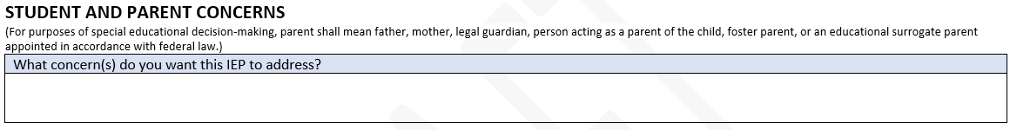

**Process Flowchart**

Not provided.

**Interface Description**

1. The system shall display the title “STUDENT AND PARENT CONCERNS”, as shown on the mockup screen.
2. The system should display, in small font, the paragraph, “(For the purposes of special educational decision-making, “parent” shall mean father, mother, legal guardian, person acting as a parent of the child, foster parent, or educational surrogate parent appointed in accordance with federal law.)”
3. The system shall display the following:
   1. The prompt, “What concern(s) do you want this IEP to address?”
   2. A text area where the user captures the student or parent’s concern. Note that the information captured in this text area can be extensive (about 2 pages of information).
4. The user is required to enter the concern(s) data element.
5. The application shall display the left-centered footer, “Massachusetts DESE Individualized Education Program”, in typeface and weight that conform to the mockup document shared by DESE.
6. If the information was previously saved, the system displays the information already saved.
7. The user shall have the ability to save the data entered/edited.

**Acceptance Criteria**

Verify that:

1. The title, text paragraphs, and prompt are properly displayed.
2. The user provides the concern information in the input text area.
3. The user shall have the ability to save the data entered/edited.
4. If the information was previously saved, the system displays the information already saved.

**Validation Messages**

If any required fields are left incomplete, the system should provide appropriate and applicable notification with instructions for the user to help rectify the issue.

## User Story – Document the Student and Team’s Vision Statements for the Student

As an authorized user, I need the ability to document the student and the IEP Team’s Vision Statements for the student, as the statements will guide the IEP decision-making processes.

The data elements associated with this user story and further details are provided in section “TEAM VISION” of the companion Excel file.

In this user story, the process flowchart will be presented before the mockup screens, as it encompasses two (2) mockup screens.

**Process Flowchart**

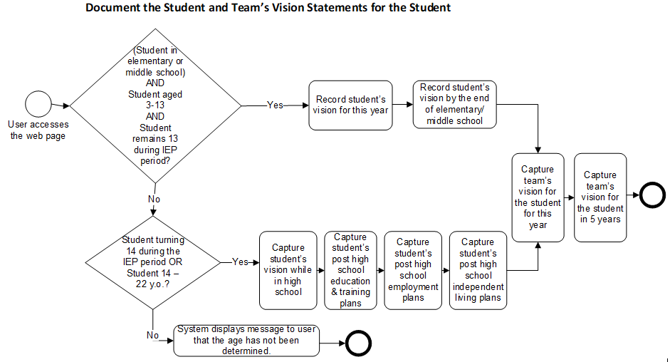

**Interface Description**

1. The system shall display the title “**STUDENT AND TEAM VISION**”, as shown on the mockup screen.

Items 2 – 5 describe the interface for the student is identified by the school information system as:

* Being in (elementary or middle school) AND
* Aged 3 through 13 AND
* If student is 13 years old, they will remain that age during the timeframe of this IEP.

**Mockup Screen**

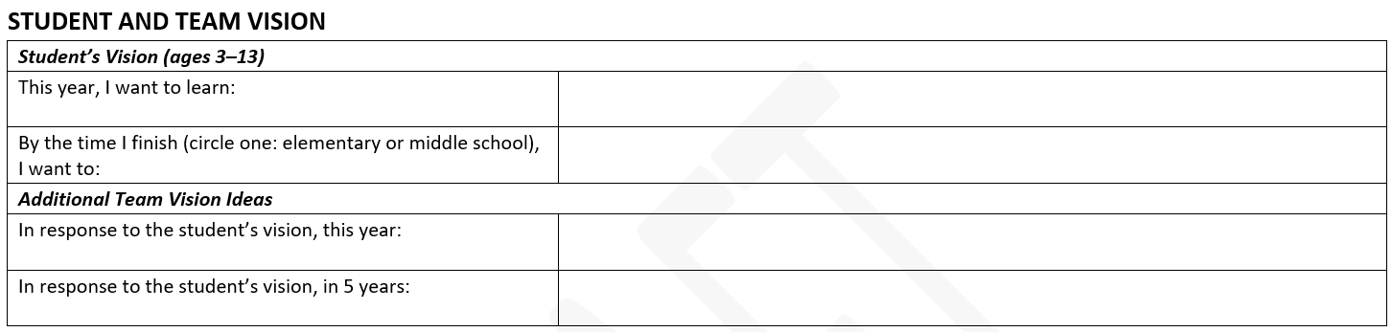

1. The system shall display the section header “***Student’s Vision (ages 3–13)***” as shown on the mockup screen.
2. The system shall display the following:
   1. The prompt, “This year, I want to learn:”
   2. A corresponding input textbox.
3. The system shall display the following:
   1. The prompt, “By the time I finish <%education level%>, I want to:”
   2. The corresponding input textbox.
4. The system shall replace the placeholder <%education level%> by the student’s education level, either elementary or middle school, as appropriate.

Items 6 – 10 concern the student is identified by the school information system as:

* Attending high school OR
* Being a 13-year-old who will turn 14 during the timeframe of this IEP, OR
* Aged between 14 to 22 years old.

**Mockup Screen**

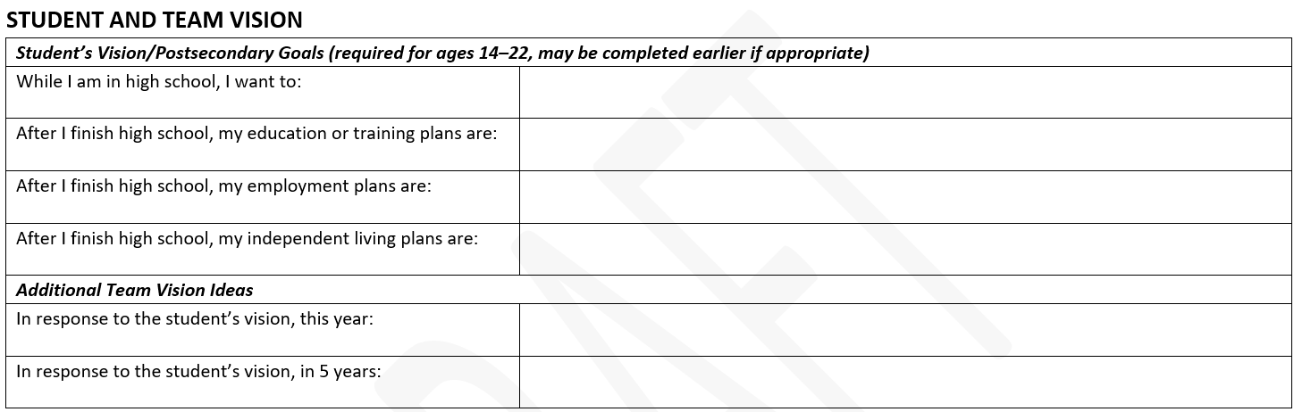

1. The system shall display the section label “***Student’s Vision/Postsecondary Goals (required for ages 14–22, may be completed earlier if appropriate)***”, as shown on the mockup screen.
2. The system shall display the following:
   1. The prompt, “While I am in high school, I want to:”
   2. A corresponding input textbox.
3. The system shall display the following:
   1. The prompt, “After I finish high school, my education or training plans are:”
   2. A corresponding input textbox.
4. The system shall display the following:
   1. The prompt, “After I finish high school, my employment plans are:”
   2. A corresponding input textbox.
5. The system shall display the following:
   1. A prompt, “After I finish high school, my independent living plans are:”
   2. A corresponding input textbox.

Items 11 – 17 below concern both groups of students

1. The system shall display the section header “***Additional Team Vision Ideas***” as shown on the mockup screen.
2. The system shall display the following:
   1. The prompt (label), “In response to the student’s vision, this year:”
   2. A corresponding input textbox.
3. The system shall display the following:
   1. The prompt, “In response to the student’s vision, in 5 years:”
   2. A corresponding input textbox.
4. The system shall display the left-centered footer, “Massachusetts DESE Individualized Education Program”, in typeface and weight that conform to the mockup document shared by DESE.
   * Note: this text will be used on every page. It could be developed independently and <included> in each page of the application.
5. The user is required to provide a response to each prompt.
6. The user shall have the ability to save the information entered/edited.
7. Upon accessing this screen, the system shall display any information previously saved.

**Acceptance Criteria**

Verify that:

1. The interface meets the age requirements.
2. The user can enter/edit information in the input textboxes/ text areas.
3. The placeholder has been replaced by its appropriate value.
4. The user has provided information for all the input fields.
5. The user can save the information.

**Validation Messages**

If any required fields are left incomplete, the system should provide appropriate and applicable notification with instructions for the user to help rectify the issue.

## User Story – Capture the student’s profile

As the authorized user, I need to set up the student’s profile, so that I can contribute to tailoring the IEP development process to their needs.

The data elements associated with this user story and further details are provided in section “STUDENT PROFILE” of the companion Excel file.

**Mockup Screen**

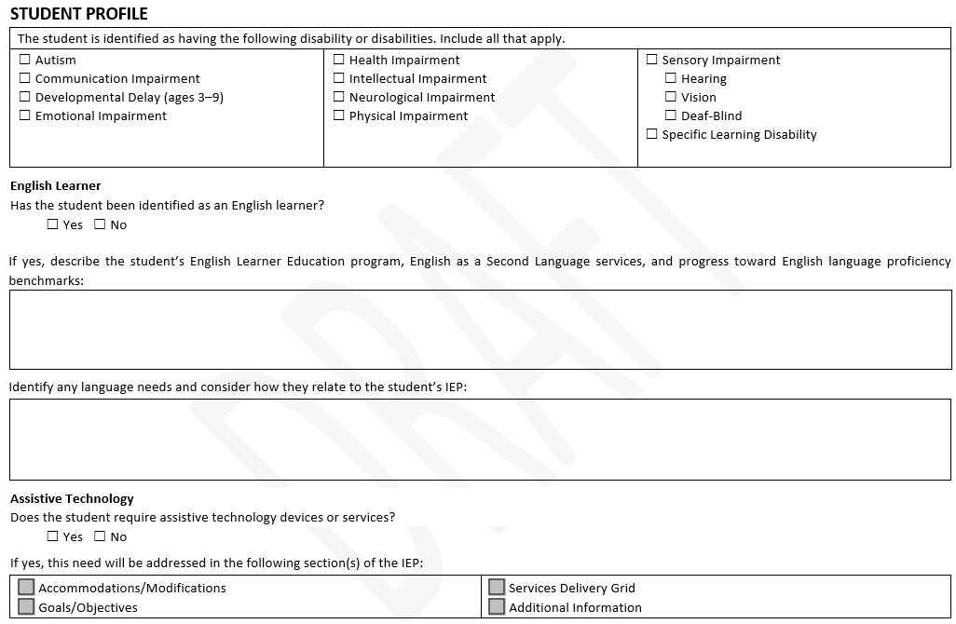

**Process Flowchart**

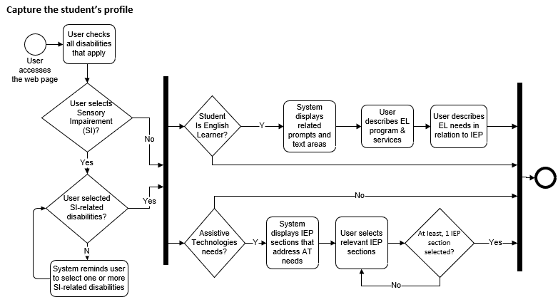

**Interface Description**

1. The system shall display the title “**STUDENT PROFILE**” as shown on the mockup screen.
2. The system shall display the section header, “The student is identified as having the following disability or disabilities. Include all that apply.”, as shown on the mockup screen.
3. The system shall display checkboxes labeled as follows:

* Autism
* Communication Impairment
* Developmental Delay (ages 3–9)
* Emotional Impairment
* Health Impairment
* Intellectual Impairment
* Neurological Impairment
* Physical Impairment
* Sensory Impairment
* Specific Learning Disability

1. The disability checkboxes shall be displayed in three (3) columns as depicted in the mockup screen above.
2. The checkbox “Developmental Delay (ages 3-9)” shall only appear if the student is between 3 and 9 years old.
3. If the user selects the “Sensory Impairment” checkbox, the system shall display the following multiselect (not mutually exclusive) checkboxes:

* Hearing
* Vision
* Deaf-Blind

1. The system shall display a subsection labeled “**English Learner**” in bold and underlined characters.
2. The system shall display the following:
   1. The prompt, “Has the student been identified as an English learner?”
   2. Two (2) mutually exclusive checkboxes
      1. One labeled “Yes”, the other labeled “No”.
      2. Related to the prompt above.
      3. Both are located on the same line.
      4. Neither checkbox is checked by default.
3. If the user selects the Yes option (student is an English Learner),
   1. The system shall display, below the set of checkboxes, the following:
      1. The prompt, “If yes, describe the student’s English Learner Education program, English as a Second Language services, and progress toward English language proficiency benchmarks:”
      2. A corresponding input textbox to capture the answer to the preceding prompt.
      3. The prompt, “Identify any language needs and consider how they relate to the student’s IEP:”
      4. A corresponding input textbox to capture the language needs requested in the preceding prompt.
4. The system shall display a subsection labeled “**Assistive Technology**” in bold and underlined characters.
5. The system shall provide the label of the prompt, “Does the student require assistive technology devices or services?”
   1. The system shall display two (2) mutually exclusive checkboxes:
      1. One labeled “Yes”, the other labeled “No”.
      2. Both are located on the same line.
      3. Neither checkbox is checked by default.
6. If the user selects the Yes option (student require assistive technology devices or services),
   1. The system shall provide the prompt, “If yes, this need will be addressed in the following section(s) of the IEP:”.
   2. The system shall display the following multiselect checkboxes—none of which checked by default—in a 2-row grid format.
      1. Accommodations/Modifications.
      2. Goals/Objectives.
      3. Services Delivery Grid.
      4. Additional Information.
7. The system shall display the left-centered footer, “Massachusetts DESE Individualized Education Program”, in typeface and weight that conform to the mockup document shared by DESE.
8. A student may be identified as having one or more disabilities.
9. If identified as having sensory impairment, a student may have one or more than one sensory impairment disability (hearing, vision, deaf-blind).
10. The user shall have the ability to save entered/edited data.
11. Verify that, upon accessing this screen, the system shall display any information previously saved.

**Acceptance Criteria**

Verify the following:

1. Titles, prompts, sub-section labels, and other texts are properly displayed.
2. The checkbox controls are functional and not checked “on” by default.
3. The user can enter/edit information in the input textboxes.
4. The checkbox “Developmental Delay (ages 3-9) is only displayed for students aged 3 through 9.
5. The checkboxes labeled “Hearing”, “Vision”, “Deaf-blind” are displayed only if the user selects the “Sensory Impairment” checkbox.
6. The user can click on or off on the Hearing, Vision, Deaf-blind checkboxes when the checkboxes are displayed.
7. If the user had previously selected the “Sensory Impairment” checkbox and captured related information such as Hearing, Vision, Deaf-blind, and
   1. The user deselects the “Sensory Impairment” checkbox,
      1. The system shall warn the user that previously entered data related to Sensory Impairment shall be lost and request that the user confirm the new choice.
      2. If the user confirms the new choice, verify that the application discards the information relative to sensory impairment disabilities.
8. If the Yes option corresponding to the English Learner prompt is selected, verify that the system displays the prompts:
   1. “If yes, describe the student’s English Learner Education program, English as a Second Language services, and progress toward English language proficiency benchmarks:” and
      1. A corresponding textbox.
   2. “Identify any language needs and consider how they relate to the student’s IEP:” and
      1. A corresponding textbox.
9. The user can only select one checkbox from a set of mutually exclusive checkboxes.
10. For assistive technology, if the user selects the “No” option or does not select either option, verify that the system does not display the prompt, “If yes, this need will be addressed in the following section(s) of the IEP:”, nor the checkboxes related to the IEP sections.
11. If the user had previously selected the Yes option for the Assistive Technology devices/services prompt, and entered information about the IEP sections where the needs will be addressed, and then
    1. The user changes their mind and selects the No option for the Assistive Technology devices/services,
       1. The system shall warn the user that previously entered data related to this control shall be lost and shall request that the user confirm the new choice.
       2. If the user confirms the No option, verify that the application:
          * Discards the information previously entered for the IEP sections where the need for Assistive Technology devices/services is addressed.
          * Hides the IEP sections relevant to the set of options.
12. Verify one or more of the following:
    1. The user has one or more disabilities from the disability checkboxes.
    2. Additionally, if the “Sensory Impairment” disability is selected,
       1. One or more related subtypes of disability (hearing, vision, deaf-blind) are selected.
    3. Additionally, If the student requires assistive technology devices or services,
       1. One or more checkboxes corresponding to the sections of the IEP are selected.

**Validation Messages**

If any required fields are left incomplete, the system should provide appropriate and applicable notification with instructions for the user to help rectify the issue.

## User Story – Document the student’s achievement and performance in Academic Areas

As an authorized user, I need to describe the student’s present levels of academic achievement and functional performance in the areas of academics, so that I can better tailor the IEP development process to the student’s needs.

The data elements associated with this user story and further details are provided in section “PRESENT LEVELS OF ACADEMIC ACHIEVEMENT AND FUNCTIONAL PERFORMANCE: ACADEMICS” of the companion Excel file.

**Mockup Screen**

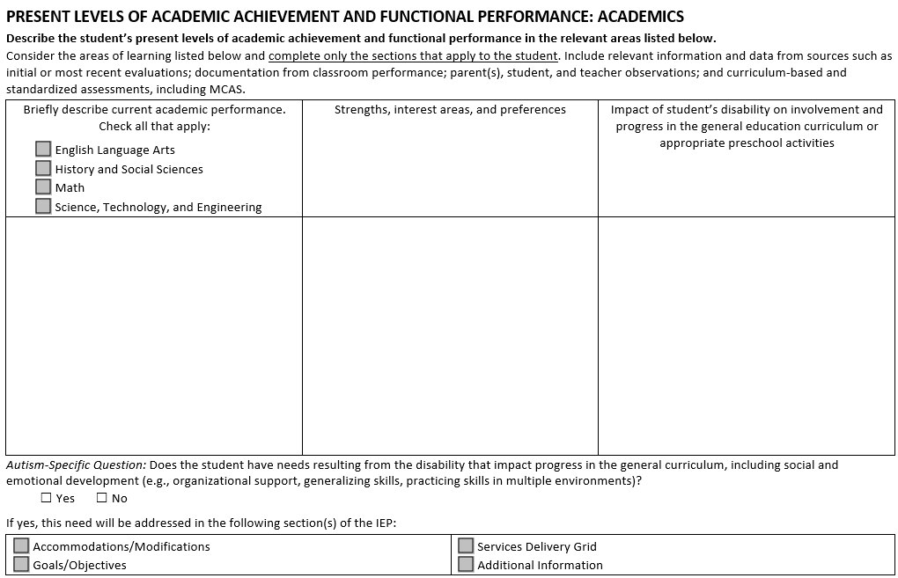

**Process Flowchart**

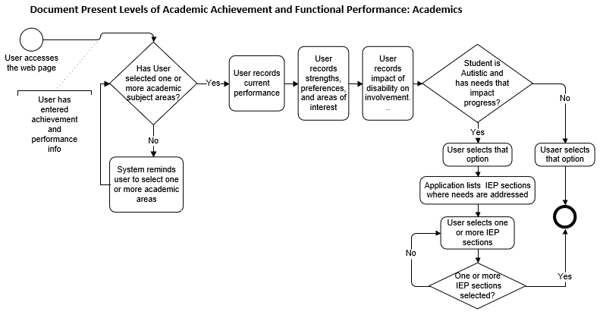 **Interface Description**

1. The system shall display the title “**PRESENT LEVELS OF ACADEMIC ACHIEVEMENT AND FUNCTIONAL PERFORMANCE: ACADEMICS**”, as shown on the mockup screen above.
2. The system shall display the paragraph, “**Describe the student’s present levels of academic achievement and functional performance in the relevant areas listed below.**”
3. The system shall display the paragraph, “Consider the areas of learning listed below and complete only the sections that apply to the student. Include relevant information and data from sources such as initial or most recent evaluations; documentation from classroom performance; parent(s), student, and teacher observations; and curriculum-based and standardized assessments, including MCAS.”, as shown on the mockup screen.
4. The system shall display a 2-row, 3-column table, including the column headers.
   1. Column headers:
      1. First row and first column – the column header is as follows:

* The center-aligned paragraph, “Briefly describe current academic performance.”
* The center-aligned paragraph, “Check all that apply:”.
* On the next line, a checkbox labeled “English Language Arts”.
* On the next line, a checkbox labeled “History and Social Sciences”.
* On the next line, a checkbox labeled “Math”.
* On the next line, a checkbox labeled “Science, Technology, and Engineering”.
  + 1. Second column – the center-aligned paragraph, “Strengths, interest areas, and preferences”.
    2. Third column – the center-aligned paragraph, “Impact of student’s disability on involvement and progress in the general education curriculum or appropriate preschool activities”.
  1. Second Row: the system shall allow the user to enter/edit data in the cells below the column headers. Note: users may enter extensive text (about one page).
     1. Fist column: a description of current academic performance in the subject areas selected.
     2. Second column: a description of student’s strengths, interest areas, and preferences.
     3. Third column: a description of the Impact of student’s disability on involvement and progress in the general education curriculum or appropriate preschool activities.

1. If the student has been identified in his profile as having autism, the system shall display:
   1. The following prompt, “Autism-Specific Question: Does the student have needs resulting from the disability that impact progress in the general curriculum, including social and emotional development (e.g., organizational support, generalizing skills, practicing skills in multiple environments)?”, as shown on the mockup screen.
   2. A set of two (2) mutually exclusive checkboxes
      1. One labeled “Yes”, the other labeled “No”.
      2. Both are located on the same line, below the prompt.
      3. Neither checkbox is checked by default.
   3. If the user answers Yes to the Autism-Specific question, the system shall display the following:
      1. The prompt, “If yes, this need will be addressed in the following section(s) of the IEP:”
      2. A grid-format listing the set of four (4) checkboxes corresponding to the different sections of the IEP (2 checkboxes per row):
         * Accommodations/Modifications.
         * Goals/Objectives.
         * Services Delivery Grid.
         * Additional Information.
2. The system shall display the left-centered footer, “Massachusetts DESE Individualized Education Program”, in typeface and weight that conform to the mockup document shared by DESE.
3. Upon accessing that screen, the system shall display any information previously saved.
4. The user shall have the ability to save any information entered or updated.

**Acceptance Criteria**

Verify the following:

1. The system displays properly the title, texts, table column headers, prompts, and checkboxes.
2. The user can click on or off the checkbox controls.
3. The user is able to enter/edit information in the row, as necessary.
4. The user is required to do the following:
   1. Select one or more checkboxes representing the academic areas (English Language Arts; History and Social Sciences; Math; Science, Technology, and Engineering).
   2. Fill out the information in the second row in the column that corresponds to the student’s current performance, strengths, and impact evaluation.
      1. “N/A” values are acceptable.
5. The user can select either the Yes or No checkbox related to the autism-specific question.
6. If the user selects No to the autism-specific question or does not make any choice, The system does **NOT** display the prompt, “If yes, this need will be addressed in the following section(s) of the IEP:” and the checkboxes related to the prompt.
7. If the user selects the Yes option to the autism-specific question, the four (4) checkboxes (IEP sections) are displayed and can be clicked on or off.
8. The user can select one or more of the checkboxes—if displayed—related to IEP sections.
9. If the user had previously answered Yes to the Autism-Specific question and provided additional information related to that option, and
   1. The user changes their mind and selects the No option of the Autism-Specific question,
      1. The system shall warn the user that previously entered data related to this control shall be lost and shall request that the user confirm the new choice.
      2. If the user confirms the No option, verify that the application:
         * Discards the information previously entered for the IEP sections where the autism-specific academic needs are addressed.
         * Hides the IEP sections relevant to the set of options.
10. The user is able to save the details.
11. Upon accessing that screen, the system shall display any information previously saved.

**Validation Messages**

If any required fields are left incomplete, the system should provide appropriate and applicable notification with instructions for the user to help rectify the issue.

## User Story – Document the Present Achievement and Performance in Behavioral, Social, and Emotional Areas

As an authorized user, I need to describe the student’s present levels of achievement and functional performance in the behavioral/social/emotional areas, so that I can contribute to tailoring the IEP development process to the student’s needs.

The data elements associated with this user story and further details are provided in section “PRESENT LEVELS OF ACADEMIC ACHIEVEMENT AND FUNCTIONAL PERFORMANCE” of the companion Excel file.

**Mockup Screen**

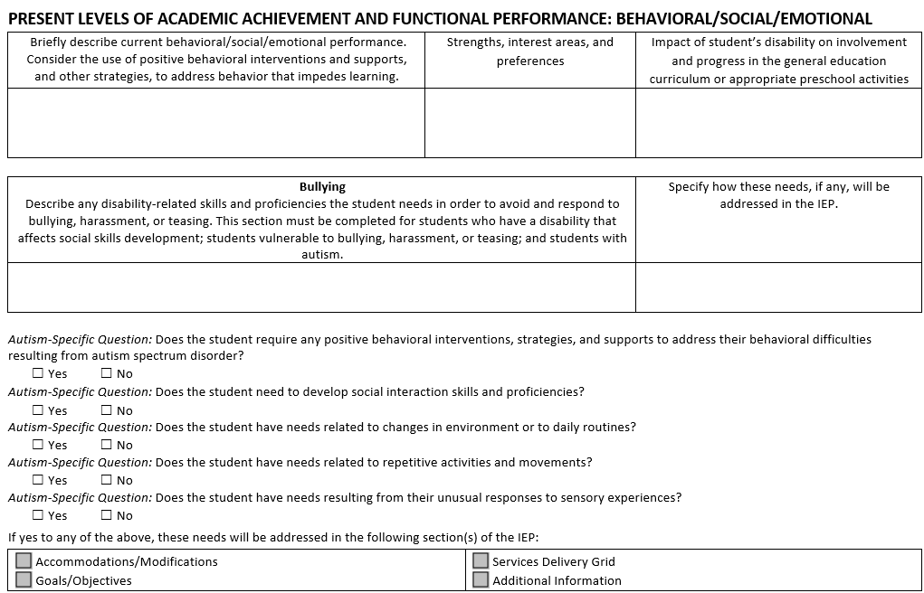

**Process Flowchart**

This process flow is drawn from the perspective of the user of the system. It follows the following display by the system:

1. A section of the webpage related to achievement and performance in the Behavioral, Social, and Emotional areas, regardless of disabilities.
2. A section about bullying and related student capacity strengthening.
3. A set of autism-related questions, if the student has been identified with the autism disability.

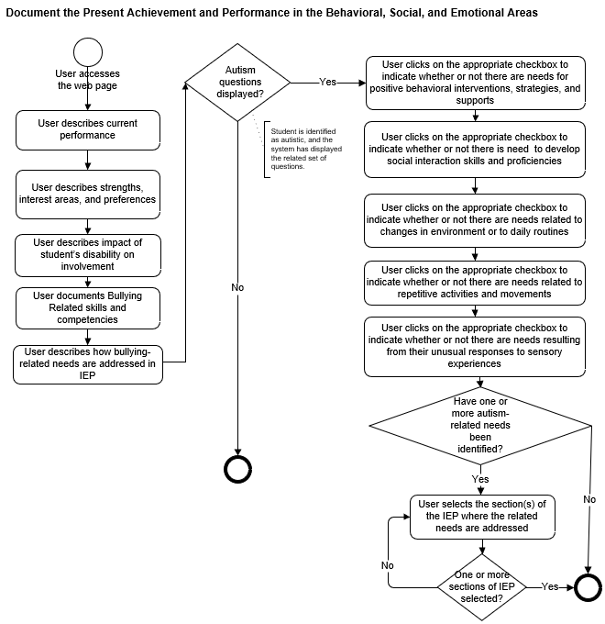

**Interface Description**

1. The system shall display the title “**PRESENT LEVELS OF ACADEMIC ACHIEVEMENT AND FUNCTIONAL PERFORMANCE: BEHAVIORAL/SOCIAL/EMOTIONAL**” as shown on the mockup screen.
2. The system shall display a 2-row, 3-column table, including the row for the column headers.
   1. Column headers:
      1. First column – the center-aligned prompt, “Briefly describe current behavioral/social/emotional performance. Consider the use of positive behavioral interventions and supports, and other strategies, to address behavior that impedes learning.”
      2. Second column – the center-aligned prompt, “Strengths, interest areas, and preferences”.
      3. Third column – the center-aligned prompt, “Impact of student’s disability on involvement and progress in the general education curriculum or appropriate preschool activities”.
   2. Second Row: In the row cells, the user shall capture the information pertaining to the corresponding column.
3. The system shall display a 2-row, 2-column table (later referred to as “Bullying table” in this user story), including the row for the column headers.
   1. Column headers:
      1. First column –
         * The center-aligned paragraph with the word “Bullying” in bold characters.
         * The center-aligned prompt, “Describe any disability-related skills and proficiencies the student needs in order to avoid and respond to bullying, harassment, or teasing. This section must be completed for students who have a disability that affects social skills development; students vulnerable to bullying, harassment, or teasing; and students with autism.”
      2. Second column – the center-aligned prompt, “Specify how these needs, if any, will be addressed in the IEP.”
   2. Second Row: In the row cells, the user shall capture the information pertaining to the corresponding column.
4. If, and only if, the student is identified, in their profile, as having autism, the system shall display the following:
   1. The prompt, “*Autism-Specific Question:* Does the student require any positive behavioral interventions, strategies, and supports to address their behavioral difficulties resulting from autism spectrum disorder?”
      1. Two (2) mutually exclusive checkboxes
         * One labeled “Yes”, the other labeled “No”.
         * Both related to the prompt that immediately precedes them.
         * Both are located on the same line, below the prompt.
         * Neither checkbox is checked by default.
   2. The prompt, “*Autism-Specific Question:* Does the student need to develop social interaction skills and proficiencies?”
      1. Two (2) mutually exclusive checkboxes
         * One labeled “Yes”, the other labeled “No”.
         * Both related to the prompt that immediately precedes them.
         * Both are located on the same line, below the prompt.
         * Neither checkbox is checked by default.
   3. The prompt, “*Autism-Specific Question:* Does the student have needs related to changes in environment or to daily routines?”
      1. Two (2) mutually exclusive checkboxes
         * One labeled “Yes”, the other labeled “No”.
         * Both related to the prompt that immediately precedes them.
         * Both are located on the same line, below the prompt.
         * Neither checkbox is checked by default.
   4. The prompt, “*Autism-Specific Question:* Does the student have needs related to repetitive activities and movements?”
      1. Two (2) mutually exclusive checkboxes
         * One labeled “Yes”, the other labeled “No”.
         * Both related to the prompt that immediately precedes them.
         * Both are located on the same line, below the prompt.
         * Neither checkbox is checked by default.
   5. The prompt, “*Autism-Specific Question:* Does the student have needs resulting from their unusual responses to sensory experiences?”
      1. Two (2) mutually exclusive checkboxes
         * One labeled “Yes”, the other labeled “No”.
         * Both related to the prompt that immediately precedes them.
         * Both are located on the same line, below the prompt.
         * Neither checkbox is checked by default.
5. If the user answers Yes to one or more of the autism-specific questions, the system shall display:
   1. The prompt, “If yes to any of the above, these needs will be addressed in the following section(s) of the IEP:”
   2. The following set of four (4) multiselect checkboxes set in a 2-row grid and related to the different sections of the IEP document:
6. Accommodations/Modifications.
7. Goals/Objectives.
8. Services Delivery Grid.
9. Additional Information.
10. If the user answers No option to all the autism-specific questions OR does not make any selection, the system shall NOT display the IEP section-related checkboxes above.
11. The system shall display the left-centered footer, “Massachusetts DESE Individualized Education Program”, in typeface and weight that conform to the mockup document shared by DESE.
12. The user is able to save the details.
13. Upon accessing that screen, the system shall display any information previously saved.

**Acceptance Criteria**

Verify that:

1. The title, text paragraphs, and prompt are properly displayed, as shown on the mockup screen.
2. The user is able to enter information into the table rows.
3. The autism-specific questions and their related checkbox controls are displayed only if the student is identified as having autism.
4. The user can click on or off on the different checkboxes.
5. Verify that, for the mutually exclusive Yes | No checkboxes, only one option can be selected at a time.
6. The user is not required to enter information related to Behavioral, Social, and Emotional present levels of achievement and functional performance, student’s strengths, and disability impact. However,
   1. Verify that, if the user provides an answer to one of the performance-related prompts (current performance …; strengths, ….; disability impact….), they are required to provide information for the two (2) other prompts.
      1. “N/A” values are acceptable.
7. Regarding the “Bullying” table, the user is not required to describe any disability-related skills and proficiencies needs and how the needs will be addressed in the IEP. However:
   1. If the user enters information for one of the row cells in that table, they are required to enter information for both cells.
      1. “N/A” values are acceptable.
8. If the user selects No to all autism-specific questions OR if the user does not make any choice at all concerning said questions, leaving all checkboxes unchecked, the system does not display the prompt (“If yes to any of the above, these needs will be addressed in the following section(s) of the IEP:”) and its related checkboxes.
9. If the user selects Yes to one or more autism-specific questions, the system displays the prompt, “If yes to any of the above, these needs will be addressed in the following section(s) of the IEP:” and its related checkboxes.
10. If the user selects Yes to one or more autism-specific questions, the user must identify one or more sections of the IEP that address the need(s).
11. If the user had previously answered Yes to one or more of the Autism-Specific questions and provided IEP-section-related additional information, and
    1. The user changes their mind and selects the No option to **all** the Autism-Specific questions,
12. The system shall warn the user that previously entered data related to this control shall be lost and shall request that the user confirm the new choice.
    1. If the user confirms the No option, verify that the application:
       1. Discards the information previously entered for the IEP sections where the autism-related behavioral, social, emotional needs are addressed.
       2. Hides the IEP sections relevant to the set of options.
13. The user is able to save the details.
14. Upon saving the information, verify that the user has provided the required information.

**Validation Messages**

If any of the requirements are unmet, the system shall provide a validation message, prompting the user to fill out the missing information.

## User Story – Document Present Levels of a Performance in Communication

As an authorized user, I need to describe the student’s present levels of achievement and functional performance in area of Communication, so that I can better tailor the IEP development process to the student’s needs.

The data elements associated with this user story and further details are provided in section “PRESENT LEVELS OF ACADEMIC ACHIEVEMENT AND FUNCTIONAL PERFORMANCE” of the companion Excel file.

**Mockup Screen**

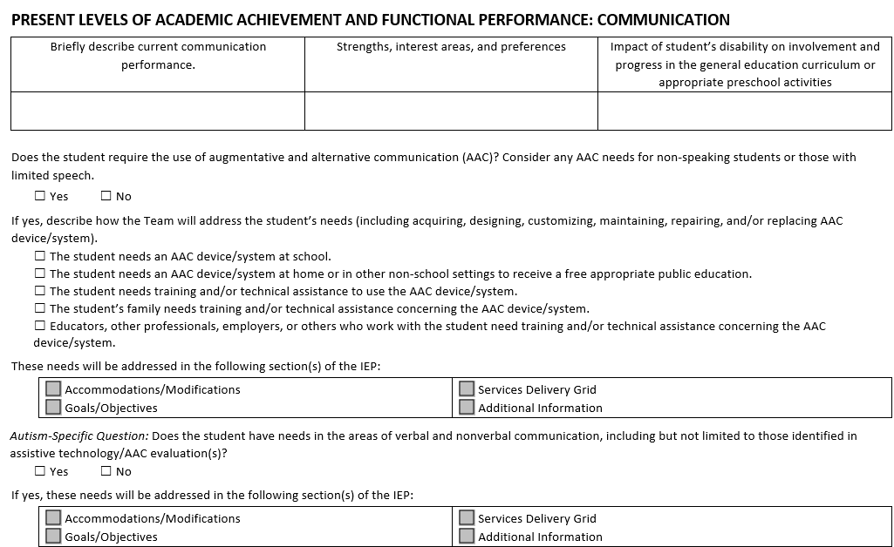

**Process Flowchart**

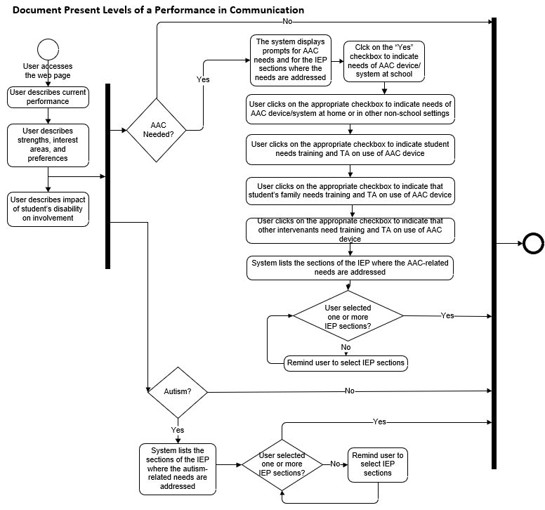

**Interface Description**

1. The system shall display the title “**PRESENT LEVELS OF ACADEMIC ACHIEVEMENT AND FUNCTIONAL PERFORMANCE: COMMUNICATION**” as shown on the mockup screen.
2. The system shall display a 2-row, 3-column table, including the column headers.
   1. Column headers:
      1. First column – the center-aligned paragraph, “Briefly describe current communication performance.”
      2. Second column – the center-aligned paragraph, “Strengths, interest areas, and preferences”
      3. Third column – the center-aligned paragraph, “Impact of student’s disability on involvement and progress in the general education curriculum or appropriate preschool activities”
   2. Second row: In the row cells, the user shall capture the information pertaining to the corresponding column.
3. Below the table, the system shall display the prompt, “Does the student require the use of augmentative and alternative communication (AAC)? Consider any AAC needs for non-speaking students or those with limited speech.”
4. Two (2) mutually exclusive checkboxes
   1. One labeled “Yes”, the other labeled “No”.
   2. Related to the AAC needs above.
   3. Both are located on the same line.
   4. Neither Checkbox is checked by default.
5. If the user answers Yes to the AAC needs question above, the system shall display the following:
   1. The prompt, “If yes, describe how the Team will address the student’s needs (including acquiring, designing, customizing, maintaining, repairing, and/or replacing AAC device/system).”
   2. The following set of multiselect checkboxes labeled as follows:
      1. The student needs an AAC device/system at school.
      2. The student needs an AAC device/system at home or in other non-school settings to receive a free appropriate public education.
      3. The student needs training and/or technical assistance to use the AAC device/system.
      4. The student’s family needs training and/or technical assistance concerning the AAC device/system.
      5. Educators, other professionals, employers, or others who work with the student need training and/or technical assistance concerning the AAC device/system.
   3. The prompt, “These needs will be addressed in the following section(s) of the IEP:”
   4. A grid displaying the following set of multiselect checkboxes that indicate the sections of the IEP where the needs will be addressed and that are labeled as follows:
      1. Accommodations/Modifications.
      2. Goals/Objectives.
      3. Services Delivery Grid.
      4. Additional Information.
6. If the student is identified, in their profile, as having autism, the system shall display the following:
   1. The prompt, “*Autism-Specific Question:* Does the student have needs in the areas of verbal and nonverbal communication, including but not limited to those identified in assistive technology/AAC evaluation(s)?”
   2. Two (2) mutually exclusive checkboxes
      1. One labeled “Yes”, the other labeled “No”.
      2. Related to the verbal/nonverbal communication needs above.
      3. Both are located on the same line.
      4. Neither checkbox is checked by default.
7. If the user answers Yes to the autism-specific question, the system shall display the following:
   1. The prompt, “If yes, these needs will be addressed in the following section(s) of the IEP:”
   2. The following set of multiselect checkboxes—set in a 2-column, 2-row grid format—that indicate the sections of the IEP where the needs will be addressed:
      1. Accommodations/Modifications.
      2. Goals/Objectives.
      3. Services Delivery Grid.
      4. Additional Information.
8. The system shall display the left-centered footer, “Massachusetts DESE Individualized Education Program”, in typeface and weight that conform to the mockup document shared by DESE.
9. The user is required to respond (Yes or No) to:
   1. The AAC needs-related question.
   2. The autism-specific question.
10. The user shall have the ability to save their data.
11. Upon accessing that screen, the system shall display any information previously saved.

**Acceptance Criteria**

Verify the following:

1. The title, text paragraphs, and prompts are properly displayed, as shown on the mockup screen.
2. The user is able to enter information into the input cells, as appropriate.
3. The checkbox controls are functional and work. as intended.
4. The information related to student’s Communication present levels of achievement and functional performance is not required. However,
   1. Verify that, if the user provides an answer to one of the performance related prompts (current performance; strengths, ….; impact of the disability….), they are required to provide information for the two (2) other prompts.
      1. “N/A” values are acceptable.
5. If the user answers Yes to the AAC prompt, the checkboxes associated with the augmentative and alternative communication (AAC) needs are displayed.
   1. Otherwise, if the user answers No to the question OR does not answer at all, the related checkboxes shall not be displayed.
6. If the user answers No to the autism-specific question or does not answer the question at all, the system **does not** display the prompt, “If yes, this need will be addressed in the following section(s) of the IEP:” and related checkboxes.
7. If the user selects Yes to the autism-specific question, the system displays the prompt, “If yes, this need will be addressed in the following section(s) of the IEP:” and related checkboxes.
8. If the user had previously answered Yes to the AAC needs question and provided additional information related to that option, and
   1. The user changes their mind and selects the No option of the AAC needs question,
      1. The system shall warn the user about the loss of previously entered data related to specific AAC needs and IEP sections where the needs are addressed; it shall request that the user confirm the new choice.
      2. If the user confirms the No option, the application:
         * Discards the previously entered information related to specific IEP needs and the IEP sections where the AAC needs are addressed.
         * Hide said AAC needs section and IEP sections.
9. If the user had previously answered Yes to the autism-specific verbal and nonverbal communication question and provided additional information (IEP sections) related to that option, and
   1. The user changes their mind and selects the No option of the Autism-Specific question,
      1. The system shall warn the user about the loss of previously entered data and shall request that the user confirm the new choice.
      2. If the user confirms the No option, the application:
         * Discards the previously entered information related to the IEP sections where the verbal and nonverbal communication needs are addressed.
         * Hide said IEP sections.
10. The user is able to save the details.

**Validation Messages**

If any of the requirements are unmet, the system shall provide a validation message, prompting the user to fill out the missing information.

## User Story – Document the Present Achievement and Performance in Additional Areas

As an authorized user, I need to describe the student’s present levels of achievement and functional performance in Additional Areas, as applicable (such as activities of daily living, health, hearing, motor, sensory, and vision), so that I can better tailor the IEP development process to the student’s needs.

The data elements associated with this user story and further details are provided in section “PRESENT LEVELS OF ACADEMIC ACHIEVEMENT AND FUNCTIONAL PERFORMANCE” of the companion Excel file.

**Mockup Screen**

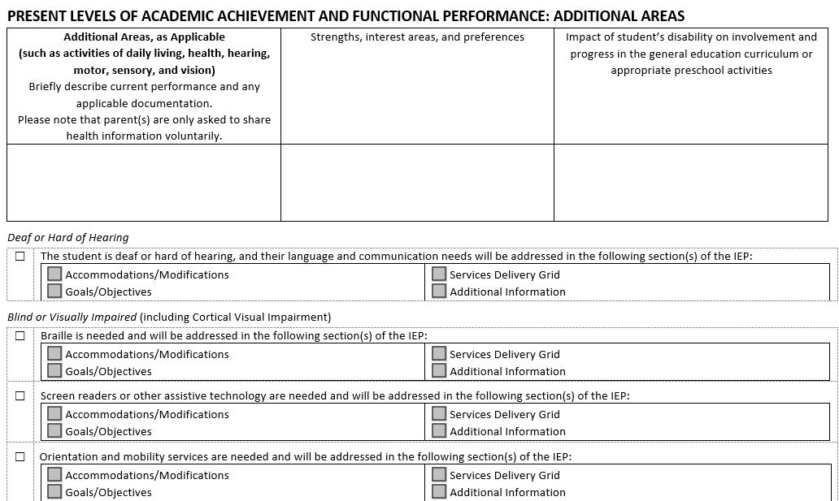

**Process Flowchart**

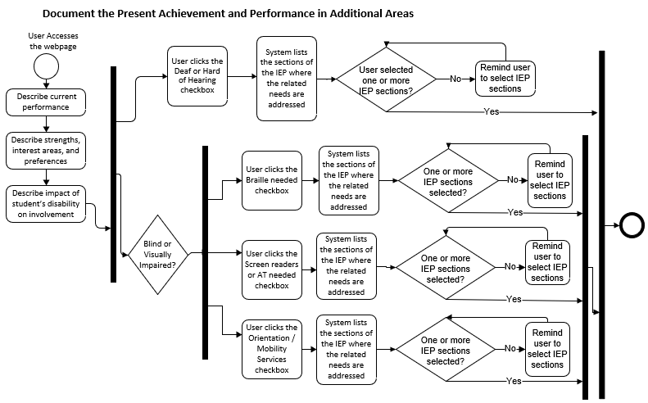**Interface Description**

1. The system shall display the title “**PRESENT LEVELS OF ACADEMIC ACHIEVEMENT AND FUNCTIONAL PERFORMANCE: ADDITIONAL AREAS**” as shown on the mockup screen.
2. The system shall display a 2-row, 3-column table, including the column headers.
   1. Column headers:
      1. First column header –
         * The center-aligned paragraph, “Additional Areas, as Applicable (such as activities of daily living, health, hearing, motor, sensory, and vision)“ in bold.
         * The center-aligned paragraph, “Briefly describe current performance and any applicable documentation.”
         * The center-aligned paragraph, “Please note that parent(s) are only asked to share health information voluntarily.”
      2. Second column header – the center-aligned paragraph, “Strengths, interest areas, and preferences”.
      3. Third column header – the center-aligned paragraph, “Impact of student’s disability on involvement and progress in the general education curriculum or appropriate preschool activities”.
   2. Second row: In the row cells, the user shall capture the information pertaining to the corresponding column.
3. If the student is identified, in their profile, as being Deaf or Hard of Hearing, the system shall display the following:
   1. A subsection labeled, “Deaf or Hard of Hearing” (corresponding profile values are: “Hearing” or “Deaf-Blind”), using the font characteristics of the mockup document.
   2. A checkbox labeled, “The student is deaf or hard of hearing, and their language and communication needs will be addressed in the following section(s) of the IEP:”.
      1. This control is not checked on by default.
   3. If this checkbox is “checked-on”, indicating a Yes value,
      1. The application shall display the following set of checkboxes, set in two rows, that indicate the sections of the IEP where the Deaf and Hard of Hearing-related needs will be addressed:

* Accommodations/Modifications.
* Goals/Objectives.
* Services Delivery Grid.
* Additional Information.
  1. If the checkbox is “checked-off”, indicating a No value,
     1. The application shall not display the related set of checkboxes.

1. If the student is identified as Blind or Visually Impaired in their profile (corresponding profile values are: “Blind” or “Deaf-Blind”), the system shall display a subsection labeled, “*Blind or Visually Impaired* (including Cortical Visual Impairment)”.
   1. A checkbox labeled “Braille is needed and will be addressed in the following section(s) of the IEP:”. The control is not checked on by default.
2. If the checkbox is “checked-on”, indicating a Yes value,
   * + - The application shall display the following set of multiselect checkboxes that indicate the sections of the IEP where the Braille needs will be addressed:

* Accommodations/Modifications.
* Goals/Objectives.
* Services Delivery Grid.
* Additional Information.

1. If the Braille-related checkbox is “checked-off”, indicating a No value,
   * + The application shall not display the multiselect textboxes related to this need.
   1. A checkbox labeled “Screen readers or other assistive technology are needed and will be addressed in the following section(s) of the IEP:”. The control is not checked on by default.
2. If the checkbox is “checked-on”, indicating a Yes value,

* The application shall display the following set of multiselect checkboxes that indicate the sections of the IEP where the screen readers and AT needs will be addressed:
* Accommodations/Modifications.
* Goals/Objectives.
* Services Delivery Grid.
* Additional Information.

1. If the screen reader/AT-related checkbox is “checked-off”, indicating a No value,
   * + The application shall not display the multiselect textboxes related to this need.
   1. A checkbox labeled “Orientation and mobility services are needed and will be addressed in the following section(s) of the IEP:”. The control is not checked on by default.
2. If the checkbox is “checked-on”, indicating a Yes value,

* The application shall display the following set of multiselect checkboxes that indicate the sections of the IEP where the orientation and mobility services will be addressed:
* Accommodations/Modifications.
* Goals/Objectives.
* Services Delivery Grid.
* Additional Information.

1. If the orientation and mobility services -related checkbox is “checked-off”, indicating a No value,
   * + The application shall not display the multiselect textboxes related to this need.
2. The system shall display the left-centered footer, “Massachusetts DESE Individualized Education Program”, in typeface and weight that conform to the mockup document shared by DESE.
3. Upon accessing that screen, the system shall display any information previously saved.
4. The user shall have the ability to save the information entered/edited.

**Acceptance Criteria**

Verify the following:

1. The title, text paragraphs, and prompts are properly displayed, as shown on the mockup screen.
2. The user is able to enter information into the input row cells, as appropriate.
3. The checkboxes are functional, and they work as intended.
4. The information related to student’s present levels of achievement and functional performance in Additional areas is **not** required. However,
   1. Verify that, if the user provides an answer to one of the performance related prompts (current performance; strengths, ….; impact of disability….), they are required to provide information for the two (2) other prompts.
      * “N/A” values are acceptable.
5. If the user indicates that “The student is Deaf or hard of hearing and their language and communication needs will be addressed in the following section(s) of the IEP: “ by setting the related checkbox to its Yes value,
   1. Verify that one or more of the IEP-related checkboxes for that option are selected.
6. If the user indicates that “Braille is needed and will be addressed in the following section(s) of the IEP:” by setting the related checkbox to its Yes value,
   1. Verify that one or more of the IEP-related checkboxes for that option are selected.
7. If the user indicates that “Screen readers or other Assistive Technology are needed and will be addressed in the following section(s) of the IEP:” by setting the related checkbox to its Yes value,
   1. Verify that one or more of the IEP-related checkboxes for that option are checked on.
8. If the user indicates that “Orientation and Mobility services are needed and will be addressed in the following section(s) of the IEP:” by setting the related checkbox to its Yes value,
   1. Verify that one or more of the IEP-related checkboxes for that option are selected.
9. The user shall have the ability to select multiple checkboxes (Braille; screen readers/AT; orientation and mobility services) related to the Blind or Visually Impaired (including Cortical Visual Impairment) section.
10. If the user had previously indicated that the student is deaf or hard of hearing and selected the IEP sections where the needs will be addressed, and
    1. The user changes their mind and selects the deselects the Deaf or Hard of Hearing related checkbox,
       1. The system shall warn the user about the loss of previously entered data and shall request that the user confirm the new choice.
       2. If the user confirms the No option, the application:
          * Discards the previous selection of IEP-related checkboxes.
          * Hides said IEP sections.
11. If the user had previously indicated that Braille is needed and selected the IEP sections where the needs will be addressed, and
    1. The user changes their mind and selects the deselects the Braille-related checkbox,
       1. The system shall warn the user about the loss of previously entered data and shall request that the user confirm the new choice.
       2. If the user confirms the No option, verify that the application:
          * Discards the information previously entered for the IEP sections where the Braille need is addressed.
          * Hides said IEP sections.
12. If the user had previously indicated that Screen users and AT are needed and selected the IEP sections where the needs will be addressed, and
    1. The user changes their mind and deselects the “Screen Users or Other AT”-related checkbox,
       1. The system shall warn the user about the loss of previously entered data and shall request that the user confirm the new choice.
       2. If the user confirms the No option, verify that the application:
          * Discards the information previously entered for the IEP sections where Screen users and Other AT needs are addressed.
          * Hides said IEP sections.
13. If the user had previously indicated that Orientation and Mobility services are needed and selected the IEP sections where the needs will be addressed, and
    1. The user changes their mind and deselects the Orientation and Mobility-related checkbox,
       1. The system shall warn the user about the loss of previously entered data and shall request that the user confirm the new choice.
       2. If the user confirms the No option, verify that the application:
          * Discards the information previously entered for the IEP sections where Orientation and Mobility services needs are addressed.
          * Hides said IEP sections.
14. The user is able to save the details.
15. Upon saving the information, the user has provided the information in cell row input areas if one the cells is filled out.

**Validation Messages**

If any required fields are left incomplete, the system should provide appropriate and applicable notification with instructions for the user to help rectify the issue.

## User Story – Track the Postsecondary Transition

As an authorized user, I need to plan postsecondary transition, so that I contribute to tailoring the IEP development process to the student’s needs.

The data elements associated with this user story and further details are provided in section “POST SECONDARY TRANSITION PLANNING (Students aged 14-22 or students who are 13 and will turn 14 during this IEP period)” of the companion Excel file.

**Mockup Screen**

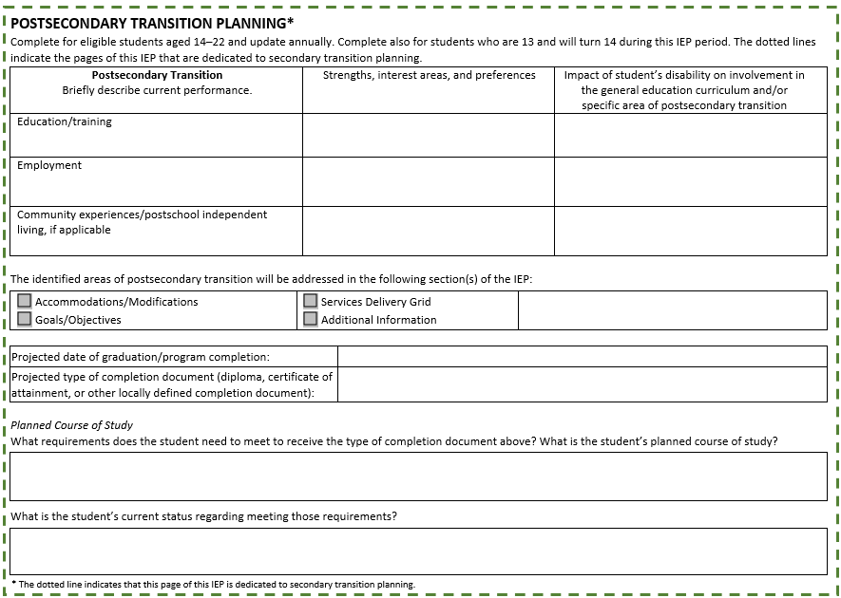

**Process Flowchart**

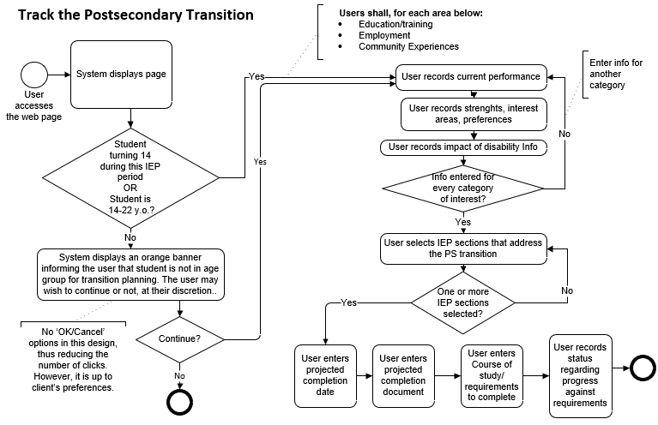

**Conditions**

This user story is valid under the conditions below:

The student is:

* 1. Aged 14-22 **OR**
  2. Aged 13 and will turn 14 during this IEP period.

**Interface Description**

1. The system shall display the title “**POSTSECONDARY TRANSITION PLANNING\***”, as shown on the mockup screen.
2. The system shall display the paragraph, “Complete for eligible students aged 14–22 and update annually. Complete also for students who are 13 and will turn 14 during this IEP period. The dotted lines indicate the pages of this IEP that are dedicated to secondary transition planning.”, as shown on the mockup screen.
3. The system shall display a 4-row, 3-column table, including the column headers.
   1. Column headers:
      1. First column header –
         * The center-aligned paragraph, “Postsecondary Transition”.
         * The center-aligned paragraph, “Briefly describe current performance.”
      2. Second column – the center-aligned header, “Strengths, interest areas, and preferences”.
      3. Third column – the center-aligned header, “Impact of student’s disability on involvement in the general education curriculum and/or specific area of postsecondary transition”.
   2. Rows:
      1. Row Headers: None.
      2. First row
         * First Column: This cell has the contained label “Education/training”.
           + Below the contained label, is an input area where the user shall have the ability to enter the current performance information related to employment.
         * Second Column: this is an input area where the user can enter the information about the student’s strengths, interest areas, and preferences with respect to education/training.
         * Third column: this is an input area where the user can enter information about the impact of the student’s disability on education and training.
      3. Second row
         * First Column: This cell has the contained label “Employment”.
           + Below the contained label, is an input area where the user shall have the ability to enter the current performance information related to employment.
         * Second Column: this is an input area where the user can enter the information about the student’s strengths, interest areas, and preferences with respect to employment.
         * Third column: this is an input area where the user can enter the information about the impact of student’s disability on employment.
      4. Third row
         * First Column: This cell has the contained label “Community experiences/postschool independent living, if applicable”.
           + Below the contained label, is an input area where the user shall have the ability to enter the current performance information related to Community experiences/postschool independent living.
         * Second Column: this is an input area where the user can enter the information about the student’s strengths, interest areas, and preferences with respect to community experiences/postschool independent living.
         * Third column: this is an input area where the user can enter information about the impact of the student’s disability on community experiences/postschool independent living.
4. The system shall display the following:
   1. A text paragraph, “The identified areas of postsecondary transition will be addressed in the following section(s) of the IEP:”.
      1. The following set of multiselect checkboxes, set in two rows, that indicate the sections of the IEP where the postsecondary transition needs will be addressed:

* Accommodations/Modifications.
* Goals/Objectives.
* Services Delivery Grid.
* Additional Information.

1. The system shall display the following:
   1. The prompt, “Projected date of graduation/program completion:”.
   2. A corresponding input textbox to capture the date information. Alternatively, the textbox could be replaced by a calendar webpart, which reduces the risk of data entry error.

Note: The date information is in MM/DD/YYYY format.

1. The system shall display the following:
   1. The prompt, “Projected type of completion document (diploma, certificate of attainment, or other locally defined completion document):”.
   2. A corresponding input textbox to capture that information.
2. The subsection paragraph header, “*Planned Course of Study*”.
3. The system shall display the following:
   1. The prompt, “What requirements does the student need to meet to receive the type of completion document above? What is the student’s planned course of study?” and
   2. A corresponding input textbox to capture the information related to the prompt.
4. The system shall display the following:
   1. The prompt, “What is the student’s current status regarding meeting those requirements?” and
   2. A corresponding input textbox to capture the information related to the prompt above.
5. The application shall display the footnote labeled, “* The dotted line indicates that this page of this IEP is dedicated to secondary transition planning.”
6. The system shall display the left-centered footer, “Massachusetts DESE Individualized Education Program”, in typeface and weight that conform to the mockup document shared by DESE.
7. The user shall have the ability to save data entered/edited.
8. Upon accessing that screen,
   1. If the student is not in the age category specified for postsecondary transition planning, the system shall provide a confirmation message to the user to that effect. (However, this provisional design does not provide “No/Yes” or “OK/Cancel” options to continue. The continue can freely continue if they wish so. In reality, the final design for each implementation will be decided by the client and its vendor.)
   2. the system shall display any information previously saved.
9. Optionally, the system could issue notifications to the IEP team leader ahead of time.

**Acceptance Criteria**

Verify the following:

1. The age requirements are met by the student.
2. The title, text paragraphs, labels, and prompts are properly displayed, as shown on the mockup screen.
3. The user can click on or off the appropriate checkboxes, as appropriate.
4. The user is able to fill out the textboxes or input areas with information.
5. If the student fits into the age range, the following fields are required:
   1. Projected date of graduation/program completion.
   2. Projected type of completion document.
   3. Requirements and Plan Course of Study.
   4. Student’s current status regarding those requirements
6. The user is required to provide information related to Education/training, Employment, and Community experiences/postschool independent living in the related table.
   1. Values of “N/A” are acceptable.
7. The Projected date of graduation is in MM/DD/YYYY format.
8. 4-row, 3-column table: Information about current performance; strengths, interest areas, and preferences; and impact of disability statement is not required. However:
   1. For each row (Education/Training, Employment, Community Experiences/Post-School Adult Living), if the user provides information for one cell of the row, they are required to provide information for the two other cells of the row.
      * Values of “N/A” are acceptable.
9. Verify that at least one checkbox (IEP section) has been selected.
10. The user is able to save the details.

**Validation Messages**

If any required fields are left incomplete, the system should provide appropriate and applicable notification with instructions for the user to help rectify the issue.

## User Story – Capture Community and Interagency Connections

As an authorized user, I need to collect information about community and interagency connections, so that I can better track the execution of the IEP to meet the student’s needs.

The data elements associated with this user story and further details are provided in section “Community and Interagency Connections” of the companion Excel file.

**Mockup Screen**

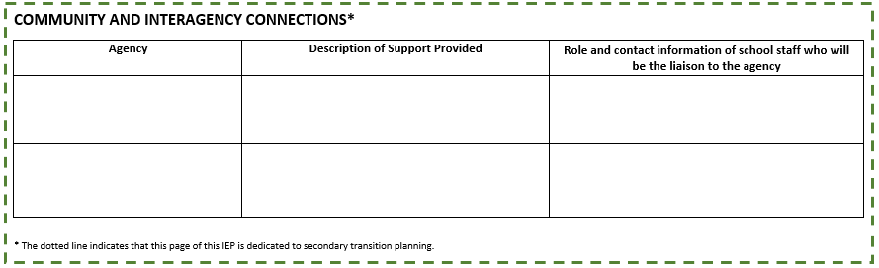

**Process Flowchart**

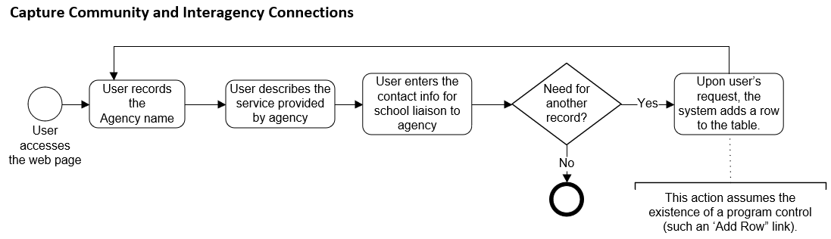 **Interface Description**

1. The system shall display the title “**COMMUNITY AND INTERAGENCY CONNECTIONS\***” as shown on the mockup screen.
2. The system shall enable users to enter agency information in a 3-row, 3-column table, including column headers.
   1. First row: The column headers of the grid are center-aligned and labeled as follows:
      1. Header for column 1 – “Agency”,
      2. Header for column 2 – “Description of Support Provided”, and
      3. Header for column 3 – “Role and contact information of school staff who will be the liaison to the agency”.
   2. The system shall enable the user to enter information into the rows of the table for each related column.
3. The user shall have the ability to add a new row to the grid to track additional agency information, as needed.
4. The application shall display the footnote labeled, “* The dotted line indicates that this page of this IEP is dedicated to secondary transition planning.”
5. The system shall display the left-centered footer, “Massachusetts DESE Individualized Education Program”, in typeface and weight that conform to the mockup document shared by DESE.
6. The user shall have the ability to save data entered/edited.
7. Upon accessing that screen, the system shall display any information previously saved.
8. Optionally, the system could issue notifications to the IEP team lead ahead of time as a reminder to this task.
9. Optionally, the system could enable the user to upload/remove relevant attachments to/from this screen (e.g., communication with community and agencies).

**Acceptance Criteria**

Verify the following:

1. The title, texts, and prompt are properly displayed, as shown on the mockup screen.
2. The user is able to enter information in the rows.
3. The user is able to save the details.
4. On the table, the information about Agency, Service Provided, and Contact Staff is not required. However,
   1. If the user provides data for one cell in a row, they are required to provide data for the two other cells.
      1. Values of “N/A” are acceptable.

**Validation Messages**

If any required fields are left incomplete, the system should provide appropriate and applicable notification with instructions for the user to help rectify the issue.

## User Story – Document the Transfer of Rights to Student

As the authorized user, I need to record the dates the notices of transfer of rights were provided to student and parent(s), so that I can better tailor the IEP implementation process to the student’s needs.

The data elements associated with this user story and further details are provided in section “TRANSFER OF RIGHTS TO STUDENT” of the companion Excel file.

**Mockup Screen**

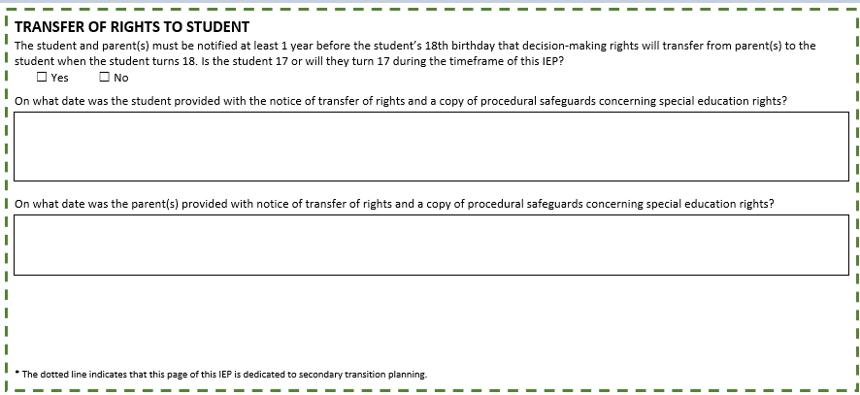

**Process Flowchart**

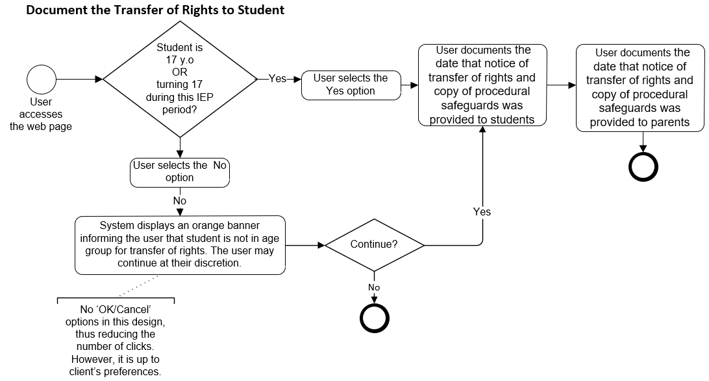

**Conditions**

This user story is valid under the conditions below:

The student is:

* 1. Aged 17 **OR**
  2. Will turn 17 during this IEP period.

**Interface Description**

1. The system shall display the title “**TRANSFER OF RIGHTS TO STUDENT**” as shown on the mockup screen.
2. The system shall display the prompt, “The student and parent(s) must be notified at least 1 year before the student’s 18th birthday that decision-making rights will transfer from parent(s) to the student when the student turns 18. Is the student 17 or will they turn 17 during the timeframe of this IEP?”.
   1. The system shall display two (2) mutually exclusive checkboxes:
      1. One labeled “Yes”, the other labeled “No”.
      2. Related to the prompt above.
      3. Both are located on the same line.
      4. Neither checkbox is checked by default.
3. If the user selects the Yes option (student in targeted age range), the system shall display the following:
   1. The paragraph, “On what date was the student provided with the notice of transfer of rights and a copy of procedural safeguards concerning special education rights?”
   2. An input textbox to capture the date of notice of rights to student. Alternatively, the input textbox could be replaced by a calendar web part, which might minimize data entry error.
      1. Date format: MM/DD/YYYY
   3. The paragraph, “On what date was the parent(s) provided with notice of transfer of rights and a copy of procedural safeguards concerning special education rights?”.
   4. An input textbox to capture the date of notice of rights to parents. Alternatively, this could be replaced by a calendar web part, which will minimize data entry error.
      1. Date format: MM/DD/YYYY
   5. Both dates of notice are required.
4. If the user answers No the question (student not in targeted age range), the sections about the dates of transfer of rights notices above are not displayed.
5. If the user has previously selected the Yes option (student in targeted age range) and provided date information.
   1. If, later, the user changes their mind and selects the No option (student not in targeted age range),
6. The system shall warn the user about the loss of previously entered data and shall request that the user confirm the new choice.
7. If the user confirms the No option, verify that the application:
   1. Discards the information previously entered for dates of notice to student and date of notice to parent.
   2. Hides date-related sections.
8. The application shall display the footnote labeled, “* The dotted line indicates that this page of this IEP is dedicated to secondary transition planning.”
9. The system shall display the left-centered footer, “Massachusetts DESE Individualized Education Program”, in typeface and weight that conform to the mockup document shared by DESE.
10. Upon accessing that screen, the system shall display any information previously saved.
11. The user shall have the ability to save the data entered/edited.
12. Optionally, the system could enable the user to upload/remove relevant attachments to/from this screen (e.g., acknowledgements of receipt from student or parents)

**Acceptance Criteria**

Verify the following:

1. The title, text paragraphs, and prompt are properly displayed, as shown on the mockup screen.
2. The student’s age requirement is met.
   1. However, if the age requirement is not met:
3. The system shall display an orange banner informing the user that the student is not in age group for transfer of rights.
4. The user may continue at their discretion. (A set of controls (Yes/No, OK/Cancel) is not designed to reduce the number of clicks. However, the final decision is up to the client district and their implementor)
5. If the user selects the Yes option, verify that:
   1. The user is able to capture date information, as necessary.
6. Date information shall be in “MM/DD/YYYY” format.
7. The user is able to save the information they have entered.
8. Upon saving, if the user has selected the Yes option, verify that the required data items have been provided.

**Validation Messages**

If any required fields are left incomplete, the system should provide appropriate and applicable notification with instructions for the user to help rectify the issue.

## User Story – Capture Decision-Making Options for Student and Track Transition to Adult Service Agency

The two (2) activities mentioned in the title of this story are on the same page of the mockup. In this document, they will be split into 2 different sub-stories: 1) Set Decision-Making Options for Student, and 2) Track Transition to Adult Service Agency, to avoid the elaboration of a long user story. The presentation herein is not intended to influence the way the larger story will be implemented in the software.

**Mockup Screen**

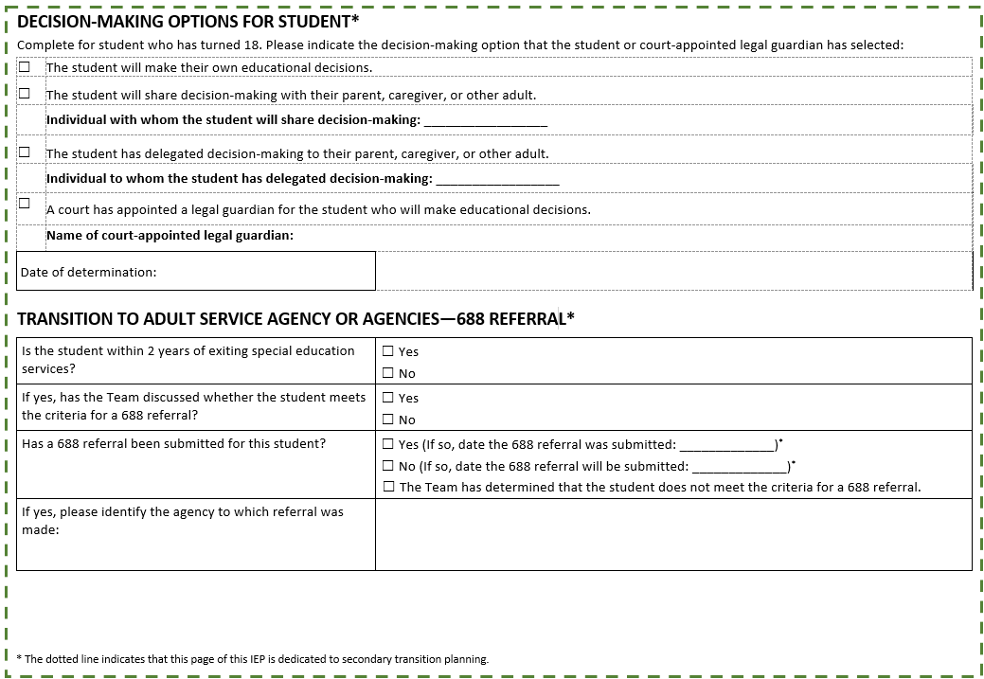

### User Story – Capture Decision-Making Options for Student

As the authorized user, I need to record the decision options determined by the student that has turned 18 or will turn 18 within the IEP period, so that I can better tailor the IEP implementation process to the student’s needs.

The data elements associated with this user story and further details are provided in section “DECISION-MAKING OPTIONS FOR STUDENT” of the companion Excel file.

**Mockup Screen**

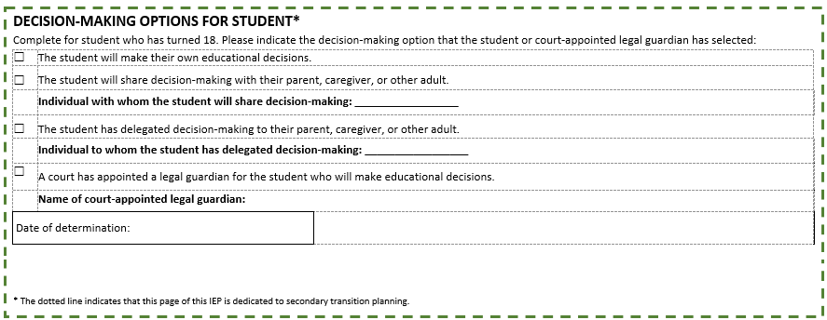

**Process Flowchart**

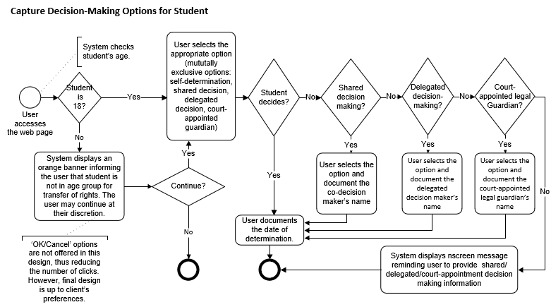

**Interface Description**

1. The system shall display the title “**DECISION-MAKING OPTIONS FOR STUDENT\***” as shown on the mockup screen.
2. The system shall display, in appropriate font, the prompt, “Complete for student who has turned 18. Please indicate the decision-making option that the student or court-appointed legal guardian has selected:”.
3. The system shall display four (4) mutually exclusive checkboxes:
   1. A checkbox labeled “The student will make their own educational decisions.”
   2. A checkbox labeled “The student will share decision-making with their parent, caregiver, or other adult.”
4. If the user selects this option (decision-sharing), the system shall display, below that paragraph,
   * + The prompt “Individual with whom the student will share decision-making:”
     + A corresponding input textbox.
   1. A checkbox labeled, “The student has delegated decision-making to their parent, caregiver, or other adult.”
   2. If the user selects this option (delegation), the system shall display, below the paragraph,
      * The prompt “Individual to whom the student has delegated decision-making:”
      * A corresponding input textbox.
   3. A checkbox labeled “A court has appointed a legal guardian for the student who will make educational decisions.”
5. If the user selects this option (court appointed guardian), the system shall display, below that checkbox,
   * + The prompt “Name of court-appointed legal guardian:”
     + A corresponding input textbox.
6. The user is required to select one of the four (4) mutually exclusive checkboxes.
7. The system shall display the following:
8. The prompt, “Date of determination:”
9. A corresponding textbox where the user can record the date of determination. Alternatively, the system could provide a calendar web part.
   * 1. The date format is MM/DD/YYYY.
10. The application shall display the footnote labeled, “* The dotted line indicates that this page of this IEP is dedicated to secondary transition planning.”
11. The system shall display the left-centered footer, “Massachusetts DESE Individualized Education Program”, in typeface and weight that conform to the mockup document shared by DESE.
12. As the user accesses the webpage, the system will determine the age of the student from existing data:
    * If the student is less than 18, the system will display an orange banner informing the user that student is not in age group for transfer of rights.
    * The user may continue at their discretion. (A set of controls (Yes/No, OK/Cancel) is not designed to reduce the number of clicks. However, the final decision is up to the client district and their implementor)
13. The user shall have the ability to save the data entered/edited.
14. Upon accessing that screen, the system shall display any information previously saved.
15. Optionally, the system could send notifications to the IEP team leader ahead of time to remind them of this task.
16. Optionally, the system could enable the user to upload/remove relevant attachments to/from this screen.

**Acceptance Criteria**

Verify the following:

1. The title, text paragraphs, prompts, and labels are properly displayed, as shown on the mockup screen.
2. A user may decide, at their discretion, to capture the information for students younger than 18 years old.
3. The system controls (mutually exclusive checkboxes) and related labels, and that the user can select/unselect the controls are functional.
4. The checkboxes are mutually exclusive, and only one checkbox can be selected.
5. If the user selects the “The student will share decision-making with their parent, caregiver or other adult.”,
   1. The prompt “Individual with whom the student will share decision-making:” and its related input textbox are displayed.
      1. The user is able to enter the contact information in the textbox.
6. If the user selects the “The student will share decision-making with their parent, caregiver or other adult.”,
   1. The prompt “Individual with whom the student will share decision-making:” and its related input textbox are displayed.
      1. The user is able to enter the contact information in the textbox.
7. If the user selects the “Name of court-appointed legal guardian:”,
   1. The prompt “Name of court-appointed legal guardian:” and its related input textbox are displayed.
      1. The user is able to enter the contact information in the textbox.
8. In the “shared decision-making” scenario, If the user has previously selected the Yes checkbox option and provided contact information,
   1. If, later, the user changes their mind and selects the No option:
      1. The system shall warn the user about the loss of previously entered data and shall request that the user confirm the new choice.
      2. If the user confirms the No option, the application clears the contact information of the individual involved in shared decision-making.
9. In the “delegated decision-making” scenario, if the user has previously selected the Yes checkbox option and provided contact information,
   1. If, later, the user changes their mind and selects the No option:
      1. The system shall warn the user about the loss of previously entered data and shall request that the user confirm the new choice.
      2. If the user confirms the No option, the application clears the contact information of the individual involved in delegated decision-making.
10. In the “shared court-appointed guardianship” scenario, if the user has previously selected the Yes checkbox option and provided guardian’s contact information.
    1. If, later, the user changes their mind and selects the No option,
       1. The system shall warn the user about the loss of previously entered data and shall request that the user confirm the new choice.
       2. If the user confirms the No option, the application clears the contact information of the court-appointed guardian.
11. If the age conditions are met, the user has selected one decision-making option.
12. The user has provided a valid date of determination of “MM/DD/YYYY” format.
13. The user is able to save the details.
14. Upon saving, verify that all requirements are fulfilled, as per narrative above.

**Validation Messages**

If any required fields are left incomplete, the system should provide appropriate and applicable notification with instructions for the user to help rectify the issue.

### User Story – Capture the Transition to Adult Service Agency or Agencies

As the authorized user, I need to capture information related to the student’s transition to adult service agency (or 688-Referral), so that I can better tailor the IEP development process to the student’s needs.

The data elements associated with this user story and further details are provided in section “TRANSITION TO ADULT SERVICE AGENCY OR AGENCIES - 688 REFERRAL” of the companion Excel file.

**Mockup Screen**

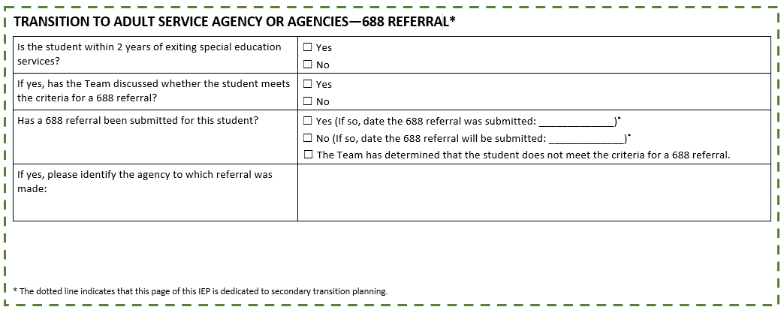

**Process Flowchart**

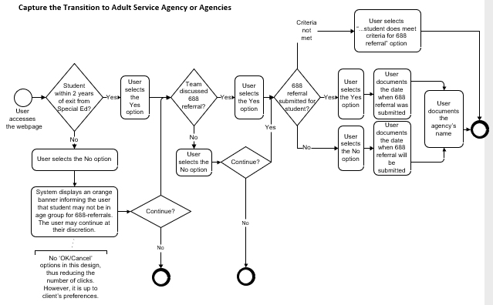

**Conditions**

The student is within two years of exiting the special education services.

**Interface Description**

1. The system shall display the title “**TRANSITION TO ADULT SERVICE AGENCY OR AGENCIES—688 REFERRAL\***” as shown on the mockup screen.
2. The system shall display a 2-column table format, the following information:
   1. Row 1, Column 1 - In appropriate font, the prompt, “Is the student within 2 years of exiting special education services?”
   2. Row 1, Column 2 - Two (2) mutually exclusive checkboxes
      1. One labeled “Yes”, the other labeled “No”.
      2. Related to the timeframe to exit prompt above.
      3. The checkboxes are located on different lines.
      4. Neither checkbox is checked by default.
   3. Row 2, Column 1 – The prompt, “If yes, has the Team discussed whether the student meets the criteria for a 688 referral?”
   4. Row 2, Column 2 - A set of two mutually exclusive checkboxes,
      1. One labeled “Yes”, the other labeled “No”.
      2. Related to the 688 Referral above.
      3. The checkboxes are located on different lines.
      4. Neither checkbox is checked by default.
   5. Row 3, Column 1 - The prompt, “Has a 688 referral been submitted for this student?”
   6. Row 3, Column 2 - A set of three mutually exclusive and stacked checkboxes, labeled as follows:
      1. “Yes (If so, date the 688 referral was submitted:”
         * On the same line as the checkbox above, the system shall display an input text area to capture the date in “MM/DD/YYYY” format. Alternatively, the system could use a calendar web part.
         * The label “*.)”
      2. “No (If so, date the 688 referral will be submitted:”
         * On the same line as the checkbox above, the system shall display an input text area to capture the date in “MM/DD/YYYY” format. Alternatively, the system could use a calendar web part.
         * The label “*.)”
      3. “The Team has determined that the student does not meet the criteria for a 688 referral.”
   7. Row 4, Column 1 - The prompt, “If yes, please identify the agency to which referral was made:”
   8. Row 4, Column 2 - An input area to capture the agency name. (Note that, depending on the information systems available, this could be a dropdown of existing agencies).
3. To the question, “Has a 688 referral been submitted for this student?”, if the user selects the
   1. Yes option or No option, they are required to:
      * Enter a date.
      * Identify the agency to which referral was or will be made.
        + Values of “N/A” are acceptable.
4. The application shall display the footnote labeled, “* The dotted line indicates that this page of this IEP is dedicated to secondary transition planning.”
5. The system shall display the left-centered footer, “Massachusetts DESE Individualized Education Program”, in typeface and weight that conform to the mockup document shared by DESE.
6. As the user accesses the webpage, the system shall use existing data to determine if the student within 2 years of exiting special education services:
   1. If the requirement is not met, the system will display an orange banner informing the user that the student is not within 2 years of exiting the program.
   2. The user may continue at their discretion. (A set of controls (Yes/No, OK/Cancel) is not designed to reduce the number of clicks. However, the final decision is up to the client district and their implementor)
7. Upon accessing that screen, the system shall display any information previously saved.
8. The user shall have the ability to save the data entered/edited.
9. Optionally, the system could enable the user to upload/remove attachments (e.g., copies of letters sent to agencies).
10. Optionally, the system could issue notifications to the IEP team as reminder to this task.

**Acceptance Criteria**

Verify the following:

1. The student is within 2 years of exiting special education services. If condition is not met,
   1. The system shall display an appropriate error message.
2. The title, text paragraphs, and prompts are properly displayed, as shown on the mockup screen.
3. The system displays the mutually exclusive checkboxes controls and related labels, and that the user can select/unselect the controls.
4. The date information is a valid date and formatted as MM/DD/YYYY.
5. Concerning the prompt “Has a 688 referral been submitted for this student?”, if the user selects the option “No (If so, indicate the date by which the 688 referral will be submitted:”, the date that follows cannot be in the past.
6. The user is able to save the details.
7. Upon saving,
   1. If the user has selected the Yes option to the 688 referral prompt,
      1. The user has provided the date of 688 referral submission.
   2. If the user has selected the No option to the 688 referral prompt,
      1. The user has provided the future date of 688 referral submission.

**Validation Messages**

If any required fields are left incomplete, the system should provide appropriate and applicable notification with instructions for the user to help rectify the issue.

## User Story – Record Accommodations and Modifications

As the authorized user, I need to capture the Student and Parents’ concerns, so that I can better tailor the IEP development process to the student’s needs.

The data elements associated with this user story and further details are provided in section “ACCOMMODATIONS AND MODIFICATIONS” of the companion Excel file.

**Mockup Screen**

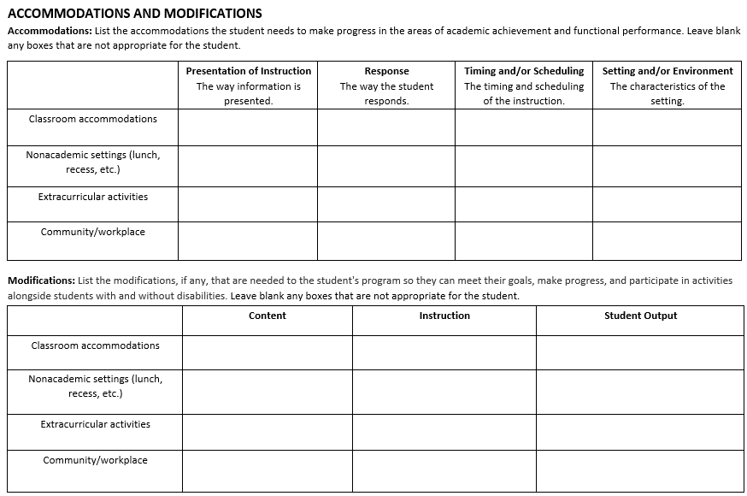

**Process Flowchart**

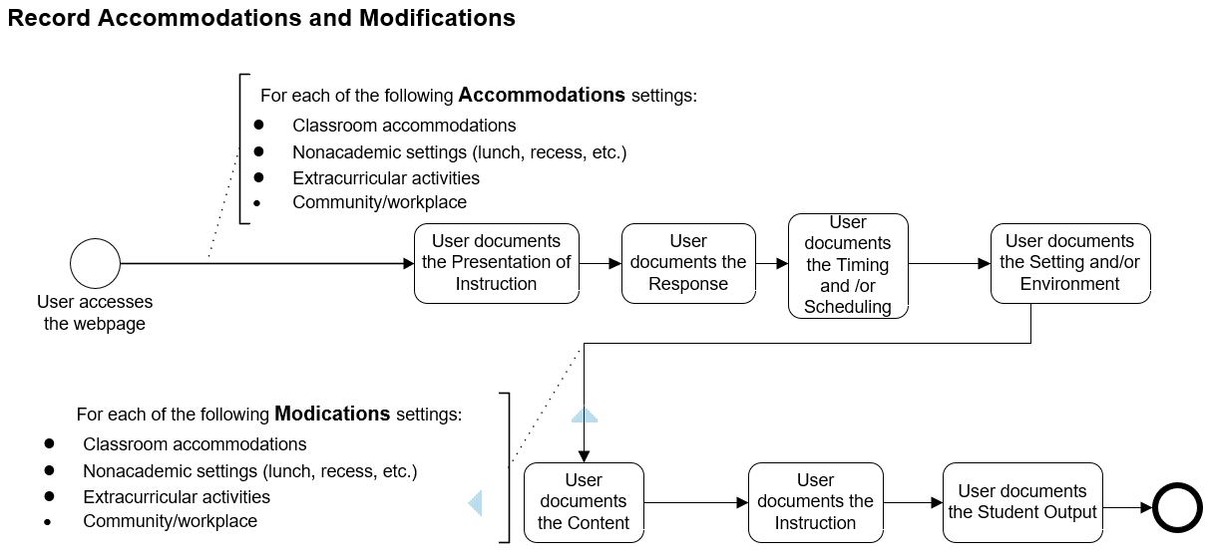

**Interface Description**

1. The system shall display the title “**ACCOMMODATIONS AND MODIFICATIONS**” as shown on the mockup screen.

NOTE: Items 2 and 3 concern the Accommodations section.

1. The system shall display the text paragraph, “**Accommodations:** List the accommodations the student needs to make progress in the areas of academic achievement and functional performance. Leave blank any boxes that are not appropriate for the student.”
2. The system shall display a 5-row, 5-column table (Gantt Chart format), the top row containing the column headers, and the first column containing the row headers.
   1. Column headers:
      1. First column header:

The center-aligned text paragraph, “**Presentation of Instruction**”.

The center-aligned text paragraph, “The way information is presented.”

* + 1. Second column header:

The center-aligned text paragraph, “**Response**”.

The center-aligned text paragraph, “The way the student responds.”

* + 1. Third column header:

The center-aligned text paragraph, “**Timing and/or Scheduling**”.

The center-aligned text paragraph, “The timing and scheduling of the instruction.”

* + 1. Fourth column header:

The center-aligned text paragraph, “**Setting and/or Environment**”.

The center-aligned text paragraph, “The characteristics of the setting.”

* 1. Row headers:
     1. First row header: the center-aligned phrase “Classroom accommodations”.
     2. Second row header: the center-aligned phrase “Nonacademic settings (lunch, recess, etc.)”.
     3. Third row header: the center-aligned phrase “Extracurricular activities”.
     4. Fourth row header: the center-aligned phrase “Community/workplace”.
  2. Row cells:
     1. The row cells, located at the intersection of a column header and a row header, shall be used as input area to capture user-supplied information.

NOTE: Items 4 and 5 concern the Modifications section.

1. Below the Accommodations table, the system shall display the text paragraph “**Modifications:**List the modifications, if any, that are needed to the student's program so they can meet their goals, make progress, and participate in activities alongside students with and without disabilities. Leave blank any boxes that are not appropriate for the student.”
2. The system shall display a 5-row, 5-column table (Gantt Chart format), the top row containing the column headers, and the first column containing the row headers.
   1. Column headers:
      1. First column: the center-aligned word “**Content**”.
      2. Second column: the center-aligned word “**Instruction**”.
      3. Third column: the center-aligned phrase “**Student Output**”.
   2. Row headers:
      1. First row: the center-aligned phrase “Classroom accommodations”
      2. Second row: the center-aligned phrase “Nonacademic settings (lunch, recess, etc.)”
      3. Third row: the center-aligned phrase “Extracurricular activities”.
      4. Fourth row: the center-aligned phrase “Community/workplace”.
   3. Row cells:
      1. The row cells, located at the intersection of a column header and a row header, shall be used as input area to capture user-supplied information.
3. Each student requires, at least, one accommodation. In other terms, the user is required to fill out information for one or more cells of the accommodation table.
4. Each student requires, at least, one modification. In other terms, the user is required to fill out information for one or more cells of the modification table.
5. In both tables, the content of one cell is independent from the content of the cells around it. For example, a student may need Classroom Accommodations for Response but may not need Classroom Accommodations for Timing and/or Scheduling.
6. The system shall display the left-centered footer, “Massachusetts DESE Individualized Education Program”, in typeface and weight that conform to the mockup document shared by DESE.
7. The user shall have the ability to enter information in any of the row cells.
8. Upon accessing that screen, the system shall display any information previously saved.
9. The user shall have the ability to save the data entered/edited.

**Acceptance Criteria**

Verify the following:

1. The title, text paragraphs, labels, and prompts are properly displayed, as shown on the mockup screen.
2. Verify that the two main sub-sections Accommodations and Modifications are clearly displayed.
3. The user is able to enter information in the cells of the accommodation section.
4. The user is able to enter information in the cells of the accommodation section.
5. The user is able to save the details.
6. The user has entered at least one accommodation.
7. The user has entered at least one modification.

**Validation Messages**

If any required fields are left incomplete, the system should provide appropriate and applicable notification with instructions for the user to help rectify the issue.

## User Story – Document the Statewide or Districtwide Assessments

As the authorized user, I need to capture the Student and Parents’ concerns, so that I can better tailor the IEP development process to the student’s needs.

The data elements associated with this user story and further details are provided in section “STATE AND/OR DISTRICTWIDE ASSESSMENT/ALTERNATE ASSESSMENT” of the companion Excel file.

**Mockup Screen**

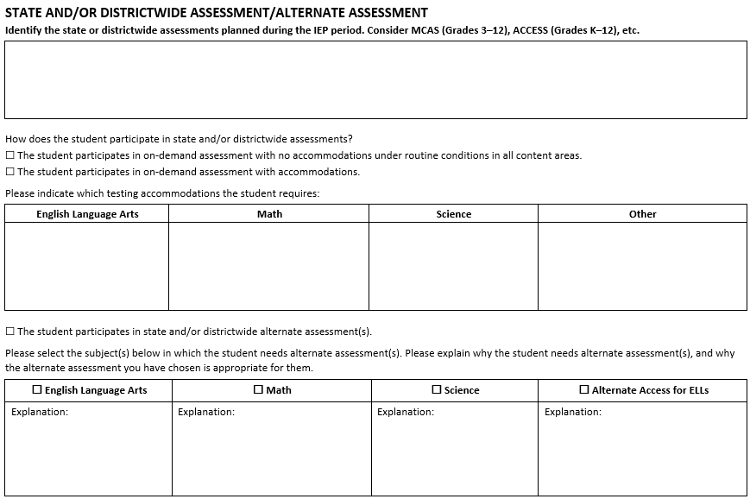

**Process Flowchart**

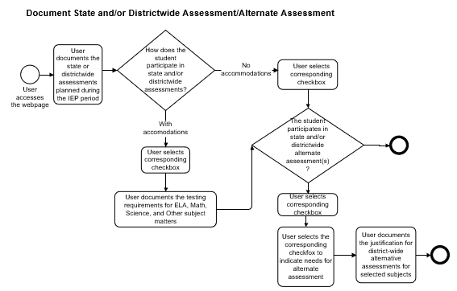

**Interface Description**

1. The system shall display the title “**STATE AND/OR DISTRICTWIDE ASSESSMENT/ALTERNATE ASSESSMENT**” as shown on the mockup screen.
2. The system shall display the prompt/text paragraph, “**Identify the state or districtwide assessments planned during the IEP period. Consider MCAS (Grades 3–12), ACCESS (Grades K–12), etc.**”
3. The system shall display an input area to capture the state or districtwide assessments planned during the IEP period.
   1. This information is required. Values of “N/A” are acceptable.
4. The system shall display the prompt, “How does the student participate in state and/or districtwide assessments?”
5. The system shall display the two (2) stacked checkboxes labeled as follows:
   1. Checkbox 1: “The student participates in on-demand assessment with no accommodations under routine conditions in all content areas.”.
   2. Checkbox 2: “The student participates in on-demand assessment with accommodations.”.
   3. Checkbox 3 labeled, “The student participates in state and/or districtwide alternate assessment(s).”
6. Checkbox selection exclusivity constraints:
   1. Checkbox 1 (on-demand assessment with no accommodations) cannot be selected at the same time as checkbox 2 (on-demand assessment with accommodations).
   2. Checkbox 3 (state and/or districtwide alternate assessments) can be selected along with either Checkbox 1 (on-demand assessment with no accommodations) or Checkbox 2 (on-demand assessment with accommodations).
7. If the user selects second checkbox to indicate participation in on-demand assessment with accommodation, the system shall display the following, below that checkbox:
   1. The paragraph, “Please indicate which testing accommodations the student requires:”
   2. A 2-row, 4-column table structure.
      * + The first row contains the column headers that are labeled as follows:
          - Column 1: “English Language Arts”.
          - Column 2: “Math”.
          - Column 3: “Science”.
          - Column 4: “Other”.
        + The second row contains cells that serve as input area for user-supplied information.
   3. The user is required to provide testing accommodations information for, at least, one of the subject areas, including “Other”.
8. If the user selects Checkbox 3, indicating participation in alternate assessments, the system shall display the following:
   1. The paragraph, “Please select the subject(s) below in which the student needs alternate assessment(s). Please explain why the student needs alternate assessment(s), and why the alternate assessment you have chosen is appropriate for them.”
   2. A 2-row, 4 column table.
      1. The top row contains the columns that are labeled as follows:
         * A checkbox labeled “English Language Arts”.
         * A checkbox labeled “Math”.
         * A checkbox labeled “Science”.
         * A checkbox labeled “Alternate Access for ELLs”.
      2. Each cell of the second row of the table displays:
         * The contained label “Explanation:”.
         * Below the contained label, is an input area for capturing user-provided information.
9. The user shall provide information for each subject whose checkbox is selected.
10. If the user had previously selected the option Yes to the “student participates in on-demand testing with accommodations” prompt and provided corresponding information, and
    1. The user changes their mind and selects another option (on-demand assessments without accommodations),
       1. The system shall warn the user about the loss of previously entered data and shall request that the user confirm the new choice.
       2. If the user confirms the newly selected option, the application discards the previous information.
11. The system shall display the left-centered footer, “Massachusetts DESE Individualized Education Program”, in typeface and weight that conform to the mockup document shared by DESE.
12. Upon accessing that screen, the system shall display any information previously saved.
13. The user shall have the ability to save the data entered/edited.

**Acceptance Criteria**

Verify the following:

1. The title, text paragraphs, prompts, and controls are properly displayed, as shown on the mockup screen.
2. The checkboxes exclusivity constraints are implemented.
3. The user is able to save the details.

**Validation Messages**

If any required fields are left incomplete, the system should provide appropriate and applicable notification with instructions for the user to help rectify the issue.

## User Story – Document the Measurable Annual Goals and Schedule of Progress Reporting

As the authorized user, I need to set measurable goals, so that I can better plan and track the student’s progress, using the IEP development tool.

The data elements associated with this user story and further details are provided in section “MEASURABLE ANNUAL GOALS” and “SCHEDULE OF PROGRESS REPORTING (of Annual Measurable Goals)” of the companion Excel file.

**Mockup Screen**

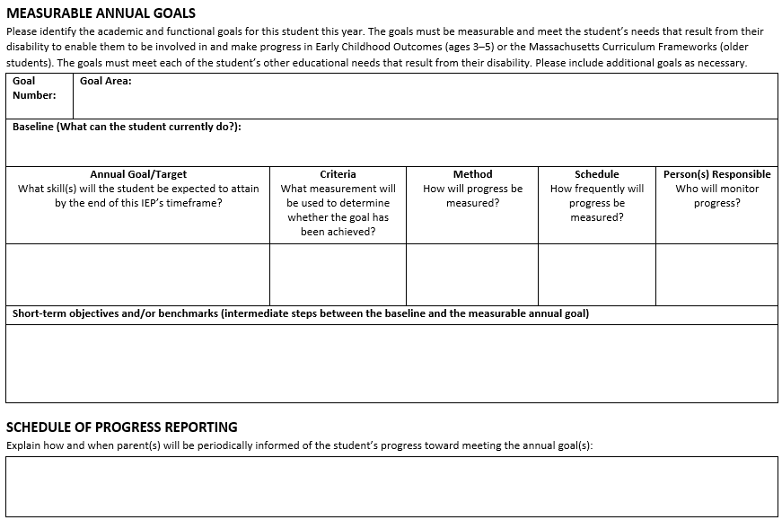

**Process Flowchart**

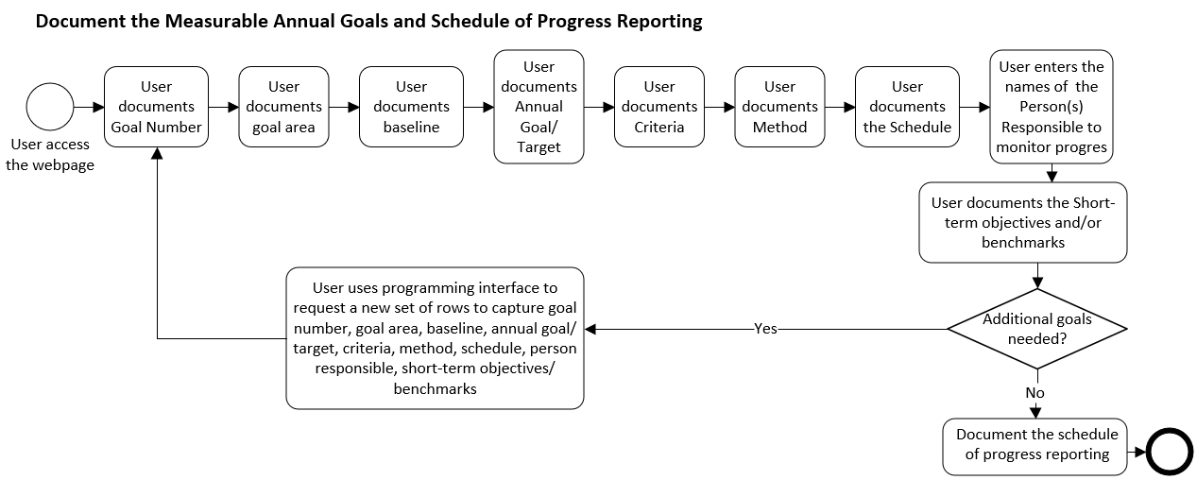

**Interface Description**

1. The system shall display the title “**MEASURABLE ANNUAL GOALS**” as shown on the mockup screen.
2. The system shall display the label “Please identify the academic and functional goals for this student this year. The goals must be measurable and meet the student’s needs that result from their disability to enable them to be involved in and make progress in Early Childhood Outcomes (ages 3–5) or the Massachusetts Curriculum Frameworks (older students). The goals must meet each of the student’s other educational needs that result from their disability. Please include additional goals as necessary.”
3. The user shall have the ability to enter multiple goals.

For each goal:

1. The system shall display a table structure that captures the information for one goal:
   1. The first row contains 2 cells:
      1. The first cell hosts the contained label “**Goal Number:** “ below which the user can capture the requested information.
      2. The second cell has the contained label “**Goal Area:**”, below which the user can capture the requested information.
   2. The second row consists of one cell with the following:
      1. The contained label “**Baseline (What can the student currently do?):”,**
      2. An input textbox or input area where the user can capture the requested information.
2. The system shall display a 2-row, 5-column table, including the column headers.
   1. First row, column header 1 –
      1. The center-aligned text paragraph, “Annual Goal/Target”.
      2. The center-aligned text paragraph, “What skill(s) will the student be expected to attain by the end of this IEP’s timeframe?”.
   2. First row, column header 2 –
      1. The center-aligned text paragraph, “Criteria”.
      2. The center-aligned text paragraph, “What measurement will be used to determine whether the goal has been achieved?”
   3. First row, column header 3 –
      1. The center-aligned text paragraph, “Method”.
      2. The center-aligned text paragraph, “How will progress be measured?”.
   4. First row, column header 4 –
      1. The center-aligned text paragraph, “Schedule”.
      2. The center-aligned text paragraph, “How frequently will progress be measured?”.
   5. First row, column header 5 –
      1. The center-aligned text paragraph, “Person(s) Responsible”.
      2. The center-aligned text paragraph, “Who will monitor progress?”.
   6. Second row cells are input areas where the user captures the information corresponding to the column headers.
3. The system shall display the following:
   1. The prompt “**Short-term objectives and/or benchmarks (intermediate steps between the baseline and the measurable annual goal)** and a corresponding input textbox to capture the short-term objectives.
   2. Below the prompt, an input area where the user enters the requested information.

End of “for each goal” statement.

1. The system shall provide the user with the ability to add a new goal, as delineated in items 4 through 6 above.
2. The system shall display the following:
   1. The title “**SCHEDULE OF PROGRESS REPORTING**”
   2. The prompt, “Explain how and when parent(s) will be periodically informed of the student’s progress toward meeting the annual goal(s):”
   3. An input textbox/area to capture the schedule of progress reporting information.
   4. The left-centered footer, “Massachusetts DESE Individualized Education Program”, in typeface and weight that conform to the mockup document shared by DESE.
3. The user is required to provide the following:
   1. At least one measurable goal for the student.
   2. Short-term objectives and/or benchmarks if they enter at least one measurable goal.
   3. Information about the schedule of reporting.
   4. Information for every input field.
      1. Values of “N/A” are acceptable.
4. Upon accessing that screen, the system shall display any information previously saved.
5. The user shall have the ability to save the data entered/edited.

**Acceptance Criteria**

Verify the following:

1. The title, text paragraphs, and prompts are properly displayed, as shown on the mockup screen.
2. The prompts and input textboxes within each section are displayed.
3. The user is able to enter information in the input textboxes and editable table cells.
4. The user has provided all required input.
5. The user is able to save the details.

**Validation Messages**

If any required fields are left incomplete, the system should provide appropriate and applicable notification with instructions for the user to help rectify the issue.

## User Story – Capture Participation in the General Education Setting

As the authorized user, I need the ability to plan the student’s participation in the general education setting, so that I can better tailor the IEP development process to the student’s needs.

The data elements associated with this user story and further details are provided in section “PARTICIPATION IN THE GENERAL EDUCATION SETTING” of the companion Excel file.

**Mockup Screen**

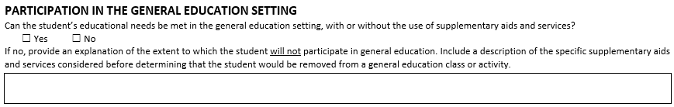

**Process Flowchart**

Not provided

**Interface Description**

1. The system shall display:
   1. The title “**PARTICIPATION IN THE GENERAL EDUCATION SETTING**” as shown on the mockup screen.
   2. The prompt “Can the student’s educational needs be met in the general education setting, with or without the use of supplementary aids and services?”
   3. Two (2) mutually exclusive checkboxes
      1. One labeled “Yes”, the other labeled “No”.
      2. Both are located on the same line.
      3. Neither checkbox is checked by default.
2. If the user selects the No option (student’s educational needs be met in the general education setting),
   1. The system shall display:
      1. The prompt, “If no, provide an explanation of the extent to which the student will not participate in general education. Include a description of the specific supplementary aids and services considered before determining that the student would be removed from a general education class or activity*.*”
      2. An input textbox/text area to capture the required explanation and description of supplementary aids/services.
3. If the user selects the Yes option, the prompt and related input textbox (item 2 above) are not displayed.
4. If the user previously selected the No option and captured the related explanation, and
   1. If the user, later, selects the Yes option, the system shall warn the user about the loss of previously entered data and shall request that the user confirm the new choice.
   2. If the user confirms the Yes option, the system shall discard the value entered in the textbox/text area.
5. The system shall display the left-centered footer, “Massachusetts DESE Individualized Education Program”, in typeface and weight that conform to the mockup document shared by DESE.
6. Upon accessing that screen, the system shall display any information previously saved.
7. The user shall have the ability to save the data entered/edited.

**Acceptance Criteria**

Verify the following:

1. The title, text paragraphs, and prompt are properly displayed, as shown on the mockup screen.
2. If the user selected the No option, they have provided an explanation in the text area.
3. The user is able to save the details.

**Validation Messages**

If any required fields are left incomplete, the system should provide appropriate and applicable notification with instructions for the user to help rectify the issue.

## User Story – Document Service Delivery

As the authorized user, I need to plan service delivery for the student, so that I can better tailor the IEP execution process to the student’s needs.

The data elements associated with this user story and further details are provided in section “SERVICE DELIVERY” of the companion Excel file.

**Mockup Screen**

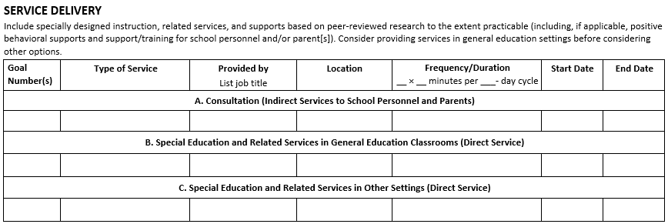

**Process Flowchart**

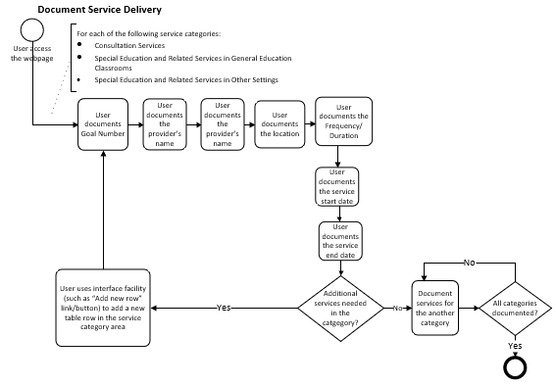 **Interface Description**

1. The system shall display the title “**SERVICE DELIVERY**” as shown on the mockup screen.
2. The system shall display the paragraph, “Include specially designed instruction, related services, and supports based on peer-reviewed research to the extent practicable (including, if applicable, positive behavioral supports and support/training for school personnel and/or parent(s)). Consider providing services in general education settings before considering other options.”
3. The system shall display a 7-column table structure. The column headers are labeled as follows:
   1. First column: **“Goal Number(s):** “
   2. Second column:the center-aligned paragraph, “**Type of Service”.**
   3. Third column:the center-aligned paragraph, “**Provided by”.**

New center-aligned paragraph, “List job title”.

* 1. Fourth column:the center-aligned paragraph, “**Location”.**
  2. Fifth column: the center-aligned paragraph, “**Frequency/Duration**”.

New center-aligned paragraph, “__ × __ minutes per ___- day cycle”.

* 1. Fifth column: **“Start Date**”**.** 
     1. Format MM/DD/YYYY. Alternatively, the system could display a calendar web part.
  2. Seventh Column: “**End Date**”**.** 
     1. Format MM/DD/YYYY. Alternatively, the system could display a calendar web part.

1. The user shall have the ability to capture the seven (7) information items (corresponding to the headers) for 3 categories of services:
   1. A. Consultation (Indirect Services to School Personnel and Parents).
   2. B. Special Education and Related Services in General Education Classrooms (Direct Service).
   3. C. Special Education and Related Services in Other Settings (Direct Service).
2. A category of service may contain one or more services.
3. The user shall have the ability to add rows to each category of service, so that they can record new services within the category.
4. The system shall display the left-centered footer, “Massachusetts DESE Individualized Education Program”, in typeface and weight that conform to the mockup document shared by DESE.
5. The user is required to provide information for one service at least.
6. Upon accessing that screen, the system shall display any information previously saved.
7. The user shall have the ability to save the data entered/edited.

**Acceptance Criteria**

Verify the following:

1. The title, text paragraphs, and prompt are properly displayed, as shown on the mockup screen.
2. The user is able to enter information in the table rows.
3. The user can add rows to the table, if needed.
4. The user has provided information for one service at least.
5. The user is able to save the information entered.

**Validation Messages**

If any required fields are left incomplete, the system should provide appropriate and applicable notification with instructions for the user to help rectify the issue.

## User Story – Document Transportation Services

As the authorized user, I need to capture information about the student’s needs in terms of transportation services, so that I can better tailor the IEP development process to the student’s needs.

The data elements associated with this user story and further details are provided in section “TRANSPORTATION SERVICES” of the companion Excel file.

**Mockup Screen**

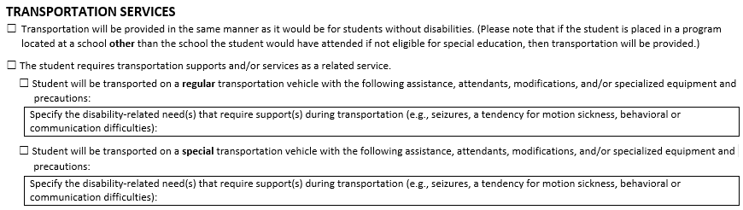

**Process Flowchart**

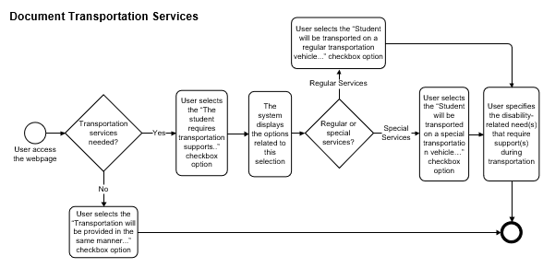

**Interface Description**

1. The system shall display the title “**Transportation Services**”.
2. The system shall display the following two (2) top-level mutually exclusive checkboxes, neither control be checked by default:
   1. Checkbox labeled, “Transportation will be provided in the same manner as it would be for students without disabilities. (Please note that if the student is placed in a program located at a school **other** than the school the student would have attended if not eligible for special education, then transportation will be provided.).”
   2. Checkbox labeled, “The student requires transportation supports and/or services as a related service.”
   3. Neither checkbox is checked by default.
3. If the user “checks on” this second checkbox (student requires transportation supports),
   1. The system shall display another set of secondary mutually exclusive checkboxes:
      1. Checkbox labeled “Student will be transported on a **regular** transportation vehicle with the following assistance, attendants, modifications, and/or specialized equipment and precautions:”
      2. Checkbox labeled “Student will be transported on a **special** transportation vehicle with the following assistance, attendants, modifications, and/or specialized equipment and precautions.”
   2. If the user selects the “Student will be transported on a **regular** transportation…” option of the secondary mutually exclusive checkboxes,
      1. The system shall display, below the checkbox, the following:
         * The prompt, “Specify the disability-related need(s) that require support(s) during transportation (e.g., seizures, a tendency for motion sickness, behavioral or communication difficulties):”.
         * An input textbox to capture the disability-related needs for regular transportation.
   3. If the user selects the “Student will be transported on a **special** transportation vehicle…” option of the secondary mutually exclusive checkboxes,
      1. The system shall display, below the checkbox, the following:
         * The prompt, “Specify the disability-related need(s) that require support(s) during transportation (e.g., seizures, a tendency for motion sickness, behavioral or communication difficulties):”.
         * An input textbox to capture the disability-related needs for special transportation.
4. If the user selects that student requires transportation supports and/or services as a related service (second top-level checkbox), they are required to select the type of transportation (regular vs. special) from the secondary checkboxes and provide the justification for the type of transportation.
5. If the user previously indicated that “the student requires transportation as a related service” (second option of the top-level mutually exclusive checkboxes) and captured secondary level information and,
   1. If the user, later, selects the first of the top-level mutually exclusive checkboxes, indicating that “transportation will be provided in the same manner as it would be for students without disabilities”:
      1. The system shall warn the user about the loss of previously entered data and shall request that the user confirm the new choice.
      2. If the user confirms their new selection, the application discards the transportation service information previously entered.
6. If the user previously selected the “**regular** transportation…” option of the secondary mutually exclusive checkboxes and captured disability-related needs and,
   1. If the user, later, changes their mind and selects the “**special** transportation vehicle…” option of the secondary mutually exclusive checkboxes,
      1. The system shall warn the user about the loss of previously entered data and shall request that the user confirm the new choice.
      2. If the user confirms their new selection, the application discards the needs information previously entered to justify regular transportation.
7. If the user previously selected the “**special** transportation…” option of the secondary mutually exclusive checkboxes and captured disability-related needs and,
   1. If the user, later, selects the “**regular** transportation vehicle…” option of the secondary mutually exclusive checkboxes,
      1. The system shall warn the user about the loss of previously entered data and shall request that the user confirm the new choice.
      2. If the user confirms their new selection, the application discards the needs information previously entered to justify special transportation.
8. The list of combinations regarding the switch of choice presented herein is not exhaustive.
9. The system shall display the left-centered footer, “Massachusetts DESE Individualized Education Program”, in typeface and weight that conform to the mockup document shared by DESE.
10. Upon accessing that screen, the system shall display any information previously saved.
11. The user shall have the ability to save the data entered/edited.

**Acceptance Criteria**

Verify the following:

1. The title, text paragraphs, and prompt are properly displayed, as shown on the mockup screen.
2. The control checkboxes are displayed and functional.
3. The hierarchical order of the information is respected.
4. The input textboxes, if any required, are properly displayed.
5. The input textboxes, if any required, are filled out with information.
6. The user is able to save the information entered.

**Validation Messages**

If any required fields are left incomplete, the system should provide appropriate and applicable notification with instructions for the user to help rectify the issue.

## User Story – Document Schedule Modification

As the authorized user, I need to capture schedule modifications, so that I can better tailor the IEP development process to the student’s needs.

The data elements associated with this user story and further details are provided in section “SCHEDULE MODIFICATION” of the companion Excel file.

**Mockup Screen**

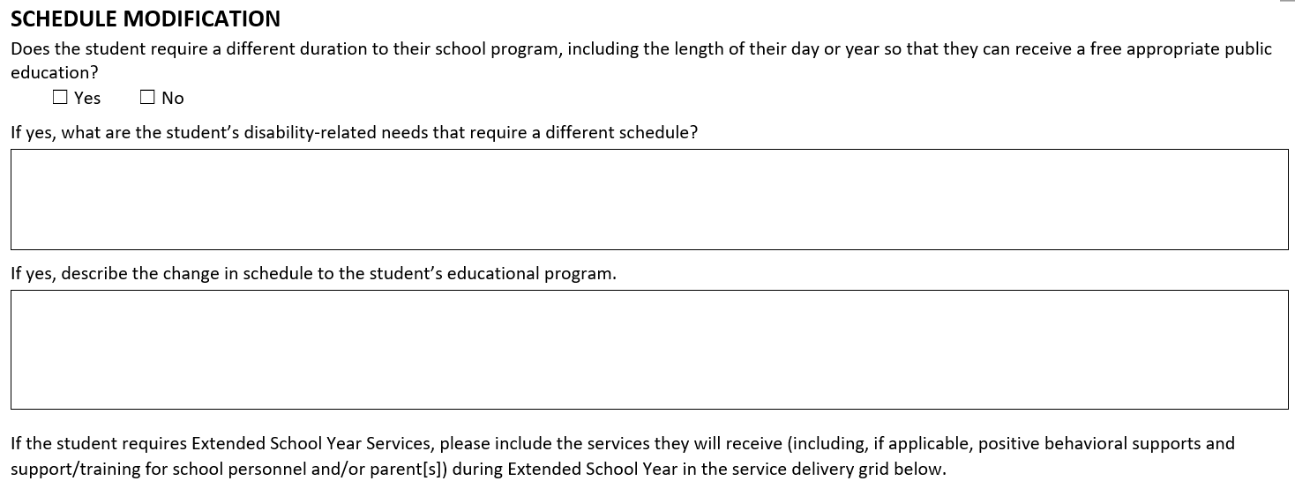

**Process Flowchart**

Not provided

**Interface Description**

1. The system shall display the title “**SCHEDULE MODIFICATION**”, as shown on the mockup screen.
2. The system shall display the prompt, “Does the student require a different duration to their school program, including the length of their day or year so that they can receive a free appropriate public education?”
3. The system shall display two (2) mutually exclusive checkboxes,
   1. One labeled “Yes”, the other labeled “No”.
   2. Both are located on the same line.
   3. Neither checkbox is checked by default.
   4. The user is required to select one of the checkboxes.
4. If the user selects the Yes option (student requires a different duration),
   1. The system shall display the following:
      1. The prompt, “If yes, what are the student’s disability-related needs that require a different schedule?”.
      2. An input textbox to capture the disability-related needs.
      3. The prompt, “If yes, describe the change in schedule to the student’s educational program.”
      4. An input textbox to capture the change in schedule information.
5. The system shall display the following text, “If the student requires Extended School Year Services, please include the services they will receive (including, if applicable, positive behavioral supports and support/training for school personnel and/or parent[s]) during Extended School Year in the service delivery grid below.”
6. The system shall display the left-centered footer, “Massachusetts DESE Individualized Education Program”, in typeface and weight that conform to the mockup document shared by DESE.
7. Upon accessing that screen, the system shall display any information previously saved.
8. The user shall have the ability to save the data entered/edited.

**Acceptance Criteria**

Verify the following:

1. The title, text paragraphs, and prompts are properly displayed, as shown on the mockup screen.
2. The control checkboxes are displayed and functional.
3. The input textbox, if any, is properly displayed.
4. The input textboxes are filled out if the user selects the Yes option.
5. If the user selects the Yes option (student requires a different duration),
   1. The disability-related needs information is required in the corresponding input textbox.
   2. The change in schedule information is required in the corresponding input textbox.
6. If the user selects the No option (student **does not** requires a different duration),
   1. The prompts and related input textboxes—related to the Yes option—are not displayed.
7. If the user previously selected the Yes option and captured the needs and change in schedule information
   1. If the user, later, selects the No option,
      1. The system shall warn the user about the loss of previously entered data and shall request that the user confirm the new choice.
      2. If the user confirms their No selection, the application discards the needs and change in schedule information previously entered.
8. The user is able to save the details.

**Validation Messages**

If any required fields are left incomplete, the system should provide appropriate and applicable notification with instructions for the user to help rectify the issue.

## User Story – Document Service delivery for extended school year (ESY)

As the authorized user, I need to plan service delivery for the student for extended school year, so that I can better tailor the IEP execution process to the student’s needs.

**Mockup Screen**

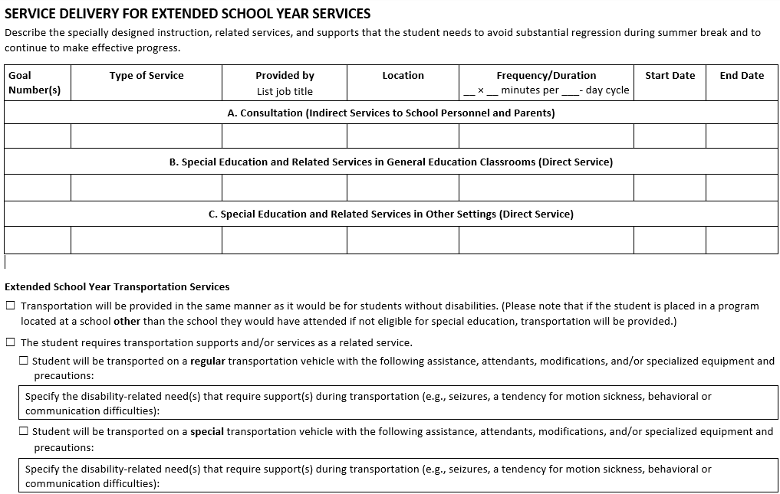

**Conditions**

If the student requires a schedule modification (see related story above)

The system shall allow the user to access this functionality and will display the interface described below.

Else:

The system shall not allow the user to access this functionality, nor display the interface described below.

For instance, if the user stories are listed on a navigation bar, the hyperlink to the “Service Delivery for Extended School Year Services” webpage will be:

* Enabled if the student requires a schedule modification.
* Disabled if the student does not require a schedule modification.

**Process Flowchart**

See process flowcharts for Document Service Delivery and “Document Transportation Services”.

**Interface Description**

1. The system shall display the title “**SERVICE DELIVERY FOR EXTENDED SCHOOL YEAR SERVICES**” as shown on the mockup screen.

The rest of interface is divided into 3 parts (or sub-units of user story) described below: a) the provisioning of education-related services, b) the provisioning of ESY transportation services, and c) the footer.

This first part of the interface captures the education-related services (direct and indirect services)

The data elements associated with this user story and further details are provided in section “ESY SERVICE DELIVERY” of the companion Excel file.

**Mockup Screen**

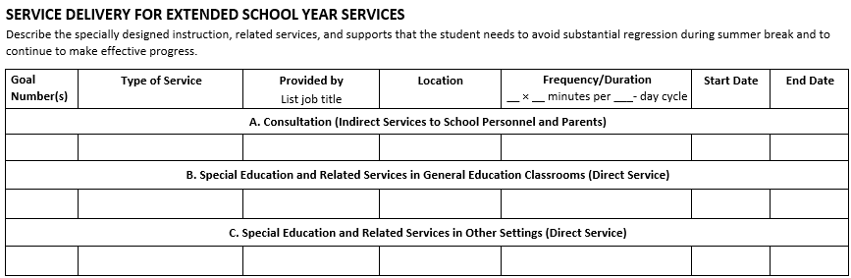

1. The system shall display the paragraph, “Describe the specially designed instruction, related services, and supports that the student needs to avoid substantial regression during summer break and to continue to make effective progress.”
2. The system shall display a 7-column table structure. The column headers are labeled as follows:
   1. First column: **“Goal Number(s):** “
   2. Second column:the center-aligned paragraph, “**Type of Service”**
   3. Third column:the center-aligned paragraph, “**Provided by”**

New center-aligned paragraph, “List job title”.

* 1. Fourth column:the center-aligned paragraph, “**Location”**
  2. Fifth column: the center-aligned paragraph, “**Frequency/Duration**”

New center-aligned paragraph, “__ × __ minutes per ___- day cycle”.

* 1. Fifth column: **“Start Date**”**.** 
     1. Format MM/DD/YYYY. Alternatively, the system could display a calendar web part.
  2. Seventh Column: “**End Date**”**.** 
     1. Format MM/DD/YYYY. Alternatively, the system could display a calendar web part.

1. The user shall have the ability to capture the seven (7) information items (corresponding to the headers) for 3 categories of services:
   1. A. Consultation (Indirect Services to School Personnel and Parents).
   2. B. Special Education and Related Services in General Education Classrooms (Direct Service).
   3. C. Special Education and Related Services in Other Settings (Direct Service).
2. A category of service may contain one or more services.
3. The user shall have the ability to add new services to each category of service.
4. For each category of service, the rows of the table capture the information about the column headers.
5. The user is required to provide information for, at least, one service.

End of first part of the interface.

This second part of the interface captures the transportation-related ESY services

The data elements associated with this user story and further details are provided in section “ESY TRANSPORTATION SERVICES” of the companion Excel file.

**Mockup Screen**

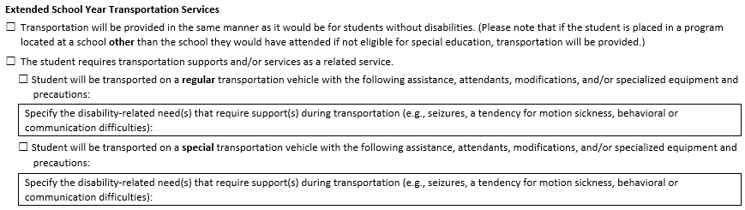

1. The system shall display the title “**Extended School Year Transportation Services**”.
2. The system shall display the following two (2) top-level or primary mutually exclusive checkboxes, neither checked by default:
   1. Checkbox labeled, “Transportation will be provided in the same manner as it would be for students without disabilities. (Please note that if the student is placed in a program located at a school **other** than the school they would have attended if not eligible for special education, transportation will be provided.).”
   2. Checkbox labeled, “The student requires transportation supports and/or services as a related service.”
3. If the user selects the second option (the student requires transportation supports…),
   1. The system shall display another set of secondary mutually exclusive checkboxes
      1. Checkbox labeled “Student will be transported on a **regular** transportation vehicle with the following assistance, attendants, modifications, and/or specialized equipment and precautions.”
      2. Checkbox labeled “Student will be transported on a **special** transportation vehicle with the following assistance, attendants, modifications, and/or specialized equipment and precautions.”
   2. If the user selects the “Student will be transported on a **regular** transportation…” option of the secondary checkboxes,
      1. The system shall display the following:
         * The prompt, “Specify the disability-related need(s) that require support(s) during transportation (e.g., seizures, a tendency for motion sickness, behavioral or communication difficulties):”
         * An input textbox to capture the disability-related needs.
   3. If the user selects the “Student will be transported on a **special** transportation vehicle…” option of the secondary checkbox,
      1. The system shall display the following:
         * The prompt, “Specify the disability-related need(s) that require support(s) during transportation (e.g., seizures, a tendency for motion sickness, behavioral or communication difficulties):”
         * An input textbox to capture the disability-related needs.
4. If the user previously indicated that “the student requires transportation as a related service” (second option of the top-level mutually exclusive checkboxes) and captured secondary level information and,
   1. If the user, later, selects the first of the top-level mutually exclusive checkboxes, indicating that “transportation will be provided in the same manner as it would be for students without disabilities”
      * The system shall warn the user about the loss of previously entered data and shall request that the user confirm the new choice.
      * If the user confirms their new selection, verify that the application discards the transportation service information previously entered.
5. If the user previously selected the “**regular** transportation…” option of the secondary mutually exclusive checkboxes and captured disability-related needs and,
   1. If the user, later, changes their mind and selects the “**special** transportation vehicle…” option of the secondary mutually exclusive checkboxes,
      * The system shall warn the user about the loss of previously entered data and shall request that the user confirm the new choice.
      * If the user confirms their new selection, verify that the application discards the needs information previously entered to justify regular transportation
6. If the user previously selected the “**special** transportation…” option of the secondary mutually exclusive checkboxes and captured disability-related needs and,
   1. If the user, later, selects the “**regular** transportation vehicle…” option of the secondary mutually exclusive checkboxes,
      * The system shall warn the user about the loss of previously entered data and shall request that the user confirm the new choice.
      * If the user confirms their new selection, verify that the application discards the needs information previously entered to justify special transportation.
7. The user shall have the ability to save the data entered/edited. The list of combinations regarding the switch of choice presented herein is not exhaustive.

End of second part of the interface.

This third part of the interface captures the footer

1. The system shall display the left-centered footer, “Massachusetts DESE Individualized Education Program”, in typeface and weight that conform to the mockup document shared by DESE.

Expected behavior:

1. Upon accessing that screen, the system shall display any information previously saved.
2. The user shall have the ability to save the data entered/edited.

**Acceptance Criteria**Verify that the title, prompts, paragraphs, and labels are correctly displayed.

1. The user is able to enter information in the table rows.
2. The user is able to save the details.
3. Verify that, upon accessing that screen, the system shall display any information previously saved.

**Validation Messages**

If any required fields are left incomplete, the system should provide appropriate and applicable notification with instructions for the user to help rectify the issue.

## User Story – Capture Additional Information

As the authorized user, I need to record additional information that is pertinent to the IEP implementation and not yet recorded, so that I can better tailor the IEP development process to the student’s needs.

The data elements associated with this user story and further details are provided in section “ADDITIONAL INFORMATION” of the companion Excel file.

**Mockup Screen**

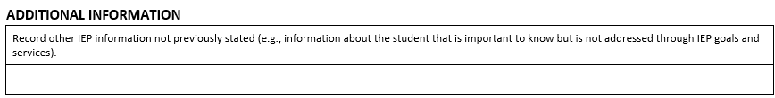

**Process Flowchart**

Not provided.

**Interface Description**

1. The system shall display the title “**ADDITIONAL INFORMATION**”.
2. The system shall display the prompt: “Record other IEP information not previously stated (e.g., information about the student that is important to know but is not addressed through IEP goals and services).”
3. The system shall display an input text area to capture the additional response. Note: the text may be extensive (about 1 page).
4. The system shall display the left-centered footer, “Massachusetts DESE Individualized Education Program”, in typeface and weight that conform to the mockup document shared by DESE.
5. The user is not required to enter additional information.
6. Upon accessing that screen, the system shall display any information previously saved.
7. The user shall have the ability to save the data entered/edited.

**Acceptance Criteria**

Verify the following:

1. The title, text paragraphs, and prompts are properly displayed, as shown on the mockup screen.
2. Verify that the input textbox information is not required.
3. The user is able to save the details.

**Validation Messages**

None.

## User Story – Record Decision Maker’s Response

As the authorized user, I need to capture the parent, student, or guardian’s response to the IEP proposal, so that I can complete this phase the IEP development process.

The data elements associated with this user story and further details are provided in section “RESPONSE” of the companion Excel file.

**Mockup Screen**

**RESPONSE SECTION**

|  |  |  |  |  |  |  |  |
| --- | --- | --- | --- | --- | --- | --- | --- |
| **School Assurance:** I certify that the goals in this IEP are those recommended by the Team and that the indicated special education services will be provided. | | | | | | | |
| Name and role of LEA representative: | |  | Signature: |  | Date: | |  |
| **Response from parent(s) or student who has reached the age of majority with decision-making rights:**  It is important to tell the district your decision as soon as possible. Please indicate your response by checking the appropriate box below and returning a signed copy to the district. | | | | | | | |
|  | **I accept this IEP as developed.** | | | | | | |
|  | **I reject the following portions of the IEP with the understanding that any portion(s) that I do not reject will be considered accepted and implemented immediately. Rejected portions are as follows:**  __________________________________________________________________________________________________________________________ | | | | | | |
|  | **I reject this IEP as developed.** | | | | | | |
|  | **Parent Comment: I would like to make the following comment(s) but realize any comment(s) made that suggest changes to the proposed IEP will not be implemented unless the IEP is amended.**  __________________________________________________________________________________________________________________________ | | | | | | |
| Signature of Parent(s), Guardian, Educational Surrogate Parent, or Student 18 and Over** | | | | | | Date: | |
|  | | | | | |  | |
| ** *Student signature is required once a student reaches 18 unless there is a court-appointed guardian.* | | | | | | | |

|  |  |
| --- | --- |
| **Meeting Request** | |
|  | I request a meeting to discuss the rejected IEP or rejected portion(s). |

**Process Flowchart**

Process Flowchart - Record Decision Maker’s Response


**Interface Description**

This user story is divided into three sections: a) the first for the signatory’s response; b) the second for a potential signatory’s meeting request; and c) the third for signatory comments.

In a first section (Response section):

1. The system shall display the title “**RESPONSE SECTION**”.
2. Items (3) through (10) below are in a table format.
3. The system shall display a one-column row with the statement, “**School Assurance:** I certify that the goals in this IEP are those recommended by the Team and that the indicated special education services will be provided.”
4. The system shall display a six-column row the following prompts and controls:
   1. First column: the prompt, “Name and Role of LEA Representative:”
   2. Second column: an input textbox to capture the Name and Role of LEA Representative information.
   3. Third column: the prompt, “Signature:”.
   4. Fourth column: a corresponding input area to capture the Representative’s signature.
   5. Fifth column: the prompt, “Date:”.
   6. Sixth column: a corresponding input textbox to capture the date of signature. Alternatively, a calendar webpart could be used instead of the text input area.
      1. Format in MM/DD/YYYY format.
5. The system shall display a one-column row with the following:
   1. The left-aligned paragraph, “**Response from parent(s) or student who has reached the age of majority with decision-making rights:**”
   2. The left-aligned paragraph, “It is important to tell the district your decision as soon as possible. Please indicate your response by checking the appropriate box below and returning a signed copy to the district.”
6. The system shall display the following three (3) primary mutually exclusive checkboxes, neither checked by default:
   1. A one-column row that contains a checkbox labeled, “**I accept this IEP as developed.”**
   2. A one-column row that contains the following:
      1. A checkbox labeled, “**I reject the following portions of the IEP with the understanding that any portion(s) that I do not reject will be considered accepted and implemented immediately. Rejected portions are as follows**:”
      2. A corresponding input area to capture the rejected portions.
   3. A one-column row that contains a checkbox labeled, “**I reject this IEP as developed.**”
7. The system shall display a one-column row that contains:
   1. The left-aligned paragraph with the prompt, “**Parent Comment: I would like to make the following comment(s) but realize any comment(s) made that suggest changes to the proposed IEP will not be implemented unless the IEP is amended**.”
   2. Below the prompt, an input area to capture the parent’s comment.
8. The system shall display a new 2-column row with the following elements:
   1. First column: the prompt, “Signature of Parent(s), Guardian, Educational Surrogate Parent, or Student 18 and Over**”.
   2. Second column: the prompt, “Date:”.
9. The system shall display a new 2-column row with the following elements:
   1. First column: an input area to capture the signature of the Parent(s), Guardian, Educational Surrogate Parent, or Student.
   2. Second column: an input area to capture the date information. Alternatively, a calendar webpart could be used instead of the text input area.
      1. Format in MM/DD/YYYY format. Alternatively, the system could display a calendar web part.
10. The system shall display a one-column row with the paragraph, “** *Student signature is required once a student reaches 18 unless there is a court-appointed guardian.”*
11. *End of first table*
12. The system shall display a new 2-row one-column table*.*
    1. First row, the paragraph, “**Meeting Request**” in bold characters.
    2. Second row,
       1. A checkbox labeled, “I request a meeting to discuss the rejected IEP or rejected portion(s).” The checkbox is not checked by default.

**Acceptance Criteria**Verify the following:

1. The title, text paragraphs, labels, and prompts are properly displayed, as shown on the mockup screen.
2. Upon accessing that screen, the system shall display any information previously saved.
3. The user shall have the ability to save the data entered/edited.
4. For the three (3) primary mutually exclusive checkboxes:
   1. If the user selects the checkbox labeled, “**I reject the following portions of the IEP with the understanding…”** and enters the information about the rejected portions in the corresponding input area, and
      1. If the user, later, selects the options “**I accept this IEP as developed.” or “I reject this IEP as developed.”,** the system shall warn them that they will lose the comments relative to the rejected portions.
      2. If the user confirms the new selection, the system shall discard the partial rejection comments previously entered.
5. The control checkboxes are displayed and function as designed.
6. The input textboxes or input areas are properly displayed.
7. The Name and role of LEA representative is required.
8. The signature of the LEA representative is required.
9. The date of signature by the LEA representative is required.
10. The user is required to select one of the three (3) mutually exclusive checkboxes (“I accept this IEP as developed”, “I reject the following portions…”, “I reject this IEP as developed”).
11. The Signature of Parent(s), Guardian, Educational Surrogate Parent, or Student is required.
12. The date of parent, guardian, surrogate parent, or student’s signature is required.
13. If the user partially rejects the IEP (checkbox labeled “I reject the following portions of the IEP…”, they are required to provide the information about the rejected portions in the corresponding input area.
14. The Parent’s comment text area is not required.
15. The Parent is not required to request a meeting.

**Validation Messages**

If any required fields are left incomplete, the system should provide appropriate and applicable notification with instructions for the user to help rectify the issue.

## User Story – Print a Copy of the Student’s IEP

As the authorized user, I need to print the IEP document, so that I can share with authorized stakeholders.

No data elements are associated with this user story.

**Acceptance Criteria**

1. The application shall print a PDF copy of the document.
2. The printed copy shall display, among other items:
   1. The student’s full name, SASID number, and Date of Birth.
   2. The IEP start and end dates.
   3. The content of the IEP document.
   4. The left-centered footer, “Massachusetts DESE Individualized Education Program”, in typeface and weight that conform to the mockup document shared by DESE.
3. The student's name is displayed at the top on each page of the printed IEP.
4. The disabilities that are not applicable to the student shall not be printed.

## Business User Acceptance

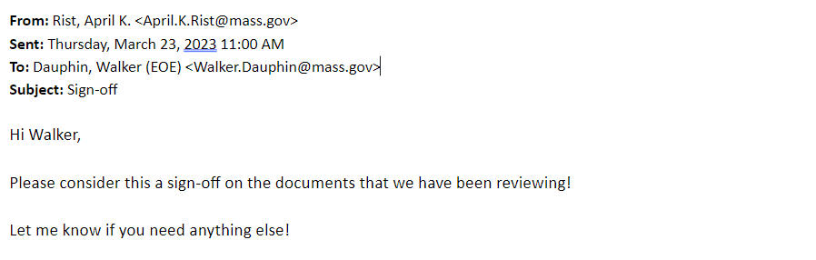

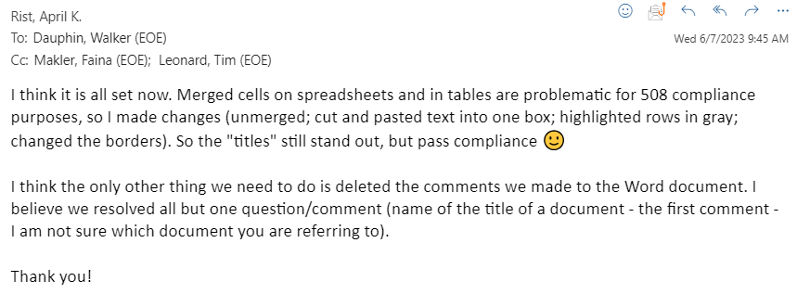

1. Massachusetts Department of Elementary and Secondary Education. Results Driven Accountability. <https://www.doe.mass.edu/sped/osep/ResultsDrivenAccountability.html>, visited on 03/01/2023.
2. Massachusetts Department of Elementary and Secondary Education. IEP Improvement Project. <https://www.doe.mass.edu/sped/improveiep/>, visited on 03/01/2023