Student Opportunity Plans
Guidance materials for FY22 SOA Plan Amendments

Jeffrey C. Riley Commissioner

Fall 2021

Table of Contents

- Basic Overview of Template and Requirements Page 3

- Suggestions for Successful Planning Page 5

- Evidence-Based Program Examples Identified by DESE Page 6

- Annotated Blank Amendment Form Template Page 8

Basic Overview of Template and Requirements

District Plan Amendment Template

The Student Opportunity Act (SOA) requires each district in the Commonwealth to create a three-year, evidence-based plan for the Commissioner’s review and provide annual updates to those plans that describe:

- progress in implementation of evidence-based program (EBP) areas,
- progress in closing opportunity gaps and outcomes for student groups; and
- substantive changes to their original plans.

The Department will once again utilize an electronic template to capture districts’ plan amendments to their original SOA plans, which are posted on DESE’s SOA Web pages.

In developing the template, the department has sought to strike a balance between making the process user-friendly and convenient and gathering enough information for stakeholders to understand where districts are in the planning and implementation of their evidence-based programs.

Districts will continue to address the four original Student Opportunity Act Commitments:
  - Intentionally focus on student groups who are not achieving at the same high levels as their peers;
  - Adopt, deepen or continue specific evidence-based programs to close opportunity and achievement gaps
for student groups and allocate resources to support these programs;
  - Monitor success in reducing disparities in learning opportunities and achievement among student groups over three years with a small number of metrics and targets; and
  - Engage families, particularly those families representing student groups most in need of support, about how best to meet their students’ needs.

Some new features this year:

- The template has been redesigned to establish clearer connections between evidence-based program choices, the student groups they are intended to serve, and the specific metrics that will be used to measure success in closing these groups’ opportunity and outcomes gaps.

- New items soliciting program-specific information on implementation progress have been added. This information will be captured in simple rubrics, and will not require detailed narrative responses from districts.

- Some sections of the template are pre-populated with external data or district-specific information from your prior submission.

A Single Template
Every district completes the same FY22 SOA plan amendment template. Districts originally completed different budget forms based on the amount of incremental FY21 Chapter 70 funding they expected to receive, with districts slated to receive $1.5 million or more in incremental funding (aka “long form districts”) required to submit a more detailed budget. This year all districts will submit their budgets directly in the amendment template. Districts receiving $1.5 million or more in incremental FY21 Chapter 70 funding will continue to provide more detailed responses wherever narrative responses are required, particularly if they plan to shift focus to a different evidence-based focus area in their plans.

Due Date for SOA Plan Amendments
SOA plan amendments are due by 5:00 P.M. on April 1, 2022 and must be submitted via the electronic plan amendment template.

SOA Resources and Supports
This guidance document as well as other FY22 SOA resources to support the development and implementation of amended SOA plans are available on the SOA website.

Starting in early December 2021, DESE will begin rolling out a variety of additional resources, including overview webinars and targeted supports in the following areas:

- Support with data analysis to clearly understand student experiences and identify where changes can be most impactful,
- How to select evidence-based programs to improve student learning experiences and outcomes,
- How to select or develop metrics to track and refine the improvement process, and
- How to use the plan template guidance for meaningful family and stakeholder engagement

The original FY21 Guidance Materials are also available on the SOA website.

Please be sure to check the SOA website frequently for updates.

Questions & Support
Please email SOAplans@doe.mass.edu with your questions, and we will provide answers and connect you with the right sources of support.

Suggestions for Successful Planning

- Focus on evidence-based program selection: In our ongoing review of plans, our focus will continue to be on which evidence-based program areas a district has selected, and the resources being allocated to those programs. To support districts in identifying specific programs that will best support their student subgroups, DESE has compiled a menu of evidence-based program examples for districts on page 7 of this document. The commissioner and his leadership team selected these examples based both on evidence and experience seeing these programs move the needle for students. This list has been aligned with evidence-based programs detailed in the ESSER III federal grant program. For that reason, the specific names of these programs may be slightly different in this iteration.

Districts that select from this menu, assuming their specific program generally matches the features of the example provided, can expect that their selection will satisfy the statutory requirement to include evidence-based programs in their plans.
- Districts may also identify their own evidence-based programs outside of the menu, so long as they align to one or more of first nine categories in the law (see SOA categories A-I at the bottom of page 6).
- Finally, districts can propose programs outside of these categories, but they will be subject to the commissioner’s review.

- Thoughtfully engage your community: We will look for districts to describe in detail how they engaged the groups outlined in the statute, alongside other local community groups, so that plans reflect student needs as identified by the community and so communities can in turn support districts in their implementation of evidence-based programs.

- Do a few things well: We encourage districts to commit to a small number of high-impact, evidence- based program areas to close opportunity and achievement gaps among groups of students they serve. A completed Student Opportunity Plan should not look and feel like a comprehensive strategic plan or spell out a laundry list of priorities and initiatives. If your district already has a strategic plan, the Student Opportunity Plan could be a chance to highlight the most critical initiatives underway and deepen them or add a few new programs that will best support student needs. As part of this amendment process, you will have the opportunity to confirm your original slate of selections or to change programs based on your experience over the last 18 months of the pandemic.

- Remember that districts can “adopt, deepen or continue” evidence-based programs. Districts may focus primarily on describing evidence-based programs already underway that are supporting specific student groups with disparities in achievement. Districts could also propose deepening certain features of these programs or expanding their scope to more students.
- However, if districts do not currently have programs to support specific student groups, districts should reallocate resources to ensure evidence-based programs in place.

- Focus on implementation: We are interested in receiving concise, thoughtful summaries of district commitments that are be backed up by high-quality implementation. The commissioner intends to focus future school visits and DESE monitoring on observing the evidence-based programs that districts described in their plans.

- This amendment process will provide a new series of program-specific implementation rubrics, asking districts to indicate where they are in the implementation process across a variety of program elements.

Evidence-Based Program Examples Identified by DESE
The Department has identified 21 examples of high-quality programs that DESE encourages districts to consider when selecting evidence-based programs to support student subgroups. Robust implementation of these programs may touch on multiple program categories (A through I) outlined in the SOA. The program examples below are organized into four domains that reflect the core work of districts. Each example is pre-aligned to the SOA program categories, which are noted in parentheses after each example.

Strategies in bold are new evidence-based strategies being added in FY22
Strategies in italics are revised, reconfigured, and/or expanded versions or FY21 SOA evidence-based strategies

Enhanced Core Instruction
- Expanded access to full-day, high-quality pre-kindergarten for 4-year-olds, including potential collaboration with other local providers (SOA categories D, F, and G)
- Research-based early literacy programs in pre-kindergarten and early elementary grades (E, F, and G)
- Early College programs focused primarily on students under-represented in higher education (I)
- Supporting educators to implement high-quality, aligned curriculum (E and F)
- Expanded access to career-technical education, including “After Dark” district-vocational partnerships and innovation pathways reflecting local labor market priorities (I)
- Culturally responsive teaching and other strategies that create equitable and culturally responsive learning environments for students. (D, E, and F)
- Expanded learning time for all students in the form of a longer school day or school year (A, B, D, and E)

Targeted Student Supports
- Inclusion/co-teaching for students with disabilities and English learners (D and E)
- Language support programs, including dual language and transitional bilingual education programs (D, E, and F)
- Acceleration Academies and/or summer learning to support skill development and accelerate advanced learners (A and E)
- Dropout prevention and recovery programs (I)

Talent Development
- Diversifying the educator/administrator workforce through recruitment and retention (D and H)
- Leadership pipeline development programs for schools (D and E)
- Strategies to recruit and retain educators/administrators in hard-to-staff schools and positions (D and E)
- Increasing opportunities for educators and academic support staff to engage in a cycle of continuous improvement, utilizing district and school teaming structures (B and E)

Conditions for Student Success
- Expanding capacity to address SEL and mental health needs of students/families (C, D and E)
- Increasing opportunities for all students to engage in arts, enrichment, world languages, athletics, and elective courses. (D and B)
- Developing effective family/school partnerships (E)
- Community partnerships for in-school enrichment and wraparound services (C)
- Labor-management partnerships to improve student performance (E)
- Facilities improvements to create healthy and safe school environments (J)

ANNOTATED BLANK AMENDMENT TEMPLATE
This template is for planning purposes only. Districts will receive a link to a web form in December to input this information online.

In this section, we have included a blank template, annotated for your reference. Please familiarize yourself with it. As noted above, the template has been restructured and streamlined for your convenience. It will also be pre-populated in select areas with DESE data and/or narrative from your prior submission data. Required questions are marked with an asterisk (*) and annotations for the purposes of the guidance document are in green italics.

Organization and Individual Confirmation

Please review your district and contact information for accuracy.

1) You are completing this survey as [DISTRICT NAME & 8-DIGIT LEA CODE]. Is the information above correct? *
[ ] Yes, this information is correct.

2) Please enter your first and last names* _________________________________________________

3) Please enter your title* _________________________________________________

4) Please enter your email address* _________________________________________________

5) Confirm email address* _________________________________________________

Commitment 1: Student Group Selection

Your original SOA plan indicated that your district will be focusing on closing gaps in student learning experiences and outcomes for the following student groups:

Your original student groups submission will appear here.

To support you in identifying relevant gaps across student groups, we are providing district-level data in the following areas: ELA and Math MCAS data, graduation rates, chronic absenteeism rates, and advanced coursework completion rates.

We have embedded an interactive data tool that you can use to explore recent student group performance against your district and state averages. You will be prompted to select your district, and then press “GO,” after which you will be directed to your data. You can look at historical information for MCAS performance and select other measures.

Screenshots of the data tool are available on the following page.

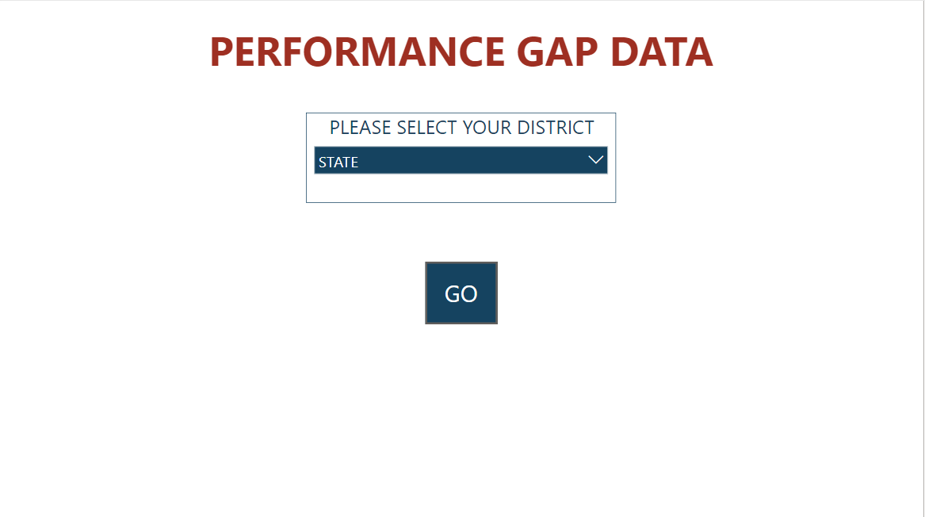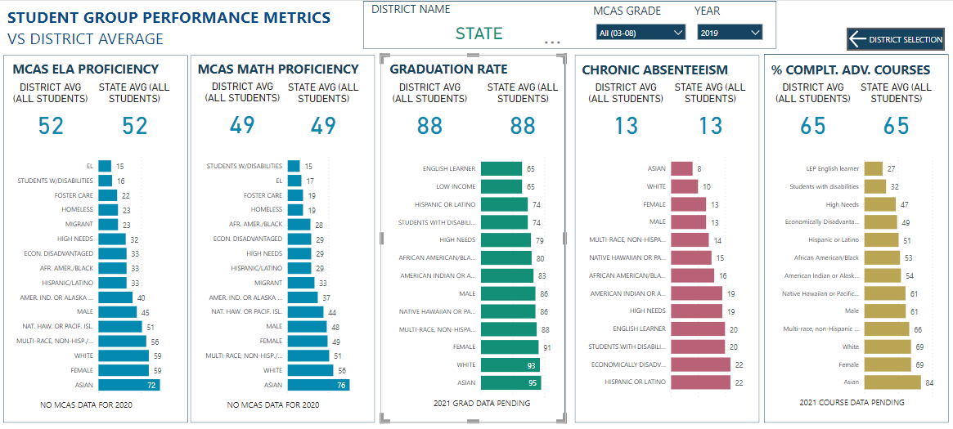

*You will be prompted to select your district before you are directed to the Student Group Performance Metrics Page. Please note that the MCAS Grade and Year filters can be used to explore your data in more detail.

These data provide a high-level view of the district landscape. And while they point out where there are gaps, they do not address why the gaps exist. If you have not done so already, we strongly recommend that your district take a deeper dive into your data and conduct additional analyses and stakeholder engagement to help your district reflect on why these gaps are occurring before selecting the evidence-based approaches that will help your district to best address them. Please see the SOA Amendment Plan Guidance website for links to strategies and resources you can use to engage in these types of analyses.

6) Which Student Groups do you want to target for gap closing?*

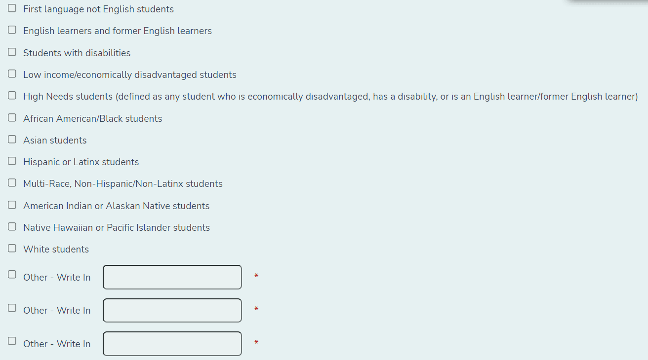
If you select “Other,” you will be required to spell out which student group you have selected.

7) Please provide your rationale for selecting these student groups, including the gaps you are addressing for each student group. Your original rationale is below, and can be revised or replaced as needed. *
This section is pre-populated with your original SOA plan’s narrative for the selection of these student groups.

Commitment 2: Evidence Based Program Selection

On this page, you will have the opportunity to review and edit the list of Evidence-Based Programs (EBPs) your district has selected to close gaps in learning experiences and outcomes.

8) Please review the summary narrative describing how you selected your program(s). You may revise it as needed. This question was optional and therefore may be blank.

You will have the opportunity to revise your original submission narrative, which will be pre-populated in the survey. If you wish to make no changes, you may leave this section of the survey blank.

9) Which Evidence-Based Programs will your district implement to reduce gaps in learning experiences and outcomes for targeted student groups? We strongly recommend selecting no more than four. *

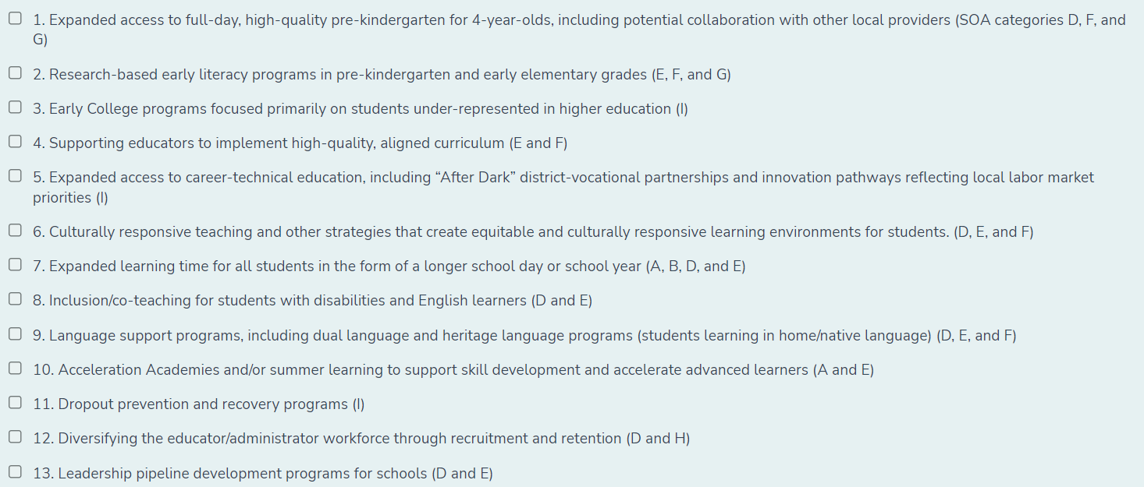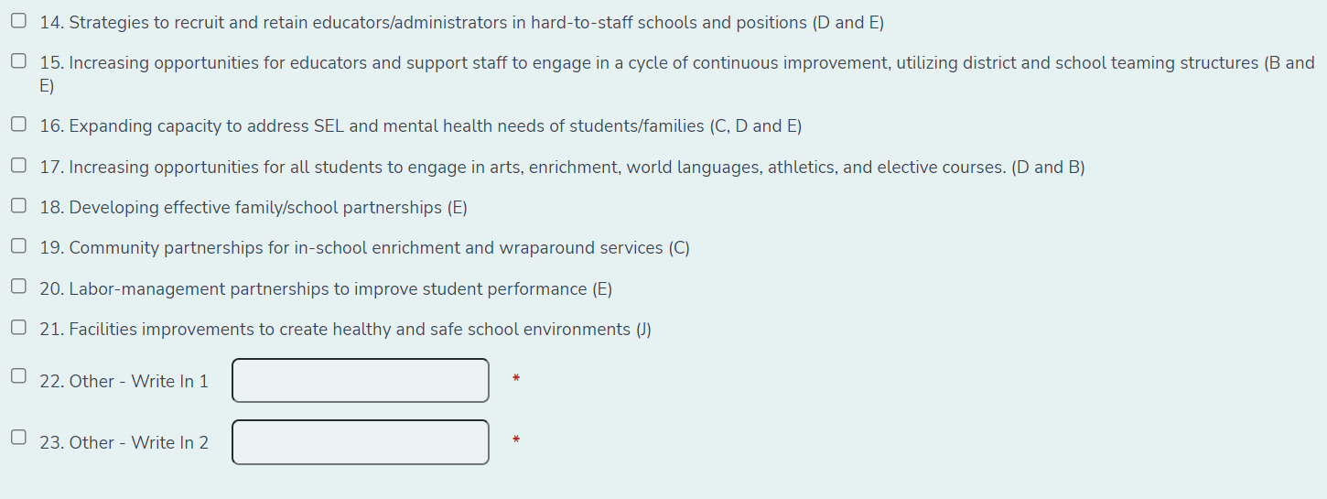

For reference, your 2020 EBP selections are below. Please note: EBP program names for 2022 have been revised and therefore the program names below may not match those in the list above exactly.
Your original SOA submission’s selected programs will appear here. Note that you MUST choose programs on the check boxes above in order to proceed with the amendment survey.

Commitments 2 & 3: Budget Detail Table, Metrics for Success, and Implementation of Evidence-Based Programs
This section will repeat the “Budget Table & Measures of Success” page for EACH of the Evidence-Based Programs selected on the prior page of the survey. It will cycle through each program in order. For example, if you select three (3) programs, you will be required to fill the page out three times. Each page will display the relevant program selection.

On this page, you will be asked to provide more information about the Evidence-Based Programs (EBPs) you selected. You will submit one response per Evidence-Based Program. Each program will appear as a separate page of the survey.

You will begin by selecting the student group(s) that your district will serve with this EBP. You may select any number of student groups.

Next, please estimate the number of students that will be served by this program only.

Please then fill out the Budget Table for this program only, taking care to break out each budget item by funding source.

Next, please select the metric(s) that your district will use to measure program success. You may select from the list of standard metrics or add any additional metric(s) you choose.

Finally, please select the phase of implementation this EBP is in and describe in a few short sentences the next steps you will be taking with this program.

Complete the budget table below for each of the Evidence Based Programs you selected in the previous question.

You are filling out the budget table for the following EBP selection:
The selected Evidence-Based Program will display here

10) Please confirm the EBP selection above. *
Please match the EBP above to the corresponding selection on the dropdown menu.

11) Please describe your rationale for selecting this EBP. (This question is optional)
Provide a brief overview of your reasons for selecting this program.

12) For which of the student groups you selected above do you anticipate seeing the greatest impact in terms of closing learning experiences and outcomes gaps as this EBP is implemented?

Select one or more student groups. *

13) Estimated number of students served by this EBP:

Please enter numbers only *

For reference, below are your district's additional FY22 Chapter 70 allocations, as well as its ESSER II and ESSER III grant allocations.
Your district’s allocation totals will populate in this section.

Instructions for Filling out the Budget Detail Section below
In the question below, you will be asked for budget detail information for your selected Evidence-Based Program. The following describes some examples.
Budget Item:
-Professional Development
-Curriculum Materials
-Inclusion/Co-Teaching Staff
Total Amount:
-Please enter only numbers. No text or $
-$50,000 should be entered as 50000
-Please include best estimate of totals - do not include per pupil amounts
Number of FTE:
-Please enter only numbers. No text
-Enter the estimated number of FTEs. Enter 0 if not applicable to that budget line
Foundation Category:
-Please select the relevant Foundation Category
Funding Source:
-Please select the relevant funding source

*Districts often use multiple funding streams to support the implementation of Evidence-Based Programs. Please indicate all the sources that you will be using to implement the Evidence-Based Programs in your SOA plan. If some expenditures (e.g. FTE salaries, curriculum materials) are split across multiple funding sources, please indicate the estimated total amount for each funding source.
For example, a staff position may be funded by both ESSER funds and Chapter 70 Aid. It should be entered into the Budget Detail table below as follows:

14) How is your district utilizing funds to implement this EBP? *

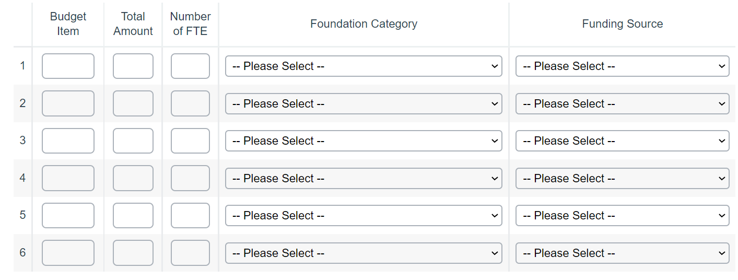

15) My budget table requires additional rows for data entry.

[ ] Select here to add more rows
By selecting this check box, you will be given additional rows for budget data entry. They will populate as a second budget table (rows 7 – 15). If you do not select this box, you will be directed to the next question about metrics.
16) How is your district utilizing funds to implement this EBP? (Additional Rows)
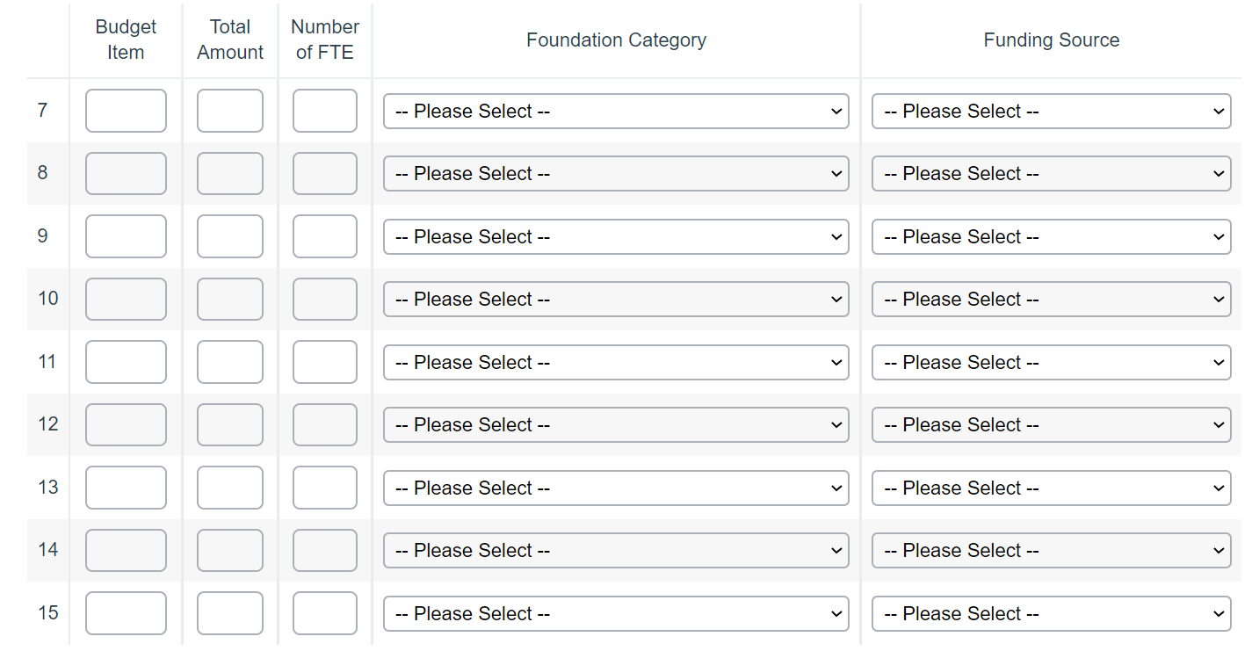

17) What metrics will you be using to assess whether this EBP is having its intended effect on gap closing? *

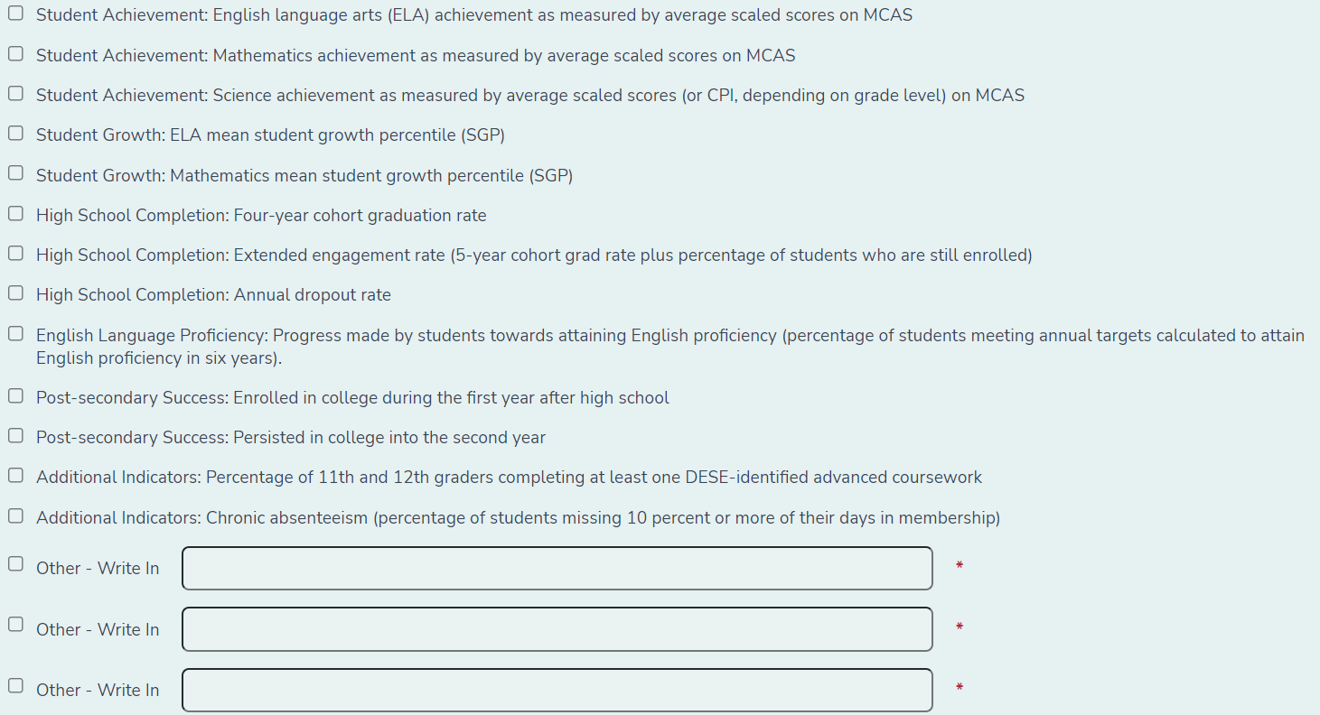
If you select “Other,” you will be required to spell out which student group you have selected.

Help us understand how your district is implementing this Evidence-Based Program. In the table below, please indicate which of the following high-quality program components are included in your approach to addressing each focus area, and the stage of implementation for each component.

18) You have selected Evidence-Based Program [#: EBP Program Description] Your EBP Program number and description will populate here. For the purposes of this guidance, we are showing the implementation table for EBP 1. Expanding access to full-day, high-quality pre-kindergarten for 4-year-olds, including potential collaboration with other local providers.
The sample rubric is available on the following page.

Sample rubric
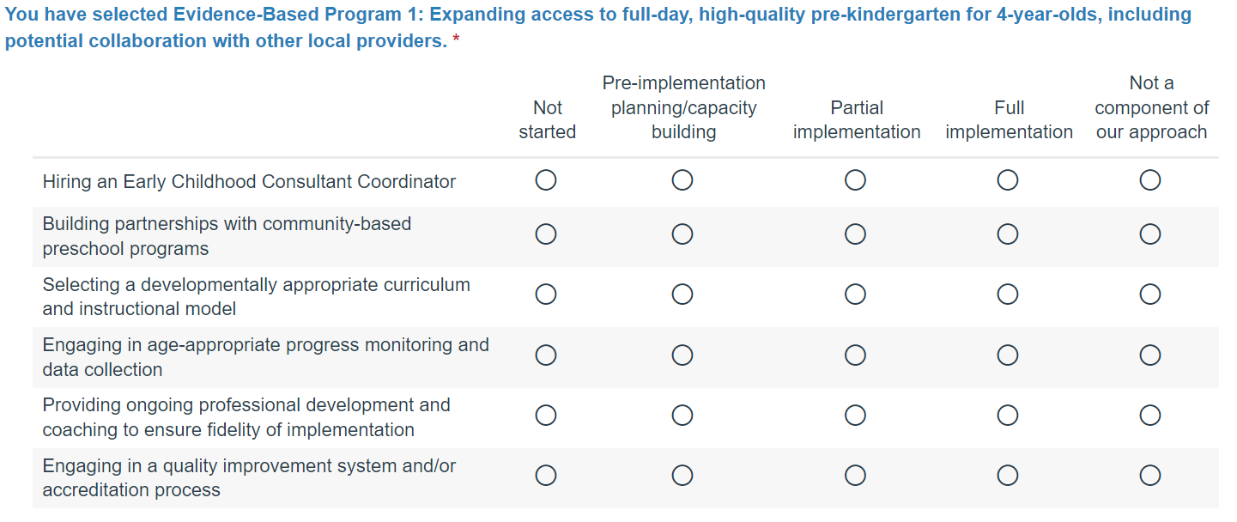

18) In one or two sentences, please describe immediate next steps for implementation of this EBP.*

19) Please feel free to provide additional information you would like to share about your approach to these strategies, or your progress in implementing them, in the text box below.

Commitment 4: Engaging All Families

As part of your efforts to close gaps in learning experiences and outcomes, it is critical districts and schools have a plan for meaningfully engaging families, particularly those of the student groups most in need of support, on an ongoing basis.
If you selected Evidence-Based Program 18 (Developing effective family/school partnerships) above, your implementation rubric will be used to describe these efforts. You will see only short answer questions below.
If you did not select Evidence-Based Program 18, you will be asked to fill out a Family Engagement rubric.

20) Here’s what your district shared about how all families, particularly those representing student groups most in need of support, have access to ongoing, meaningful engagement regarding their students' needs. Please feel free to edit or revise your response. *

The rubric is available on the following page.

Please fill out the following rubric to describe how your district is engaging families. 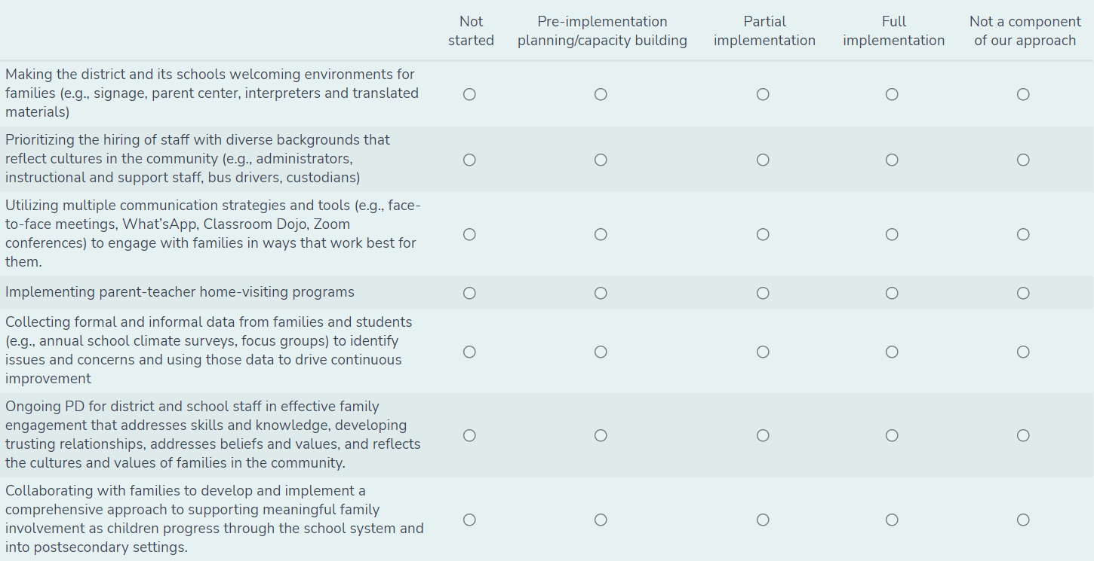

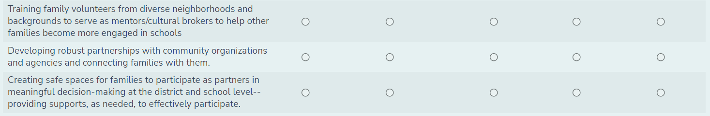
As noted above, if your district selected Evidence-Based Program 18 above, you will NOT be prompted to fill out this rubric a second time.

21) What metrics will your district use to measure greater family engagement?

Stakeholder Engagement & Other Certifications

22) For reference, please see below for your prior submission, which summarized your original stakeholder engagement process.
Your district’s original submission language will appear here.

23) Districts and schools are expected to reengage stakeholders are part of the SOA amendment process. We also recognize that districts engaged stakeholders through the ESSER III plan submission. In a few sentences, please tell us more about what you heard from your stakeholders, particularly those from historically underserved groups, and how that feedback is reflected in this amendment. *

24) I attest that any amendments to the district's SOA plan have been shared with and reviewed as appropriate by the relevant School Committee in my district. *

[ ] Yes

[ ] No

You will be able to submit the results of your FY22 Student Opportunity Act survey once you have completed all required questions.

Thank you for your submission of the FY22 Student Opportunity Act survey. Your response is very important to us.

The SOA Program categories are as follows: A) Expanded learning time in the form of a longer school day or year; B) Increased opportunity for common planning time for teachers; C) Social services to support students’ social-emotional and physical health; D) Hiring school personnel that best support improved student performance; E) Increased or improved professional development; F) Purchase of curriculum materials and equipment that are aligned with the statewide curriculum frameworks; G) Expanded early education and pre-kindergarten programming within the district in consultation or in partnership with community based organizations; H) Diversifying the educator and administrator workforce; I) Developing additional pathways to strengthen college and career readiness; J) Any other program determined to be evidence-based by the commissioner.

