Influence 100 Year-end
Field Guide Report

Prepared by:
Jeremiah Johnson, PhD Jackie Stein, MPH
Katie Ness, MS
Final: August 10, 2021

Contents

Introduction 1
Key Findings 2
Methods 3
Findings 5
Benchmarks Summary: Impacts on Fellows 6
Benchmarks Summary: Impacts on Districts 7
Benchmarks Summary: Impacts on System 8
Findings: Positive Impacts on Cohort 1 Fellows 9
Impacts on Districts—Year 1, Cohort 1 Survey Findings 10
Lessons Learned & Implications 12
Strategic Considerations 15
Appendix 16

Introduction

Influence 100 was launched at the beginning of the 2019–20 school year by the Massachusetts Department of Elementary and Secondary Education (DESE) “to increase the racial and ethnic diversity of superintendents in Massachusetts, create more culturally responsive districts and leaders across the state, and promote better outcomes for students.”¹ Influence 100 includes two primary elements: 1) a fellowship program for qualified educators who desire to move into the superintendent role in the next five years, and 2) support for school districts to become more culturally responsive and to engage in intentional strategy development and execution around diversifying their educator workforce.

The UMass Donahue Institute (UMDI) was hired by DESE as an independent, third-party evaluator for the Influence 100 program. The purposes of the evaluation are: 1) to provide formative feedback about Influence 100 strategies to support prospective superintendents for the superintendency and to support participating districts as they work to diversify the educator workforce and develop equitable and culturally responsive practices; 2) to provide formative feedback about the successes and challenges of fellows’ and districts’ efforts to increase equity; and 3) to assess the impacts of the program on fellows and their districts. DESE has contracted with UMDI to conduct evaluation activities during the second and third year of the four-year project. Evaluation activities and products generated during this time are intended to position the program for continued learning into Year 4 and beyond.

UMDI began working on the Influence 100 evaluation in August 2020, after the first year of the program. During the first year of the evaluation, UMDI worked with DESE and staff from The Leadership Academy (a DESE vendor collaborating on the fellowship sessions) to design and implement three primary data collections (two sets of surveys and one focus group), and to develop a list of benchmarks that can be used for program monitoring in the pilot phase and to inform the development of criteria to measure programmatic success in later phases. Data from two of the three primary data collections are included in this year-end report: findings from the first-year surveys and from a mid-year focus group conducted in February 2021. Both reflect data gathered from Cohort 1. Findings from the third collection (the second-year surveys) will be included in the next year-end report (in 2022). Benchmarking metrics are presented for the data available at the time of this reporting. A brief summary of methods is included below.

This report focuses on high-level findings about the first year of the Influence 100 program (2019–20 school year) based on data collected from the first cohort of fellows and districts to participate in the program. The first cohort included 26 fellows from 15 Massachusetts school districts.

1 https://www.doe.mass.edu/teach/diversity.html

Key Findings

- Most Cohort 1 fellows completed the fellowship (24 of 26, 92%) and nearly a quarter were promoted during their two-year fellowship period (6 of 26, 23%), including one fellow who became a superintendent/receiver.

- Fellows reported positive program impacts on their equity mindset, their sense of personal efficacy as equity-focused leaders, their knowledge and understanding of the superintendent role, and their connection to their peers in the program.

- By the end of the first year of the program, Cohort 1 districts (on average) increased the number of equity-focused practices they developed or changed. Out of a list of 22 equity-focused practices, Cohort 1 districts reported having developed or changed an average of 10 of those practices (47%) prior to participation in Influence 100. By the end of the first year of the program, they reported having developed or changed an average of 17 out of the 22 assessed practices (77%). In addition, most Cohort 1 districts indicated that Influence 100 played some role in facilitating at least half of the developments or changes to policy and practice they made during the 2019–20 school year.

- District engagement (with Influence 100 programming and with equity-focused practices more broadly) was variable, and this impacted fellows’ experiences with mentorship and created a disconnect for some fellows between their engagement/experience with Influence 100 and the support or buy- in they felt from their districts. Fellows’ experiences varied widely depending on the level of district and mentor engagement with the program.

Methods

This report includes findings from two primary data collections and one secondary data collection, all related to the first cohort of Influence 100 fellows (participants during the 2019–20 school year, their first year of participation in Influence 100). Cohort 1 included 26 fellows from 15 districts. We include a brief summary of methods here. Complete descriptions of each of the primary data collections summarized in this report (surveys and focus group) are provided in Appendix A and Appendix B.²

Cohort 1, Year 1 Surveys
In fall 2020, UMDI administered three surveys. One survey each was designed for fellows, district leaders, and superintendents (who served as fellows’ mentors). The UMDI evaluation team collaborated with DESE and The Leadership Academy staff to draft survey instruments that focused on experiences and practices during the first year of the program.

- The Fellows Survey included questions about growth in equity mindset, preparation for superintendency, and reflections on experiences with their Influence 100 mentors. Eighty percent (20 of 25) of surveyed fellows responded.³ The instrument is in Appendix C.
- The District Leadership Team (DLT) Survey asked about changes or developments in a set of 22 equity-focused practices at two time points: prior to the 2019–20 school year (before the first year of
Influence 100) and during the 2019–20 school year (the first year of Influence 100).⁴ UMDI, DESE, and The Leadership Academy collaboratively developed this list of practices to capture district-level equity-promoting actions in five broad areas: human capital, climate, curriculum & instruction, policies & practices, and leadership. The instrument is in Appendix C. Eighty Percent (12 of 15) of Cohort 1 districts completed the survey. District Leadership Team members within each district were encouraged to collaborate to complete the survey, however, in 9 of the 12 responding districts (75%), responses were completed by a single Leadership Team member—without collaboration.
- The Mentor Survey asked superintendents to report on their mentorship practices and their reflections on fellows’ growth/progress. Fifty-four percent (7 of 13) of Cohort 1 mentors completed

2 Appendix A includes Interim Evaluation Briefing #1, on the fall 2020 surveys. Appendix B includes Interim Evaluation Briefing #2, on the February 2021 focus group.
3 DESE provided UMDI with a list that included 25 fellows—and UMDI sent surveys to these individuals. UMDI later learned, after the surveys closed, that a 26th fellow from Cohort 1 was not included in the original list.
4 Throughout this report, when referring to the data from the district survey, we often compare responses about the period prior to the 2019–20 school year with a point at the end of the first year of Influence 100 (which includes any practices developed or changed either before or during the 2019–20 school year). This comparison captures change in practice over time.

the survey.⁵ The instrument is in Appendix C. Three of the seven responding mentors mentored two fellows and the survey asked these mentors several questions about each of the fellows they mentored. Thus, the results of these questions are reported at the mentor-fellow pairing level (n=10).
All three surveys requested general reflections and feedback about the Influence 100 program. The three surveys were administered between November 20 and December 10, 2020. Descriptive details about each survey, survey instruments, and detailed findings are provided in Appendix A.

Cohort 1 Focus Group
UMDI conducted a one-hour focus group, via Zoom, with a subset of Influence 100 Cohort 1 fellows in February 2021 (the middle of that cohort’s second academic year of participation in Influence 100).
UMDI collaborated with DESE and The Leadership Academy staff to draft a focus group protocol with questions that focused on fellows’ experiences in the program to date. Question topics included change in equity mindset, exposure to superintendent-level leadership and management processes, opportunities to process experience and learning, district support, and program impacts both on fellows and beyond (see instrument in Appendix D). UMDI selected 12 potential participants (from a list of 24 Cohort 1 fellows who remained in the program) using a semi-random approach—including only one participant from districts with multiple fellows and with a goal of maximizing the diversity of the sponsoring districts represented. All 12 potential participants were invited, and ten fellows ultimately participated. These fellows represented a range of role levels, genders, locale types (e.g., city, suburb, rural), and district sizes.⁶ Detailed findings are included in Appendix B.

Benchmarks
Working with DESE and The Leadership Academy, the UMDI evaluation team developed a set of “benchmarks” to monitor and measure program impact in three broad areas: impact on district practice, impact on fellows, and impact on system.⁷ All of these metrics were designed to be assessed across multiple points in time. The data in this report present a baseline and a partial look at the first two-year program cycle. Please see Appendix E for more detailed methodological notes.

- Impact on district practice metrics are summary measures derived from the list of key equity- promoting practices that were developed for the DLT Survey by UMDI, DESE, and The Leadership Academy (described above). The list of practices was intended to capture a broad range of district

5 The Year 1 Mentor Survey was not distributed to two of the 15 district mentors because they were new to the program in Year 2 and the survey was designed to collect feedback about the Influence 100 program during the 2019–20 school year— the year before both of these mentors joined their respective districts.
6 District type and size was based on Locale Classifications from the National Center for Education Statistics public school districts search tool: https://nces.ed.gov/ccd/districtsearch/. Information about NCES Locale Classifications can be found here: https://nces.ed.gov/programs/edge/docs/locale_definitions.pdf.
7 Please note, we refer to these metrics as “benchmarks,” although clearly defined criteria for progress or success have not been specified. The current “benchmarks” serve as useful measures of progress.

actions that contribute to increased equity at all levels in the district. The summary metrics measure equity-practice implementation and perceptions of the impact of Influence 100 on that implementation across participating districts.⁸
- Impact on fellows metrics include some items from the UMDI Fellows Survey (about program effectiveness and impact on growth in equity mindset), some items measured by the program office (promotions and rate of program completion), and some items from surveys designed and administered to fellows by The Leadership Academy (perceptions of readiness for superintendency, impact of Influence 100 on reducing challenges to superintendency).
- Impact on system metrics include several items measuring the racial/ethnic diversity of district leadership (drawn from DESE Education Personnel Information Management System [EPIMS] data). In future years, these metrics may also include summary indicators of school climate from the DESE Views Of Climate And Learning (VOCAL) survey and summary indicators of equity in student access to experienced, in-field, and highly-rated teachers.⁹ Notably, indicators of staff perceptions of school climate would be valuable additions to these system-level metrics and relevant to Influence 100. DESE has developed a model survey that includes such measures; however these surveys are optional and not widely used.¹⁰

Findings

The findings presented in this report are organized into two broad sections. First, we present summaries of the benchmarking metrics at the fellow, district, and system levels (one level per page). These metrics provide a baseline overview of preliminary program impact after the first year of the two-year program cycle.¹¹ After these summaries of metrics, we present a few broader findings about program impacts on fellows and districts (including references to some of the benchmarking metrics).

8 These metrics are based on the Year 1 district-level survey for Cohort 1 and only capture practices from the 12 (of 15) districts that submitted valid responses to the survey. The full list of practices can be found in the DLT Survey Instrument in Appendix C.
9 These other metrics in the impact on system area will be included in the future but are not included in this report due to delays in access to these data.
10 See Staff Survey on DESE Model Feedback Instruments Administrations Protocols web page here: https://www.doe.mass.edu/edeval/evidence/feedback/surveys.html?section=faq4#faq
11 Detailed findings from the benchmarking metrics are included in Appendix E.

Influence 100 Benchmarks Summary: Impacts on Fellows (Benchmarks A–H)

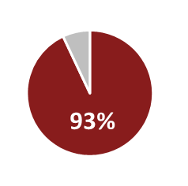

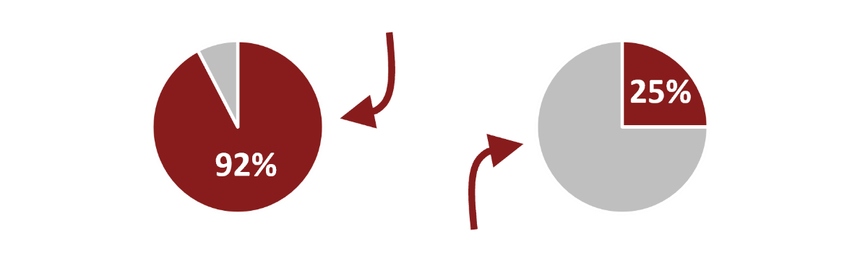
A. Nearly all (92%) Cohort 1 fellows completed the fellowship (24 out of 26).

25%

E. Most Cohort 1 fellows reported the program was effective

in supporting their growth in equity mindset.

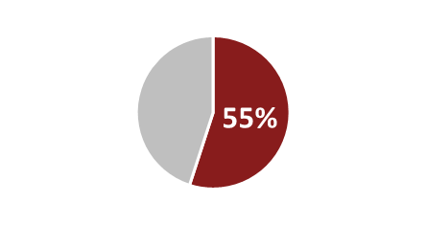
B. A quarter of those who completed (6 of 24) were promoted during their time in the program. One of those six was promoted to superintendent/receiver.²
On average, across all six Equity Leadership Disposition areas, 93% of responding fellows rated Influence 100 to be "moderately" or "very" effective in supporting their growth in those areas.¹

F. Most Cohort 1 fellows reported the program was effective in supporting their growth as

C. About half of fellows reported that their overall experience

“equity-minded district leaders.”

with their mentors supported their progress toward becoming a superintendent.
On average, across the 14 aspects of the Influence 100
program included in the survey, 93% of responding fellows rated aspects of the Influence 100 program to be "moderately" or "very" helpful in supporting their growth as equity-minded district leaders.¹

Eleven of 20 (55%) responding fellows reported that their
experience with their Influence 100 mentor supported their progress toward becoming a superintendent to at least "a moderate extent.” The other nine fellows (45%) reported mentorship experiences that offered little or no support for their progress toward becoming a superintendent.
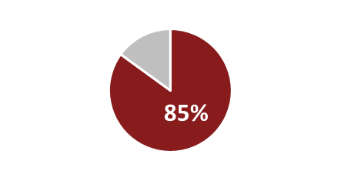

G. Most Cohort 1 fellows felt moderately prepared to be a superintendent both before and after their first year in the program.
“How prepared do you feel for the role of superintendent?”

Not at all
Completely

D. Most Cohort 1 fellows

indicated that the supports they received from their mentors were helpful in supporting their progress toward superintendency.

The average response was 6.3 (on a scale of 1–10) on both pre and post surveys.³

H. Most Cohort 1 fellows reported that Influence

On average, across nine types of mentorship support, 85% of fellows who reported receiving a support or opportunity rated it "very" or "moderately" helpful in supporting their progress toward superintendency.

100 helped them lessen challenges on their paths to superintendency.
“To what degree has the Influence100 program helped you to lessen the challenge posed by each of those hurdles?”

NOTES: See appendix for detailed methods 1. Cohort 1, Year 1

Survey, 2. Data from program office, 3. Pre-Post survey data from The Leadership Academy. The “challenges” question followed a question where respondents were asked to list up to three “factors that have been hurdles in your path to superintendency.” The average response about the impact of Influence 100 on lessening the challenge of the first “hurdle” was 5.2. Across all
three hurdles, the average was 5.

The average response was about 5 (on a scale of 1–10) after the first year of the program.³
6

Influence 100 Benchmarks Summary: Impacts on Districts (Benchmarks A–D)*

The average number of equity- promoting practices that districts developed or changed increased from 10 (47%) out of 22, to 17 (77%).**

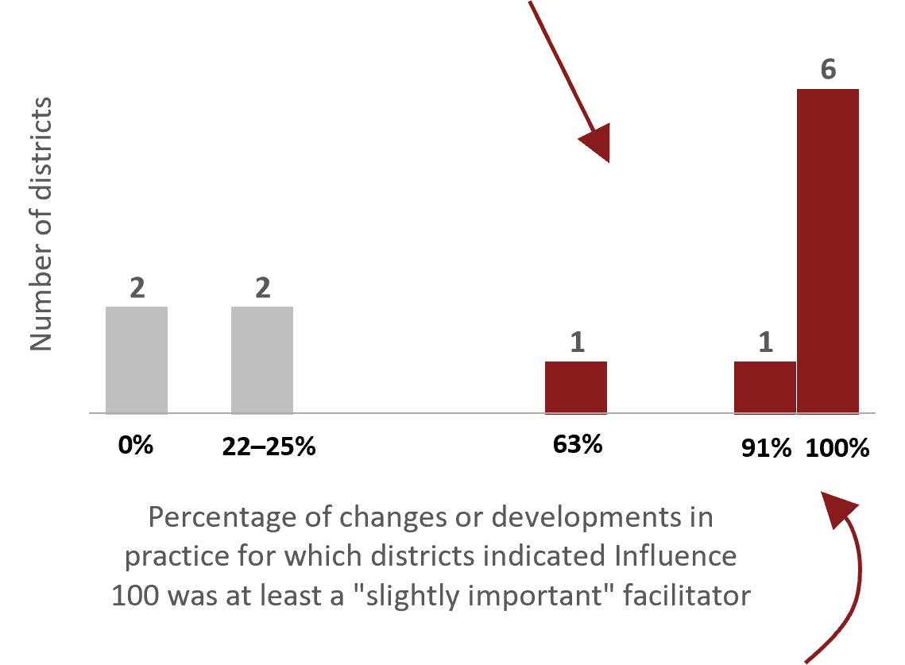
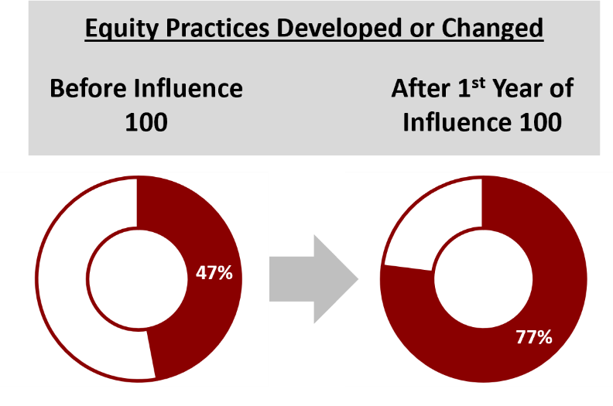
Eight of 12 (67%) responding districts indicated that Influence 100 played a role in facilitating at least half of the developments or changes they made to equity-promoting practices during their district’s first year of participation in Influence 100.****
- Most Cohort 1 districts indicated that Influence 100 played a role in facilitating at least half of the developments or changes equity- promoting practices they made during their first year in the program.

The number of responding districts that developed or changed at least half (n=11) of the 22 equity-promoting practices increased from eight (67%) to 10 (83%) districts.***
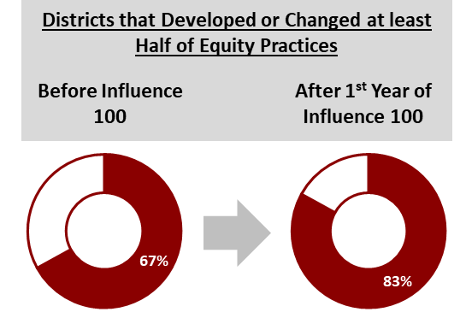

Seven districts indicated that Influence 100 was at least a slightly important facilitator in 90%+ of the developments or changes made to equity-promoting practices during their first year of participation.

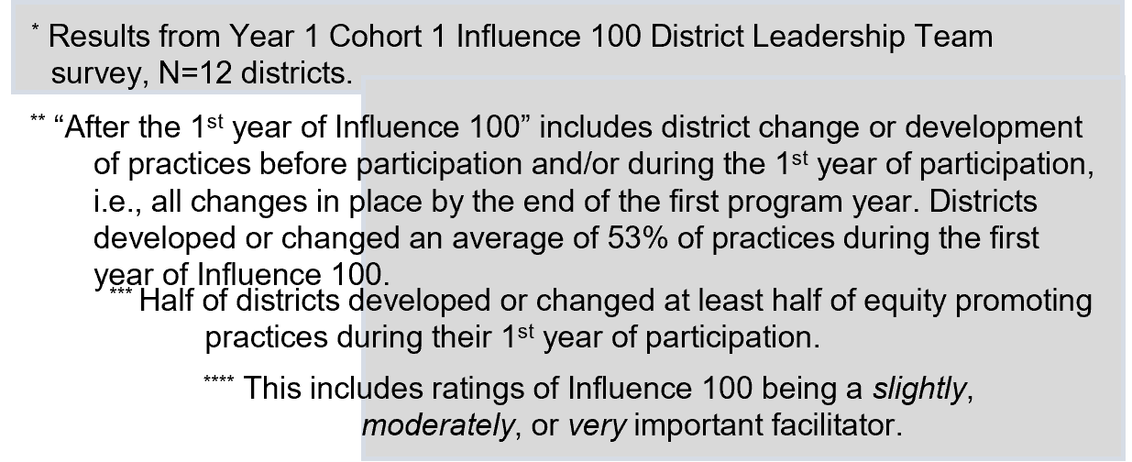

D. Of all the developments or changes districts made to equity-promoting practices during their first year of participation, districts indicated that, on average, Influence 100 was at least a slightly important facilitator in 67% of those developments or changes.

7

Influence 100 Benchmarks Summary: Impacts on System (Benchmarks A–D)

Note: It is too early to see system-level impacts, but the following metrics provide a useful baseline against which to develop criteria for success. Only Cohort 1 districts are included below.

Increasing the representation of people of color in district leadership positions is an overall goal of the Influence 100 program. We acknowledge that the category, “people of color,” includes many groups of individuals with varying experiences. Please see Appendix E for more information on (1) the racial/ethnic categories used for these benchmarks, and (2) the roles included in these benchmarks.

A. The overall percentage of district leaders of color in Cohort 1 districts remained steady from fall 2018 through fall 2020. ¹¹

C. The racial/ethnic makeup of school building administrators/leaders in Cohort 1 districts remained steady from fall 2018 to fall 2020.

B. The overall percentage of classroom teachers of color in Cohort 1 districts remained similar from fall 2018 through fall 2020.

D. The racial/ethnic makeup of district/central office staff remained similar from fall 2018 to fall 2020.

Notably, classroom teachers are less racially diverse, overall, than the other district leadership roles captured in these metrics.

8
11 Data from the 2018–19 school year represents an indication of district data before Cohort 1 districts began participating in the program. Data from the 2019–20 school year shows data from the first year Cohort 1 districts participated in Influence 100. Data from the fall of 2020 is the most recent data available, showing data from first part of Cohort 1 districts’ second year of participation.

Findings: Positive Impacts on Cohort 1 Fellows

This section summarizes high-level findings about impacts on Cohort 1 fellows informed by UMDI data collections, Influence 100 program office data, and data from The Leadership Academy.

Most fellows who started in Cohort 1 completed the fellowship (24 of 26, 92%) and nearly a quarter were promoted during their two-year fellowship period (6 of 26, 23%). One of the six fellows who was promoted became a superintendent/receiver. (Fellows benchmarks A and B, from Influence 100 program office records.)

Most fellows who responded to the survey reported having positive experiences with Influence 100 during their first year of participation. Fellows reported positive impacts on their equity mindset, their sense of personal efficacy as equity-minded leaders, and their knowledge and understanding of the superintendent role. (From Year 1 survey of Cohort 1; n=20.)

All fellows who participated in the focus group (n=10) valued aspects of the Influence 100 program and appreciated the opportunity to participate. There were three main aspects of the program that fellows highlighted as particularly valuable. (From Year 2 focus group with Cohort 1; n=10.)
- Most appreciated the sense of community, the support, and the collaborative learning fostered through the fellowship.
- Most talked about gaining knowledge, awareness, skill, and/or a sense of personal agency and confidence related to issues of equity.
- Many gave examples of how the program had helped them to shift their mindset or approach to leadership on equity issues.

Fellows and mentors generally agreed that certain mentorship practices encouraged by Influence 100 were helpful to fellows, although, as noted, fellows’ access to these practices varied. (From Year 1 Fellows Survey and Year 2 focus group). These practices included:
- Opportunities to work on district-level tasks and decision-making processes.
- Access to mentors for debriefing and one-on-one consultation.
- Opportunities to see mentors in action or modeling how they do their work.
Most cohort 1 fellows felt that Influence 100 helped them lessen the challenges of self-identified hurdles on their path to superintendency. (Fellows benchmark H, from The Leadership Academy 2019–20 year-end survey.)

Impacts on Districts—Year 1, Cohort 1 Survey Findings

Most districts reported that Influence 100 was at least slightly important in facilitating some of the developments or changes made to equity-promoting practices in their district during their first year of participation. Two-thirds (8) of the 12 responding districts indicated that Influence 100 was slightly, moderately, or very important in more than half of their district’s developments or changes made to equity promoting practices during the 2019–20 school year. Half (6) of the responding districts indicated that Influence 100 was at least slightly important in all (100%) of the developments or changes made to equity-promoting practices. The remaining four districts reported that Influence 100 was at least slightly important for 0% to 25% of developments or changes their district made.

Some districts also rated Influence 100 as very important for facilitating developments or changes made to equity-promoting practices in their district during their first year of participation. Half of reporting districts indicated that Influence 100 was very important to at least some of the developments or changes made to equity promoting practices in their district. Among this group, the proportion of developments or changes in practices where Influence 100 was rated as very important ranged from 5% to 100%. The other half (6) of reporting districts did not report Influence 100 as very important for any of the developments or changes made.

Participating districts increased the number of equity-promoting practices they developed or changed. As noted in District Benchmark A (see page 7), on average, districts showed an increase in the proportion of equity-promoting practices they had developed or changed since the beginning of Influence 100 (see Appendix E). Of the 22 practices inquired about through the DLT Survey, districts indicated that, on average, they had developed or changed about half (10, 47%) of the practices listed prior to their participation in Influence 100. After the first year of Influence 100— considering practices developed or changed both before their participation and during—districts had developed or changed an average of 17 (77%) of those practices. Ten of the 12 responding districts (83%) indicated that they had developed or changed at least 50% of practices (11 of 22) by the end of the first year of Influence 100 (either before or during their Influence 100 participation), which was an increase from the eight districts (67%) that had done so before participating in the program.

The equity-promoting practices that districts developed or changed between the beginning of Influence 100 and the end of their first year of participation were different. The equity-promoting practices that were most commonly developed or changed by districts by the end of the first year of Influence 100 centered on educating school staff, improving school/district strategic plans, and advocating for equity policy development. All districts “provide[d] professional development on culturally responsive practices for school-based staff” and “prioritize[d]

equity in school improvement/strategic plans (e.g., mission, vision, and values).” Further, nearly all responding districts (n=11) “advocate[d] for the school committee to develop equity policies” and “improve[d] and/or created a district strategic plan centered on equity.”

In contrast, the equity-promoting practices that were most commonly developed or changed by districts before they began participating in Influence 100 were “expand[ed] access to rigorous courses for student groups who have been historically marginalized,” which was done so by nine districts. The second most commonly developed practices were: “provide[d] professional development on culturally responsive practices for school-based staff;” “use[d] data about school climate to inform and/or enhance district policies/practices that support diversity, equity, and inclusion;” and “promote[d] practices that supported diversity/inclusion for students”—each of which was reported as developed or changed by eight districts.

Some key equity-promoting practices inquired about through the DLT Survey were not frequently developed or changed by districts over time. The equity- promoting practices that were least commonly developed or changed by districts by the end of their first year of Influence 100 centered on diversifying district workforce and adapting curriculum. Notably, by the end of the first year of Influence 100, all 22 equity-promoting practices had at least seven districts that had reported them as developed or changed. The practices that were least commonly developed or changed (each reported by seven districts) include: “use[d] targeted recruitment strategies in an effort to increase the diversity of district/central office staff;” “create[d] intentional pipeline programs (e.g., grow-your-own models, prep partnerships, residency programs) designed explicitly to diversify the workforce at all levels (i.e., for classroom teachers, school building administrators and leaders, and district-level staff);” and “change[d] curriculum to be more inclusive of historically marginalized groups.”

Similarly, some key equity-promoting practices were not commonly reported as developed or changed by districts before their participation in Influence 100. These practices include: “use[d] targeted recruitment strategies in an effort to increase the diversity of classroom teachers (i.e., not paraprofessionals);” “create[d] intentional pipeline programs (e.g., grow-your-own models, prep partnerships, residency programs) designed explicitly to diversify the workforce at all levels (i.e., for classroom teachers, school building administrators and leaders, and district-level staff);” “promote[d] practices that supported diversity/inclusion for staff;” and “advocate[d] for the school committee to develop equity policies”—each of which was reported as developed or changed by three districts prior to Influence 100 participation. Furthermore, only two districts reported that they “add[ed] district-level position(s) focused on district-wide implementation of policies/practices that support diversity, equity, and inclusion” prior to participation in Influence 100.

Lessons Learned & Implications

This section summarizes lessons learned and implications that emerged from this retrospective look at the first year of the Influence 100 program. First, we found that the ways and the extent to which districts engaged with the program and supported their fellows varied widely—a finding with implications for program impact across all levels (fellows, districts, system). Second, fellows and mentors offered insightful and actionable suggestions for improving the fellowship experience.

District engagement varied
District engagement was variable, both with Influence 100 programming (including mentoring) and with equity-focused practices more broadly. This variation in engagement was reflected in the data collected through the Year 1 surveys. Fellows reported that their experiences were impacted by variation in the engagement of their sponsoring districts—including their experiences with mentorship and with the support or buy-in for the goals of Influence 100 within their districts.

Districts varied in the number of equity-promoting practices they have had in place over time. Of the 22 equity-promoting practices measured through the Year 1 Cohort 1 DLT Survey, districts indicated that they had developed or changed between one and 18 of the practices before their participation in Influence 100, with an average of 10.4 practices. By the end of the first year of Influence 100, districts reported having developed or changed between eight and 22 of the practices (either before or during their Influence 100 participation), with an average of 11.0 practices. No trends in district development/change were identified over time, as the difference between the number of equity-promoting practices districts had in place before their participation in Influence 100 and during their first year of participation varied by district.

Districts varied in their ratings of the importance of Influence 100 in facilitating changes or developments in equity-promoting practices. The number of practices in which districts rated Influence 100 as at least slightly important ranged from zero practices to 20 practices, with an average of 8.9 practices.

Mentorship practice varied considerably across fellow-mentor pairings. Fellows and mentors generally agreed about the mentorship practices that were helpful to fellows (see positive impacts on fellows section), however, responses from both groups to the Year 1 Cohort 1 surveys suggested that application of these practices varied considerably across fellow-mentor pairings.

Fellows’ experiences varied dramatically depending on the level of district and mentor engagement with the program. Cohort 1 fellows were split, with about half of fellows reporting that their experience with their mentors supported their progress toward becoming a superintendent and the other half indicating that their experience with their Influence 100 mentor offered either little or no support for their progress toward becoming a superintendent. (See impacts on fellows section of metrics/benchmarks.)

Mentors varied in the frequency with which they met with their fellows, and the frequency with which they were able to provide supports to their fellow. The Mentor Survey asked about the frequency of two different kinds of meetings with fellows: one-on-one meetings and brief check-ins. Mentor-fellow pairings had one-on-one meetings as often as daily and as seldom as less frequently than monthly. Weekly, monthly, and less frequently than monthly were the most common frequencies, at three mentor-fellow pairings (30%) each. There was also variation in the frequency with which mentors had regular brief check-ins with the fellows, ranging from daily (N=1, 10% of mentor-fellow pairings) to monthly (N=2; 20% of mentor-fellow pairings). Weekly was the most common frequency for brief check-ins, at five mentor-fellow pairings (50%). It is worth noting that one mentor-fellow pairing (10%) did not have regular brief check-ins. That mentor reported requesting that the fellow set up a regular check-in meeting and that the fellow did not do so.

Mentors also varied in the frequency with which they reported providing certain supports to their fellows (including opportunities for discussion and debriefing and access to leadership development opportunities). The most common frequency indicated for each type of support was sometimes, with 40%–70% of mentor-fellow pairings providing each of the four supports sometimes. Very frequently was the second most common frequency with which mentors provided the four supports, with 10%–30% of mentor-fellow pairings providing each of the supports very frequently.

Suggestions for improvement/moving forward
Through the surveys and focus group, Influence 100 fellows and mentors suggested particular ways to improve the program to better serve fellows and mentors and, generally, to support the program’s goals of increasing the racial and ethnic diversity of superintendents in Massachusetts, creating more equity- minded public-school districts and leaders across the state, and ultimately promoting better outcomes for students. Those suggestions are described below.

Create more structure around mentorship and district engagement. Fellows and mentors suggested that increased programmatic structure related to mentorship and district engagement would be beneficial to both parties. Their suggestions included:

- Increased program-office communication with mentors, possibly including regular check-ins, copying mentors on emails with program materials for fellows, coordinating with districts around professional development schedules when scheduling district leadership convenings, and clarifying expectations of mentors and fellows.
- Creating coaching or mentorship structures for fellows outside of a fellow’s own district/superintendent.
- Clarifying pathways to superintendency certification for fellows.
Provide more access to practical experience. In the Fellows Survey and the focus group, many fellows expressed a desire to have more “real experiences” with activities such as budgeting, contract negotiations, and day-to-day leadership work. They suggested the program could incorporate more case studies, practical problem-solving opportunities, and guest speakers. Relatedly, most fellows

in the focus group wanted more opportunities to process, discuss, and learn from the experiences of those who had been in the field at the superintendent level.

Clarify the role of Influence 100 in facilitating fellows’ progress toward superintendency. Some fellows’ expectations about how the program would help them navigate the process of moving toward superintendency seemed misaligned with the scope of the Influence 100 program as implemented. Pathways to superintendency are varied and tend to be controlled by dominant culture norms and gatekeepers (e.g., Davis and Bowers 2019, Tallerico 2000), leaving those pathways susceptible to a lack of transparency that tends to perpetuate inequity (DESE Influence 100 Root Cause Analysis).¹² In the survey and the focus group, fellows expressed a desire for greater transparency and structure in the pathways to superintendency. They voiced the expectation that the Influence 100 program might help to create or clarify such pathways in such a way that would enable fellows to assess and improve their own readiness and track their progress in a more transparent and stepwise manner. One fellow described their request this way, “a clear progression of skill development or dispositions to meet the challenges of the job. If we do not set up indicators of growth, it is hard to determine how ready we are to be able to do the job.” Relatedly, a few fellows expressed the expectation that the program’s efforts to prepare and promote its fellows would have done more to enhance their professional reputations and/or more tangibly improve their access to the positions they aspired to hold.

Address the larger context of support and reception of people of color in educational leadership. Several fellows in the focus group commented that they felt unprepared to navigate a system that did not generally welcome people of color in leadership roles. These fellows noted that they felt unprepared in part because they had few opportunities to develop an understanding of “the political elements” of those roles and in part because they perceived a lack of systematic support (at state, district, and local levels) for people of color in those positions.

12 Tallerico, M. (2000). Gaining access to the superintendency: Headhunting, gender, and color. Educational Administration Quarterly, 36(1), 18–43. https://doi.org/10.1177/00131610021968886
Davis, B. W., & Bowers, A. J. (2019). Examining the Career Pathways of Educators with Superintendent Certification. Educational Administration Quarterly, 55(1), 3–41. https://doi.org/10.1177/0013161X18785872

Strategic Considerations

Clarify agreements for district participation. Fellows’ experiences in the program varied depending on the level of engagement from their district and their mentor. Clarifying expectations for districts and mentor engagement might increase the impact of the program on fellows and districts.

Foster relationships between Influence 100 and other organizations and stakeholders across the state. Leveraging such relationships has the potential to extend the reach of the program and the network of the participating fellows. Influence 100 has engaged a diverse and talented set of fellows. Enhancing the connections between the program, the department, fellows, and other organizations and stakeholders may be mutually beneficial for all involved. Establishing such connections would also contribute to furthering the program’s and DESE’s efforts to diversify the educational workforce in Massachusetts.

Appendix

- Interim Evaluation Briefing #1: Fall 2020 Surveys Summary: Cohort 1, Year 1 (January 29, 2021)

- Interim Evaluation Briefing #2: Winter 2021 Focus Group Summary: Cohort 1, Year 2 (April 30, 2021)

- Fall 2020 survey instruments (Year 1, Cohort 1):

  - Fellows Survey
  - DLT Survey
  - Mentor Survey
- Focus group protocol – Cohort 1 fellows (February 2021)
- Benchmark metrics details

