WIDA Screener for Kindergarten – Cut Scores for English Proficiency
The Offices of Language Acquisition and Student Assessment
Prepared by Melanie Manares, Daniel Wiener, and Shannon Cullen
February 2022
Purpose
A panel of experts consisting of SAS, OLA, and WIDA test development staff reviewed the K W-APT, K MODEL, and the new WIDA Screener for Kindergarten (aka the “K Screener”) in August 2021 to determine a “cut score” for English proficiency on the new K Screener for incoming kindergarteners. The Department also recruited districts on a voluntary basis to “double-screen” incoming kindergarten students on the oral portions (Listening and Speaking) of the K W-APT or K MODEL and screened concurrently on the new K Screener in July, August, and September 2021. The results of the “double-screening” field study were intended to verify the cut scores recommended by the expert panel to ensure alignment.
Results of the “Double-Screening” Field Study
Thirty-one districts volunteered to participate in the field study and 14 districts submitted “double-screener" results for 60 students in Speaking and Listening.
As shown in Table 1 below, students who scored Level 5 or above on each of the oral language domains on the K MODEL also scored at Level 5 or above in the oral domains of the K Screener. Some students performed slightly better on the K Screener than on the K MODEL.
Table 1. K MODEL scores compared to K Screener scores (oral domains)
K MODEL vs K Screener Oral by Test
Total # of responses | K MODEL listening | K MODEL speaking | K MODEL oral | K Screener listening | K Screener speaking | K Screener oral
6 | 6 | 6 | 6 | 6 | 6 | 6
2 | 5 | 5.5 | 6 | 6 | 6 | 6
1 | 6 | 5.5 | 6 | 5 | 6 | 6
1 | 5.5 | 5.5 | 6 | 5.5 | 6 | 6
1 | 5 | 5 | 6 | 5 | 6 | 6
1 | 5 | 5 | 6 | 5 | 5 | 5.5
1 | 4 | 5 | 6 | 6 | 4 | 5.5
1 | 5 | 5 | 4 | 5 | 2 | 3.5

The cut score for oral proficiency on the K-WAPT is 29 or higher. As shown in Table 2 below, students who scored 29 or 30 on the oral portions of the K W-APT attained an oral proficiency score between Level 4 and Level 6 on the K Screener, with an average score of Level 5 in each oral domain.

Table 2. K W-APT scores compared to K Screener scores (oral domains)

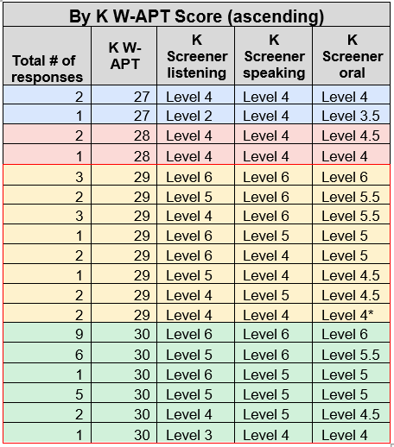
*one student lost interest after 10 minutes.

The panel of experts noted the lower level of linguistic and cognitive demand on the K W-APT compared to the K Screener. Students who scored well on the K W-APT might be expected, as a result, to exhibit somewhat lower scores on the more robust K Screener. Additionally, the K W-APT has fewer test items and provides a less varied sample of what a student can do in English.
Final Recommendations for WIDA Screener for Kindergarten “Cut Scores”
Based on the recommendations of the expert panel that met in August 2021 and a review of kindergarten screener scores from several districts that “double-screened” their incoming students (i.e., screened once on either the K W-APT or K MODEL and again on the K Screener), we are now providing Massachusetts schools and districts with the final cut scores for the WIDA Screener for Kindergarten that should be used to identify a student as an English learner.

The following WIDA K Screener cut scores in Listening and Speaking should be used to identify an incoming first-semester kindergarten student as an EL if they do not attain both scores listed below:
- Listening – at least Level 5; AND
- Speaking – at least Level 5

The following WIDA K Screener cut scores should be used to identify an incoming second-semester kindergarten student or first-semester grade 1 student as an EL if they do not attain all scores listed below:
- Listening – at least Level 5; AND
- Speaking – at least Level 5; AND
- Reading and Writing – at least Level 5 in one domain and at least Level 4 in the other
Composite proficiency level scores on the K Screener should not be used to identify a student as an EL, since a higher score in one domain could offset a lower score in another.
Proposal to Modify Existing K MODEL Cut Scores
The expert panel review and field study also resulted in a modification of the current K MODEL cut scores. We are providing the following K MODEL cut scores for a second-semester incoming kindergarten student (or incoming first-semester student in grade 1) of:
- Listening Level 5 AND
- Speaking Level 5; AND
- Level 4 in either Reading or Writing AND Level 5 in the other domain
Composite proficiency level scores should not be used as the basis for determining English language proficiency for the purpose of this screener.

Next Steps
Districts should begin using the WIDA Screener for Kindergarten for their incoming students on March 1, 2022 and should have already begun training staff to administer this screener. The Department recommends screening incoming kindergarten students during the summer before entering school, or in the fall of the school year in which they have entered, to obtain the most accurate and valid English proficiency screener results.
By January 2023, all schools and districts will be expected to use the WIDA Screener for incoming Kindergarten students in place of the existing K W-APT and K MODEL screeners. WIDA is expected to phase out the existing K W-APT screener by that date.

