The Massachusetts Curriculum Frameworks present a vision for rigorous, coherent, and relevant student learning. Yet, Massachusetts school and district leaders say they often lack the time and information necessary to make well-informed decisions about selecting curricular materials that reflect these frameworks. As a result, teachers are left scrambling to find good materials or to develop them from scratch. Ensuring each content area has standards-aligned materials can be an overwhelming process, especially with the number of programs and products claiming to be standards-aligned. This Quick Reference Guide provides an overview of a process for district leaders to use when selecting high-quality instructional materials.
Curricular materials can make a real difference. Providing teachers with access to higher-quality, better-aligned curricular materials can prompt improvement in student outcomes:
- Comparable to over half a year of additional learning (Kane et al., 2016)
- About 1.5 times the difference between an average teacher and one at the 75th percentile (Chingos & Whitehurst, 2012)
- Greater than the difference between a new teacher and one with three years of experience (Kane, 2016)

Key Aspects of the Selection Process
Get the right people in the room: Engaging a range of staff, especially teachers, early and often will generate trust and collaboration. | 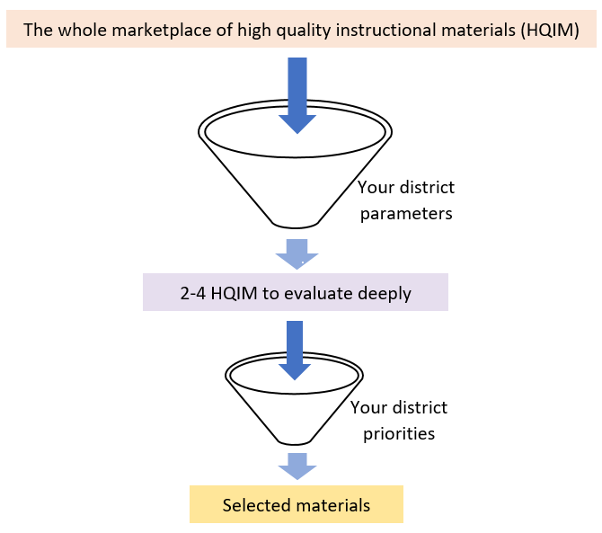
Know your why: Your instructional vision, priorities, and district parameters will focus and drive your process.
Establish your own district lens: Doing this work with your student needs and your stakeholders in mind will support a just-right fit.
This whole process is PD! Adopting new curricular materials requires ongoing curriculum embedded training which is highly impactful for both students and teachers.
This whole process is managed by YOU: Publisher-driven selections are old school. Your informed priorities and your critical lens drive the decisions (including using rubrics and neutral third-party ratings to identify high-quality programs and whether and how to pilot). You set agendas when you meet with publishers!
Selecting new materials is only the half of it! A thoroughly planned launch followed by ongoing implementation guidance and monitoring are crucial to long term success.
Equity for all content areas: Student access to high-quality materials from classroom to classroom increases opportunities for equitable outcomes for all students within a school and district.

Additional Resources
- CURATE  - EdReports  - Instructional Partners  - NextGen TIME | - Ensuring Curricular Coherence QRG  - Assessing Your Curriculum Landscape QRG  - Aligning Curriculum to Massachusetts Standards QRG

Process Overview*

Implement & Monitor (1-4 years)
- Continue targeted training of teachers, support staff, and administrators
- Teach and refine instruction
- Continually support and monitor implementation and training

3
2
4
District Instructional Vision
1
Learn & Prepare (1-2 months)
- Establish a committee, selection timeline, and final decision-making process
- Develop a common understanding of content frameworks among your curriculum council
- Establish your local lens
  - Identify parameters for your decision (budget, grades, content area, etc.)
  - Gather data about your local context and district, including evaluating current materials
  - Develop your vision and goals for instruction and assessment
  - Set priorities to guide your decision process
- Plan for stakeholder engagement throughout the entire process
- Understand the market landscape: What are your options?

Investigate & Select (4-6 months)
- Narrow your choices: Use your parameters to identify a subset of programs (2-4) that can be deeply investigated
- Investigate and pilot the materials (2-4 months)
- Use your instructional vision and priorities to rate each product
- Gather data from other districts, stakeholders, and publishers
- Field test and/or Pilot materials
- Make a decision
  - Synthesize and analyze evidence
  - Make a final selection that meets your local priorities
  - Communicate the decision and plan for implementation to all stakeholders

Launch (3+ months)
- Procure materials and plan for distribution
- Set implementation goals for assessments, pacing, monitoring
- Train teachers, support staff, and administrators
- Plan for assessment and grading
- Set expectations for use and collaborative planning
- Determine the plan for coaching

*Process is adapted from resources from EdReports, Instructional Partners, and NextGen TIME

