In the EdGrants system, any change made to a previous Application Submission is an amendment. The most common types of amendments are budget amendments. Amendments appear as sequential versions of the Application Submission in EdGrants.

In this document you will find:
When are Budget Amendment Required?
How to Request an Amendment
How to Submit an Amendment in EdGrants
Notes Regarding Amendments
Exporting to PDF

Budget Amendments are Required When:
- there is any significant change in program objectives; or
- there is any increase or decrease in the total amount of the grant; or
- an increase in a line of the budget exceeds $100 or 10% of the line (whichever is greater), or exceeds $10,000.
Amendments should be submitted at least thirty (30) days prior to the desired change and must be submitted thirty (30) days before the conclusion of the project. The maximum number of amendments to any grant may not exceed three (excepting any required by the Department). Exceptions to this limit may be allowed based on sufficient justification as determined by the appropriate and responsible approving authority in the Department.

How to Request an Amendment:

- Contact program office personnel (i.e., program staff) at DESE and tell them an amendment needs to be submitted.

Some programs require districts to retrieve the final approved workbook from the last approved Application Submission in EdGrants. Other program offices may require districts to obtain this info from another online system. Make sure to find out which is the preferred method from your program contact.

When you contact DESE program staff, they should be telling you what is required as part of your amendment submission (i.e., revised workbook, etc.).

- Program staff will send an amendable Application Submission back to the Applicant entity within the EdGrants system for editing / changes.

Submitting an Amendment:

- To access the amendable Application Submission log in to Front Office with your user credentials.
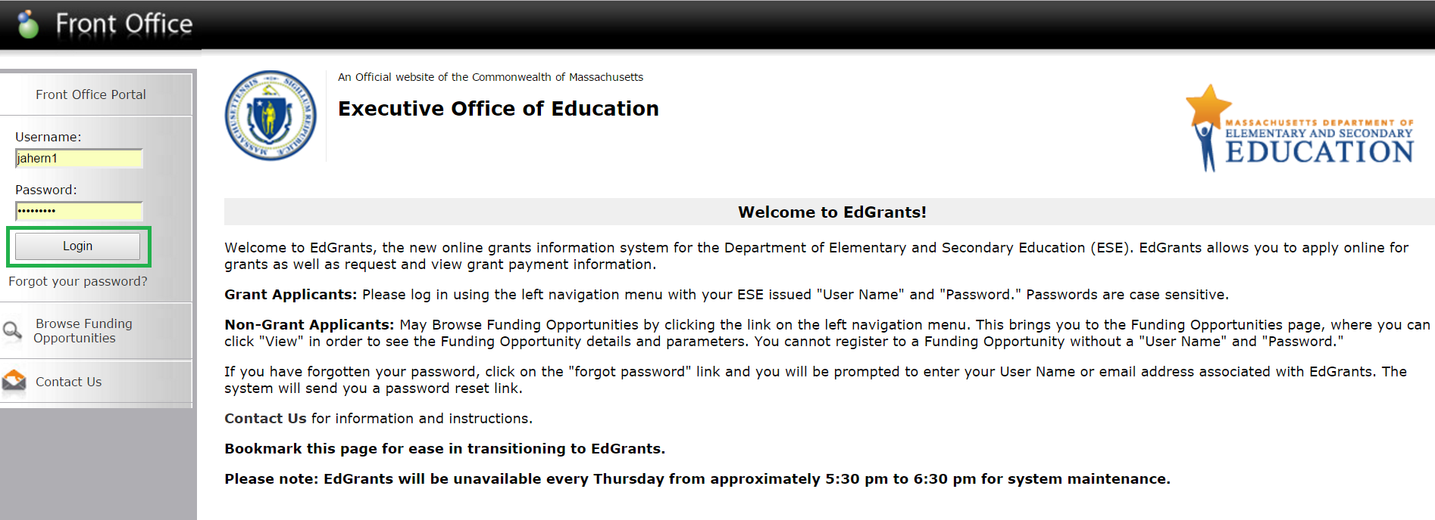

- Once logged in, click on Submissions.

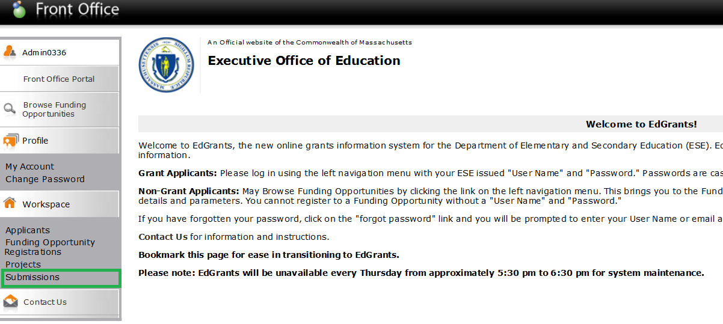

- Filter on the project that needs amending.
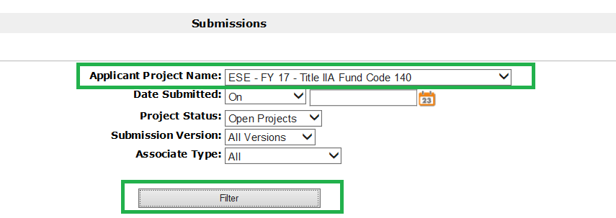

- Once filtered, user will see Application Submission Version 1 (original Application Submission) and as long as the DESE program office personnel has assigned project back to the district for amending, user should also see Version 2 (or greater, if this is not the first amendment). The version to use for the amendment is the latest version number that has no date / time stamp.

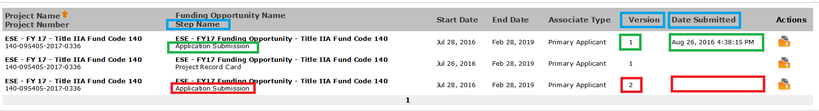

- Under Actions, click the orange folder of the amendment ready Application Submission.

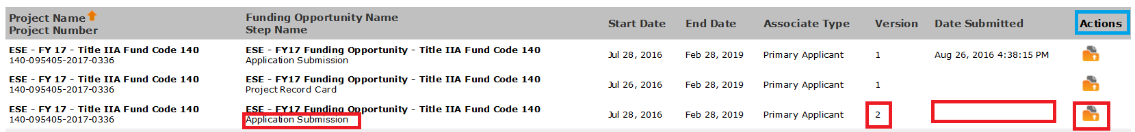

- Once opened, changes can be made. The amendable version that user opens up will have retained all of the information that was contained within the last submitted version of the Application Submission. That means that the user only has to navigate to the formlets where changes are needed because all other information is retained.

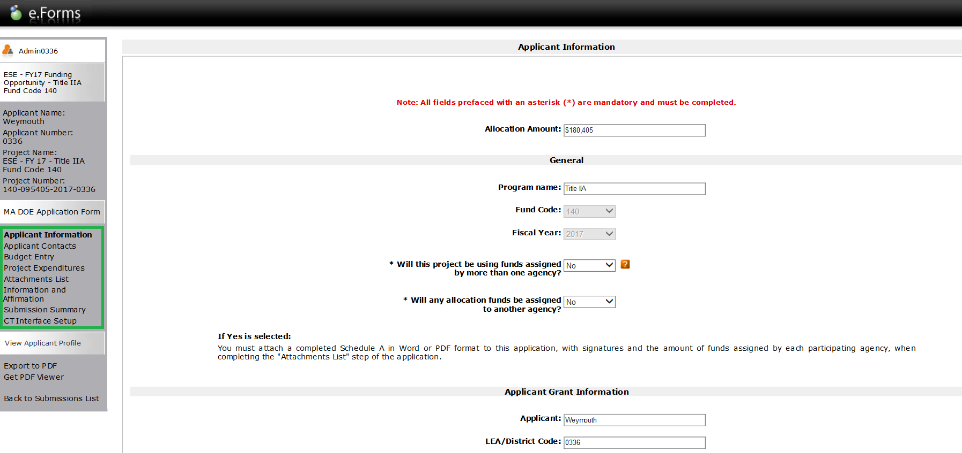
- To amend your budget, use the left hand navigation menu to navigate to the Budget Entry formlet.

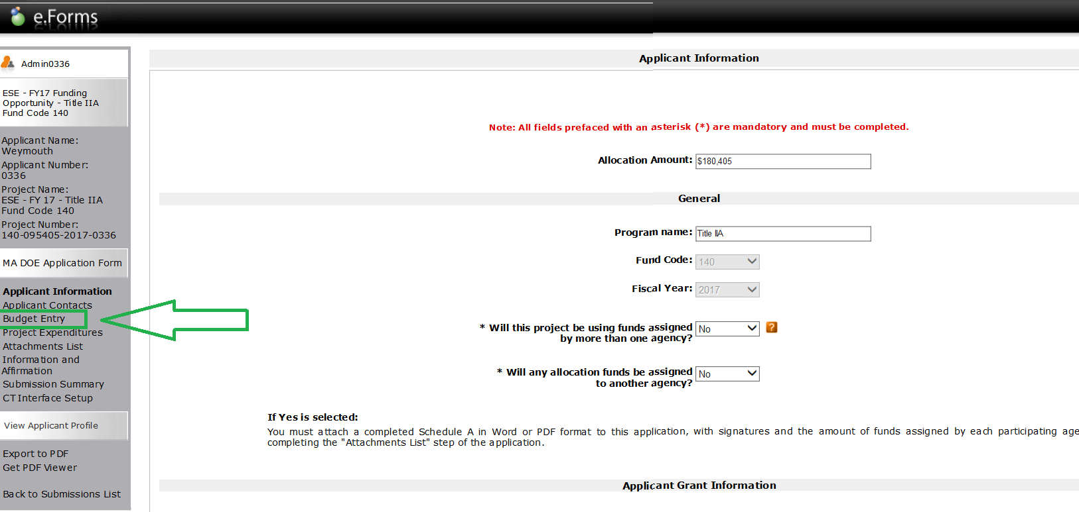

- Once the Budget Entry formlet is open, enter in the justification / explanation for the amendment in the Response box. The Response box can contain more characters than it appears, but brevity is encouraged. Hint: a subsequent amendment would retain the previous amendment’s changes including the justification in the Response box, so simply delete what is already there and type in the current justification.

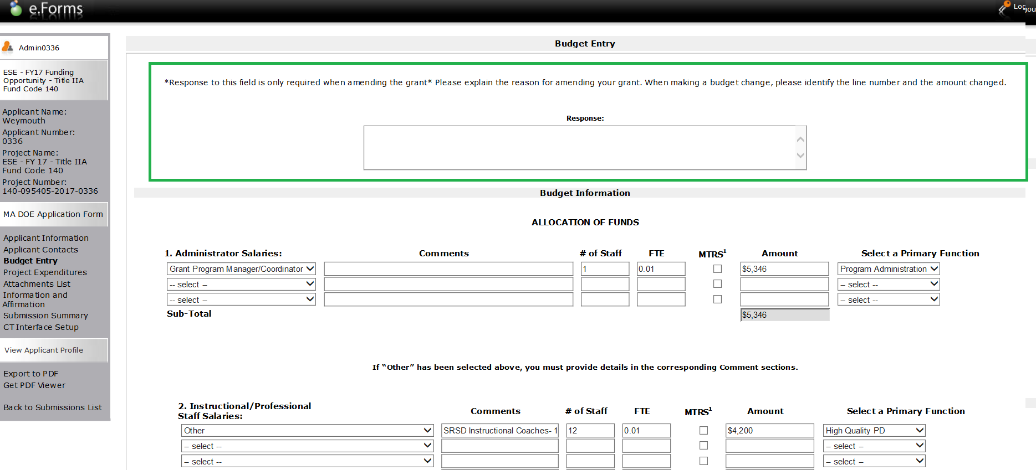

- Enter revisions / changes. Just as with the original budget entry, make sure all fields associated with the dollar amount are filled in, i.e., select categories, enter comments / descriptions, fill in # of Staff, FTE (where applicable) and select Primary Functions anywhere that is a new line entry.
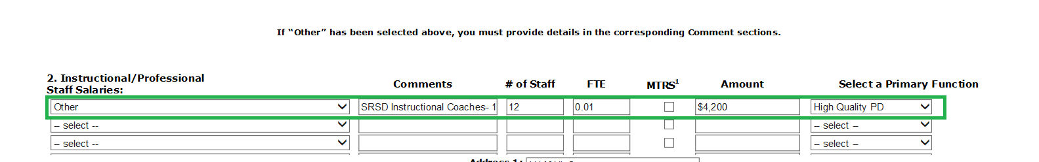

If you are REMOVING funds completely from a line, delete the funding amount and make sure to clear out the fields that were associated with the line. If you do not clear out the fields, you will get a submission error when you try to submit.

For example, the funds have been removed, but other fields have not been cleared; user must also flip the category and Primary Function fields back to “Select.”
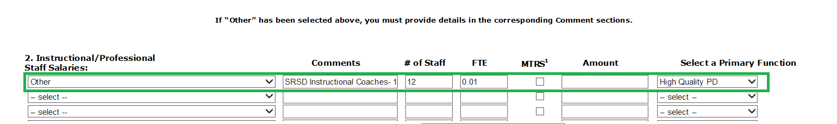

Do not enter $0 in a line that you are removing as the system will see $ there and you will get submission errors. Simply delete the entry from Amount and roll everything back to select / delete info as explained above.

- Click Save & Next at the bottom of the Budget Entry formlet to save changes as well as to navigate to the next formlet, the Project Expenditures to review the changes.

Hint: Users can also click calculate as changes are entered to make sure full allocation is budgeted / not exceeding the allocation amount as funds are moved around between the lines. Calculate does NOT save your changes. You must hit Save or Save & Next to make sure your changes are retained.
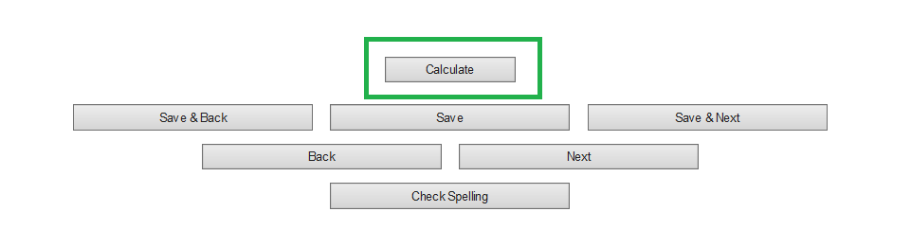

- Review changes made on the Project Expenditures formlet.

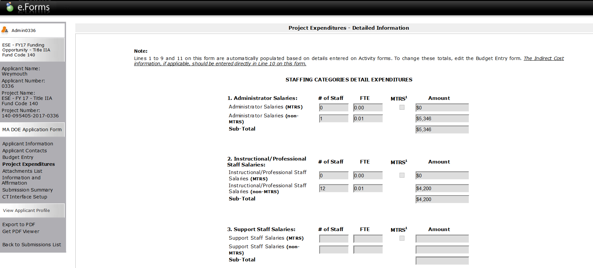
At the bottom of the Project Expenditures formlet, you can also review the Total Allocation Amount, Total Funds Requested (budgeted) MTRS Applicable Amount and Balance Remaining (remains to budget).

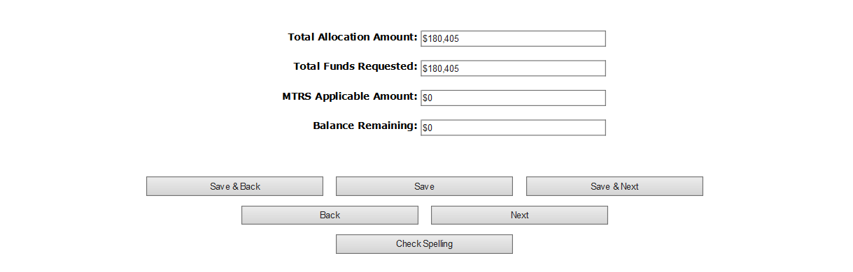

To make additional changes to the budget, user would have to go back to Budget Entry. The only thing that can be revised from the Project Expenditures page is the Indirect Costs.

- Click Save & Next to get to the Attachments List. If required* by the program unit, in the Attachments List, user will need to delete the old version of the workbook and attach the revised version which should mirror what has just been entered in the Budget Entry formlet.

*Some workbooks contain no budgetary information and may not be necessary to submit with a budget amendment. Always ask your DESE program contact what is required. Follow steps 15 – 19 if it is necessary to upload a revised document as part of the amendment submission.

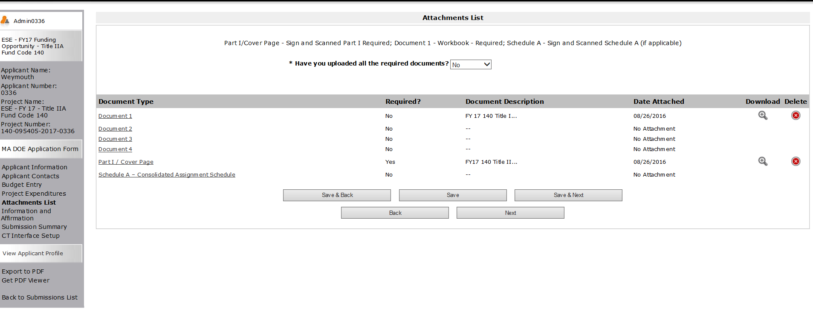

- Click the Delete symbol (red x) next to Document 1 (which should be where your workbook is attached).

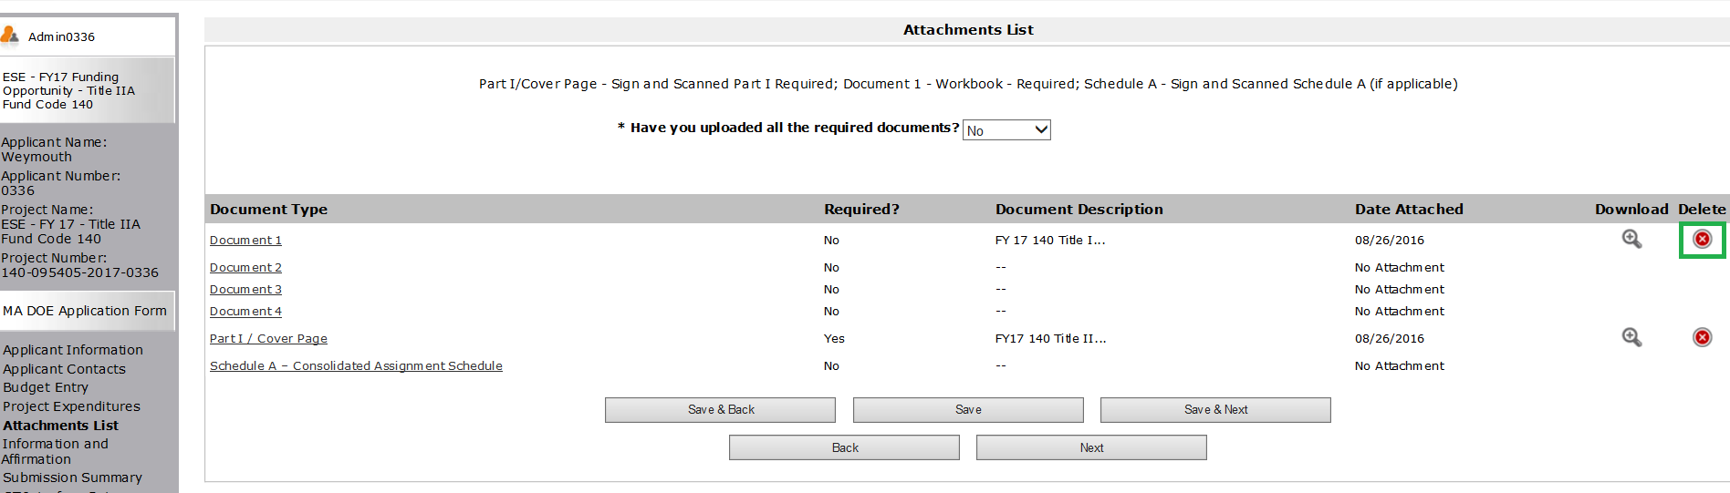

The system will prompt to see if you do in fact want to remove the attachment. Select OK.

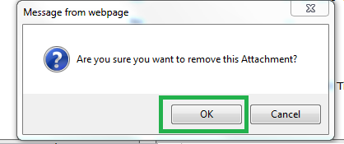

- Once deleted, Select the Document 1 link

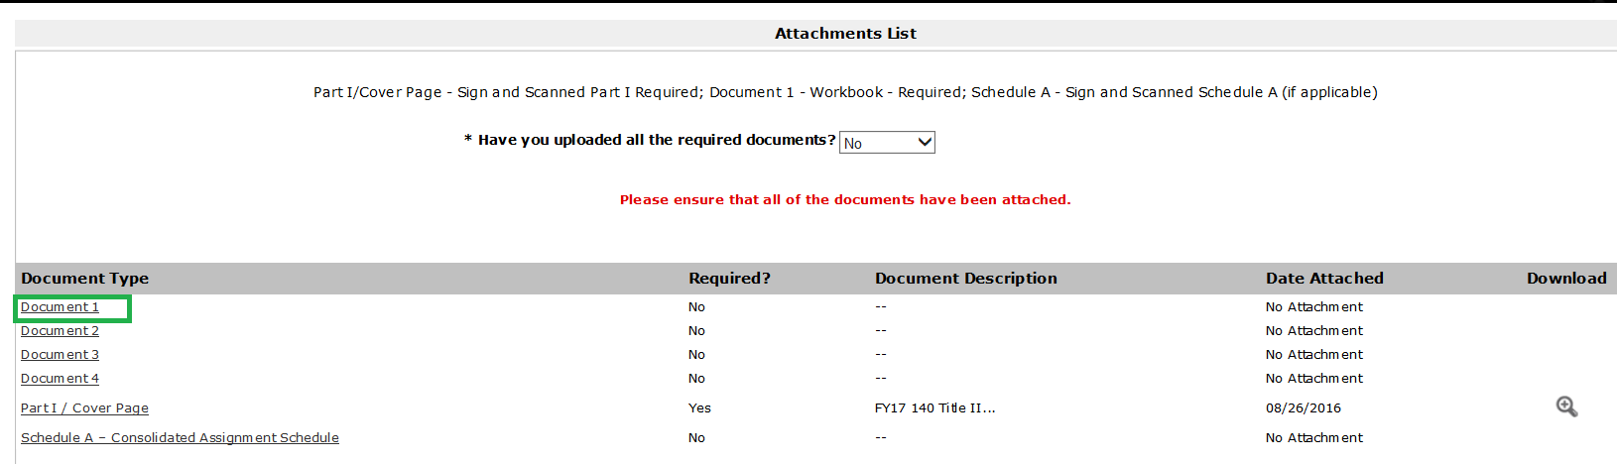

- Fill in the *Document Description as “Revised Workbook_date” and click browse to search for / attach the revised workbook file.

Hint: If you forget to fill in the *Document Description or attach a file in *File Name, it will prevent submission.

- Click Save & Back to List

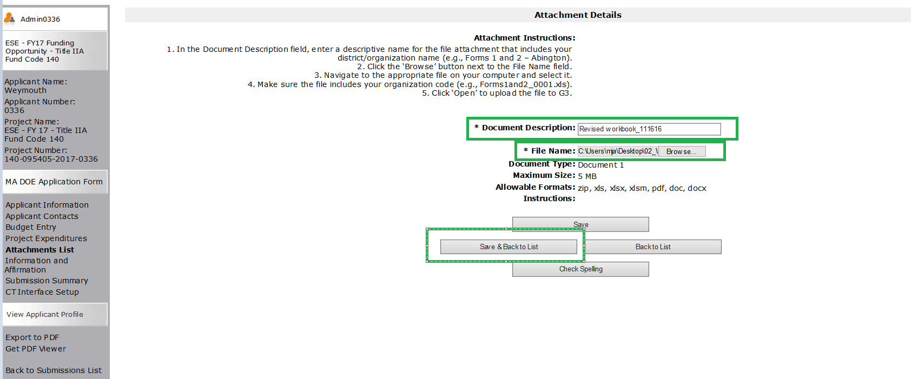

- User will now see today’s date under Date Attached. User can click the magnifying glass under Download to verify that the correct workbook was attached.

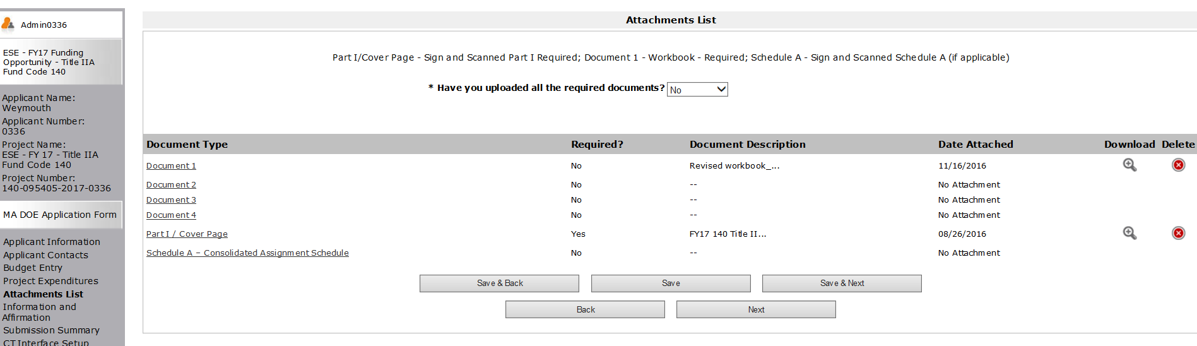

Districts do NOT need to attach a revised Part I / Cover page for amendments unless:

- It is an increase or decrease to the overall budget of the grant
- It is a significant change in the program objectives

If you must attach a revised cover page, follow the same instructions described above to delete the old Part I / Cover Page attach the revised.

- Click Save & Next

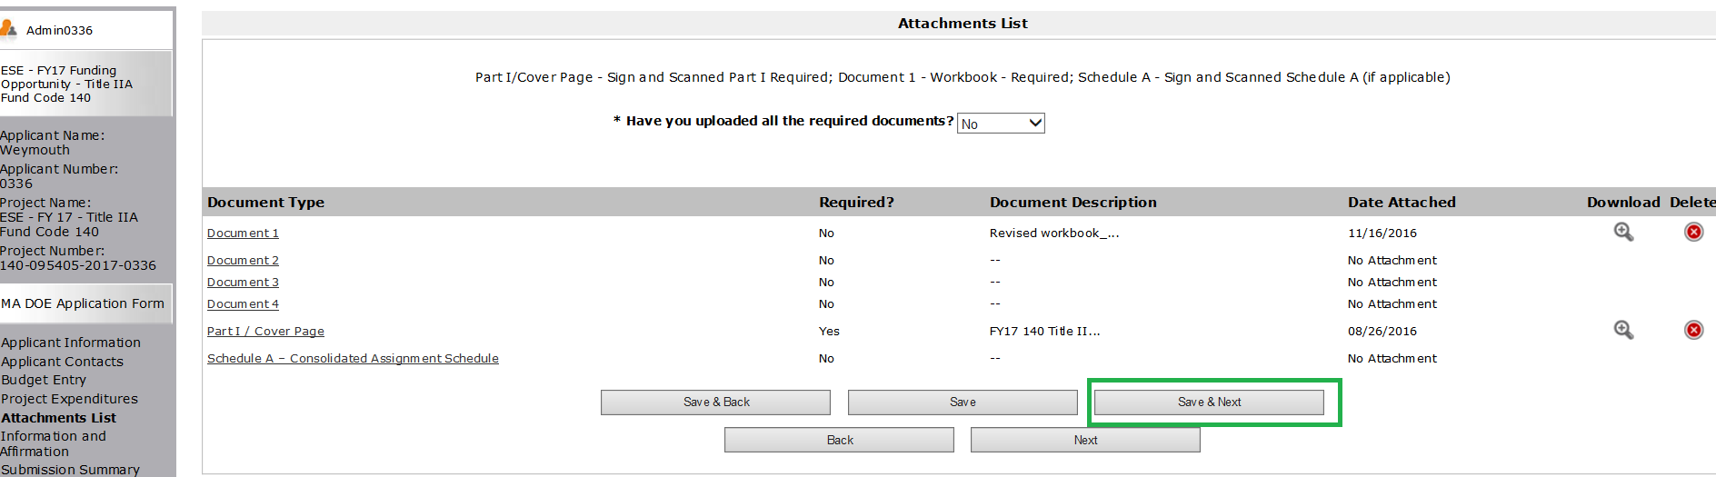

- The next formlet is the Information and Affirmation formlet which will still have retained previously submitted information so if this remains unchanged click Save & Next again to get to the Submission Summary formlet.

- Once in the Submission Summary formlet, Click Submit.
(If user sees 4 green check marks and an active Submit button then user can Submit.)

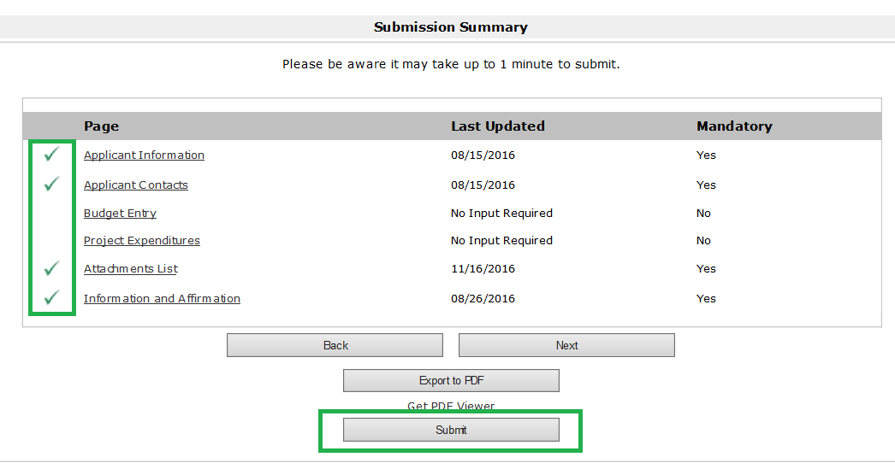

Once the amendment has been submitted, EdGrants will bring you back out to the main Submissions menu. User will now see Application Submission version 2 (or higher if this is not the first amendment) with a date and time stamp. Users can always open the Application Submission to review and/or export formlets to PDF by clicking the orange folder under Actions.

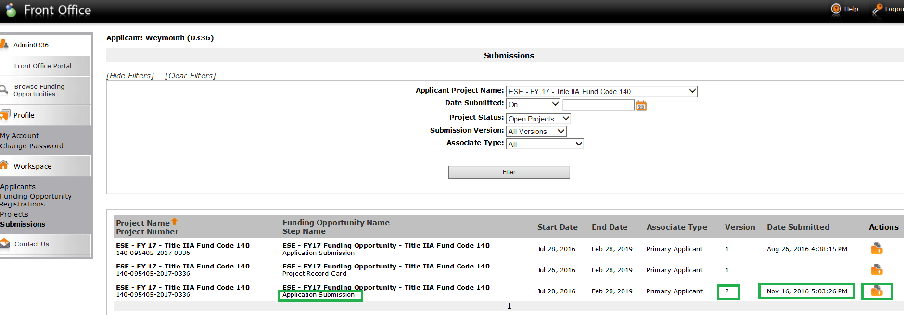

Error Messages / Inactive Submit Button:

If user sees an inactive Submit button OR an area that says Please Complete (as well as some notes directing user to issues) the Submit button will not be activated and user will not be able to submit until the issues are addressed.

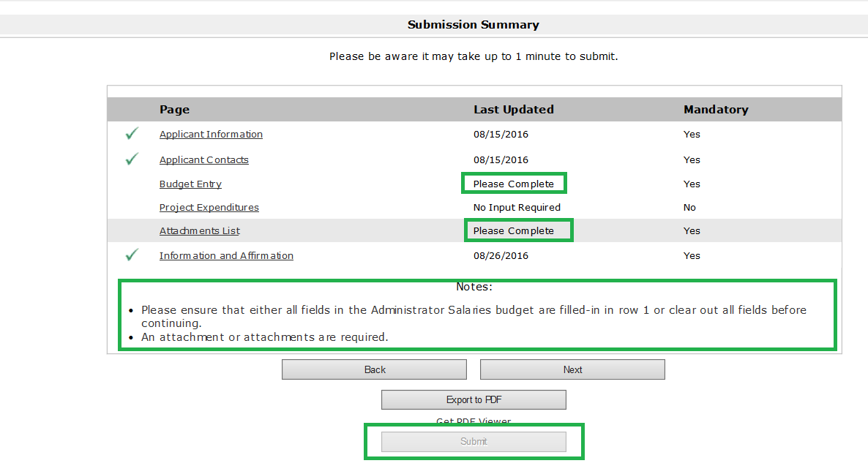

If Budget Entry says Please Complete navigate back to the Budget Entry formlet and make sure that the change to the budget reflects:
- Category selected
- Comments / Description where necessary
- # of Staff and FTE complete
- Rate Type Selected and Rate filled in (if applicable)
- Primary Function selected
OR
- Ensure that all fields associated with a line that was removed (dollars deleted) has everything set back to select / no other info entered in

As a reminder, do not enter $0 in a line that you are removing as the system will see $ there and you will get submission errors. Simply delete the entry from Amount and roll everything back to select / delete info as explained previously.

Once corrected, error messages will not clear until you hit Save or Save & Next.

If Attachments List says Please Complete navigate back to Attachments List and make sure that *Document Description is filled in and that all attachments are attached as required.

Notes Regarding Amendments:

It is fine to begin to enter revisions and save and exit EdGrants to complete / submit at a later time. A few things to keep in mind –

- A project amended back to the Application Submission step of the workflow will prohibit submission of payment requests since payment requests happen later in the workflow (Post Award Reporting step).

- DESE has an internal workflow, where program office staff review and approve grants and amendments and grant staff process the financials. Amendments not completely approved through our workflow back to the Post Award Reporting will prohibit submission of payment requests during the payment window. If you submit an amendment on the 19th of the month, it is unlikely that a payment will be able to be requested on the 20th as it has to complete the internal workflow.

As a reminder, never leave EdGrants by clicking the browser close button, ALWAYS use the Logout button in EdGrants or users could get locked out.
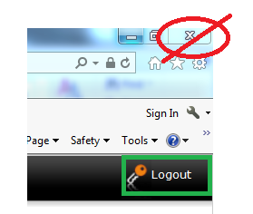

Also, never use the browser back and forward buttons – always use the buttons and/or links within the EdGrants system for navigation.
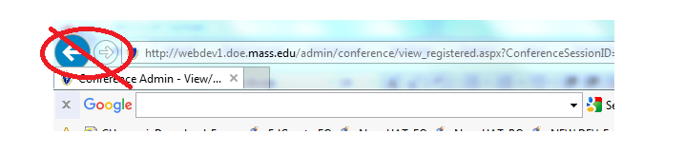

Exporting to PDF:

- To export a form, open the Application Submission by clicking the orange folder under Actions. It is recommended that forms be exported AFTER they are submitted. Nothing in EdGrants prevents a user form exporting a form before they hit the submit button. We have seen instances where folks have exported, and neglected hitting the submit button.

- Once opened, click Export to PDF on the left hand navigation menu.
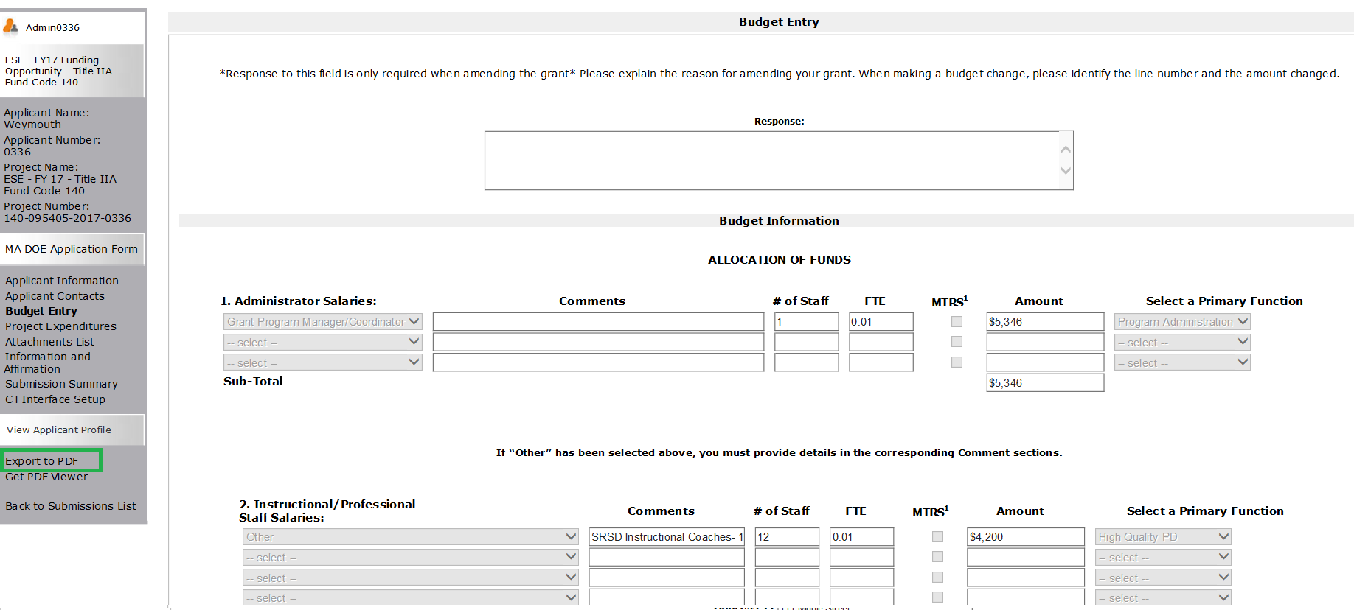

- User will be prompted to configure the export. If user would like to export the entire Application Submission, click Export to PDF.

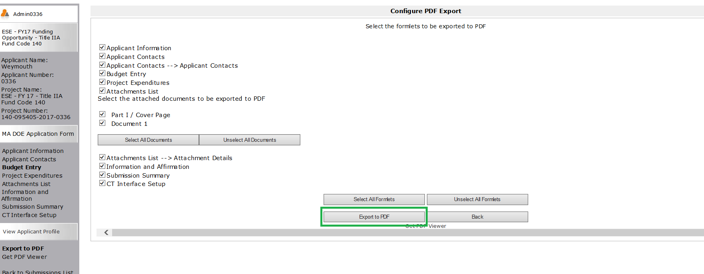

- User can also deselect certain formlets if desired. In this example, user is trying to print the Budget Entry, Project Expenditures and Attachments List. It will also export the attachments themselves that are PDFs (it will not export the excel workbook in this case, even though it is checked off).

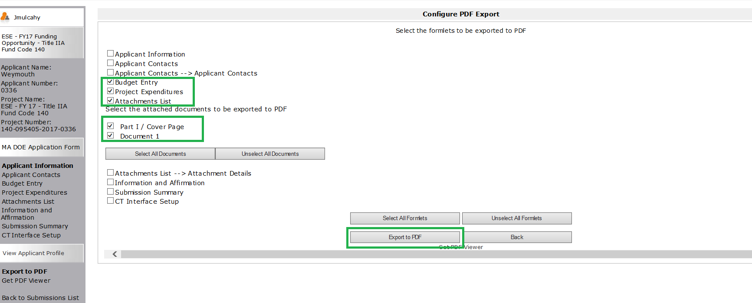

- The file will download and you can then Save it as a file and attach it to an email.

- When finished, click Back to Submissions List on the left hand navigation menu.

