ESSA Evidence Quick Reference Guide
How to Make the Most of ESSA’s Tier 4 Evidence

Why Tier 4? As part of its definitions of “evidence-based,” ESSA’s approach gives districts the flexibility to adopt and evaluate new approaches. Districts can implement programs and refine them based on research they conduct. Without building evidence, it is impossible to know how programs are being implemented, how they are working, or how to tailor them to meet the needs of students.

What are the tiers of evidence in ESSA? ESSA defines four categories or tiers of evidence. The definitions of the first three categories are based solely on study methodology and design and not by the strength of the study results or their applicability to a district’s context. The first three tiers require a previous study to have demonstrated a statistically significant effect on improving student outcomes or other relevant outcomes. The fourth level is designed for ideas that hold promise but do not yet have an evidence base qualifying for the first three levels, so long as those approaches are coupled simultaneously with ongoing efforts to examine the effects.

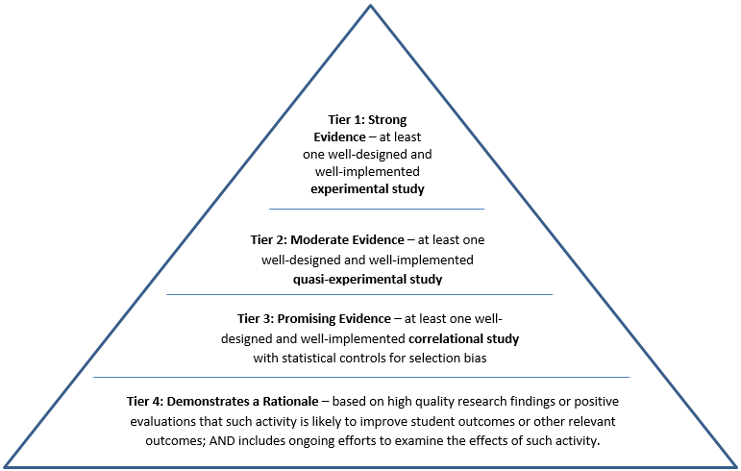

Are Tiers 1 through 3 better than Tier 4? No. An intervention based on a Tier 4 evidence base may be very effective; it is just that research has yet to be conducted or published on the intervention with a study design that meets the criteria for the first three tiers. Tier 4 is the base of the pyramid above because DESE thinks many interventions districts are actually implementing qualify for Tier 4. Numerous educational practices simply do not have strong experimental evidence, and Tier 4 can help build that necessary evidence. Tier 1 evidence is particularly hard to find because it means successfully conducting a randomized trial, which is difficult in public education settings.

What do districts have to do? When districts apply for their ESSA funds (specifically Title I, Title II-A, and Title IV-A) and other state-sponsored grants, they should be aware of when evidence is required and when Tier 4 evidence is an option. The tables below outline the required and allowable uses of the ESSA evidence-based provisions where Tier 4 evidence is applicable. If districts are spending ESSA funds on the categories below, they must plan some way to examine the effects of the strategies they are implementing. As DESE and Massachusetts districts develop knowledge of these evidence tiers, the expectation that districts can build evidence will grow. DESE expects that this process will be gradual to give districts time to gain familiarity with the evidence base and how to access it.

 | Tier 4 allowed?
LEA Required Uses: Must Do and Must Be Evidence Based
Title I: School comprehensive support and improvement (CSI) plans must include one or more evidence-based interventions (EBI). Schools that receive funds from the Title I 7% set aside (Section 1003 services funds) must use EBIs that meet the top three levels of evidence as defined by ESSA. | NO
Title I: LEA Targeted support and improvement (TSI) plans for schools with low performing subgroups must include one or more evidence-based interventions. Schools that receive funds from the Title I 7% set aside (Section 1003 services funds) must use EBIs that meet the top three levels of evidence as defined by ESSA. | NO
Title I: LEAs must conduct, with the meaningful involvement of parents and family members, an annual evaluation of their parent and family engagement strategies and policies and then use the findings of such evaluation to design evidence-based strategies for more effective parental involvement, and to revise, if necessary, the parent and family engagement policies described. | YES
LEA Allowable Uses: May Do, But If Done, Must Be Evidence-Based
Title II-A: reduce class size to a level that is evidence-based | YES
Title II-A: support other activities that meet the purpose of this title except for activities that are allowed without evidence, for example developing educator evaluation and support systems, and initiatives to recruit, hire, and retain effective teachers.* | YES
Title II-A: provide high-quality, personalized professional development except for professional development activities that are allowed without evidence, for example professional development on when and how to refer students affected by trauma, high-quality instruction, and effective strategies to integrate rigorous academic content* | YES
Title IV-A: provide drug and violence prevention activities and programs | YES
Title IV-A: provide comprehensive school-based mental health services | YES
Title IV-A: reduce exclusionary discipline practices | YES
*Please see ESSA for Title II-A activities and professional development that do and do not require evidence.

How can districts demonstrate a rationale based on research? As part of its efforts to support districts in using, building, and sharing evidence, the department has launched the “How Do We Know?” Initiative. “How Do We Know?” includes web pages, resources, guiding questions, and other sources of information. On these web pages, the section on “How do I evaluate and select evidence-based interventions?” includes a list of questions that will help districts to identify a research-based rationale to support trying out a particular intervention.

How can districts examine the effects of an intervention? DESE has developed a brief evaluation guide, "How Do We Know" … if Our Program is Working? An Introduction to Program Design and Program Evaluation. The guide provides an overview of the major steps and considerations in program evaluation design.

Why is building evidence important? ESSA’s Tier 4 gives districts an opportunity to build evidence on locally designed, research-informed interventions. Building evidence generates the information necessary to examine and reflect on both the implementation and impacts of an intervention. Examining and reflecting is a step in a cycle of continuous improvement that is critical to adjusting interventions to better meet the needs of your district. Without evidence that allows you to determine whether an intervention was implemented in the way you intended or whether it has the impacts you hoped for, it is impossible to know whether an intervention met its objectives or how to improve it. For this reason, DESE encourages districts to engage in Tier 4 evidence-building as part of a process of continuous improvement whenever possible, not just when ESSA requires evidence.
For more information about ESSA’s levels of evidence, see ESSA Evidence-Based Interventions

