Dr. James F. Cobbs
Executive Director of Operations/Principal, Thomas Edison Academy
Brockton Public Schools

Dr. James F. Cobbs, Jr. (Jim) has served as the Principal of the Thomas Edison Academy since 2013, and was also the principal of Champion High School and the former BB Russell Alternative School in 2014-2015. Jim has 20 years of experience as an educator including experience as a teacher and Assistant Principal in Boston Public Schools and Principal of a grade 5-12 charter school in New Bedford, MA. Additionally, in 2011-12, as a US Army Executive Officer, Jim oversaw a yearlong deployment in Kuwait, the Second-in-Command of a deployed Transportation Battalion, facilitating redeployment of troops from Iraq. Jim served a total of 35 years of active and reserve military service in engineering and transportation units. In his current role as Executive Director of Operations for Brockton Public Schools, Jim oversees the facilities department, is the district’s liaison for Massachusetts School Building Authority projects, as well as school safety, security, transportation, and liaison with the Mayor’s office and other city departments. Jim holds a Master Electrician’s License, a Nursing Home Administrator Licenses, a Master of Education degree from Cambridge College, a Master of Arts degree in Organizational Development and a Ph.D. in Human and Organizational Systems from the Fielding Graduate University in Santa Barbara, CA.

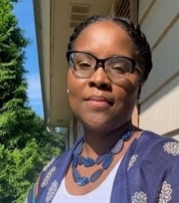
Arria Coburn
Principal, The Springfield Renaissance School
Springfield Public Schools

Arria Coburn is the principal of The Springfield Renaissance School, a 6-12 EL Education School located in Springfield, Massachusetts. The school has earned the distinction of being named an English Learner Education Credentialed and Mentor School. She is entering her sixth year as principal and has been in education for 14 years. Prior to becoming a principal, she worked as a special education teacher before transitioning into the role of an assistant principal. Under her leadership the school earned the title of Secondary Magnet School Merit Award of Excellence. In 2018 she was named the Magnet School 2018 Region 1 Principal of the year. She is also a part of the 2018 cohort of Students at the Center Distinguished Fellows and has spent the past two years collaborating and researching about practices that increase student achievement of marginalized groups. She entered the EdD program in Curriculum, Teaching, Learning, and Leadership (CTLL) at Northeastern University during the fall of 2018 with an interest in studying how to use student centered learning strategies to increase the achievement of African American students. Her research on student centered learning strategies has given her a deep understanding of how to utilize student voice to build a sense of community for all students.
Dr. Charmie Curry
Director of Diversity, Equity and Inclusion
Wellesley Public Schools

Dr. Curry joined the Wellesley Public Schools in September 2019 as the inaugural director of the Office of Diversity, Equity and Inclusion. Dr. Curry has been an educator for more than 10 years, serving as an elementary teacher, elementary school leader, and teacher effectiveness coach. She has worked in all school types, and with education reform-minded organizations such as Teach Plus and The New Teacher Project (TNTP). Dr. Curry’s personal philosophy of education centers on the ideals of liberation, equity, and justice. Prior to joining WPS, Dr. Curry served in the Boston Public Schools’ Office of Human Capital on the Performance Management team. In that role, she supported principals with educator effectiveness, and evaluated cohorts of educators in the district’s Suitable Professional Capacity program. Dr. Curry earned a B.A. in Journalism from Temple University, a Master of Arts in Teaching (M.A.T.) from Northeastern University, and a Doctor of Education in Pre-K-12 Educational Leadership from Endicott College.

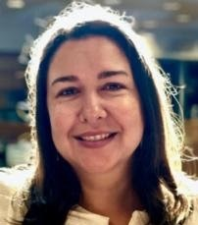
Jennifer G. Farber
Principal, Woodland Elementary School
Weston Public Schools

Jennifer G. Faber is a long time Massachusetts public school educator. Currently, in her sixth year as the Principal at Woodland Elementary School in Weston, MA. During her tenure in Weston, she has led the District Safety Team to ensure the safety of all students. She has committed her work to affording innovative and enriching experiences for the whole child. As a native Spanish speaker and Cuban-American, she is committed to serving as a role model for students of color, as well as, helping others understand the importance of diversity. Jennifer received her undergraduate degree in education from Barry University in Miami Shores, Florida in 1998. She received both her Master’s degrees from Lesley University in Special Needs & Literacy and Administration. She previously served as the Assistant Principal at the Barbieri School, a dual language elementary school in Framingham. Prior to her three years at Barbieri, she was a classroom teacher in both the Sudbury and Lexington Public School Systems. Raised in Miami Beach, Florida, she relocated to Massachusetts with her husband in 1998 and has been actively involved in a number of charitable efforts benefitting children and young adults. She is the mother of two teenage daughters whom she and her husband have raised in Sudbury, MA. Jennifer has found a great work life balance with family travel being an activity of choice.

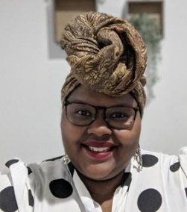
Kiesha Lamb
Director of Educational Equity
Assabet Valley Collaborative

Kiesha Lamb is the Director of Educational Equity at Assabet Valley Collaborative. She has sought out equity throughout her career, from her days as a paraprofessional in Saint Paul Public Schools, to her work as a professional development facilitator and private consultant for Education Minnesota (EdMN) and the American Federation of Teachers (AFT). Kiesha has dedicated her career to seeking equity in the classroom and community alike. She has a B.A. in Educational Equity and the Arts; she prioritizes using her skills and passion for Equity Leadership to creatively redesign and transform education to advance student achievement and coach stakeholders invested in student and family success. When she’s not busy working she’s focused on writing, traveling (COVID, yikes!), and healing.

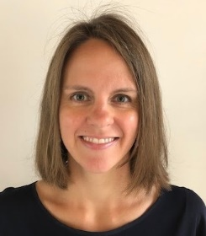
Erin Linville
Chief of Strategy and Turnaround
Holyoke Public Schools

Erin Linville is the Chief of Strategy and Turnaround for the Holyoke Public Schools (HPS). She is responsible for ensuring effective, reflective and urgent implementation of the district turnaround plan. The District was placed into receivership by the State of Massachusetts in Spring 2015, due to struggling performance well below the state average. Since being in receivership, the District has experienced many promising successes, including a 20-point increase in graduation rates and the implementation of high school redesign where students prepare for success in college, career and community leadership. HPS has also doubled the number of 4-year-olds in preschool; extended the school day for students in preschool to 8th grade; and expanded choice programs such as dual language and STEM. Erin was formerly the Interim Executive Director and Chief of Staff of Citizen Schools Illinois, Director of Strategy and Instructional Support Leader in Chicago Public Schools and consultant at Bain & Company. She holds a Bachelor’s Degree in Economics from the University of Notre Dame, Master’s Degree in Business Administration from the Kellogg School of Management at Northwestern University and Master’s Degree in Educational Leadership from The Broad Center for the Management of School Systems. She is originally from Green Bay, Wisconsin (Go Pack!); she and her husband are the proud parents of two school-aged children and a busy toddler.

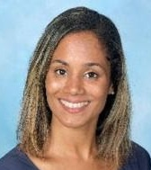
Caridad Lopez
Assistant Principal, Woodland Elementary School
Milford Public Schools

Caridad strongly believes family and school relationships are very important as parents are their child’s first teacher and expert in their lives. She completed her Bachelor’s Degree from the University of Massachusetts-Boston in Social Psychology with a Program of Study in Early Childhood. After 5 years as a youth leader and administrative roles in schools, she decided to seek a degree in Educational Administration from UMass Boston and is currently enrolled in a Doctorate's Program. After working in Natick for 5 years in Early Childhood, she transitioned to the Boston Public Schools to continue her career. She has taught elementary grades in pilot schools, turnaround schools and K-8 schools since 2010. During these years, she has worked alongside principals as a teacher leader and representative of the Instructional Leadership Team. In her current role, Caridad has focused on breaking the status quo by moving away from conventional teaching, going beyond a pacing guide and focusing on teaching through relationships. She has led educators in understanding the role cultural competence plays in developing the classroom culture. She has used student behavior data and teacher referrals to implement Positive Behavioral Interventions and Supports and build a culture of high expectations where staff members and students listen, recognize each other's emotions, praise the good work done and correct through teaching expectations as needed by everyone. Rita Pierson stated that students need to believe, "I am somebody. I was somebody when I came. I'll be a better somebody when I leave. I am powerful, and I am strong. I deserve the education that I get here. I have things to do, people to impress, and places to go." Caridad feels it is her job to instill this in every student.

Lisa Martiesian
Associate Executive Director
South Coast Educational Collaborative (SCEC)

Lisa is an educator and leader who works closely with SCEC’s member and non-member school districts, collaborative administrators, teachers, clinicians, related service professionals and families relative to meeting the needs of students with complex disabilities. This includes ensuring equal access to all available services. Lisa began her career as a special education teacher at the Jeremiah E. Burke High School in Boston where she taught students with emotional disabilities. She continued to serve in various capacities in the Boston Public Schools over the next fifteen years. As Director of Special Education and Support Services in Attleboro, MA, Lisa supervised the planning, coordination, management, and assessment of all special education programs/services to ensure all students had access to the general curriculum. She facilitated, with the Director of English Learners, an English Learner/Special Education Task Force whose purpose was to develop a protocol for schools to follow when deciding whether or not a student who is an English Learner should rightfully and appropriately, be referred for special education services. While working in the Boston Public Schools, Lisa attended the Public Education Leadership Project (PELP), a joint initiative of the Harvard Business School (HBS) and Harvard Graduate School of Education. She earned an Ed.M. in special education from Boston University and a M.Ed. in educational administration from Boston College.

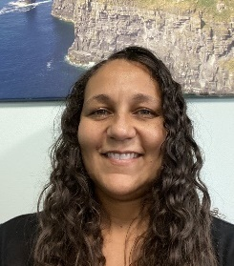
Dr. Kathleen Moran
Fellow and Executive Director of Human Resources
Brockton Public Schools

Dr. Kathleen Moran is Executive Director of Human Resources for the Brockton Public Schools. Prior to that role, she served as the principal of several elementary schools in Brockton. She began her career as an elementary teacher in the Boston Public Schools. She made the transition from school to district leadership with a vision of recruiting and retaining the highest quality educators and support staff in an effort to give back to the district where she grew up. She holds a Bachelor of Art in Modern Language from Providence College, a Masters of Education from Boston College, a Masters of Education from Harvard University, a Certificate of Advanced Graduate Study from Bridgewater State University, and a Doctorate in Administration, Planning, and Social Policy from Harvard University. She is a proud resident of Brockton where she resides with her husband and two daughters.

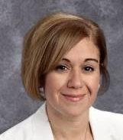
Brenda Peña
Associate Principal, Waltham High School
Waltham Public Schools

Brenda Peña is of Puerto Rican descent and is a former English Language Learner. She began her career in education with Waltham Public Schools in 2006 providing social-emotional support as a school adjustment counselor for eight years. She served as a resource and supported students with transitions, emotional struggles, peer interpersonal difficulties, and academic stressors. Her focus was to support all students’ social emotional needs, in addition to providing referrals and supports in accessing community resources. In 2014, Peña took her first leadership position as Head of Family and Community Engagement/Dean of Students with Bentley Academy in Salem, MA. In that role she worked closely with internal and external stakeholders to plan, implement, and monitor the school’s improvement and turnaround efforts. She was one of the founding members of Bentley, a school that has now achieved Level 1 status. In 2017, Peña took the leadership role of Associate Principal and is the first Latinx Administrator of the Waltham Public Schools. She holds a Bachelor of Social Work from Wheelock College, and a Master’s in Social Work from Boston College, and has completed coursework in Educational Leadership through University of New England. She holds certifications as a PK-12 Principal, Attendance Officer, School Adjustment Counseling, and Superintendent Provisional.

Sheryl S. Rabbitt
Director of Curriculum, Secondary ELA and Math
Fall River Public Schools

Mrs. Rabbitt is a 28-year veteran public school educator. She started her career as a high school English teacher in Rhode Island and, early on, became increasingly interested in understanding the inequities of school experiences across urban, suburban and rural settings and between private and public institutions. This led her to work with the National Center on Education and the Economy and its America’s Choice initiative, a forerunner in the standards-based school reform movement. It was during her time with NCEE working in New York City public schools that she grounded her focus and commitment to school design, systems thinking and instructional best practices in service to all children. This work eventually brought her to Massachusetts, when she was selected to lead, in partnership with DESE, the project for the first turnaround intervention work in the state, serving the then chronically underperforming Kuss Middle School in Fall River. The ripple effect from this successful turnaround reached across the district and today the Fall River recovery continues to serve as a case study for effective systemic public school redesign. Over her career, she has served as a teacher, school redesign coach, turnaround consultant/partner, K-12 ELA/literacy supervisor, middle school principal, director of curriculum and instruction and Chief Academic Officer. She holds a B.A. in English Literature with a secondary school teaching endorsement and a minor in writing and M.Ed. in Educational Leadership from Rhode Island College. Mrs. Rabbitt is honored to join the Influence 100 leaders across the Commonwealth in the ongoing and collective commitment to the promise of American public schools.

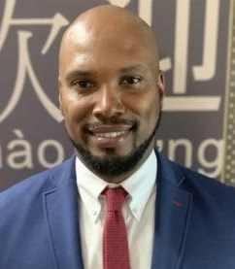
Tahon Ross
Principal, Stacy Middle School
Milford Public Schools

Tahon Ross is the first African American to serve as Principal in the town of Milford. Ross earned both his undergraduate degree in English Literature and master’s in Education Administration from UMass Amherst. Before being named the Principal of the Stacy Middle School, Ross, who grew up in Springfield, MA, served as an Assistant Principal at public schools in Washington, D.C. and Atlanta. Before that, he was the Dean of School Culture for D.C. public schools. In those positions, Ross provided effective instructional support to teachers and honed his curriculum-building skills. Throughout his career, he has worked proactively to eliminate opportunity gaps by interrupting institutional bias and investing in effective strategies to ensure every student succeeds. He also developed a student-centric perspective and learned how to work with all members of a community to build positive school cultures. Ross’s professional success belies a difficult upbringing and family life that resulted in his eventual placement in foster care. He believes that his principalship allows him to have a greater impact educating students and shaping their character. This is his way of paying it forward.

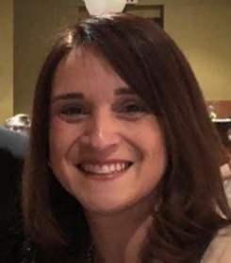
Glenda M. Soto
Elementary School Principal
Somerville Public Schools

Born and raised in San Juan, Puerto Rico. At age 18, Glenda Soto moved to NYC where she completed a Bachelors of Arts in Biology with a Minor in Elementary Education at Herbert Lehman College, CUNY in 1998. She began her 21-year career in education in New York City Public Schools teaching Science and Math in a middle school in the Bronx. Between the years, 2000 - 2010, she taught at a Catholic Private School and Private Independent School in Puerto Rico teaching Math and Science in grades 4 - 12, including courses in Algebra, Chemistry, Biology and Forensic Science. In addition to completing coursework in Special Education, in 2006 she completed her Master’s Degree in School Administration and Supervision at the University of Phoenix, Puerto Rico Campus. In 2010, she moved to Massachusetts and joined Somerville Public Schools to teach Science and Math in the district's Dual Language Program. Over these past ten years in Somerville, she has held various positions: Teacher, Redirect Teacher, District's Coordinator of Summer School Programs, Assistant Principal and Principal. In 2018, she became the first Hispanic Principal in Somerville Public Schools and is driven by a strong commitment to disrupt inequitable systems that impact Hispanic, Black and immigrant students.

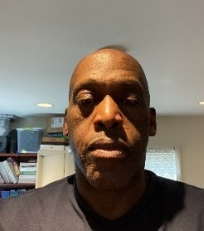
Raymond Steele, M.A.

Raymond Steele has been employed by South Coast Educational Collaborative (SCEC) as a Technology Director for fourteen years. He holds a Master’s in Technology in Education from Lesley University and a Bachelor’s in International Relations from Brown University. In addition to his responsibilities at SCEC, Raymond is an instructor at Bristol Community College in computer information systems and a football coach at Somerset Berkley Regional High School.

Dr. Jessica Stephens
Vice Principal, 9th Grade Academy at Durfee High School
Fall River Public Schools

Jess is most committed to helping students and families in urban school systems maximize potential by fostering a school environment that routinely identifies/addresses individual needs - rather than promoting a one size fits all approach in education. Through her mantra of “Love Works” she aims to support educators at Durfee High School in Fall River (particularly within the Freshman Academy where she is the lead administrator as the vice principal) to connect with student needs by remaining grounded in their initial reasons for pursuing urban education – and most importantly by keeping this critical “why” rooted firmly in their hearts and at the forefront of their professional practices always. In the roles of teacher, social worker, special education team facilitator and vice principal, Jess has worked in education since graduating from The College of the Holy Cross in 2005. She has worked in the public school systems of Boston, Brockton, New Bedford and Fall River along with the Foxborough Regional Charter School, unwaveringly focused on positively impacting school culture and its implications regarding student achievement (the subject of her doctoral thesis in 2015). Jess has successfully supported many students, families and staff through extenuating, challenging and inequitable situations, which have always been made easier by the guiding notion that our work improves not only the lives of students and families but our communities, country and world at large.

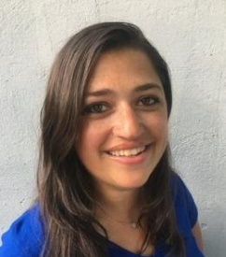
Sissela Tucker
Associate Principal, Milfrod High School
Milford Public Schools

For the past three years, Sissela has worked as the Associate Principal for Milford High School. Prior to that, she was the Assistant Principal there. An urban educator by both passion and training, Sissela has tirelessly dedicated her career to focusing on bridging gaps for underserved populations. After graduating from The George Washington University with a Bachelor’s of Science in Biology, Sissela began her teaching career in an international school in Buenos Aires, Argentina. Upon her return to the States, she finished her Master’s of Arts in Education in Teaching and Learning, and continued her career at the largest public high school in Washington, DC. There, she was twice awarded with a Standing Ovation award for Excellence in Teaching. After relocating back to New England, Sissela began working at a small charter school in Providence, RI, and continued her education through the Center for Leadership and Educational Equity in the Principal Residency Program. Upon completion, she started working at Milford High School. As a bilingual educator (Spanish-English), Sissela fervently believes that educational equity is the single most important factor in determining student success. Much of her career has centered around improving teacher hiring, training, and retention, especially of candidates from diverse backgrounds, creating learning opportunities that allow students to gain experience and skills for post-secondary pathways of all types, and fostering a rigorous academic experience for all students.

Stella Ukairo
Adjustment Counselor
Assabet Valley Collaborative

Stella Ukairo is a solutions-oriented Licensed Independent Clinical Social Worker (LICSW) with several years experience of working with children, youth, and families in community agencies, schools, outpatient, and residential settings. She has a passion for learning and education and has a Bachelor’s in Library Science, a Masters of Science in Information Systems & Technology and a Master’s in Clinical Social Work. Stella worked for over 15 years in the banking, technology, and healthcare industries, prior to obtaining her Master’s in Social Work. In her current capacity as a School Social Worker at Assabet Valley Collaborative, Stella is dedicated to using a nurturing, disciplined, and evidenced-based approach to help at-risk children, their teachers, and their families to identify strengths and positive options that will assist them as they work toward their individualized treatment goals and academic success. She enjoys adopting a collaborative approach towards shared solutions. Influenced by her Social Work lens, Stella is seeking to find solutions to address the inequities in education based on race, social economic status, disability and other social factors.

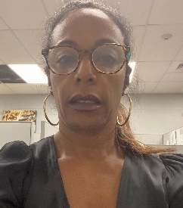
Fernanda Vera-Cruz
Director, Multi Language Learner Department
Fall River Public Schools

Fernanda Vera-Cruz was born in the Cape Verde Islands and immigrated to the USA with her nuclear family at the age of 16 years old. Her parents are college graduates, but were at a loss in trying to understand and maneuver a much different system, not only linguistically, but culturally when they first arrived in America. It was not easy, but yet, like many immigrant families, they endured and prevailed. Fernanda received a Bachelor’s Degree in Arts and Science from the University of Massachusetts, Dartmouth and a Master’s Degree in Applied Linguistics from University of Massachusetts, Boston. She is a career changer (International Banker) but has been in the field of education for the last 19 years. She has always worked for the ESL Department at various capacities, but always in true collaboration with other departments. She has been in her current district for five years where they have built a Multilingual department that is well structured, with systems in place to increase multilingual learners’ academic achievement and develop a culture of high expectations for all students, in-spite of obstacles and hardships they may encounter in their own personal life. Fernanda is a single mother to her son, Julio, her pride and joy.

Will Verbits
Program Director of Bedford Programs
EDCO Collaborative

Will Verbits is currently a Program Director at EDCO Collaborative in Bedford, MA. He has worked for many years as a Special Education Director and started his career as a School Psychologist. He is the parent to three wonderful kids and in his free time enjoys traveling, cooking and yard work.

Ina Williams
Transportation Coordinator
Assabet Valley Collaborative

Ina Williams realized long ago that not everyone has the same access to quality education as a single parent of school aged children. Ina has a BA in Sociology and brings 30 years of corporate and non-profit management experience to the table. Ina is an Accounts Payable/Transportation Specialist at Assabet Valley Collaborative (AVC). She facilitates, coordinates and supports Special Education Transportation for AVC’s member districts. Ina collaborates across stakeholders at all levels of education for the success of students and families. Areas of expertise include management and reconciliation of budgetary accounts, vendor engagement and supervision, equipment acquisition and accounts payable/receivables. Through much of her career, she developed a strong commitment to narrow the educational and occupational divide that exists for many under-represented populations. Ina has worked as a case manager for elder services, emergency department unit coordinator, emergency advocate for victims of sexual assault/domestic violence and substitute teacher. Ina is seeking to leverage her business experiences and human service commitment into an opportunity to re-design and re-align systems that predictably fail people and progress.

