Massachusetts Department of Elementary and Secondary Education
Special Board Meeting on Social and Emotional Learning (SEL), April 25, 2016
Social and Emotional Learning Definitions

The Department is committed to preparing all students for success in the world that awaits them after high school. One of our five core strategies to achieve that goal is supporting the social, emotional, and health needs of students and families. As noted in the Department’s Strategic Plan (May 2015), in order to have opportunities to be successful after high school, students need to have healthy social/emotional skills. Furthermore, developing students’ social and emotional competencies helps schools create safe learning environments that contribute to academic achievement for all.
There are many terms and definitions used to refer to social and emotional and related competencies and learning needs of students. This document includes the definition currently referenced most frequently by the Department (below), as well as a selection of additional ones referenced by speakers at the Special Board meeting as well as others in the field (the next page). This is not an all-inclusive list.

SOCIAL AND EMOTIONAL LEARNING
Collaborative for Academic, Social, and Emotional Learning (CASEL)

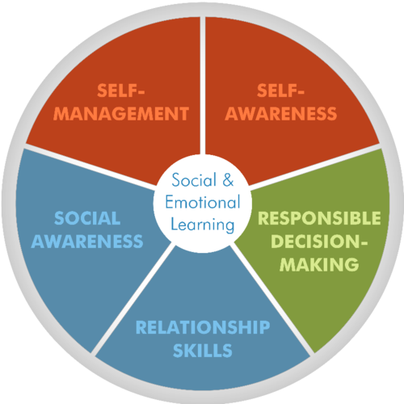

Social and emotional learning (SEL) is the process through which children and adults acquire and effectively apply the knowledge, attitudes, and skills necessary to understand and manage emotions, set and achieve positive goals, feel and show empathy for others, establish and maintain positive relationships, and make responsible decisions. CASEL has identified the following five competency clusters that are interrelated sets of cognitive, affective, and behavioral competencies.

- Self-awareness: The ability to accurately recognize one’s emotions and thoughts and their influence on behavior. This includes accurately assessing one’s strengths and limitations and possessing a well-grounded sense of confidence and optimism.
- Self-management: The ability to regulate one’s emotions, thoughts, and behaviors effectively in different situations. This includes managing stress, controlling impulses, motivating oneself, and setting and working toward achieving personal and academic goals.
- Social awareness: The ability to take the perspective of and empathize with others from diverse backgrounds and cultures, to understand social and ethical norms for behavior, and to recognize family, school, and community resources and supports.
- Relationship skills: The ability to establish and maintain healthy and rewarding relationships with diverse individuals and groups. This includes communicating clearly, listening actively, cooperating, resisting inappropriate social pressure, negotiating conflict constructively, and seeking and offering help when needed.
- Responsible decision making: The ability to make constructive and respectful choices.

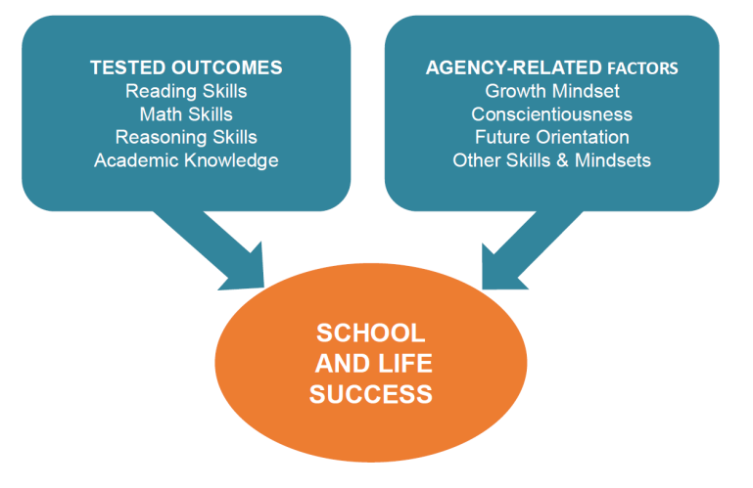
AGENCY

Achievement Gap Initiative (AGI) at Harvard University / Tripod Project for School Improvement -
The Influence of Teaching Beyond Standardized Test Scores: Engagement, Mindsets, and Agency
Agency is the capacity and propensity to take purposeful initiative—the opposite of helplessness. Young people with high levels of agency do not respond passively to their circumstances; they tend to seek meaning and act with purpose to achieve the conditions they desire in their own and others’ lives. The development of agency may be as important an outcome of schooling as the skills we measure with standardized testing. TESTED OUTCOMES Reading
MESH
Transforming Education -
Ready To Be Counted: The Research Case for Education Policy Action on Non-Cognitive Skills
Research shows that students need a variety of Mindsets, Essential Skills, and Habits (MESH) to succeed in college, career, and life. MESH includes both intrapersonal skills and mindsets, such as conscientiousness, self-regulation, growth mindset, and self-efficacy; and interpersonal skills, such as social competence and collaborative problem solving.
21ST CENTURY SKILLS
Partnership for 21st Century Skills / National Education Association (NEA)
The six elements of 21st century learning are:
- Emphasize core subjects
- Emphasize learning skills
- Use 21st century tools to develop learning skills
- Teach and learn in a 21st century context
- Teach and learn new 21st century content
- Use 21st century assessments that measure core subjects and 21st century skills
DEEPER LEARNING AND 21ST CENTURY SKILLS
National Research Council (NRC) -
Education for Life and Work: Developing Transferable Knowledge and Skills in the 21st Century
The Committee on Defining Deeper Learning and 21st Century Skills identified three broad domains of competence—cognitive, intrapersonal, and interpersonal, as a way to organize the various terms for 21st century skills and provide a starting point for further research as to their meaning and value. The cognitive domain involves reasoning and memory; the intrapersonal domain involves the capacity to manage one’s behavior and emotions to achieve one’s goals (including learning goals); and the interpersonal domain involves expressing ideas, and interpreting and responding to messages from others.

SAFE AND SUPPORTIVE SCHOOLS
M.G.L., Ch. 60, Section 1P (a)
Safe and Supportive Schools are schools that foster a safe, positive, healthy & inclusive whole-school learning environment that:
- enable students to develop positive relationships with adults and peers, regulate their emotions and behavior, achieve academic and non-academic success in school and maintain physical and psychological health and well-being; and
- integrate services and aligns initiatives that promote students' behavioral health, including social and emotional learning, bullying prevention, trauma sensitivity, dropout prevention, truancy reduction, children's mental health, foster care and homeless youth education, inclusion of students with disabilities, positive behavioral approaches that reduce suspensions and expulsions and other similar initiatives.

