Antonelli Mejia
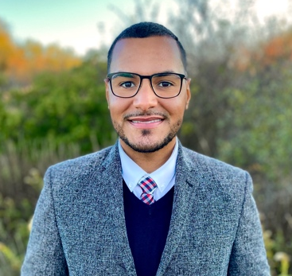
Boston
During his career in education, Antonelli has focused on supporting students and families as a teacher and school administrator. His passion has always been working with students who recently emigrated to the country and need language support. Currently, as the Principal at one of the K-8th Dual Language schools in Boston, he remains committed to leading the work of educational equity and accountability to ensure that teachers provide equitable access to a rigorous and relevant curriculum to all children. In addition to his passion for working with students and their families, Antonelli is the co-founder of Herramientas Del Saber, a nonprofit that works to promote and cultivate the love for education in the Dominican Republic. For the past several years, the organization has served nearly 800 children in underserved communities by providing school supplies and other academic programs. Antonelli invests his time and resources to break generational cycles of poverty and ensure that Dominican children have a fair chance to succeed. Recently, Antonelli completed his School Management and Leadership Certification at the Harvard Graduate School of Education and participated in the Lynch Leadership Academy Fellowship. Antonelli holds a B.A. in Psychology and Human Resources from Boston College, and a Master's of Education and Curriculum Training from Boston University.

Ashley Clerge
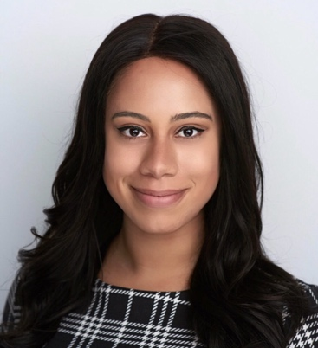
Boston
Ashley Clerge teaches fifth-grade Humanities at the Hugh Roe O'Donnell and is currently in her seventh year of teaching. She plays an active role in her school as a lead teacher, supporting the upper-grade levels in implementing equitable literacy practices. Ashley was a semi-finalist for the Teacher of the Year award in 2022 and is seen as a leader within the field of literacy. In 2022 Ashley received her Ed.M. in Language and Literacy from the Harvard Graduate School of Education. She also holds a B.S. in Political Science from Northeastern University. In her free time, you can find Ashley reading, painting, or eating some really great food with friends.

Bryan W. Riley
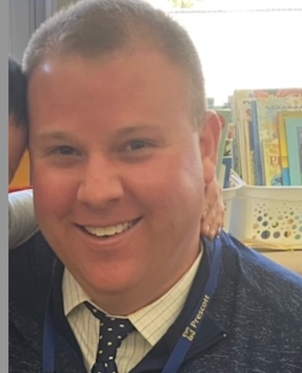
Norwood
Bryan W. Riley currently serves as the Principal at the CJ Prescott Elementary School in Norwood, Massachusetts. He completed his undergraduate and graduate studies at American University in Washington, D.C. Bryan went on to serve as both a teacher and school leader in the District of Columbia Public Schools (DCPS) where he participated in a "Reality PD" series around his teaching practices with the Gates Foundation and served on the Chancellor's Teacher Cabinet. Additionally, Bryan served as an Adjunct Professor in the teacher preparation program in the School of Education at American University and still serves on the Advisory Board in the AU School of Education. You can follow him on Twitter at @RileyPrincipal

Caitlan Sheehan
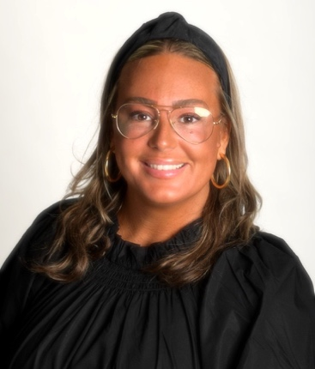
Duxbury
Caitlan Sheehan has been an educator of history to both middle and high school students for the past decade, where her focus was fostering the social-emotional growth of her students, cultivating essential civic dispositions, and providing access to explicit literacy instruction to foster habits of critical and analytical thinking. She now serves as the Director of Diversity, Equity, and Inclusion for the Duxbury Public Schools. Caitlan holds a Bachelor of Arts in History from the University of Massachusetts Amherst, a Master's of Education from Lesley University, and after receiving her Certificate of Advanced Graduate Study from the University of Massachusetts Boston, She is incredibly passionate about providing obstacle-free access for all students to enhance their sense of belonging and respect in order to establish a learning environment that fosters a respect for all viewpoints and inclusivity for all groups, especially those that have been historically marginalized.

Carla Johnson
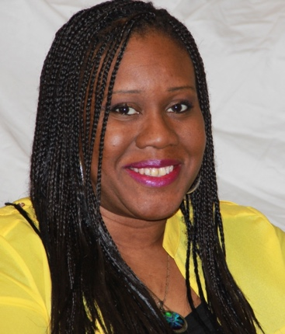
Boston
Carla Johnson is a third generation Boston Public School educator who is committed to preparing students for success. She has over twenty years of experience working with preschool-first grade students and is passionate about helping her students to develop the foundational skills they will build upon throughout their educational careers. A born and raised Bostonian and graduate of Boston Latin School, she takes pride in providing students with high quality, inclusive early childhood educational experiences.
Carla has worked with colleagues and families in many roles including: mentor, union activist, Instructional Leadership Team member, and affinity group leader. She has taken an active role in her school community with the desire to help students become actively engaged citizens, life-long learners, and the best versions of themselves.
Carla is also passionate about cooking, knitting, crocheting, and other creative pursuits.

Cody Marx
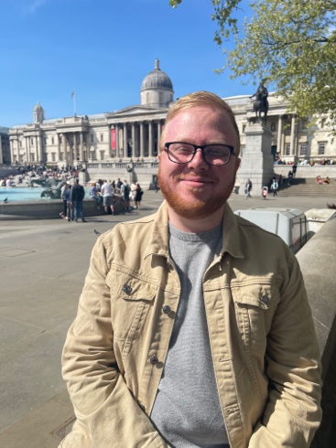
King Philip Regional School District
A product of East Bridgewater Public Schools, Cody Marx has been teaching English language arts at the secondary level in public Massachusetts school systems since 2018. He currently teaches at King Philip Regional High School in Wrentham where he is also the advisor of the student newspaper. Cody has a Bachelor of Arts degree in English and Secondary Education from Bridgewater State University and a Master of Education degree in Curriculum and Teaching from Fitchburg State University. Additionally, he is working on a Doctor of Education degree in Curriculum, Teaching, Learning, and Leadership at Northeastern University; his dissertation research focuses on supporting educators to identify communication strategies that will enable the development of relationships between a student's family and their school.

Erica R. Thomas
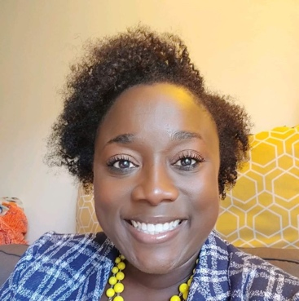
Seekonk
Ms. Erica Thomas enters her third year as Associate Principal for Instruction and Guidance at Seekonk High School. She holds a Masters Degree in School Counseling from Rivier University and a C.A.G.S in School Leadership from American International College. Prior to her arrival in Seekonk, she worked as a guidance counselor for Diman Regional Vocational Technical High School and Wilmington High School for over 13 years collectively. Erica has done extensive work regarding Social-Emotional Learning and has described it as a passion of hers adding that every student should have access to these supports and have the ability to succeed in high school with SEL supports. She is also passionate about advocating for Culturally Responsive teaching and learning. When she's not at work, you can find her in the kitchen creating various dishes, reading, enjoying New England Sports teams, and traveling.

Ezequiel Sanchez Santiago
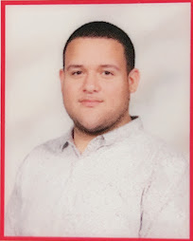
Baystate Academy Charter School
Born in Puerto Rico and raised in Springfield, MA, I, Ezequiel Sanchez Santiago defied all the laws there were to every Hispanic kid. Being the youngest of 5 children brought its challenges. Throughout pre-k and elementary I struggled with speaking due to a language barrier. I was seen as any other student. Noticing this I decided to push on forward and with the love and support of my family, especially my parents, Angel Sanchez and Xiomara Santiago, I was able to accomplish it. When I entered BACPS, a middle and high school, my journey began. After graduating in the top 10 of my class. I got my certification as a paraprofessional and started working at the school that helped me. Also, with my hand of encouragement and principal, Joretha S. Lewis. I can now say: I am a 19 year old with almost two years of teaching experience and looking to go on even further.

Dr. Hannah Vidmar
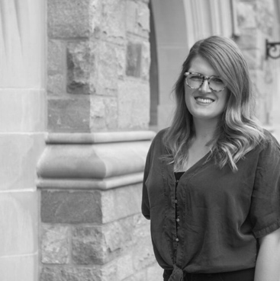
New Heights Charter School
Dr. Hannah Vidmar (she/her/hers) is a teacher, researcher, and writer. She currently teaches 10th grade history at New Heights Charter School of Brockton, one of the first wall-to-wall early college schools in Massachusetts. She received her doctorate in African American and African Studies from the Ohio State University where she researched the politics of language and public space in Dar es Salaam, Tanzania. Her research addresses the intersection of youth performance, language practices, and resistance politics in postcolonial Tanzania, examining the hybrid use of English and Swahili—referred to as Swanglish—in contemporary hip-hop and spoken word art of Tanzania's youth. Now in her tenth year of teaching, she previously taught at the Ohio State University and Boston College before joining New Heights. In addition to teaching U.S. and World History, Dr. Vidmar also teaches classes on media studies, global hip-hop cultures, coordinates her district's high school civics project, and advises the school's yearbook program. In addition to being a member of the Principal and Teacher Advisory Cabinet this year, she is serving as a Civics Fellow with DESE and serving on her school’s Global Leadership Development Committee. Dr. Vidmar is passionate about reimagining the possibilities of education for all students. She remains committed to serving as a leader when it comes to educational accessibility and equity in the classroom to ensure culturally responsive practices paired with rigorous and relevant curriculum are provided to all students.

Hope Z. Fernandes
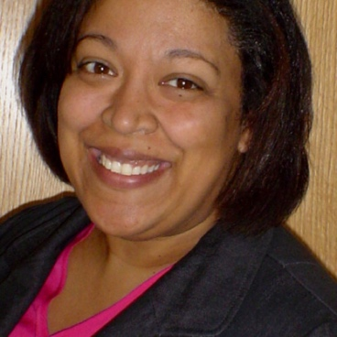
New Heights Charter School
Hope Z. Fernandes has been an educator and educational administrator for thirty years. She has worked in public, private, urban, and online schools as an English Teacher, Assistant Principal of Teaching and Learning, 504 Coordinator, ELA Department Chair, Special Education Director and Civil Rights Officer.

Jayashree Pillai
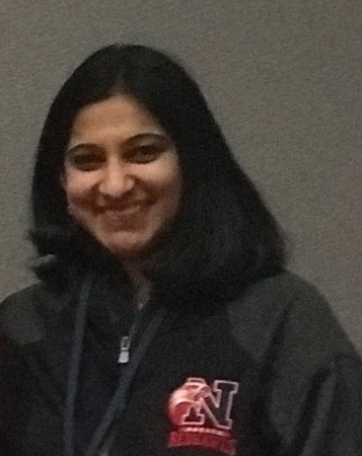
Natick
I am Jayashree Pillai, Math Teacher in Natick High School for the past six years. Prior to Natick, I was teaching at a Catholic school in Boston for about nine years. I moved to the United States from Chennai, India to pursue my graduate education in Mathematics. My teaching career began in Chennai where I was a lecturer at a college teaching Statics, Dynamics and Computer Science. It has been a great journey as I strive my hardest to implement the best of the three education systems I have been associated with so far - the Indian education, the Catholic education, and now the public education. I am passionate about instilling in my students the love for mathematics and thereby shaping their minds to be problem solvers and critical thinkers. As a returning PAC member I look forward to contributing to this year's cabinet, learning from fellow educators, and creating a positive impact for educators across the state.

Jedediyah Williams
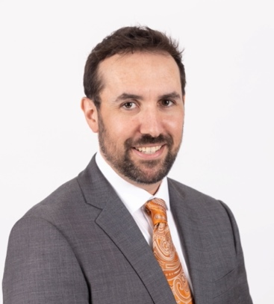
Nantucket
Jedediyah Williams teaches mathematics and sciences at Nantucket High School where he was once a student himself. A first-generation college graduate, Jed is personally aware of how the cultural backgrounds of students deeply shape their academic lives. Jed has earned a B.S. in Computer Systems Engineering from the University of Massachusetts Amherst, an M.Ed. in Curriculum and Teaching from Fitchburg State University, and a Ph.D. in Computer Science from Rensselaer Polytechnic Institute (RPI). While at RPI, Jed was selected for an National Science Foundation (NSF) Graduate STEM Fellowship in K-12 Education, working with RPI's Triple Helix program where he built culturally situated design tools that he implemented with Albany Public Schools. He is a recipient of the Presidential Award for Excellence in Mathematics and Science Teaching.

Jessica Bazinet
Lenox
Jessica Bazinet is a passionate educator who has been teaching for 17 years in Berkshire County. She teaches with positivity and enthusiasm and uplifts her students everyday. She empowers her students by giving them opportunities to lead and build their confidence and creates learning environments that are experiential and hands on to make learning more meaningful and fun. She often does room transformations so her students are engaged and feel more connected with the content and uses project based learning throughout the year. Technology integration is another big piece of her teaching toolbox, bringing in green screen technology, interactive presentations and virtual learning experiences whenever she can. She also uses yoga, meditation and positive affirmations in her classroom. They are given many opportunities to collaborate and share with their peers and are encouraged to work hard to reach their goals by having a growth mindset. Jessica was as a finalist for the 2022 MA Teacher of the Year award has her Master's Degree in Language and Literacy and a Bachelor's Degree in Early Childhood Education. She is a certified Wilson Reading Instructor and mentor teacher for student teachers from the Massachusetts College of Liberal Arts (MCLA). She has also been a mentor teacher for Pittsfield Public Schools, the Greylock Teaching Fellows Program, a member of the PBIS Team in Pittsfield, the Leadership Team in Lenox, and has mentions of her work in articles and books from the Center For Educational Improvement. She also received the Berkshire County Educator Recognition Award in 2012.

Maria J. Davis
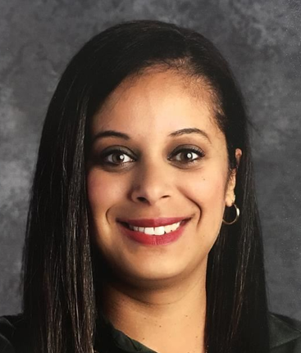
Framingham
Maria earned her bachelor's degree in English and Secondary Education from Regis College. She began teaching in Framingham Public Schools as a 6th grade French Teacher and grades 6-8 Spanish teacher. Maria later served as the Department Head of World Languages of Framingham High School and earned her master's degree in Education Administration from Endicott College through the Massachusetts Secondary School Administrators’ Association (MSSAA) administrators' preparation program. In 2017, she transitioned to elementary education serving as a vice principal at Barbieri Elementary School where she is now in her second year as principal.
Marta Garcia
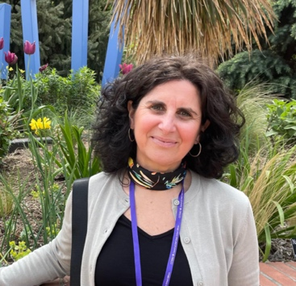
Salem
My name is Marta García and I have been a teacher for over 20 years. I have served both in dual language and ESL instructional settings in California and Massachusetts. Currently, I am an ESL/multilingual learner (ML) teacher in Salem, MA, where I have taught for 15 years. I have taken part in multiple leadership initiatives in Salem. The most recent was my participation in the Dual Language Task Force for the last two years, which resulted in the implementation of Dual Language program in one of the Salem public elementary schools. I am also actively involved in anti-racist and social justice focused work, as it has direct implications in the lives of my multilingual and immigrant students. I amplify their voices, issues, and successes in the greater school community. I am a Spaniard, an immigrant, a mother of two bilingual young adults, and passionate about all cultures of the world. I am also the 2022 Massachusetts Teacher of the Year.

Maya Birks
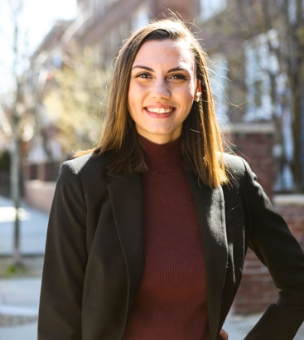
Ware
Maya Birks is a Special Education teacher at Ware Jr./Sr. High School this year. While new to the Ware Public Schools she brings her experience from her past work in the Holyoke Public Schools. Maya graduated from the University of Massachusetts Dartmouth, where she earned her bachelor's degree in English. Her final semester of college, she enrolled with the College for Social Innovation, which provided her the opportunity to intern with a nonprofit organization, Empower Schools. Maya is now an alumni of Teach Western Mass and Americorps. Dedicated to furthering her education, she is seeking her master's degree in Moderate Disabilities.

Michelle Charles
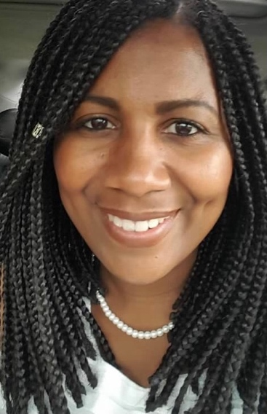
Woburn
I come from a long line of educators so one would think that I would have been destined to follow along in their shoes. However, it didn't happen (right away). Instead, I tried on several different pairs of shoes and chose several many other paths. I never thought about becoming a teacher until I joined the US Peace Corps. It was then that I did one of the hardest jobs they said that I'd ever love, which involved teaching. This year will be my 16th year teaching Multilingual Learners and I couldn't be more satisfied with my career because I know that I make a difference and impact my students every day! My work is guided by integrity as well as a passion for ensuring that all children receive a quality education through equitable mechanisms. I am committed to accomplishing the goal of increasing academic and social achievement for all students through cultural competence, leadership and pedagogy.

Norma B Gordon
Norma Borenstein-Gordon is an accomplished educator with over 30 years of diverse experience in various sectors. Her career began in technology start-ups requiring both technical proficiency and an ability to translate and teach on novel scientific concepts. Norma transferred these competencies to the public school system in 1997 where she was able to hone her teaching and professional development skills by engaging in dynamic learning for, with, and from students and colleagues. Working within public education spaces and the education start-up ecosystem she explores and shares the intersectionality of cultural responsiveness and social-emotional instruction to foster engaged learning in classrooms, staff rooms, and for all stakeholders in the community. Her current driving question is, "What does it mean to be a curious and present learner?" Norma currently holds positions in the Public Schools of Brookline and at Lesley University and supervises pre-service Boston University teacher candidates. She provides professional development, advises education companies and is actively engaged in mathematics social media spaces.

Ralph Saint-Louis
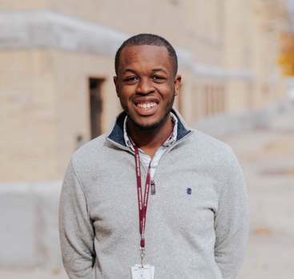
Lowell
Ralph Saint-Louis (B.S, M.S) is a first-generation Haitian American with 11+ years of working in formal and informal education fields from afterschool enrichment programs, the Museum of Science Boston, Public Libraries, and Educational podcast. For Ralph, becoming an educator was a calling from early childhood leading him to his current role as a 5th Year Biology Teacher at Lowell Public High School. From the moment he began his career as a formal classroom teacher he hit the ground running as he found true purpose behind his passion for Culturally and Linguistically Sustaining practices in STEAM education while serving the students and community members. Outside the classroom, Ralph serves on school-based and district-wide leadership teams. Some of his outside involvements include serving on the UMass Lowell School of Education Advisory Board, as a community organizer with the local community and state-wide legislative groups, and as a Senior Policy Fellow with Teach Plus MA. Ralph has a commitment to excellence in the classroom that has been recognized at the local, regional, state, and national levels, most recently being acknowledged as one of 10 educators to receive the 2022 TIME Magazine Innovative Educator Award.

Robert "Bobby" Travers
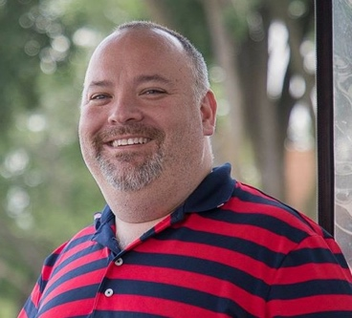
Cambridge
Bobby Travers is a native to Cambridge, Massachusetts and attended Cambridge Public Schools. He currently serves as a library paraprofessional assigned to the Peabody School. Bobby graduated from Cambridge College with a Bachelor degree in Multidisciplinary Studies. He currently serves as the Treasurer of Cambridge Education Association, the local affiliate of the Massachusetts Teachers Association and National Education Association. Bobby looks forward to collaborating with other educators around the state to help shape education policy in the Commonwealth.

Sally Kim
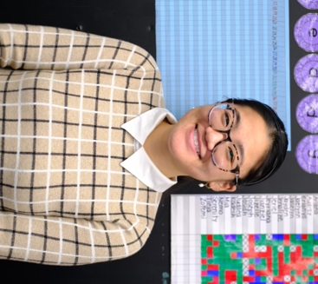
Springfield
Sally is originally from Aberdeen, South Dakota and is a second generation Korean American. She currently teaches 6th grade math at The Academy at Kiley and has been a middle school math teacher in the Springfield Empowerment Zone since 2016. Sally graduated from the University of Michigan with a bachelors and masters in Psychology and is a former Teach for America corps member.

Samantha Roman McKee
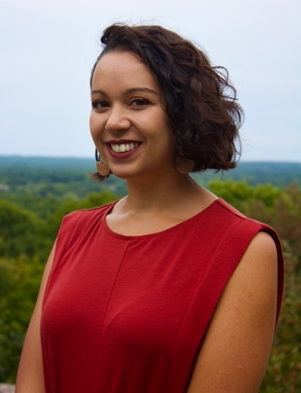
Atlantis Charter School
My name is Samantha Roman McKee and I have been working in the early education field for 10 years. I joined AmeriCorps through Bridgewater State University's Jumpstart program and moved into Teach for America once I finished my B.A. in Spanish and B.S. in Elementary Education. I was placed at my school in Fall River in 2016 and have stayed there ever since, teaching first and second grade. I am finishing my MAT in Teaching English to Speakers of Other Languages (TESOL) and earning my Graduate Bilingual Education Certificate back at BSU. I am inspired by my students to get a little better every day, developing my lessons in new ways that reach more students so they have a chance to shine. Through AmeriCorps especially, I've been surrounded by incredible groups of educators ready to do the impactful work of helping students of all backgrounds build successful lives and I'm happy to be a part of another!

Sandra Kozatek
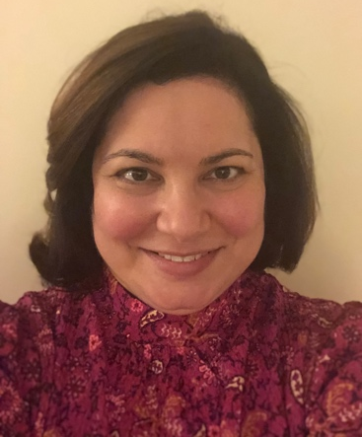
Swansea
Sandra Kozatek is a district-wide Special Education Reading Specialist for the Swansea Public School District. In this role, Sandra specializes in conducting diagnostic reading evaluations and providing multisensory, structured, and systematic literacy instruction to students diagnosed with a specific learning disability in reading, Dyslexia. Additionally, Sandra has implemented a new reading and English language arts curriculum in the special education programs in grades PreK-12 within her district. She provides ongoing professional development to teachers and staff to ensure fidelity and vertical alignment. Sandra earned her Master of Education degree in Special Education from Bridgewater State University in 2015. She was awarded with a Master of Education degree in Reading from American International College in 2020. Sandra is certified as a Structured Literacy Dyslexia Interventionist through the Center for Effective Reading Instruction. She is also certified in Orton Gillingham through the Institute for Multisensory Education. In her free time, Sandra enjoys reading, gardening, spending time with her family, and visiting Martha's Vineyard and Nantucket in the summer.

Sarah Halloran
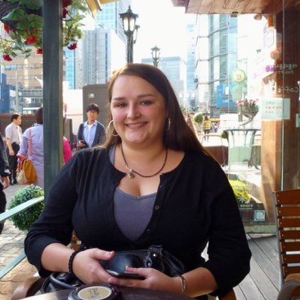
Veritas PREP CHARTER SCHOOL
Sarah Halloran was born and raised in the Pioneer Valley and has worked as a committed bilingual educator of students with diverse needs for over 10 years. She earned an B.A. in International Studies from Macalester College before moving to Daegu, South Korea to teach English in the EPIK program, where she earned a certification in Teaching English to Speakers of Other Languages (TESOL). She then returned to the U.S. and began working with multilingual learners as teaching fellow in the charter world, followed by students with disabilities in Northampton Public Schools as a paraprofessional, and working with undocumented out-of-school youth as a teacher with the Massachusetts Migrant Education Program. During that time, she earned a master's degree in Bilingual, ESL, and Multicultural Education from UMASS-Amherst, writing a master's thesis on the impact of incorporating home language and translanguaging into the classroom for a multilingual student with exceptional needs. For the last 7 years, she has served middle and high school students in Springfield as a teacher and an instructional coach, working to provide them access to high-quality, joyful, affirming, rigorous literacy instruction.

Shannon Sheldon
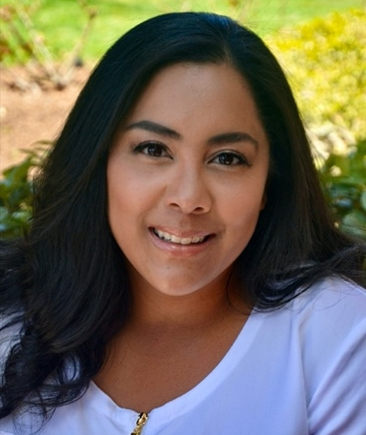
Brockton
Shannon has been a teacher for 16 years, all of which having been served in Brockton Public Schools as an ESL/Sheltered English Immersion (SEI) teacher. Shannon is passionate about improving equity and access to all students, increasing diversity in the workforce, and including and valuing all backgrounds and people in her environments. She has been known to burst out in song at the drop of a hat, or bust a move just for fun in the hopes of creating energetic, engaging, and welcoming spaces for all members of our learning community. She's also notorious for her classroom playlists, secret handshakes, and ruthless knockout skills at recess. Shannon hopes to share her love for teaching with others as she steps into a new role as English Language Acquisition Coach at the Gilmore, where she coincidentally started her journey 16 years ago.

Dr. Sonya White Hope
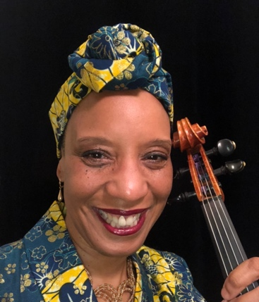
Boston
Dr. Sonya White Hope has been performing and teaching strings and related music courses in and around Boston for over 30 years. She earned her doctorate in Music Education and Bachelors and Masters degrees in Viola Performance from Boston University. Centering scholarship on Arts Education as Cultural Emancipation (AECE) philosophy, Dr. White Hope examines topics at the intersection of culturally relevant music & arts education, Africa-descended students, and the arts of the African Diaspora. Most recently, Dr. White Hope founded Sankofa Songs, a nonprofit organization dedicated to producing events and projects that cultivate outstanding culturally relevant and Africentric arts education and that deepen arts educators' practice. When she isn't teaching, researching, or performing, Dr. White Hope enjoys making all sorts of art, cycling and swimming.
Stefania Khoda
Southbridge
Stefania Khoda is a Grade 8 Science Teacher at Southbridge Middle School. Stefania earned her Bachelor's Degree in Neuroscience at the College of the Holy Cross in Worcester, Massachusetts. Following graduation in 2016, she worked as a Research Assistant at Massachusetts General Hospital, studying the effects that socioeconomic status and stress have on overall health and well-being in various populations. In this research, it was clear that people with access to a high quality education had better life outcomes than those who did not. It was through this experience that Stefania realized that her purpose was to become an educator in high-needs public schools. In 2019, Stefania graduated from Harvard University, where she obtained her Master's in Education with a focus on Teaching and Curriculum. Upon graduation, she chose to work at Southbridge Middle School; she spent time researching Southbridge's history and context and knew that this was the right place for her. Stefania holds deeply the belief that a high-quality education has the power to disrupt deficit narratives about student potential and achievement. In her classroom, Stefania works to bridge the gap between science and students' lives. She pushes students to apply scientific thinking to uncover truths about their reality and provides a platform for students to develop the skills to transform their world. Students in Stefania's classroom develop an acute awareness of how scientific literacy and critical thinking skills can be harnessed to dismantle injustice in their world. In addition to her work in the classroom, Stefania also serves as a teacher leader at Southbridge Middle School; she is the Grade 8 Team Leader and a member of the Instructional Leadership Team.
Steph Richmond
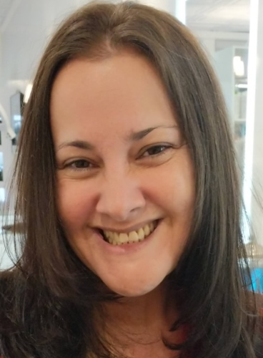
Baystate Academy Charter Public School
Steph Richmond was born and raised in Miami, Florida, and has a bachelor's and master's degrees in English Literature. Additionally, she completed 7 years of education towards a PhD in English Literature and she has finished all but her dissertation (ABD). Steph went on to earn an initial license in ELA 5-12 and CAGS certificate. Over her 17 year teaching career, she has taught in Florida, Connecticut, Massachusetts, Illinois, and California at middle schools, high schools, and universities. For the last 5 years, she has worked in Springfield, Ma as a high school English teacher, Instructional Coach, and is currently the Director of Curriculum and Instruction at Baystate Academy Charter Public School. Steph believes that education is a powerful engine for disrupting structural racism, and while she is passionate about the pursuit of educational equity, she is also painfully aware of how far we are from this ideal. She is thrilled to be part of this cabinet's work to better integrate culturally responsive teaching into teacher preparation programs.
Stephanie Feuer-Beck
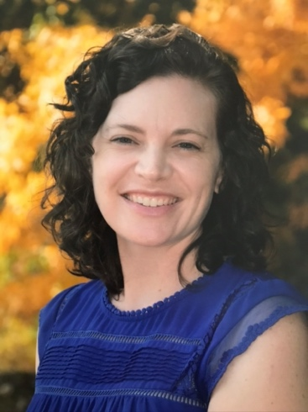
Westwood
I teach 4th grade at the Hanlon School in Westwood, where I am in my 13th year as a classroom teacher. I co-founded and co-lead an Anti-Bias Anti-Racist group for educators in my school. I identify as a lifelong learner and I see teaching as social justice work. I have a B.A. in Psychology from University of Massachusetts Amherst and an M.Ed. from Hunter College in NYC. When I'm not teaching, I enjoy nature walks, painting, traveling, and making a mess in the kitchen.

Suzanne F. Marx
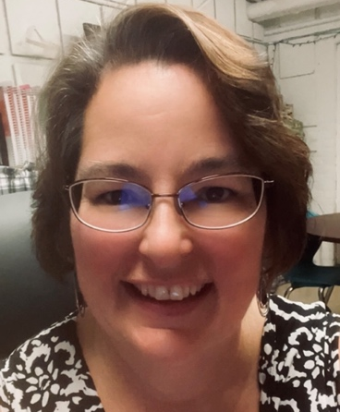
Springfield
Suzanne Marx, M.Ed. currently serves as an Instructional Leadership Specialist with Springfield Public Schools. She is passionate about literacy, equity, inclusion, and culturally responsive instruction. She received a B.S. from Southern Connecticut State University and twenty years later earned her M.Ed. from Fitchburg State College. Suzanne served several terms as a DESE CURATE Fellow where she developed her interest in high quality instructional materials. In Springfield, she co-chaired the ELA curriculum selection team for grades 3-5, and is actively involved in the district's strategic planning process. With a diverse background in business, not-for-profit, public education, and leadership, she is excited to be a part of the 2022-2023 Principal and Teacher Advisory Cabinet.

Veronica Ramos Rowlinson
Somerville
Veronica is a native of Salt Lake City, Utah but has spent her teaching career teaching in both Boston Public Schools and Somerville Public Schools after earning a Masters in Education from UMass Boston. She has served as a curriculum coach focusing on the implementation of Critical Literacy within Somerville High School's English Department. Veronica is a strong advocate for improving and encouraging access to equitable learning experiences for students by serving as an advisor for various student organizations, participating in SHS's Equity Committee, and supporting developing educators in their journeys. In addition to her educational experience, Veronica is also a proud mother to two rambunctious boys.

